Practical 2
Semantic HTML5 Pages with Accessibility-Ready Structure
Problem Definition
Develop static HTML5 skeletons for at least 10 StudentHub pages such as Home, About, Register, Login, Dashboard, Events, Profile, Contact, Admin, FAQ, and Feedback. Use semantic HTML5 tags and accessibility-friendly structures to create clean, consistent, and easy-to-navigate web pages.
In this practical, static HTML5 structures were created for the StudentHub portal using semantic HTML5 elements such as header, nav, main, section, article, aside, and footer. Ten pages including Home, About, Register, Login, Dashboard, Events, Profile, Contact, Admin, FAQ, and Feedback were linked together using navigation links. Accessibility features such as proper form labels, heading hierarchy, alternative text for images, and meaningful navigation links were used to make the pages easier to understand and navigate. A consistent structure was maintained across all pages.
Questions:
1. Are semantic tags such as header, nav, main, section, article, aside, and footer used properly?
Yes, semantic HTML5 tags were used properly to organize the webpage structure. The header contains the page heading and navigation, nav contains the navigation links, main contains the primary content, section and article are used to divide related content, aside is used for additional information, and footer contains footer information. This makes the page structure clear and meaningful.
2. Are form labels, headings, image alt text, and navigation links accessible?
Yes, form fields were provided with proper labels, headings were arranged in a logical hierarchy, and images were given suitable alt text. Navigation links were given meaningful names so users can understand their purpose. These practices improve accessibility and make the website easier to use with screen readers and other accessibility tools.
3. Is the page structure consistent across all pages?
Yes, a consistent structure was maintained across all StudentHub pages. Common elements such as the header, navigation menu, main content area, and footer were used throughout the pages. This provides a similar navigation experience and makes the website easier for users to understand.
Dashboard :
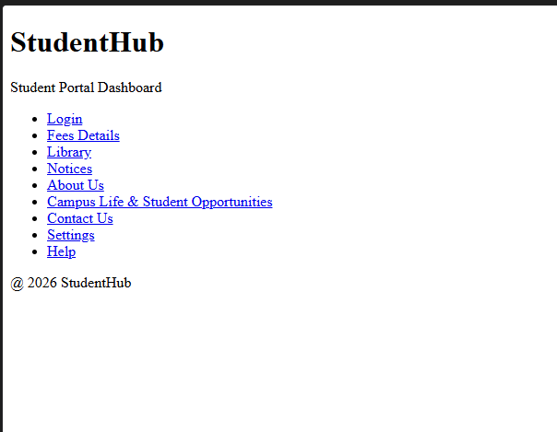

Login :
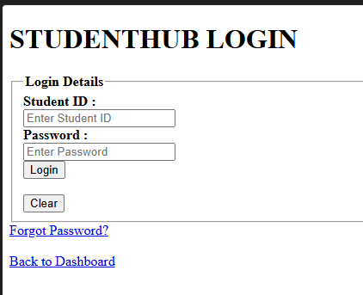
Fees :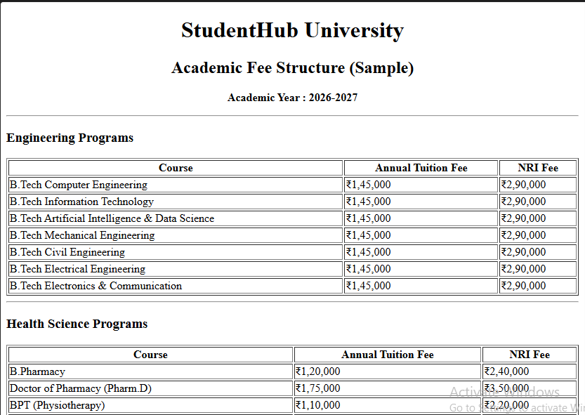 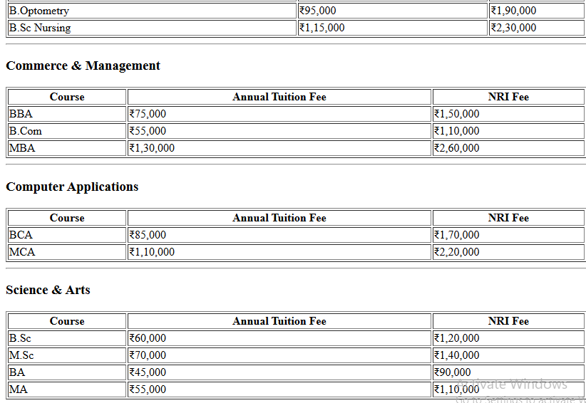 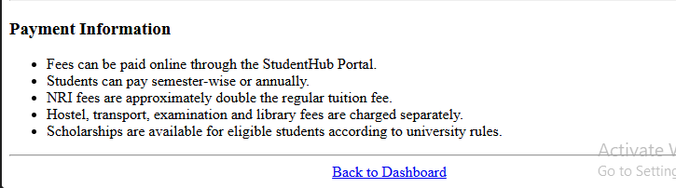Library :
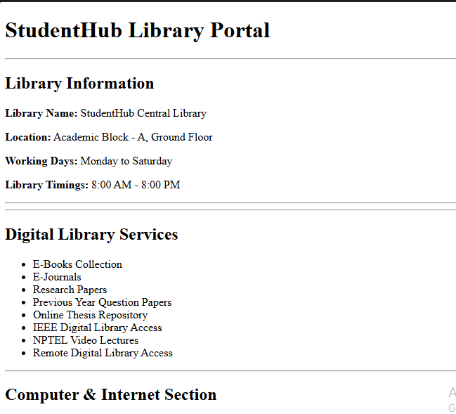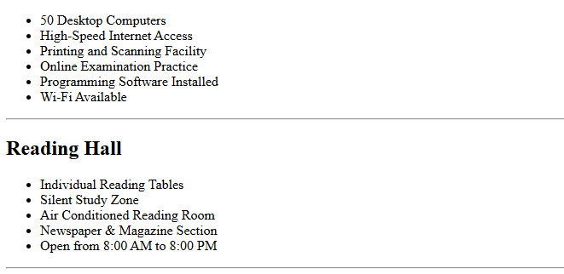
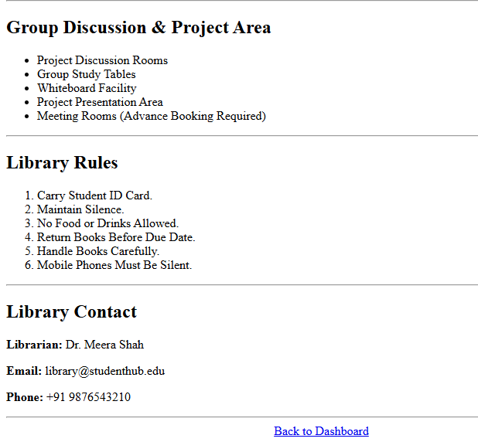

Notices :
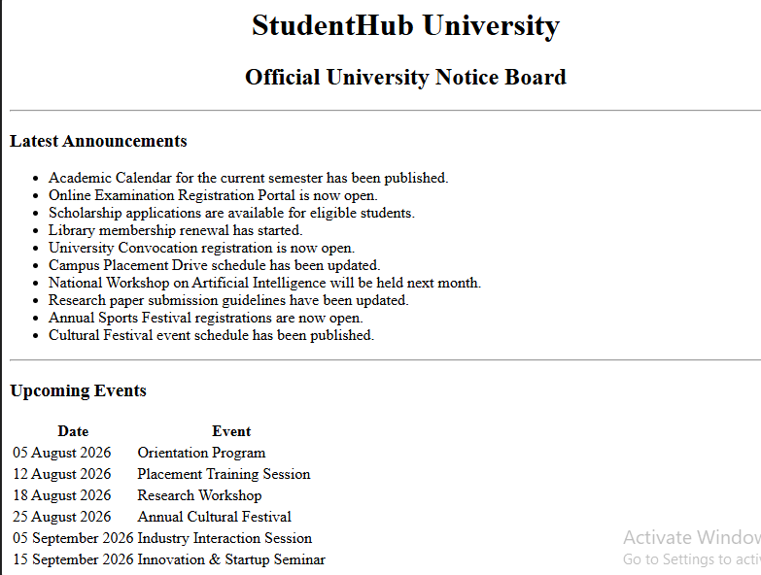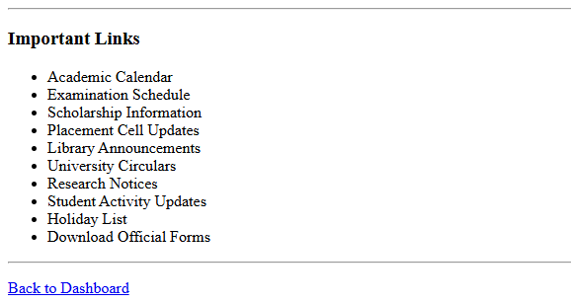
About Us:
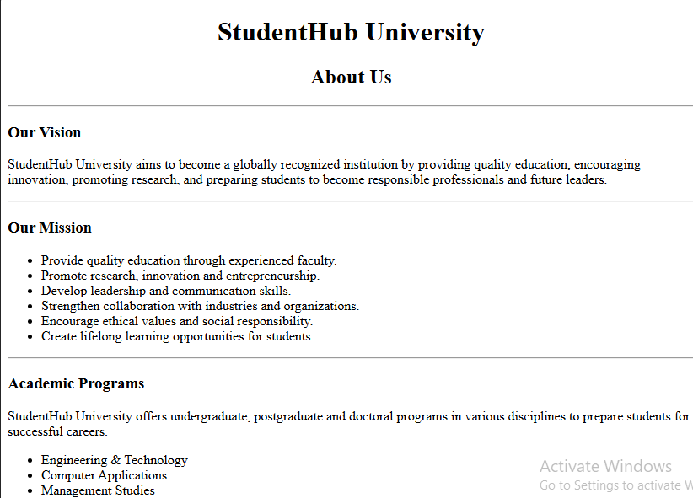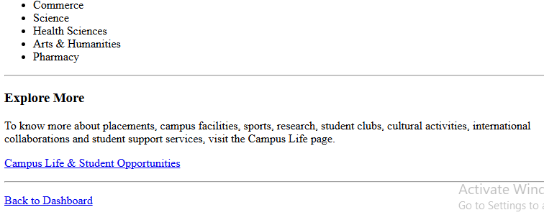
Campus Life :
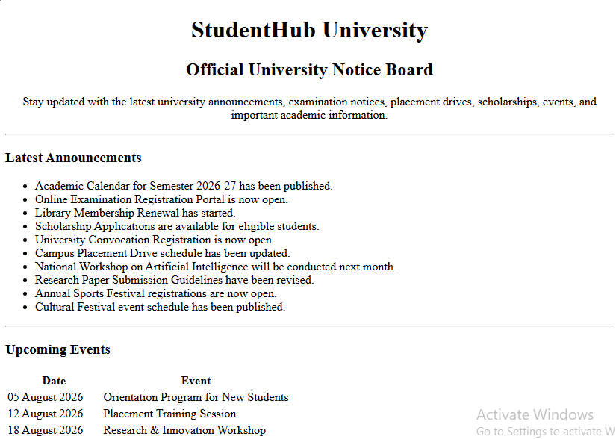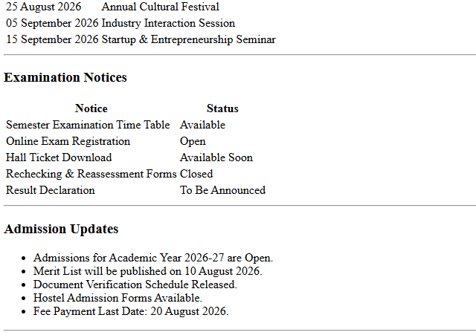
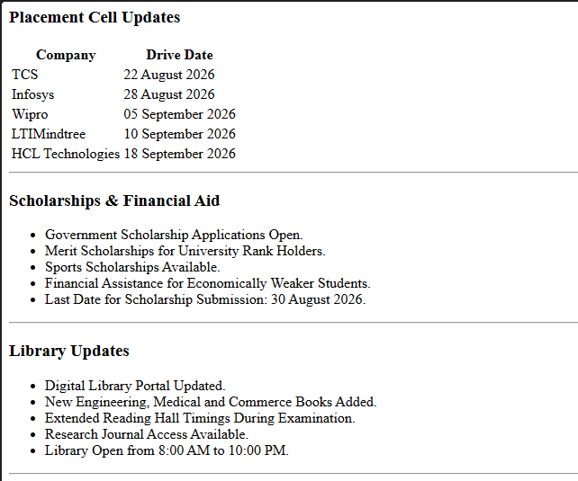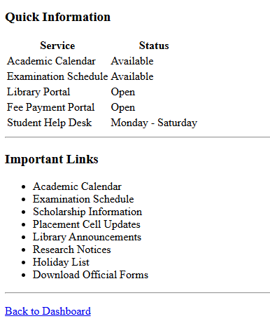
Contact Us :
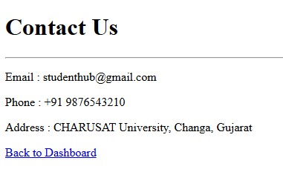

Settings :
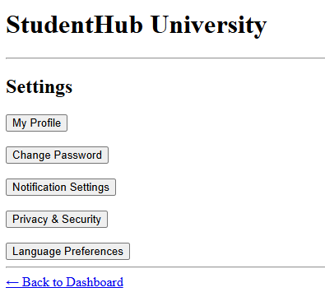
Help :
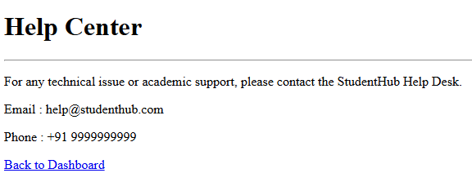

Learning Outcomes:
Students were able to create clean and structured StudentHub web pages using semantic HTML5 elements. They learned to use header, nav, main, section, article, aside, and footer correctly, create accessible forms with proper labels, add alt text to images, and link multiple pages through navigation. They also understood the importance of consistent page structure and basic accessibility practices.
Conclusion:
The practical successfully demonstrated how semantic HTML5 and accessibility features can be used to create well-structured and user-friendly StudentHub pages. The use of proper semantic tags, accessible forms, meaningful navigation links, and consistent page layouts makes the website easier to understand, navigate, and maintain.
Changes That I made :
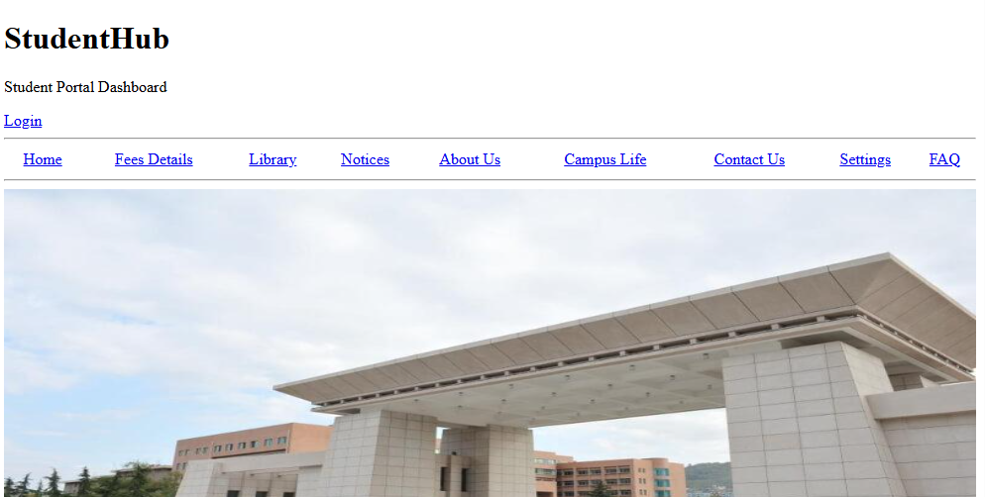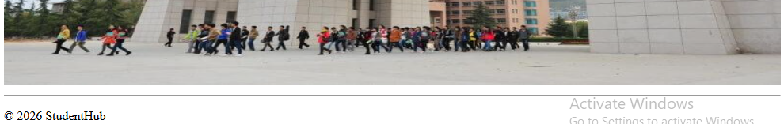

The Students Dashboard:
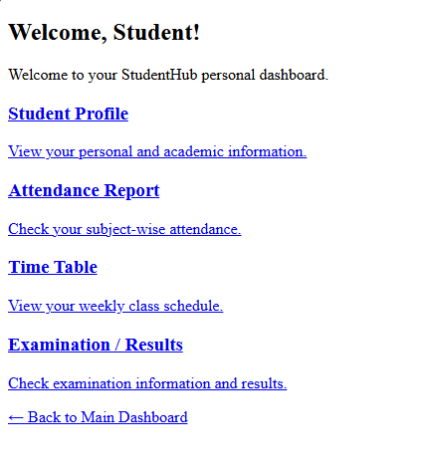
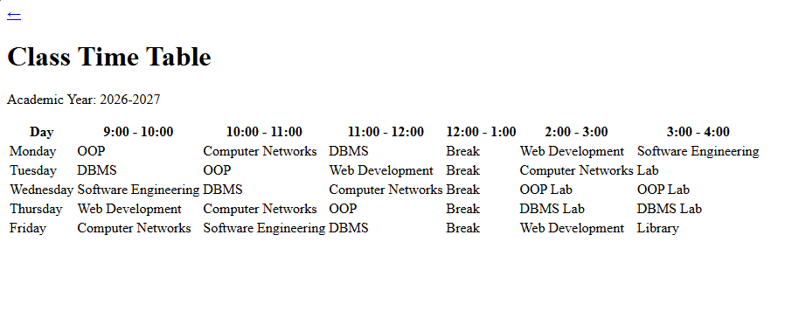
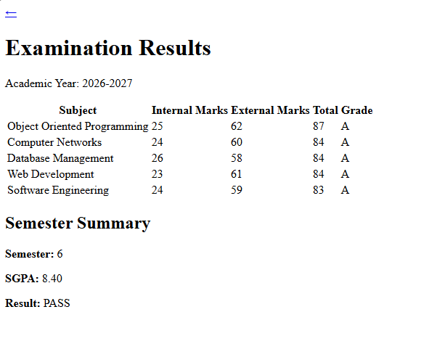
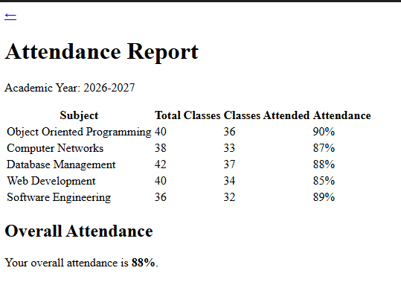
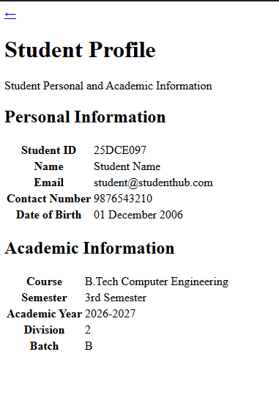
The Code for This all the output Screenshots is uploaded on Github :
https://github.com/raiyanidrashti21-bit/25dce097-Web

