Practical 8: MySQL Schema Design, ER Model, PDO Connectivity, and Prepared Statements

Problem Definition
To design a normalized MySQL database for the StudentHub application containing students, events, and registrations. Create the tables with appropriate primary and foreign keys, represent their relationships using an Entity-Relationship (ER) model, and establish a PHP database connection. Use PDO and prepared statements to securely interact with the database.

Key Questions / Analysis / Interpretation
1. Is the schema normalized properly?
Yes, database normalization organizes information into related tables and reduces unnecessary data duplication. For example, student details are stored in the students table, event details in the events table, and registration information in the registrations table. This structure improves consistency and makes data easier to manage.
2. Are primary keys and foreign keys correctly defined?
Primary keys uniquely identify each record in a table. For example, student_id identifies a student, while event_id identifies an event. Foreign keys establish relationships between tables. In the registrations table, student_id and event_id can reference the corresponding records in the students and events tables, maintaining referential integrity.
3. Is the database connection handled securely?
Yes, PHP can connect to MySQL using PDO with proper database credentials and exception-based error handling. Credentials should be stored securely rather than exposed publicly. Prepared statements should be used for queries containing user input to help prevent SQL injection attacks.

Output:

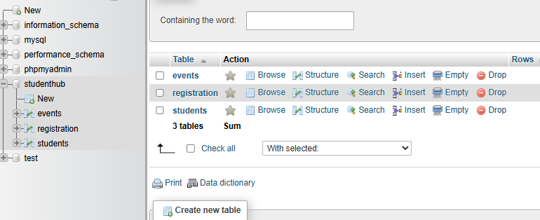

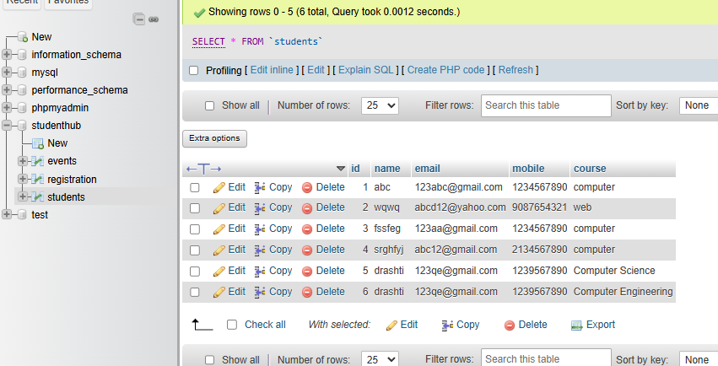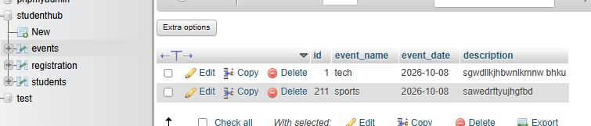

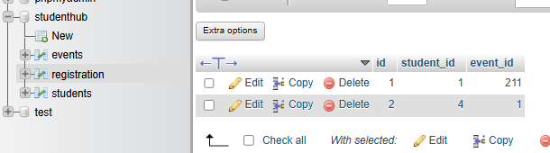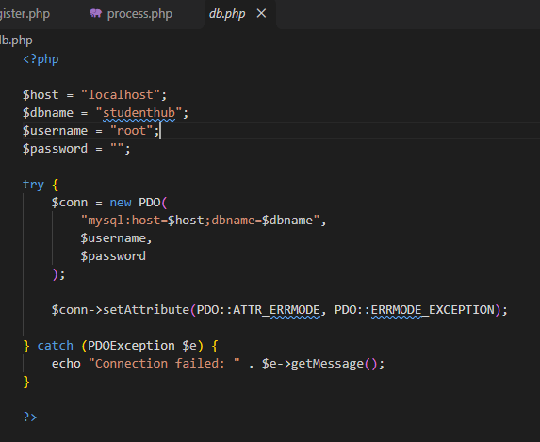Conclusion
In this practical, a normalized MySQL database was designed for StudentHub using students, events, and registrations tables. Primary keys and foreign keys established relationships between the tables, while PDO provided connectivity between PHP and MySQL. Prepared statements and secure credential handling helped improve database security and reliability.

