Practical 6: Rendering External JSON Data using Fetch API, Search and Filter

Problem Definition
To fetch external JSON data using the Fetch API and display it dynamically on a webpage. Implement search, filtering, sorting, pagination, and proper loading and error handling.

Key Questions and Answers
1. How is JSON fetched, parsed, and rendered?
JSON data is fetched from an external file using the fetch() method. The response is converted into JavaScript objects using the .json() method. JavaScript then renders the data dynamically on the webpage by creating HTML elements and displaying the required information.
2. Which array methods are used for search, filter, sort, and pagination?
The filter() method selects records matching a search term or condition. The sort() method arranges records in ascending or descending order. The slice() method selects a limited number of records for pagination, while map() can be used to generate HTML content from array data.
3. How are loading and error states handled?
A loading message is displayed while the JSON data is being fetched. If the request fails or the file cannot be loaded, an error message is displayed using .catch() or try...catch. The HTTP response status should also be checked to identify unsuccessful requests.
4. How is modularity maintained in JavaScript files?
Modularity is maintained by dividing the code into separate functions or files. For example, one function fetches JSON data, another renders the records, and other functions handle searching, filtering, sorting, and pagination. This makes the code easier to understand, test, and maintain.

Output :

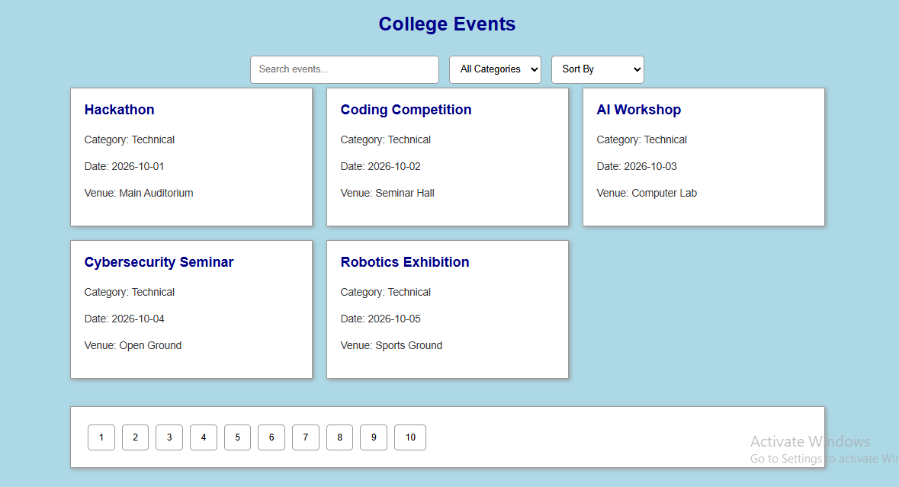

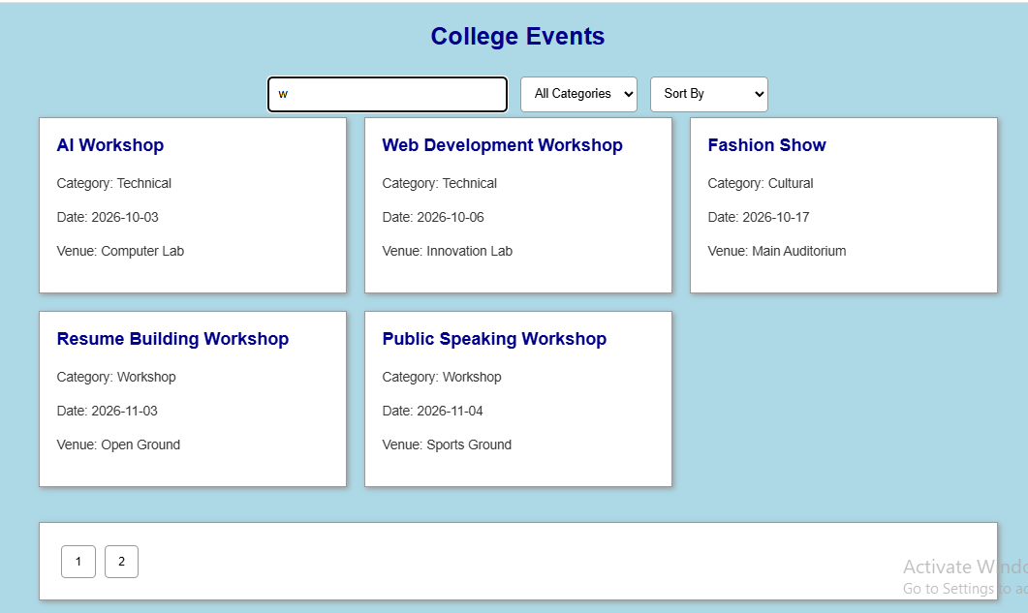

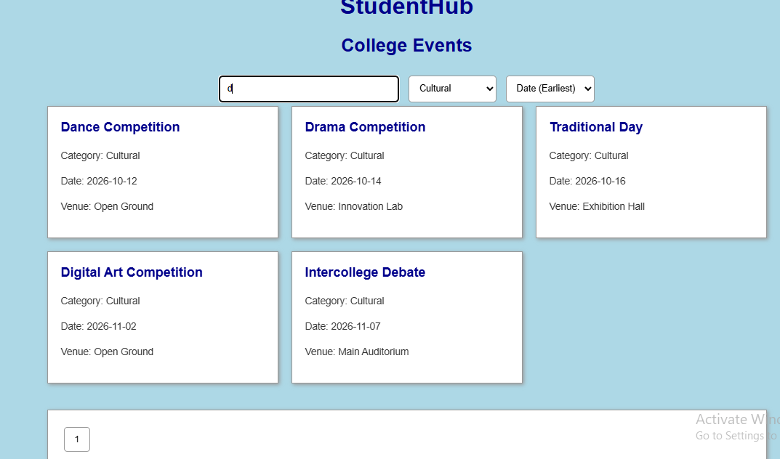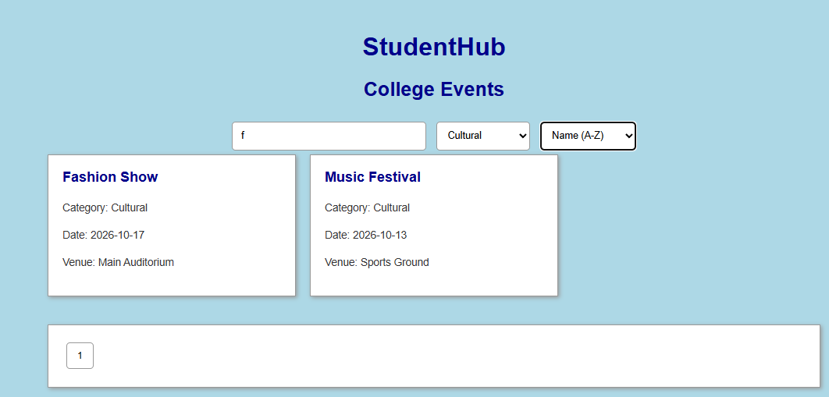

Conclusion
The Fetch API was used to retrieve JSON data and display it dynamically. Search, filtering, sorting, pagination, and error handling made the webpage more interactive and user-friendly.

