SYNOPSIS

**1. Introduction**

The banking sector is the backbone of any economy. A reliable and efficient banking system is vital for managing customers, accounts, loans, transactions, and related operations. Our "Banking System" project is a comprehensive database management system (DBMS) built using Oracle SQL. It supports key banking functions such as account creation, deposits, withdrawals, fund transfers, loan management, EMI payments, and employee management. The system focuses on data consistency, integrity, and security while offering scalability and simplicity. By automating these processes, the system improves operational efficiency and minimizes manual intervention.

#### ****2. Objectives****

The primary objectives of the Banking System project are:

1. To maintain structured and secure banking data.
2. To store and manage customer information and contact details.
3. To handle multiple types of bank accounts per customer.
4. To allow secure deposit and withdrawal of money.
5. To enable inter-account fund transfers.
6. To manage customer loan requests and EMI payments.
7. To keep track of all transaction histories.
8. To link each bank branch to a parent bank and employees.
9. To implement and test PL/SQL procedures and functions.
10. To validate business rules such as balance checks before withdrawals.
11. To provide analytical functions like total loan amount by customer.
12. To reduce redundancy and improve data normalization.
13. To ensure proper foreign key relationships between entities.
14. To prepare an extendable and modular design for future improvements.
15. To allow easy data retrieval for decision-making and audits.

#### ****3. Problem Statement****

Banks deal with massive volumes of customer, transaction, and loan data. Managing this data manually or with fragmented systems often leads to inefficiency, data inconsistency, and delayed processing. A centralized, secure, and automated banking database is necessary to reduce these issues. Our project addresses this by building a full-fledged database system for banks that can automate routine operations, reduce human error, and maintain data integrity across branches, customers, and financial services.

#### ****4. Scope of the Project****

The current implementation supports essential banking operations like customer onboarding, bank account management, transaction tracking, and loan processing. In the future, this project can be expanded to include:

* Real-time web or mobile banking interfaces.
* Integration with credit score systems.
* Fraud detection mechanisms.
* Transactional analytics dashboards.
* Multi-level user authentication and access control.
* SMS/email alerts for transactions.
* Investment and insurance services modules.
* Support for international transactions.
* AI-driven customer support.
* Blockchain for secure record-keeping.

#### ****5. Database Design Methodology****

##### **a) Entity-Relationship Modeling**

We identified the core entities such as Bank, Branch, Customer, Bank_Account, Transaction, Loan, Payment, Card, Employee, and Manage. Each of these entities holds critical data elements related to banking operations. Their relationships are defined with clear primary and foreign keys.

##### **b) Cardinality and Table Structure Analysis**

Each Bank can have multiple Branches; each Branch can serve multiple Customers; a Customer can own multiple Accounts, Loans, or Cards; each Account can have multiple Transactions. Cardinality was analyzed to avoid redundancy and ensure optimized table design.

##### **c) ER-to-Table Conversion**

Each entity from the ER model was converted into a table using SQL CREATE TABLE statements. Primary keys and foreign keys were carefully assigned to maintain referential integrity.

##### **d) Normalization Process**

The schema is normalized to at least the third normal form (3NF). Repeating groups are eliminated, each table has a primary key, and transitive dependencies are resolved. For example, account and branch information are kept in separate tables and linked via foreign keys.

##### **e) PL/SQL Implementation**

Advanced operations like deposits, withdrawals, transfers, and loan approvals are handled through PL/SQL stored procedures and functions. These scripts ensure that business rules are enforced at the database level (e.g., preventing overdrafts, logging transactions automatically).

#### ****6. Expected Outcome of the Project****

The final Banking System database will:

* Allow efficient data entry, querying, and updating.
* Automate transactional operations through PL/SQL.
* Maintain high data accuracy and reduce redundancy.
* Support all major banking workflows digitally.
* Be scalable for future enhancements or real-time integration.
* Improve performance through relational design and indexing.
* Provide a strong foundation for real-world banking application development.

ER DIAGRAM

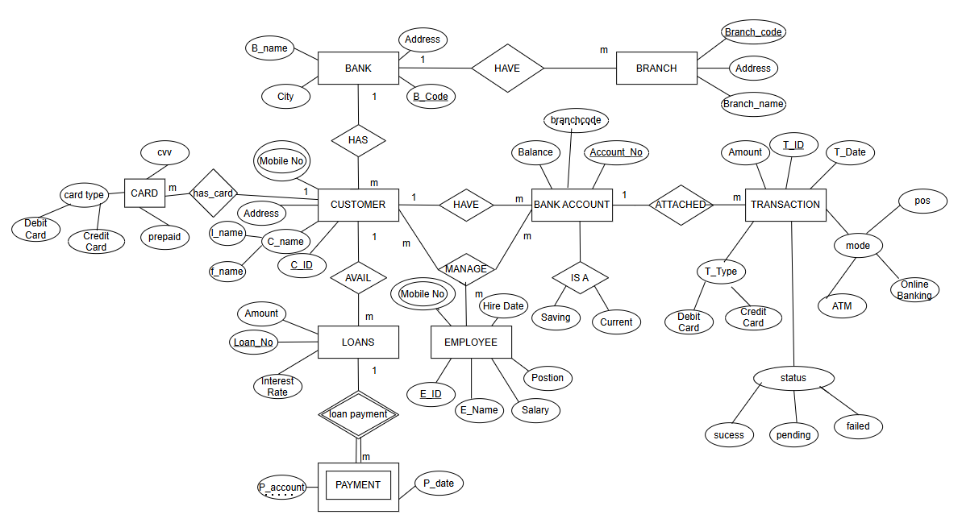

ER TO TABLE CONVERSION

1. BANK(B_Code, City, B_name, Address)
2. BRANCH(Branch_code, B_Code, Branch_name, Address)
3. CUSTOMERX(C_ID, Customerx, Address,Mobile_No)
4. EMPLOYEE(E_ID, E_Name,Position, Salary ,Hire_Date, Branch_code ,Mobile_No)
5. BANK_ACCOUNT(Account_No, Balance , Branch_code ,C_ID, Account_Type)
6. CARD(Card_No, Card_Type, C_ID)
7. LOANS(Loan_ID, Amount , Interest_Rate ,C_ID, E_ID)
8. PAYMENT(P_Account, P_Date, Loan_No, Amount)
9. TRANSACTION(T_ID, Account_No, T_Date, Amount, Modex,Status,Card_No)

ENTITIES AND THEIR ATTRIBUTES &CONSTRAINTS

### ****1. BANK****

* **Primary Key**: B_Code
* **Attributes**: City, B_Name, Address

### ****2. BRANCH****

* **Primary Key**: Branch_code
* **Foreign Key**: B_Code → BANK(B_Code)
* **Attributes**: Branch_name, Address

### ****3. CUSTOMERX****

* **Primary Key**: C_ID
* **Attributes**: Customerx (Name), Address, Mobile_No

### ****4. EMPLOYEE****

* **Primary Key**: E_ID
* **Foreign Key**: Branch_code → BRANCH(Branch_code)
* **Attributes**: E_Name, Position, Salary, Hire_Date, Mobile_No

### ****5. BANK_ACCOUNT****

* **Primary Key**: Account_No
* **Foreign Keys**:
  + Branch_code → BRANCH(Branch_code)
  + C_ID → CUSTOMERX(C_ID)
* **Attributes**: Balance, Account_Type

### ****6. LOANS****

* **Primary Key**: Loan_No
* **Foreign Keys**:
  + C_ID → CUSTOMERX(C_ID)
  + E_ID → EMPLOYEE(E_ID) (optional)
* **Attributes**: Amount, Interest_Rate

### ****7. PAYMENT****

* **Primary Key**: (Composite) P_Account, P_Date
* **Foreign Keys**:
  + P_Account → BANK_ACCOUNT(Account_No)
  + Loan_No → LOANS(Loan_No)
* **Attributes**: Amount

### ****8. CARD****

* **Primary Key**: Card_No
* **Foreign Key**: C_ID → CUSTOMERX(C_ID)
* **Attributes**: Card_Type

### ****9. TRANSACTION****

* **Primary Key**: T_ID
* **Foreign Keys**:
  + Account_No → BANK_ACCOUNT(Account_No)
  + Card_No → CARD(Card_No) (optional)
* **Attributes**: T_Date, Amount, Modex, Status

RELATIONSHIP AND CARDINALITY

**1. BANK – BRANCH**

* **Relationship:** *HAS / HAVE*
* **Cardinality:** One Bank → Many Branches (1:M)
* **Explanation:** A bank can have multiple branches located in different cities, but each branch belongs to exactly one bank.

**2. BANK – CUSTOMER**

* **Relationship:** *HAS*
* **Cardinality:** One Bank → Many Customers (1:M)
* **Explanation:** A bank services many customers, but each customer is associated with one bank in this design

**3. CUSTOMER – BANK ACCOUNT**

* **Relationship:** *HAVE*
* **Cardinality:** One Customer → Many Accounts (1:M)
* **Explanation:** A customer can hold multiple types of accounts (e.g., savings, current), but each account is owned by only one customer.

**4. BANK ACCOUNT – TRANSACTION**

* **Relationship:** *ATTACHED*
* **Cardinality:** One Bank Account → Many Transactions (1:M)
* **Explanation:** Each transaction is linked to one account, while a bank account may have many transactions over time.

**5. CUSTOMER – CARD**

* **Relationship:** *HAS_CARD*
* **Cardinality:** One Customer → Many Cards (1:M)
* **Explanation:** A customer can own multiple cards (credit, debit, prepaid), but each card belongs to only one customer.

**6. CUSTOMER – LOANS**

* **Relationship:** *AVAIL*
* **Cardinality:** One Customer → Many Loans (1:M)
* **Explanation:** A customer can avail multiple loans, each recorded separately.

**7. LOANS – PAYMENT**

* **Relationship:** *LOAN PAYMENT*
* **Cardinality:** One Loan → Many Payments (1:M)
* **Explanation:** A loan is repaid in installments (EMIs), and each installment is recorded as a payment.

**8. CUSTOMER – EMPLOYEE**

* **Relationship:** *MANAGE*
* **Cardinality:** Many-to-Many (M:N)
* **Explanation:**  
  An employee can manage multiple customers (e.g., as a relationship manager), and a customer may be managed by multiple employees (e.g., for loans, services, account issues).

**9.BANK ACCOUNT – EMPLOYEE**

* **Relationship:** *MANAGE*
* **Cardinality:** Many-to-Many (M:N)
* **Explanation:**  
  Multiple employees (e.g., tellers, auditors, managers) may manage the same bank account at different times or roles, and one employee may manage multiple bank accounts.

NORMALISATION

* 1. **BANK**

**FDs:**  
 B_Code → B_name, City, Address

|  |  |  |
| --- | --- | --- |
| **Attribute** | **Data-type** | **Constraint** |
| B_Code | VARCHAR2(10) | Primary Key |
| B_Name | VARCHAR2(100) | NOT NULL |
| City | VARCHAR2(100) | NOT NULL |
| Address | VARCHAR2(200) | NOT NULL |

**1NF**: No multivalued attributes  
**2NF**: Fully dependent on B_Code (single attribute PK)  
**3NF**: No transitive dependency  
**BCNF**: B_Code is only determinant

**2. BRANCH**

**FDs:**  
Branch_code → Branch_name, Address, B_Code  
B_Code → Bank Details (via FK)

|  |  |  |
| --- | --- | --- |
| **Attribute** | **Data-type** | **Constraint** |
| Branch_code | VARCHAR2(10) | Primary Key |
| Branch_name | VARCHAR2(100) | NOT NULL |
| Address | VARCHAR2(200) | NOT NULL |
| B_Code | VARCHAR2(10) | Foreign Key → BANK(B_Code) |

**1NF**: Complies  
**2NF**: All attributes dependent on full PK  
**3NF**: No transitive dependencies  
**BCNF**: Satisfies all conditions

**3. CUSTOMERX**

**FDs:**  
C_ID → Name, Address, Mobile_No

|  |  |  |
| --- | --- | --- |
| **Attribute** | **Data-type** | **Constraint** |
| C_ID | NUMBER | Primary Key |
| Customerx | VARCHAR2(100) | NOT NULL |
| Address | VARCHAR2(200) | NOT NULL |
| Mobile_No | VARCHAR2(15) | NOT NULL |

**1NF**: No repeating attributes  
**2NF**: All fields dependent on PK  
**3NF**: No non-key attribute depends on another non-key  
**BCNF**: C_ID is the only determinant

**4. EMPLOYEE**

**FDs:**  
E_ID → E_Name, Position, Salary, Hire_Date, Branch_code, Mobile_No

|  |  |  |
| --- | --- | --- |
| **Attribute** | **Data-type** | **Constraint** |
| E_ID | NUMBER | Primary Key |
| E_Name | VARCHAR2(100) | NOT NULL |
| Position | VARCHAR2(50) | NOT NULL |
| Salary | NUMBER | NOT NULL |
| Hire_Date | DATE | NOT NULL |
| Branch_code | VARCHAR2(10) | Foreign Key |
| Mobile_No | VARCHAR2(15) | NOT NULL |

**1NF**: No multivalued fields  
**2NF**: All attributes fully depend on E_ID  
**3NF**: No transitive dependency  
**BCNF**: E_ID is the only determinant

**5. BANK_ACCOUNT**

**FDs:**  
Account_No → Balance, Branch_code, C_ID, Account_Type

|  |  |  |
| --- | --- | --- |
| **Attribute** | **Data-type** | **Constraint** |
| Account_No | NUMBER | Primary Key |
| Balance | NUMBER | NOT NULL |
| Branch_code | VARCHAR2(10) | Foreign Key |
| C_ID | NUMBER | Foreign Key |
| Account_Type | VARCHAR2(20) | CHECK (values IN ‘Saving’, ‘Current’) |

|  |  |  |
| --- | --- | --- |
|  |  |  |
|  |  |  |
|  |  |  |
|  |  |  |
|  |  |  |
|  |  |  |

**1NF**: No repeating groups  
**2NF**: Single attribute PK  
**3NF**: No transitive dependency  
**BCNF**: Account_No is a candidate key and only determinant

**6. LOANS**

**FDs:**  
Loan_No → Amount, Interest_Rate, C_ID, E_ID

|  |  |  |
| --- | --- | --- |
| **Attribute** | **Data-type** | **Constraint** |
| Loan_No | NUMBER | Primary Key |
| Amount | NUMBER | NOT NULL |
| Interest_Rate | NUMBER(5,2) | NOT NULL |
| C_ID | NUMBER | Foreign Key |
| E_ID | NUMBER | Foreign Key |

**1NF**: Complies  
 **2NF**: Single attribute PK  
 **3NF**: No non-prime depends on another  
 **BCNF**: Loan_No is the only determinant

**7. PAYMENT**

**FDs:**  
(P_Account, P_Date) → Loan_No, Amount

|  |  |  |  |  |
| --- | --- | --- | --- | --- |
| **Attribute** | **Data-type** | **Constraint** |  |  |
| P_Account | NUMBER | Foreign Key |  |  |
| P_Date | DATE | Composite PK |  |  |
| Loan_No | NUMBER | Foreign Key |  |  |
| Amount | NUMBER | NOT NULL |  |  |

**1NF**: Complies  
**2NF**: Composite PK with full dependency  
**3NF**: No transitive dependency  
**BCNF**: All determinants are candidate keys

**8. CARD**

**FDs:**  
Card_No → Card_Type, C_ID

|  |  |  |  |  |  |
| --- | --- | --- | --- | --- | --- |
| **Attribute** | **Data-type** | **Constraint** |  |  |  |
| Card_No | VARCHAR2(20) | Primary Key |  |  |  |
| Card_Type | VARCHAR2(20) | NOT NULL |  |  |  |
| C_ID | NUMBER | Foreign Key |  |  |  |

**1NF**: No multivalued attributes  
**2NF**: Complies  
**3NF**: No transitive dependency  
**BCNF**: Card_No is the only determinant

**9. TRANSACTION**

**FDs:**  
T_ID → Account_No, T_Date, Amount, Modex, Status, Card_No

|  |  |  |
| --- | --- | --- |
| **Attribute** | **Data-type** | **Constraint** |
| T_ID | NUMBER | Primary Key |
| Account_No | NUMBER | Foreign Key |
| T_Date | DATE | NOT NULL |
| Amount | NUMBER | NOT NULL |
| Modex | VARCHAR2(20) | CHECK (ATM, Online, POS) |
| Status | VARCHAR2(10) | CHECK (Success, Pending, Failed) |
| Card_No | VARCHAR2(20) | Foreign Key (Nullable) |

**1NF**: Complies  
 **2NF**: All fully dependent on T_ID  
 **3NF**: No non-key transitive dependencies  
 **BCNF**: Satisfies BCNF

|  |  |  |
| --- | --- | --- |
|  |  |  |
|  |  |  |
|  |  |  |
|  |  |  |
|  |  |  |
|  |  |  |
|  |  |  |

PL/SQL CODES

1. Create BANK Table

CREATE TABLE BANK (

B_Code VARCHAR2(10) PRIMARY KEY,

City VARCHAR2(50) NOT NULL,

B_Name VARCHAR2(100) NOT NULL,

Address VARCHAR2(255)

);

2. Create BRANCH Table

CREATE TABLE BRANCH (

Branch_code VARCHAR2(10) PRIMARY KEY,

Branch_name VARCHAR2(100) NOT NULL,

Address VARCHAR2(255),

B_Code VARCHAR2(10) NOT NULL,

FOREIGN KEY (B_Code) REFERENCES BANK(B_Code)

);

3. Create CUSTOMERX Table

CREATE TABLE CUSTOMERX (

C_ID VARCHAR2(10) PRIMARY KEY,

Customerx VARCHAR2(100) NOT NULL,

Address VARCHAR2(255),

Mobile_No VARCHAR2(15) UNIQUE

);

4. Create EMPLOYEE Table

CREATE TABLE EMPLOYEE (

E_ID VARCHAR2(10) PRIMARY KEY,

E_Name VARCHAR2(100) NOT NULL,

Position VARCHAR2(50),

Salary NUMBER(10, 2),

Hire_Date DATE,

Branch_code VARCHAR2(10) NOT NULL,

Mobile_No VARCHAR2(15) UNIQUE,

FOREIGN KEY (Branch_code) REFERENCES BRANCH(Branch_code)

);

5. Create BANK_ACCOUNT Table

CREATE TABLE BANK_ACCOUNT (

Account_No VARCHAR2(20) PRIMARY KEY,

Balance NUMBER(15, 2) DEFAULT 0 CHECK (Balance >= 0),

Branch_code VARCHAR2(10) NOT NULL,

C_ID VARCHAR2(10) NOT NULL,

Account_Type VARCHAR2(20) CHECK (Account_Type IN ('Saving', 'Current', 'Fixed Deposit')),

FOREIGN KEY (Branch_code) REFERENCES BRANCH(Branch_code),

FOREIGN KEY (C_ID) REFERENCES CUSTOMERX(C_ID) -- Changed to reference CUSTOMERX

);

6. Create LOANS Table

CREATE TABLE LOANS (

Loan_No VARCHAR2(10) PRIMARY KEY,

Amount NUMBER(15, 2) NOT NULL CHECK (Amount > 0),

Interest_Rate NUMBER(5, 4) NOT NULL CHECK (Interest_Rate > 0),

C_ID VARCHAR2(10) NOT NULL,

E_ID VARCHAR2(10), -- Assuming an employee might be assigned to a loan, but not strictly mandatory based on ER

FOREIGN KEY (C_ID) REFERENCES CUSTOMERX(C_ID), -- Changed to reference CUSTOMERX

FOREIGN KEY (E_ID) REFERENCES EMPLOYEE(E_ID)

);

7. Create PAYMENT Table

CREATE TABLE PAYMENT (

P_Account VARCHAR2(20),

P_Date DATE,

Loan_No VARCHAR2(10) NOT NULL,

Amount NUMBER(15, 2) NOT NULL CHECK (Amount > 0),

PRIMARY KEY (P_Account, P_Date), -- Composite primary key

FOREIGN KEY (P_Account) REFERENCES BANK_ACCOUNT(Account_No),

FOREIGN KEY (Loan_No) REFERENCES LOANS(Loan_No)

);

8. Create CARD Table

CREATE TABLE CARD (

Card_No VARCHAR2(20) PRIMARY KEY,

Card_Type VARCHAR2(20) CHECK (Card_Type IN ('Debit Card', 'Credit Card', 'Prepaid')),

C_ID VARCHAR2(10) NOT NULL,

FOREIGN KEY (C_ID) REFERENCES CUSTOMERX(C_ID) -- Changed to reference CUSTOMERX

);

9. Create TRANSACTION Table

CREATE TABLE TRANSACTION (

T_ID VARCHAR2(20) PRIMARY KEY,

Account_No VARCHAR2(20) NOT NULL,

T_Date DATE NOT NULL,

Amount NUMBER(15, 2) NOT NULL CHECK (Amount >= 0),

Modex VARCHAR2(50),

Status VARCHAR2(20) CHECK (Status IN ('success', 'failed', 'pending')),

Card_No VARCHAR2(20), -- Optional, as not all transactions use a card

FOREIGN KEY (Account_No) REFERENCES BANK_ACCOUNT(Account_No),

FOREIGN KEY (Card_No) REFERENCES CARD(Card_No)

);

Functions and Procedures

1. Function to get Account Balance

CREATE OR REPLACE FUNCTION GET_ACCOUNT_BALANCE (

p_account_no IN VARCHAR2

)

RETURN NUMBER

IS

v_balance NUMBER(15, 2);

BEGIN

SELECT Balance

INTO v_balance

FROM BANK_ACCOUNT

WHERE Account_No = p_account_no;

RETURN v_balance;

EXCEPTION

WHEN NO_DATA_FOUND THEN

DBMS_OUTPUT.PUT_LINE('Error: Account number ' || p_account_no || ' not found.');

RETURN NULL;

WHEN OTHERS THEN

DBMS_OUTPUT.PUT_LINE('An error occurred: ' || SQLERRM);

RAISE;

END GET_ACCOUNT_BALANCE;

/

2. Procedure for Deposit

CREATE OR REPLACE PROCEDURE DEPOSIT_TO_ACCOUNT (

p_account_no IN VARCHAR2,

p_amount IN NUMBER,

p_mode IN VARCHAR2

)

IS

v_current_balance NUMBER(15, 2);

v_t_id VARCHAR2(20);

BEGIN

IF p_amount <= 0 THEN

DBMS_OUTPUT.PUT_LINE('Error: Deposit amount must be positive.');

RETURN;

END IF;

SELECT Balance INTO v_current_balance

FROM BANK_ACCOUNT

WHERE Account_No = p_account_no

FOR UPDATE OF Balance;

UPDATE BANK_ACCOUNT

SET Balance = Balance + p_amount

WHERE Account_No = p_account_no;

SELECT 'TRANS' || TO_CHAR(SYSDATE, 'YYYYMMDDHH24MISS') || DBMS_RANDOM.STRING('U', 5) INTO v_t_id FROM dual;

INSERT INTO TRANSACTION (T_ID, Account_No, T_Date, Amount, Modex, Status)

VALUES (v_t_id, p_account_no, SYSDATE, p_amount, p_mode, 'success');

COMMIT;

DBMS_OUTPUT.PUT_LINE('Deposit of ' || p_amount || ' to account ' || p_account_no || ' successful.');

EXCEPTION

WHEN NO_DATA_FOUND THEN

DBMS_OUTPUT.PUT_LINE('Error: Account number ' || p_account_no || ' not found.');

ROLLBACK;

WHEN OTHERS THEN

DBMS_OUTPUT.PUT_LINE('An error occurred during deposit: ' || SQLERRM);

ROLLBACK;

RAISE;

END DEPOSIT_TO_ACCOUNT;

/

3. Procedure for Withdrawal

CREATE OR REPLACE PROCEDURE WITHDRAW_FROM_ACCOUNT (

p_account_no IN VARCHAR2,

p_amount IN NUMBER,

p_mode IN VARCHAR2,

p_card_no IN VARCHAR2 DEFAULT NULL

)

IS

v_current_balance NUMBER(15, 2);

v_t_id VARCHAR2(20);

BEGIN

IF p_amount <= 0 THEN

DBMS_OUTPUT.PUT_LINE('Error: Withdrawal amount must be positive.');

RETURN;

END IF;

SELECT Balance INTO v_current_balance

FROM BANK_ACCOUNT

WHERE Account_No = p_account_no

FOR UPDATE OF Balance;

IF v_current_balance < p_amount THEN

DBMS_OUTPUT.PUT_LINE('Error: Insufficient funds in account ' || p_account_no);

SELECT 'TRANS' || TO_CHAR(SYSDATE, 'YYYYMMDDHH24MISS') || DBMS_RANDOM.STRING('U', 5) INTO v_t_id FROM dual;

INSERT INTO TRANSACTION (T_ID, Account_No, T_Date, Amount, Modex, Status, Card_No)

VALUES (v_t_id, p_account_no, SYSDATE, p_amount, p_mode, 'failed', p_card_no);

COMMIT;

RETURN;

END IF;

UPDATE BANK_ACCOUNT

SET Balance = Balance - p_amount

WHERE Account_No = p_account_no;

SELECT 'TRANS' || TO_CHAR(SYSDATE, 'YYYYMMDDHH24MISS') || DBMS_RANDOM.STRING('U', 5) INTO v_t_id FROM dual;

INSERT INTO TRANSACTION (T_ID, Account_No, T_Date, Amount, Modex, Status, Card_No)

VALUES (v_t_id, p_account_no, SYSDATE, p_amount, p_mode, 'success', p_card_no);

COMMIT;

DBMS_OUTPUT.PUT_LINE('Withdrawal of ' || p_amount || ' from account ' || p_account_no || ' successful.');

EXCEPTION

WHEN NO_DATA_FOUND THEN

DBMS_OUTPUT.PUT_LINE('Error: Account number ' || p_account_no || ' not found.');

ROLLBACK;

WHEN OTHERS THEN

DBMS_OUTPUT.PUT_LINE('An error occurred during withdrawal: ' || SQLERRM);

ROLLBACK;

RAISE;

END WITHDRAW_FROM_ACCOUNT;

/

4. Procedure to Create a New Customer

CREATE OR REPLACE PROCEDURE CREATE_NEW_CUSTOMER (

p_c_id IN VARCHAR2,

p_customerx_name IN VARCHAR2,

p_address IN VARCHAR2,

p_mobile_no IN VARCHAR2

)

IS

BEGIN

INSERT INTO CUSTOMERX (C_ID, Customerx, Address, Mobile_No)

VALUES (p_c_id, p_customerx_name, p_address, p_mobile_no);

COMMIT;

DBMS_OUTPUT.PUT_LINE('New customer ' || p_customerx_name || ' with ID ' || p_c_id || ' created successfully.');

EXCEPTION

WHEN DUP_VAL_ON_INDEX THEN

DBMS_OUTPUT.PUT_LINE('Error: Customer ID or Mobile Number already exists.');

ROLLBACK;

WHEN OTHERS THEN

DBMS_OUTPUT.PUT_LINE('An error occurred during customer creation: ' || SQLERRM);

ROLLBACK;

RAISE;

END CREATE_NEW_CUSTOMER;

/

5. Procedure to Create a New Bank Account

CREATE OR REPLACE PROCEDURE CREATE_NEW_ACCOUNT (

p_account_no IN VARCHAR2,

p_branch_code IN VARCHAR2,

p_c_id IN VARCHAR2,

p_account_type IN VARCHAR2

)

IS

v_customer_exists NUMBER;

v_branch_exists NUMBER;

BEGIN

SELECT COUNT(*)

INTO v_customer_exists

FROM CUSTOMERX

WHERE C_ID = p_c_id;

IF v_customer_exists = 0 THEN

DBMS_OUTPUT.PUT_LINE('Error: Customer with ID ' || p_c_id || ' does not exist.');

RETURN;

END IF;

SELECT COUNT(*)

INTO v_branch_exists

FROM BRANCH

WHERE Branch_code = p_branch_code;

IF v_branch_exists = 0 THEN

DBMS_OUTPUT.PUT_LINE('Error: Branch with code ' || p_branch_code || ' does not exist.');

RETURN;

END IF;

INSERT INTO BANK_ACCOUNT (Account_No, Balance, Branch_code, C_ID, Account_Type)

VALUES (p_account_no, 0, p_branch_code, p_c_id, p_account_type);

COMMIT;

DBMS_OUTPUT.PUT_LINE('New account ' || p_account_no || ' created successfully for customer ' || p_c_id || ' at branch ' || p_branch_code);

EXCEPTION

WHEN DUP_VAL_ON_INDEX THEN

DBMS_OUTPUT.PUT_LINE('Error: Account number ' || p_account_no || ' already exists.');

ROLLBACK;

WHEN OTHERS THEN

DBMS_OUTPUT.PUT_LINE('An error occurred during account creation: ' || SQLERRM);

ROLLBACK;

RAISE;

END CREATE_NEW_ACCOUNT;

/

-- Trigger to update the account balance after a transaction is inserted

-- This trigger fires AFTER each row INSERTED into the TRANSACTION table

CREATE OR REPLACE TRIGGER TRG_UPDATE_ACCOUNT_BALANCE

AFTER INSERT ON TRANSACTION

FOR EACH ROW

WHEN (NEW.Status = 'success')

DECLARE

v_account_type VARCHAR2(20);

BEGIN

SELECT Account_Type

INTO v_account_type

FROM BANK_ACCOUNT

WHERE Account_No = :NEW.Account_No;

IF :NEW.Amount > 0 THEN

UPDATE BANK_ACCOUNT

SET Balance = Balance + :NEW.Amount

WHERE Account_No = :NEW.Account_No;

END IF;

EXCEPTION

WHEN NO_DATA_FOUND THEN

DBMS_OUTPUT.PUT_LINE('Error in trigger: Account ' || :NEW.Account_No || ' not found.');

WHEN OTHERS THEN

DBMS_OUTPUT.PUT_LINE('Error in trigger: ' || SQLERRM);

RAISE_APPLICATION_ERROR(-20001, 'Error updating account balance: ' || SQLERRM);

END TRG_UPDATE_ACCOUNT_BALANCE;

/

-- Trigger to prevent withdrawal if account balance is insufficient

-- This trigger fires BEFORE each row INSERTED into the TRANSACTION table

CREATE OR REPLACE TRIGGER TRG_PREVENT_INSUFFICIENT_WITHDRAWAL

BEFORE INSERT ON TRANSACTION

FOR EACH ROW

WHEN (NEW.Modex = 'Withdrawal')

DECLARE

v_current_balance BANK_ACCOUNT.Balance%TYPE;

BEGIN

SELECT Balance

INTO v_current_balance

FROM BANK_ACCOUNT

WHERE Account_No = :NEW.Account_No;

IF v_current_balance < :NEW.Amount THEN

RAISE_APPLICATION_ERROR(-20002, 'Insufficient funds for withdrawal from account ' || :NEW.Account_No);

END IF;

EXCEPTION

WHEN NO_DATA_FOUND THEN

RAISE_APPLICATION_ERROR(-20003, 'Account number ' || :NEW.Account_No || ' not found for withdrawal.');

WHEN OTHERS THEN

RAISE_APPLICATION_ERROR(-20004, 'An unexpected error occurred during withdrawal check: ' || SQLERRM);

END TRG_PREVENT_INSUFFICIENT_WITHDRAWAL;

/

-- PL/SQL block using a cursor to apply interest to savings accounts

DECLARE

CURSOR savings_accounts_cur IS

SELECT Account_No, Balance

FROM BANK_ACCOUNT

WHERE Account_Type = 'Saving';

v_account_no BANK_ACCOUNT.Account_No%TYPE;

v_balance BANK_ACCOUNT.Balance%TYPE;

v_interest_rate NUMBER := 0.005;

v_interest_amount NUMBER(15, 2);

BEGIN

OPEN savings_accounts_cur;

LOOP

FETCH savings_accounts_cur INTO v_account_no, v_balance;

EXIT WHEN savings_accounts_cur%NOTFOUND;

v_interest_amount := v_balance * v_interest_rate;

UPDATE BANK_ACCOUNT

SET Balance = Balance + v_interest_amount

WHERE Account_No = v_account_no;

DBMS_OUTPUT.PUT_LINE('Applied interest of ' || v_interest_amount || ' to account ' || v_account_no);

END LOOP;

CLOSE savings_accounts_cur;

COMMIT;

DBMS_OUTPUT.PUT_LINE('Interest application process completed.');

EXCEPTION

WHEN OTHERS THEN

DBMS_OUTPUT.PUT_LINE('An error occurred during interest application: ' || SQLERRM);

ROLLBACK;

RAISE;

END;

/

-- PL/SQL block using a cursor to generate an account statement

DECLARE

p_account_no BANK_ACCOUNT.Account_No%TYPE := 'ACC1001';

p_start_date DATE := TO_DATE('2025-05-01', 'YYYY-MM-DD');

p_end_date DATE := TO_DATE('2025-05-31', 'YYYY-MM-DD');

CURSOR account_statement_cur IS

SELECT

T_ID,

T_Date,

Amount,

Modex,

Status,

Card_No

FROM

TRANSACTION

WHERE

Account_No = p_account_no

AND T_Date BETWEEN p_start_date AND p_end_date

ORDER BY

T_Date, T_ID;

v_t_id TRANSACTION.T_ID%TYPE;

v_t_date TRANSACTION.T_Date%TYPE;

v_amount TRANSACTION.Amount%TYPE;

v_mode TRANSACTION.Modex%TYPE;

v_status TRANSACTION.Status%TYPE;

v_card_no TRANSACTION.Card_No%TYPE;

v_current_balance BANK_ACCOUNT.Balance%TYPE;

BEGIN

DBMS_OUTPUT.ENABLE(NULL);

DBMS_OUTPUT.PUT_LINE('--- Account Statement for Account: ' || p_account_no || ' ---');

DBMS_OUTPUT.PUT_LINE('Period: ' || TO_CHAR(p_start_date, 'YYYY-MM-DD') || ' to ' || TO_CHAR(p_end_date, 'YYYY-MM-DD'));

DBMS_OUTPUT.PUT_LINE('---------------------------------------------------------');

DBMS_OUTPUT.PUT_LINE(RPAD('T_ID', 10) || ' | ' || RPAD('Date', 10) || ' | ' || RPAD('Amount', 10) || ' | ' || RPAD('Mode', 20) || ' | ' || RPAD('Status', 10) || ' | ' || RPAD('Card_No', 15));

DBMS_OUTPUT.PUT_LINE('---------------------------------------------------------');

OPEN account_statement_cur;

LOOP

FETCH account_statement_cur INTO v_t_id, v_t_date, v_amount, v_mode, v_status, v_card_no;

EXIT WHEN account_statement_cur%NOTFOUND;

DBMS_OUTPUT.PUT_LINE(

RPAD(v_t_id, 10) || ' | ' ||

TO_CHAR(v_t_date, 'YYYY-MM-DD') || ' | ' ||

RPAD(TO_CHAR(v_amount, 'FM9999999.00'), 10) || ' | ' ||

RPAD(v_mode, 20) || ' | ' ||

RPAD(v_status, 10) || ' | ' ||

RPAD(NVL(v_card_no, 'N/A'), 15)

);

END LOOP;

CLOSE account_statement_cur;

BEGIN

SELECT Balance

INTO v_current_balance

FROM BANK_ACCOUNT

WHERE Account_No = p_account_no;

DBMS_OUTPUT.PUT_LINE('---------------------------------------------------------');

DBMS_OUTPUT.PUT_LINE('Current Balance as of ' || TO_CHAR(SYSDATE, 'YYYY-MM-DD') || ': ' || TO_CHAR(v_current_balance, 'FM99999999.00'));

EXCEPTION

WHEN NO_DATA_FOUND THEN

DBMS_OUTPUT.PUT_LINE('Error: Account number ' || p_account_no || ' not found for final balance.');

END;

DBMS_OUTPUT.PUT_LINE('--- End of Statement ---');

EXCEPTION

WHEN NO_DATA_FOUND THEN

DBMS_OUTPUT.PUT_LINE('Error: Account number ' || p_account_no || ' not found.');

WHEN OTHERS THEN

DBMS_OUTPUT.PUT_LINE('An error occurred during statement generation: ' || SQLERRM);

IF account_statement_cur%ISOPEN THEN

CLOSE account_statement_cur;

END IF;

RAISE;

END;

/

This view is intended to be queried by filtering on C_ID to show a specific customer's data.

CREATE OR REPLACE VIEW CUSTOMER_FULL_DETAILS_V AS

SELECT

c.C_ID,

c.Customerx AS Customer_Name,

c.Address AS Customer_Address,

c.Mobile_No AS Customer_Mobile,

ba.Account_No,

ba.Balance AS Account_Balance,

ba.Account_Type,

b.Branch_code,

b.Branch_name,

b.Address AS Branch_Address,

bk.B_Name AS Bank_Name,

bk.City AS Bank_City,

t.T_ID AS Transaction_ID,

t.T_Date AS Transaction_Date,

t.Amount AS Transaction_Amount,

t.Modex AS Transaction_Mode,

t.Status AS Transaction_Status,

t.Card_No AS Transaction_Card_No,

card.Card_Type AS Transaction_Card_Type

FROM

CUSTOMERX c

JOIN

BANK_ACCOUNT ba ON c.C_ID = ba.C_ID

JOIN

BRANCH b ON ba.Branch_code = b.Branch_code

JOIN

BANK bk ON b.B_Code = bk.B_Code

LEFT JOIN

TRANSACTION t ON ba.Account_No = t.Account_No

LEFT JOIN

CARD card ON t.Card_No = card.Card_No;

SELECT * FROM CUSTOMER_FULL_DETAILS_V WHERE C_ID = 'CUST01';

 

SOME SAMPLE QUERIES WITH OUTPUT

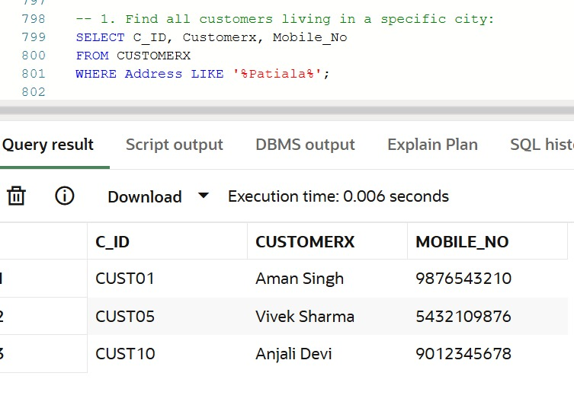

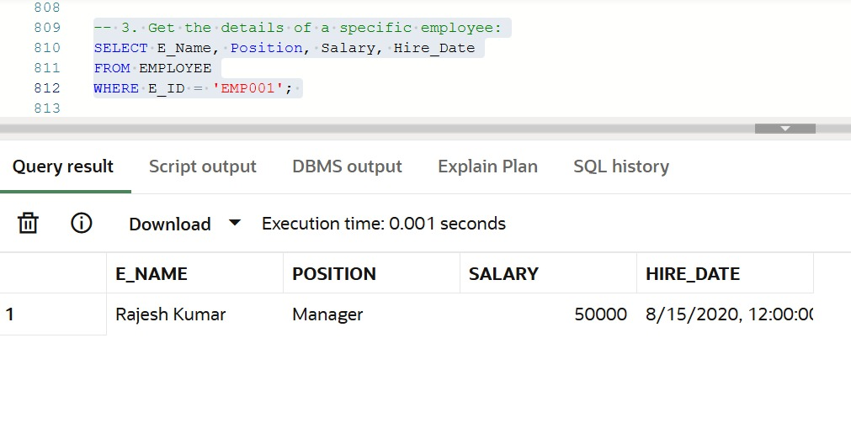

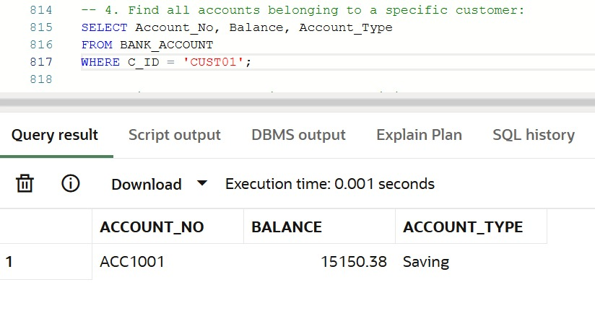

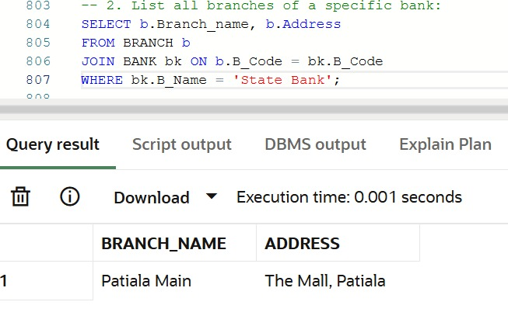

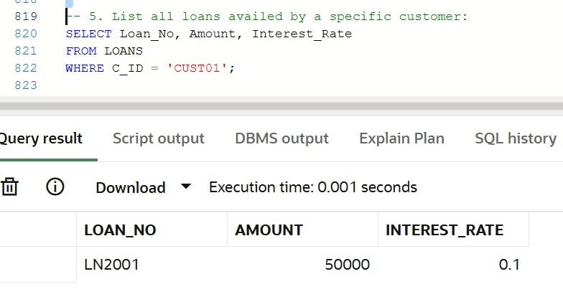

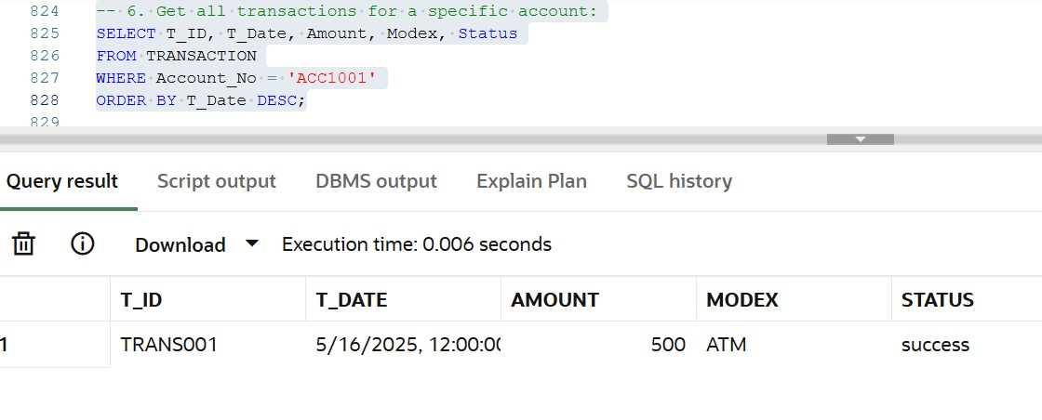

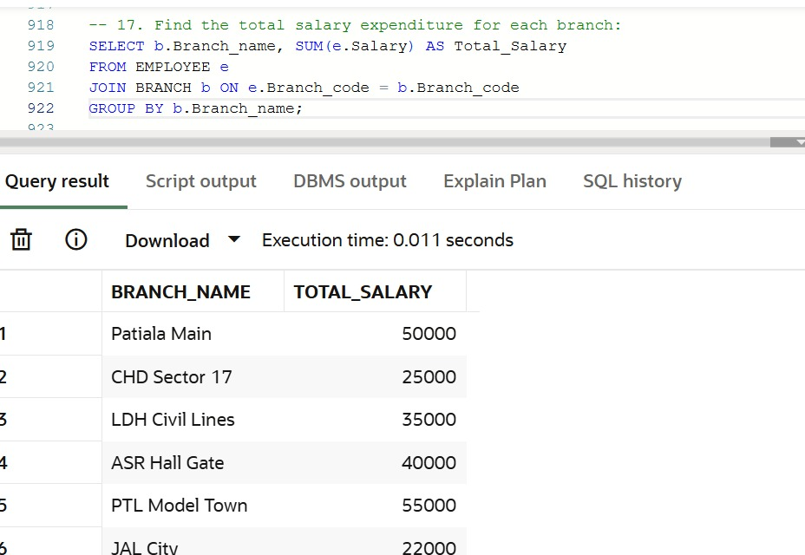

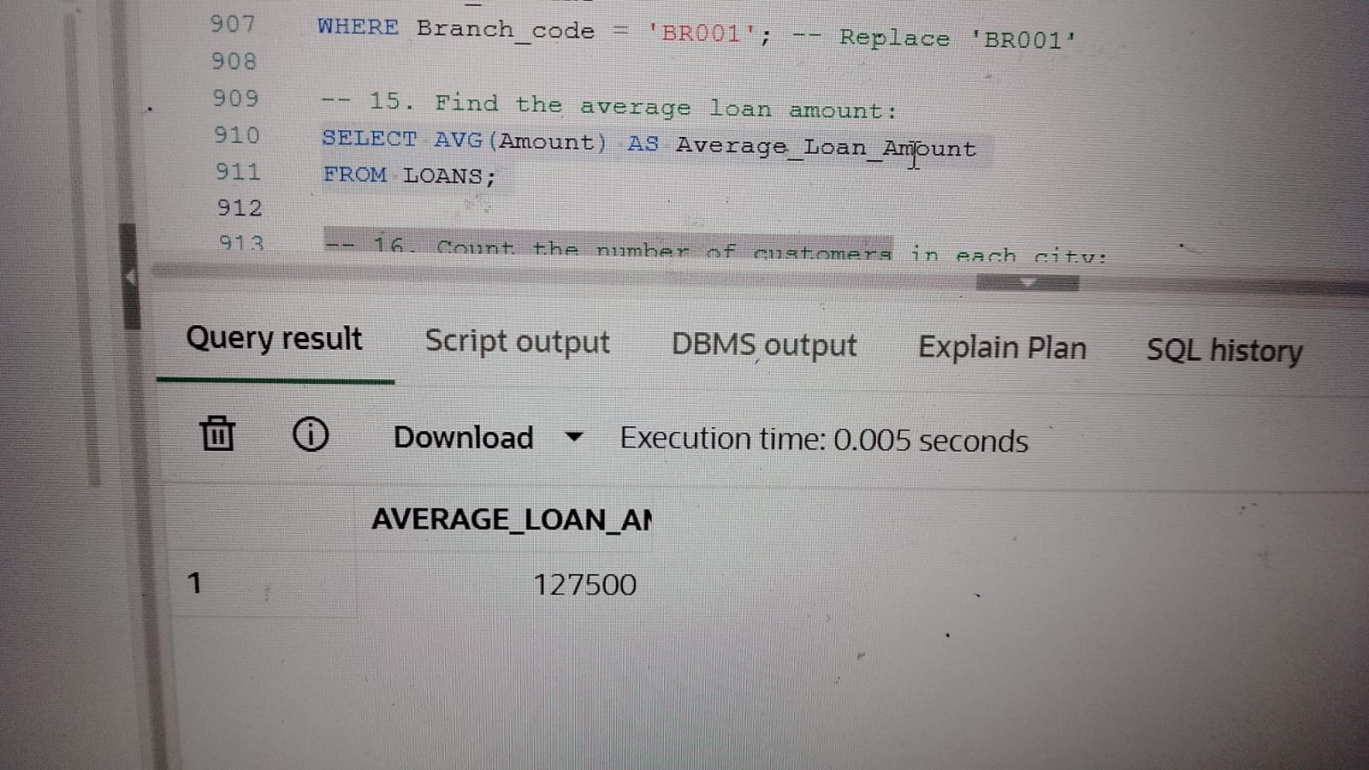

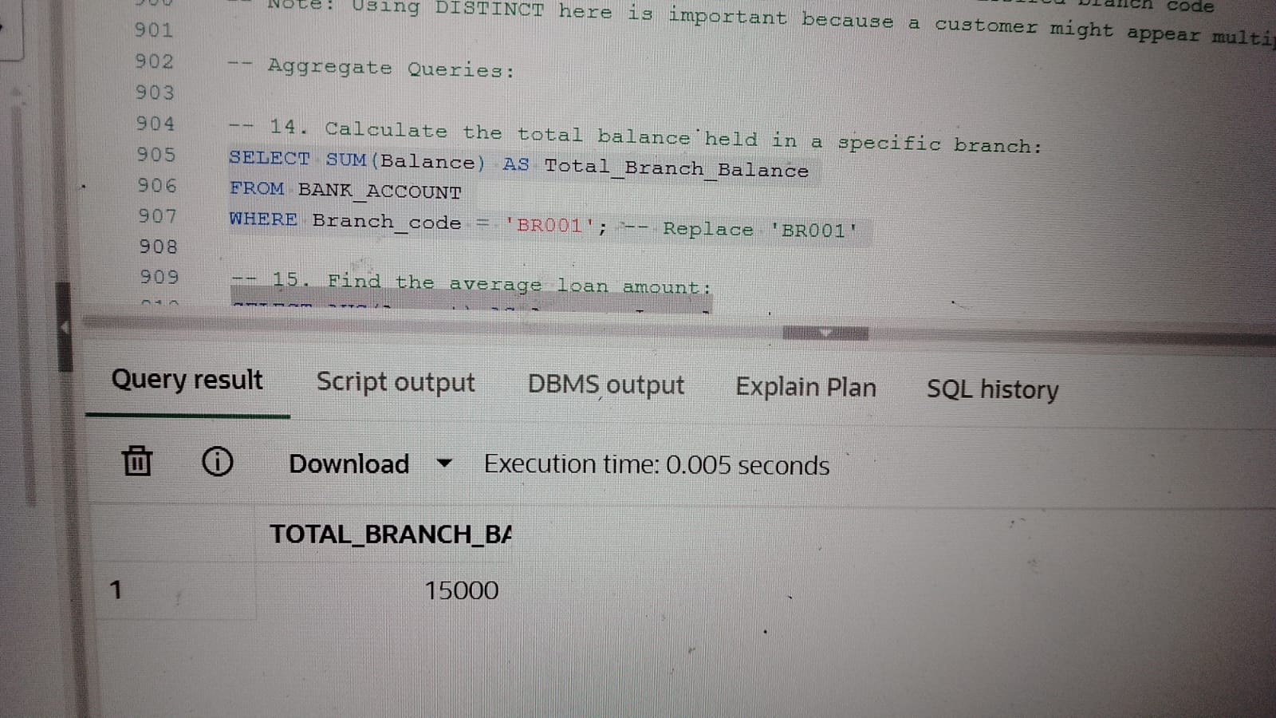

REFERENCES

* Silberschatz, A., Korth, H. F., & Sudarshan, S. (2020). *Database System Concepts* (7th ed.). McGraw-Hill Education.
* Elmasri, R., & Navathe, S. B. (2015). *Fundamentals of Database Systems* (7th ed.). Pearson Education.
* Date, C. J. (2003). *An Introduction to Database Systems* (8th ed.). Addison-Wesley.
* Oracle. (n.d.). *PL/SQL Language Reference*. Oracle Documentation.  
  <https://docs.oracle.com/en/database/oracle/oracle-database/>
* W3Schools. (n.d.). *SQL Tutorial*.  
  <https://www.w3schools.com/sql/>
* GeeksforGeeks. (n.d.). *SQL Tutorials and Examples*.  
  <https://www.geeksforgeeks.org/sql-tutorial/>
* Oracle Live SQL. (n.d.). *Oracle Cloud Live SQL Environment*.  
  <https://livesql.oracle.com/>