AFRICAN MUSIC

CLASSIFICATION OF MUSICA INSTRUMENTS

* Idiophones - These are the percussion instruments that are either struck with mallet or against one another.
* Membranophones - Instruments which have vibrating animal membranes that used to produced sounds.
* Lamellaphones - Instruments with plucked keys mounted in sounding board
  + Kalimba - Thumb piano that is made by metal and attached into a wooden board with resonator also known as the walker’s friend
* Chordophones - Instruments which produced sound from vibration of strings
* Aerophones - Instruments which are produced initially trapped vibrating bar

Musical Instruments of African Music

|  |  |  |
| --- | --- | --- |
| Balafon - An African Xylophone used to announce death and during mourning | TYCOON TGO-L AGOGO BELL – D&D MusicAgogo - Bell that originated in Yoruba music. It it’s the oldest instruments that consist of highest pitch and used for the used to announce a court decision | Slit Drum - A hallow drum that consist of resonator |
| Djembe - An hour glass shape drum that covers by a goat skin | Body Percussion - Their body serves as a drum to produce exciting rhythms | Atingting kon - Gongs that carved out of wood to resemble ancestors that produce a loud sound to communicate from one another |
| Taking Drum - Drum that used to send message to announce a certain occasion | Musical Bow - Ancestors of all strings that consist of a single string that is attached into a wood | Kora - Sophisticated harp that consist of 21 strings. |

|  |  |  |
| --- | --- | --- |
| Kudu horn - Horn that produce mellow and warm sound | Nyamwezi 'Zeze' - Hartenberger World ... Zeze  African fiddle played with a bow, a small wooden stick, or plucked with the fingers | SHEKERE: DANCING GOURD IN BEADED SKIRT ...Shekere  Gourd and shell megaphone consisting of a dried gourd with beads woven into a net covering the gourd. |

TRADITIONAL MUSIC OF AFRICA

**Afrobeat**

* It is a term used to describe the fusion of West African with Black American music.

**Apala (Akpala)**

* It is a musical genre from Nigeria in the Yoruba tribal style to wake up the worshippers after fasting during the Muslim holy feast of Ramadan.

**Axe**

* It is a popular musical genre from Salvador, Bahia, and Brazil. It fuses the Afro-Caribbean styles of marcha, reggae, and calypso

**Jit**

* It is a hard and fast percussive dance music played on drums with guitar accompaniment influenced by mbira-based guitar styles.

**Jive**

* Lively and uninhibited variation of the jitterbug, a form of swing dance.

**Kwassa Kwassa**

* Popularized by Kanda Bongo Man. In this dance style, the hips move back and forth while the arms move following the hips.

LATIN AMERICAN MUSIC

MUSICAL INSTRUMENT OF LATIN AMERICAN

|  |  |  |
| --- | --- | --- |
| Xxl Teponaztli Drum Mexican Aztec ...Teponaztli  Slit drum with designs of human figures or animals to be used for religious and recreational purposes | Five things you didn't know about conch ...Conch  Wind instrument made from a seashell usually of a large sea snail. It usually blown into as if it were a trumpet. | Guiro | magyardob.huRasp  It is a hand percussion instrument whose sound is produced by scraping a group of notched sticks with another stick |
| Mexico 'Panhuéhuetl'- Aztec (B ...Huehueti  tubular drum that is made of wood opened at the bottom and standing on three legs cut from the base, with its stretched skin beaten by the hand or a wooden mallet. | Ocarina  Ocarina - Wikipedia  Ancient vessel flute made of clay or ceramic with four to 12 finger holes and a mouthpiece that projected from the bod | Panpipes (Illustration) - World History ...Zampoñas (Panpipes)  These are ancient instruments tuned to different scalar varieties, played by blowing across the tubetop. |

Reggae - Jamaican music that used guitar and drum that used mento approach.

Tango - It developed as the foremost urban song and dance form in the working class areas of Buenos, Aires, Argentina related to the Cuban contradanza and habanera. Argentinian most expressive music to express their love

Bossa Nova - The music integrates melody, harmony, and rhythm into a swaying feel, where the vocal style is often nasal.

Rumba =-A ballroom dance that came from Afro-Cuban and used hips rocking steps to a fast – fast – slow sequence

Salsa - Swing dance that involves shifting of weight by stepping sideways causing the hips to move while upper body remains level

TECHNOLOGY BASED ART - An art that used new media technologies that is essentially computer generated rather than artist own hand to produce the desire image effect

CHARCATERISTICS OF TECHNOLOGY BASED ART

* It is produced digitally
* Easy to reproduce
* Communication between artist and audience+
* Easy access and shared
* Uses different qualities in creating visual effect

REASON FOR DIGITAL ARTS

* Communication
* Accessible to mass consumption
* Wider range of artforms
* More Practical

MOBILE PHOTOGRAPHY - Mobile Photography is the art of photography using a smartphone or mobile device.

* Pixlr- A powerful free online image editor
* Pic Collage - allows you to make collages incorporating photos, stickers, text, and frames.
* Photo Grid - a downloadable application for android phones that allows you to make collages out of images from your photo gallery
* Doodle Booth - an iPad application (with a free downloadable version) that enables you to ‘doodle’ on your stickers.
* Picsart - a free photo editor and drawing application, as well as a social network for you to share your art with others.
* Picmonkey - A free online photo editing tool that provides filters, frames text and effects to manipulate your images
* Magic Mirror Booth -Application that allows you to take amusing, distorted images and simulating camera effects
* Instagram - A fast and fun way to share images with others via Facebook Twitter Tumblr and more

DIGITAL PHOTOGRAPHY - The art of Science of producing and manipulating digital photographs through generating an original image is to capture it as a digital file

TYPES OF DIGITAL PHOTOGRAPGHY

* POINT AND SHOOT - Automatically make adjustment in lightning, focus and even removal of red eye.
* DSLR - Gives the photographer much more artistic freedom and control to select the camera setting.

TIPS ON TAKING GOOD PHOTOGRAPHY

1. Good Location
2. Natural lights in the outdoor
3. Avoid taking shots facing the light
4. Position your subject where you want with the relation to the location
5. Take a variety of shots

RECRARTION - An activity that people engage in their free time that they enjoy and recognize as having social redeeming values

PASSIVE RECRETAIOLN activities which you spend your leisure without exerting much of your physical prowess.

ACTIVE RECREATION - activities that require deliberately physical efforts which may range from light to vigorous intensities

LIFESTYLE - The way in which individual lives which includes the typical patterns of an individual’s behavior that are related to elevated or reduced health risk

* RISK FACTORS - Risk factors are variables in the lifestyle that may lead to certain diseases like (NCDs)
  + Age -Cardiovascular
  + Heredity -Cancer
  + Nutrition -Asthma
  + Activities -Diabetes

**Weight Management**

* WEIGHT GAIN - Energy consumed is greater than energy exertion
* WEIGHT LOSS - Energy consumed is less than energy exertion
* WEIGHT MAINTENANCE - Energy consumed is the same with food intake

EATING DISORDERS

* ANOREXIA NERVOSA - Eating disorder characterized by self imposed starvation to lose and maintain very low body weight
* BINGE EATING - Eating disorder characterized by uncontrollable episodes of eating excessive amounts of food with in a relatively short time
* BULIMIA NERVODA - AN eating disorder characterized by a pattern of binge eating and purging in an attempt to lose weight
* EMOTIONAL EATING -The consumption of large quantities of food to suppress negative emotion

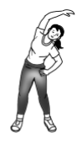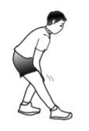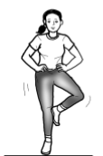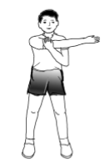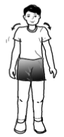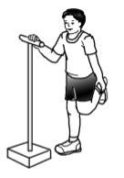

Hamstring Stretch

Side Stretch

Shoulder Rolls

One Foot Stand

Quadriceps Stretch

Side Arm Stretch

Neck Stretch

Tricep Stretch

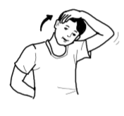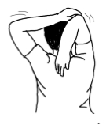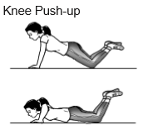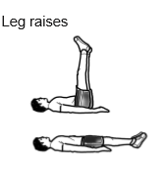

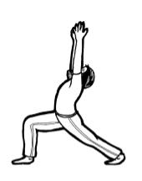

Warrior Pose 1

Outer Thigh Stretch

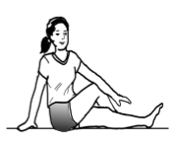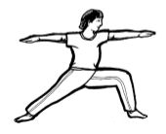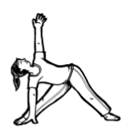Extended Side Angle Warrior pose 2

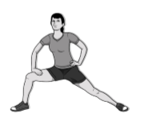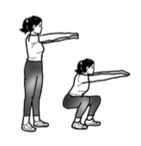

Knee Bends/Squat

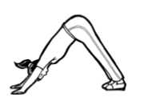Downward Facing Dog Position Inner Thigh Stretch

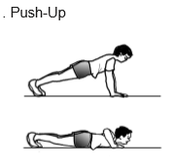0

Body Rotation

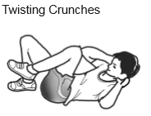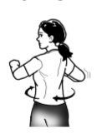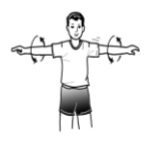

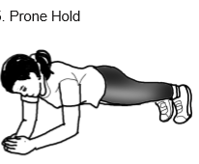

Glute Lift

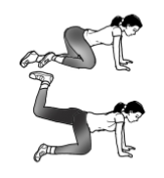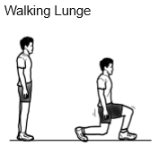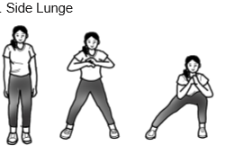

Consumer Act of the Philippines (RA 7394)

* -General welfare of the costumers
* -Maintain standards of the product and services
* -Safety of products
* -Protection against hazardous substances
* -Proper labeling and fair packaging

Traditional and Alternative Act of 1997 (RA 8423)

* Philippine Institute if Traditional and Alternative Health Care
* -Indigenous societies in their traditional medicine
* -Financial return for commercial use
* -Use of medicinal plants

Responsible Parenthood and Reproductive Health Act of 2012 (RA 10354)

- Guarantees access to methods such as contraception, fertility control, sexual education, and maternal care

REPRODUCTIVE EHALTH

This implies that people can have a responsible, safe, consensual, and satisfying sex life, that they have the capability to reproduce and the freedom to decide if, when, and how often to do so.

PILLARS OF REPRODUCTIVE HEALTH

* Informed Choice – Provide information and services for everyone and inclusion of sex education
* -Respect of Life – Abortion is illegal
* -Birth Control - supplies shall be made available and provides preferences and choices for family planning
* -Responsible Parenthood – couples determine their ideal family size

Philippine AIDS Prevention and   
Control Act of 1998 (RA 8504)

* Promulgating policies and prescribing measures for the prevention and control of HIV/AIDS in the Philippines
* HIV - viral infection that attacks and slowly destroys the immune system of the infected person
* -Acquired Immune Deficiency Syndrome (AIDS) - weakens the immune system susceptible to other life-threatening infections.
* -DepEd and CHED as an agencies for HIV information
* -Misleading information
* -Requirement for blood donation
* -Medical Confidentiality
* -Discrimination act and Policy

National Blood Services Act of 1994 (RA 7719)

* promotes voluntary blood donation
* Public awareness that blood donation is a humanitarian act.
* -consciousness on the importance of blood donation in saving the lives of millions of Filipinos

Cybercrime Prevention Act of 2012 (RA 10175)

* -cybercrime is simply any crime committed in cyberspace
* Illegal Access -– access to the whole or any part of a computer system without the right to do so
* Data interference – intentional or reckless alteration, damaging, deletion, or deterioration of computer data
* System Interference – intentional alteration or reckless hindering or interference with the functioning of a computer or computer
* Misuse of Devices – production, sale, procurement, importation, distribution without right
* Illegal Access -– access to the whole or any part of a computer system without the right to do so
* Cybersquatting – acquisition of a domain name over the internet in bad faith to profit, mislead, destroy reputation, and deprive others
* Cybersex – willful engagement, maintenance, control or operation, directly or indirectly, of any lascivious exhibition

National Environmental Awareness and Education Act of 2008 (RA 9512)

* provides for the promotion of environmental awareness through environmental education
* Concept of environmental preservation, protection and rehabilitation
* Responsible citizenry to value the environment
* Natural Resources

Seat Belts Use Act of 1999 (RA No. 8750)

* aims to secure and safeguard its citizenry of private and public motor vehicles, from the ruinous and extremely injurious effects of vehicular accidents.
* Children are not allowed to sit in front seats
* Mandatory wearing of seat belt devices

Comprehensive Dangerous Drugs Act of 2002 (RA No. 9165)\

* safeguards the well-being of its citizenry, particularly the youth, from the harmful effects of dangerous drugs
* Using of dangerous drugs is prohibited
* Importing and exporting of dangerous drug
* No Selling, trading and buying of dangerous Drug
* Maintaining Drug den
* Possessing of dangerous drug
* Unnecessary prescribing dangerous drug

RA 8049 ANTI HAZING LAW

* Initiation rite as a prerequisite (No Physical Infliction
* No hazing shall be aloud without prior notice to the school
* Period of initiation shall not exceed into 3 days
* Two representative of the school shall be present