# RAJIV GANDHI UNIVERSITY OF HEALTH SCIENCES, KARNATAKA

### “EFFECT OF FOCAL MUSCLE VIBRATION THERAPY ON REACTION TIMING, SPASTICITY, IMPAIRMENT AND VOLUNTARY CONTROL OF UPPER LIMB FUNCTION IN TRAUMATIC BRAIN INJURY PATIENTS.”

By

### PRATIKSHA SINGH REG NO: 22TN091

Dissertation submitted to the

### Rajiv Gandhi University of Health Sciences, Karnataka, Bangalore

In partial fulfillment

Of the requirements of the degree of

### MASTER OF PHYSIOTHERAPY (MPT)

In

### NEUROLOGICAL SCIENCES

Under the guidance of **DR KALIDASAN.V** PROFESSOR



### KRUPANIDHI COLLEGE OF PHYSIOTHERAPY, BENGALURU

**2022-2024**

**RAJIV GANDHI UNIVERITY OF HEALTH SCIENCES, BENGALURU**

# DECLARATION BY THE CANDIDATE

I hereby declare that this dissertation/thesis entitled **“EFFECT OF FOCAL MUSCLE VIBRATION THERAPY ON REACTION TIMING, SPASTICITY, IMPAIRMENT AND VOLUNTARY CONTROL OF UPPER LIMB FUNCTION IN TRAUMATIC BRAIN**

**INJURY PATIENTS”** is a bonafide and genuine research work carried out by me under the guidance of Dr.KALIDASAN .V (PT) , Professor, Department of Physiotherapy, Krupanidhi College of Physiotherapy, Bengaluru-560035

### Date:

**Place**: Bengaluru **PRATIKSHA SINGH**

### CERTIFICATE BY THE GUIDE

This is to certify that the dissertation entitled **“EFFECT OF FOCAL MUSCLE VIBRATION THERAPY ON REACTION TIMING, SPASTICITY, IMPAIRMENT AND VOLUNTARY CONTROL OF UPPER LIMB FUNCTION IN TRAUMATIC BRAIN INJURY PATIENTS”**

is a bonafide research work done by **PRATIKSHA SINGH** in partial fulfilment of the requirement for the degree Master of Physiotherapy

### Date :

**Place** : Bengaluru

### DR. KALIDASAN.V (PT),

Professor,

Krupanidhi College Of Physiotherapy, Bengaluru- 560035

### ENDORSEMENT BY THE HOD, PRINCIPAL/HEAD OF THEINSTITUTION

This is to certify that the dissertation **“EFFECT OF FOCAL MUSCLE VIBRATION THERAPY ON REACTION TIMING, SPASTICITY, IMPAIRMENT AND VOLUNTARY CONTROL OF UPPER LIMB FUNCTION IN TRAUMATIC BRAIN INJURY PATIENTS”**

is a bonafide research work done by **PRATIKSHA SINGH** under the guidance of **Dr. KALIDASAN.V(PT),** Professor, Krupanidhi college of Physiotherapy, Bengaluru-560035

### Date :

**Place** : Bengaluru

Seal & Signature of the Principal

### DR SUDHAN SG,

Professor & Principal,

Krupanidhi College Of Physiotherapy, Bengaluru- 560035

# COPYRIGHT

### Declaration by the Candidate

I, **PRATIKSHA SINGH,** hereby declare that the Rajiv Gandhi University of Health Sciences, Karnataka shall have the rights to preserve, use and disseminate this dissertation / thesis in printor electronic format for academic / research purpose.

**Date**: Signature of the candidate

**Place**: Bengaluru. **PRATIKSHA SINGH**

# © Rajiv Gandhi University of Health Sciences, Karnataka.

**ACKNOWLEDGEMENT**

I am immensely grateful to all for the successful completion of my thesis during my two-year course of research in Krupanidhi college of physiotherapy. Firstly, I believe everything that one achieves is simply hard work with grace of almighty and I’m humbled by strength and patience bestowed upon me by god. I just want to take a moment to express my heartfelt thanks to my amazing parents, **Mr. Dhirendra Kumar Singh** and **Mrs. Anita Singh**, for always being there for me with their love and support. And to my wonderful in-laws, your encouragement has meant the world to me. My husband, **Mr. Shashank Raj**, has been my rock, constantly inspiring me to aim for greatness in everything I do. I couldn't have asked for a better partner in life. I also want to give a shout-out to my brother**, Mr. Prateek Singh**, for always coming through with his technical know-how whenever I hit a snag.

And to my dear friends**, Riya Dwivedi** and **Sourabh Kumar**, your friendship has been a source of strength and joy throughout this journey. You've made even the toughest challenges feel conquerable. Last but not least, a big thank you to my friend, **Princee Jain**, for your invaluable support in my research endeavors. Your contribution has truly made a difference.

**Date**: Signature of the candidate

**Place**: Bengaluru. **PRATIKSHA SINGH**

# LIST OF ABBREVATIONS USED

|  |  |
| --- | --- |
| **TBI** | Traumatic brain injury |
| **FMVT** | Focal muscle vibration therapy |
| **RDT** | Ruler-drop test |
| **FMA** | Fugl-meyer scale |
| **BVCG** | Brunnstrom voluntary control grading |
| **M-CIMT** | Modified constraint induced movement therapy |
| **MAS** | Modified ashworth scale |
| **SD** | Standard Deviation |
| **NS** | Non-significant |

**TABLE OF CONTENTS**

|  |  |  |
| --- | --- | --- |
| **Serial No.** | **Topic** | **Page No.** |
| 1 | INTRODUCTION | 1 |
| 2 | NEED OF STUDY | 4 |
| 3 | AIMS AND OBJECTIVES | 5 |
| 4 | REVIEW OF LITERATURE | 7 |
| 5 | METHODOLOGY | 14 |
| 6 | PROCEDURE | 19 |
| 7 | STATISTICS | 22 |
| 8 | DISCUSSION | 47 |
| 9 | LIMITATION & RECOMMENDATION | 51 |
| 10 | CONCLUSION | 52 |
| 11 | SUMMARY | 53 |
| 12 | REFERENCES | 54 |
| 13 | ANNEXURES | 63 |

# LIST OF TABLES

|  |  |  |
| --- | --- | --- |
| **Serial No.** | **Tables** | **Page No.** |
| 1 | Distribution of traumatic brain injury patients according to gender in  both groups. | 22 |
| 2 | Range, mean and SD of age of the traumatic brain injury patients in  both the groups. | 23 |
| 3 | Comparison of pre interventional outcomes of traumatic brain injury  patients in between the groups | 26 |
| 4 | Pre and post interventions of outcome measures of traumatic brain  injury patients in group-A | 29 |
| 5 | Pre and post interventions of outcome measures of traumatic brain  injury patients in group-B | 33 |
| 6 | Comparison of Post interventional-1 outcomes of traumatic brain  injury patients in between the groups | 37 |
| 7 | Comparison of Post interventional-2 outcomes of traumatic brain  injury patients in between the groups | 40 |
| 8 | Pre and post interventions of outcome measures of traumatic brain  injury patients in both the groups | 44 |

**LIST OF GRAPHS**

|  |  |  |
| --- | --- | --- |
| **Serial No.** | **Graphs** | **Page No.** |
| 1a | Gender proportion of subjects in group-A. | 22 |
| 1b | Gender proportion of subjects in group-B | 22 |
| 2 | Mean and SD of age of the traumatic brain injury patients in both the groups | 24 |
| 3 | Mean and SD of height (cm) of traumatic brain injury patients in both the  groups | 24 |
| 4 | Mean and SD of weight (kg) of traumatic brain injury patients in both the  groups | 25 |
| 5 | Mean and SD of BMI of traumatic brain injury patients in both the groups | 25 |
| 6 | Pre test MAS traumatic brain injury patients in between the groups | 27 |
| 7 | Pre test FMS of traumatic brain injury patients in between the groups | 27 |
| 8 | Pre test RDT of traumatic brain injury patients in between the groups | 28 |
| 9 | Pretest Brunnstrom grade scores of traumatic brain injury patients in between  the groups | 28 |
| 10 | Pre and post tests outcomes of FMS scores of traumatic brain injury patients  in group-A | 31 |
| 11 | Pre and post tests outcomes of MAS scores of traumatic brain injury patients  in group-A | 31 |
| 12 | Pre and post tests outcomes of RDT scores of traumatic brain injury patients  in group-A | 32 |
| 13 | Pre and post tests outcomes of Brunnstrom grade scores of traumatic brain  injury patients in group-A | 32 |
| 14 | Pre and post tests outcomes of FMS scores of traumatic brain injury patients  in group-B | 35 |
| 15 | Pre and post tests outcomes of MAS scores of traumatic brain injury patients  in group-B | 35 |
| 16 | Pre and post tests outcomes of RDT scores of traumatic brain injury patients  in group-B | 36 |
| 17 | Pre and post tests outcomes of Brunnstrom grade scores of traumatic brain  injury patients in group-B | 36 |

|  |  |  |
| --- | --- | --- |
| 18 | Post test-1 FMS of traumatic brain injury patients in between the groups | 38 |
| 19 | Post test-1 MAS traumatic brain injury patients in between the groups | 39 |
| 20 | Post test-1 RDT of traumatic brain injury patients in between the groups | 39 |
| 21 | Post test-1 Brunnstrom grade scores of traumatic brain injury patients in  between the group | 40 |
| 22 | Post test-2 FMS of traumatic brain injury patients in between the groups | 42 |
| 23 | Post test-2 MAS traumatic brain injury patients in between the groups | 42 |
| 24 | Post test-2 RDT of traumatic brain injury patients in between the groups | 43 |
| 25 | Post test-2 Brunnstrom grade scores of traumatic brain injury patients in  between the groups | 43 |
| 26 | Pre and Post tests outcomes of FMS scores of traumatic brain injury patients  in between the groups | 45 |
| 27 | Pre and Post tests outcomes of MAS scores of traumatic brain injury patients  in between the groups | 45 |
| 28 | Pre and Post tests outcomes of RDT scores of traumatic brain injury patients  in between the groups | 46 |
| 29 | Pre and Post tests outcomes of Brunnstrom grade scores of traumatic brain  injury patients in between the groups | 46 |

# LIST OF FIGURES

|  |  |  |
| --- | --- | --- |
| **Serial**  **No.** | **Figure** | **Page**  **No.** |
| 1. | Procedure of the study | 19 |
| 2.a | Focal muscle vibration therapy | 88 |
| 2.b | Focal muscle vibration therapy | 88 |
| 3. | PNF Hold-relax | 89 |
| 4. | Sustained stretching | 89 |

**ABSTRACT**

### TITLE: “EFFECT OF FOCAL MUSCLE VIBRATION THERAPY ON REACTION TIMING, SPASTICITY, IMPAIRMENT AND VOLUNTARY CONTROL OF UPPER LIMB FUNCTION IN TRAUMATIC BRAIN INJURY PATIENTS”

**BACKGROUND:** Traumatic brain injury (TBI) arises from external mechanical force, disrupting normal brain function and posing a significant global burden. Incidence varies across demographics, with road traffic accidents (RTAs) being a prominent cause. TBI manifests as complex clinical issues, impacting individuals and society with long-term impairments. Common features include spasticity, impaired sensory and motor control, increased reaction time, and impaired hand function. Understanding these challenges is vital for guiding effective treatment and rehabilitation strategies.

**OBJECTIVE:** The study was assess the effect of focal muscle vibration therapy(FMVT) on reaction timing, spasticity, impairment and voluntary control of upper limb function in traumatic brain injury patients.

**METHODS:** 60 participants meeting specific criteria were divided into experimental and control groups through block randomization. Spasticity, reaction timing, hand impairment and voluntary control were assessed using Modified Ashworth Scale (MAS), Ruler-Drop test, Fugl Meyer Scale and Brunnstrom Voluntary Control Grading respectively. The experimental group received focal muscle vibration therapy and modified constrained induced movement therapy (M-CIMT) four and five days a week respectively for six weeks. In contrast, the control group underwent sustained stretching, PNF hold-relax, and M-CIMT four and five days a week respectively for six consecutive weeks. Post-assessments were conducted at weeks 3 and 6, and data analysis was performed using SPSS.

**RESULT AND INTERPRETATION:** The Study findings indicated that FMVT significantly improves clinical outcomes compared to the control group. Reaction time, assessed using the Ruler Drop Test (RDT), significantly improved in the experimental group from 194.30 ± 8.25 ms at week 3 to 185.90 ± 9.12 ms at week 6. Spasticity, with the Modified Ashworth Scale (MAS), decreased from 2.37 ± 0.61 to 1.67 ± 0.84. Motor impairment, evaluated using the Fugl Meyer Scale (FMS), showed marked improvement from 9.77 ± 1.71 to 10.40 ± 1.71. Voluntary motor control, assessed by Brunnstrom Voluntary Control Grading (BVCG), improved from 4.57 ± 0.67 to 5.17 ± 0.69. The experimental group consistently outperformed the control group in all measures (p<0.05).

**CONCLUSION:** Focal muscle vibration therapy (FMVT) is significantly effective in improving reaction timing, spasticity, impairment and voluntary control among traumatic brain injury (TBI) patients.

**KEYWORDS:** Traumatic Brain Injury, Focal Muscle Vibration Therapy, Upper Limb Function, Spasticity, Impairment

# INTRODUCTION

Traumatic brain injury (TBI) is disruption in normal functioning of the brain as a result of an acquired insult to the brain from an external mechanical force that stands as one of the most pressing challenges in modern healthcare, encompassing a wide spectrum of neurological impairments and functional deficits that may be temporary or permanent.1, 2 The classification of brain injury into traumatic and non-traumatic categories underscores the diverse etiology of these conditions.3 Traumatic brain injury arises from external physical assaults to the head, such as motor vehicle accidents, falls, or assaults, while non-traumatic brain injury results from internal factors like ischemia, stroke, tumors, or infections.4 Understanding the underlying mechanisms and risk factors associated with each type of injury is crucial for guiding appropriate treatment and rehabilitation strategies.

Further subdivision into primary and secondary injuries offers insights into the temporal progression of damage and the potential for intervention. Primary injury occurs at the moment of impact and involves direct mechanical trauma to the brain tissue, leading to immediate neuronal dysfunction and tissue damage. Secondary injury, which unfolds over hours to days following the initial insult, encompasses a cascade of pathological and metabolic processes, including inflammation, oxidative stress, and excitotoxicity, which can exacerbate tissue damage and neuronal loss4. TBI presents a complex array of clinical manifestations that can have profound implications for individuals, families, and society at large. It is a major cause of morbidity and mortality worldwide5 leading to long term consequences in the form of physical, emotional and behavioral impairements.6 It is a leading cause of death and disability worldwide with significant economic and societal costs.7 In low- and middle- income countries, where access to healthcare and resources may be limited, the burden of TBI is especially pronounced, underscoring the need for targeted interventions and support systems.8 The global burden of TBI is substantial, with an annual estimated population of approximately 50 million suffering from TBI with 1.2 million annual deaths.9

The incidence of TBI varies across different demographic groups and regions, with certain populations, such as young adults and older adults, being particularly vulnerable with its highest occurrence of nearly 30% in under 45 years of age in the most productive years of life, depriving the society of vital drivers of economy.10 A review from Indian head injury foundation shows that India has 25 times higher incidence of head injury than in developed countries in the world with one person dying every 3 minutes and more than 150,000 lives being lost annually.11 Road traffic accidents (RTAs) is the most frequent cause, with 60% of all the head injuries caused by vehicular accidents with a fatality rate of 70 per 10,000 vehicles. WHO predicted 147% increase in RTA related deaths in India by 2020.7

Survivors of TBI often experience a wide range of impairments and disabilities that can have far- reaching effects on their quality of life and functional independence. TBI includes several types of insults to the brain. One of the most severe damage mechanisms is the hemorrhagic cerebral contusion causing permanent damage to the tissue of the cerebrum.12 Skeletal muscle spasticity (UL>LL)13, impaired sensory and motor control as a result of an upper motor neuron lesion is the typical manifestation in traumatic brain injury.14 30% of population with mild brain injury have impaired balance and gait.15, 16

Cognitive impairments may manifest as memory deficits, attention difficulties, and executive dysfunction. Psychosocial challenges, such as depression, anxiety, and social isolation, are also common among individuals with TBI, further complicating their recovery and rehabilitation. Other common features include increased reaction time17,18,19, impaired handfunction20 and loss of voluntary control.21 Hand functions are mostly affected in brain injury as a result of spasticity and its related deformities.22

**Dafda Renuka H et al in 2021** conducted a comparative study to determine the effect of Hold-Relax V/S Static Stretching on elbow flexors muscle spasticity in stroke patient and concluded that there was improvement in both the groups but the experimental (Hold-Relax) group showed a significant reduction in spasticity of elbow flexors muscle when compared to the control group (static stretching). Both the conventional therapies including sustained stretching and PNF-Hold Relax techniques are widely used for treating spasticity and has been proven quite effective.23 Traditional rehabilitation approaches for TBI typically involve a multidisciplinary team of healthcare professionals, including physicians, physical therapists, occupational therapists, speech therapists, neuropsychologists, and social workers. Treatment plans are individualized based on the needs and goals of each patient and may include a combination of pharmacological interventions, cognitive rehabilitation, physical therapy, occupational therapy, speech therapy, and psychosocial support.

Focal muscle vibration (FMV) therapy is a relatively new, innovative and an effective tool for stimulating a specific muscle which is widely used in rehabilitation of neurological disorders. It applies vibration stimulation through a small portable device .It is a non-invasive, safe and well- tolerated intervention giving it an advantage over the traditional intervention techniques. Based on a systemic review by **Luigi Fattorini et al, in 2021**, FVT with a stimulus frequency of 100 Hz was a brief, efficient stimulus and was able to enhance the conditional capacities in healthy individuals, attributed to a better agonist/antagonist interplay because of a rearrangement in central and segmental nervous pathways.24

Hence, if applied at a therapeutic dose of high frequency and low amplitude, it results in improvement of spasticity by activating both central (inhibition of cortico- spinal activity) and spinal mechanism (reciprocal inhibition).25 Several studies have investigated the potential benefits of FMV therapy in TBI rehabilitation, with promising results.The non-invasive nature of FMV therapy, combined with its ease of use and tolerability, makes it an attractive option for inclusion in comprehensive rehabilitation programs for TBI.

**Cosimo COSTANTINO et al, in 2017** conducted a single-blind randomized control trial to evaluate the effects of local muscle high frequency mechano-acoustic vibratory treatment on grip muscle strength, muscle tonus, disability and pain in post-stroke individuals with upper limb spasticity and the results demonstrated significant improvement in muscle strength, decreased muscle tonus, disability and pain in upper limb of hemiplegic post-stroke patients.26

Despite the promising evidence supporting the use of FMV therapy in TBI rehabilitation, further research is needed to better understand its mechanisms of action, optimal treatment parameters, and long-term effects that may help optimize treatment protocols and maximize functional outcomes for individuals with TBI.

The present study aims to determine the effect of focal muscle vibration therapy on reaction timing, spasticity, impairment and voluntary control of upper limb function in traumatic brain injury patients.

# NEED OF THE STUDY

The cardinal manifestations of traumatic brain injury like skeletal muscle spasticity, increased reaction timing, motor hand impairment, loss of voluntary control, hemiparesis, abnormal dexterity etc. cause long term disability with severe impact on physical as well as mental health.

Keeping in consideration the nature of pathology which requires major attention, there is an absolute need to develop proper protocol for early intervention which in turn will improve the outcomes of people with TBI. A survey states that most fatalities due to TBI are under 45 years of age (the most productive age), directly impacting the performance and functional independence.

Changing response to medications, age and severity level of patients, focal muscle vibration (FMV) therapy, an innovative and effective approach which is non- invasive and well- tolerated is more preferred and is safer on administration.27

**Tomokazu et al in 2020** studied the effect of direct application of vibratory stimuli on spasticity in hemiplegic upper limb of post stroke patients and concluded that the direct application of vibratory stimuli has anti-spastic effects and showed significant improvements immediately after the intervention, which remained 30 minutes later in the hemiplegic upper limbs in post stroke population.28

There are numerous studies proving the effectiveness of FMV therapy on spasticity in stroke population, however there is a dearth of research that uses FMV therapy as an intervention to improve these cardinal manifestations of TBI, an upper motor neuron disease, thereby improving overall quality of life with minimal risk.

Hence arising the need to focus on appropriate, specific rehabilitation protocol with FMV therapy as an intervention, essential for preventing the worsening of disease and reducing burden on caregivers by helping patient achieve maximum independency and social engagement.

# AIM OF THE STUDY

To analyse the effect of focal muscle vibration therapy reaction timing, spasticity, impairment and voluntary control of upper limb function in traumatic brain injury patients.

# OBJECTIVES OF THE STUDY

* To evaluate the effect of FMV therapy on Reaction timing, Spasticity, Hand function impairment and Voluntary control.
* To evaluate the effect of conventional therapy on Reaction timing, Spasticity, Hand function impairment and Voluntary control.
* To compare the effects of FMV therapy against conventional therapy on Reaction timing, Spasticity, Hand function impairment and Voluntary control.

# HYPOTHESIS OF THE STUDY

**Null Hypothesis (H0) :** There will be no significant difference of focal muscle vibration therapy against conventional therapy on reaction timing, spasticity, impairment and voluntary control of upper limb function in traumatic brain injury patients.

**Alternate Hypothesis (H1) :** There will be significant difference of focal muscle vibration therapy against conventional therapy on reaction timing, spasticity, impairment and voluntary control of upper limb function in traumatic brain injury patients.

# REVIEW OF LITERATURE

1. **Ying-Lun Chen et al. (2023):** conducted a randomized, single-blinded controlled trial on 64 stroke participants was done to assess the effects of focal vibration administered by a trained operator to the ankle plantar flexor and dorsi flexor muscles on post- stroke lower limb spasticity. The author concluded reduction in post-stroke spasticity of the plantar flexor muscles by changing muscle stiffness along with more enhanced ambulation with vibration of tibialis anterior than the vibration of gastrocnemius or physiotherapy alone.29 This can be further utilized in the current study to understand the relationship between the spasticity reduction and changing muscle stiffness.
2. **Nicoletta Manzo et al. (2023):** conducted a study to investigate the effects of a focal muscle vibration protocol on sensorimotor integration in healthy subjects. The author concluded that FMV is able to modulate somatosensory temporal discrimination threshold (STDT) movement when applied over the muscle involved in the motor task. This result provided further information on the mechanism underlying FMV and its potential future implications in basal ganglia disorders characterized by altered sensorimotor integration.30 In the present research it assists in comprehending the working principles of FMV and its capacity to modulate the sensorimotor.
3. **Lian Wang et al. (2023):** conducted a randomized controlled trial to investigate the effectiveness and electrophysiological mechanisms of focal vibration on upper limb motor dysfunction in patients with sub-acute stroke. The study showed that FV was effective in improving upper limb motor function in sub-acute stroke patients. The underlying mechanism of FV may be that it enhances the efficacy of sensory pathways and induces plastic changes in the sensorimotor cortex.31 This can be further applied in the ongoing study to understand the improved pathways and adaptive changes for upper limb in subjects with Traumatic Brain Injury (TBI). This study has been incorporated into the current study as a conventional treatment to analyze enhancements in motor performance and fine hand movements, serving as a benchmark for comparing improvements with the experimental intervention.
4. **Dr. Sobha Saseendrababu (2022):** conducted a randomized controlled trail assess the effect of Modified Constraint Induced Movement Therapy on motor performance and daily functions in patients one to nine months after stroke. the author concluded that Modified Constraint

Induced Movement Therapy was very effective in improving the motor performance of the upper extremity, fine motor movements of the hand such as grasp, grip, pinch and gross movement and daily functions in stroke patients.32 In this study, it facilitated a clear picture of the correlation between reduced spasticity and alterations observed in brain oscillatory activity.

1. **Wei Li et al. (2022):** conducted a study to explore the correlation between the changes in brain oscillatory activity and the relief of post-stroke spasticity (PSS) following focal vibration (FV). The finding indicated that the relief of PSS can be associated with the activation of bilateral S1-M1 where the activation of the ipsilesional S1-M1 was higher than that of the contralesional one. This study showed the brain oscillatory activity in the bilateral S1-M1 correlating with the relief of PSS following FV, which could contribute to establishing cortex oscillatory activity as a biomarker of the relief of PSS and providing a potential mechanism explanation of the relief of PSS.33
2. **Noureddin Nakhostin Ansari et al. (2022):** conducted a preliminary study to investigate the inter- and intra-rater reliability of the Modified Modified Ashworth Scale (MMAS) in the assessment of lower extremity spasticity in children with spastic cerebral palsy (CP). The author concluded that the MMAS showed an excellent reliability for the assessment of lower extremity muscle spasticity in children with cerebral palsy.34
3. **Hongwu Wang et al. (2022):** this study aimed to design and develop a novel wearable focal vibration device for upper limb rehabilitation in stroke survivors. The author gave an insight about the use of focal vibration for home-based rehabilitation and concluded that the developed Fo Vi could provide stroke survivors a sustainable home-based intervention and allow therapists to track the compliance and the progress of the rehabilitation.35
4. **Esma Nur Kolbasi et al. (2022):** this systemic review aimed to investigate the effect of upper limb focal muscle vibration on cortical activity. The outcome of the review showed contradictory effects on cortical areas with reduction of cortical activity in the primary motor cortex (M1) and somatosensory cortex (S1), no changes in the cortical activity of M1 and increased cortical activity of M1 and S1.36
5. **Lucrezia Moggio et al. (2022):** this umbrella of 16 systematic review summarizes the findings and evaluates the role of vibratory therapy in rehabilitation of neurological diseases and concluded that both WBV and FMV plays a considerable role in reducing spasticity and improving gait, balance, and motor function but focal muscle appears to be more useful when

applied to non-spastic antagonist muscles with reciprocal inhibitory action on spastic muscles in subjects affected by stroke.37

1. **Sameen Tahir et al. (2022):** this review evaluates and summarizes the available evidence on the emerging role of focal muscle vibration in neurorehabilitation and found it to be well tolerated, cost effective and successful way to reduce spasticity, promote motor activity and motor learning, enhancing functional recovery and gait training.25
2. **Dafda Renuka H et al. (2021):** conducted a comparative study to determine the effect of Hold- Relax V/S Static Stretching on elbow flexors muscle spasticity in stroke patient. The author concluded that the experimental (Hold-Relax) group showed a significant reduction in spasticity of elbow flexors muscle, compared to the control group (static stretching). 23
3. **Fatma Ayvat et al. (2021):** conducted a study on 27 patients to compare the effects of low vs. high frequency local vibration on mild-moderate muscle spasticity. The author concluded that the decrease in spasticity and the increase in fascicle length were found to be statistically significant in the low frequency (50 Hz) group.38
4. **Luigi Fattorini et al. (2021):** this systematic review aimed to review the studies and characterize the FVT effectiveness on long-term conditional capacities in relation to FVT characteristics. The author concluded that FVT with a stimulus frequency of 100 Hz was a brief, efficient stimulus and was able to enhance the conditional capacities in healthy individuals, attributed to a better agonist/antagonist interplay because of a rearrangement in central and segmental nervous pathways.24
5. **Harald Hefter et al. (2021):** conducted a case study on a 53 year old male to demonstrate an increase in muscle action potentials and an enhancement of the efficacy of botulinum toxin after mechanical leg vibration using vibration ergometry training (VET).the author concluded that local mechanical leg vibration has a short- and long-term training effect. Compared to other studies analyzing the reduction in extensor digitorum brewis (EDB) compound muscle action potential (CMAPs) after BoNT injections, the reduction of EDB CMAPs in the present study observed after combined application of BoNT and VET was much faster and more pronounced.39
6. **Christian Avvantaggiato et al. (2021):** this systematic review aimed to describe the use of local muscle vibration (LMV) in post-stroke patients to improve motor recovery, reduce

spasticity and disability in both upper and lower limb. The authors concluded that LMV may be a feasible and safe tool that can be integrated into traditional and conventional neurorehabilitation programs to reduce spasticity in post-stroke patients, whereas the available clinical trials doesn’t indicate vibration therapy as effective in functional motor recovery, despite some studies showing encouraging results.40

1. **I Aprile et al. (2020):** conducted a randomized controlled trial to investigate the efficacy of focal muscular vibration in the treatment of upper limb spasticity in subjects with stroke outcomes**.** The objective of this study was to evaluate the effects on spasticity of FMV on the upper limb flexor spastic muscles compared to the effects of FMV on the upper limb extensor muscles in sub-acute stroke patients. The authors concluded that the same treatment protocol can determine an improvement in muscle tone and in the duration to perform a task, regardless of the muscles treated, while the pain improves if we treat the agonist muscles.41
2. **Tomokazu et al. (2020):** conducted a randomized controlled study to investigate whether the direct application of vibratory stimuli inhibits spasticity in hemiplegic upper limb of post stroke patients and concluded that the direct application of vibratory stimuli has anti-spastic effects and showed significant improvements in F- wave parameters and Modified Ashworth Scale scores immediately after the intervention, which remained 30 minutes later in the hemiplegic upper limbs in post stroke population.28
3. **Wei Li et al. (2019):** conducted an EEG based study to assess the effects of focal vibration over upper limb muscles on the activation of sensorimotor cortex network. The author concluded that FV on upper limb muscles could activate the bilateral primary somatosensory cortex and strengthen functional connectivity of the ipsilateral central area and contralateral central area and contribute to understanding the effect of FV over upper limb muscles on the brain cortical network.42
4. **Tijana Jevtic Vojinovic et al. (2019):** conducted a study to investigate the effects of focal vibration and robotic assistive therapy on upper limb spasticity in incomplete spinal cord injury. FV was applied to relaxed spastic wrist flexor and extensor muscle for 15 min. subsequently, the wrist was engaged in a robotic assisted game. The author concluded that the trial was promising and showed short-term decrease in wrist stiffness, with improved active ROM and reduced joint stiffness.43
5. **Anas R Alashram et al. (2019):** this systematic review was conducted to investigate the effects of FMV to identify the effective training protocol in reducing upper extremities spasticity post- stroke. The authors concluded that FMV may be an efficient intervention in reducing upper extremity spasticity in stroke population.44
6. **Robin Souron et al. (2018):** conducted a study on 20 subjects to investigate the effects of muscle length and vibration site on LV induced on motor evoked potentials (MEPs) changes. The author concluded that LV should be applied to the tendon at an intermediate muscle length to optimize the acute effects of LV on the knee extensors neuromuscular function.45
7. **Hui Guang et al. (2018):** conducted a study that focus on disclosing the neuromechanical mechanism of focal vibration using a high-speed camera and a method of image processing to quantify the muscle vibration rigorously. The author concluded that the focal vibration stretches muscle by producing muscle waves with the same frequency as the vibrator and thus inducing the tonic vibration reflex via spinal circuits.46
8. **Lorenzo Rocchi et al. (2018):** conducted a study on plasticity induced in the human spinal cord with an aim to assess whether FMV can induce plasticity at the SC level when applied to different muscles of the upper limb. The author concluded that FMV was able to induce long- term depression-like plasticity in specific spinal cord circuits depending on the muscle vibrated and the findings helped understand the basic mechanisms underlying the effects of FMV that might help to develop more advanced stimulation protocols.47
9. **Cosimo COSTANTINO et al. (2017):** conducted a single-blind randomized control trial to evaluate the effects of local muscle high frequency mechano-acoustic vibratory treatment on grip muscle strength, muscle tonus, disability and pain in post-stroke individuals with upper limb spasticity. The results demonstrated significant improvement in muscle strength, decreased muscle tonus, disability and pain in upper limb of hemiplegic post-stroke patients.26
10. **Han Gil Seo et al. (2016):** conducted a study to assess the effect of focal muscle vibration on calf muscle spasticity. Vibrations of frequency 40, 80 and 120 Hz and amplitudes of 0.1, 0.3, and 0.5 mm were tested. The study suggested that focal muscle vibration may be an adjuvant therapy during gait rehabilitation in patients with calf muscle spasticity and focal vibration at 80 Hz and 0.3 mm amplitude applied to the gastrocnemius was found to be effective in inhibiting the segmental reflex pathway.48
11. **Daniela POENARU et al. (2016):** conducted a study on local application of vibration in motor rehabilitation. The author concluded that a vibratory stimulus, applied locally on the musculo- tendinous junction, with a high frequency and a low amplitudes, is to be included in the rehabilitation protocols as a contractility and flexibility modulator.49
12. **Zachary K Pope et al. (2015):** conducted a study to investigate the effects of acute and prolonged muscle vibration on the function of the muscle spindle’s reflex arc. The author concluded that acute vibration increased total reflex latency and the use of prolonged vibration is a practical means to decrease the function of the muscle spindle’s arc.50
13. **Mohammad Etoom et al. (2015):** conducted a case study to estimate the effect of focal muscle vibration on the spasticity of antagonist muscle group (biceps brachii) and upper extremity muscles when applied to agonist muscle group (triceps brachii). The author concluded that focal muscle vibration on triceps brachii muscle can reduce the spasticity for both elbow and wrist joint muscles.51
14. **Gianluca Del Rossi et al. (2014):** conducted a descriptive laboratory study to determine if the ruler-drop test is susceptible to practice effects after serial administration. It was concluded that the ruler-drop test has acceptable test-retest reliability that compares favorably with computerized measures of reaction time.52
15. **Casale R et al. (2014):** conducted a randomized double-blind study to test 3 hypotheses,
    * Can a selective vibration of upper limb flexor antagonist, triceps brachii, reduce the spasticity of the flexor biceps brachii muscle.
    * If its association with physiotherapy better than physiotherapy alone in reducing spasticity and improving function.
    * If this possible effect last for longer than the stimulation period.

The author concluded that

* + 100 Hz antagonist muscle vibration in association with physiotherapy was able to reduce the spasticity in the flexor agonist.
  + This association was found to be better than physiotherapy alone.
  + And the reduction in spasticity and functional improvement lasted beyond the period of application of the vibration, supporting its role in spastic hemiplegic rehabilitation.53

1. **Gangpyo Lee, MD et al. (2014):** conducted a study that aims in evaluating the differential electrophysiological effects of focal vibrator on the tendon and muscle belly in healthy people. The authors verified the effects of focal vibration on the muscle belly to be more effective site for reducing the H-reflex compared to the tendon, providing the basis for a selective and safe rehabilitation program for spasticity management with focal vibration.54
2. **Emanuela Tavernese et al. (2013):** conducted a randomized controlled trial to investigate the possibility of improving upper limb motor function by using segmental muscle vibration (SMV). The author concluded that, SMV is effective in improving upper limb motor performances of reaching movements in chronic stroke patients when applied w with general physical therapy.55
3. **Pamela W. Duncan et al. (1983):** conducted a study to establish intratester reliability for all components of physical performance and intertester reliability for the total scores of upper and lower extremity motor performance in a cumulative numerical scoring system. The author concluded that all intratester and intertester reliability coefficients were high and statistically significant thereby, establishing the reliability of the Fugl-Meyer method of assessing recovery of function following cerebrovascular accidents.56

# METHODOLOGY

### STUDY DESIGN

Randomized Controlled Trial (RCT)

### SOURCE OF DATA

* Krupanidhi College of Physiotherapy Out Patient Department.
* Home settings, Neuro-rehabilitation centers and multispeciality hospitals in Bengaluru.

### SAMPLE SIZE

60 subjects allocated into two groups (30 in each group)

### SAMPLE SIZE CALCULATION

𝟐

{𝒁𝑎/𝟐√𝟐𝑷(𝟏−𝑷)+𝒁𝟏−𝖰√𝑷𝟏(𝟏−𝑷𝟏)+𝑷𝟐(𝟏−𝑷𝟐)}

**N1 =**

(𝑷𝟏

−𝑷𝟐

)𝟐

Where:

P1 : Prevalence of outcome in the unexposed group P2 : Prevalence of outcome in the exposed group

P = (P1 – P2)/2

α = Level of significance β = 1- Power of Test

Z = The z-score corresponding to the degree of confidence N1 = Calculated sample size per arm

# CALCULATION:

𝟐

## {𝟏. 𝟐𝟖√𝟐 × 𝟎. 𝟔𝟕(𝟏 − 𝟎. 𝟔𝟕) + 𝟎. 𝟖𝟒√𝟎. 𝟓𝟒(𝟏 − 𝟎. 𝟓𝟒) + 𝟎. 𝟖𝟎(𝟏 − 𝟎. 𝟖𝟎)}

(𝟎. 𝟓𝟒 − 𝟎. 𝟖𝟎)𝟐

𝟐

## {𝟏. 𝟐𝟖√𝟎. 𝟒𝟒𝟐𝟐 + 𝟎. 𝟖𝟒√𝟎. 𝟒𝟎𝟖𝟒}

𝟎. 𝟎𝟔𝟕

𝟏.𝟗𝟎𝟒𝟒

# =

𝟎.𝟎𝟔𝟕

**=** 29.16 ≅ 𝟑𝟎 in each group (Control and Experimental)

60 subjects allocated into two groups (30 in each group)

The subjects were randomly allocated into experimental group (Intervention group, n=30) and control group (Control group, n=30). The data for the outcome measures was collected thrice i.e., pre-test, before starting the intervention and post-tests after 3 and 6 weeks respectively.

### STUDY DURATION

12 months

### STUDY SUBJECTS

Traumatic Brain Injury Patients

### SAMPLING METHOD

Simple Random sampling technique

# SELECTION CRITERIA

### Inclusion Criteria:

* Subjects diagnosed with Traumatic Brain Injury
* Age between 18-40 years57
* Moderate to severe TBI, GCS score- 9-12 ( according to mayo classification)58
* Minimum 10 degrees wrist extension, thumb abduction and finger extention59
* Both male and female

### Exclusion Criteria:

* Severe head injury (GCS<3)60
* Spastic hand
* Deformities of hand
* Cognitively impaired (MMSE score <24)

# OUTCOME MEASURES

### Modified Ashworth Scale (MAS)

Spasticity was assessed using modified Ashworth scale. Patient was asked to lie on the bed with hands by the side and elbow flexed at 90 degrees. Elbow, position in which the muscle is maximally shortened and rapidly the muscle was manually stretched by moving the elbow joint through the opposite movement (extending the patient limb first from a position of maximal possible flexion to maximal possible extension and then assessed while moving from extension to flexion). It is the most universally accepted clinical tool used to measure the increase of muscle tone. In 1964, Bryan Ashworth published the Ashworth Scale as a method of grading spasticity while working with multiple sclerosis patients. The original Ashworth scale was a 5 point numerical scale that graded spasticity from 0 to 4, with 0 being no resistance and 4 being a limb rigid in flexion or extension. In 1987, Bohannon and Smith modified the Ashworth scale by adding 1+ to the scale to increase sensitivity. Since its modification, the modified Ashworth scale (MAS), has been applied in clinical practice and research as a measure of spasticity with moderate to good intra-rater reliability and poor to moderate inter-rater reliability.34

### Ruler-Drop test

Ruler- drop test (RDT) is a simple test of visual reaction time with good relative reliability in which the subject was asked to sit on the couch and was made to attempts to stop a falling ruler, and the height fallen was used to determine the time taken to react to the event. It was measured in 3 attempts and the mean of the 3 attempts was calculated.61

### Fugl Meyer Scale

The Fugl-Meyer scale was developed as the first quantitative evaluative instrument for measuring sensorimotor stroke recovery, based on Twitchell and Brunnstrom’s concept of sequential stages of motor return in the hemiplegic stroke patient. The Fugl-Meyer is a well- designed, feasible and efficient clinical examination method that has been tested widely in the stroke population and was used to assess motor impairement in TBI subjects. Its primary value is the 100-point motor domain. Patient was asked to sit on the couch and using paper, ball, pencil and a small jar the patient was assessed for motor impairement and scored based on direct observation of performance. Based on the evidence, the Fugl-Meyer scale is highly recommended as a clinical and research tool for evaluating changes in motor impairment.56

### Brunnstrom Voluntary Control Grading

It was developed by the Swedish physical therapist Signe Brunnstrom, and emphasizes on the synergic pattern of movement which develops during recovery. This voluntary control grading is used to measure motor performance of patient.The six component stages were used to assess the TBI subjects that described the voluntary control. 62

# PROCEDURE

Ethical Clearance has been taken

EXPERIMENTAL GROUP (n=30)

Pre-test scores

* Spasticity
* Reaction timing
* Hand impairment
* Voluntary control

Consent form will be given to all participants. The Subjects will be advised to continue with the medication throughout the study

Structured M-CIMT for 10 minutes, Sustained stretching and PNF-Hold- relax technique to agonist for 15 minutes each.

CONTROL GROUP (n=30)

Pre-test scores

* Spasticity
* Reaction timing
* Hand impairment
* Voluntary control

Subject Recruited and assessed for eligibility based on inclusion and exclusion criteria

Data analysis.

Assessment: 3 (post test scores at week 6)

Assessment: 2 (post test score at week 3)

Assessment: 3 (post test score at week 6)

### Figure 1: Procedure of the study

Assessment: 2 (post test score at week 3)

Structured M-CIMT for 10 minutes along with Focal muscle vibration (FMV) therapy on the belly of antagonist for 30 minutes.

Institutional Ethical clearance was obtained for conducting the study from the Ethical committee. The subjects were informed regarding the purpose and procedure of the study. A written consent for participation after explanation were obtained from each subject individually and all the 60 subjects were recruited on the basis of selection criteria. The subjects were randomly divided into control and experimental group with 30 participants in each group. Patients were advised to continue their prescribed medications throughout the study.

Pre-test scores for both, control and experimental group, for spasticity, reaction timing, hand impairment and voluntary control were assessed at week 0, using Modified Ashworth Scale (MAS), Ruler-Drop test, Fugl Meyer Scale and Brunnstrom Voluntary Control Grading respectively.

The subjects in control group were given structured M-CIMT therapy as a baseline treatment alongside sustained stretching and PNF-Hold-relax technique. The subjects in experimental group were administered structured M-CIMT therapy as a baseline along with Focal Muscle Vibration (FMV) Therapy. Two Post-test scores for both control and experimental group, for spasticity, reaction timing, hand impairment and voluntary control were assessed at week-3 and week-6 and statistical analysis was done.

# INTERVENTION

Interventions were included for both control group and experimental group.

Structured M-CIMT was given to both control and experimental group as a baseline intervention for 10 minutes

**Structured M-CIMT**: the patient was instructed to wear a constraint glove on the non-affected arm for 5 hours per day, 5 days a week for 6 weeks.63

The steps of the functional tasks relevant to everyday function were taught and encouraged to repetitively practice it in home therapy sessions under the supervision of caregiver for 10 minutes per day.

Functional task included:32

* Stacking blocks
* Reaching and grasping objects
* Tapping tasks – tapping table with each finger
* Hand cupping task – scooping coins into palm of other hand

### In Control Group:

**Sustained stretching** and **PNF-Hold-relax** was given to agonist for 15 minutes, 3 days/ week for 6 weeks with patient in supine, hand supinated and supported by a towel under the wrist.23

### In Experimental Group:

**Focal muscle vibration (FMV)** therapy was applied to the muscle belly of the antagonist muscle33 for 30 minutes, 3 days/ week26 for 6 weeks with patient in supine, hand pronated and supported by a towel roll.

# RESULTS

### STATISTICAL ANALYSIS

The analysis was conducted using SPSS 21.0, a statistical programme. A combination of inferential and descriptive analysis was the approach taken. Both parametric and non-parametric tests were appropriately used. The graphical editors MS-WORD and SPSS were used to create the tables and graphs in the proper manner.

**Table-1**: Distribution of traumatic brain injury patients according to gender in both groups.

|  |  |  |  |
| --- | --- | --- | --- |
| **S. No.** | **Gender** | **Group** | |
| **Group-A**  **Experimental** | **Group-B Control** |
| 1 | **Male** | 17(56.7%) | 16(53.3%) |
| 2 | **Female** | 13(43.3%) | 14(46.7%) |
|  | | Chi-Square value=0.067  df=1, p=0.795,NS | |

NS-Not significant. ie.,p>0.05.

The above table shows the proportion of traumatic brain injury patients according to gender. In group- A, the traumatic brain injury patients 17(56.7%) of them were males and 13(43.3%) of them were females. In group-B, the traumatic brain injury patients 16(53.3%) of them were males and 14(46.7%) of them were females. The chi-square test was used to test the significance of gender proportion over the groups, it was found to be not significant (p>0.05).

**Graph-1a) Gender proportion of subjects in group-A.**

43.3%

56.7%

**Male Female**

**Graph-1b) Gender propotion of subjects in group-B**

46.7%

53.3%

**Male Female**

**Table-2**: Range, mean and SD of age of the traumatic brain injury patients in both the groups.

|  |  |  |  |  |  |  |
| --- | --- | --- | --- | --- | --- | --- |
| **S.No.** | **Variable** | **Group-A:**  **Experimental** | | **Group-B: Control** | | **Unpaired t-test** |
| **Range** | **Mean ± SD** | **Range** | **Mean ± SD** |
| 1 | **Age in years** | 21-40 | 32.27±5.23 | 21-40 | 30.30±5.77 | t=1.382,  p=0.172, NS |
| 2 | **Height(m)** | 1.50-  1.70 | 165.93±7.11 | 1.53-1.76 | 166.30±6.57 | t=0.207,  p=0.836, NS |
| 3 | **Weight(kg)** | 45-81 | 64.50±11.35 | 53-87 | 67.20±10.05 | t=1.040,  p=0.187, NS |
| 4 | **BMI** | 17.40-  31.50 | 23.95±3.90 | 18.80-33.31 | 24.31±3.45 | t=0.404,  p=0.687, NS |

NS-Not significant. ie.,p>0.05.

The table 2 presents the outcomes for age, height, weight, and BMI of traumatic brain injury patients in both Group A and Group B. In Group A, the subjects ranged in age from 21 to 40 years, with a mean age of 32.27 years and a standard deviation (SD) of 5.23 years. Similarly, in Group B, the subjects ranged in age from 21 to 40 years, with a mean age of 30.30 years and an SD of 5.77 years. In terms of height, the subjects in Group A ranged from 1.50 to 1.70 meters, with a mean height of 1.6593 meters and an SD of 0.0711 meters. In Group B, the subjects' heights ranged from 1.53 to 1.76 meters, with a mean height of 1.6630 meters and an SD of 0.0657 meters.

Regarding weight, the subjects in Group A ranged from 45 to 81 kilograms, with a mean weight of

64.50 kilograms and an SD of 11.35 kilograms. Similarly, in Group B, the subjects' weights ranged from 53 to 87 kilograms, with a mean weight of 67.20 kilograms and an SD of 10.05 kilograms. Additionally, the BMI of subjects in Group A ranged from 17.40 to 31.50 kg/m², with a mean BMI of

23.95 kg/m² and an SD of 3.90 kg/m². In Group B, the subjects had BMIs ranging from 18.80 to 33.31 kg/m², with a mean BMI of 24.31 kg/m² and an SD of 3.45 kg/m².

The unpaired t-test was carried to compare the means of background variables in between the groups which was found to be insignificant at 5% level (ie., p>0.05). It revealed that the baseline characteristics

are more or less homogeneous in both the groups.

.

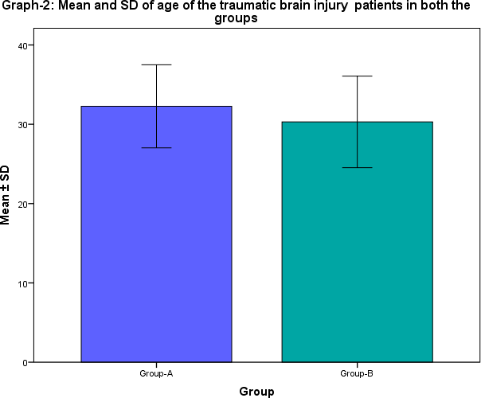

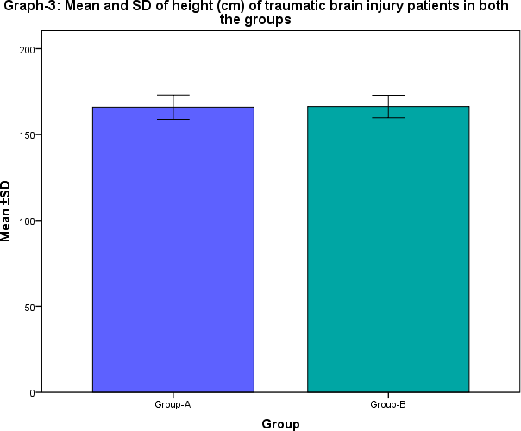

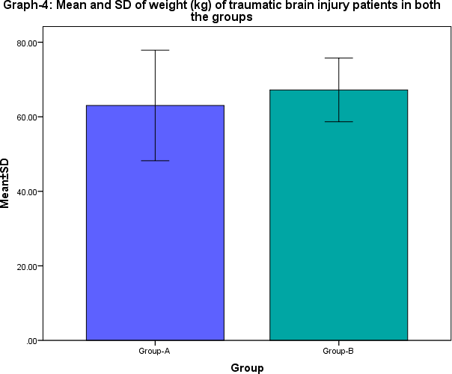

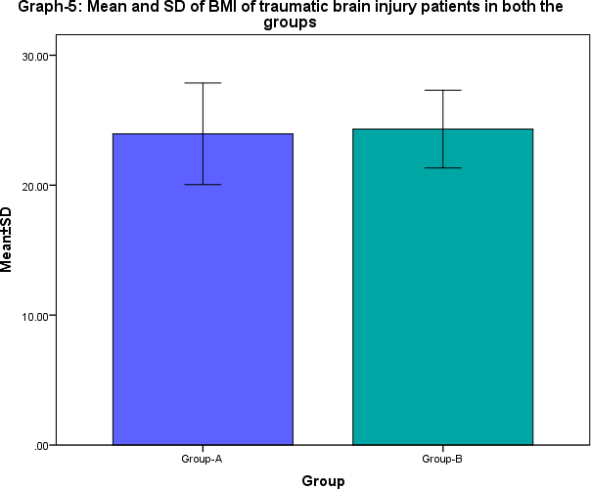

**Table-3:** Comparison of pre interventional outcomes of traumatic brain injury patients in between the groups

|  |  |  |  |  |  |  |
| --- | --- | --- | --- | --- | --- | --- |
| **S.**  **No.** | **Outcome Measures** | **Pre interventional** | | | | **Mann Whitney U test**  **/Unpaired t- test, p-value** |
| **Group-A:**  **Experimental** | | **Group-B: Control** | |
| **Range** | **Mean ±**  **SD** | **Range** | **Mean ±**  **SD** |
| 1 | **FMS** | 4-10 | 6.77±1.83 | 2-9 | 6.50±2.14 | z=0.233  p=0.816 |
| 2 | **MAS** | 2-4 | 3.47 ±0.62 | 2-4 | 3.43±0.82 | z=0.330,  p=0.742 |
| 3. | **RDT(m sec)** | 189-271 | 231.90  ±23.54 | 191-271 | 227.10  ±21.43 | t=0.734,  p=0.466 |
| 4. | **BVCG** | 2-4 | 3.07 ±0.64 | 2-4 | 2.97  ±0.61 | z=0.622  p=0.534 |

**Note**: p<0.05-Significant, p>0.05-Not significant, t-unpaired t-test, z- Normal approximation of of Mann-Whitney U test

The above table-3 depicts the pretest outcomes of outcome measures among traumatic brain injury patients in experimental and control group . In experimental group, the pre test, the Fugl Meyer Scale (FMS) was ranging within 4-10 with mean and SD of 6.77±1.83. In control group it was within the range of 2- 9 with mean and SD of 6.50±2.14. The pre test FMS was found to be more or less similar in both the groups, the non parametric test for between group comparison when the scores are ordinal, the Mann-Whitney U test was carried out and found to be insignificant(p>0.05).

Similarly, in experimental group, the pre test Modified Ashworth Scale (MAS) scores were ranging within 2-4 with mean and SD of 3.47 ±0.62. In control group it was within the range of 2-4 with mean and SD of 3.43±0.82. The pre test MAS was found to be more or less similar in both the groups, the non parametric test for between group comparison when the scores are ordinal, the Mann-Whitney U test was carried out and found to be insignificant(p>0.05).

Regarding Ruler Drop Test (RDT) in experimental group, the pre test values were ranging within 189- 271 with mean and SD of 231.90 ±23.54 which was more or similar to the pre test range of 191-271 with mean and SD of 227.10 ±21.43 in control group. The parametric test comparison of between groups outcomes, when the scores are measurable, the unpaired t-test was worked out and found to be insignificant (p>0.05).

Regarding Brunnstrom Voluntary Control Grading (BVCG) in experimental group, the pre test values were ranging within 2-4 with mean and SD of 3.07 ±0.64which was more or similar to the pre test

range of 2-4 with mean and SD of 2.97 ±0.61in control group. The non parametric test comparison of between groups outcomes, when the scores are ordinal, the Mann-Whitney U test was worked out and found to be insignificant (p>0.05).

The above findings implied that the baseline data of outcome measures of FMS, MAS, RDT and BVCG were more or less homogeneous in both the groups.

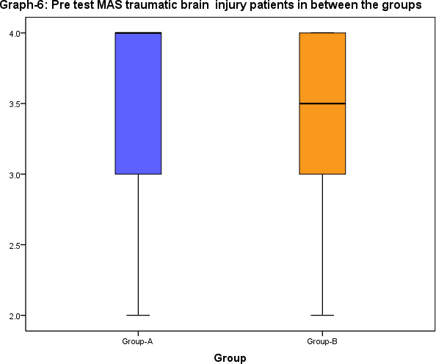

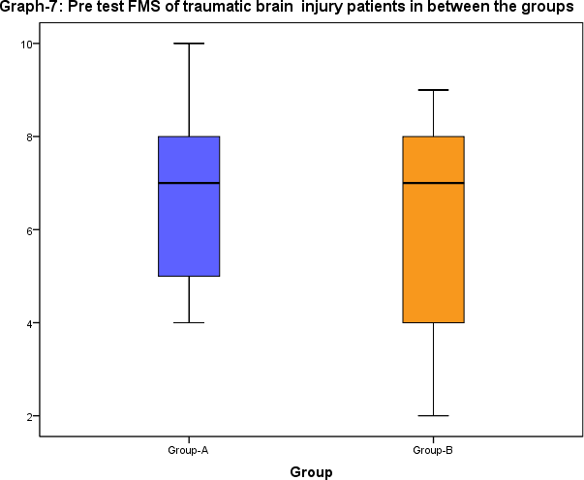

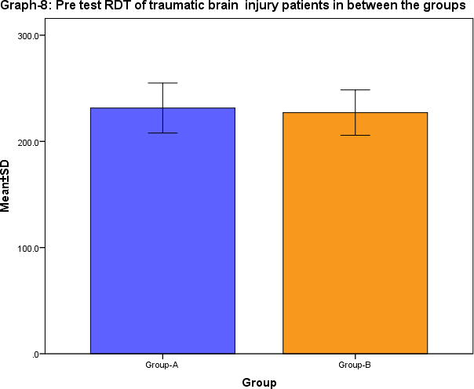

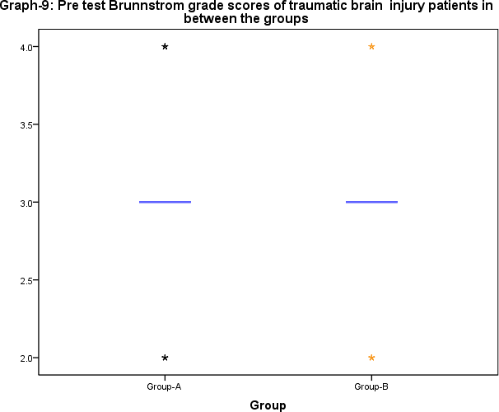

**Table-4**: Pre and post interventions of outcome measures of traumatic brain injury patients in group-A

|  |  |  |  |  |  |  |  |  |
| --- | --- | --- | --- | --- | --- | --- | --- | --- |
| **S.No**  **.** | **Outcome measures** | **Group-A: Experimental** | | | | | | Friedman test ANOVA/ F-  test ANOVA |
| **Pre test** | | **Post test-1** | | **Post test-2** | |
| **Range** | **Mean ±SD** | **Range** | **Mean ±SD** | **Range** | **Mean**  **±SD** |
| 1 | **FMS** | 4-10 | 6.77±1.83 | 6-12 | 9.77 ±1.71 | 6-13 | 10.40  ±1.71 | Fr=40.467, p=0.000 |
| 2 | **MAS** | 2-4 | 3.47 ±0.62 | 1-3 | 2.27±0.61 | 0-3 | 1.67±0.  84 | Fr=52.019, p=0.000 |
| 3. | **RDT(m**  **sec)** | 189-  271 | 231.90  ±23.54 | 182-  215 | 194.30  ±8.25 | 178-  219 | 185.90  ±9.12 | F=68.147, p=0.000 |
| 4. | **BVCG** | 2-4 | 3.07 ±0.64 | 3-6 | 4.57±0.67 | 4-6 | 5.17±0.  69 | Fr=57.728, p=0.000 |
| Pairs of **Pre with post-1:** | | * FMS: z=4.398, p=0.000, S * MAS: z=4.830, p=0.000, S * RDT: t=8.819, p=0.000, S * BVCG: t=10.570, p=0.000, S | | | Pairs of **Post-1 with post-2:** | * FMS: z=3.827, p=0.000, S * MAS: z=3.272, p=0.001, S * RDT: t=2.396, p=0.023, S BVCG: t=4.039, p=0.000, S | | |
| Pairs of **Pre with post-2:** | | * FMS: z=4.648, p=0.000, S * MAS: z=4.823, p=0.000, S * RDT:t=9.294, p=0.000, S BVCG: t=37.696, p=0.000, S | | | |  | | |

Note: p<0.05-Significant, p>0.05-Not significant, t-unpaired t-test, Fr- Friedman test-Non parametric repeated measure ANOVA, F-test –Parametric test repeated measure ANOVA.t-test paired outcomes, z-Wilcoxon test for paired outcomes.

The above table-4 depicts the pretest, post test-1 and post test -2 outcome measures among traumatic brain injury patients in experimental and control group . In experimental group, the pre test, the Fugle Meyer Scale (FMS) was ranging within 4-10 with mean and SD of 6.77±1.83. But, follow ups, post test-1 it was found to be increased to be the range of 6-12 with mean and SD of 9.77 ±1.71. Further in post test-2 it was found to be increased to the range of 6-13 with mean and SD of 10.40 ±1.71,. Since the FMS scores were ordinal , the Non-parametric ANOVA for repeated measures Friedman test was carried out to test significance of increase over the follow up, it was found to be was statistically significant(p<0.05).

In pre test, the MAS scores were ranging within 2-4 with mean and SD of 3.47 ±0.62. But, follow ups, post test-1 it was found to be decreased to be the range of 1-3 with mean and SD of 2.37±0.61. Further

in post test-2 it was found to be decreased to the range of 0-3 with mean and SD of 1.67±0.84,. Since the MAS scores were ordinal , the Non-parametric ANOVA for repeated measures Friedman test was carried out to test significance of increase over the follow up, it was found to be was statistically significant(p<0.05).

In pre test, the Ruler Drop test (RDT) was ranging within 189-271 with mean and SD of 231.90

±23.54. But in post test-1, it was found to be decreased to the range 182-215 with mean and SD 194.30

±8.25.. Further, in follow up (post test-2) it was found to be decreased to the range of 178-219 with mean and SD of 185.90 ±9.12, Since, the RDT scores were time units, the parametric ANOVA for repeated measures F-test for repeated measures ANOVA was suitably employed to carry out the significance of decrease over the follow up, it was found to be was statistically significant(p<0.05).

In pre test, the BVCG scores were ranging within 2-4 with mean and SD of 3.07 ±0.64. But, follow ups, post test-1 it was found to be increased to be the range of 3-6 with mean and SD of 4.57±0.67. Further in post test-2 it was found to be increased to the range of 4-6 with mean and SD of 5.17±0.69,. Since the MAS scores were ordinal , the Non-parametric ANOVA for repeated measures Friedman test was carried out to test significance of increase over the follow up, it was found to be was statistically significant(p<0.05).

Within pairs comparison of follow ups, pre with post-1, post-1 with post-2 and pre with post-2. The non parametric test for testing the significance of two pairs when the scores are ordinal, the Wilcoxon test was carried out for pairs of FMS, MAS and BVCG were found to be significant (p>0.05) The paired t-test was used to test the significance of RDT within the pairs and found to be statistically significant(p<0.05)

The above results evidenced that the intervention of FMVT was significantly effective in increasing the FMS and BVCG and decrease in MAS and RDT(sec) among traumatic brain injury patients.

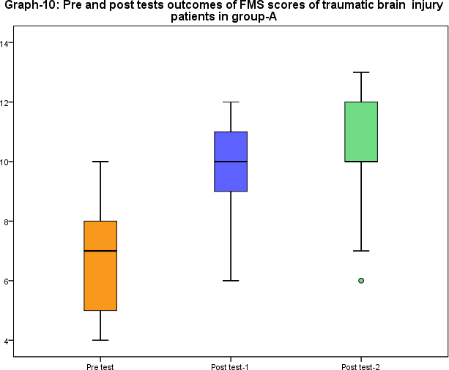

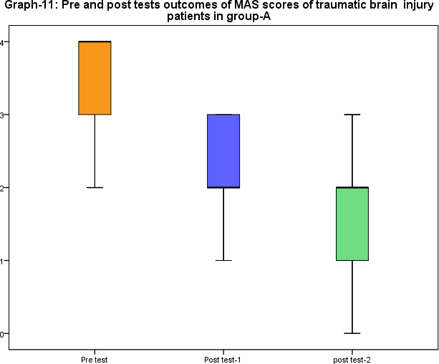

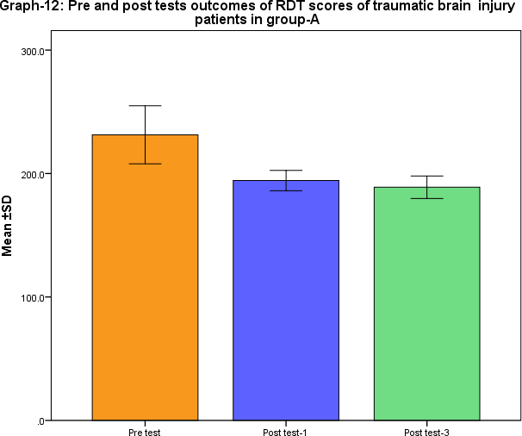

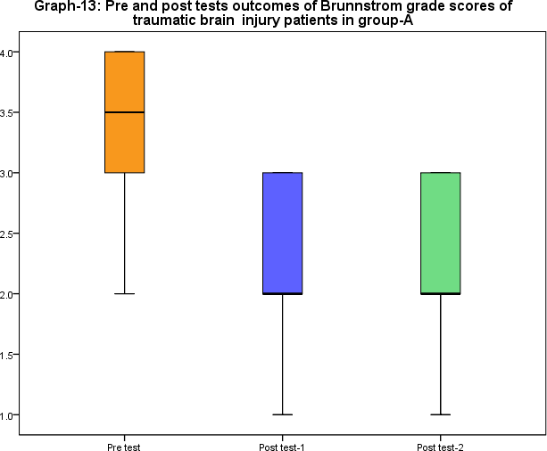

**Table-5**: Pre and post interventions of outcome measures of traumatic brain injury patients in group-B

|  |  |  |  |  |  |  |  |  |
| --- | --- | --- | --- | --- | --- | --- | --- | --- |
| **S.No**  **.** | **Outcome measures** | **Group-B: Control** | | | | | | Friedman test ANOVA/ F-  test ANOVA |
| **Pre test** | | **Post test-1** | | **Post test-2** | |
| **Range** | **Mean ±SD** | **Range** | **Mean ±SD** | **Range** | **Mean**  **±SD** |
| 1 | **FMS** | 2-9 | 6.50±2.14 | 5-13 | 8.73 ±1.81 | 6-13 | 8.97  ±1.77 | Fr=21.394, p=0.0000 |
| 2 | **MAS** | 2-4 | 3.43±0.82 | 1-3 | 2.43 ±0.86 | 0-3 | 1.95  ±0.81 | Fr=38.655, p=0.000 |
| 3. | **RDT(m**  **sec)** | 191-  271 | 227.10  ±21.43 | 185-  248 | 211.13  ±17.77 | 183-  225 | 203.02  ±13.02 | F =14.321, p=0.000 |
| 4. | **BVCG** | 2-4 | 2.97 ±0.61 | 2-5 | 3.63±0.65 | 4-5 | 4.43±0.  54 | Fr=42.297, p=0.000 |
| Pairs of **Pre with post-1:** | | * FMS: z=3.112, p=0.019, S * MAS: z=3.271, p=0.001, S * RDT: t=6.909, p=0.000, S * BVCG: t=2.511, p=0.036, S | | | Pairs of **Post-1 with post-2:** | * FMS: z=1.913, p=0.063, NS * MAS: z=0.699, p=0.485, NS * RDT: t=2.215, p=0.035, S BVCG: t=3.442, p=0.001, S | | |
| Pairs of **Pre with post-2:** | | * FMS: z=2.964, p=0.026, S * MAS: z=2.845, p=0.031, S * RDT: t=3.421, p=0.001, S BVCG: t=4.832, p=0.000, S | | | |  | | |

Note: p<0.05-Significant, p>0.05-Not significant, t-unpaired t-test, Fr- Friedman test-Non parametric repeated measure ANOVA, F-test –Parametric test repeated measure ANOVA.t-test paired outcomes, z-Wilcoxon test for paired outcomes.

The above table-5 depicts the pretest, post test-1 and post test -2 outcome measures among traumatic brain injury patients in experimental and control group . In control group, the pre test, the Fugle Meyer Scale (FMS) was ranging within 2-9 with mean and SD of 6.50±2.14. But, follow ups, post test-1 it was found to be increased to be the range of 5-13 with mean and SD of 8.73 ±1.81. Further in post test-2 it was found to be increased to the range of 6-13 with mean and SD of 8.97 ±1.77,. Since the FMS scores were ordinal , the Non-parametric ANOVA for repeated measures Friedman test was carried out to test significance of increase over the follow up, it was found to be was statistically significant(p<0.05).

In pre test, the MAS scores were ranging within 2-4 with mean and SD of 3.43±0.82. But, follow ups, post test-1 it was found to be decreased to be the range of 1-3 with mean and SD of 2.33 ±0.86. Further in post test-2 it was found to be decreased to the range of 0-3 with mean and SD of 1.95 ±0.81,. Since

the MAS scores were ordinal , the Non-parametric ANOVA for repeated measures Friedman test was carried out to test significance of increase over the follow up, it was found to be was statistically significant(p<0.05).

In pre test, the Ruler Drop test (RDT) was ranging within 191-271 with mean and SD of 227.10

±21.43. But in post test-1, it was found to be decreased to the range 185-245 with mean and SD 211.13

±17.77.. Further, in follow up (post test-2) it was found to be decreased to the range of 183-225 with mean and SD of 203.02 ±13.02, Since, the RDT scores were time units, the parametric ANOVA for repeated measures F-test for repeated measures ANOVA was suitably employed to carry out the significance of decrease over the follow up, it was found to be was statistically significant(p<0.05).

In pre test, the BVCG scores were ranging within 2-4 with mean and SD of 2.97 ±0.61. But, follow ups, post test-1 it was found to be increased to be the range of 2-5 with mean and SD of 3.63±0.65. Further in post test-2 it was found to be increased to the range of 4-5 with mean and SD of 5.17±0.69,. Since the MAS scores were ordinal , the Non-parametric ANOVA for repeated measures Friedman test was carried out to test significance of increase over the follow up, it was found to be was statistically significant(p<0.05).

And also, within pairs comparison of follow ups, pre with post-1, post-1 with post-2 and pre with post-

2. The non parametric test for testing the significance of two pairs when the scores are ordinal, the Wilcoxon test was carried out for pairs of FMS, MAS and BVCG were found to be significant (p>0.05). The paired t-test was used to test the significance of RDT within the pairs and found to be statistically significant(p<0.05)

The above results evidenced that the intervention of FMVT was significantly effective in increasing the FMS and BVCG and decrease in MAS and RDT(sec) among traumatic brain injury patients.

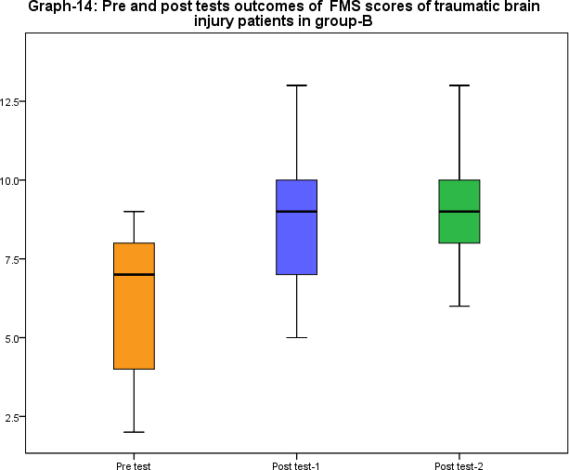

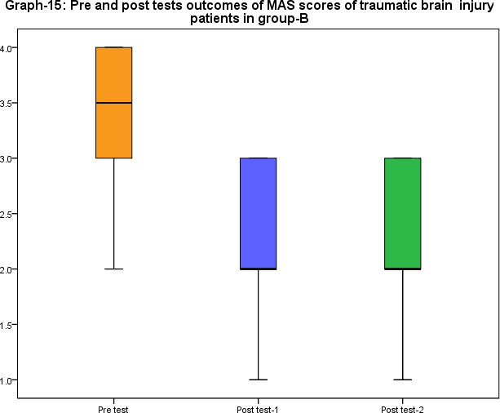

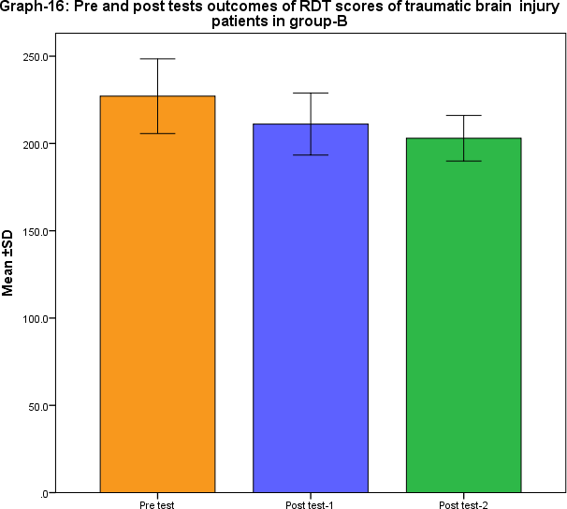

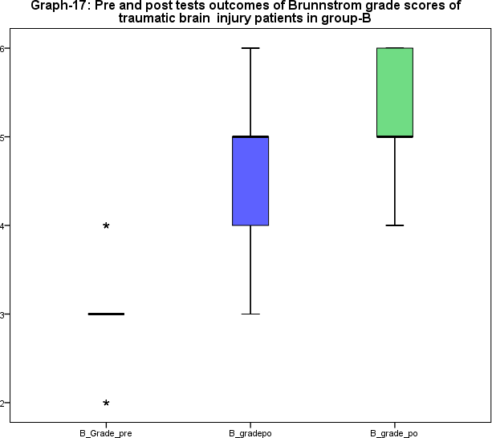

**Table-6:** Comparison of Post interventional-1 outcomes of traumatic brain injury patients in between the groups

|  |  |  |  |  |  |  |
| --- | --- | --- | --- | --- | --- | --- |
| **S.No.** | **Outcome Measures** | **Post interventional-1** | | | | **Mann Whitney U test**  **/Unpaired t- test, p-value** |
| **Group-A:**  **Experimental** | | **Group-B: Control** | |
| **Range** | **Mean ±**  **SD** | **Range** | **Mean ±**  **SD** |
| 1 | **FMS** | 6-12 | 9.77 ±1.71 | 5-13 | 8.73  ±1.81 | z=2.240  p=0.033 |
| 2 | **MAS** | 1-3 | 2.27±0.61 | 1-3 | 2.43  ±0.86 | z=2.140,  p=0.012 |
| 3. | **RDT(m sec)** | 182-215 | 194.30  ±8.25 | 185-248 | 211.13  ±17.77 | t=2.152,  p=0.031 |
| 4. | **BVCG** | 3-6 | 4.57±0.67 | 2-5 | 3.63±0.65 | z=4.010  p=0.000 |

Note: p<0.05-Significant, p>0.05-Not significant, t-unpaired t-test, z- Normal approximation of Mann- Whitney U test.

The above table-6 depicts the post test-1 outcomes of outcome measures among traumatic brain injury patients in experimental and control group . In experimental group, the post test-1, the Fugle Meyer Scale (FMS) was ranging within 6-12 with mean and SD of 9.77 ±1.71. In control group it was within the range of 5-13 with mean and SD of 8.73 ±1.81. The post test-1 FMS in experimental group was found to be greater than the FMS control group, the non parametric test for between group comparison when the scores are ordinal, the Mann-Whitney U test was carried out and found to be significant(p<0.05).

Similarly, in experimental group, the post test-1 MAS scores were ranging within 1-3 with mean and SD of 2.37±0.61. In control group it was within the range of 2-4 with mean and SD of 2.33 ±0.86. The post test-1 MAS was found to be less than the control groups, the non parametric test for between group the Mann-Whitney U test was carried out and found to be significant(p<0.05).

Regarding RDT(m sec) in experimental group, the post test-1 values were ranging within 182-215 with mean and SD of 194.30 ±8.25 but in control group it was within the range of 185-248 with mean and SD of 211.13 ±17.77. The post test-1 RDT scores in experimental group was comparably less than the post test-1 scores in control group. The parametric test comparison of between groups outcomes, when the scores are measurable, the unpaired t-test was worked out and found to be significant (p<0.05).

Regarding BVCG in experimental group, the post test-1 values were ranging within 3-6 with mean and SD of 4.57±0.67 , but in control group it was within the range of 2-5 with mean and SD of 3.63±0.65. The post test-1 outcomes were greater than the post test- scores in control group. The non parametric test comparison of between groups outcomes, when the scores are ordinal, the Mann-Whitney U test was worked out and found to be significant (p<0.05).

The above findings evidence that the post test-1 data of outcome measures of differ significantly in between the groups. The above results evidenced that the intervention of FMVT was significantly better than the control group among traumatic brain injury patients.

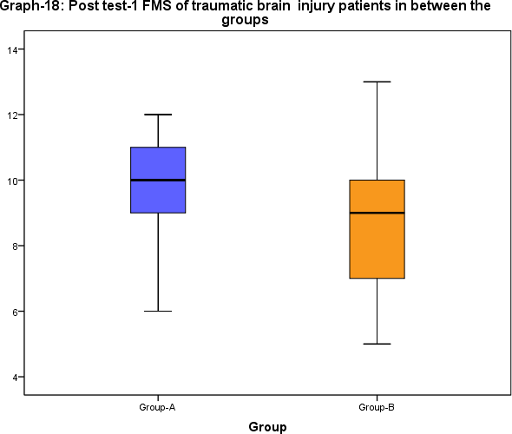

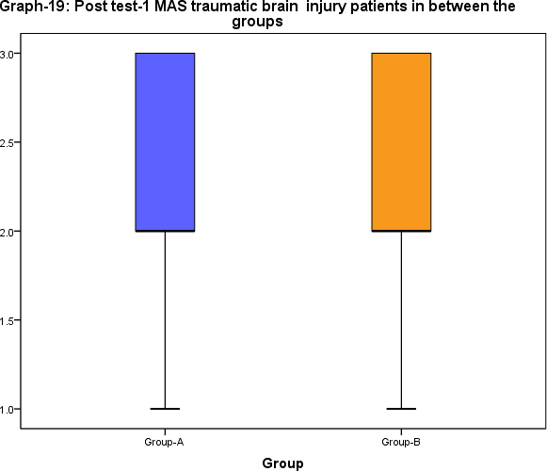

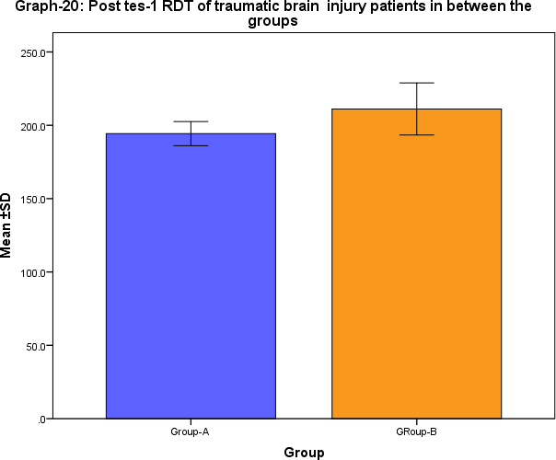

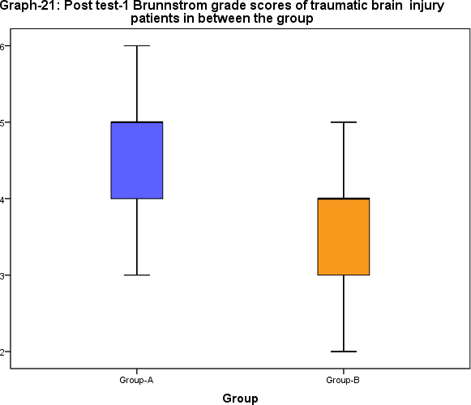

**Table-7:** Comparison of Post intervention-2 outcomes of traumatic brain injury patients in between the groups

|  |  |  |  |  |  |  |
| --- | --- | --- | --- | --- | --- | --- |
| **S.No.** | **Outcome Measures** | **Post interventional-2** | | | | **Mann Whitney U test**  **/Unpaired t- test, p-value** |
| **Experimental (n=30)** | | **Control (n=30)** | |
| **Range** | **Mean ± SD** | **Range** | **Mean ± SD** |
| 1 | **FMS** | 6-13 | 10.40  ±1.71 | 6-13 | 8.97  ±1.77 | z=2.656  p=0.009 |
| 2 | **MAS** | 0-3 | 1.67±0.84 | 0-3 | 1.95  ±0.81 | z=3.087,  p=0.002 |
| 3. | **RDT(m sec)** | 178-219 | 185.90  ±9.12 | 183-225 | 203.02  ±13.02 | t=4.847,  p=0.000 |
| 4. | **BVCG** | 4-6 | 5.17±0.69 | 4-5 | 4.43±0.54 | z=3.941  p=0.000 |

**Note**: p<0.05-Significant, p>0.05-Not significant, t-unpaired t-test, z- Normal approximation of Mann- Whitney U test

The above table-7 depicts the post test-2 outcomes of outcome measures among traumatic brain injury

patients in experimental and control group . In experimental group, the post test-2, the Fugle Meyer Scale (FMS) was ranging within 6-13 with mean and SD of 10.40 ±1.71. In control group it was within the range of 6-13 with mean and SD of 8.97 ±1.77. The post test-2 FMS in experimental group was found to be greater than the FMS control group, the non parametric test for between group comparison when the scores are ordinal, the Mann-Whitney U test was carried out and found to be significant(p<0.05).

Similarly, in experimental group, the post test-2 MAS scores were ranging within 0-3 with mean and SD of 1.67±0.84. In control group it was within the range of 0-3 with mean and SD of 1.95 ±0.81. The post test-2 MAS was found to be less than the control group, the non parametric test for between group the Mann-Whitney U test was carried out and found to be significant(p<0.05).

Regarding RDT(m sec) in experimental group, the post test-2 values were ranging within 178-219 with mean and SD of 185.90 ±9.12, but in control group it was within the range of 183-225 with mean and SD of 203.02 ±13.02. The post test-2 RDT scores in experimental group was comparably less than the post test-2 scores in control group. The parametric test comparison of between groups outcomes, when the scores are measurable, the unpaired t-test was worked out and found to be significant (p<0.05).

Regarding BVCG in experimental group, the post test-2 values were ranging within 4-6 with mean and SD of 5.17±0.69, but in control group it was within the range of 4-5 with mean and SD of 4.43±0.54. The post test-2 outcomes were greater than the post test- scores in control group. The non parametric test comparison of between groups outcomes, when the scores are ordinal, the Mann-Whitney U test was worked out and found to be significant (p<0.05).

The above findings evidence that the post test-2 data of outcome measures of differ significantly in between the groups. The above results evidenced that the intervention of FMVT was significantly better than the control group among traumatic brain injury patients.

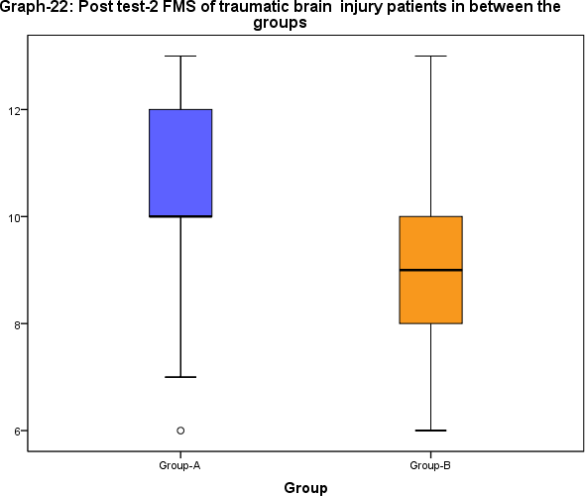

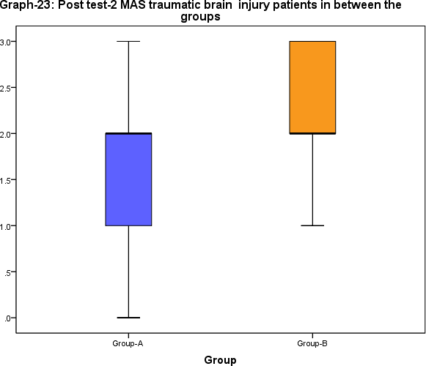

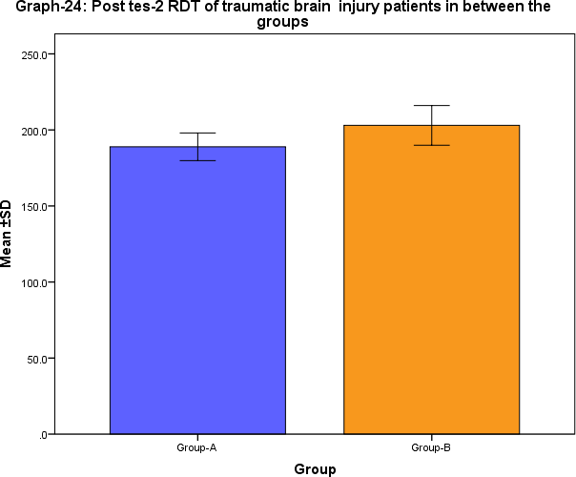

**Graph-25: Post test-2 Brunnstrom grade scores of traumatic brain injury patients in between the groups**

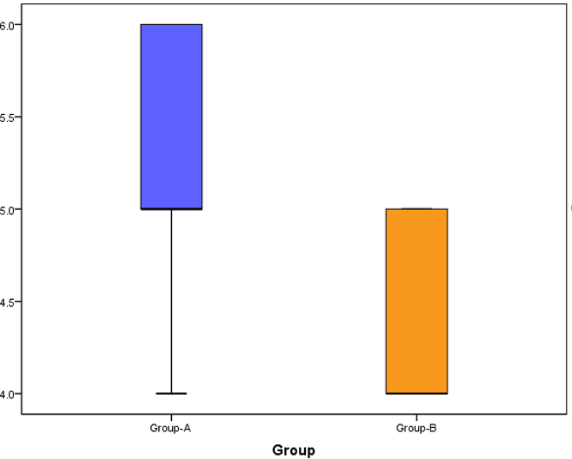

**Table-8**: Pre and post interventions of outcome measures of traumatic brain injury patients in both the groups

|  |  |  |  |  |  |  |  |  |
| --- | --- | --- | --- | --- | --- | --- | --- | --- |
| **S.No**  **.** | **Outcome measures** | **Group-A: Experimental** | | | | | | Friedman test ANOVA/ F-  test ANOVA |
| **Pre test** | | **Post test-1** | | **Post test-2** | |
| **Range** | **Mean ±SD** | **Range** | **Mean ±SD** | **Range** | **Mean**  **±SD** |
| 1 | **FMS** | 4-10 | 6.77±1.83 | 6-12 | 9.77 ±1.71 | 6-13 | 10.40  ±1.71 | Fr=40.467, p=0.000 |
| 2 | **MAS** | 2-4 | 3.47 ±0.62 | 1-3 | 2.27±0.61 | 0-3 | 1.67±0.  84 | Fr=52.019, p=0.000 |
| 3. | **RDT(m**  **sec)** | 189-  271 | 231.90  ±23.54 | 182-  215 | 194.30  ±8.25 | 178-  219 | 185.90  ±9.12 | F=68.147, p=0.000 |
| 4. | **BVCG** | 2-4 | 3.07 ±0.64 | 3-6 | 4.57±0.67 | 4-6 | 5.17±0.  69 | Fr=57.728, p=0.000 |
| **Group-B: Control** | | | | | | | | |
| 1 | **FMS** | 2-9 | 6.50±2.14 | 5-13 | 8.73 ±1.81 | 6-13 | 8.97  ±1.77 | Fr=21.394, p=0.0000 |
| 2 | **MAS** | 2-4 | 3.43±0.82 | 1-3 | 2.43 ±0.86 | 0-3 | 1.95  ±0.81 | Fr=38.655, p=0.000 |
| 3. | **RDT(m**  **sec)** | 191-  271 | 227.10  ±21.43 | 185-  248 | 211.13  ±17.77 | 183-  225 | 203.02  ±13.02 | F =14.321, p=0.000 |
| 4. | **BVCG** | 2-4 | 2.97 ±0.61 | 2-5 | 3.63±0.65 | 4-5 | 4.43±0.  54 | Fr=42.297, p=0.000 |

The table-8 presents the pre and follow up outcomes of all the outcome measures in beteen the groups. Intially in pre test more or less the outcomes are similar.But in follow ups, in post test- 1 and post test- 2 in experimental group was significantly better than the contrl group(table-6 and table-7).The following graphs depict the changes observed in follow ups in between the groups.

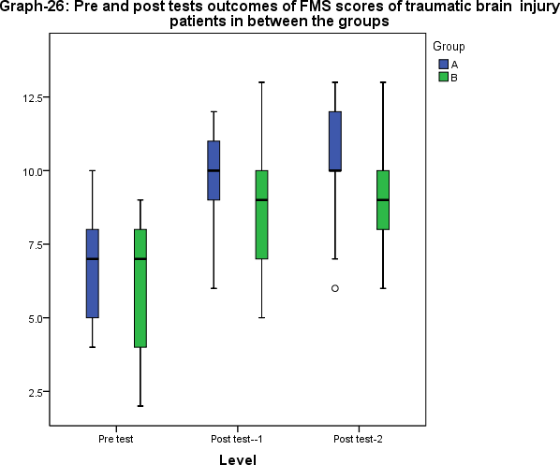

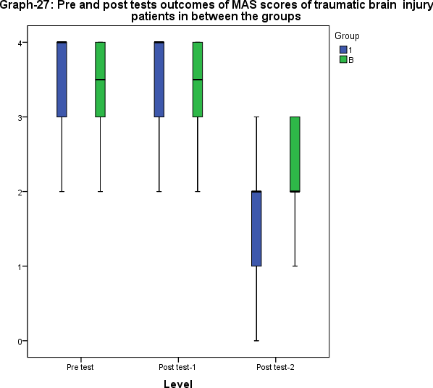

**Graph-28: Pre and Post tests outcomes of RDT scores of traumatic brain injury patients in between the groups**

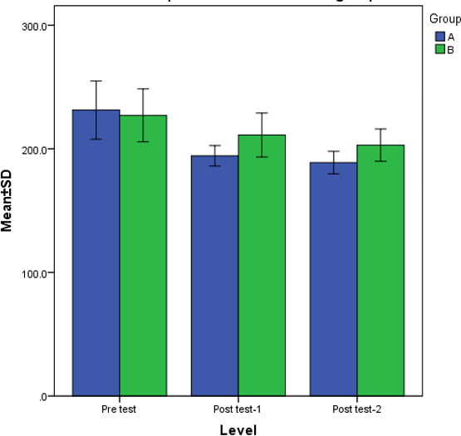

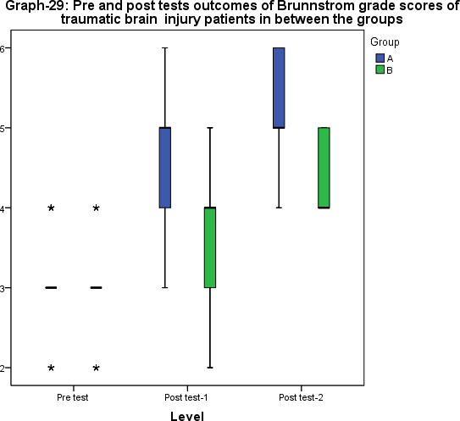

**Result**: While comparing the follow up outcomes (post test-1 and post test-2) in between the groups the intervention of FMVT is significantly effective than the control group in treating traumatic brain injury patients.

# DISCUSSION

TBI mostly results in significant long-term impairments64 including delayed response time18, hypertonicity, and loss of volitional coordination and impaired motor functions16 along with cognitive and emotional impairement65. The study's objective was three-fold, aiming to assess the impact of focal muscle vibration therapy, conventional therapy, and their comparative effects on reaction timing, spasticity, hand function impairment, and voluntary control of upper limb function in TBI patients. The study involved a total of 60 participants with 30 participants in each group. Assessment parameters included reaction timing, spasticity, impairment and voluntary control which were measured using ruler-drop test (RDT), Modified Ashworth Scale (MAS), Fugl Meyer Scale (FMS) and Brunnstrom Voluntary Grading Scale (BVGS) respectively.

Evaluations for all the outcome parameters were done at baseline and post intervention at week 3 and week 6, for both control and experimental group. The mean and SD for reaction timing, spasticity, impairment and voluntary control were taken for both the groups. There was a significant difference between the pre and post scores for reaction time in both the groups. In the control group, the RDT values improved from the initial baseline measurement of 227.10 ±21.43 to 211.13 ±17.77 at week 3 and further to 203.02 ±13.02 at week 6. Similarly, in the experimental group, the scores improved from baseline of 231.90 ±23.54 to 194.30 ± 8.25 ms and continued till week 6 with the value of 185.90 ±

9.12 ms. However, when compared to the control group, the experimental group showed significantly better results.

In terms of spasticity, the scores of the control and experimental group differed significantly. The control group’s MAS scores saw an improvement from the baseline of 3.43±0.82, progressing through week 3 with 2.43 ±0.86 and week 6 with 1.95 ±0.81. Likewise, the experimental group showed a marked improvement from baseline level of 3.47 ±0.62 to week 3 with 2.27 ± 0.61, which was sustained through week 6, reaching to 1.67 ± 0.84. The experimental group’s improvement was significantly greater than that of the control group.

The pre- and post-test results for upper limb impairment demonstrated significant differences in mean and SD. Observing the control group, it was seen that FMS scores improved from baseline levels of 6.50±2.14 to 8.73 ±1.81 at week 3 , and were further enhanced by week 6 to 8.97 ±1.77. In the experimental group, scores were also improved from baseline level of 6.77±1.83 to week 3 with 9.77

± 1.71, with continued progress noted at week 6, reaching 10.40 ± 1.71. A substantial difference was revealed in the comparison between groups, with significantly better outcomes shown by the

experimental group.

Both groups experienced improvements in voluntary control on BVCG scale, with the control group showing gains from a baseline of 2.97 ±0.61to 3.63±0.65at week 3 and further to 4.43±0.54 at week 6. The experimental group, however, progressed from baseline of 3.07 ±0.64 to 4.57 ± 0.67 at week 3 and continued to show substantial improvements through week 6, reaching 5.17 ± 0.69. Comparisons study was done between the experimental and control groups for both post-test 1 and post-test 2 and revealed that the experimental group consistently outperformed the control group indicated by significant differences favouring the experimental group (p<0.005).The results strongly indicated the effectiveness of FMVT in improving reaction timing, reducing spasticity, and enhancing voluntary motor control and overall impairment in TBI patients.

The present study finding indicated improved reaction timing, which was found to be consistent with another research done by **Antonella Macerollo et al. (2018)66** , indicating significantly faster mean reaction time 302.83 ± 52.82 ms following the administration of high-frequency peripheral vibration of 80Hz. The current study showed reduction in spasticity with FMV , which aligned with earlier work by **Casale R et al. (2014)53** who demonstrated improvements in spasticity of the flexor agonist, biceps brachii ,P=0.0001 with 100 Hz vibration in conjunction with physiotherapy to the triceps brachii of a spastic upper limb. This study suggested significant improvement in hand impairment, reinforcing the findings of **Lian Wang et al. (2023)31**, who reported that FV significantly improved upper limb motor function in sub acute stroke patients, as measured by the Fugl-Meyer assessment for upper extremity (FMA-UE),P=0.029. However, a contrasting study by **Niyousha Mortaza et al. (2019)67** found insufficient evidence to support clinical improvement in upper limb functional movement with standard mean difference of -0.32, after tendon/muscle vibration treatment in persons with sub acute and chronic stroke. This highlighted the need for further research with larger sample sizes and high-quality studies

. Additionally, the importance of considering various factors that may influence treatment outcomes was emphasized.

FMV uses mechanical oscillations as a stimulus to stimulate reciprocal inhibition **(Sameen Tahir et al.,2022)25**. This study further demonstrated that the brain oscillatory activity through EEG analysis indicated that the relief of PSS could be associated with the activation of bilateral S1-M1 **(Wei Li et al., 2022)33**. Research on FMVT has revealed its ability to induce long-term depression-like plasticity in specific spinal cord circuits depending on the muscle vibrated. A body of literature pointed toward presynaptic changes in the spinal cord, reflected by a decrease in the amplitude of the H reflex , a phenomenon known as post-vibration depression (PVD). Additionally, alterations in SEP are associated with changes in cortical plasticity **(Lorenzo Rocchi et al., 2018)47.**Studies on LV suggest it

may also alter corticospinal excitability, which can be investigated through the recording of motor evoked potentials (MEPs) **(Clara Pfenninger et al., 2023)68.**

FMV is known to induce activation of muscle proprioceptors, generate adaptive synaptic changes, and lead to long-term potentiation in the CNS. This is supported by findings that show FMV's ability to generate ta afferent impulses by activating the muscle spindle. This activation leads to alterations in the corticospinal pathway, triggering ta afferent impulses to the alpha motor neuron and the 1a inhibitory interneuron in the spinal cord, resulting in reflexive contraction in the antagonist muscle **(Sameen Tahir et al., 2022)24**. Furthermore, it has been indicated that this modulation affects proprioceptive reflex circuits **(Enrico Alfonsi et al., 2015)69**.

Constraint-Induced Movement Therapy (CIMT) has been shown to promote the recovery of motor function by enhancing AMPA receptor-mediated synaptic transmission in the ischemic hemisphere. Additionally, CIMT enhances the plasticity of dendrites and dendritic spines in both the ipsilateral and contralateral sensorimotor cortex **(Hui et al., 2021)70**. CIMT also increased the number of synapses in the contralateral cortex but did not do so in the intact ipsilateral cortex **(Liu et al., 2019)71.**Further research indicates that CIMT promotes the reconstruction of inter hemispheric axonal connections **(Nesin et al., 2019)72**. It also promotes neurogenesis and angiogenesis by increasing the expression of factor-1α and vascular endothelial growth factor, ultimately inducing neuroprotection and functional recovery after cerebral ischemia **(Li et al., 2017)73**. Additionally, mCIMT effectively reduces the glutamate content in the contralateral hippocampus **(Gao et al., 2020)74**.Studies on animal models have shown that CIMT significantly improved the function of the forelimbs in rats, related to the reduction in the expression of phosphorylated extracellular signal-regulated kinases in the bilateral cortex and hippocampus **(Zhang et al., 2015)75**.

Furthermore, CIMT has been found effective in restoring motor function in various conditions, including stroke, cerebral palsy, and traumatic brain injury (TBI), combining neurological and behavioral mechanisms to induce neuroplastic changes and overcome learned non-use **(Gulrandhe et al., 2023)76**.CIMT may induce greater changes in the unlesioned hemisphere due to the nonuse of the unaffected arm. Conversely, repetitive training (RT) may induce more pronounced changes in the lesioned hemisphere due to the high number of repetitions performed with the paretic arm **(Li et al., 2019)42**. Motor improvements in participants with chronic stroke are related to decreases in cortical excitability in the lesioned hemisphere as measured with transcranial magnetic stimulation (TMS). Furthermore, the balance of both EEG power and EEG alpha peak frequency in the lesioned hemisphere is related to motor improvement **(Marcel Simis et al., 2023)77.**

Sustained stretching aims at promoting muscle relaxation and effective elongation. Stretch force to a muscle-tendon unit leads to change in length, thereby eliciting the stretch reflex. However reciprocal inhibition may also facilitate the stretching process by inhibiting the antagonist muscle and allowing for a deeper stretch to agonist muscle. Additionally, Golgi Tendon Organ (GTO) plays an inhibitory effect, known as autogenic inhibition that enables reflexive muscle relaxation. The traditional explanation of the underlying mechanisms of PNF stretching posits that reflexive relaxation occuring as a result of autogenic or reciprocal inhibition, resulting in decreased resistance of the muscle to stretch stimulus . **(Corolyn Kisner, Therapeutic Exercise)** 78.

# LIMITATIONS

* The absence of long-term follow-up data prevents insights into the durability of intervention effects beyond the immediate post-intervention period, hindering the assessment of the intervention's lasting impact.
* Variations in participants' adherence to the intervention protocols, such as home exercises can influence participants' motor control outcomes, potentially impacting the study results.
* The specific population (TBI patients) studied may limit the generalizability of the findings to other neurological conditions or broader patient populations.
* Patient with cognitive issues were not included.

# RECOMMENDATION

* Implementation of long-term follow-up to gain insights into the durability of intervention effects beyond the immediate post-intervention period can be recommended.
* Developing strategies to enhance participants' adherence to intervention protocols, such as regular check-ins and reminders can be recommended.
* Further research can be conducted to explore the applicability of the findings to other neurological conditions with broader patient populations.

# CONCLUSION

Our findings demonstrate significant improvements in reaction timing, spasticity, hand function impairment, and voluntary control following FMVT compared to conventional therapy alone. These findings highlight the potential of FMVT as a valuable therapeutic approach for optimizing outcomes and enhancing the quality of life for individuals with TBI.

# SUMMARY

Traumatic brain injury (TBI) is a major cause of morbidity and mortality worldwide, with long-term consequences such as physical, emotional, and behavioral impairments. In this study, the effects of focal muscle vibration (FMV) therapy on upper limb function in TBI patients are explored, an area that remains relatively unexplored. Sixty participants were divided into experimental and control groups, with FMV therapy administered alongside standard therapy to the experimental group, while only standard therapy was provided to the control group over six weeks. Key parameters were assessed, including reaction timing, spasticity, impairment, and voluntary control using the Ruler Drop Test, Modified Ashworth Scale, Fugl Meyer Scale, and Brunnstrom Voluntary Control Grading, respectively. Significant improvements were observed in the experimental group across all metrics, suggesting that FMV therapy may enhance motor function and reduce spasticity more effectively than conventional therapies alone. These findings are aligned with existing research on FMV's benefits in other neurological conditions, highlighting its promise as a non-invasive, well-tolerated intervention in TBI rehabilitation.

# REFERENCES

1. Capizzi A, Woo J, Verduzco-Gutierrez M. Traumatic Brain Injury: An Overview of Epidemiology, Pathophysiology, and Medical Management. Med Clin North Am. 2020 Mar;104(2):213-238.
2. Khellaf A, Khan DZ, Helmy A. Recent advances in traumatic brain injury. J Neurol. 2019 Nov;266(11):2878-2889.
3. Goldman L, Siddiqui EM, Khan A, Jahan S, Rehman MU, Mehan S, Sharma R, Budkin S, Kumar SN, Sahu A, Kumar M, Vaibhav K. Understanding Acquired Brain Injury: A Review. Biomedicines. 2022 Sep;10(9):2167.
4. Kjeldgaard A, Soendergaard PL, Wolffbrandt MM, Norup A. Predictors of caregiver burden in caregivers of individuals with traumatic or non-traumatic brain injury: A scoping review. NeuroRehabilitation. 2023;52(1):9-28.
5. Najem D, Rennie K, Ribecco-Lutkiewicz M, Ly D, Haukenfrers J, Liu Q, Nzau M, Fraser DD, Bani-Yaghoub M. Traumatic brain injury: classification, models, and markers. Biochem Cell Biol. 2018 Aug;96(4):391-406.
6. Chung JY, Zeller SL, Cooper JB, Pisapia JM, Sofjan I, Wecksell M, Salik I. Socioeconomic Disparities in Pediatric Traumatic Brain Injury Transfer Patterns: An Analysis of Area Deprivation Index and Clinical Outcomes. World Neurosurg. 2024. [https://doi.org/10.1016/j.wneu.2024.05.](https://doi.org/10.1016/j.wneu.2024.05)
7. Jamjoom AAB, Rhodes J, Andrews PJD, Grant SGN. The synapse in traumatic brain injury. Brain. 2021 Feb 12;144(1):18-31.
8. Hyder AA, Wunderlich CA, Puvanachandra P, Gururaj G, Kobusingye OC. The impact of traumatic brain injuries: a global perspective. NeuroRehabilitation. 2007;22(5):341-53.
9. Indian Head Injury Foundation. Traumatic Brain Injury. <https://indianheadinjuryfoundation.org/traumatic-brain-injury/>
10. Dash HH, Chavali S. Management of traumatic brain injury patients. Korean J Anesthesiol. 2018 Feb;71(1):12-21.
11. Veerappan VR, Nagendra B, Thalluri P, Manda VS, Rao RN, Pattisapu JV. Reducing the Neurotrauma Burden in India-A National Mobilization. World Neurosurg. 2022 Sep;165:106- 113.
12. Pellot JE, De Jesus O. Cerebral Contusion. StatPearls Publishing. 2023.
13. Sunnerhagen KS, Opheim A, Alt Murphy M. Onset, time course and prediction of spasticity after stroke or traumatic brain injury. Ann Phys Rehabil Med. 2019 Nov;62(6):431-434. doi: 10.1016/j.rehab.2019.05.007.
14. Enslin JMN, Rohlwink UK, Figaji A. Management of Spasticity after Traumatic Brain Injury in Children. Front Neurol. 2020 Feb 21;11:126.
15. Basford JR, Chou LS, Kaufman KR, Brey RH, Walker A, Malec JF, Moessner A, Brown AW. An assessment of gait and balance deficits after traumatic brain injury. Arch Phys Med Rehabil. 2003 Mar;84(3):343-349. doi: 10.1053/apmr.2003.50034.
16. Namdar I, Feldman R, Glazer S, Meningher I, Shlobin NA, Rubovitch V, Bikovski L, Been E, Pick CG. Motor Effects of Minimal Traumatic Brain Injury in Mice. J Mol Neurosci. 2020 Mar;70(3):365-377.
17. Norman RS, Shah MN, Turkstra LS. Reaction time and cognitive-linguistic performance in adults with mild traumatic brain injury. Brain Inj. 2019;33(9):1173-1183.
18. Churchill NW, Hutchison MG, Graham SJ, Schweizer TA. Brain function associated with reaction time after sport-related concussion. Brain Imaging Behav. 2021 Jun;15(3):1508-1517.
19. Incoccia C, Formisano R, Muscato P, Reali G, Zoccolotti P. Reaction and Movement Times in Individuals with Chronic Traumatic Brain Injury with Good Motor Recovery. Cortex. 2004 Jan;40(1):111-115.
20. Flint RD, Li Y, Wang PT, Vaidya M, Barry A, Ghassemi M, Tomic G, Brkic N, Ripley D, Liu C, Kamper D, Do AH, Slutzky MW. Noninvasively recorded high-gamma signals improve synchrony of force feedback in a novel neurorehabilitation brain-machine interface for brain injury. J Neural Eng. 2022 Jun 1;19(3):10.1088/1741-2552/ac7004.
21. Sangari S, Chen B, Grover F, Salsabili H, Sheth M, Gohil K, Hobbs S, Olson A, Eisner- Janowicz I, Anschel A, Kim K, Chen D, Kessler A, Heinemann AW, Oudega M, Kwon BK, Kirshblum S, Guest JD, Perez MA. Spasticity Predicts Motor Recovery for Patients with

Subacute Motor Complete Spinal Cord Injury. Ann Neurol. 2023 Aug 22.

1. Sedighimehr N, Zafarshamspour S, Sadeghi M. Effects of dry needling on muscle spasticity of the upper limb in a survivor of traumatic brain injury: a case report. J Med Case Rep. 2022 Jun 14;16(1):237.
2. Dafda RH, Shah SR, Prajapati RD, Mahida AG. A Study to Compare Effect of Hold-Relax v/s Static Stretching on Elbow Flexors Muscle Spasticity in Stroke- A Comparative Study. Int J Health Sci Res. 2021 Jul;11(7).
3. Fattorini L, Rodio A, Pettorossi VE, Filippi GM. Is the Focal Muscle Vibration an Effective Motor Conditioning Intervention? A Systematic Review. J Funct Morphol Kinesiol. 2021 Apr 28;6(2):39.
4. Tahir S, Baig M, Rathore F, Aslam H. Focal Muscle Vibration (Review). J Pak Med Assoc. 2022;72:2126-2128. doi: 10.47391/JPMA.22-106.
5. Costantino C, Galuppo L, Romiti D. Short-term effect of local muscle vibration treatment versus sham therapy on upper limb in chronic post-stroke patients: a randomized controlled trial. Eur J Phys Rehabil Med. 2017 Feb;53(1):32-40.
6. Toscano M, Palermo S, Giannoni MF, Del Colle A, Tombini M, Briganti C, Mandolesi G, Trebbastoni A, Carotenuto A, Marra C, Mercuri NB. Motor Recovery After Stroke: From a Vespa Scooter Ride Over the Roman Sampietrini to Focal Muscle Vibration (fMV) Treatment. A 99mTc-HMPAO SPECT and Neurophysiological Case Study. Front Neurol. 2020 Nov 12;11:567833. doi: 10.3389/fneur.2020.567833.
7. Noma T, Matsumoto S, Shimodozono M, Etoh S, Kawahira K. Anti-spastic effects of the direct application of vibratory stimuli to the spastic muscles of hemiplegic limbs in post-stroke patients: A proof-of-principle study. J Rehabil Med. 2012 Jul;44(7):637-641.
8. Chen YL, Jiang LJ, Cheng YY, Chen C, Hu J, Zhang AJ, Hua Y, Bai YL. Focal vibration of the plantarflexor and dorsi-flexor muscles improves post stroke spasticity: a randomized single- blind controlled trial. Ann Phys Rehabil Med. 2023;66(3):101670.
9. Manzo N, Montesi L, Panzarasa S, Di Santo SG, Casolo A, Montano N, Carnevale L. Investigating the Effects of a Focal Muscle Vibration Protocol on Sensorimotor Integration in Healthy Subjects. Brain Sci. 2023 Apr 15;13(4):664.
10. Wang L, Wang S, Zhang S, Dou Z, Guo T. Effectiveness and electrophysiological mechanisms of focal vibration on upper limb motor dysfunction in patients with subacute stroke: A randomized controlled trial. Brain Res. 2023;1809:148353.
11. Saseendrababu S. The effect of Modified Constraint Induced Movement Therapy on Motor Performance and Daily Functions in Patients One to Nine Months after Stroke. Health Sci J. 2022;16(3):933.
12. Li W, Luo F, Xu Q, Liu A, Mo L, Li C, Ji L. Brain oscillatory activity correlates with relief of post-stroke spasticity following focal vibration. J Integr Neurosci. 2022;21(3):96.
13. Ansari NN, Rahimi M, Naghdi S, Barzegar-Ganji Z, Hasson S, Moghimi E. Inter- and intra- rater reliability of the modified ashworth scale in the assessment of muscle spasticity in cerebral palsy: A preliminary study. J Pediatr Rehabil Med. 2022;15(1):151-158.
14. Wang H, Ghazi M, Chandrashekhar R, Rippetoe J, Duginski GA, Lepak LV, Milhan LR, James SA. User Participatory Design of a Wearable Focal Vibration Device for Home-Based Stroke Rehabilitation. Sensors (Basel). 2022 Apr 26;22(9):3308.
15. Kolbaşı EN, Huseyinsinoglu BE, Bayraktaroğlu Z. Effect of upper limb focal muscle vibration on cortical activity: A systematic review with a focus on primary motor cortex. Eur J Neurosci. 2022 Aug;56(3):4141-4153. doi: 10.1111/ejn.15731. Epub 2022 Jun 21. PMID: 35673835.
16. Moggio L, de Sire A, Marotta N, Demeco A, Ammendolia A. Vibration therapy role in neurological diseases rehabilitation: an umbrella review of systematic reviews. Disabil Rehabil. 2022 Oct;44(20):5741-5749.
17. Ayvat F, Özçakar L, Ayvat E, Aksu Yıldırım S, Kılınç M. Effects of low vs. high frequency local vibration on mild-moderate muscle spasticity: Ultrasonographical and functional evaluation in patients with multiple sclerosis. Mult Scler Relat Disord. 2021 Jun;51:102930.
18. Hefter H, Beek J, Rosenthal D, Samadzadeh S. Enhanced Effect of Botulinum Toxin A Injections into the Extensor Digitorum Brevis Muscle after Local Mechanical Leg Vibration: A Case Report. Toxins (Basel). 2021 Jun 15;13(6):423.
19. Avvantaggiato C, Casale R, Cinone N, Facciorusso S, Turitto A, Stuppiello L, Picelli A, Ranieri M, Intiso D, Fiore P, Ciritella C, Santamato A. Localized muscle vibration in the treatment of motor impairment and spasticity in post-stroke patients: a systematic review. Eur J Phys Rehabil Med. 2021 Feb;57(1):44-60.
20. Aprile I, Iacovelli C, Pecchioli C, Cruciani A, Castelli L, Germanotta M. Efficacy of focal muscular vibration in the treatment of upper limb spasticity in subjects with stroke outcomes: randomized controlled trial. J Biol Regul Homeost Agents. 2020 Sep-Oct;34(5 Suppl. 3):1-9. PMID: 33386031.
21. Li W, Li C, Xu Q, Ji L. Effects of Focal Vibration over Upper Limb Muscles on the Activation of Sensorimotor Cortex Network: An EEG Study. J Healthc Eng. 2019 May 27;2019:9167028.
22. Vojinovic TJ, Linley E, Zivanovic A, Loureiro R. Effects of Focal Vibration and Robotic Assistive Therapy on Upper Limb Spasticity in incomplete Spinal Cord Injury. IEEE Int Conf Rehabil Robot. 2019 Jun;2019:542-547.
23. Alashram AR, Padua E, Romagnoli C, Annino G. Effectiveness of focal muscle vibration on hemiplegic upper extremity spasticity in individuals with stroke: A systematic review. NeuroRehabilitation. 2019 Dec 18;45(4):471-481.
24. Souron R, Oriol M, Millet GY, Lapole T. Intermediate Muscle Length and Tendon Vibration Optimize Corticospinal Excitability During Knee Extensors Local Vibration. Front Physiol. 2018 Sep 5;9:1266.
25. Guang H, Ji L, Shi Y. Focal Vibration Stretches Muscle Fibers by Producing Muscle Waves. IEEE Trans Neural Syst Rehabil Eng. 2018 Apr;26(4):839-846.
26. Rocchi L, Suppa A, Leodori G, Celletti C, Camerota F, Rothwell J, Berardelli A. Plasticity Induced in the Human Spinal Cord by Focal Muscle Vibration. Front Neurol. 2018 Nov 2;9:935.
27. Seo HG, Oh BM, Leigh JH, Chun C, Park C, Kim CH. Effect of Focal Muscle Vibration on Calf Muscle Spasticity: A Proof-of-Concept Study. PM R. 2016 Nov;8(11):1083-1089.
28. Poenaru D, Cinteza D, Petrusca I, Cioc L, Dumitrascu D. Local Application of Vibration in

Motor Rehabilitation - Scientific and Practical Considerations. Maedica (Bucur). 2016 Sep;11(3):227-231.

1. Pope ZK, DeFreitas JM. The effects of acute and prolonged muscle vibration on the function of the muscle spindle's reflex arc. Somatosens Mot Res. 2015;32(4):254-261.
2. Etoom M, Marchetti A. Effect of focal muscle vibration above triceps brachii muscle on upper limb spasticity in a patient with a chronic spinal cord injury: a case report. Int J Physiother Res. 2015;3(4):1171-1174.
3. Del Rossi G, Malaguti A, Del Rossi S. Practice effects associated with repeated assessment of a clinical test of reaction time. J Athl Train. 2014 May-Jun;49(3):356-359. doi: 10.4085/1062- 6059-49.2.04. Epub 2014 Mar 27. PMID: 24673236; PMCID: PMC4080596.
4. Casale R, Damiani C, Maestri R, Fundarò C, Chimento P, Foti C. Localized 100 Hz vibration improves function and reduces upper limb spasticity: a double-blind controlled study. Eur J Phys Rehabil Med. 2014;50(5):495-504.
5. Lee G, Cho Y, Beom J, Chun C, Kim CH, Oh BM. Evaluating the Differential Electrophysiological Effects of the Focal Vibrator on the Tendon and Muscle Belly in Healthy People. Ann Rehabil Med. 2014 Aug;38(4):494-505.
6. Tavernese E, Paoloni M, Mangone M, Mandic V, Sale P, Franceschini M, Santilli V. Segmental muscle vibration improves reaching movement in patients with chronic stroke. A randomized controlled trial. NeuroRehabilitation. 2013;32(3):591-599.
7. Duncan PW, Propst M, Nelson SG. Reliability of the Fugl-Meyer Assessment of Sensorimotor Recovery Following Cerebrovascular Accident. Phys Ther. 1983 Oct;63(10):1606-1610.
8. Adegboyega G, Zolo Y, Sebopelo LA, Dalle DU, Dada OE, Mbangtang CB, Tetinou F, Kanmounye US, Alalade AF. The Burden of Traumatic Brain Injury in Sub-Saharan Africa: A Scoping Review. World Neurosurg. 2021 Dec;156:e192-e205. doi: 10.1016/j.wneu.2021.09.021. Epub 2021 Sep 11. PMID: 34520864.
9. Malec JF, Brown AW, Leibson CL, Flaada JT, Mandrekar JN, Diehl NN, Perkins PK. The mayo classification system for traumatic brain injury severity. J Neurotrauma. 2007 Sep;24(9):1417-1424.
10. Bonifer N, Anderson KM. Application of Constraint-Induced Movement Therapy for an Individual With Severe Chronic Upper-Extremity Hemiplegia. Phys Ther. 2003 Apr;83(4):384- 398.
11. Bodien YG, Barra A, Temkin NR, Barber J, Foreman B, Vassar M, Robertson C, Taylor SR, Markowitz AJ, Manley GT, Giacino JT, Edlow BL; TRACK-TBI Investigators. Diagnosing Level of Consciousness: The Limits of the Glasgow Coma Scale Total Score. J Neurotrauma. 2021 Dec;38(23):3295-3305.
12. Ferreira S, Raimundo A, Del Pozo-Cruz J, Leite N, Pinto A, Marmeleira J. Validity and reliability of a ruler drop test to measure dual-task reaction time, choice reaction time and discrimination reaction time. Aging Clin Exp Res. 2024 Mar 7;36(1):61.
13. Naghdi S, Ansari NN, Mansouri K, Hasson S. Neurophysiological and clinical study of Brunnstrom recovery stages in the upper limb following stroke. Brain Inj. 2010;24(11):1372- 1378. doi: 10.3109/02699052.2010.506860.
14. Page SJ, Sisto SA, Levine P, McGrath RE. Efficacy of modified constraint-induced movement therapy in chronic stroke: a single-blinded randomized controlled trial. Arch Phys Med Rehabil. 2004 Jan;85(1):14-18.
15. Chung JY, Zeller SL, Cooper JB, Pisapia JM, Sofjan I, Wecksell M, Salik I. Socioeconomic Disparities in Pediatric Traumatic Brain Injury Transfer Patterns: An Analysis of Area Deprivation Index and Clinical Outcomes. World Neurosurg. 2024 Jun 3:S1878- 8750(24)00929-X.
16. Rai V, Mendoza-Mari Y, Radwan MM, Brazdzionis J, Connett DA, Miulli DE, Agrawal DK. Transcriptional and Translational Regulation of Differentially Expressed Genes in Yucatan

Miniswine Brain Tissues following Traumatic Brain Injury. J Bioinform Syst Biol. 2024;7(1):81-91.

1. Macerollo A, Palmer C, Foltynie T, Korlipara P, Limousin P, Edwards M, Kilner JM. High- frequency peripheral vibration decreases completion time on a number of motor tasks. Eur J Neurosci. 2018;48(2):1789-1802.
2. Mortaza N, Abou-Setta AM, Zarychanski R, Loewen H, Rabbani R, Glazebrook CM. Upper limb tendon/muscle vibration in persons with subacute and chronic stroke: a systematic review and meta-analysis. Eur J Phys Rehabil Med. 2019;55(5):558-569.
3. Pfenninger C, Grosboillot N, Digonet G, Lapole T. Effects of prolonged local vibration superimposed to muscle contraction on motoneuronal and cortical excitability. Front Physiol. 2023 Jan 12;14:1106387.
4. Alfonsi E, Paone P, Tassorelli C, De Icco R, Moglia A, Alvisi E, Marchetta L, Fresia M, Montini A, Calabrese M, Versiglia V, Sandrini G. Acute effects of high-frequency microfocal vibratory stimulation on the H reflex of the soleus muscle. A double-blind study in healthy subjects. Funct Neurol. 2015 Oct-Dec;30(4):269-274.
5. Hu J, Li C, Hua Y, Liu P, Gao B, Wang Y, Bai Y. Constraint-induced movement therapy improves functional recovery after ischemic stroke and its impacts on synaptic plasticity in sensorimotor cortex and hippocampus. Brain Res Bull. 2020;160:8-23.
6. Liu P, Li C, Zhang B, Zhang Z, Gao B, Liu Y, Wang Y, Hua Y, Hu J, Qiu X, Bai Y. Constraint induced movement therapy promotes contralesional-oriented structural and bihemispheric functional neuroplasticity after stroke. Brain Res Bull. 2019;150:201-206.
7. Nesin SM, Sabitha KR, Gupta A, Laxmi TR. Constraint Induced Movement Therapy as a Rehabilitative Strategy for Ischemic Stroke-Linking Neural Plasticity with Restoration of Skilled Movements. J Stroke Cerebrovasc Dis. 2019;28(6):1640-1653.
8. Li C, Zhang B, Zhu Y, Li Y, Liu P, Gao B, Tian S, Du L, Bai Y. Post-stroke Constraint-induced

Movement Therapy Increases Functional Recovery, Angiogenesis, and Neurogenesis with Enhanced Expression of HIF-1α and VEGF. Curr Neurovasc Res. 2017;14(4):xxx-xxx.

1. Gao BY, Xu DS, Liu PL, Li C, Du L, Hua Y, Hu J, Hou JY, Bai YL. Modified constraint- induced movement therapy alters synaptic plasticity of rat contralateral hippocampus following middle cerebral artery occlusion. Neural Regen Res. 2020 Jun;15(6):1045-1057. doi: 10.4103/1673-5374.274328.
2. Zhang B, He Q, Li YY, Li C, Bai YL, Hu YS, Zhang F. Constraint-induced movement therapy promotes motor function recovery and downregulates phosphorylated extracellular regulated protein kinase expression in ischemic brain tissue of rats. Neural Regen Res. 2015 Dec;10(12):2004-2010. doi: 10.4103/1673-5374.172331.
3. Gulrandhe P, Acharya S, Patel M, Shukla S, Kumar S. Pertinence of Constraint-Induced Movement Therapy in Neurological Rehabilitation: A Scoping Review. Cureus. 2023 Sep 13;15(9):e45192. doi: 10.7759/cureus.45192.
4. Simis M, Thibaut A, Imamura M, Battistella LR, Fregni F. Neurophysiological biomarkers of motor improvement from Constraint-Induced Movement Therapy and Robot-Assisted Therapy in participants with stroke. Front Hum Neurosci. 2023 Sep 15;17:1188806. doi: 10.3389/fnhum.2023.1188806.
5. Kisner C, Colby LA. Therapeutic Exercise: Foundations and Techniques. 7th ed. Philadelphia:

F.A. Davis Company; 2017.

**ANNEXURE -1**

**PARTICIPANT INFORMATION SHEET**

**Title:** effect of structured M-CIMT, sustained stretching and PNF-Hold-relax technique and Focal Muscle Vibration Therapy on reaction timing, spasticity, motor impairment and voluntary control of upper limb function in traumatic brain injury patients.

**Principal Investigator:** PRATIKSHA SINGH

**About this form:** This form gives you important information about a research study. Please read it carefully. One of our staff members will be with you to answer any questions you may have about the study and what you will be asked to do. If you decide to be a participant (called a “subject”), you will have to sign this form. We will give you a copy of it to keep.

**Why is this research being done?**

The purpose of this research is to find out the effect of structured M-CIMT, sustained stretching and PNF-Hold-relax technique and Focal Muscle Vibration Therapy on reaction timing, spasticity, motor impairment and voluntary control of upper limb function in traumatic brain injury patients. We are inviting you to join the study. We would be requiring about 30 people to take part in this study.

**How long will I take part in this study?**

You will spend 6 weeks from the beginning to the end of the study. During this time, we will give the treatment and also we will teach you activities that you will do at the rehabilitation center, clinic, hospital and at home and you will come to this clinic for learning the activities and for testing.

**What will happen in this research study?**

If you agree to be in this study, you will be given treatment using a structured M-CIMT, sustained stretching, PNF-Hold-relax technique and FMV therapy. For structured M-CIMT, you will be instructed to wear a constraint glove on the non-affected arm for 5 hours per day, 5 days a week for 6 weeks.

The steps of the functional tasks relevant to everyday function like Stacking blocks, reaching and grasping objects, Tapping tasks and hand cupping task, will be taught and you will be encouraged to repetitively practice it in home therapy sessions under the supervision of caregiver daily for 10 minutes.

Sustained stretching for 15 minutes, PNF-hold-relax technique for 15 minutes with your hand in supination and well supported and FMV therapy for 30 minutes with hands in pronation and well supported will be applied.

The total duration of treatment will be 40 minutes per day, 3 days in a week for 6 weeks. Considering the long treatment duration, 1 minute rest period will be given between each intervention.

Before your program begins, you will be assessed for spasticity, reaction timing, hand impairment and voluntary control at week 0, using Modified Ashworth Scale (MAS), Ruler- Drop test, Fugl Meyer Scale and Brunnstrom Voluntary Control Grading.

After the intervention, you will be assessed again at week 3 and week 6 by performing the same Modified Ashworth Scale (MAS), Ruler-Drop test, Fugl Meyer Scale and Brunnstrom Voluntary Control Grading that have been done prior to the treatment.

**What is the risk and possible discomforts from being in this research study?**

During the intervention and during your activities program, it is possible that you could feel the slight breathless. You may feel tired at the end of the intervention or activities period. If this happens, a short rest period would be a good idea.

**What are the possible benefits from being in this study?**

1. Description of the condition.
2. Description of alternative treatments (if they exist)
3. Improvement in motor symptoms in the upper extremity and thereby increased independence in performing daily activities.
4. Privacy and HIPAA authorization, explaining what information will be taken and how it will be used.
5. Right to withdraw from the study at any time without prejudice or bias

### INFORMED CONSENT FORM

**Project Title:** The effect of focal muscle vibration therapy on spasticity, reaction timing, impairment and voluntary control of upper-limb function in traumatic brain injury patients.

I confirm I have read the participant information sheet for the above study and its content were explained and I have had the opportunity to ask questions and received satisfactory answers.

I understand that my participation in the study is voluntary and that I have the right to withdraw at any time without giving any reason, without my medical care or legal rights being affected.

I agree to take part in the above study. I confirm that I have received a copy of the participant information sheet along with this signed and dated informed consent form.

Name of the Research Participant:

Age of the Research Participant:

Address of the Research Participant:

Occupation:

Annual Income of the Participant (indicate so if not ready to disclose): Name & Address of the Nominee(s) and his Relation to the Participant:

Signature of the Research Subject:

Date:

Name and Signature of the Witness:

Date:

Name & Signature of the Person Explaining the Consent: Date:

**ANNEXURE -2**

**ANNEXURE-3**

### NEUROLOGICAL PHYSIOTHERAPY EVALUATION FORM

1. **SUBJECTIVE ASSESSMENT**

Name: Age: Gender: M/F IP/OP

Occupation: Handedness: R/L Referred by: Address:

Chief Complaints:

Past Medical History:

Personal History:

Family History:

Socioeconomic History:

Symptoms History:

Side: Site:

Onset: Duration:

Type: Severity:

Aggravating Factors:

Relieving Factors:

Vital Signs:

|  |  |
| --- | --- |
| Temperature: | Heart Rate: |
| Blood Pressure: | Respiratory Rate: |

### OBJECTIVE EXAMINATION

1. ON OBSERVATION:
   * Attitude of limbs:
   * Built:
   * Posture:
   * Gait:
   * Pattern of Movement:
   * Mode of Ventilation:
   * Type/ Pattern of Respiration:
   * Edema:
   * Muscle Wasting:
   * Pressure Sores:
   * Deformity:
   * Wounds:
   * External Appliances:
2. ON PALPATION
   * Warmth:
   * Tenderness:
   * Tone:
   * Swelling:
3. ON EXAMINATION
4. HIGHER MENTAL FUNCTIONS:
   * Level of Consciousness:
   * Orientation:
     + Person:
     + Place:
     + Time:
   * Memory:
     + Immediate:
     + Recent:
     + Remote:
     + Verbal:
     + Visual:
   * Communication:
   * Cognition:
     + Fund of Knowledge:
     + Calculation:
     + Proverb Interpretation:
   * Attention:
   * Emotional Status:
   * Perception:
   * Body Scheme/ Body Imaging:
   * Agnosia/ Apraxia:
   * Special Senses:
5. CRANIAL NERVES:

|  |  |  |  |  |
| --- | --- | --- | --- | --- |
| Nerves | Comments | Nerves | | Comments |
| I - Olfactory |  | I- | Facial |  |
| II - Optic |  | II- | Vestibulocochlear |  |
| III - Oculomotor |  | III- | Glossopharyngeal |  |
| IV - Trochlear |  | IV- | Vagus |  |
| V - Trigeminal |  | V- | Accessory |  |
| VI - Abducent |  | VI- | Hypoglossal |  |

SENSORY SYSTEM:

|  |  |  |  |  |  |  |  |
| --- | --- | --- | --- | --- | --- | --- | --- |
| Location | Upper extremity | | Lower extremity | | Trunk | | Comments |
|  | Right | Left | Right | Left | Right | Left |  |
| **Superficial** | | | | | | | |
| Pain |  | |  | |  | |  |
| Temperature |  | |  | |  | |  |
| Touch |  | |  | |  | |  |
| Pressure |  | |  | |  | |  |
| **Deep** | | | | | | | |
| Mov. Sense |  | |  | |  | |  |
| Pos. Sense |  | |  | |  | |  |
| Vibration |  | |  | |  | |  |
| **Cortical** | | | | | | | |
| Tactile Localization |  | |  | |  | |  |
| 2 pt. discrimination |  | |  | |  | |  |
| Stereognosis |  | |  | |  | |  |
| Barognosis |  | |  | |  | |  |
| Graphesthesia |  | |  | |  | |  |
| Texture Recognition |  | |  | |  | |  |
| Double Simultaneous  Stimulation |  | |  | |  | |  |

1. MOTOR SYSTEM :
   * Muscle Girth:

|  |  |  |
| --- | --- | --- |
| Area | Right (cm) | Left (cm) |
| Arm |  |  |
| Forearm |  |  |
| Thigh |  |  |
| Calf |  |  |

* Voluntary Control:

|  |  |  |
| --- | --- | --- |
| Side | Right | Left |
| Upper limb |  |  |
| Lower limb |  |  |

* Range of Motion:

|  |  |  |  |  |
| --- | --- | --- | --- | --- |
| Joint | Side | Movement | Limitation | Limiting factor |
| Shoulder |  |  |  |  |
| Elbow |  |  |  |  |
| Forearm |  |  |  |  |
| Wrist |  |  |  |  |
| Hand and fingers |  |  |  |  |
| Hip |  |  |  |  |
| Knee |  |  |  |  |
| Ankle and foot |  |  |  |  |
| Cervical spine |  |  |  |  |
| Thoracic spine |  |  |  |  |
| Lumbar spine |  |  |  |  |

* Limb Length:

|  |  |  |
| --- | --- | --- |
| Side | Right (cm) | Left (cm) |
| True |  |  |
| Apparent |  |  |

* Muscle Tone:

|  |  |  |  |  |  |  |  |  |  |
| --- | --- | --- | --- | --- | --- | --- | --- | --- | --- |
|  | | | | |  | | | | |
|  | Muscles | Right | Left |  |  | Muscles | Right | Left |  |
|  | **Shoulder** | | | **Hand** | | |
|  | Flexors |  |  | Intrinsic |  |  |
|  | Extensors |  |  | Extrinsic |  |  |
|  | Abductors |  |  | **Hip** | | |
|  | Adductors |  |  | Flexors |  |  |
|  | External Rotators |  |  | Extensors |  |  |
|  | Internal Rotators |  |  | Abductors |  |  |
|  | | | | |  | | | | |
|  | Muscles | Right | Left |  |  | Adductors |  |  |  |
|  | **Elbow** | | | External Rotators |  |  |  |
|  | Flexors |  |  | Internal Rotators |  |  |  |
|  | Extensors |  |  | **Knee** | | |  |
|  | **Forearm** | | | Flexors |  |  |  |
|  | Pronators |  |  | Extensors |  |  |  |
|  | Supinator |  |  | **Ankle** | | |  |
|  | | | | |  | | | | |
|  | Muscles | Right | Left |  |  | Dorsiflexors |  |  |  |
|  | **Wrist** | | | Plantar flexors |  |  |  |
|  | Flexors |  |  | **Foot** | | |  |
|  | Extensors |  |  | Invertors |  |  |  |
|  | Radial Deviators |  |  | Evertors |  |  |  |
|  | Ulnar Deviators |  |  | Intrinsics |  |  |  |
|  |  |  |  | Extrinsics |  |  |  |
|  | | | | |  | | | | |

* Muscle Power:

|  |  |  |  |  |  |
| --- | --- | --- | --- | --- | --- |
| Muscles | Right | Left | Muscles | Right | Left |
| **Shoulder** | | | **Hip** | | |
| Flexors |  |  | Flexors |  |  |
| Extensors |  |  | Extensors |  |  |
| Abductors |  |  | Adductors |  |  |
| Adductors |  |  | Abductors |  |  |
| External Rotators |  |  | External rotators |  |  |
| Internal Rotators |  |  | Internal rotators |  |  |
| **Elbow** | | | **Knee** | | |
| Flexors |  |  | Flexors |  |  |
| Extensors |  |  | Extensors |  |  |
| Forearm | | | **Ankle** | | |
| Pronators |  |  | Dorsiflexors |  |  |
| Supinators |  |  | Plantar flexors |  |  |
| **Wrist** | | | **Foot** | | |
| Flexors |  |  | Invertors |  |  |
| Extensors |  |  | Evertors |  |  |
| Radial Deviators |  |  | Intrinsics |  |  |
| Ulnar Deviators |  |  | Extrinsics |  |  |
| **Hand** | | | **Trunk** | | |
| Intrinsics |  |  | Flexors |  |  |
| Extrinsics |  |  | Extensors |  |  |
|  |  |  | Side flexors |  |  |
|  |  |  | Rotators |  |  |

:

* Reflexes:

|  |  |  |  |
| --- | --- | --- | --- |
|  | Reflex | Right | Left |
| Superficial | Abdominal |  |  |
| Plantar |  |  |
| Deep | Biceps |  |  |
| Brachioradialis |  |  |
| Triceps |  |  |
| Knee |  |  |
| Ankle |  |  |

Pathological:

* Coordination:

|  |  |  |  |  |
| --- | --- | --- | --- | --- |
| Non- equilibrium tests | Right | Left | Equilibrium tests | Grade |
| Finger to nose |  |  | Standing: Normal Posture |  |
| Finger opposition |  |  | Standing: Normal Posture with |  |
| Mass Grasp |  |  | vision occluded |  |
| Pronation/Supination |  |  | Standing: Feet together |  |
| Rebound test |  |  | Standing on one foot |  |
| Tapping (Hand) |  |  | Standing: Lateral trunk flexion |  |
| Tapping (Foot) |  |  | Tandem walking |  |
| Heel to knee |  |  | Walk: Sideways |  |
| Drawing a circle (Hand) |  |  | Walk: Backward |  |
| Drawing a circle (Foot) |  |  | Walk in a circle |  |
|  |  |  | Walk on heels |  |
|  |  |  | Walk on toes |  |

* + Balance:
    - Sitting:
    - Standing:
    - Balance Reactions:
  + Posture:
    - Lying:
    - Sitting:
    - Standing:
  + Gait
    - Step Length:
    - Stride Length:
    - Base width:
    - Cadence:
    - Biomechanical Deviations:
  + Hand Functions:
    - Reaching:
    - Grasping:
    - Releasing:
  + Assistive Devices:

### SYSTEMS REVIEW:

* + INTEGUMENTARY SYSTEM:
    - Skin Status:
    - Pressure Sores:
  + RESPIRATORY SYSTEM:
    - RS Status:
    - Secretions:
    - Pattern of breathing:
    - Chest wall/Thoracic spine deformity:
  + CARDIOVASCULAR SYSTEM
    - CVS Status:
    - Deep Vein Thrombosis:
  + MUSCULOSKELETAL SYSTEM
    - Contractures:
    - Subluxations:
    - Joint mobility:
    - Other pathology:
  + BLADDER & BOWEL FUNCTIONS
    - Incontinence:
  + GASTROINTESTINAL SYSTEM
    - Status:
  + AUTONOMIC SYSTEM
    - Vasomotor:
    - Pseudo motor:
    - Trophic Changes:
    - Postural Hypotension:
    - Reflex Sympathetic Dystrophy:

### FUNCTIONAL ASSESSMENT: (THE FUNCTIONAL INDEPENDENCE MEASURE)

* EVALUATION 1: SELFCARE
  + Item 1. Food
  + Item 2. Care of appearance
  + Item 3. Hygiene
  + Item 4. Dressing upper body
  + Item 5. Dressing lower body
* EVALUATION 2: SPHINCTER CONTROL
  + Item 6. Control of bladder
  + Item 7. Control of bowel movements
* EVALUATION 3: MOBILITY
  + Item 8. Bed, chair, wheel chair
  + Item 9. To go to the toilets
  + Item 10. Bath-tub, shower
* EVALUATION 4: LOCOMOTION
  + Item 11. Go, wheel chair
  + Item 12. Staircases
* EVALUATION 5: COMMUNICATION
  + Item 13. Auditive comprehension
  + Item 14. Verbal expression
* EVALUATION 6: SOCIAL ADJUSTMENT/COOPERATION
  + Item 15. Capacity to interact and to socially communicate
  + Item 16. Resolution of the problems
  + Item 17. Memory

### INVESTIGATION FINDINGS:

**PROBLEM LIST:**

|  |  |  |
| --- | --- | --- |
| S1 | Impairment | Functional limitation |
|  |  |  |
|  |  |  |
|  |  |  |
|  |  |  |
|  |  |  |

### FUNCTIONAL DIAGNOSIS:

1. **MANAGEMENT**

GOALS:

|  |  |
| --- | --- |
| Short term goals | Long term goals |
|  |  |
|  |  |
|  |  |
|  |  |

TREATMENT:

### MODIFIED ASHWORTH SCALE

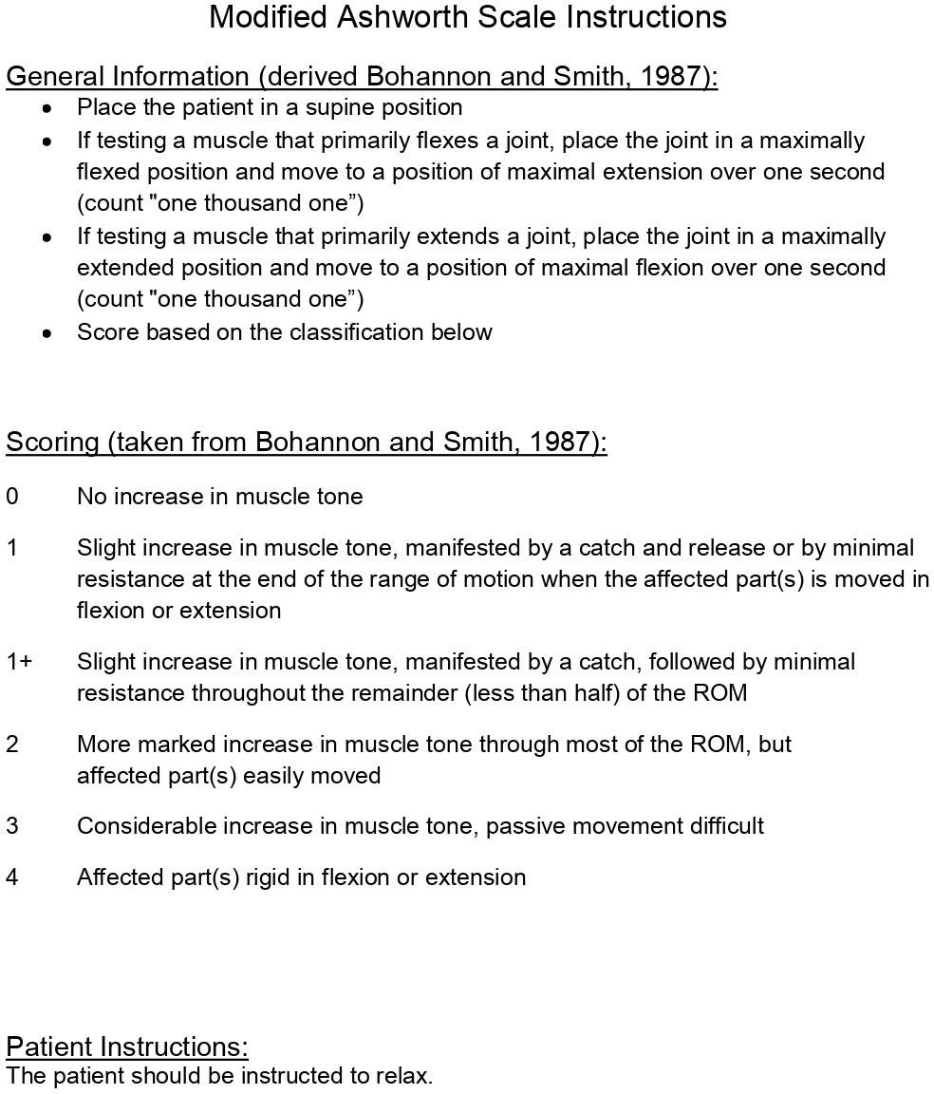

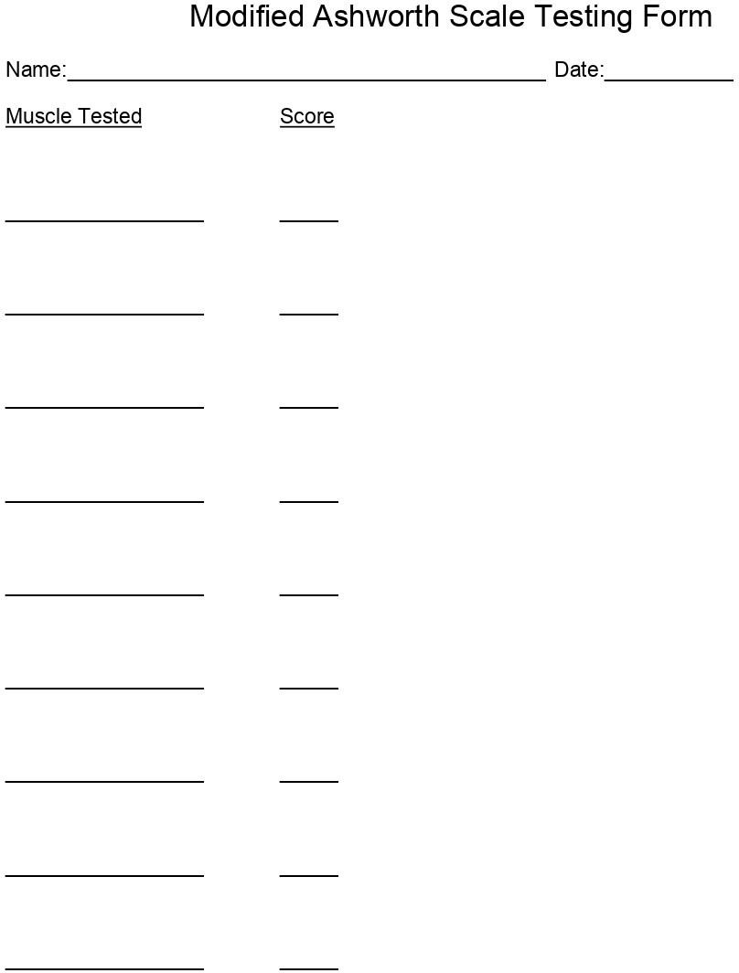

**FUGL-MEYER SCALE**

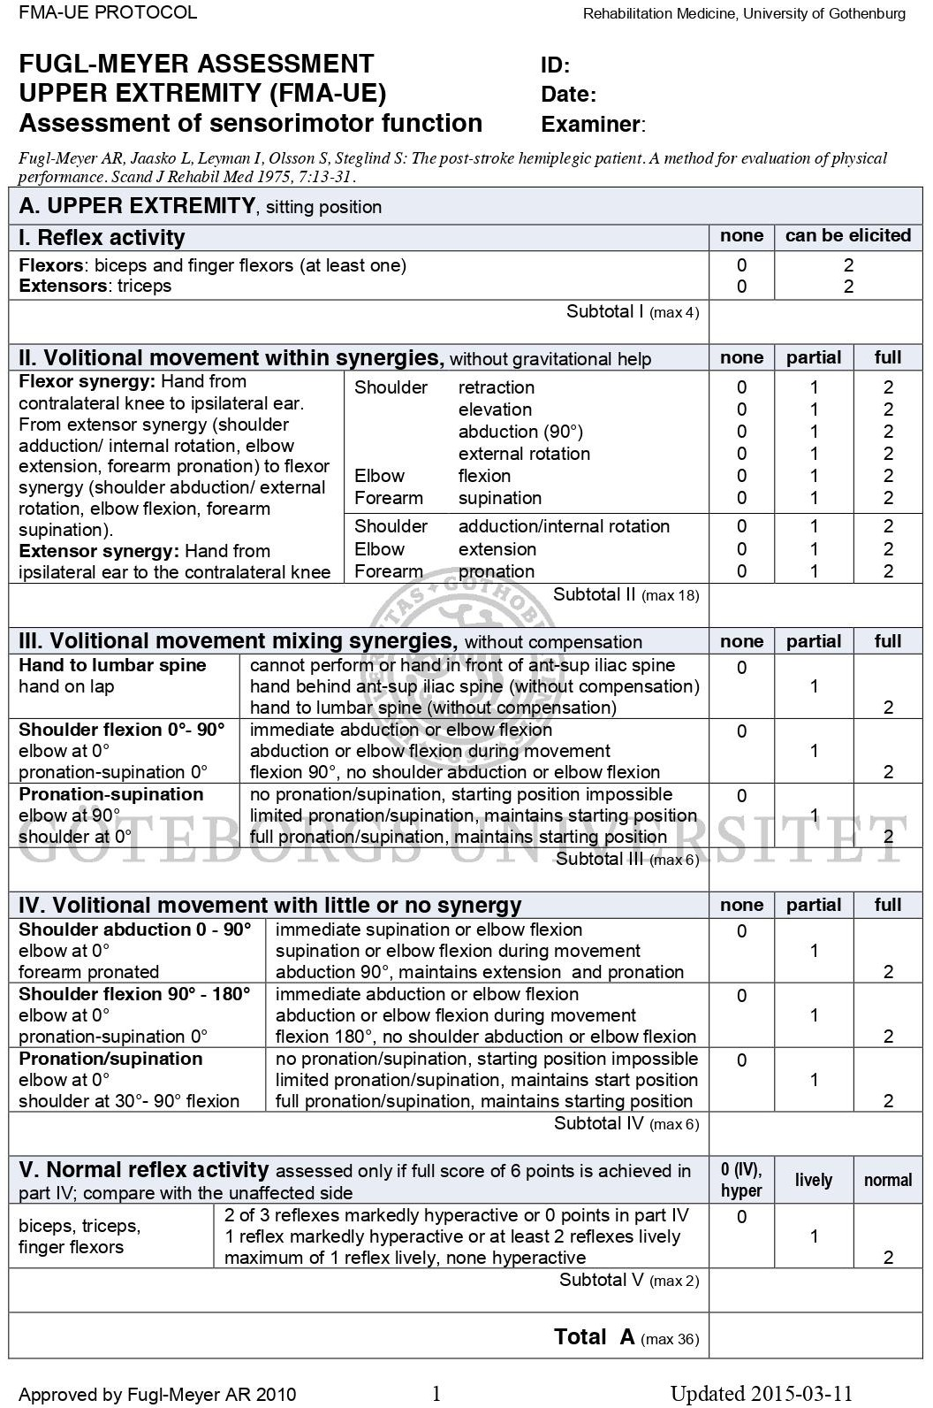

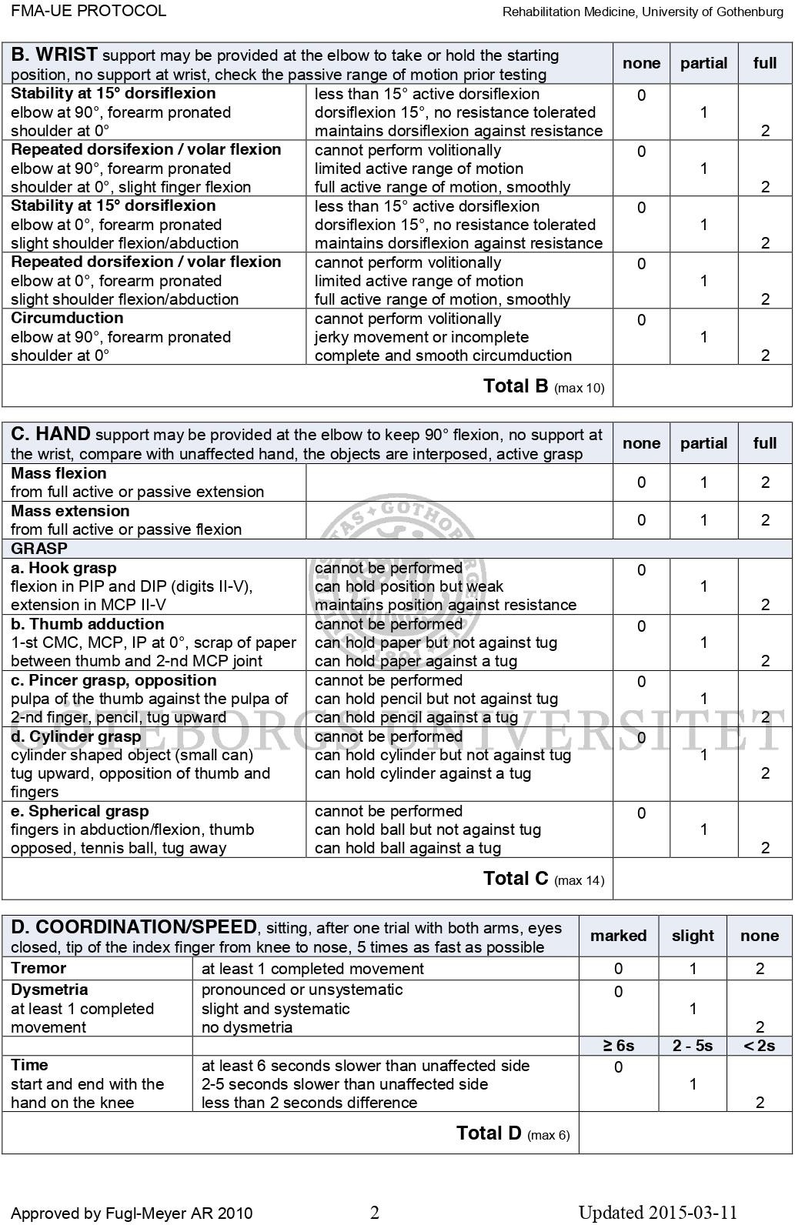

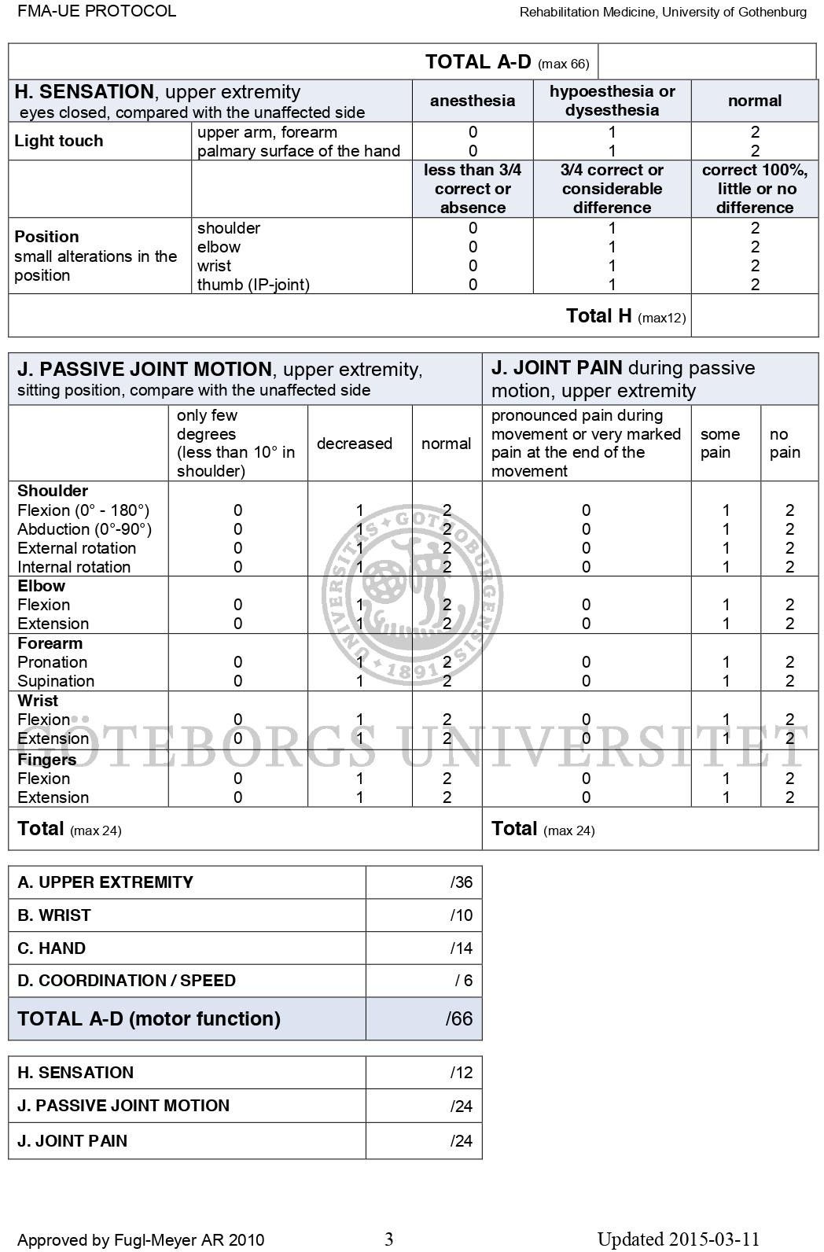

### BRUNNSTROM VOLUNTARY CONTROL GRADING

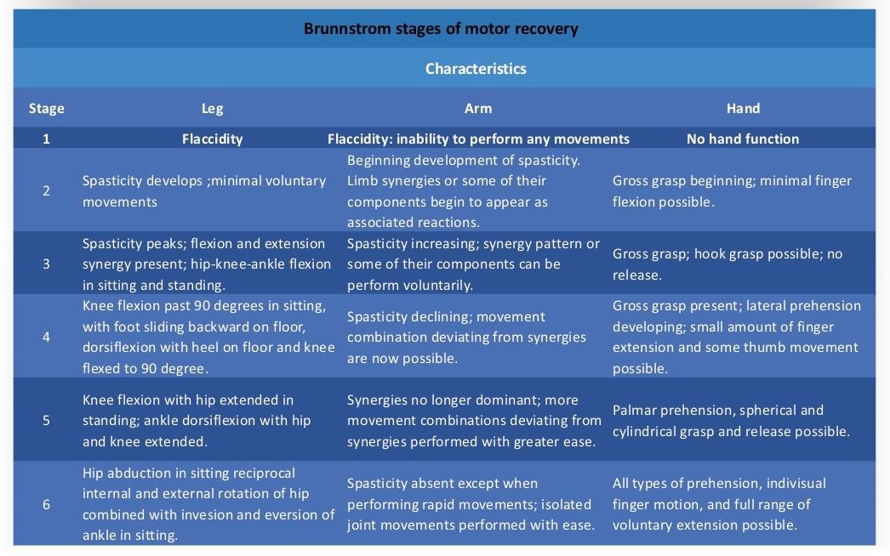

**MAYO CLASSIFICATION SYSTEM FOR TBI SEVERITY**

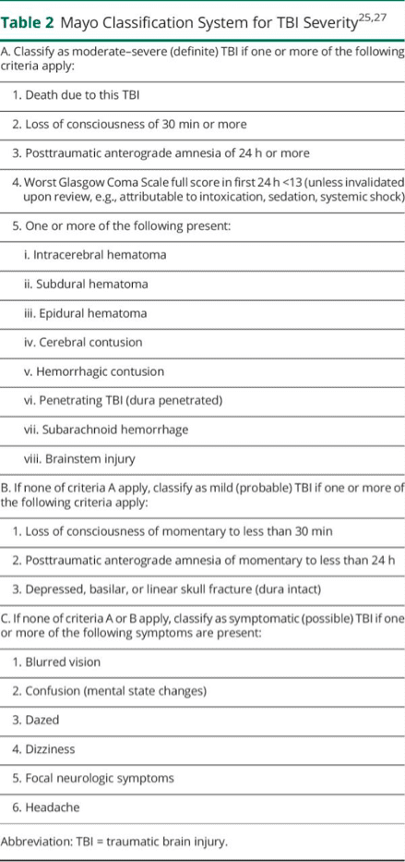

# ANNEXURE-4

|  |  |  |  |  |  |  |  |  |  |  |  |  |  |  |  |  |  |
| --- | --- | --- | --- | --- | --- | --- | --- | --- | --- | --- | --- | --- | --- | --- | --- | --- | --- |
| **CONTROL GROUP** | | | | | | | | | | | | | | | | | |
| S.no | Age | Gender | Height (m) | Weight (kg) | BMI  (Kg/m2) | MAS | | | Fugl Meyer Scale | | | Ruler Drop test(ms) | | | Voluntary control  grade | | |
| Pre | Post  1 | Post  2 | Pre | Post  1 | Post  2 | Pre | Post  1 | Post  2 | Pre | Post  1 | Post  2 |
| 1 | 40 | F | 1.68 | 71 | 25.2 | 3 | 3 | 1 | 4 | 6 | 8 | 244 | 221 | 189 | 3 | 3 | 4 |
| 2 | 36 | M | 1.62 | 62 | 23.6 | 4 | 2 | 2 | 8 | 9 | 9 | 201 | 189 | 186 | 3 | 3 | 5 |
| 3 | 28 | M | 1.53 | 78 | 33.3 | 4 | 3 | 2 | 9 | 10 | 10 | 204 | 192 | 190 | 3 | 4 | 5 |
| 4 | 26 | M | 1.65 | 67 | 24.6 | 3 | 1 | 2 | 8 | 10 | 10 | 240 | 220 | 198 | 4 | 5 | 5 |
| 5 | 30 | M | 1.72 | 65 | 22 | 4 | 2 | 3 | 2 | 5 | 6 | 218 | 198 | 199 | 3 | 3 | 5 |
| 6 | 23 | F | 1.69 | 55 | 19.3 | 4 | 2 | 3 | 4 | 7 | 7 | 221 | 214 | 225 | 3 | 4 | 5 |
| 7 | 27 | M | 1.68 | 87 | 30.8 | 2 | 2 | 2 | 6 | 7 | 7 | 264 | 244 | 221 | 2 | 2 | 4 |
| 8 | 24 | M | 1.55 | 54 | 22.5 | 4 | 3 | 3 | 8 | 9 | 9 | 268 | 248 | 215 | 3 | 4 | 4 |
| 9 | 33 | F | 1.78 | 77 | 24.3 | 3 | 3 | 3 | 7 | 9 | 9 | 271 | 247 | 185 | 2 | 4 | 4 |
| 10 | 37 | F | 1.60 | 67 | 26.2 | 4 | 2 | 3 | 6 | 9 | 9 | 232 | 222 | 213 | 3 | 5 | 5 |
| 11 | 30 | M | 1.62 | 68 | 25.9 | 3 | 3 | 1 | 4 | 7 | 7 | 244 | 224 | 217 | 3 | 5 | 5 |
| 12 | 22 | F | 1.69 | 72 | 25.2 | 4 | 3 | 3 | 8 | 9 | 9 | 221 | 201 | 216 | 2 | 4 | 4 |
| 13 | 35 | F | 1.67 | 57 | 20.4 | 3 | 2 | 2 | 9 | 11 | 11 | 238 | 227 | 183 | 2 | 3 | 4 |
| 14 | 32 | M | 1.68 | 58 | 20.5 | 3 | 3 | 3 | 7 | 9 | 9 | 243 | 223 | 192 | 4 | 5 | 5 |
| 15 | 22 | F | 1.58 | 56 | 22.4 | 4 | 1 | 1 | 8 | 9 | 9 | 227 | 217 | 188 | 3 | 4 | 4 |
| 16 | 24 | M | 1.78 | 82 | 25.9 | 3 | 2 | 2 | 9 | 10 | 10 | 207 | 187 | 187 | 2 | 3 | 4 |
| 17 | 38 | M | 1.74 | 73 | 24.1 | 4 | 2 | 2 | 3 | 6 | 6 | 235 | 215 | 205 | 3 | 3 | 4 |
| 18 | 30 | F | 1.69 | 72 | 25.2 | 4 | 2 | 2 | 7 | 13 | 13 | 234 | 219 | 195 | 4 | 4 | 5 |
| 19 | 34 | F | 1.62 | 67 | 25.5 | 2 | 2 | 3 | 4 | 12 | 11 | 244 | 218 | 213 | 3 | 3 | 4 |
| 20 | 29 | M | 1.68 | 67 | 23.7 | 4 | 3 | 3 | 8 | 9 | 9 | 191 | 185 | 216 | 3 | 2 | 4 |
| 21 | 28 | M | 1.74 | 73 | 24.1 | 3 | 1 | 2 | 9 | 10 | 11 | 198 | 194 | 196 | 3 | 4 | 4 |
| 22 | 22 | F | 1.68 | 53 | 18.8 | 4 | 2 | 2 | 6 | 9 | 9 | 210 | 190 | 193 | 3 | 3 | 5 |
| 23 | 35 | F | 1.63 | 63 | 23.7 | 3 | 2 | 2 | 9 | 10 | 12 | 194 | 189 | 218 | 4 | 4 | 5 |
| 24 | 32 | M | 1.69 | 63 | 22.1 | 4 | 2 | 3 | 4 | 8 | 8 | 227 | 207 | 207 | 3 | 5 | 4 |

|  |  |  |  |  |  |  |  |  |  |  |  |  |  |  |  |  |  |
| --- | --- | --- | --- | --- | --- | --- | --- | --- | --- | --- | --- | --- | --- | --- | --- | --- | --- |
| 25 | 22 | F | 1.58 | 56 | 22.4 | 3 | 3 | 2 | 5 | 6 | 6 | 217 | 197 | 197 | 2 | 3 | 4 |
| 26 | 24 | M | 1.59 | 68 | 26.9 | 3 | 3 | 1 | 3 | 7 | 7 | 223 | 215 | 215 | 3 | 3 | 5 |
| 27 | 35 | M | 1.72 | 71 | 24 | 3 | 2 | 2 | 8 | 10 | 11 | 244 | 218 | 218 | 3 | 3 | 4 |
| 28 | 37 | F | 1.58 | 68 | 27.2 | 4 | 3 | 2 | 7 | 8 | 9 | 201 | 198 | 198 | 3 | 4 | 4 |
| 29 | 40 | F | 1.68 | 68 | 24.1 | 3 | 3 | 3 | 9 | 10 | 10 | 212 | 195 | 195 | 3 | 3 | 4 |
| 30 | 34 | m | 1.75 | 78 | 25.5 | 4 | 3 | 2 | 6 | 8 | 8 | 240 | 220 | 220 | 4 | 4 | 5 |

|  |  |  |  |  |  |  |  |  |  |  |  |  |  |  |  |  |  |
| --- | --- | --- | --- | --- | --- | --- | --- | --- | --- | --- | --- | --- | --- | --- | --- | --- | --- |
| **EXPERIMENTAL GROUP** | | | | | | | | | | | | | | | | | |
| S.no | Age (years) | Gender | Height (m) | Weight (kg) | BMI  (Kg/m2) | MAS | | | Fugl Meyer Scale | | | Ruler Drop test  (ms) | | | Voluntary control  grade | | |
| Pre | Post  1 | Post  2 | Pre | Post  1 | Post  2 | Pre | Post  1 | Post  2 | Pre | Post  1 | Post  2 |
| 1 | 36 | F | 1.63 | 51 | 19.2 | 3 | 1 | 0 | 6 | 9 | 10 | 250 | 192 | 188 | 2 | 4 | 4 |
| 2 | 21 | M | 1.68 | 31 | 21.6 | 4 | 2 | 1 | 7 | 11 | 13 | 263 | 195 | 189 | 4 | 5 | 6 |
| 3 | 39 | M | 1.58 | 48 | 19.2 | 4 | 3 | 3 | 4 | 7 | 7 | 244 | 187 | 186 | 3 | 4 | 5 |
| 4 | 30 | M | 1.65 | 61 | 22.4 | 3 | 2 | 2 | 8 | 9 | 11 | 217 | 193 | 190 | 3 | 5 | 5 |
| 5 | 22 | F | 1.60 | 61 | 23.8 | 3 | 2 | 0 | 9 | 12 | 12 | 235 | 187 | 184 | 3 | 4 | 5 |
| 6 | 35 | F | 1.68 | 75 | 26.6 | 4 | 3 | 1 | 6 | 9 | 11 | 216 | 199 | 192 | 3 | 5 | 6 |
| 7 | 32 | M | 1.56 | 46 | 18.9 | 4 | 2 | 2 | 10 | 12 | 12 | 244 | 182 | 179 | 3 | 4 | 5 |
| 8 | 22 | F | 1.70 | 72 | 24.9 | 3 | 2 | 2 | 4 | 8 | 10 | 191 | 183 | 178 | 3 | 4 | 6 |
| 9 | 24 | M | 1.72 | 68 | 23 | 4 | 2 | 1 | 5 | 6 | 6 | 189 | 191 | 192 | 2 | 4 | 4 |
| 10 | 36 | M | 1.62 | 52 | 19.8 | 3 | 3 | 2 | 5 | 9 | 10 | 226 | 193 | 184 | 3 | 5 | 5 |
| 11 | 40 | F | 1.65 | 73 | 26.8 | 4 | 2 | 2 | 6 | 10 | 10 | 194 | 192 | 183 | 4 | 5 | 6 |
| 12 | 39 | m | 1.60 | 53 | 20.7 | 4 | 3 | 1 | 7 | 11 | 11 | 248 | 192 | 190 | 2 | 4 | 4 |
| 13 | 27 | F | 1.67 | 65 | 23.3 | 2 | 3 | 3 | 9 | 12 | 12 | 217 | 195 | 186 | 3 | 5 | 5 |
| 14 | 39 | M | 1.71 | 51 | 17.4 | 4 | 2 | 2 | 6 | 9 | 9 | 223 | 198 | 180 | 3 | 3 | 5 |
| 15 | 36 | F | 1.50 | 17 | 31.6 | 3 | 3 | 3 | 4 | 7 | 8 | 244 | 196 | 182 | 2 | 5 | 4 |
| 16 | 34 | M | 1.78 | 77 | 24.3 | 4 | 3 | 2 | 7 | 10 | 10 | 201 | 215 | 188 | 3 | 6 | 5 |
| 17 | 32 | M | 1.69 | 51 | 17.9 | 3 | 2 | 1 | 9 | 12 | 12 | 204 | 190 | 188 | 3 | 5 | 6 |
| 18 | 29 | F | 1.53 | 74 | 31.6 | 4 | 3 | 2 | 7 | 10 | 10 | 240 | 185 | 182 | 3 | 5 | 5 |
| 19 | 31 | F | 1.73 | 65 | 21.7 | 3 | 1 | 0 | 5 | 9 | 9 | 218 | 195 | 186 | 4 | 4 | 6 |
| 20 | 33 | F | 1.70 | 68 | 23.5 | 3 | 2 | 2 | 4 | 7 | 8 | 221 | 197 | 192 | 3 | 4 | 5 |
| 21 | 37 | M | 1.68 | 78 | 27.6 | 4 | 2 | 2 | 6 | 12 | 13 | 264 | 198 | 187 | 4 | 5 | 6 |
| 22 | 34 | M | 1.59 | 67 | 26.5 | 3 | 2 | 1 | 8 | 10 | 10 | 268 | 215 | 191 | 3 | 4 | 5 |
| 23 | 33 | F | 1.75 | 78 | 25.5 | 4 | 3 | 2 | 9 | 12 | 13 | 271 | 214 | 182 | 2 | 5 | 4 |
| 24 | 35 | M | 1.65 | 73 | 26.8 | 4 | 2 | 2 | 7 | 11 | 11 | 232 | 197 | 219 | 3 | 4 | 5 |
| 25 | 32 | M | 1.70 | 69 | 23.9 | 2 | 2 | 1 | 4 | 9 | 10 | 244 | 195 | 187 | 4 | 5 | 6 |
| 26 | 29 | F | 1.76 | 72 | 23.2 | 4 | 3 | 3 | 8 | 9 | 11 | 221 | 189 | 190 | 4 | 6 | 6 |

|  |  |  |  |  |  |  |  |  |  |  |  |  |  |  |  |  |  |
| --- | --- | --- | --- | --- | --- | --- | --- | --- | --- | --- | --- | --- | --- | --- | --- | --- | --- |
| 27 | 28 | M | 1.58 | 78 | 31.2 | 3 | 3 | 2 | 9 | 12 | 12 | 238 | 184 | 218 | 3 | 4 | 5 |
| 28 | 38 | M | 1.61 | 74 | 28.5 | 4 | 3 | 2 | 7 | 9 | 9 | 243 | 192 | 196 | 3 | 4 | 5 |
| 29 | 33 | M | 1.76 | 81 | 26.1 | 3 | 2 | 2 | 8 | 10 | 10 | 268 | 195 | 186 | 3 | 5 | 5 |
| 30 | 32 | F | 1.72 | 62 | 21 | 4 | 3 | 1 | 9 | 10 | 12 | 207 | 193 | 192 | 4 | 5 | 6 |

Signature of the Guide

**DR. KALIDASAN.V (PT),**

Professor,

Krupanidhi College of Physiotherapy, Bengaluru- 560035

Signature of the candidate

**PRATIKSHA SINGH**

# ANNEXURE-5

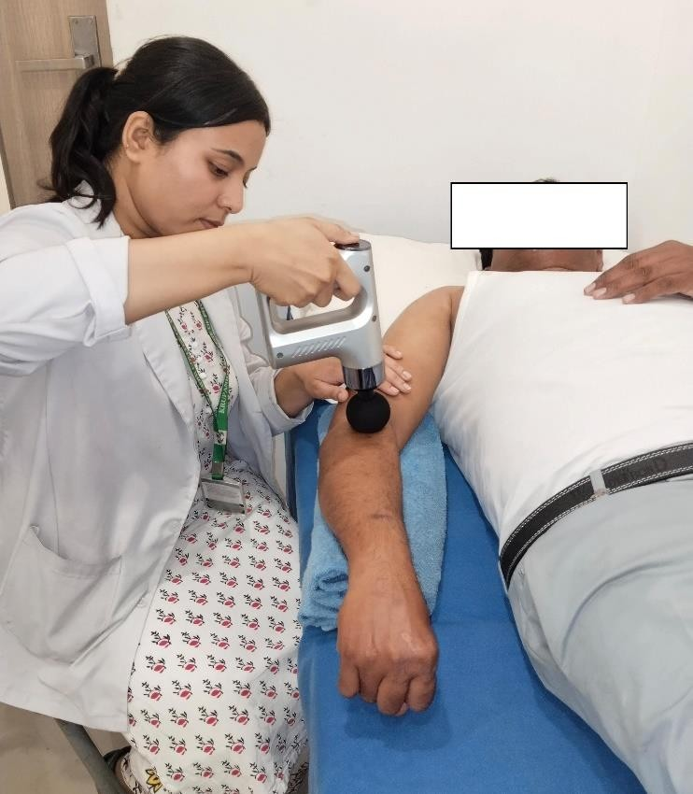

### Figure-2.a and Figure-2.b: Focal muscle vibration therapy

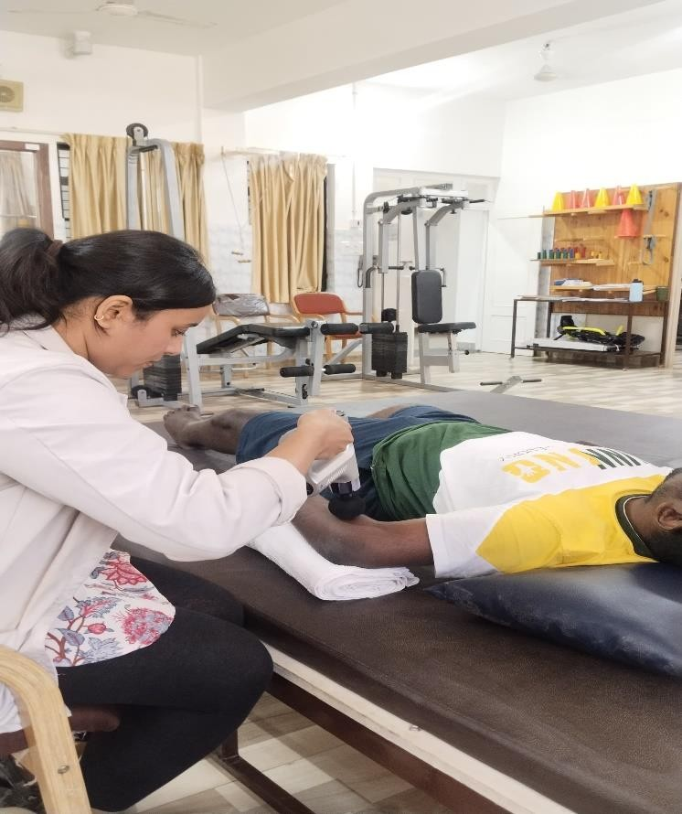

**Figure-2.b**

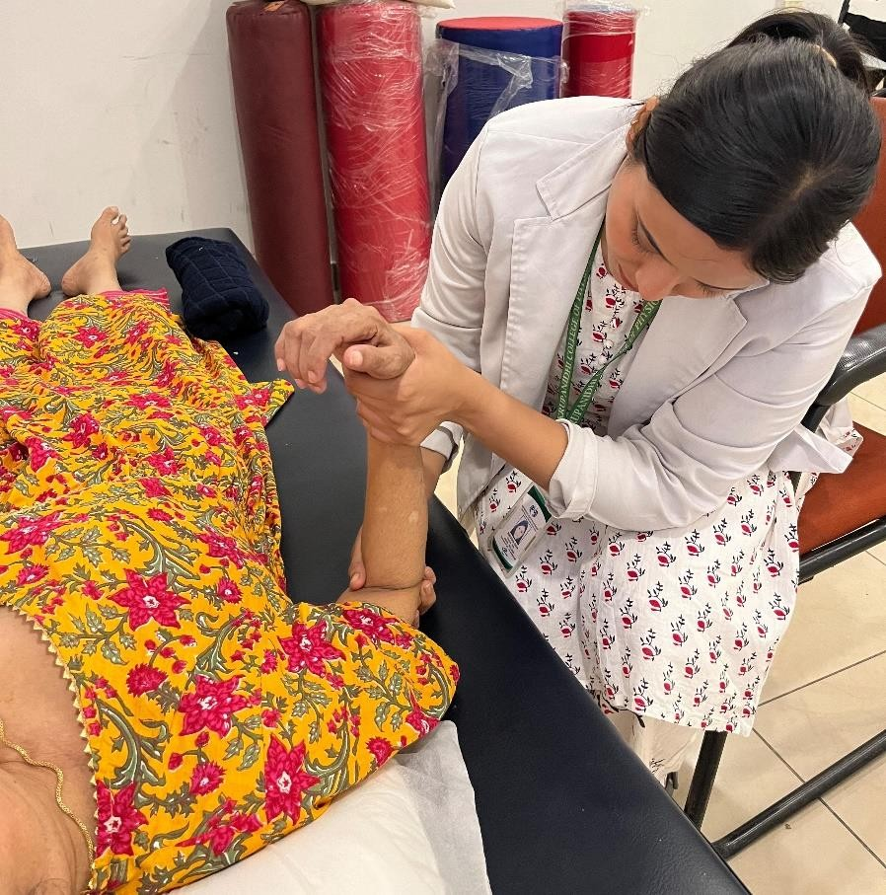

### Figure-3: PNF Hold-relax

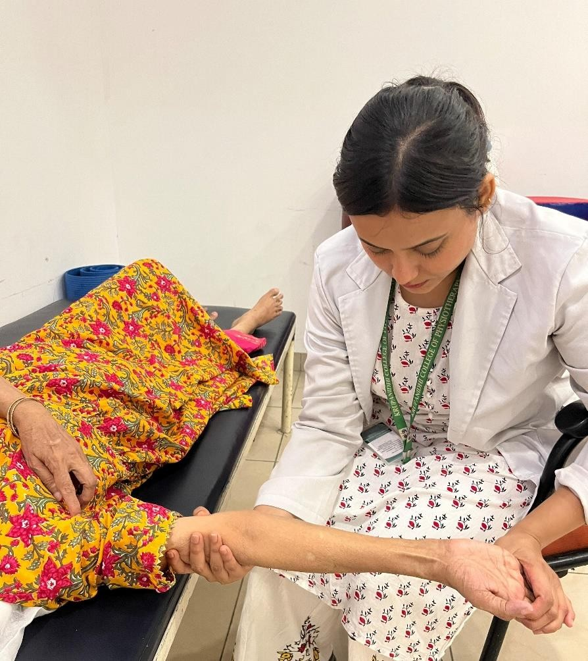

**Figure-4: Sustained stretching**