Application of ML in Credit card fraud detection

By – **Raj Narayan Banerjee**

Introduction: In today's digital age, credit card fraud has become a significant concern for both financial institutions and consumers. With the increasing sophistication of fraudulent techniques, traditional rule-based systems alone are often insufficient to detect and prevent fraudulent activities effectively. However, the emergence of machine learning (ML) techniques has revolutionized the landscape of fraud detection, offering more robust and adaptive solutions to combat fraudulent transactions.

Now we will discuss The Credit Card Fraud Detection here –

UNDERSTANDING Credit Card Fraud Detection:

Credit card fraud detection involves the identification of unauthorized or fraudulent activities associated with credit card transactions. These fraudulent activities can take various forms, including stolen card information, identity theft, and unauthorized purchases. Traditional methods of fraud detection relied heavily on predefined rules and thresholds, making them susceptible to evasion tactics employed by fraudsters. Moreover, the sheer volume of transactions necessitates a more sophisticated approach beyond manual monitoring.

Roal of ML: The role of machine learning (ML) in credit card fraud detection is pivotal, offering advanced capabilities to analyze vast amounts of transaction data and identify fraudulent patterns efficiently. Here's a breakdown of the key roles ML plays in credit card fraud detection:

* Pattern Recognition: ML algorithms can automatically learn patterns and trends from historical transaction data, including legitimate and fraudulent transactions. By analyzing various attributes such as transaction amount, frequency, location, time of day, and user behavior, ML models can identify subtle deviations that may indicate fraudulent activity.
* Anomaly Detection: ML techniques, particularly unsupervised learning algorithms, excel at anomaly detection. These algorithms can identify transactions that deviate significantly from normal behavior without the need for labeled fraud examples. Unusual patterns such as sudden large transactions, transactions in uncommon locations, or irregular spending patterns can be flagged as potential fraud by ML-based anomaly detection systems.
* Fraud Scoring and Risk Assessment: ML models assign risk scores to individual transactions based on their likelihood of being fraudulent. Supervised learning algorithms, trained on labeled data, can classify transactions into different risk categories (e.g., low, medium, high risk). These risk scores are used to prioritize transactions for further review or action by fraud analysts.
* Adaptability and Continuous Learning: ML models can adapt and evolve over time to stay ahead of evolving fraud tactics. By continuously learning from new transaction data, ML-based fraud detection systems can adjust their detection criteria and update their models to detect emerging fraud patterns effectively.
* Reducing False Positives: ML algorithms help minimize false positives, where legitimate transactions are incorrectly flagged as fraudulent. By accurately distinguishing between genuine and fraudulent transactions, ML-based fraud detection systems improve the efficiency of fraud prevention efforts and reduce the o customers caused by false alerts.

diagram and analysis:

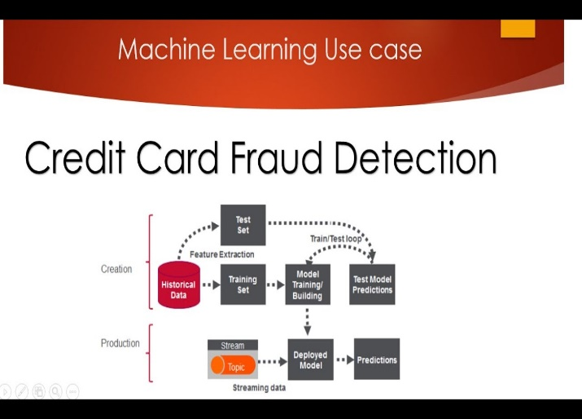

ML-based credit card fraud detection

systems offer several advantages,

including:

* Improved detection accuracy: ML algorithms can analyse vast amounts of transaction data and identify complex patterns indicative of fraudulent activities, leading to enhanced detection accuracy.
* Real-time detection: ML models can be deployed for real-time fraud detection, allowing financial institutions to promptly identify and prevent fraudulent transactions, thereby minimizing losses.
* Adaptability: ML models can adapt to evolving fraud patterns by continuously learning from new data, making them more resilient to emerging threats.
* Reduced false positives: ML algorithms can distinguish between genuine and fraudulent transactions more accurately, resulting in fewer false positives and fewer disruptions for legitimate cardholders.

However, ML-based fraud detection systems also face challenges, such as:

* Data quality and imbalance: Imbalanced datasets with a small proportion of fraudulent transactions pose challenges for ML algorithms, leading to biased models and decreased detection performance.
* Model interpretability: Complex ML models, such as deep learning architectures, lack interpretability, making it challenging to understand the rationale behind their predictions, which is crucial for regulatory compliance and model transparency.
* Adversarial attacks: Fraudsters may attempt to evade detection by crafting malicious transactions specifically designed to bypass ML based fraud detection systems, necessitating robust defences against adversarial attacks.

application of credit card fraud detection:

Credit card fraud detection using machine learning (ML) is an essential application in the financial industry to identify and prevent fraudulent activities. ML techniques are adept at analyzing large volumes of transaction data, identifying patterns, and detecting anomalies that may indicate fraudulent behavior. Here are some common ML techniques and approaches used in credit card fraud detection:

* Anomaly Detection: One of the primary applications of ML in credit card fraud detection is anomaly detection. By leveraging techniques such as clustering, classification, and outlier detection, ML models can identify transactions that deviate significantly from the expected behavior. Unsupervised learning algorithms, such as Isolation Forest and k-means clustering, are particularly effective in detecting anomalous transactions without the need for labeled training data.
* Supervised Learning Algorithms:
* **Random Forest:** Effective for handling large datasets and capturing complex interactions between features.
* **Gradient Boosting Machines (GBM):** Algorithms like **XG Boost** or **Light GBM** are powerful for classification tasks and can handle imbalanced datasets well.
* **Logistic Regression:** It's commonly used for binary classification problems, such as fraud detection.
* Un Supervised Learning Algorithms:
* **K-means Clustering:** Can be used to cluster normal and fraudulent transactions based on transaction features.
* **Isolation Forest:** Particularly effective for anomaly detection tasks, isolating anomalies as they are few and different from normal instances.
* **Autoencoders:** A type of neural network used for dimensionality reduction that can be trained to reconstruct normal transactions, thereby identifying anomalies.
* Deep Learning: Deep learning, particularly **convolutional neural networks** **(CNNs)** and **recurrent neural networks (RNNs)**, has shown promising results in credit card fraud detection. These complex neural network architectures can automatically extract relevant features from transactional data, enabling them to capture intricate patterns that may be missed by traditional algorithms.
* Real-time Monitoring: ML models can be deployed in real-time to monitor credit card transactions as they occur. By continuously analyzing incoming transaction data and comparing it against learned patterns, these models can swiftly flag suspicious activities for further investigation. Real-time fraud detection systems enable prompt intervention to prevent fraudulent transactions before they can cause significant financial losses.
* Feature Engineering: Creation of new features from existing data, such as transaction frequency, time of day, location, etc., which can enhance the model's ability to detect fraud.

Feature scaling and normalization are crucial to ensure that features are on similar scales, preventing certain features from dominating the learning process.

Example code:

Below is a snippet of Python code demonstrating credit card fraud detection using a dataset:

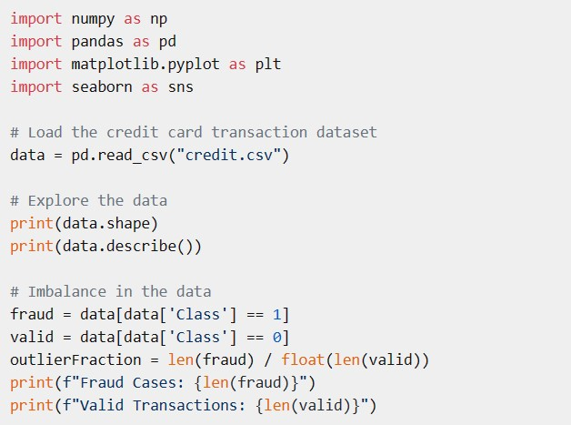

Challenges and consideration: Credit card fraud detection using machine learning poses several challenges and considerations, primarily due to the constantly evolving nature of fraud tactics and the need for robust and accurate detection systems. Below are some key challenges and considerations:

* Imbalanced Data: Credit card fraud is relatively rare compared to legitimate transactions, leading to imbalanced datasets where fraudulent transactions represent only a small portion. This class imbalance can lead to biased models that tend to classify most transactions as non-fraudulent. Techniques such as oversampling, under sampling, or synthetic data generation (e.g., SMOTE) are often used to address this issue.
* Concept Drift: Fraudsters continually adapt their techniques to evade detection, leading to changes in the characteristics of fraudulent transactions over time. Models trained on historical data may become less effective as new fraud patterns emerge. Continuous monitoring and updating of the model are necessary to account for concept drift.
* Feature Engineering: Identifying relevant features that distinguish fraudulent transactions from legitimate ones can be challenging, especially in complex datasets with numerous variables. Domain knowledge and collaboration with fraud experts are essential for selecting informative features and detecting subtle patterns indicative of fraud.
* Real-time Processing: Fraud detection systems must operate in real-time to flag potentially fraudulent transactions before they are approved. This requires efficient algorithms and infrastructure capable of processing large volumes of data within tight time constraints.
* Model Interpretability: Interpretable models are crucial for understanding the reasoning behind fraud detection decisions, especially in regulated industries where transparency is required. However, highly complex models like deep learning neural networks often lack interpretability, making it difficult to explain why a particular transaction was flagged as fraudulent.
* Adversarial Attacks: Fraudsters may attempt to manipulate the system by generating adversarial examples—slightly modified inputs designed to deceive the model into misclassifying a transaction. Robustness against adversarial attacks is essential for ensuring the reliability of fraud detection models.
* Privacy Concerns: Fraud detection systems often rely on sensitive customer information, raising privacy concerns regarding data collection, storage, and usage. Adhering to data protection regulations such as GDPR and ensuring secure handling of personal data is paramount.
* Scalability: As transaction volumes increase, fraud detection systems must scale accordingly to maintain performance and accuracy. Scalable architectures and distributed computing techniques may be necessary to handle the computational demands of large-scale deployments.
* Cost of False Positives: False positives occur when legitimate transactions are incorrectly flagged as fraudulent, potentially leading to customer dissatisfaction and loss of revenue for businesses. Balancing the trade-off between false positives and false negatives (missed fraud) is crucial to optimize the performance of fraud detection systems.
* Regulatory Compliance: Compliance with industry regulations and standards (e.g., PCI DSS) is essential for ensuring the security and integrity of credit card transactions. Fraud detection systems must adhere to regulatory requirements while still maintaining high levels of accuracy and efficiency.

***---------***

Conclusion:

Machine learning has emerged as a powerful tool in the fight against credit card fraud, offering sophisticated algorithms capable of detecting fraudulent activities with high accuracy and efficiency. By leveraging techniques such as anomaly detection, supervised learning, ensemble methods, and real-time monitoring, ML-based fraud detection systems enable financial institutions to mitigate risks, protect consumers, and safeguard the integrity of electronic payment systems. As fraudsters continue to evolve their tactics, the ongoing development and application of machine learning hold the key to staying one step ahead in the battle against credit card fraud.