Experiment – 4
Low Contrast Image Enhancement
AIM: To enhance a low-contrast image using contrast stretching and histogram equalization, and compare their effects through image and histogram analysis.

Theory
1. Grayscale Conversion
- It converts a multi-channel RGB image into a single-channel representation based on luminance.
- This technique reduces the image data dimensionality while preserving essential structural information.
- It serves as a fundamental preprocessing step for intensity-based enhancement algorithms.
2. Contrast Stretching (Normalization)
- Contrast stretching is a linear transformation that maps the existing range of pixel intensities to a wider, full range (usually 0 to 255 for 8-bit images).
- It improves the visibility of details in narrow-range, low-contrast images by making midtones more distinct.
- This method linearly maps pixel values to utilize the complete dynamic range of the display.
3. Histogram Equalization
- This process redistributes grayscale intensities so that the image histogram becomes more uniform.
- It increases global contrast, which is particularly effective when usable data is concentrated in a small intensity range.
- The technique utilizes the cumulative distribution of pixels to spread out the most frequent intensity levels.
4. False Colour Mapping
- It involves applying a colour map to a grayscale image to intensify visual differences.
- This technique helps to highlight specific structures and is primarily used for enhanced visualization rather than scientific radiometry.
- It leverages human colour perception to detect subtle patterns that are difficult to distinguish in monochrome.

Code
from skimage import io, color, exposure, img_as_ubyte
import matplotlib.pyplot as plt
import numpy as np
from pathlib import Path

img_path = "./content/fox.jpg"

# Read image
I= io.imread(img_path)

# If image has alpha channel, drop it
if I.ndim == 3 and I.shape[2] == 4:
I = I[ ... , :3]

# Normalize to float [0,1]
if I.dtype not in [np.float32, np.float64]:
I_float = (I /255.0).astype(np.float32)
else:
I_float = I.copy()

# Convert to grayscale (float [0,1])
g = color.rgb2gray(I_float)

# Contrast stretching similar to MATLAB imadjust(g,[0.3 0.7], [])
in_min, in_max = 0.3, 0.7
J= exposure.rescale_intensity(g, in_range=(in_min, in_max), out_range=(0, 1))

# False-color enhanced image: map grayscale through a vivid colormap
gray_for_colormap = img_as_ubyte(g)
cmap = plt.get_cmap('inferno') # try 'viridis','plasma','inferno' etc.
D_color = cmap(gray_for_colormap / 255.0)[ ... , :3] # drop alpha

# Histogram equalization of grayscale
m = exposure.equalize_hist(g)

# Plot similar layout (4 rows x 2 cols)
fig, axs = plt.subplots(4, 2, figsize=(10,13))
plt.tight_layout(pad=3.0)

axs[0, 0].imshow(I_float)
axs[0, 0].set_title("Original Image")
axs[0, 0].axis('off')

axs[0, 1].imshow(D_color)
axs[0, 1].set_title("Enhanced Image 2 (False Color)")
axs[0, 1].axis('off')

axs[1, 0].imshow(J, cmap='gray', vmin=0, vmax=1)
axs[1, 0].set_title("Enhanced Image (contrast stretch)")
axs[1, 0].axis('off')

axs[1, 1].imshow(m, cmap='gray', vmin=0, vmax=1)
axs[1, 1].set_title("Equalized Image")
axs[1, 1].axis('off')

axs[2, 0].imshow(g, cmap='gray', vmin=0, vmax=1)
axs[2, 0].set_title("Gray Image")
axs[2, 0].axis('off')

# Histogram of equalized image
axs[2, 1].hist((m.ravel()*255).astype(np.uint8), bins=256, range=(0,255))
axs[2, 1].set_title("Histogram of Equalized Image")
axs[2, 1].set_xlim(0,255)

# Histogram of original gray image
axs[3, 0].hist((g.ravel()*255).astype(np.uint8), bins=256, range=(0,255))
axs[3, 0].set_title("Histogram of Gray Image")
axs[3, 0].set_xlim(0,255)

# small original preview for balance
axs[3, 1].imshow(I_float, extent=[0,1,0,1])
axs[3, 1].set_title("Original (small)")
axs[3, 1].axis('off')

plt.subplots_adjust(hspace=0.6)
plt.show()

Output
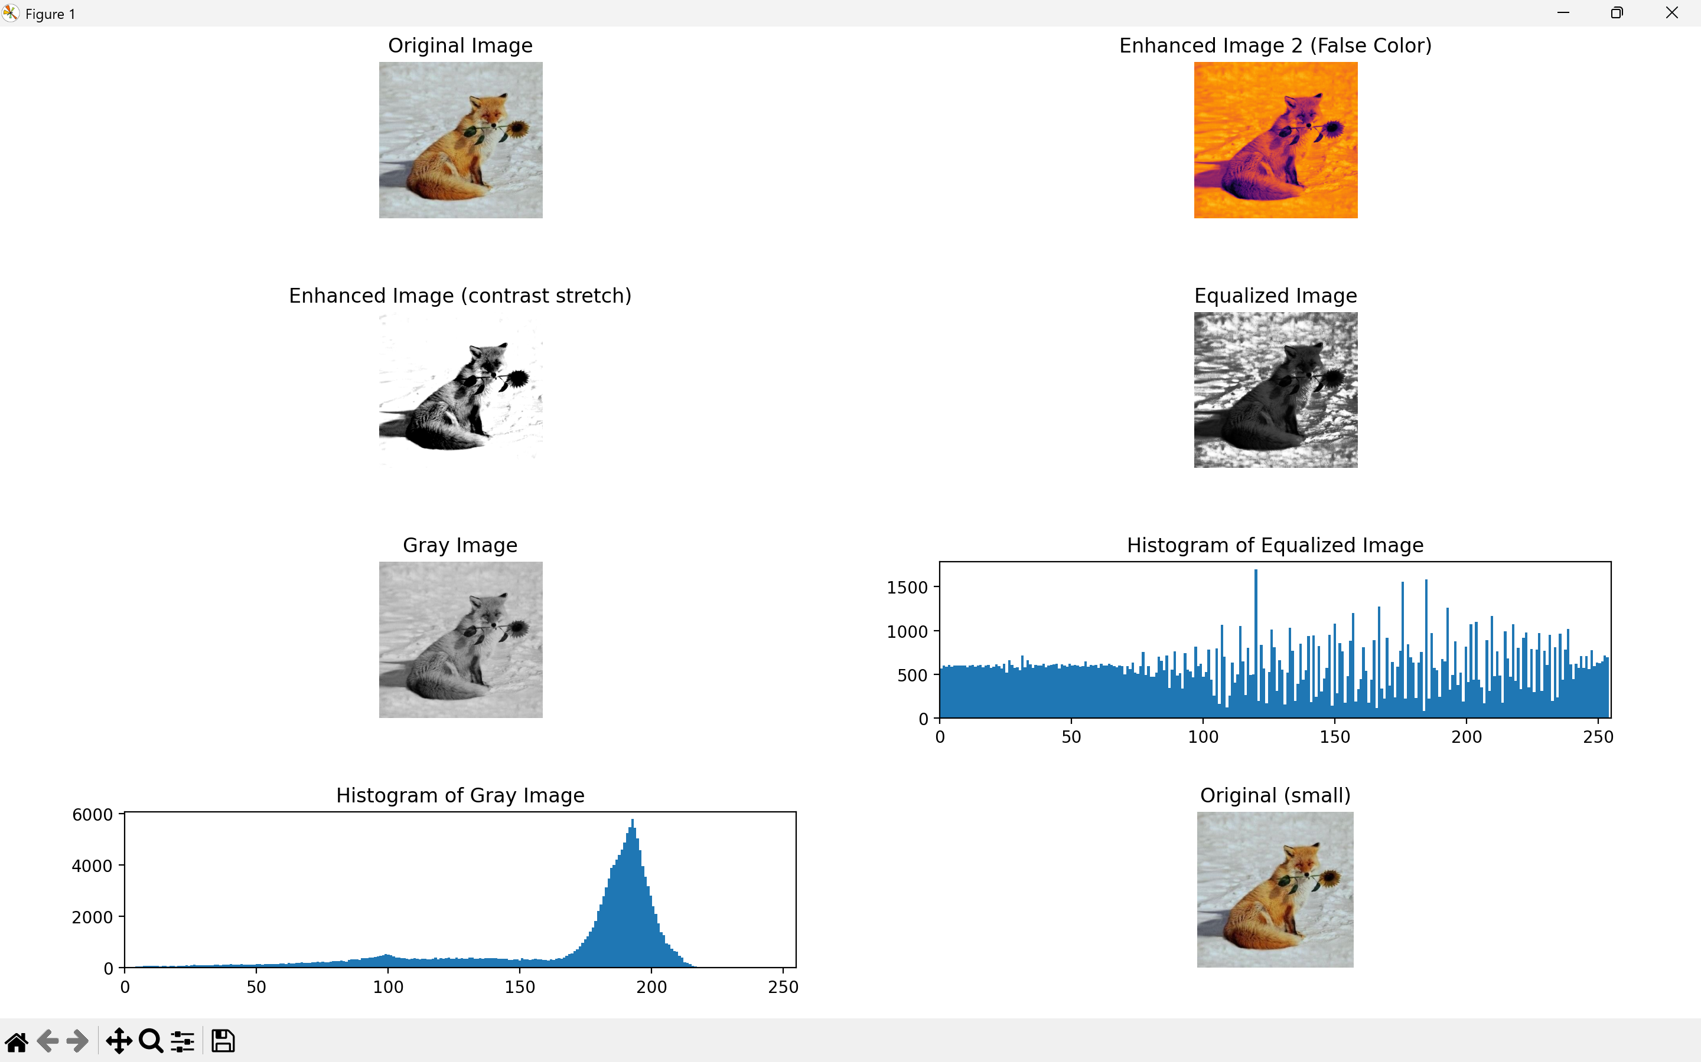

Results and Discussion
This experiment demonstrates the enhancement of low light image through grayscale conversion, contrast stretching, histogram equalization and false colour mapping. Grayscale conversion simplifies an image into luminance while contrast enhancement techniques are necessary to improve visibility. Contrast stretching linearly expands the input intensity range to the full output range which improves details in low-contrast images. In comparison, histogram equalization redistributes intensities to create a more uniform histogram, which significantly increases global contrast in areas where data is concentrated. Finally, false-colour mapping serves as a powerful visualization tool by applying a colormap to the grayscale image which intensifies visual differences and highlights structures that are otherwise difficult to distinguish.

