Experiment - 5
Decomposition of Grayscale Image
AIM: To decompose a grayscale image into its 8-bit planes and analyze the contribution of each bit to the overall image.

Theory
Each pixel in an 8-bit grayscale image is represented by 8 binary bits - from the least significant bit (LSB) to the most significant bit (MSB).
- Bit Plane 0 (LSB) contains the smallest details and noise.
- Bit Plane 7 (MSB) contains the most significant visual information and structure. By visualizing these bit planes separately, we can understand how pixel intensity is distributed across the 8 bits and how much each plane contributes to the visual content.

Code
from skimage import io, color, img_as_ubyte
import matplotlib.pyplot as plt
import numpy as np

img_path = "./content/landscape.jpg"

# Read image and convert to grayscale
I = io.imread(img_path)
if I.ndim == 3:
I=color.rgb2gray(I)
I = img_as_ubyte(I) # convert to 8-bit grayscale

# Extract bit planes
bit_planes = [(I >> k) & 1 for k in range(8)] # bit 0 to bit 7

# Display original + 8 bit planes
fig, axs = plt.subplots(3, 3, figsize=(10, 10))
axs = axs.ravel()

axs[0].imshow(I, cmap='gray')
axs[0].set_title("Original Image")
axs[0].axis('off')

for k in range(8):
axs[k+1].imshow(bit_planes[k], cmap='gray')
axs[k+1].set_title(f"BIT PLANE {k}")
axs[k+1].axis('off')

plt.tight_layout(pad=2)
plt.show()

Output
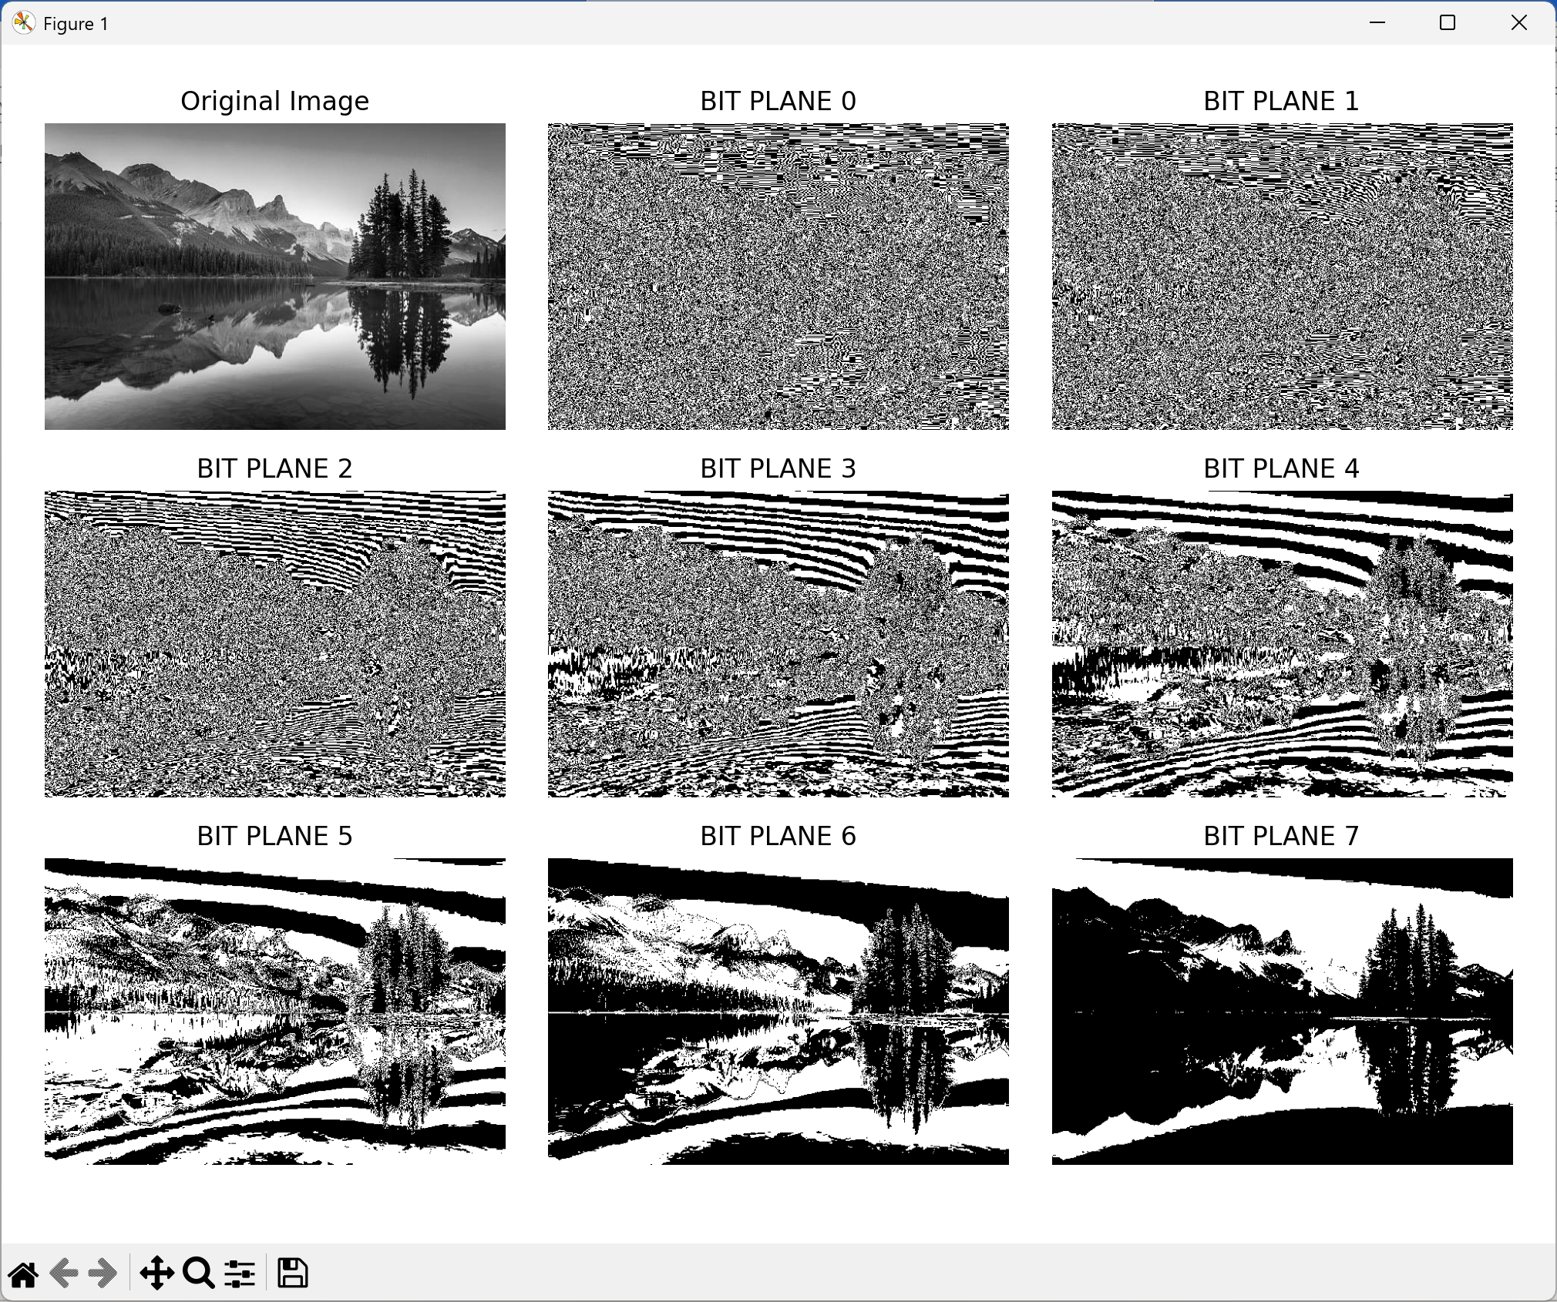

Results and Discussion
The experiment successfully decomposed the 8-bit grayscale image into its constituent bit planes using bitwise logical operations. It was observed that Bit Plane 7 (MSB) contains the majority of the visually recognizable structural information and contrast, closely resembling a binary version of the original image. As the bit level decreases toward Bit Plane 0 (LSB), the planes progressively lose discernible structural content, appearing increasingly as random noise or fine textures. This confirms that higher-order bits contribute most to the significant visual content, while lower-order bits represent subtle intensity variations and noise.

