# Project Meeting Minutes

*The main purpose of the document is to capture all the work that has been done by the group and* ***not*** *to write down what was discussed in a single meeting. You should be meeting and/or working throughout the week*.

Date of meeting(s): 24-02-2023

Group Number:

Group members present (Name, ID):

* Richa Jayeshkumar Patel (0790483)
* Surbhi Patel (0794150)
* Dharmikkumar Patel (0794492)
* Raj Bharatkumar Bhalodwala (0792055)

Specific Activities that were completed/worked on:

* List brief description of activities carried out **by group members.**
* The dataset has been finalized. We got the data from the food and drug administration. It is clear dataset. There are many columns related to the recall which will clearly give the output to our dataset.
* We have done with the cleaning process as well as EDA.
* We have used charts like pie, bar and histogram for data visualization.

Specific Output from work:

* Include a brief summary of any written work or any code developed.
* In cleaning process, there is one missing value in the column called distribution pattern.

So, we have used **data= data[pd.notnull(data['Distribution Pattern'])]** code to deal with null value.

* Final output of the null value is:

* Other than that, there is no any cleaning process remain for the dataset.
* We have visualized some graph which clearly define some insights of the problems.

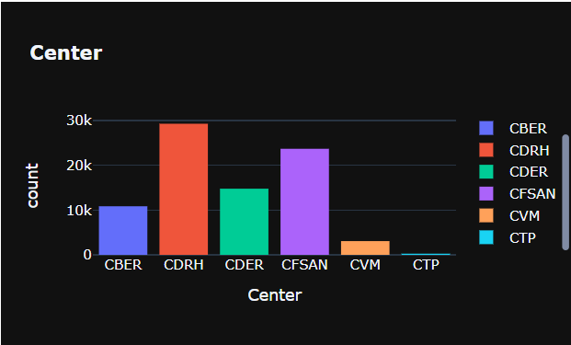

On Target:

* Indicate the current status of your project:
  + _____ green: everything on track for completion by due date
  + _____ yellow: a small number of tasks are off track and completion by due date is at risk
  + _____ red: many tasks are off track and project will not be completed by due date

Challenges/Disagreements:

* List any challenges identified/discussed and possible solutions.
  + include tasks causing a yellow or red flag for your project.

We are not decided final problem statement yet. Above is the one idea and it will be finalized after discussion with the professor.

* List any notable disagreements and subsequent discussion and resolution.

There is no any disagreement as of now.

Planned Activities for coming week:

* List brief description of activities **by group member**
* In the dataset, we have all categorical columns. We want to use machine learning models for prediction, so we have decided to perform tokenization for dependent columns which is reason of recall.
* After that we will start visualization part in tableau as well as we will start performing machine learning model.
* Make sure tasks are assigned to address yellow and red flag items.