# Project Meeting Minutes

*The main purpose of the document is to capture all the work that has been done by the group and* ***not*** *to write down what was discussed in a single meeting. You should be meeting and/or working throughout the week*.

Date of meeting(s): 24-03-2023

Group Number:

Group members present (Name, ID):

* Richa Jayeshkumar Patel (0790483)
* Surbhi Patel (0794150)
* Dharmikkumar Patel (0794492)
* Raj Bharatkumar Bhalodwala (0792055)

Specific Activities that were completed/worked on:

* List brief description of activities carried out **by group members.**
* As in our dataset there is only categorical column, so we all group members decided to find something insight from any website or case study.
* We mainly go through the website below, which we found great helpful to our dataset.

Link: [Analyzing categorical data | Statistics and probability | Khan Academy](https://www.khanacademy.org/math/statistics-probability/analyzing-categorical-data)

Link: [Categorical Data Analysis | Statgraphics](https://www.statgraphics.com/categorical-data-analysis)

Although there is only a different graph available in this link, we can be able to learn graphs and how and when we can use this graph.

* We have also done with the label encoding to convert it into categorical to numerical.
* Come up with our main target, which is tableau graph, storytelling, and Dashboard.
* Right now we only have created graphs and a temporary dashboard which is not finalized yet. But we will work on it.

Specific Output from work:

* Include a brief summary of any written work or any code developed.
* Firstly, we have tried to convert columns into numerical by label encoding.

* We have created charts in tableau, some of the graphs are listed below.

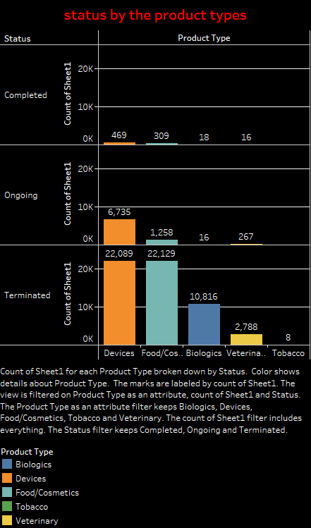

On Target:

* Indicate the current status of your project:
  + _____ green: everything on track for completion by due date
  + _____ yellow: a small number of tasks are off track and completion by due date is at risk
  + _____ red: many tasks are off track and project will not be completed by due date

Challenges/Disagreements:

* List any challenges identified/discussed and possible solutions.

There is no any challenges. Some of the challenges are solved with online sources.

* List any notable disagreements and subsequent discussion and resolution.

There is no any disagreement as of now.

Planned Activities for coming week:

* List brief description of activities **by group member**
* We will start to create machine learning model and will find which model performs best to our dataset by observing accuracy of the model.
* Apart from that we will create dashboards and storytelling for our dataset.
* Model: Surbhi, Richa
* Tableau: Dharmik, Raj
* Make sure tasks are assigned to address yellow and red flag items.