\
BUSAWU: A REAL-TIME BUS TRACKING AND DIGITAL FARE MANAGEMENT SYSTEM
BY
Raj guRUNG
T.U. REGISTRATION NO.: [XX-X-XXX-XXX-20XX]
SYMBOL NO.: [XXXXX / XX]
NATIONAL COLLEGE OF COMPUTER STUDIES
A Project Report Submitted To
Faculty of Management, Tribhuvan University
in partial fulfilment of the requirements for the degree of
Bachelor of Information Management (BIM)
Kathmandu
[Month, Year]

Student Declaration
This is to certify that I have completed the Project entitled "BusAwu: A Real-Time Bus Tracking and Digital Fare Management System" under the guidance of "Sumit Ghising" in partial fulfilment of the requirements for the degree of Bachelor of Information Management at Faculty of Management, Tribhuvan University. This is my original work, and I have not submitted it earlier elsewhere.
Date: [Date] Signature:
Name: [Your Full Name]

Certificate from the Supervisor
This is to certify that the project entitled "BusAwu: A Real-Time Bus Tracking and Digital Fare Management System" is an academic work done by "[Your Full Name]" submitted in the partial fulfilment of the requirements for the degree of Bachelor of Information Management at Faculty of Management, Tribhuvan University under my guidance and supervision. To the best of my knowledge, the information presented by him/her in the project report has not been submitted earlier.
_____________________
Signature of the Supervisor
Name: Sumit Ghising
Designation: Project Supervisor Date: [Date]

Approval Sheet
This is to certify that the project titled BusAwu: A Real-Time Bus Tracking and Digital Fare Management System submitted by [Your Full Name] has been examined and approved. In our opinion, it meets the required scope and quality standards for a project submitted in partial fulfilment of the requirements for the degree of Bachelor of Information Management (BIM).
Approval Panel:
S.No. | Name | Designation | Signature
1 | Sumit Ghising | Project Supervisor
2 | [Program Coordinator Name] | Program Coordinator
3 | [Internal Examiner Name] | Internal Examiner
4 | [External Examiner Name] | External Examiner
Date of Defense: [Date]
Department: Bachelor of Information Management (BIM)
Faculty: Management

Acknowledgements
I would like to extend my heartfelt gratitude to Mr. Sumit Ghising, my project supervisor, for his invaluable guidance, motivation, and insightful suggestions throughout the planning, development, and deployment of this project. His continuous support played a vital role in the successful completion of this work.
I am also sincerely thankful to the faculty members of the National College of Computer Studies for their valuable knowledge and guidance throughout my academic journey. I would like to thank my family and friends for their constant encouragement, patience, and understanding during this project.
Lastly, I would like to acknowledge my own dedication, perseverance, and determination, which enabled me to successfully complete this project despite numerous technical challenges encountered along the way.
_____________________
[Your Full Name]
Symbol No.: [XXXXX/XX]
T.U. Registration No.: [XX-X-XXX-XXX-20XX]
[Month, Year]

Abstract
BusAwu is a real-time public bus tracking and digital fare management system designed to modernize Kathmandu’s public transportation experience. Developed using Flutter for the mobile front end and FastAPI (Python) for the backend, the system connects a driver application and a passenger application through a persistent WebSocket relay, allowing passengers to see a bus’s live location on an interactive map. The platform also introduces a QR-code-based digital fare system: passengers scan a code when boarding and again when alighting, and the system calculates a distance-based fare using the Haversine formula and deducts it from an in-app wallet. Routes are modelled as ordered lists of stops, enabling a bus company/route selection flow for drivers and a From/To route-search feature for passengers. The backend is deployed on Render, giving the system a fixed public endpoint reachable from any network. The project demonstrates the practical application of real-time client-server communication, geolocation processing, and mobile application development to solve a real transportation problem faced by commuters in Kathmandu.
Keywords: Real-time GPS tracking, WebSocket communication, Digital fare system, QR-code payment, Flutter, FastAPI, Public transportation, Mobile application development.

Table of Contents
Title Page ......................................................................................................... i
Student Declaration ......................................................................................... ii
Certificate from the Supervisor ....................................................................... iii
Approval Sheet ................................................................................................ iv
Acknowledgements ........................................................................................... v
Abstract ............................................................................................................ vi
Table of Contents ............................................................................................ vii
List of Figures .................................................................................................. ix
List of Tables ..................................................................................................... x
List of Abbreviations ....................................................................................... xi
CHAPTER I: INTRODUCTION ..................................................................... 1
1.1 Background of the Project ............................................................................ 1
1.2 Problem Statement ...................................................................................... 1
1.3 Objectives ..................................................................................................... 2
1.4 Review of Related Work and Literature ...................................................... 2
1.5 Development Methodology .......................................................................... 3
1.6 Scope and Limitations .................................................................................. 4
1.7 Report Organization ..................................................................................... 4
CHAPTER II: SYSTEM DEVELOPMENT PROCESS ................................. 6
2.1 Analysis ......................................................................................................... 6
2.2 System Design ............................................................................................ 15
2.3 Implementation ........................................................................................... 17
CHAPTER III: CONCLUSION AND RECOMMENDATION ....................... 24
3.1 Summary ..................................................................................................... 24
3.2 Conclusion .................................................................................................. 24
3.3 Recommendation ....................................................................................... 24
REFERENCE ...................................................................................................... 25
APPENDIX ............................................................................................................ a

List of Figures
Figure 1.1: Iterative Development Methodology
Figure 2.1: Use Case Diagram
Figure 2.2: Gantt Chart
Figure 2.3: Class Diagram
Figure 2.4: Object Diagram
Figure 2.5: Sequence Diagram of Driver GPS Broadcasting
Figure 2.6: Sequence Diagram of QR-Based Boarding and Exit (Fare Calculation)
Figure 2.7: Passenger State Diagram
Figure 2.8: Activity Diagram of the Live Tracking and Fare Process
Figure 2.9: Refinement of Class Diagram
Figure 2.10: Component Diagram
Figure 2.11: Deployment Diagram

List of Tables
Table 2.1: Unit Testing
Table 2.2: Integration Testing
Table 2.3: System Testing

List of Abbreviations
API: Application Programming Interface
APK: Android Package Kit
BIM: Bachelor of Information Management
CASE: Computer-Aided Software Engineering
FPS: Frames Per Second (n/a) – removed
GPS: Global Positioning System
HTTP/HTTPS: HyperText Transfer Protocol (Secure)
JSON: JavaScript Object Notation
JWT: JSON Web Token
KM: Kilometre
NCCS: National College of Computer Studies
NPR: Nepalese Rupee
QR: Quick Response (Code)
REST: Representational State Transfer
SDK: Software Development Kit
UML: Unified Modeling Language
URL: Uniform Resource Locator
UUID: Universally Unique Identifier
WSGI: Web Server Gateway Interface
WSS: WebSocket Secure

Chapter I: Introduction

1.1 Background of the Project
Public bus transportation in Kathmandu remains one of the most widely used modes of travel, yet it continues to rely on largely manual, uncoordinated systems. Passengers have no reliable way of knowing where a bus currently is, how long it will take to arrive, or whether a bus travelling a given route also passes through their intended stop. Fare collection is almost entirely cash-based, which is slow, error-prone, and inconvenient for both passengers and conductors. As smartphone penetration and mobile data access have grown rapidly across Nepal, similar problems in ride-hailing and delivery services (such as Pathao and inDrive) have already been solved through real-time GPS tracking and digital wallets. BusAwu applies the same underlying principles — live location broadcasting, digital fare calculation, and a simple mobile interface — specifically to the fixed-route public bus system.
The project was developed as a sixth-semester BIM project at the National College of Computer Studies, Tribhuvan University, under the supervision of Sumit Ghising. It combines a Flutter-based mobile front end with a FastAPI backend, using WebSockets for real-time communication between a driver application and a passenger application, and a QR-code-based fare mechanism for automated, distance-based fare deduction.

1.2 Problem Statement
Commuters using Kathmandu’s public bus system currently face several recurring problems: they cannot see where a bus currently is or estimate its arrival time, they have no simple way to check which buses travel between two specific stops, and fare payment depends entirely on cash handled manually by a conductor, which is slow, hard to audit, and inconvenient for both passengers and operators. There is no existing, centralized digital system that solves these three problems together for Nepal’s fixed-route bus network. BusAwu addresses this gap by providing live GPS-based bus tracking, a route-search feature built on top of predefined stop sequences, and an automated, distance-based digital fare system driven by QR-code scans.

1.3 Objectives
- To develop a real-time GPS tracking system that allows passengers to view a bus’s live location on a map.
- To design a route-matching mechanism that lets passengers search for buses travelling between a chosen start and end stop.
- To build a QR-code-based digital fare system that calculates fare automatically from the distance travelled between boarding and exit points and deducts it from a digital wallet.
- To deploy the backend service to a publicly accessible server so that the driver and passenger applications can communicate over any network, not only a shared local network.

1.4 Review of Related Work and Literature
1.4 Review of Related Work and Literature
The transition from traditional cash-based public transportation to automated fare collection has been widely studied as part of the development of intelligent transportation systems. Automated fare collection (AFC) systems are designed to simplify fare payment, reduce manual cash handling, improve transaction accuracy, and generate digital records of passenger activity. Bieler et al. (2022) reviewed automated fare collection solutions and highlighted the increasing importance of mobile devices in public transportation ticketing. Their study found that mobile-based ticketing can make public transportation more seamless while also generating useful transactional data for transportation operators. The researchers also identified mobile technologies, sensor data, and automated validation as important areas for the future development of public transportation systems.
Pelletier et al. (2011) conducted a comprehensive review of smart card data use in public transportation. Their research explains that automated fare collection systems not only simplify revenue collection but also generate large amounts of information about passenger transactions. Such information can be used for operational management, service planning, ridership analysis, and understanding passenger travel patterns. Smart card systems can therefore provide benefits beyond payment by allowing transportation authorities to make better decisions using historical transaction data. This concept is relevant to the proposed system because digital records of fares and journeys can be maintained and later used for monitoring and analysis.
Faroqi et al. (2018) further examined the applications of transit smart cards beyond their original purpose of fare collection. Their literature review identified several uses of automated fare collection data, including origin-destination estimation, travel pattern analysis, trip-purpose detection, route-choice modelling, and transit performance measurement. The study demonstrates that digital fare systems can become an important source of transportation information rather than functioning only as payment mechanisms. The proposed Digital Bus Pass and Fare Management System similarly maintains digital records of passenger payments and rides, which can provide useful information for future transportation analysis.
Mobile ticketing has also been investigated as an alternative to conventional physical tickets and smart cards. The MobiPag system presented by Rinne et al. (2014) explored an integrated mobile payment and ticketing solution using near-field communication (NFC). The system allowed users to purchase bus tickets through a mobile device, store tickets electronically, validate them during travel, and review transaction information. This work demonstrates how mobile devices can combine payment, ticket storage, validation, and transaction management within a single platform. Although the proposed BusAm system uses QR-based validation rather than NFC, it follows a similar principle of replacing physical tickets with digitally managed transportation services.
QR-code-based ticket validation has also been explored as a practical approach for public transportation. The Beep4Me system studied by Buda et al. (2022) investigated automatic ticket validation using smartphone sensors and QR codes. In the existing configuration described in the study, passengers could purchase tickets through a mobile application and scan a QR code placed inside a vehicle to validate their journey. The research demonstrates the feasibility of combining smartphones, QR codes, GPS, Bluetooth, and other device sensors to simplify the passenger validation process. This approach is particularly relevant to the proposed system because BusAm also uses QR-based interaction between passengers and buses for digital fare processing.
Real-time vehicle tracking is another important component of modern public transportation systems. Corsar et al. (2017) developed the GetThere system to provide real-time passenger information by integrating transportation data with GPS-based vehicle locations and information contributed through mobile devices. The system allowed users to view available bus services and obtain information about vehicle locations. The research demonstrated that real-time passenger information systems can integrate different sources of transportation data to provide passengers with useful journey information. This supports the use of GPS-based bus tracking in the proposed system, where passengers can view nearby buses and obtain their current locations through a mobile application.
Brakewood et al. (2014) investigated the effects of real-time transit information on bus passengers in Tampa, Florida. Their experimental study found that providing real-time information improved the passenger waiting experience, with users experiencing reductions in perceived waiting time as well as lower levels of anxiety and frustration. The study indicates that access to information about bus arrival and location can improve passenger satisfaction even when the underlying transportation service itself has not changed. Therefore, integrating real-time GPS information into a digital bus application can provide an important usability benefit for passengers.
More recent research has continued to demonstrate the importance of real-time transportation information. A 2025 study examining real-time public transport information applications in Chile found that such applications can influence travel behaviour and passenger satisfaction. The applications studied provided real-time bus locations, expected arrival information, route planning, and service notifications. The findings emphasize the value of accurate and accessible real-time information for improving the public transportation experience. These findings support the inclusion of live GPS-based bus tracking and passenger information features in modern mobile transportation platforms.
Another relevant area of research concerns the use of fare transaction data for understanding passenger movement. Liu et al. (2018) reviewed the use of smart card data for estimating passenger destinations and analysing public transportation demand. The study noted that automated fare collection systems commonly record boarding information, while passenger destination information may be unavailable. This limitation demonstrates the importance of combining fare transaction data with other sources of information, such as GPS and journey data. The proposed system addresses this concept by combining digital fare transactions with location-based information, creating an opportunity to maintain more comprehensive records of passenger journeys.
Overall, the reviewed literature demonstrates a clear movement toward mobile, automated, and data-driven public transportation systems. Existing research has established the advantages of automated fare collection, mobile ticketing, digital validation, smart cards, QR-based ticketing, and real-time GPS information. However, many existing solutions focus primarily on one particular function, such as ticketing, payment, or vehicle tracking. The proposed Digital Bus Pass and Fare Management System aims to integrate several of these functions into one mobile platform. The system combines a digital wallet, QR-based fare payment, prepaid bus passes, transaction history, GPS-based live bus tracking, and user-oriented transportation services. This integration is intended to provide a practical and relatively low-infrastructure solution for improving the convenience, transparency, and efficiency of bus transportation in the Kathmandu context.

1.5 Development Methodology
The BusAm project was developed using the Incremental development model, in which the system is built and delivered in small, functional segments rather than as a single complete unit at the end of the development period. Each increment builds upon the previous one, adding new functionality while ensuring that the core system remains stable and testable throughout the development process. This approach was chosen because the project's requirements evolved naturally as development progressed, for instance, the initial increment focused solely on establishing real-time GPS communication between the driver and passenger applications, after which subsequent increments introduced route searching, QR-based fare collection, digital wallet functionality, ride passes, and finally user authentication with database persistence. Each increment was designed, implemented, tested, and deployed to a live server before the next increment began, allowing issues to be identified and corrected early rather than accumulating until a final integration phase. This iterative addition of features also allowed the system architecture to adapt as new requirements were identified, such as introducing a PostgreSQL database only once user authentication became necessary, rather than over-engineering the system with unused infrastructure from the outset. The incremental model was particularly well suited to this project given the limited development timeframe and the need to maintain a consistently working, demonstrable application at every stage rather than risking a non-functional system until the very end.
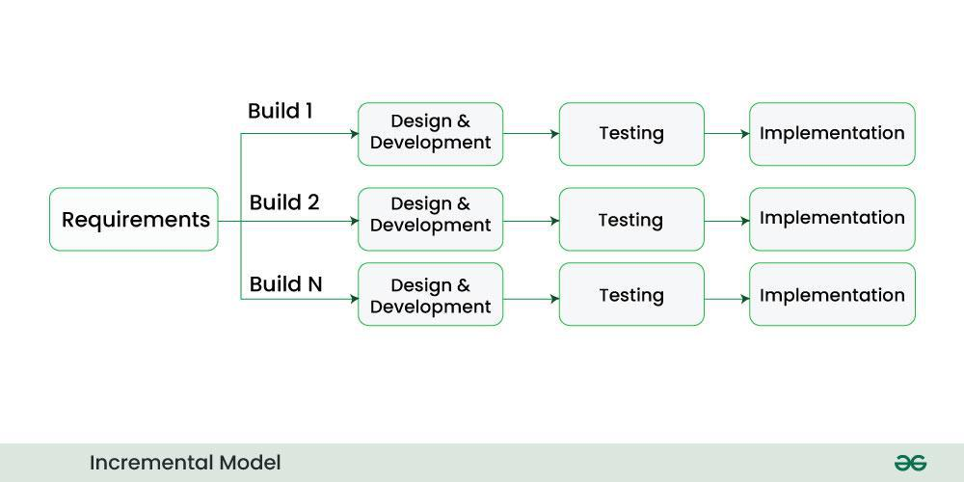
[Figure 1.1: Iterative Development Methodology diagram here]
Figure 1.1: Iterative Development Methodology

1.6 Scope and Limitations

1.6.1 Scope
- Role-based mobile application with separate Driver and Passenger flows, launched from a single role-selection screen.
- Real-time GPS broadcasting from the driver’s device to all connected passenger devices using a WebSocket relay.
- Live map display (OpenStreetMap tiles via flutter_map) showing the bus’s current position and the passenger’s own position.
- Route modelling as ordered lists of named stops, with a company/route selection flow for drivers and a From/To autocomplete search for passengers.
- QR-code-based boarding and exit scanning, with automatic distance calculation (Haversine formula) and tiered fare deduction from an in-app wallet.
- Backend deployment to a public cloud host (Render), giving the system one fixed URL reachable from any network.

1.6.2 Limitation
- No persistent database is currently integrated; wallet balances, trip state, and live location data are stored in memory and are cleared whenever the backend service restarts.
- No user authentication/login system exists yet; each device is identified only by a locally generated device ID.
- Only a small, hardcoded set of routes and stops is supported; there is no admin interface for managing routes.
- Fare distance is calculated as a straight-line (Haversine) distance between boarding and exit points rather than the actual road distance travelled.
- The digital wallet top-up (Load Money) feature via the eSewa payment gateway was designed but not fully completed within the project timeline.
- The system depends on an active internet connection on both the driver’s and the passenger’s device; there is no offline mode.

1.7 Report Organization

Chapter I: Introduction
This chapter introduces the background, problem statement, and objectives of BusAwu, reviews related transportation and fare-tracking platforms, describes the Iterative Development Methodology used, and defines the project’s scope and limitations.

Chapter II: System Development Process
This chapter documents the complete development lifecycle: requirement analysis, feasibility study, object-oriented system modelling, system design, implementation details of each module, and the testing performed on the system.

Chapter III: Conclusion and Recommendation
This chapter summarizes what was achieved, reflects on the outcome of the project, and provides recommendations for future enhancement, including database integration, authentication, and completion of the payment gateway.

Chapter II: System Development Process

2.1 Analysis

BusAwu is a mobile and backend system built using Flutter for the client applications and FastAPI (Python) for the server. It uses a WebSocket-based publish-subscribe architecture to relay GPS data from a driver’s device to all connected passenger devices in real time, and a REST-style HTTP endpoint for QR-based fare calculation and wallet management. The following sections detail the analysis, design, and implementation carried out to build the system.

2.1.1 Requirement Analysis
i. Functional Requirement
- Role selection: the app must let a user choose to open the application as either a Driver or a Passenger.
- Driver location broadcast: the driver’s screen must read the device’s live GPS position and send it to the backend at regular intervals while “Go Online” is active.
- Route selection (driver): the driver must be able to select a bus company and a specific route (an ordered list of stops) before broadcasting.
- Live map display (passenger): the passenger’s screen must display the driver’s current position as a moving marker on a live map, along with the passenger’s own position.
- Route search (passenger): the passenger must be able to search for buses travelling between a chosen “From” stop and “To” stop, matched against the currently active route.
- QR-based boarding and exit: the passenger must be able to scan a QR code pasted on the bus to record a boarding event (capturing GPS location and time), and scan again on exit to close the trip.
- Fare calculation: on exit, the system must calculate the straight-line distance between the boarding and exit locations and apply a tiered fare rate, deducting the result from the passenger’s wallet balance.
- Wallet balance: the system must track a per-device wallet balance and reject a fare deduction if the balance is insufficient.
ii. Non-Functional Requirement
- Real-time performance: location updates broadcast from the driver must reach connected passengers within a few seconds to feel “live”.
- Availability: the backend must remain reachable from any network once deployed, without requiring the driver’s and passenger’s devices to share a local network.
- Usability: the driver and passenger interfaces must be simple enough to operate with minimal instruction — a single toggle for the driver, and one QR scan action for the passenger.
- Portability: the client application must run on Android smartphones using a single Flutter codebase.
- Data consistency: a QR scan for “exit” must only be processed if a corresponding “board” event is already open for that device, preventing duplicate or out-of-order fare calculations.

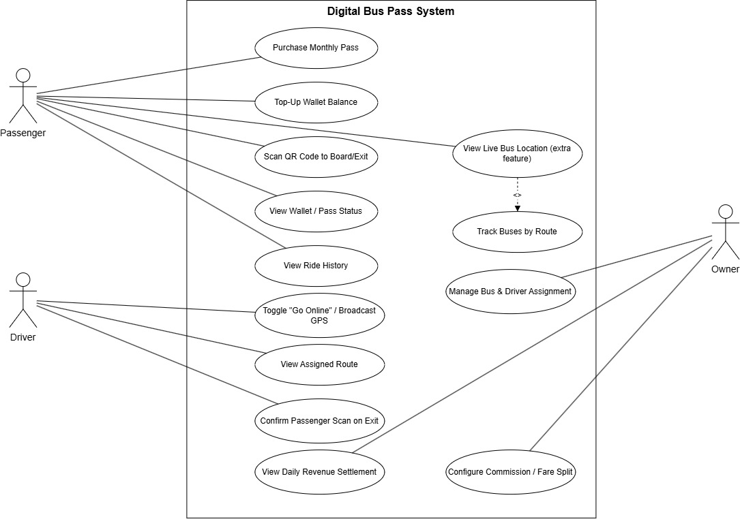
Figure 2.1: Use Case Diagram
The use case diagram illustrates two primary actors, Driver and Passenger, interacting with the BusAwu system. The Driver actor selects a company and route and starts broadcasting live GPS coordinates. The Passenger actor views the live map, searches for a route between two stops, and performs QR scans to board and exit a trip, which triggers automatic fare calculation and wallet deduction.

2.1.2 Feasibility Study

i. Technical Feasibility
The system is built using widely supported, open-source technologies: Flutter/Dart for the mobile client and FastAPI (Python) for the backend, communicating over WebSockets and HTTP. Packages used — geolocator for GPS access, flutter_map with OpenStreetMap tiles for mapping, mobile_scanner for QR scanning, and web_socket_channel for real-time communication — are all mature, actively maintained Flutter packages. No proprietary or licensed SDKs are required, making the system technically feasible to build and maintain with standard developer tools.

ii. Operational Feasibility
The Driver interface requires only a single toggle (“Go Online”/“Go Offline”) after selecting a route, and the Passenger interface requires only opening the app and scanning a QR code, making the system usable without prior training. Since public bus drivers already operate smartphones for other purposes (such as ride-hailing platforms), operating a similar broadcast-toggle app is a realistic expectation.

iii. Economic Feasibility
The project uses entirely open-source and free-tier tools: Flutter and FastAPI are free and open source, OpenStreetMap tiles are free to use, and the backend is hosted on Render’s free web-service tier, which requires no payment or credit card. The only ongoing cost anticipated for a production deployment would be mobile data usage on the driver’s device, which is minimal since only small JSON coordinate payloads are transmitted every few seconds.

iv. Schedule Feasibility
The project was developed iteratively within the sixth-semester project timeline, with the core GPS tracking feature completed first, followed by route modelling, the QR-based fare system, and cloud deployment in successive stages, allowing a working system to be demonstrated at each milestone rather than only at the final deadline.
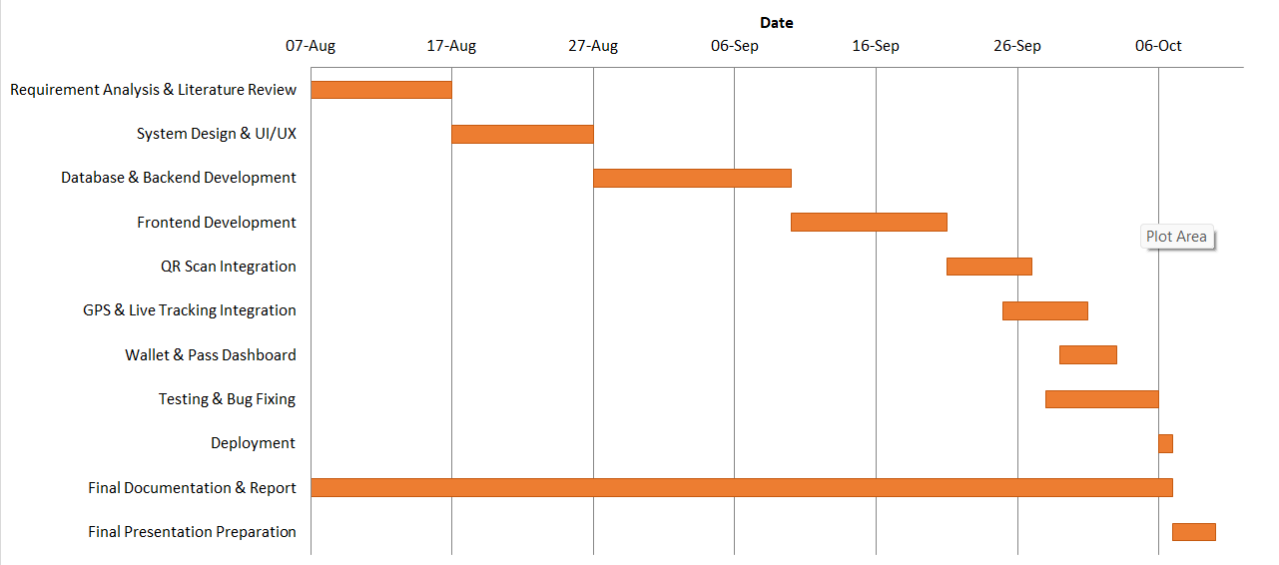
Figure 2.2: Gantt Chart

2.1.3 System Modelling
An Object-Oriented approach was used for system modelling.

i. Object Modelling using Class and Object Diagrams
The class diagram defines the BusAwu architecture, centred on a BusRoute entity that groups an ordered list of Stop names under a Company. A Trip class links a device (identified by a device ID) to a boarding location, an exit location, a calculated distance, and a resulting Fare. A Wallet class tracks the balance associated with each device ID. A LiveLocation class represents the most recent broadcast position and the currently active route ID.
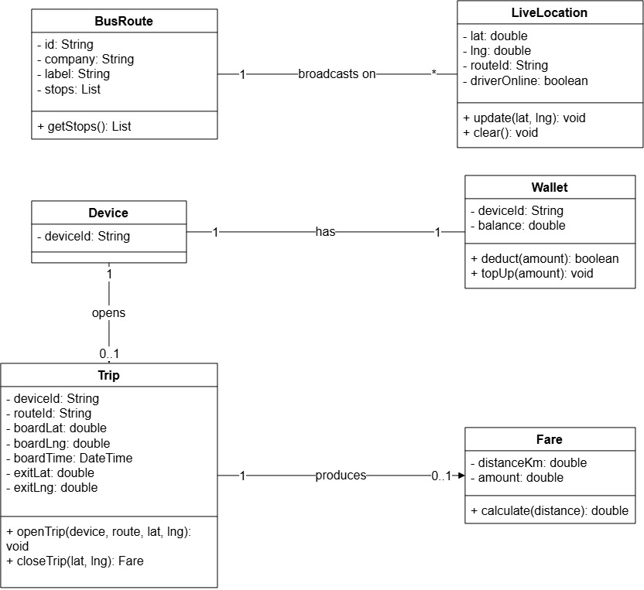

Figure 2.3: Class Diagram
The object diagram illustrates a concrete snapshot of the system: a Driver device broadcasting under route “mayuri_baudha” (Kalanki → Banasthali → Balaju → Samakhusi → Chabahil → Baudha), and a Passenger device with an open Trip that began at Kalanki and is currently awaiting an exit scan, alongside that device’s current Wallet balance.
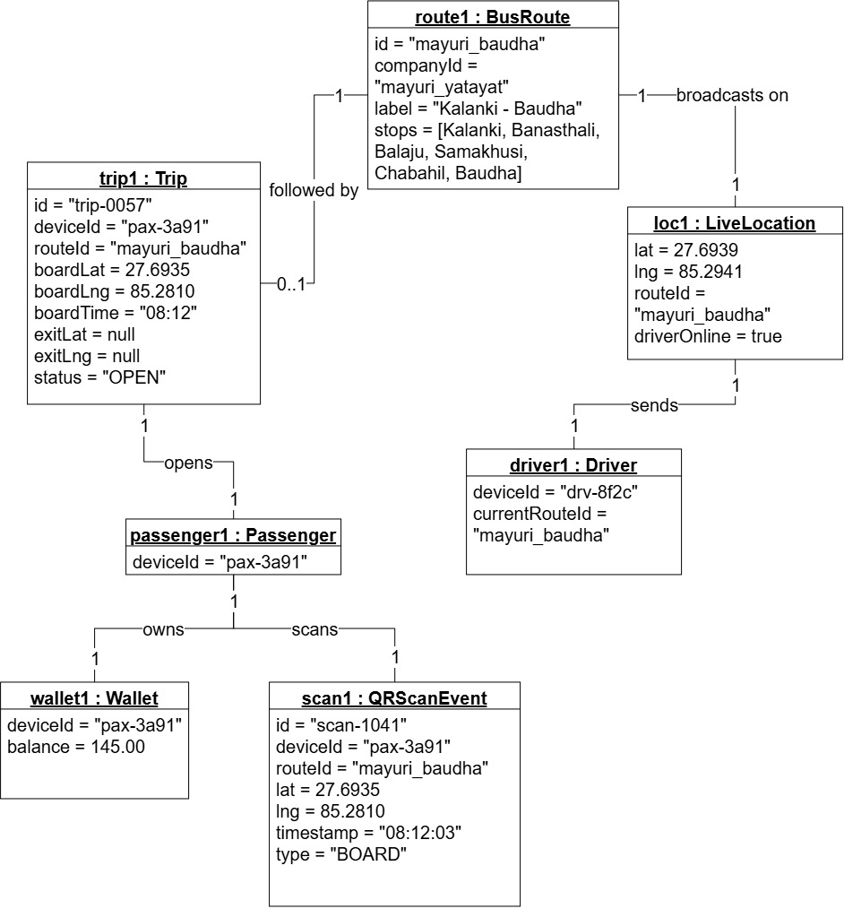
Figure 2.4: Object Diagram

ii. Dynamic Modelling using State and Sequence Diagrams
The sequence diagram below traces the driver GPS broadcasting flow: the Driver app connects to the /ws/driver WebSocket endpoint, sends a location payload (latitude, longitude, and route ID) every two to three seconds, and the backend immediately relays that payload to every currently connected Passenger app over the /ws/passenger endpoint.

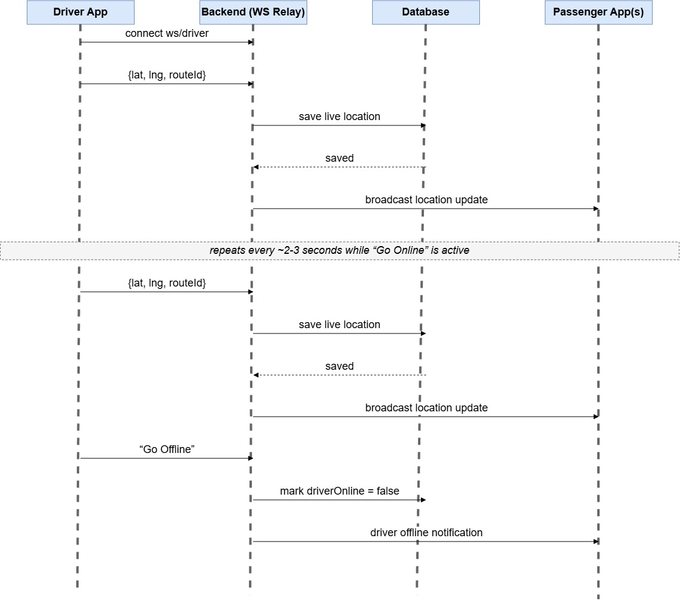
Figure 2.5: Sequence Diagram of Driver GPS Broadcasting
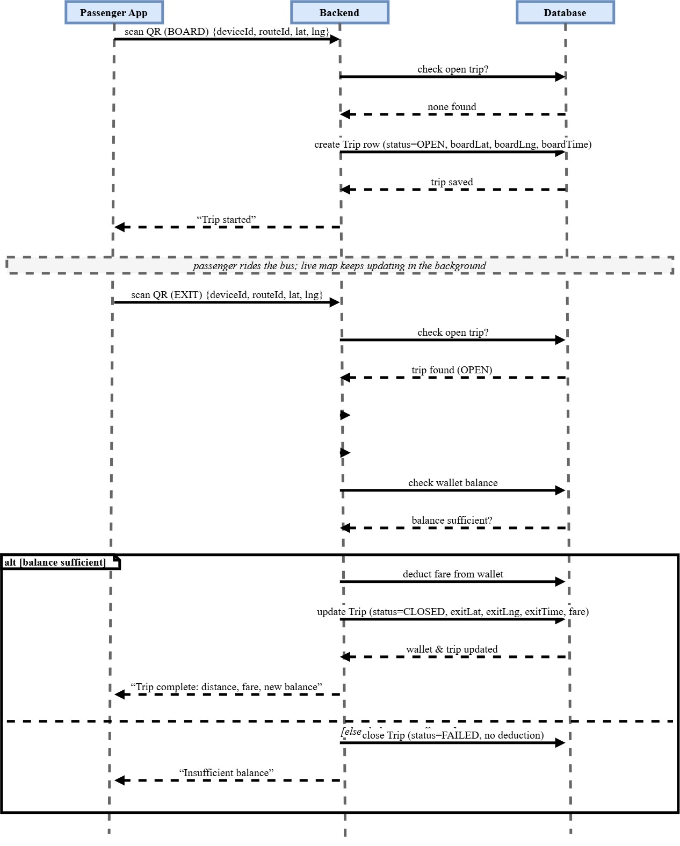
Figure 2.6: Sequence Diagram of QR-Based Boarding and Exit
The passenger state diagram shows the lifecycle of a passenger’s session within the app: from Idle, to Viewing Live Map, to Searching Route, to Trip Boarded (after the first QR scan), to Trip Completed (after the second QR scan and fare deduction), returning to Idle.
[Figure 2.7: Passenger State Diagram showing states Idle, Viewing Live Map, Searching Route, Trip Boarded, and Trip Completed here]
Figure 2.7: Passenger State Diagram

iii. Process Modelling using Activity Diagram
The activity diagram illustrates the overall passenger workflow: opening the app, viewing the live map, optionally searching for a route between two stops, scanning the bus QR code to board, riding the bus while the live marker updates, scanning the QR code again to exit, and receiving the calculated fare and updated wallet balance.
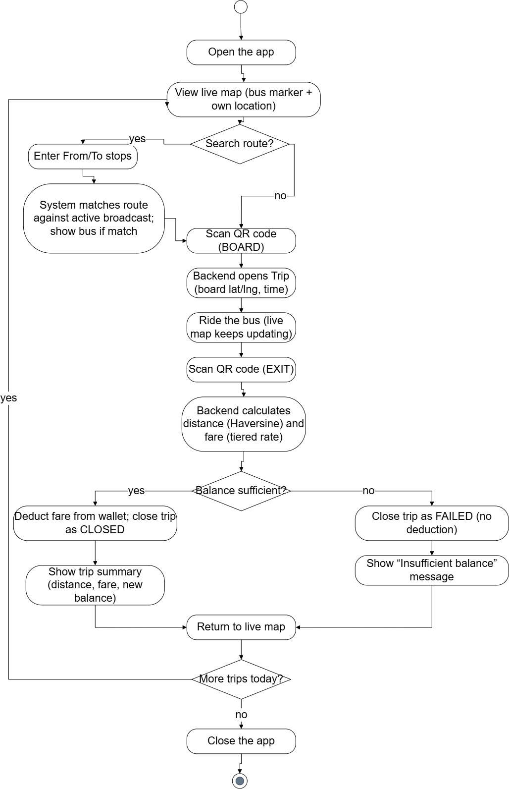
Figure 2.8: Activity Diagram of the Live Tracking and Fare Process
2.2 System Design
2.2.1 Refinement of Classes and Objects
The class diagram was refined to reflect the actual data structures implemented in code: a Dart BusRoute class (id, company, label, stops: List<String>) used identically on both the driver and passenger screens; a Python-side in-memory dictionary structure for wallets (device_id → balance) and open_trips (device_id → {route_id, board_lat, board_lng}); and a latest_location dictionary (lat, lng, route_id, driver_online) representing the single live broadcast state.
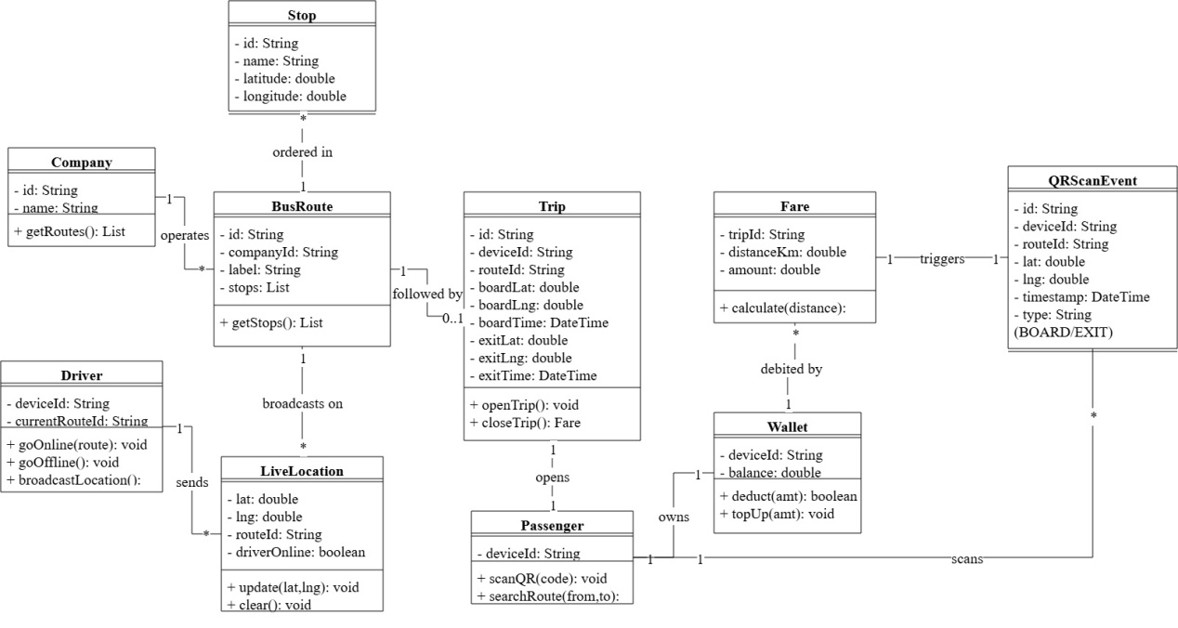
Figure 2.9: Refinement of Class Diagram
2.2.2 Component Diagram
The component diagram groups the system into a Client Layer (Driver App, Passenger App — both built with Flutter), a Communication Layer (WebSocket Relay for GPS broadcast, HTTP endpoints for QR scan and wallet operations), an Application Services layer (Route Matching Service, Fare Calculation Service, Wallet Service), and a Deployment Layer (the FastAPI application hosted on Render).
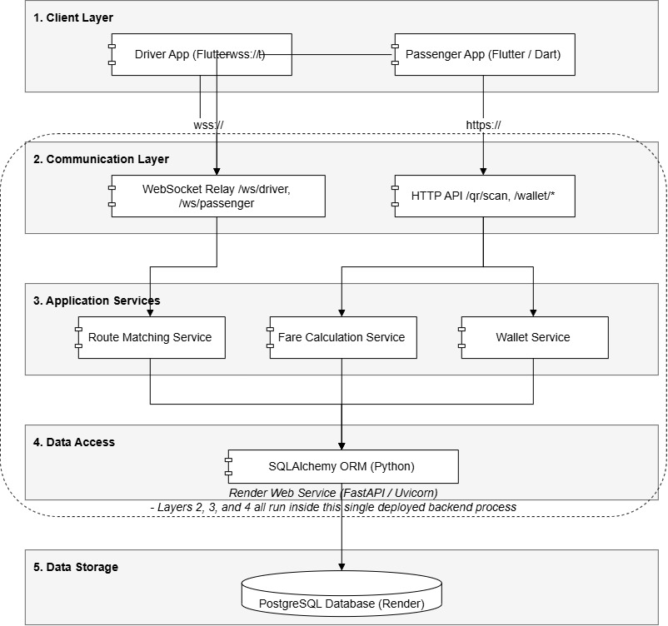

Figure 2.10: Component Diagram
2.2.3 Deployment Diagram
The deployment diagram shows the Driver and Passenger smartphones (Client Devices) communicating over the public internet (WSS/HTTPS) with the FastAPI backend deployed as a Web Service on Render. The backend process runs a single Uvicorn ASGI server that handles both the WebSocket endpoints (/ws/driver, /ws/passenger) and the HTTP endpoints (/qr/scan, /wallet/{device_id}, /wallet/load), with all state currently held in server memory rather than a separate database tier.
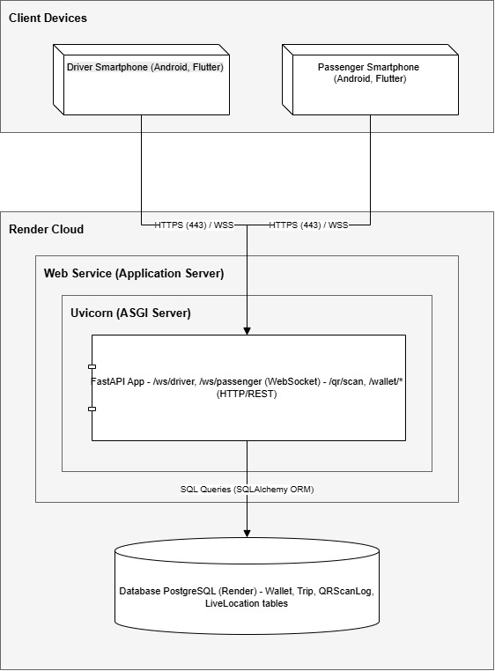
Figure 2.11: Deployment Diagram

2.3 Implementation

2.3.1 Tools Used
i. CASE Tools
- Draw.io: used to create the UML diagrams — use case, class, object, sequence, state, activity, component, and deployment diagrams.
ii. Programming Languages and Frameworks
Client Application:
- Flutter / Dart — cross-platform mobile application framework
- geolocator — device GPS access and live position streaming
- flutter_map + latlong2 — interactive map rendering using OpenStreetMap tiles
- web_socket_channel — WebSocket client for real-time communication
- mobile_scanner — camera-based QR-code scanning
- http — REST API calls to the backend for QR scan and wallet operations
- shared_preferences — local persistence of a per-device generated ID
Backend:
- FastAPI (Python 3) — web framework used for both WebSocket and REST endpoints
- Uvicorn — ASGI server used to run the FastAPI application
- Python’s math module — used to implement the Haversine distance calculation
iii. Deployment and Hosting Platform
- Render — free-tier cloud web service hosting used to deploy the FastAPI backend with a fixed public URL
- GitHub — version control and the source repository connected to Render for continuous deployment

2.3.2 Implementation Detail of Modules

i. Role Selection Module
The application opens on a role-selection screen with two buttons, “I’m the Driver” and “I’m the Passenger”. Selecting a role navigates to the corresponding screen using Flutter’s Navigator, allowing a single installed application (and a single codebase) to serve both roles without a separate build for each.

ii. Live GPS Broadcasting Module (Driver)
On the driver screen, the user selects a bus company and then a specific route from a dependent dropdown (the list of available routes filters based on the chosen company). Tapping “Go Online” opens a persistent WebSocket connection to the backend’s /ws/driver endpoint and starts a repeating timer that reads the device’s current GPS position (using the geolocator package) approximately every two to three seconds and sends it, together with the selected route ID, as a JSON payload over the open connection.

iii. WebSocket Relay Module (Backend)
The backend maintains two WebSocket endpoints. The /ws/driver endpoint accepts a single driver connection, stores the most recently received location and route ID in a shared latest_location object, and immediately forwards that payload to every currently connected passenger. The /ws/passenger endpoint accepts any number of connections, registers each new connection in a list of connected passengers, sends the current latest_location to a newly connected passenger so they are not left blank, and removes a passenger from the list when their connection closes.

iv. Live Map and Route Search Module (Passenger)
The passenger screen renders a live map using flutter_map with OpenStreetMap tiles, showing the bus’s current position (received over the WebSocket connection) as a moving marker and the passenger’s own live GPS position as a second marker. A From/To search bar, backed by an autocomplete text field, lets the passenger search for routes whose ordered stop list contains both the chosen “From” and “To” stop in the correct order; the bus marker is only shown on the map if the currently broadcasting route matches the passenger’s search (or if no search has been performed).

v. QR-Based Fare Module
A single QR code, encoding a route ID, is pasted on the physical bus. When the passenger scans it for the first time, the app sends the device ID, route ID, and current GPS coordinates to the backend’s /qr/scan endpoint, which records this as an “open trip” for that device (boarding location and time). When the same QR code is scanned again, the backend recognises the open trip, calculates the straight-line distance between the boarding and current location using the Haversine formula, applies a tiered fare (for example, NPR 30 for 0–15 km and NPR 50 for 15–30 km), and deducts the resulting fare from the passenger’s wallet balance if sufficient funds are available; otherwise the trip is closed and an “insufficient balance” message is returned.

vi. Wallet Module
A simple in-memory wallet, keyed by a randomly generated device ID stored locally via shared_preferences, tracks each device’s balance. The wallet balance is checked and updated during fare deduction, and a “Load Money” screen was designed to top up the balance through the eSewa payment gateway’s sandbox (UAT) environment using an HMAC-signed, WebView-based redirect flow, though this feature was not fully completed within the project timeline.

vii. Deployment Module
The backend, together with its requirements.txt dependency list, was pushed to a GitHub repository and connected to a Render Web Service, configured with the build command pip install -r requirements.txt and the start command uvicorn main:app --host 0.0.0.0 --port $PORT. This produced a fixed public URL that both the driver and passenger applications connect to (over wss:// for WebSocket endpoints and https:// for REST endpoints), removing the earlier requirement that both devices and the development laptop share the same local WiFi network.

2.3.3 Testing
Table 2.1: Unit Testing
ID | Scenario | Test Steps | Expected Result | Status
UT01 | Haversine Distance Calculation | Call haversine_km() with two known coordinate pairs | Returns the correct straight-line distance in kilometres | Pass
UT02 | Fare Tier Calculation | Call calculate_fare() with distances in each tier boundary | Correct fare (e.g. NPR 30 for ≤ 15 km) returned for each tier | Pass
UT03 | Route Search Matching | Call searchRoutes() with a valid From/To stop pair | Returns only routes containing both stops in the correct order | Pass
The unit tests confirm that the two core calculation functions — Haversine distance and tiered fare — and the route search/matching logic behave correctly in isolation, forming the foundation for the fare and route-search features.
Table 2.2: Integration Testing
ID | Scenario | Test Steps | Expected Result | Status
IT01 | Driver Broadcast to Passenger Display | Driver goes online and sends location; passenger app is connected | Passenger map marker updates to the driver’s new position within a few seconds | Pass
IT02 | Route-Filtered Search | Passenger searches a From/To pair not matching the active broadcasting route | Bus marker and route are hidden from the search results | Pass
IT03 | QR Board-then-Exit Flow | Passenger scans QR to board, then scans again at a different location | Backend returns calculated distance, fare, and updated wallet balance | Pass
IT04 | Insufficient Balance Handling | Passenger exits a trip with a wallet balance lower than the calculated fare | Trip closes with an “insufficient balance” response and no negative balance | Pass
The integration tests validate that the driver, backend relay, passenger, and QR-fare modules work correctly together end to end, including edge cases such as an insufficient wallet balance.
Table 2.3: System Testing
ID | Scenario | Test Steps | Expected Result | Status
ST01 | Cross-Network Live Tracking | Driver and passenger devices on two different networks (WiFi and mobile data) after backend deployment | Live tracking works correctly without requiring a shared local network | Pass
ST02 | Rapid Repeated QR Scans | Passenger holds the camera on the QR code for several seconds | Only the first detection is processed; subsequent detections are ignored via a scan lock | Pass
ST03 | Driver Disconnection Handling | Driver goes offline mid-session | Passenger app is notified the driver is offline and the bus marker is cleared | Pass
ST04 | Late-Joining Passenger | A passenger connects after the driver has already been broadcasting | Passenger immediately receives the last known bus location instead of a blank map | Pass
The system tests confirm that BusAwu behaves correctly under realistic, full-system conditions — including the deployed, cross-network scenario that reflects real-world usage — and that edge cases such as repeated scans, mid-session disconnection, and late joining are handled gracefully.

Chapter III: Conclusion and Recommendation

3.1 Summary
BusAwu is a Flutter and FastAPI-based system that brings real-time GPS bus tracking and a QR-code-driven digital fare model to Kathmandu’s public bus network. The project delivers a working driver/passenger live-tracking loop over a WebSocket relay, a route-modelling and search feature built on ordered stop lists, a distance-based automated fare calculation using the Haversine formula, an in-memory wallet system, and a backend deployed to a public cloud host so the system works across different networks rather than only on a shared local WiFi connection.

3.2 Conclusion
The project successfully demonstrates that a real-time, GPS-based tracking and automated fare system can be built for a fixed-route public bus network using only widely available, open-source mobile and backend technologies, without requiring specialized transit hardware such as dedicated smart-card readers. By reusing the same route-modelling data both for driver route selection and passenger route search, and by driving fare calculation directly from GPS coordinates captured at QR-scan time, the system keeps its architecture simple while still solving the three core problems identified in the problem statement: live visibility of a bus’s location, the ability to search for a bus travelling a given path, and automated digital fare collection. The current in-memory, single-bus implementation is sufficient to demonstrate and validate this approach, while leaving clear next steps for turning it into a production-ready, multi-bus system.

3.3 Recommendation
The following recommendations are proposed for future enhancement of the system:

Short-term
- Integrate a persistent database (such as PostgreSQL) to store wallet balances, trip history, and route definitions so that data survives server restarts.
- Complete the eSewa “Load Money” payment flow so that passengers can top up their wallet directly within the app.
- Add basic user authentication (login/registration) so that a wallet is tied to a verified account rather than only a locally generated device ID.

Medium-term
- Extend the system to support multiple buses and multiple simultaneous drivers on different routes, rather than a single active broadcast.
- Build an administrative interface for managing bus companies, routes, and stops, removing the need to hardcode route data in the client application.
- Replace straight-line (Haversine) fare distance with actual road-route distance for more accurate fare calculation.

Long-term
- Introduce estimated time of arrival (ETA) predictions based on historical and live GPS data.
- Add offline trip-data caching on the driver’s device so that GPS points logged during a signal drop can be synced once connectivity is restored.
- Explore a native digital pass/subscription system alongside the existing pay-per-trip wallet model.

Reference
FastAPI. (2026). FastAPI framework, high performance, easy to learn, fast to code, ready for production. Retrieved from https://fastapi.tiangolo.com/
Flutter. (2026). Flutter – Build apps for any screen. Retrieved from https://flutter.dev/
OpenStreetMap Foundation. (2026). OpenStreetMap. Retrieved from https://www.openstreetmap.org/
Render Services, Inc. (2026). Render: Cloud application hosting for developers. Retrieved from https://render.com/
eSewa. (2026). eSewa ePay developer documentation. Retrieved from https://developer.esewa.com.np/
Pathao Nepal. (2026). Pathao – Ride, food, and courier services. Retrieved from https://pathao.com/

Appendix
This appendix would normally contain screenshots of the implemented application screens, including:
- The role-selection screen (“I’m the Driver” / “I’m the Passenger”)
- The Driver screen showing company/route selection and the “Go Online” control
- The Passenger home screen showing the live map, bus marker, and From/To search bar
- The QR scan screen and its “Trip started” / “Trip complete” result messages
- The wallet balance and Load Money screen
[Appendix Figure a: Screenshot of the Driver screen with company/route selection and Go Online button here]
[Appendix Figure b: Screenshot of the Passenger home screen with live map and From/To search here]
[Appendix Figure c: Screenshot of the QR scan screen showing a completed trip with distance and fare here]
[Appendix Figure d: Screenshot of the wallet balance and Load Money screen here]

