1.What is Angular ?
Ans:- Angular is a JS UI framework which help us to build single page application using routing and it is also help us to MVC pattern.It is the product of google and Miško Hevery is inventor of angular.Primary language is Typescript(its develop by microsoft).It is modular in nature.

2.What is difference between angularjs and angualar ?
Ans:-
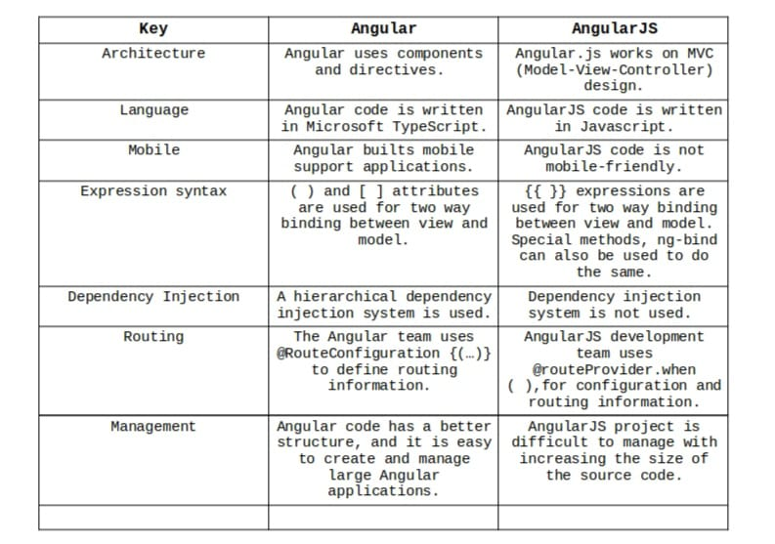

3.What are basic building blocks of angular ?
Ans:- The main building blocks for Angular are modules, components, templates, metadata, data binding, directives, services, and dependency injection.

4.What is component? how to create component in angular?
Ans:- The component is the basic building block of Angular. It has a selector, template, style, and other properties, and it specifies the metadata required to process the component.
Or
We can say that it is the part of UI which is render on browser.
Command to create component:-
ng g c <component_name>
OR
ng generate component <component_name>

5.What is service ? How to create service in angular ?
Ans:- Service is simple Typescript class which is used to provide data to the components.And we can also write some business logic inside the service.
OR
We might come across a situation where we need some code to be used everywhere on the page. It can be for data connection that needs to be shared across components, etc. Services help us achieve that. With services, we can access methods and properties across other components in the entire project.
Command to create service:-
ng g service myservice
ng g s myservice

6.What is module ? how to create module in angular application?
Ans:-Module is a simply class which is follwed by @ngModule decorator .
Module deal with components and services
OR
Module in Angular refers to a place where you can group the components, directives, pipes, and services, which are related to the application.
In case you are developing a website, the header, footer, left, center and the right section become part of a module.
To define module, we can use the NgModule.
Command to create module:-
ng g module main --routing

7.What is dependecny injection and how angular use it ?
Ans:-
Dependency injection is the ability to add the functionality of components at runtime.
OR
Dependency injection, or DI, is a design pattern. With the help of DI system we can get external resources in a class. Angular's DI framework provides dependencies to a class upon instantiation. Use Angular DI to increase flexibility and modularity in your applications.
Example: constructor(private productService:ProductService) {}

8.What is pipe ? how to create pipe in angular ?
Ans:-Pipes are a useful feature in Angular. They are a simple way to transform values in an Angular . There are some built in pipes, but you can also build your own pipes. A pipe takes in a value or values and then returns a value
OR
Pipes takes an input and convert input into desired output
*Two tpes of :-
1. Built-in
a) parameterized
b) non parameterized
2. Custome
a) parameterized
b) non parameterized

Pipes are used for:-
To modify or formate a value
As a function
To display only some filtered elements from an array

Example:
Steps Involved In Creating a Custom Pipe In Angular are:
1) Create a Pipe Class and decorate it with the decorator @Pipe.
2) Supply a name property to be used as template code name.
3) Register your Pipe in the module under declarations.
4) Finally, implement PipeTransform and write transformation logic.
5) Use your pipe in the HTML using ‘|’, which represents a pipe.
6) Also, add Custom arguments if you want to.
import { Pipe, PipeTransform } from '@angular/core';
@Pipe({
name: 'salutation'
})
export class SalutationPipe implements PipeTransform {

transform(value: unknown, ...args: unknown[]): unknown {
if (args[0] == "M") {
return "Mr. " + value;
}
else if (args[0] == "F") {
return "Mrs. " + value;
}
return value;
}
}

9.What is data binding and explain types of data binding with
suitable example.
Ans:- Data binding is the core concept of Angular and used to define the communication between a component and the DOM.

Example: There are several ways to bind data between components and view in Angular.
* 1. Interpolation
<li>Name:{{user.name}}</li>

* 2. Property binding
<input type="email"[value]="user.email">

3. Class binding
<h1 [class] = "geeky">
GeeksforGeeks
</h1>

4. Style binding
<h1 [style.color]= “red” >GeeksforGeeks</h1>

5. Attribute binding
<p [attr.attribute-you-are-targeting]="expression"></p>

* 6. Event binding
<button (click)="cookBacon()"></button>

* 7. Two-way binding
[(ngModel)] = "property of your component"

10. Explaing Angular life cycle hooks
Ans:- The life cycle hooks are the methods that angular invokes on the directives and components as it creates, changes and destroy them . Using lifecycle hooks we can fine-tune the behaviour of our components during creation , updation and destruction.there 8 lifecycle hooks.
OR
Lifecycle hooks are a special functionality in Angular that allow us to “hook into” and run code at a specific lifecycle event of a component or directive.
Below is a summary of the Angular lifecycle hooks in a table:

ngOnChanges = Called when the input properties have changed
ngOnInit = Called on initialization
ngDoCheck = Developer’s custom change detection
ngAfterContentInit = Called when the component’s content ngContent is initialized
ngAfterContentChecked = Called when the component’s content is updated or checked for updates
ngAfterViewInit = Called when the component’s projected view has been initialized
ngAfterViewChecked = Called after the projected view has been checked
ngOnDestroy = Called before the component is destroyed

Note: ^ ye jis sequence me likhe he us hi sequence me execute honge.

11. What is difference between ngOnInIt and ngOnChange
Ans:-

ngOnInit | NgOnChange
ngOnInit() is used to execute any piece of code for only one time (for eg : data fetch on load). | ngOnChanges() will execute on every @Input() property change.  If you want to execute any component method, based on the @Input() value change, then you should write such logic inside ngOnChanges().
It will execute After NgOnChanges | It will execute before NgOnInit
It will response after full component is initialized | It will response after Changes in @Input property
To use NgOnInit implements NgOnInit interface | To use NgOnChanges implements NgOnChanges interface

Q why do we need ngOnInit() when we have ngOnChanges()?
Ans:- it is because you cannot execute one time code, on every @Input() property change. And you cannot use constructor as the replacement of ngOnInit() as well. Because the bindings, such as @Input properties are not available within the constructor.

12. What is difference between ngOnInit and constructor
Ans:-
ngOnInit | Constructor
Its a life cycle hook which provided by Angular. | It is not life cycle hook it is the feature of Typescript.
If you wanna perform any task at the time of component initialization then use it. | If you wanna inject any dependency and to initialize the property then use constructor.
We can call the ngOnInit as per the requirement | We can’t call the constructor as per the requirement

13. What is eager loading and lazy loading in angular?
Ans:- Eager: Feature modules under Eager Loading would be loaded before the application starts. This is the default module-loading strategy.
Example-

@NgModule({
declarations: [
AppComponent
],
imports: [
BrowserModule,
AppRoutingModule,
EagerLoadingModule
],
bootstrap: [AppComponent]
})

Lazy: Feature modules under Lazy Loading would be loaded on demand after the application starts. It helps to start application faster.
Example-
const routes: Routes = [
{
path: 'items',
loadChildren: () => import('./items/items.module').then(m => m.ItemsModule)
}
];

14. How to send Http request from angular application to server?
Ans:- With the help of HttpClient class which is provided by HttpClientModule
we can send http request on server.
Example:
import { HttpClient } from '@angular/common/http';
import { Injectable } from '@angular/core';
import { Observable } from 'rxjs';

@Injectable({
providedIn: 'root'
})
export class Service {

constructor(private http: HttpClient) { }

public nursuryList(): Observable<Nursury[]> {
let nursuryListApi = "https://prakritee.herokuapp.com/admin/nursery/nursery-list";
return this.http.get<Nursury[]>(nursuryListApi);
}

}

15. What are decorator in angular ?
Ans:- Decorators are a design pattern that is used to separate modification or decoration of a class without modifying the original source code.
Types of Decorators:
1. Class Decorator - @Component and @NgModule are widely used.
2. Property Decorators - @Input (),@Output,@ReadOnly (),@Override ()
3. Method Decorator - @HostListener
4. Parameter Decorators - @Inject ()

16. What are angular directive ? How many type of angular directive
Ans:- The Angular directives are used to manipulate the DOM. By using Angular directives, you can change the appearance, behavior or a layout of a DOM element. It also helps you to extend HTML.
Angular directives can be classified in 3 categories based on how they behave:
• Component Directives
• Structural Directives
• Attribute Directives
Component Directives: Component directives are used in main class. They contain the detail of how the component should be processed, instantiated and used at runtime.

Structural Directives: Structural directives start with a * sign. These directives are used to manipulate and change the structure of the DOM elements. For example, *ngIf directive, *ngSwitch directive, and *ngFor directive.
• *ngIf Directive: The ngIf allows us to Add/Remove DOM Element.
• *ngSwitch Directive: The *ngSwitch allows us to Add/Remove DOM Element. It is similar to switch statement of C#.
• *ngFor Directive: The *ngFor directive is used to repeat a portion of HTML template once per each item from an iterable list (Collection).

Attribute Directives: Attribute directives are used to change the look and behavior of the DOM elements. For example: ngClass directive, and ngStyle directive etc.
• ngClass Directive: The ngClass directive is used to add or remove CSS classes to an HTML element.
• ngStyle Directive: The ngStyle directive facilitates you to modify the style of an HTML element using the expression. You can also use ngStyle directive to dynamically change the style of your HTML element.

17.What is Observable and how to get data from observable
Ans:- Observable is the sequence of data which arrives over the time.It is used to handle the asynchronous operations in Angular. It is provided by the external library called RXJS(Reactive Extensions for JavaScript) .

OR
Observables provide support for data sharing between publishers and subscribers in an angular application. It is referred to as a better technique for event handling, asynchronous programming, and handling multiple values as compared to techniques like promises.

To get the data from Observable we have to subscribe the observable by subscribe() method.

18. How to subscribe and unsubscribe observalble.
Ans:- We can subscribe observable by subscribe() method and unsubscribe by unsubscribe() method -
ex-
@Component({...})
export class AppComponent implements OnInit, OnDestroy {
subscription: Subscription
ngOnInit () {
var observable = Rx.Observable.interval(1000);
.subscription = observable.subscribe(x => console.log(x));
}
ngOnDestroy() {
this.subscription.unsubscribe()
}
}

19. What is use @Injectable decorator in angular
Ans:- The @Injectable() decorator specifies that Angular can use this class in the DI system. The metadata, providedIn: 'root' , means that the Service is visible throughout the application.
Example -
import { Injectable } from '@angular/core';

@Injectable({
providedIn: 'root',
})
export class HeroService {
constructor() {}
}

20. What is use of @ViewChild decorator
Ans:-A ViewChild is a component, directive, or element as a part of a template. If we want to access a child component, directive, DOM element inside the parent component, we use the decorator @ViewChild() in Angular.
To understand this, suppose we have two components, a child and a parent one. Since the child component can be located inside the parent component, it can accessed as @ViewChild.
We can use @ViewChild decorator to send the data to the child component
Example: First-1 use DOM element accessing
html:
<p #mess>welcome</p>

ts:
@ViewChild('mess') msg: ElementRef | any;
ngAfterViewInit(): void {
this.msg.nativeElement.innerHTML = "hello"
}

Second-2 child component accessing
Child ts:
sayhello() {
alert("Hello");
}

Parent ts:
@ViewChild(ChildComponent) child: ChildComponent| any;
childMethod() {
this.child.sayhello();
}

21. How to manage parent child component in angular?

22. How to manage childrouting for child component

23. What is router outlet in angular
Ans:- Router-Outlet is an built-in Angular directive from the router library that is used to insert the component matched by routes to be displayed on the screen. It's exported by the RouterModule and added to the template as shown below:
s<router-outlet></router-outlet>
Two types router outlet-
1. Name less (primary router outlet)
ex- <router-outlet></router-outlet>
2. Named (Secondory or auxilary router outlet)
ex- <router-outlet name = “name”></router-outlet>
it’s entry in app.routing.js file me :-
{path: “home”, commponent: HomeCommponent, outlet: “name”}

24. How to navigate from component to another component in angular
Ans:- We can navigate one commponent to another component by Router class method navigate.
Example:
import {Router} from '@angular/router'; // import router from angular router

export class Component{ // Example component..
constructor(private route:Router){}

go(){
this.route.navigate(['/page']); // navigate to other page
}
}

25. How to register service at component level and root level
Ans:- Root Level: In this level service class object is singleton means it’s only create one object.
Ex-
@NgModule({
declarations: [AppComponent],
imports: [BrowserModule],
providers: [DemoService],
bootstrap: [AppComponent]
})
Or
@Injectable({
providedIn: 'root'
});
export class DemoService {
someProperty = 'Some Value';
constructor() {}
}

Component Level: In this level service class create separate object curresponding to component where it has been registered.
Ex-
@Component({
selector: 'app-root',
templateUrl: './app.component.html',
styleUrls: ['./app.component.css'],
providers : [DemoService]
})
export class AppComponent {
title = 'FormsProject';
}

26. What is HTTP_INTERCEPTOR in angular ?
Ans:- It is the special service that helps us to modify the HTTP Request by intercepting it before the Request is sent to the back end. The Interceptor can be useful for adding custom headers to the outgoing request, logging the incoming response etc.
Example:
@Injectable()
export class TokenIntercepterService implements HttpInterceptor {
constructor() { }

intercept(req: HttpRequest<any>, next: HttpHandler) {
let tokenizedRequest = req.clone({
setHeaders: {
authorization: 'Bearer ' + sessionStorage.getItem('token')
}
});
return next.handle(tokenizedRequest);
}
}
Intercepter Entry in App.module.js -
providers: [
{
provide: HTTP_INTERCEPTORS,
useClass: TokenIntercepterService,
multi: true
},
],

27. How to secure the route in angular ?
Ans:- A great way to take your app to the next level is to implement Guards , which are interfaces that protect routes and grant access based on defined permissions. This is useful for apps with an admin dashboard.
Example:
@Injectable({
providedIn: 'root'
})
export class AuthGaurdService implements CanActivate {
constructor(private router: Router) { }
canActivate() {
if (sessionStorage.getItem('userId'))
return true
else {
this.router.navigate(['signin']);
return false
}
}
}
Entry of Guard- {path: “home”, commponent: HomeCommponent, outlet: “name”, canActivate:
AuthGaurdService}

28. How to pass the data from parent to child and child to parent component in angular?
Ans:- Parent to child -
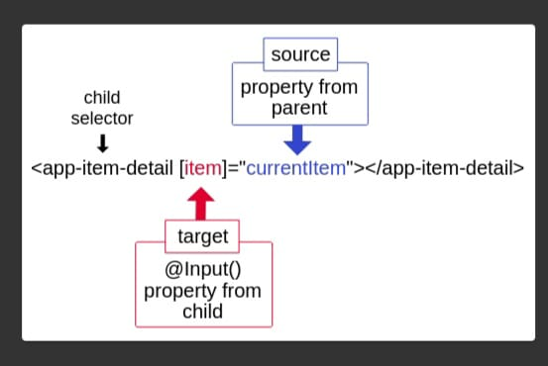

Child to Parent Or Parent to child-
parent component html:-
<app-child-parent (event)="getMsg($event)" [parentMsg]="msgForChild"></app-child-parent>
<h1>Bache ka msg {{childMsg}}</h1>
parent component ts:-
msgForChild: String = "HI mere bachee";
childMsg: String = "";
getMsg(data: any) {
this.childMsg = data;
}

Child component html:-
<h1>papa ka msg :- {{parentMsg}}</h1>
<button type="submit" (click)="sendingMsg()">Reply </button>
Child component ts:-
@Input() parentMsg: String = "";
@Output() event = new EventEmitter();
sendingMsg() {
this.event.emit("bol mere baap");
}

29. What is angular material ?
Ans:- angular material is a lib for anguler like we have bootsrap it also provide us accessible and well tested components for bulding a responsive ui.

Steps to use Angular Material:
- Step 1: Install Angular Material, Angular CDK and Angular Animations
npm install @angular/material @angular/cdk @angular/animations --save
OR
ng add @angular/material
- Step 2: Configure animations
@NgModule({
imports: [BrowserAnimationsModule],
})
export class AppModule { }

- Step 3: Import the Angular Material component modules
import { MatCheckboxModule} from '@angular/material';

@NgModule({
imports: [
MatCheckboxModule,
]})
- Step 4: Then simly use it
<mat-checkbox>Check me!</mat-checkbox>

30. Which is the entry point of angular application
Ans:- main.ts is the entry point of angular application . What parts of the application will be compiled is being determined by your main.ts file, and mostly the line
platformBrowserDynamic().bootstrapModule(AppModule)
which defines the AppModule to be the "entry point" of your application
31. Where to register feature module in angular application
Ans:- there are two ways to register feture module-
1. Eager loading – Entry app.module.ts
@NgModule({
declarations: [],
imports: [
featureModule
]
})
export class AppModule { }
2. Lazy loading - Entry in app.routing.ts
const routes: Routes = [
{
path: "feature",
loadChildren: () => import("./module/feature-module/feature-module.module").then(m => m.featureModule),
canActivate: [AdminGuardService]
},
];

32. where to register component in angular application
Ans:- if we create component by angular CLI then we don’t need to register the component it will automatically registered the component in app.module.ts file
declaration[] array.And if create component without CLI then we have to register the component.
Example:
@NgModule({
declarations: [
AppComponent,
CustomerComponent
],
imports: [
BrowserModule,
AppRoutingModule
],
providers: [],
bootstrap: [AppComponent]
})
export class AppModule { }

33. Programming example of *ngIf and *ngFor
Ans:-
<ul *ngIf="true">
<li *ngFor="let item of friendslist">
{{ item.name }} is {{ item.age }} years old
</li>
</ul>
34. Write angular code to send http get request and http post
request from angular to backend server
Ans:-
@Injectable({
providedIn: 'root'
})
export class UserService {
constructor(private http: HttpClient) { }
public signIn(user: User) {
let signInApi = "https://prakritee.herokuapp.com/user/signin";
return this.http.post<any>(signInApi, { userEmail: user.userEmail, userPassword: user.userPassword });
}
public viewProfile(): Observable<User> {
let viewProfileApi = "https://prakritee.herokuapp.com/user/user-by-id/" + sessionStorage.getItem('userId');
return this.http.get<User>(viewProfileApi);
}
}

35. How to modify http request in angular application
Ans:- We can modify http request by HttpIntercepter.
It is bydirectional proccess.
Example:
@Injectable()
export class TokenIntercepterService implements HttpInterceptor {
constructor() { }
intercept(req: HttpRequest<any>, next: HttpHandler) {
let tokenizedRequest = req.clone({
setHeaders: {
authorization: 'Bearer ' + sessionStorage.getItem('token')
}
});
return next.handle(tokenizedRequest);
}
}
Intercepter Entry in App.module.js -
providers: [
{
provide: HTTP_INTERCEPTORS,
useClass: TokenIntercepterService,
multi: true
},
],

36. What is RxJs in angular
Ans:- The full form of RxJS is Reactive Extension for Javascript. It is a javascript library that uses observables to work with reactive programming that deals with asynchronous data calls, callbacks and event-based programs. RxJS can be used with other Javascript libraries and frameworks. It is supported by javascript and also with typescript.

37. When angular create a singlton object for service class
Ans:- When we register Service class at root level then it will create a singleton object.
Example:
@NgModule({
declarations: [AppComponent],
imports: [BrowserModule],
providers: [DemoService],
bootstrap: [AppComponent]
})
Or
@Injectable({
providedIn: 'root'
});
export class DemoService {
someProperty = 'Some Value';
constructor() {}
}

38. What are the features of angular
Ans:-
0. Super fast
1. DI system Dependency Injection.
2. Popular for SPA(single page application)
3. Modular nature that’s why it’s easy to manage.
4. Provide wide variety of UI components
5. HttpIntercepter
6. Data binding
7. Angular CLI

Q. How to implement caching functionality in angular ?
Ans)
import { HttpHandler, HttpInterceptor, HttpRequest, HttpResponse } from '@angular/common/http';
import { Injectable } from '@angular/core';
import { of, tap } from 'rxjs';
@Injectable()
export class CacheInterceptorService implements HttpInterceptor{
cache:Map<string,HttpResponse<any>> = new Map<string,HttpResponse<any>>();
constructor() { }
intercept(request:HttpRequest<any>,next:HttpHandler){
if(request.method !='GET'){
console.log("Request send to Server.....");
return next.handle(request);
}
let cachedResponse = this.cache.get(request.url);
if(cachedResponse){
console.log("Response return from cached........");
return of(cachedResponse);
}else{
return next.handle(request).pipe(tap(statevent=>{
if(statevent instanceof HttpResponse){
this.cache.set(request.url,statevent.clone());
}
}));
}
}
}

39. How to access the dom element in angualar component class

40. How to make dynamic route in angular.

41. How to pass the data to the component while navigating

42. How to detect changes in angular route.
Ans) We can detect with help of Router class method events()
Example:
this.router.events.subscribe(event => {
if (event instanceof NavigationEnd) {
location.reload();
}
})

Q difference between Observable vs Promise
Ans)
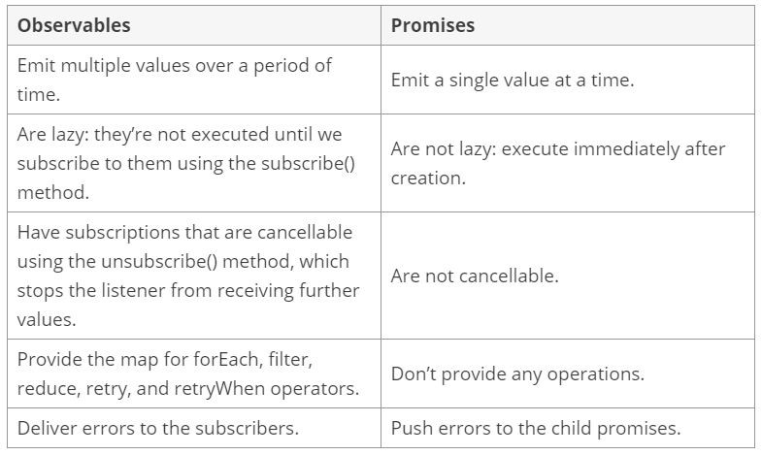

43. What is difference between Route and ActivatedRoute

44. What is FormsModule, Two-way binding, HttpClientModule

45. What is the use BrowserModule in angular application

46. How to create anuglar application

47. How to run the angular application

48. What is argument type of @NgModule and @Component decorator

49. What is root module in angular application ? and
what type of configuration/entery it contains.

50. Where to register component, where to register module and where to register service in angular application

51. What import array of @NgModule contains ?

52. What declaration array of @NgModule contains ?

53. What providers array of @NgModule contains ?

Q Difference between AOT(Ahead of time) & JIT(Just In Time)
Ans)




