1) HOW TO EXPORT / IMPORT EXCEL FILE WITH DJANGO MODELS FIELDS : -

- pip install django_import_export

settings.py : -

INSTALLED_APPS = [
‘import_export’
]

Models.py :

class Student(models.Model):
name = models.CharField(max_length=100)
email = models.EmailField(unique=True, help_text='enter your unique mail-id')
age = models.IntegerField(default=18)
roll = models.IntegerField()
address = models.CharField(max_length=120)
def __str__(self):
return self.name

Admin.py : -

from django.contrib import admin
from .models import *
from import_export.admin import ImportExportModelAdmin
@admin.register(Student)
class StudentAdmin(ImportExportModelAdmin):
list_display = ['id', 'name', 'email', 'age', 'roll', 'address']
Export Excel sheet : -

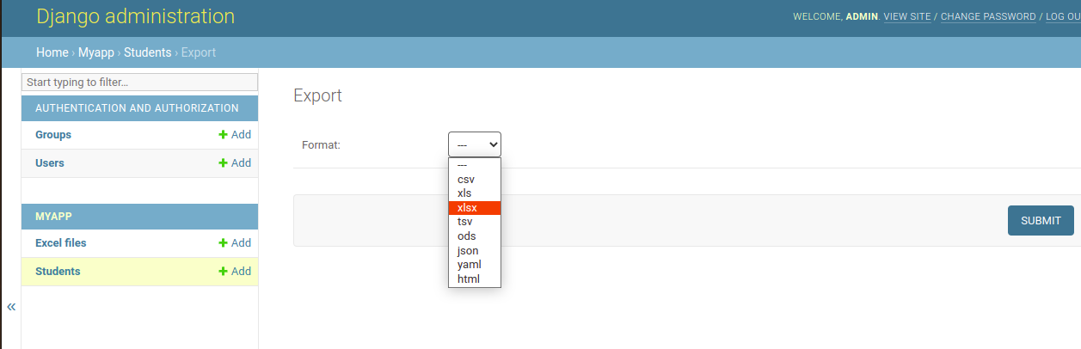

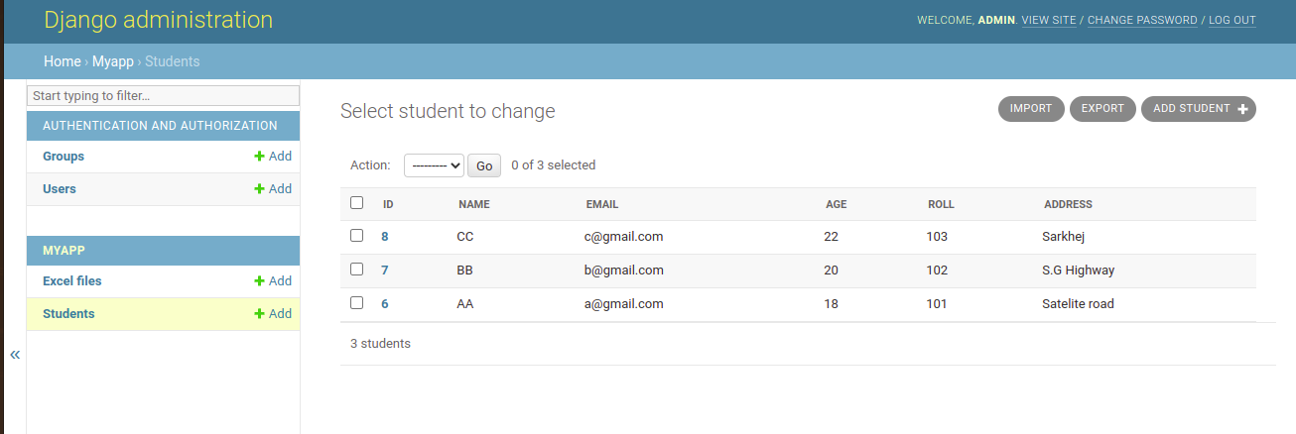

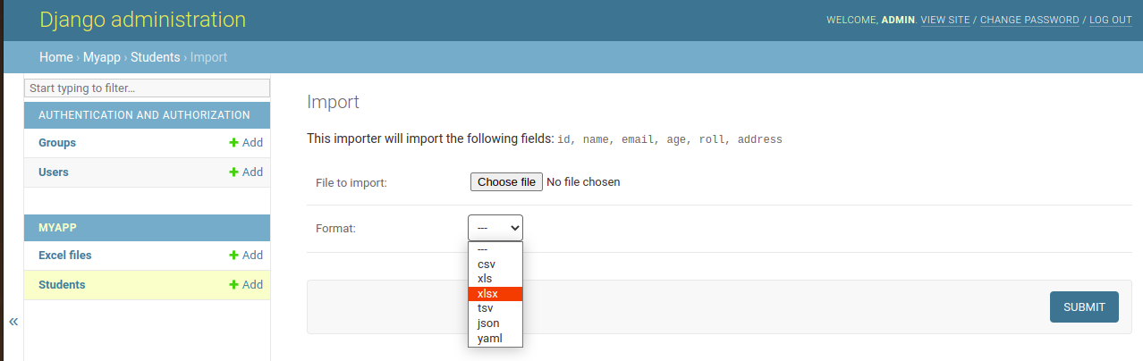
- IMPORT EXCEL SHEET : -

2 . ) Direct Download excel sheet in our project folder .

- Using Pandas Library : -
pip install pandas

Views . Py : -

from rest_framework import generics
from .serializers import *
import pandas as pd
from django.http import JsonResponse
def export_excel(request):
stu = Student.objects.all()
data = []
for s in stu:
data.append({
'id': s.id,
'name': s.name,
'email': s.email,
'age': s.age,
'roll': s.roll,
'address': s.address
})
pd.DataFrame(data).to_excel('myexcel.xlsx', index=False)
return JsonResponse({'status': 200})
- Load Multiple Excel sheet : -

excel = pd.read_excel('sample.xlsx', sheet_name=None, engine=’xlsxwriter’)

print(excel)
Note :
If we pass sheet_name = None to show all the model name with their data .

