INSTITUTE OF AERONAUTICAL ENGINEERING

(Autonomous)

Dundigal, Hyderabad-500 043

**Project Based Learning**

(Prototype / Design Building) External Evaluation Report

Title of your Idea : Gas Leakage and Fire Detection Using IOT

Thrust Area / Sector : IOT

Branch : Computer Science and Engineering

Year / Semester : 3 RD YEAR - 5 TH SEMESTER

|  |  |  |  |  |
| --- | --- | --- | --- | --- |
| **S. No** | **Name of the Student** | **Roll Number** | **Mobile Number** | **Signature** |
| **1** | Lakkaram Nithish | 20955A0509 | 7337561130 | L.Nithish |
| **2** | Satyala Pradeepthi | 20955A0510 | 9676404455 | S.Pradeepthi |
| **3** | Katakola Prashanthi | 20955A0511 | 8008851869 | K.Prashanthi |
| **4** | Dokka Raj Kumar | 20955A0512 | 9052503135 | D.Raj Kumar |

Team Members (Max. 4) :

1. **Background of the Idea (Min. 500 words):**

LPG (liquified petroleum gas), simply called as propane or butane, is highly flammable gas that is often used as fuel for cooking purposes. Due to the flammable nature of LPG, its leakage can cause damage to life and property. It is very important to be sure that gas leakage has not occurred in our kitchen. LPG, being heavier than air, does not disperse easily and leads to suffocation when inhaled. Unfortunately, many people die every year in their homes or industries or elsewhere due to gas cylinder explosions or fire outbreaks. These terrible accidents are occurring because of a massive number of gas users who are not proficient in the use of gas. Presently it becomes an emerging topic for technical, economic, agricultural, etc. Natural gas pipeline leakage also creates a fire that is a threat to humans. Sometimes viperous gas leakage creates environmental pollution, which is dangerous for human beings and species. Moreover, fire accidents have become a threat to human life. At present, cylinders and chemical explosions are more responsible for fire accidents in Bangladesh. Almost fifty people were injured, and ten people died in a year for gas cylinder blast and fire occurrence. In the present time, fire accidents take appalling situations. New technologies are now focusing more on those accidents and working on how to diminish these accidents. Several systems have been implemented for detecting gas leakage and fire occurrence. All orders have some constraints, such as they cannot use the money, space, and time efficiently. From this perspective, our project has some advantages

• a real-life helpful and cost-efficient sensible project

• accurate info

• less complex circuit

• no environmental impact or no impact of physical conditions

1. **Problem Statement (Min 100 words):**

A lot people die every year in their apartments or industries or elsewhere on account of gas cylinder discharges or fire outbreaks. These terrible accidents are happening because of a massive number of gas users who are not skilled in the use of gas. Presently it enhances an emerging topic for scientific, economic, agricultural, etc. Gas pipeline leakage too creates a fire namely a threat to humans. Constantly viperous gas discharge creates environmental pollution, that is dangerous for human beings and species. Additionally, fire accidents have become a threat to human being. At present, cylinders and chemical explosions are more responsible for fire accidents in Bangladesh. Nearly fifty people were harmed, and ten people died in a year for gas cylinder blast and fire incident.

1. **Proposed Solution (Min 100 words):**

The primary purpose of doing this work is to sense LPG gas that is responsible for the fire and detect fire occurrence, and also sense smoke flows out from the light. Sometimes when gas leaks or fires occur, people don’t understand that situation, but the temperature increases, which is harmful to human health and the environment. Generally, when fire incidence occurs at any place, the temperature of that place is about 70◦-120◦C concerning different distances (by preliminary information) that is relatively high than average temperature. The proposed system uses an alarm and a Global System for Mobile Communications (GSM) to aware of the gas leakage

1. **Technology concept formulation:**

Gas Sensor (MQ2 Sensor), Fire Sensor are interfaced to the microcontroller ATMEGA328. These sensors act as input to the system. The interfaced GSM module is capable of connecting to Internet through mobile data network. Gas Sensor detects gas leakage. As soon as leakage of gas is detected, user is notified about it so that he/she can turn off the gas valve Fire sensor detects fire and on detection of fire, buzzer starts beeping to alert user about the mishap going on in their home. The response of all these sensors can be viewed in LCD-Display. GSM Module makes use of AT commands for sending SMS

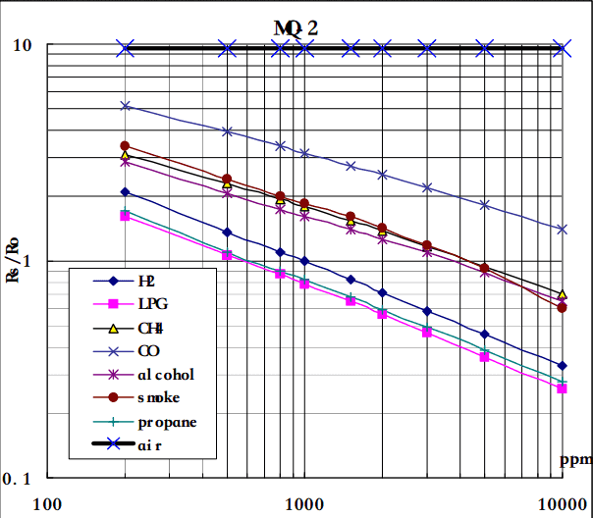

1. **Prototype of proposed system (UI screens / block diagrams / circuits / designs):**

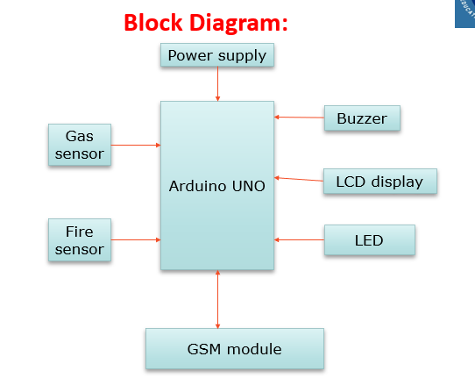

1. **Detailed description of prototype / product / project (Min 1000 words):**

This project can be used by anybody, without any prior knowledge of any hardware or software programming needed. The device monitors the gas content in the air and any flame before displayed to the user The workflow of this system is straightforward. The gas sensor and fire sensor installed on the Arduino device monitor the gas content in the air and the existing flame continuously. When the gas content in the air exceeds the normal limit or any flame is detected, the device sends a notification to the user based on the type of the detected value.A basic description of how each component is given below.The gas sensor is a module used on the micro-controller to detect gas in the air. There are several types of gas and gas sensors that can be identified by the module also vary. To detect household gases, M2 gas sensors are used to detect Methane, Butane, LPG and cigarette Smoke. a fire sensor is a sensor that can detect the presence of a fire and convert it to an analog quantity of its representation. This flame sensor is different from the heat sensor, where the heat sensor uses temperature parameters while the fire sensor measures the flame.

The Arduino UNO is a microcontroller board which is based on the Microchip ATmega328P microprocessor. This board consists of 14 digital pins and 4 analog pins. It can be programmed with the Arduino IDE by means of a type B USB cable It is operated at the voltage of 12V.

Buzzer, often called as beeper, is an audio signaling device that may be either mechanical, electromechanical, or piezoelectric. It makes use of transistor and capacitor to convert electrical energy into sound energy. The most popular applications of buzzer include alarm devices, timers, and confirmation of user input (for e.g., mouse click or keystroke). It starts beeping when some action has been performed. (Ex: In our proposed topic, the buzzer starts beeping when no vessel is detected over gas burner even after specified time period)

1. **Final version of prototype / product (only images):**

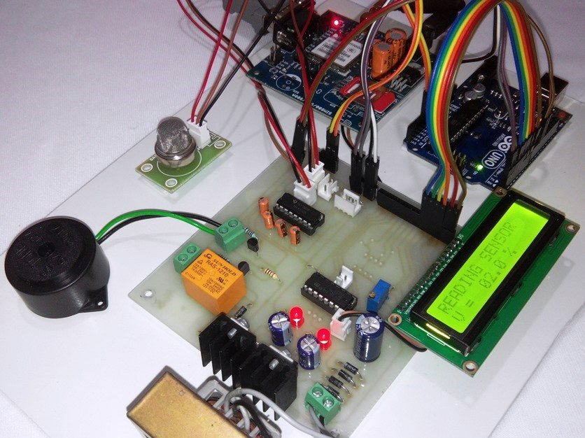

1. **Any other information:**

The Bhopal disaster, also referred to as the Bhopal gas tragedy, was a gas leak accident on the night of 2–3 December 1984 at the Union Carbide India Limited (UCIL) pesticide plant in Bhopal, Madhya Pradesh, India. It is considered among the world's worst industrial disasters Over 500,000 people were exposed to methyl isocyanate (MIC) gas. The highly toxic substance made its way into and around the small towns located near the plant.

Dean-CLET DeanTIIC