Connecting to server

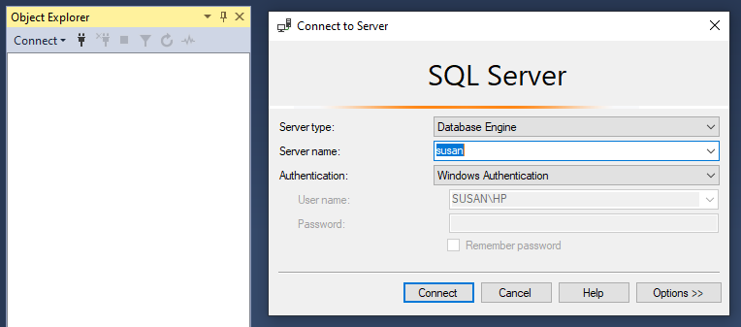

Connected to server

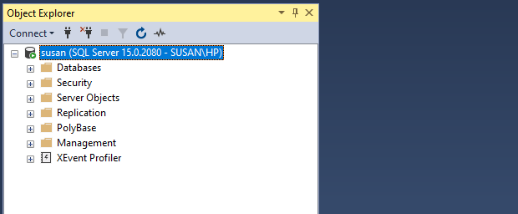

1. Creating and removing database queries

Syntax:

CREATE DATABASE databasename;

Query with Output:

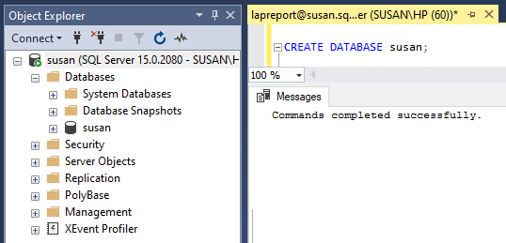

Syntax:

DROP DATABASE databasename;

Query with Output:

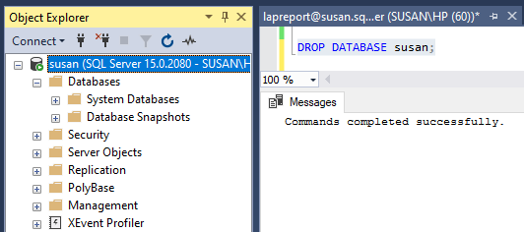

1. Creating and Removing Table Queries

Syntax:

CREATE TABLE tbl_name(

column datatype,

column2 datatype..);

Query with Output:

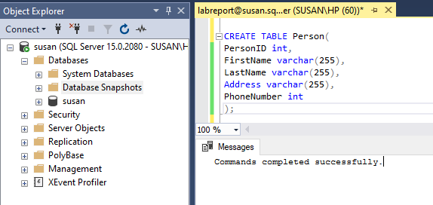

Syntax:

DROP TABLE tbl_name;

Query with Output:

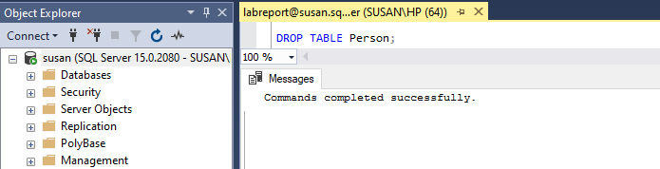

3.Insert into the table, select all, and select distinct from the table.

Syntax:

INSERT INTO table_name(column1, column2, column3,…)

VALUES (value1, value2, value3,....);

Query with Output:

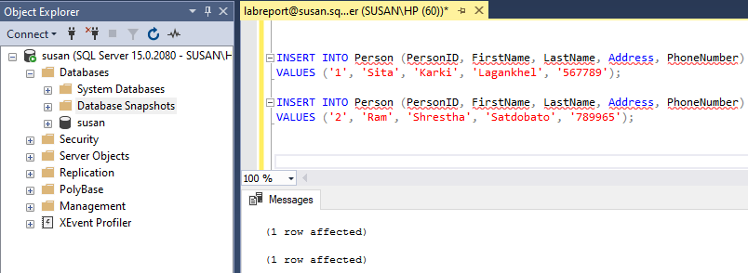

Syntax:

SELECT * FROM table_name;

Query with Output:

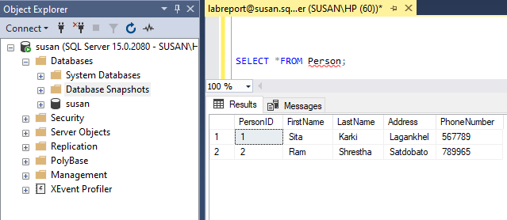

Syntax:

SELECT DISTINCT column1, column2, ....

FROM table_name;

Query with Output:

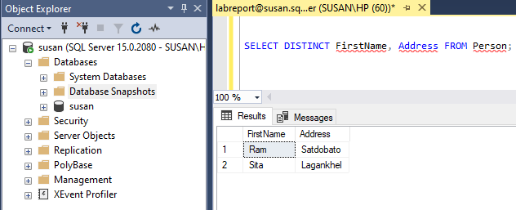

4.To show the auto increment in the primary key

Syntax:

CREATE TABLE table_name(

Column int INDENTITY(starting digits, increment by number) PRIMARY,

Coulmn 2,

Coulmn 3….);

Query with Output:

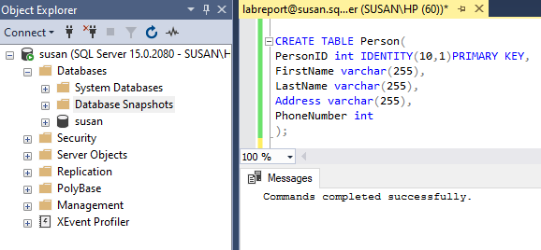

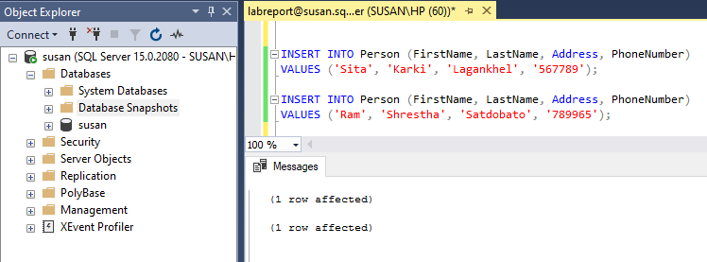

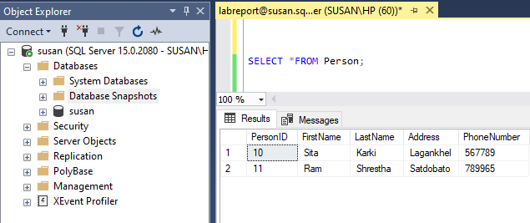

1. Altering the table and adding a column to the table

Syntax:

ALTER TABLE tb_tablename

ADD column_name datatype ;

Query with Output:

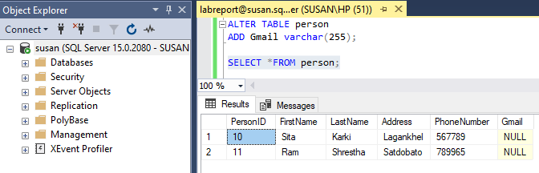

6.Declare constraints in the table and remove one of them.

1. Syntax:(Unique)

CREATE TABLE tb_tablename(

Column 1 datatype NOT NULL UNIQUE,

Coulmn 2 NOT NULL,

Coulmn 3….

CONSTRAINT UC_TABLENAME UNIQUE (column_name,column_name));

Query with Output:

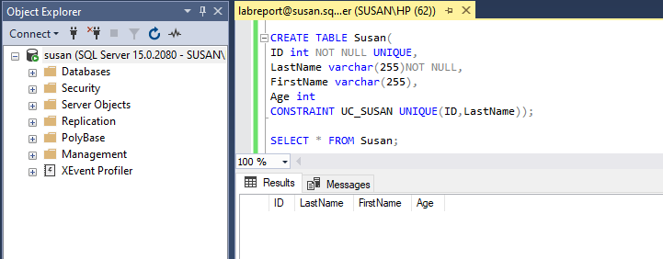

1. Syntax: (Droping Unique)

ALTER TABLE table_name

DROP CONSTRAINT UC_TABLENAME;

Query with Output:

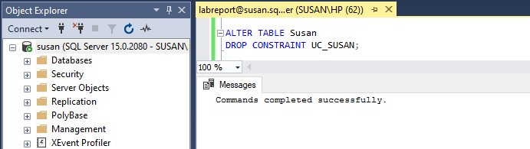

1. Syntax:(Primary Key)

CREATE TABLE tb_tablename(

Column 1 datatype NOT NULL UNIQUE,

Coulmn 2 NOT NULL,

CONSTRAINT PK_TABLENAME PRIMARY KEY (column_name,column_name));

Query with Output:

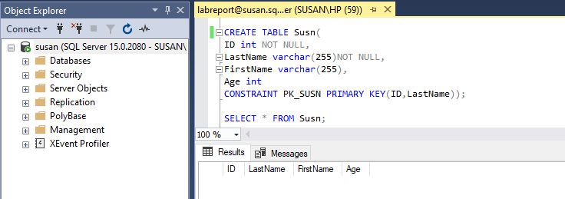

1. Syntax:(Function Key)

CREATE TABLE tb_tablename(

Column 1 datatype NOT NULL UNIQUE,

Coulmn 2 NOT NULL,

CONSTRAINT FK_TABLENAME FOREIGN KEY (column_name)

REFERENCES tablename(column_name));

Query with Output:

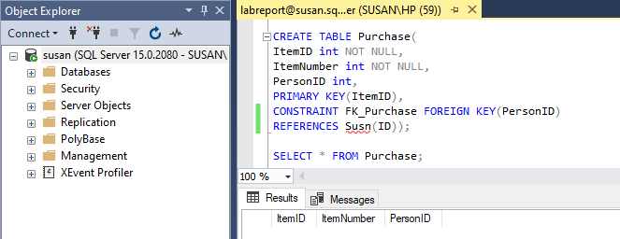

7.Use the WHERE clause in the query.

Syntax:

SELECT column1, column2,….

FROM table_name

WHERE condition;

Query with Output:

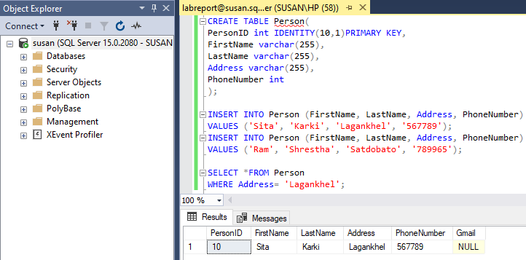

1. Use AND, OR, NOT queries

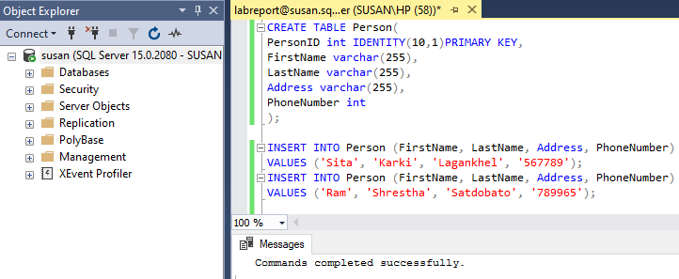

1. Syntax:(AND)

SELECT column1, column2, …

FROM table_name

WHERE condition1 AND condition2 AND condition3….;

Query with Output:

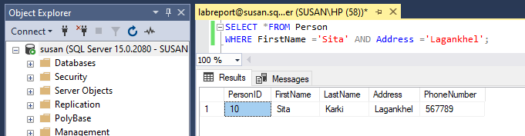

1. Syntax:(OR)

SELECT column1, column2, …

FROM table_name

WHERE condition1 OR condition 2 or condition3….;

Query with Output:

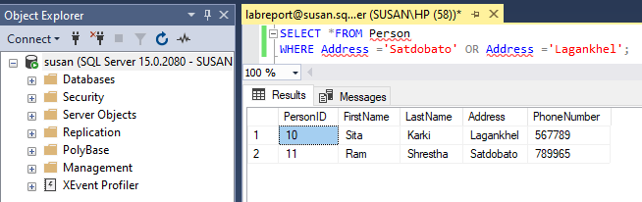

1. Syntax:(NOT)

SELECT column1, column2, …

FROM table_name

WHERE NOT condition;

Query with Output:

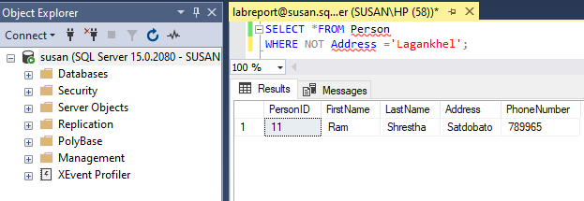

1. Use “ ORDER BY ” query for both ascending and descending orders.



1. Syntax:(.Ascending)

SELECT column1, column2,….

FROM table_name

ORDER BY column1, column2,….ASC;

Query with Output:

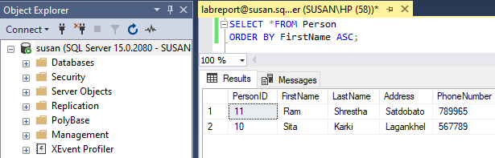

1. Syntax: (Descending)

SELECT column1, column2,….

FROM table_name

ORDER BY column1, column2,…. DESC;

Query with Output:

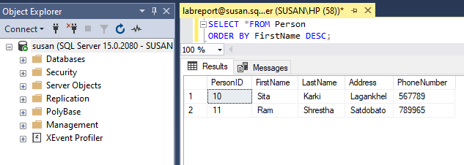

10.Update and delete table fields.



1. Syntax:(UPDATE)

UPDATE table_name

SET column1= value1, column2=value2,…..

WHERE condition;

Query with Output:

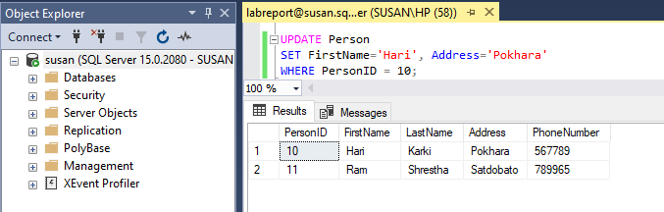

1. Syntax:(DELETE)

DELETE FROM table_name

WHERE condition;

Query with Output:

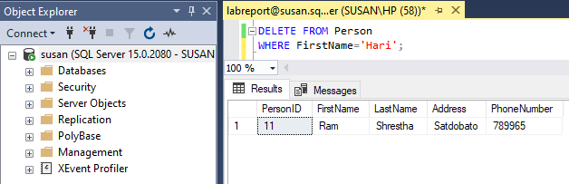

1. Use Join queries

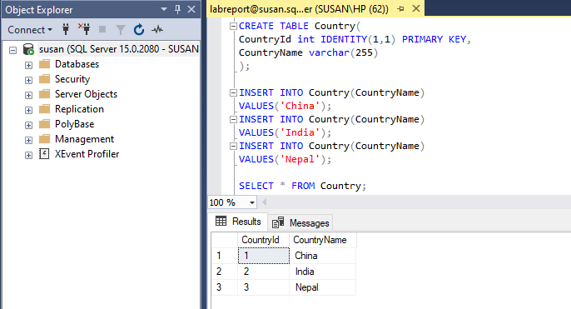

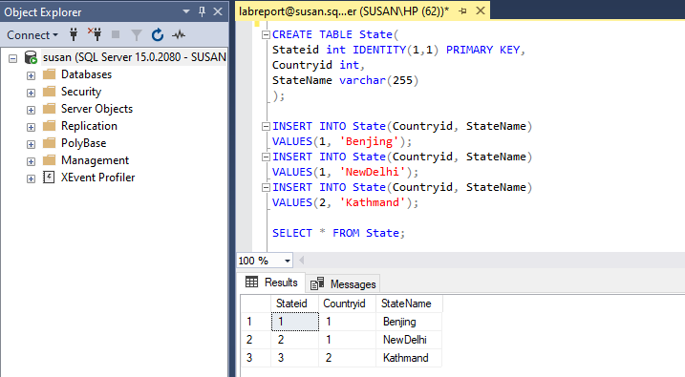

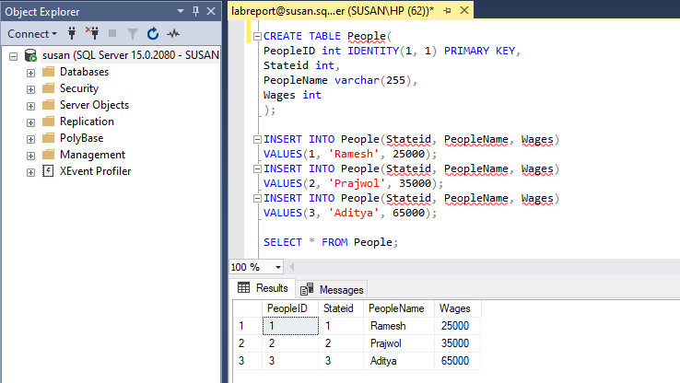

i.Syntax: (INNER JOIN)

SELECT column_name(s) FROM table1

INNER JOIN table2

ON table1.column_name = table2.column_name;

Query with Output:

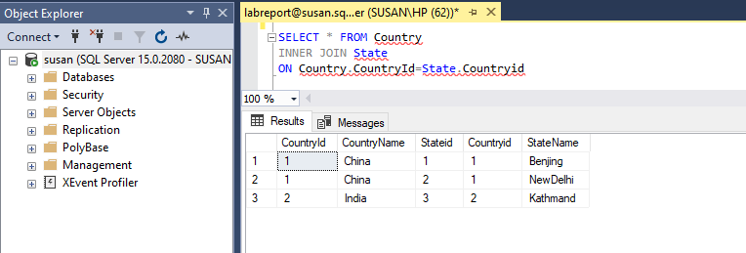

ii.Syntax: (LEFT JOIN )

SELECT column_name(s) FROM table1

LEFT JOIN table2

ON table1.column_name = table2.column_name;

Query with Output:

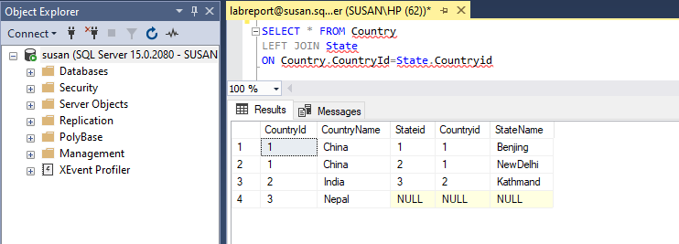

iii.Syntax: (RIGHT JOIN)

SELECT column_name(s) FROM table1

RIGHT JOIN table2

ON table1.column_name = table2.column_name;

Query with Output:

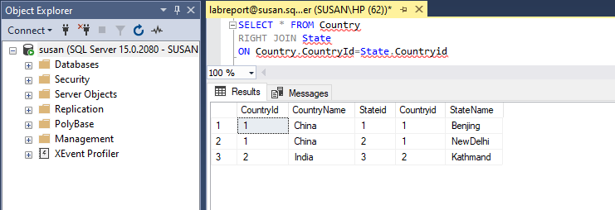

iv.Syntax: (FULL OUTER JOIN)

SELECT column_name(s) FROM table1

FULL OUTER JOIN table2

ON table1.column_name = table2.column_name;

WHERE condition;

Query with Output:

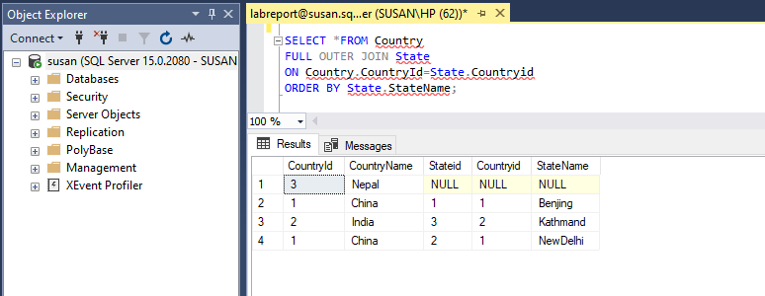

12. Use the min and max functions.

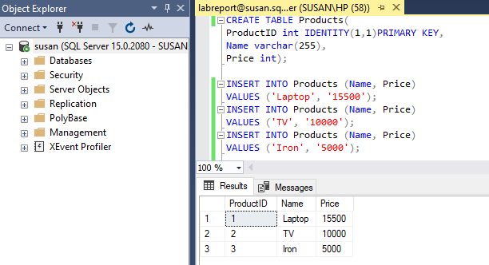

1. Syntax: (MIN)

SELECT MIN(column_name)

FROM table_name

WHERE condition;

Query with Output:

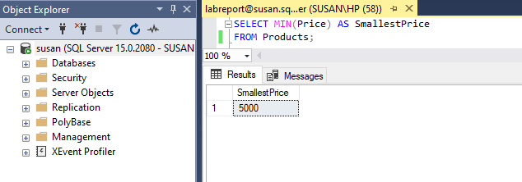

1. Syntax: (MAX)

SELECT MAX(column_name)

FROM table_name

WHERE condition;

Query with Output:

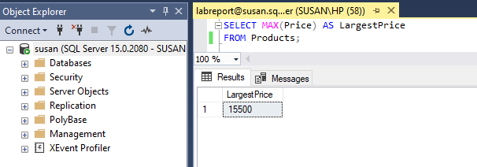

13. Use the count, average, and sum functions.



1. Syntax:(COUNT)

SELECT COUNT (column_name)

FROM table_names

WHERE condition;

Query with Output:

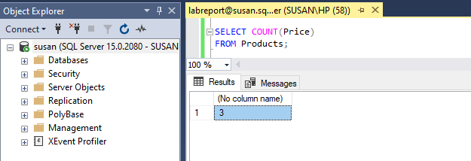

1. Syntax:(AVERAGE)

SELECT AVG(column_name)

FROM table_name

WHERE condition;

Query with Output:

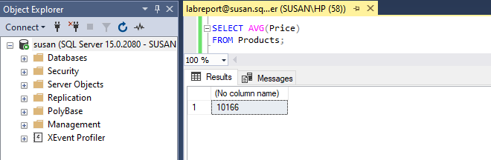

1. Syntax:(SUM)

SELECT SUM (column_name)

FROM table_name

WHERE condition;

Query with Output:

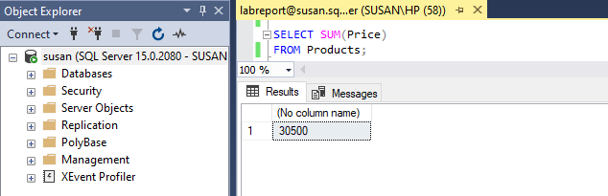

1. Display students' names with "or" in any position.

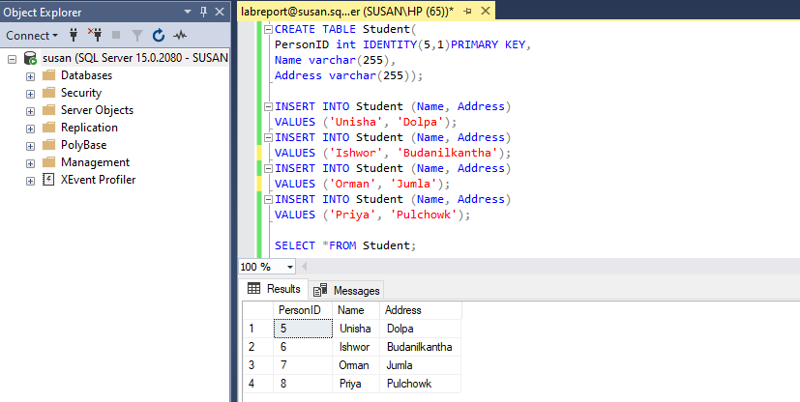

Syntax:

SELECT * FROM table_name

WHERE column_name LIKE ‘%a%’;

Query with Output:

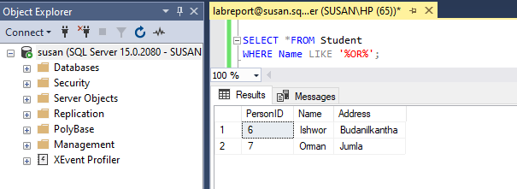

1. Display all customers that are not located in India and the USA.

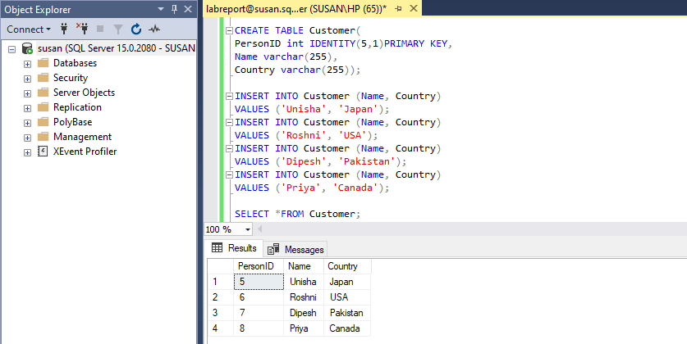

Syntax:

SELECT column1, column2, .....

FROM table_name

WHERE NOT condition ;

Query with Output:

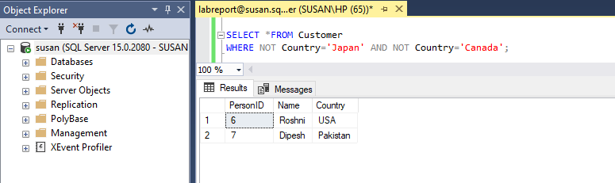

16. Display all orders with an OrderDate between '01-July-2020' and '31-July-2020'.

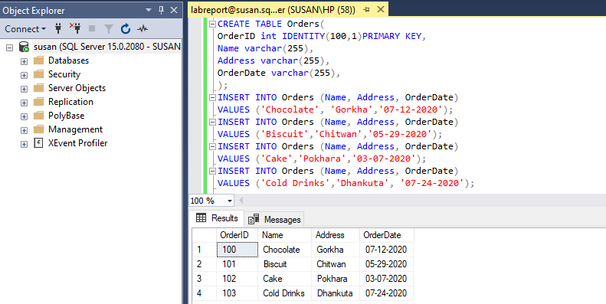

Syntax:

SELECT column_name(s)

FROM table_name

WHERE column_name BETWEEN value1 AND value2;

Query with Output:

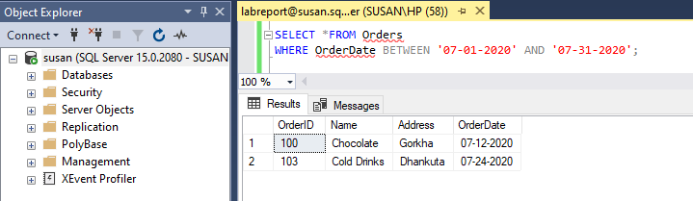

17. Count the number of customers in each country.

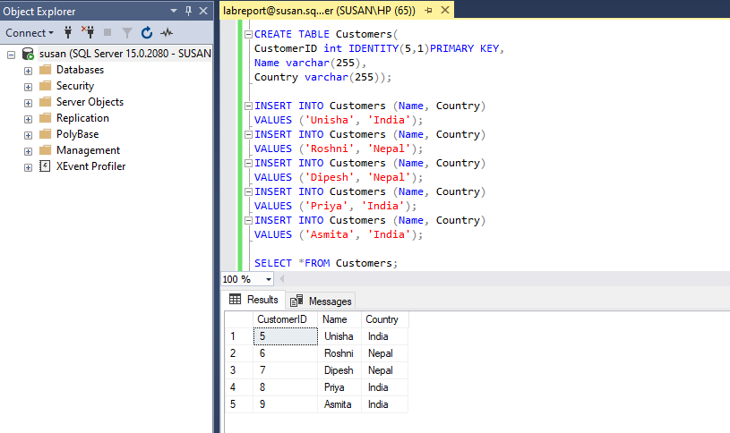

Syntax:

SELECT COUNT (column_name)

FROM table_name

GROUP BY column_name;

Query with Output:

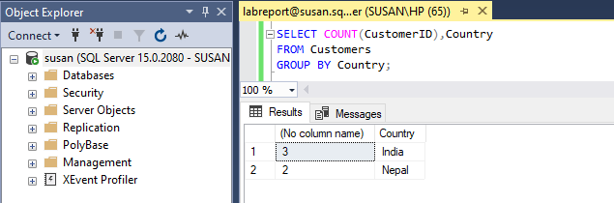

1. Create a view to display all tourists from China.

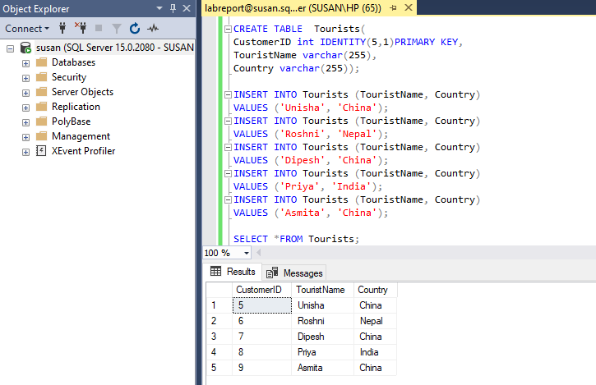

Syntax:

CREATE VIEW view_name AS

SELECT column1, column2, …..

FROM table_name

WHERE condition;

Query with Output:

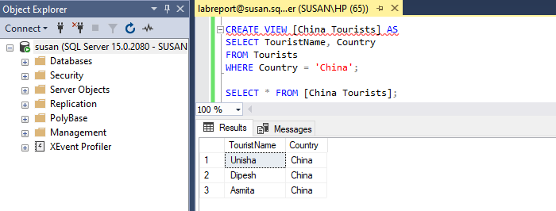

1. Create a stored procedure named "SelectAllStudents" that selects all records from the "Students" table.

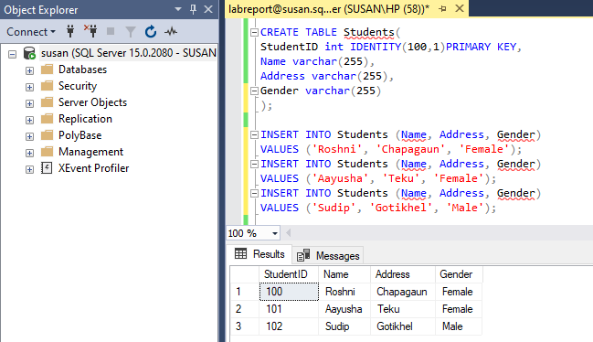

Syntax:

CREATE PROCEDURE procedure_name

AS

sql_statement

GO;

Query with Output:

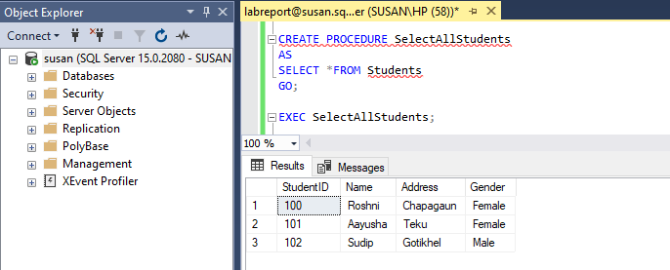

1. Create a trigger that stores transaction records of each inserted operation on the Students table.

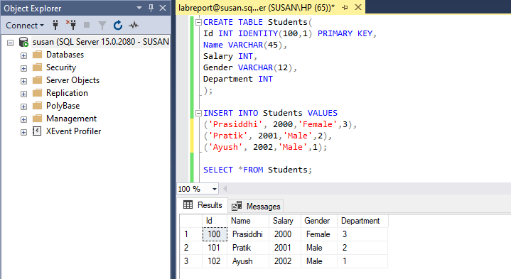

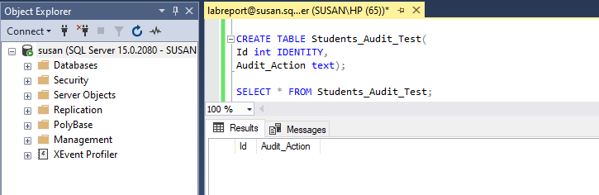

Syntax:

CREATE TRIGGER schema.trigger_name

ON table_name

AFTER {INSERT}

{NOT FOR REPLICATION}

AS

{SQL Statements}

Query with Output:

