**FST_M4 Hadoop Activity 2**

Create a text file named file01.txt in the local filesystem. Add the following text to the file

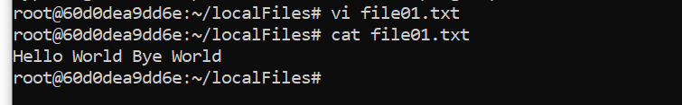

Copy file01.txt to the HDFS

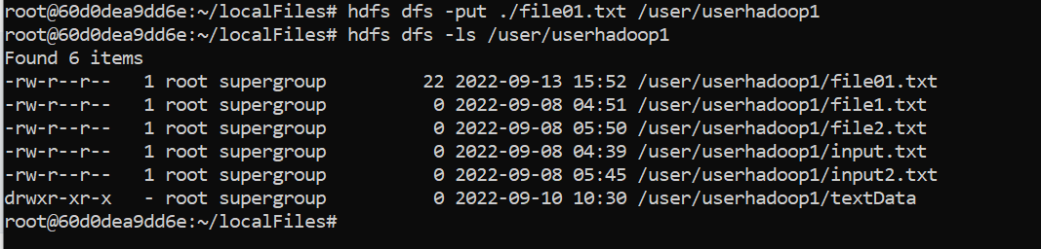

Create a file named wordcount.pig in the local filesystem. Add the following text to the file

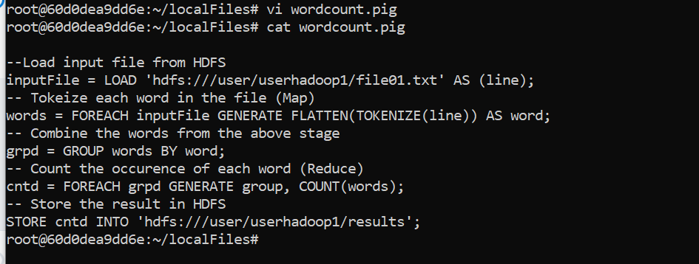

start historyserver



To execute the script, simply run the command as shown below

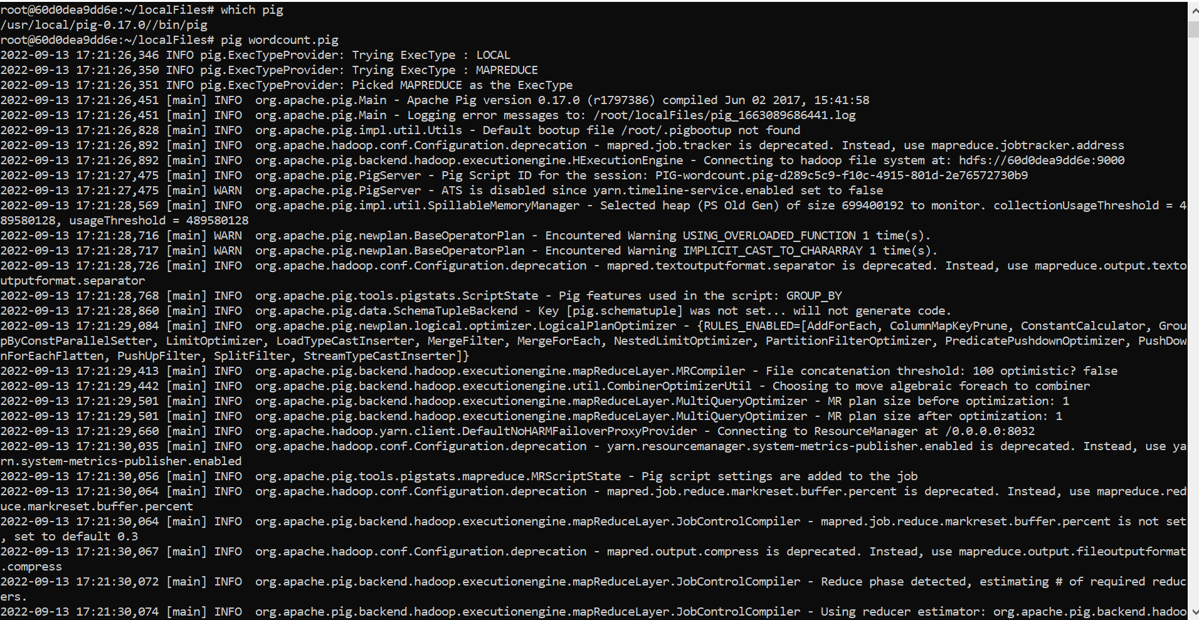

Verify the result folder is created in HDFS

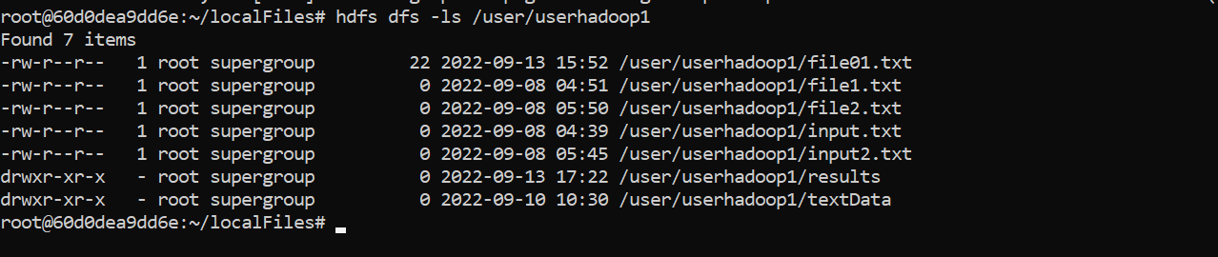

To view the result, you can use the cat command in the HDFS:

