**FST_M4 Hadoop Activity 3**

Create a text file named sales.csv in the local filesystem. Add the following text to the file

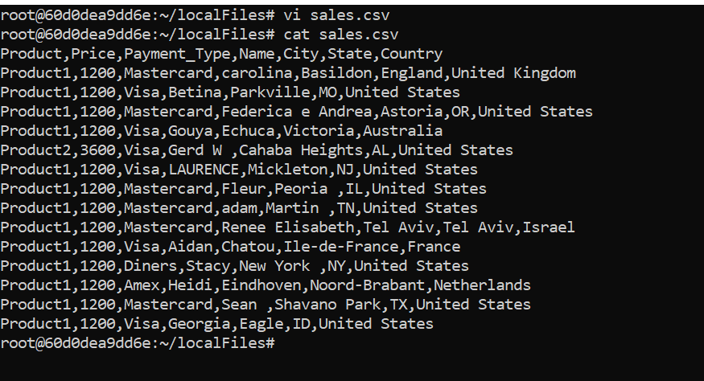

Copy sales.csv to the HDFS

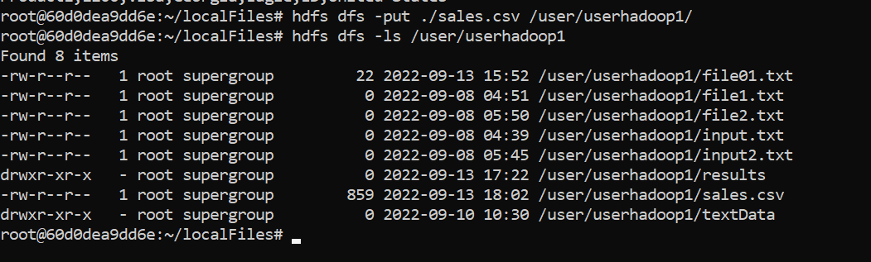

Create a file named salesCSV.pig in the local filesystem. Add the following text to the file

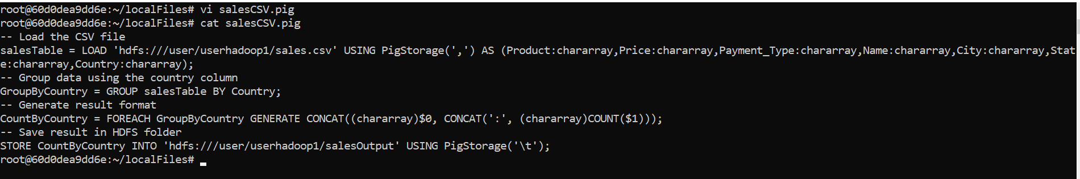

To execute the script, simply run the command as shown below: $ pig salesCSV.pg

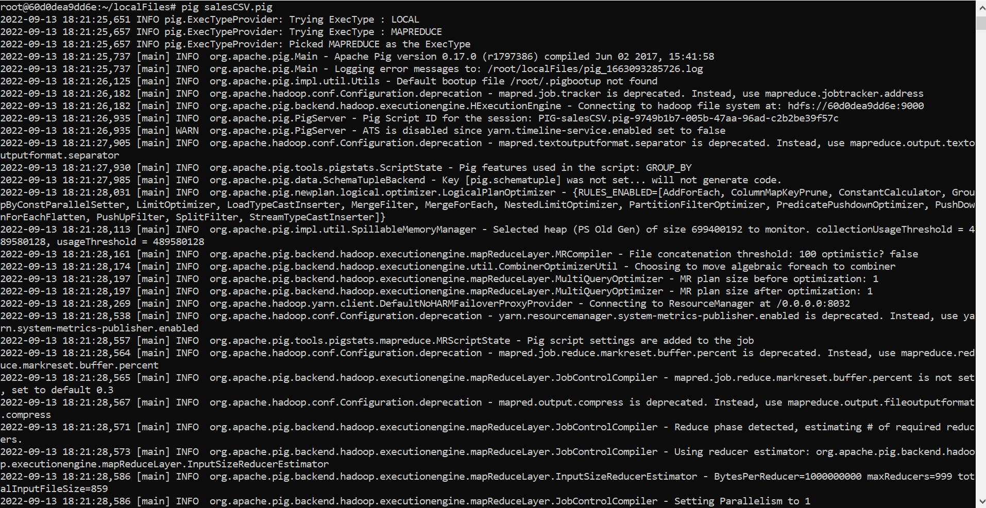

Verify the salesOutput folder is created in HDFS

To view the result, you can use the cat command in the HDFS:

