**FST_M4 Hadoop Hive Activity 4**

# To run the hive command to start the Hive CLI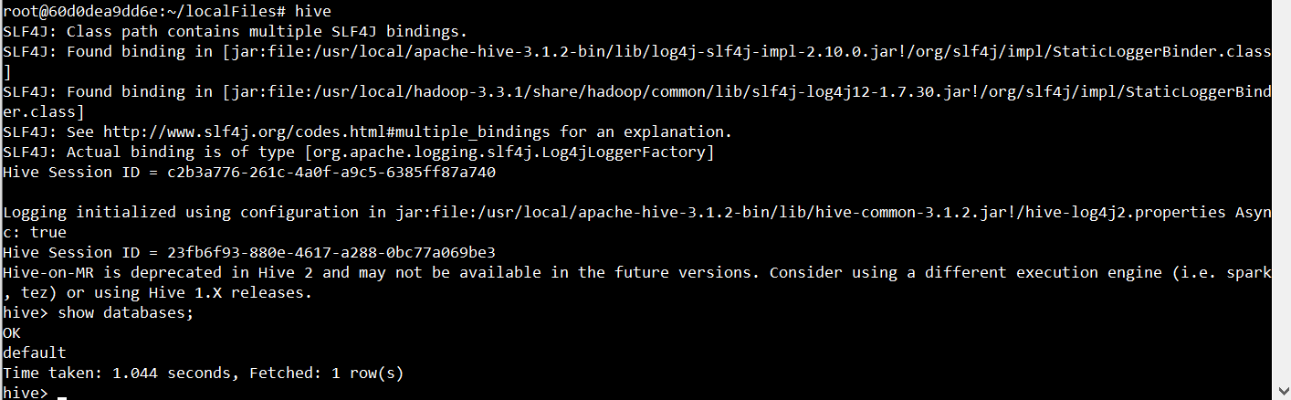

# Create a table to store results



# Load data into the database using a file on your local system (NOT HDFS)



# Create a new table using data from the files table

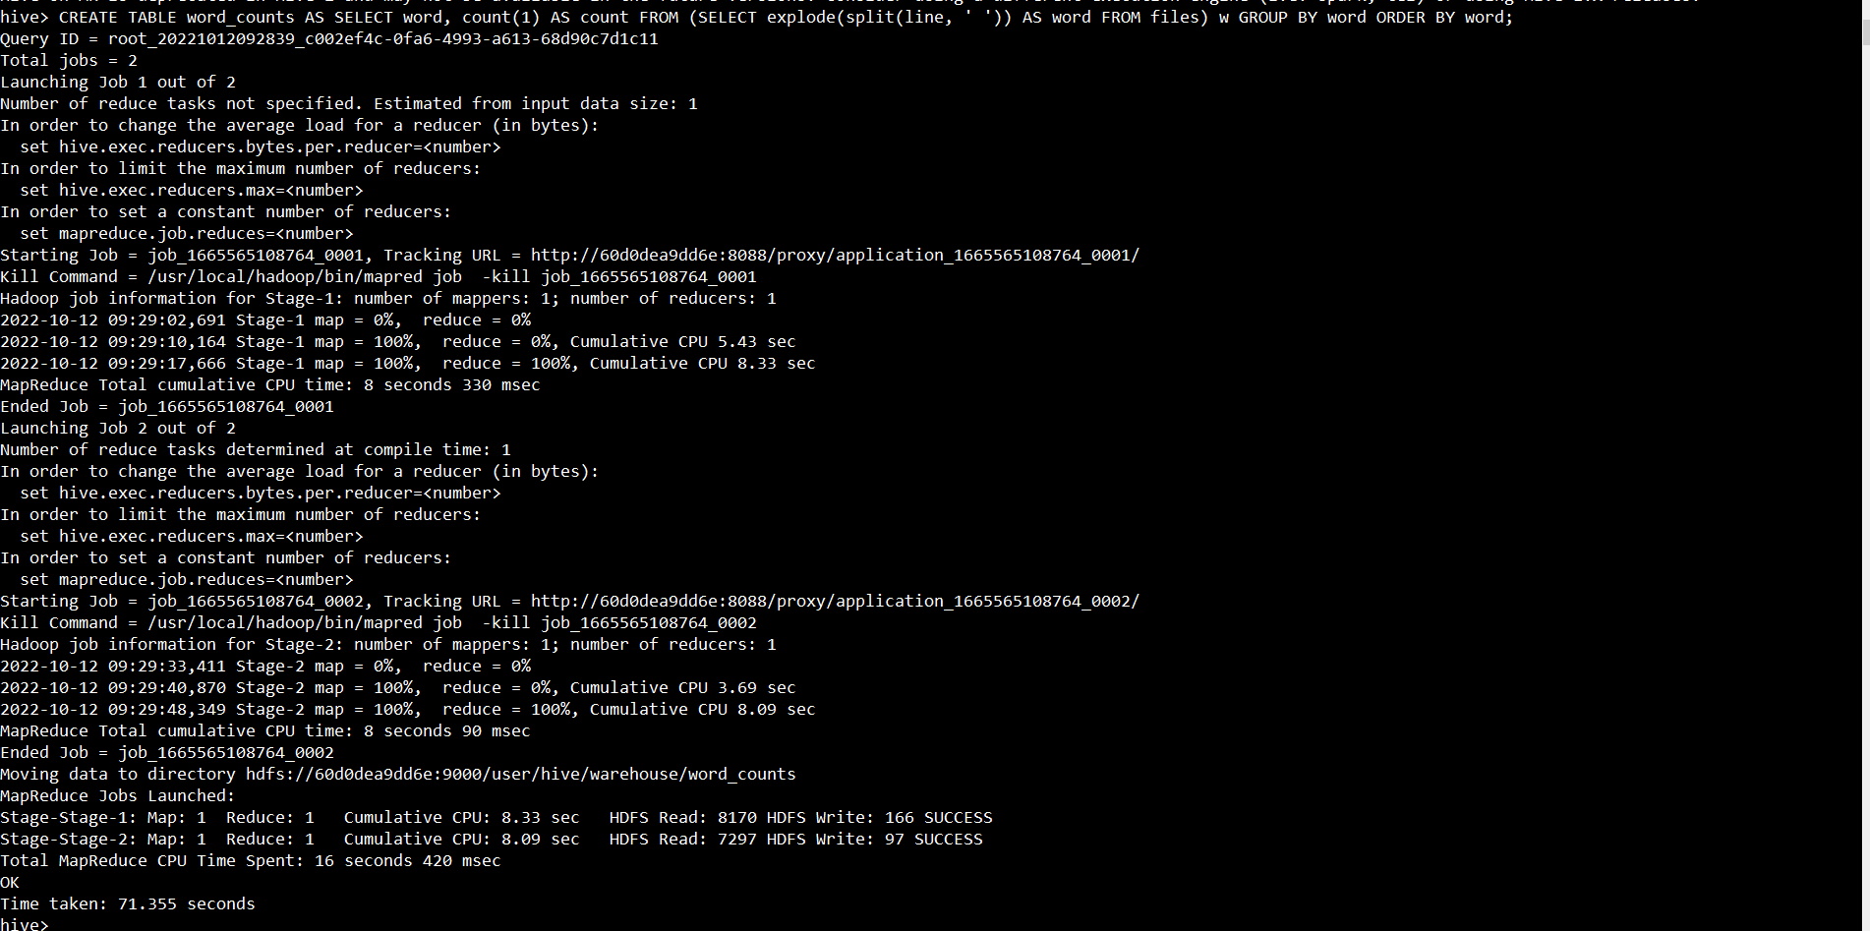

# To see the result, run a SELECT query on the word_counts table

