**FST_M4 Hadoop Hive Activity 5**

# Create a text file named EmpData.csv in the local filesystem. Add the following text to the file

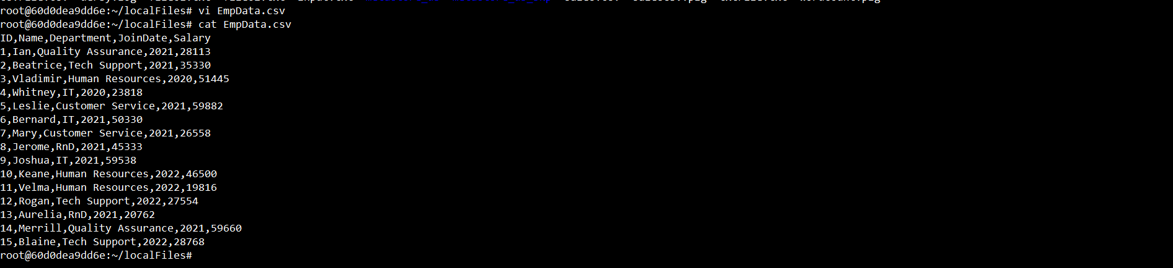

# To run the hive command to start the Hive CLI

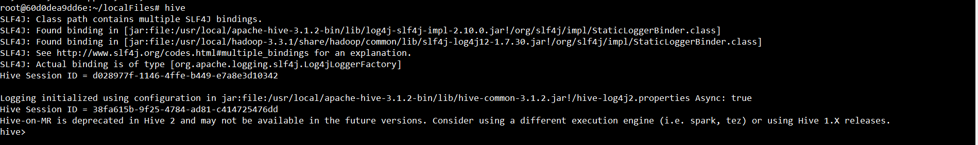

# Create a database named office



# Query to set office as the default DB



# To create a table named employee

# Use the DESCRIBE clause to see the structure of the table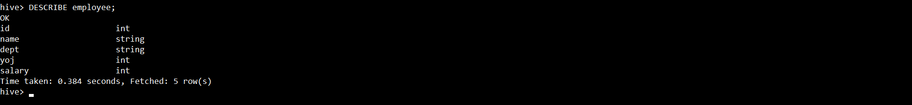

# To add into the employee table from a local file



# To see the data that has been loaded into the employee table

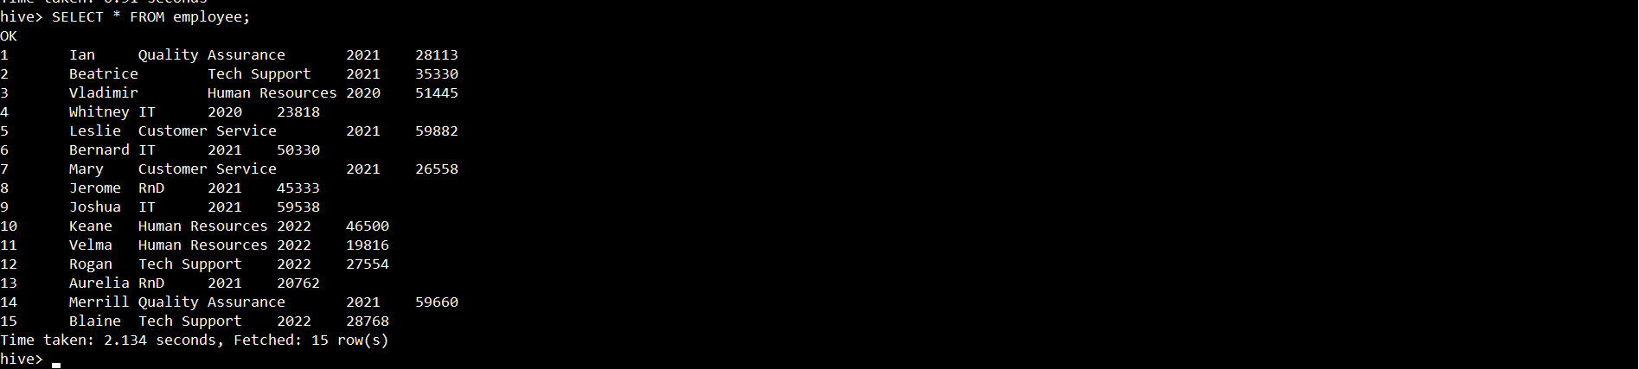

# To count the number of rows in the table, we can use

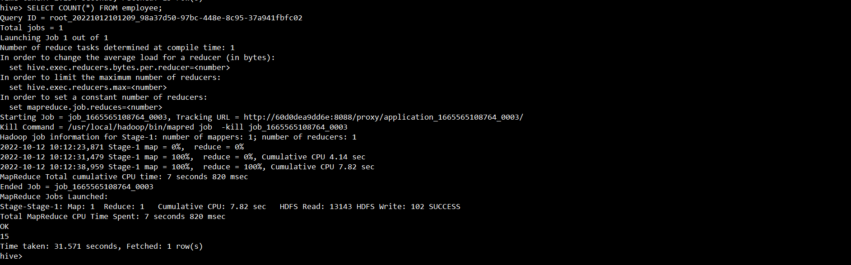

# Column operations

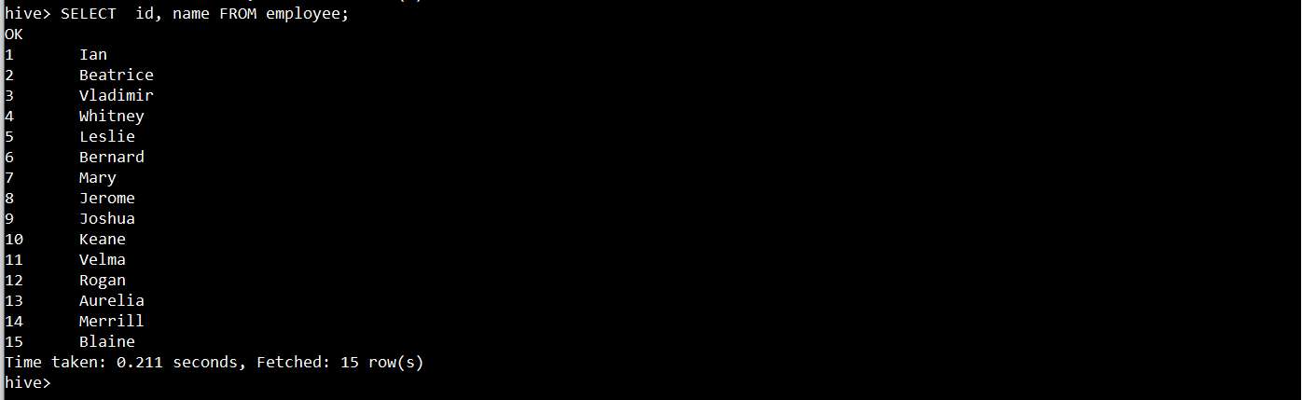

# Row operation

# Exports results to HDFS directory

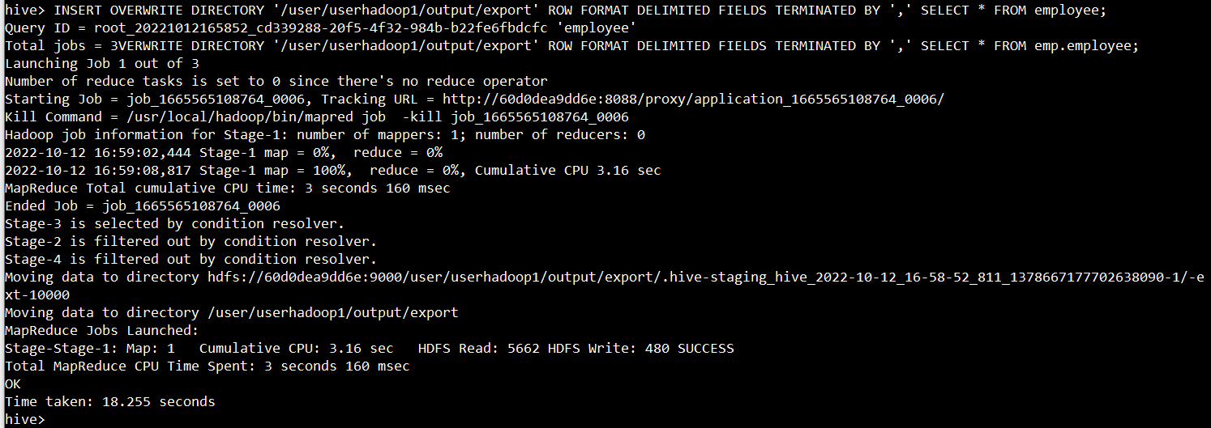

# To execute DFS commands from Hive CLI



# Exports to LOCAL directory

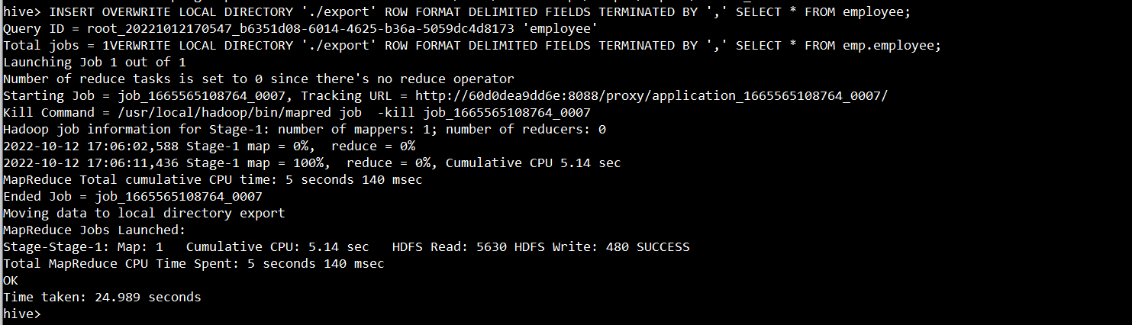

# To view the result

