**FST_M4 Informatica Activity 2**

Create Mapping2

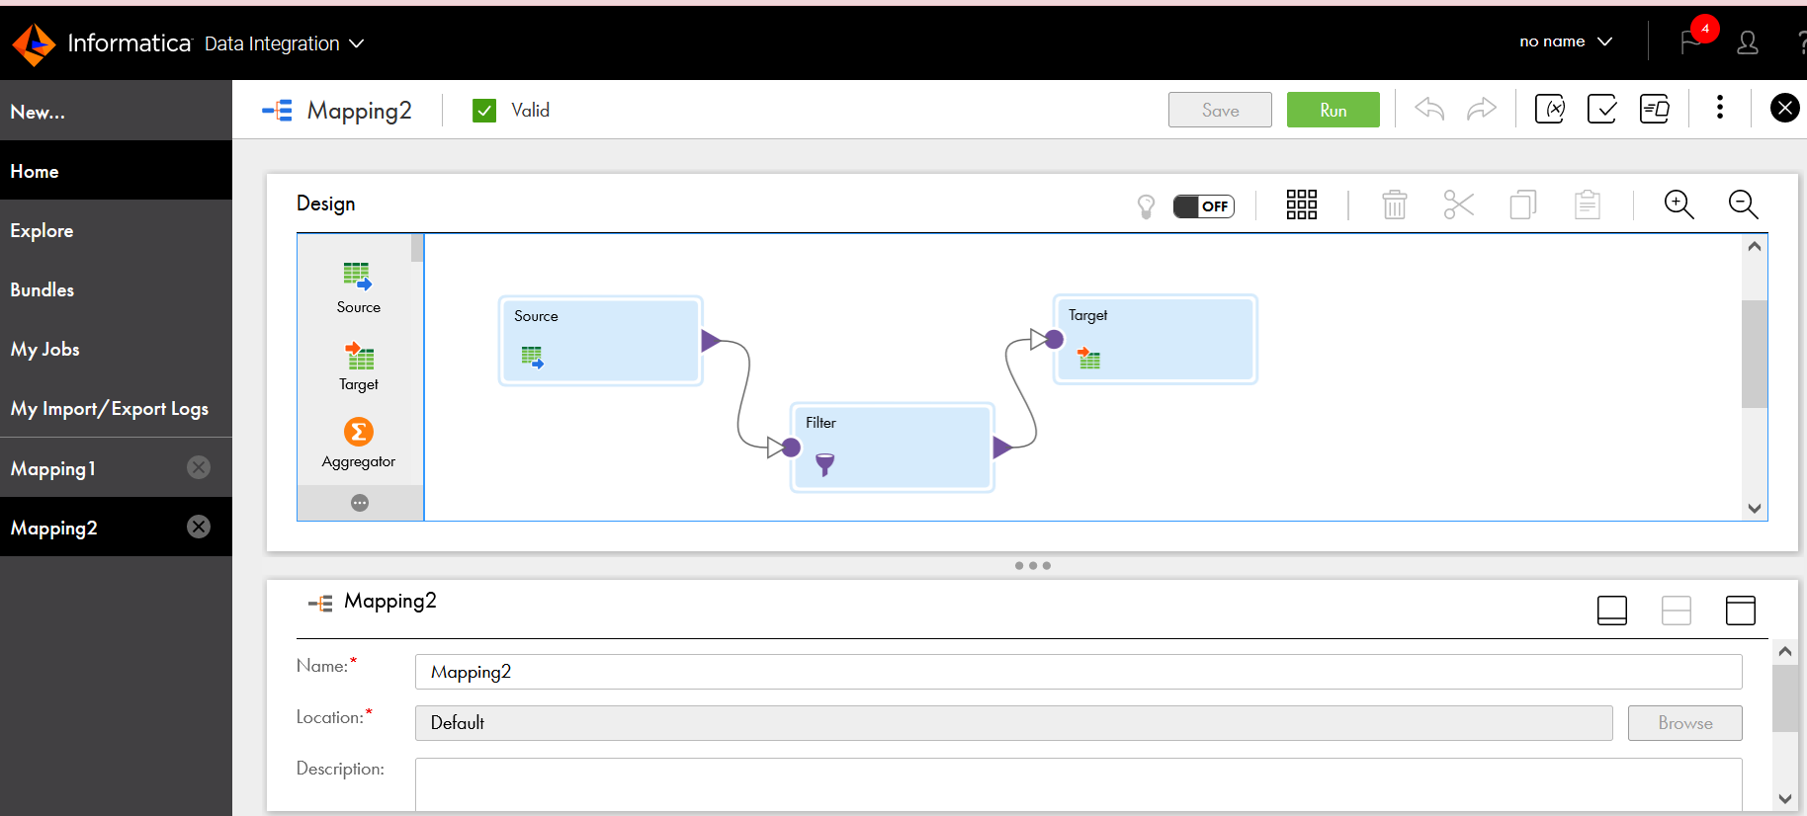

Add Source properties

Add Target properties

Add Filter

Mapping2 job after running

