**FST_M4_Project Informatica Activity-1**

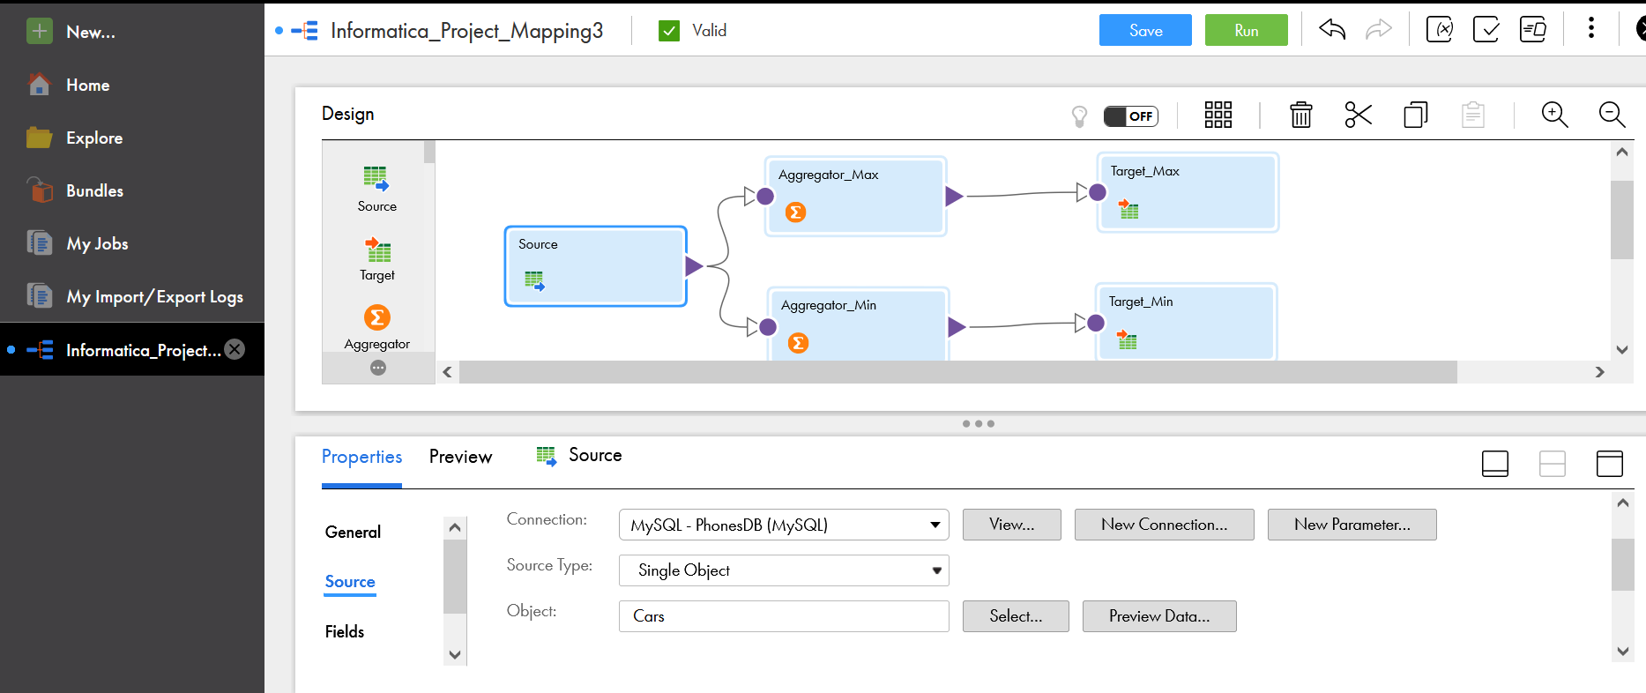

Max_Car_Prices

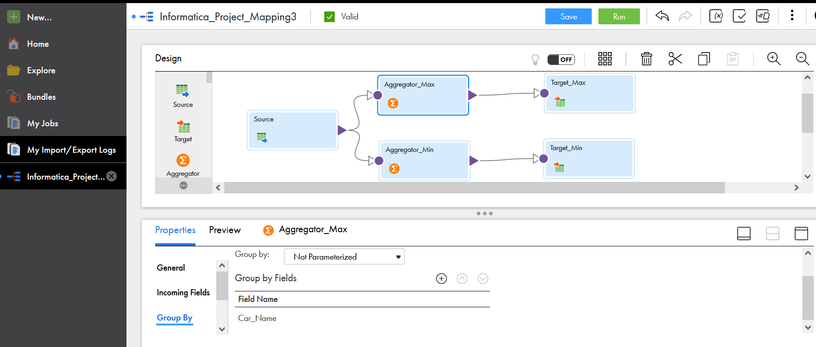

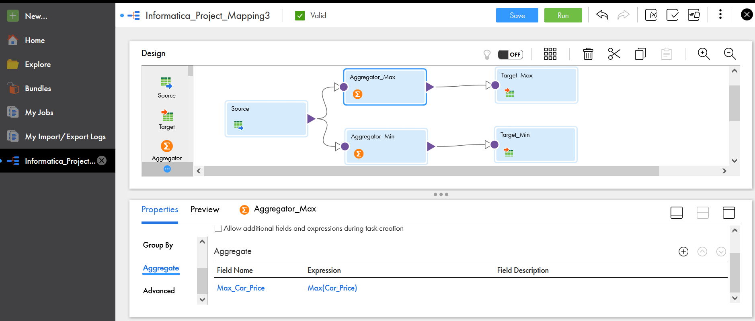

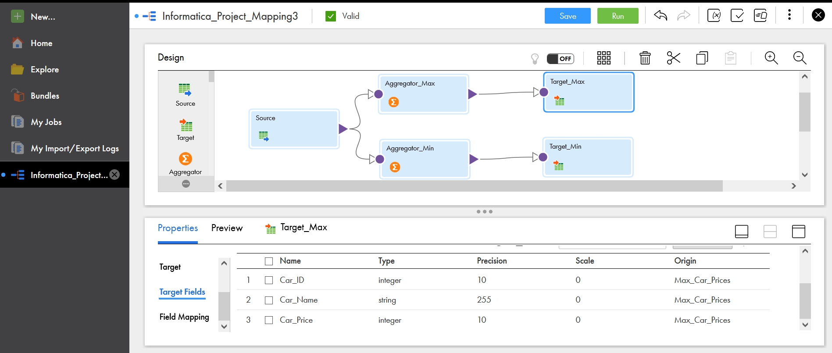

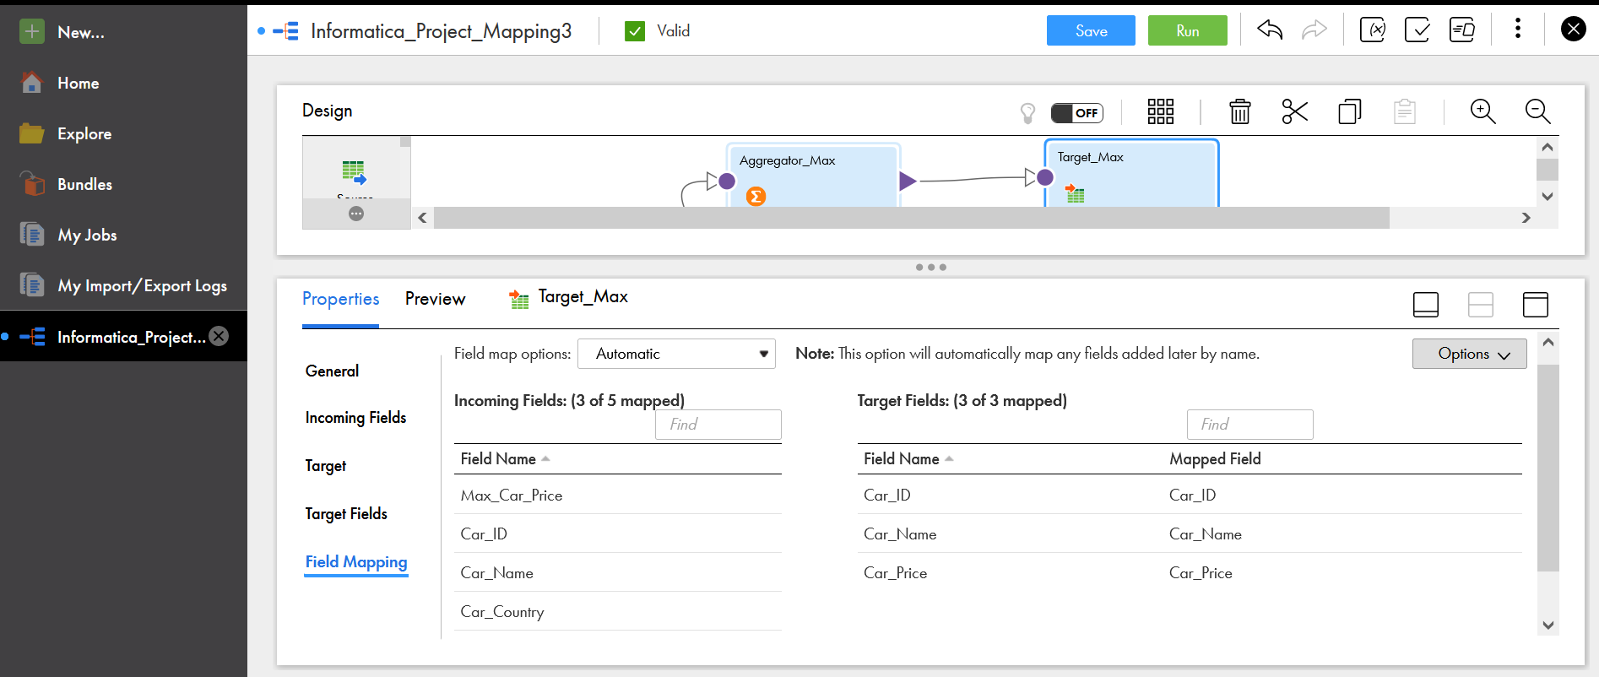

Min_Car_Prices

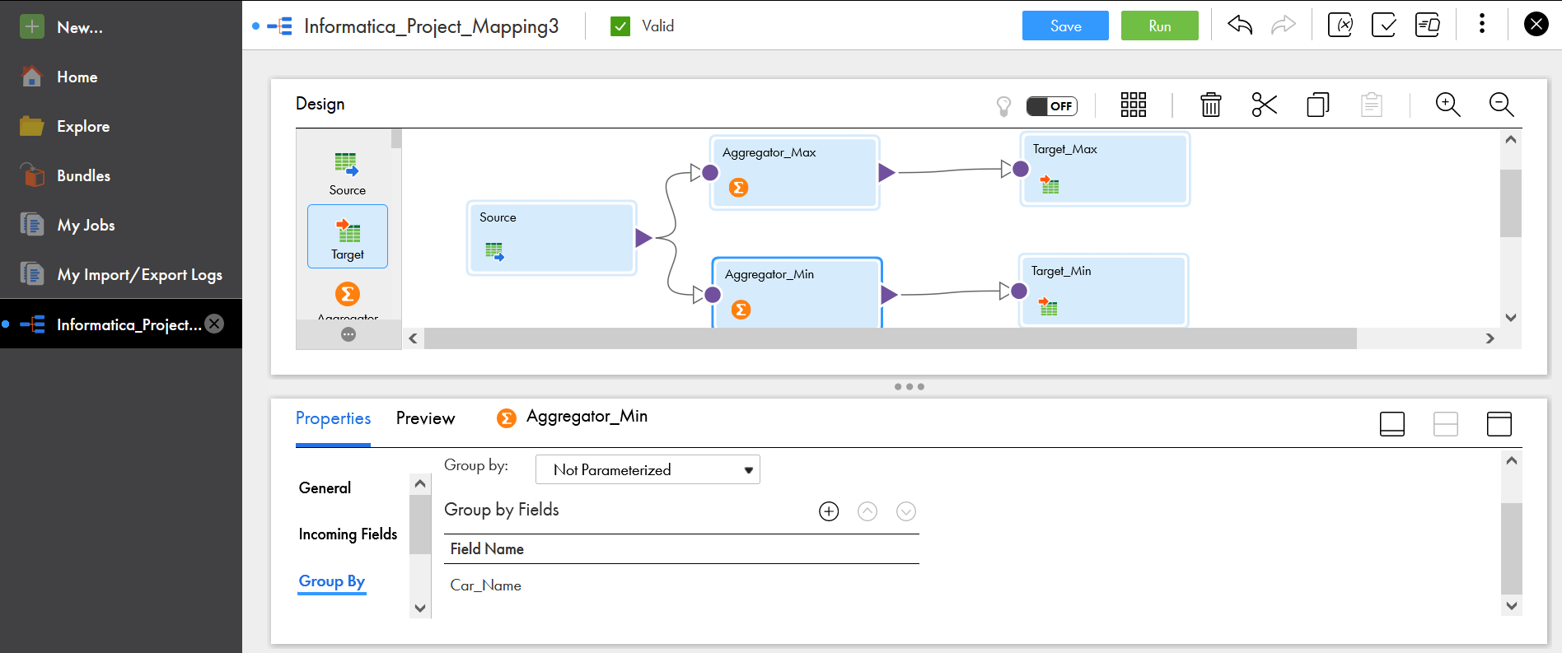

Jobs:

