**FST_M4_Project Pig Activity-1**



root@e0e871ac43a6:~/localFiles# vi episodeIV_dialouges.txt

root@e0e871ac43a6:~/localFiles# cat episodeIV_dialouges.txt



root@e0e871ac43a6:~/localFiles# vi episodeV_dialouges.txt

root@e0e871ac43a6:~/localFiles# cat episodeV_dialouges.txt



root@e0e871ac43a6:~/localFiles# vi episodeVI_dialouges.txt

root@e0e871ac43a6:~/localFiles# cat episodeVI_dialouges.txt

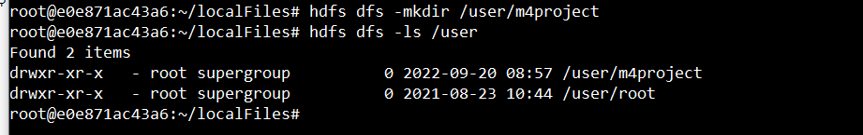

Copy text files to the HDFS

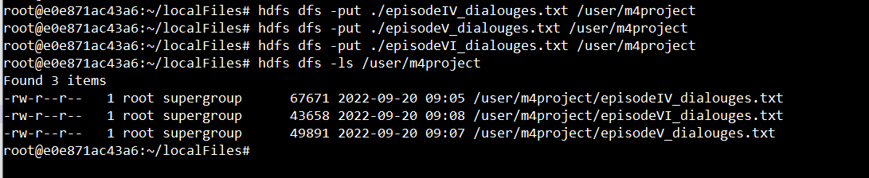

Create a file named episodeIV.pig in the local filesystem. Add the following text to the file

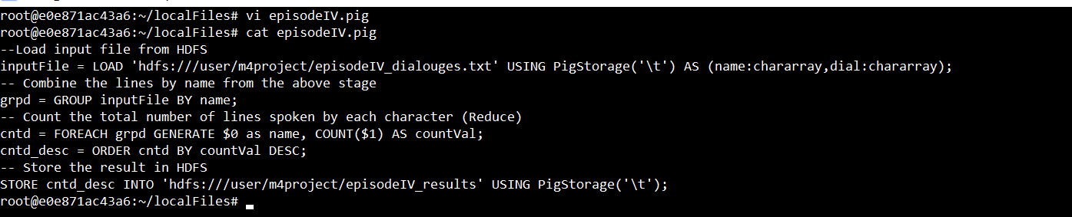

To execute the script, run the command as shown below:

$ pig episodeIV.pg

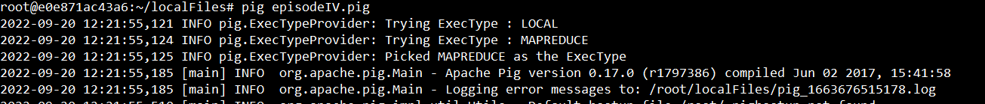

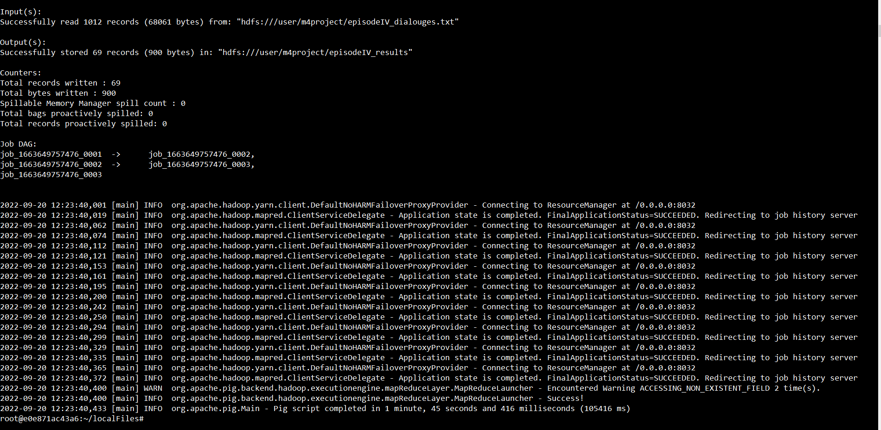

Verify the episodeIV_results folder is created in HDFS

To view the result, you can use the cat command in the HDFS:

Create a file named episodeV.pig in the local filesystem. Add the following text to the file

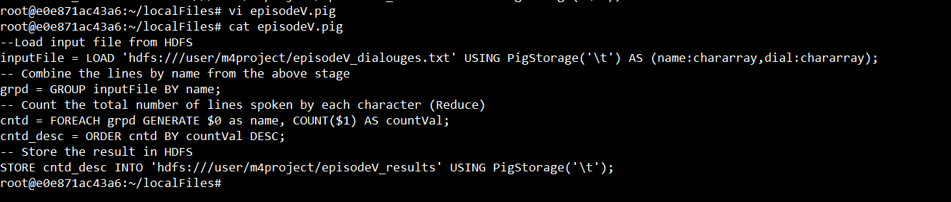

To execute the script, run the command as shown below:

$ pig episodeV.pg

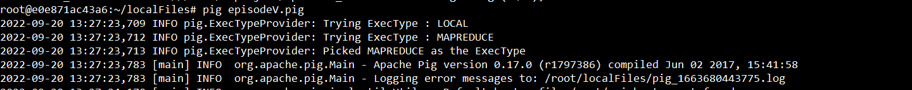

Verify the episodeV_results folder is created in HDFS

To view the result, you can use the cat command in the HDFS:

Create a file named episodeVI.pig in the local filesystem. Add the following text to the file

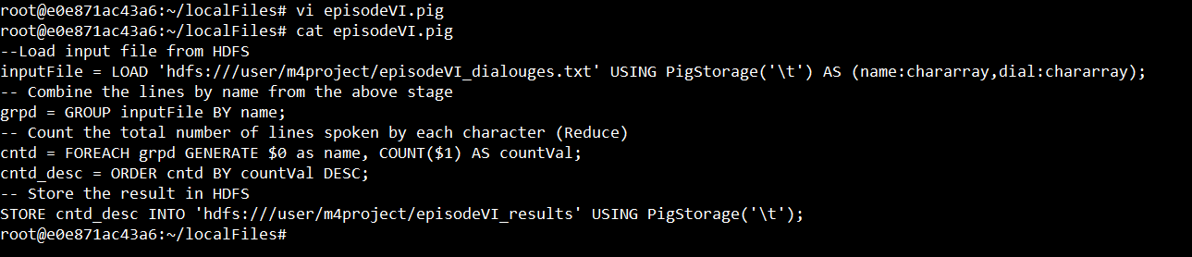

To execute the script, run the command as shown below:

$ pig episodeVI.pg

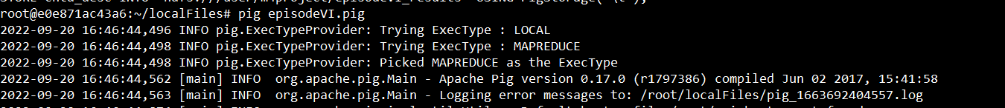

Verify the episodeVI_results folder is created in HDFS

To view the result, you can use the cat command in the HDFS

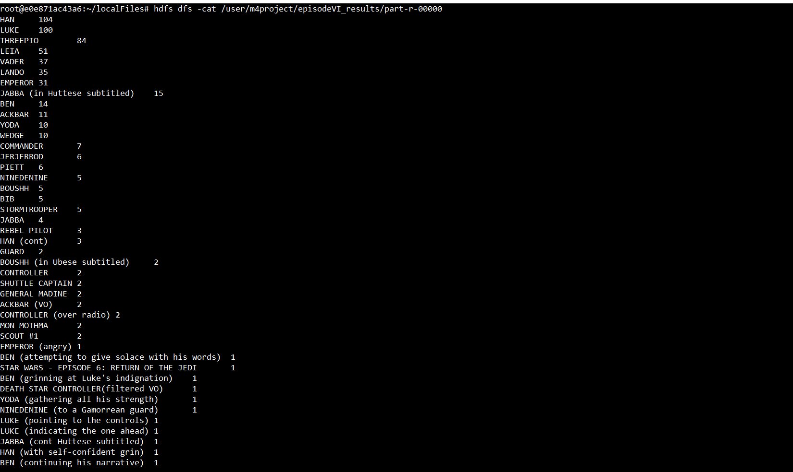

To save copy of the output file episodeIV_results in the local system



To save copy of the output files episodeV_results, episodeVI_results in the local system

