**James Cook Australia Institute of Higher Learning**



**CP5637 – Content Management System**

Assignment 3

Project Plan and Small Website

**Submitted to**

Professor : Dr. Cue Nguyen

Subject Coordinator : Lindsay ward

**Submitted by**

Name : Rajkumar Govindaraj Viswanathan

Student ID : 13102957  
Trimester : SP22 2016

**Project Plan**

The plan of this project is to create an online shopping website “O.Z. Shop”. The main objective is to develop a website for online shopping Apple and Samsung mobile. I have focus on the Apple and Samsung products like Mac, iPhones, iPad and iWatch. This website will provide detailed information of Apple and Samsung products. The users can also compare a product with other Apple products, the users can also rate the product based on the design, performance and usability.

**Goals**

O.Z. Shop was created as a practice of website project. Later this website will be further developed with WordPress and Joomla for a full and functional website. This website will not be just a basic study level project rather I have started creating website in professional manner where I will be using this for my future project purposes.

**Success Evolution**

Success of the website will be counted on the below metrics.

1. The success login attempts will be counted to check how many members have logged-in.

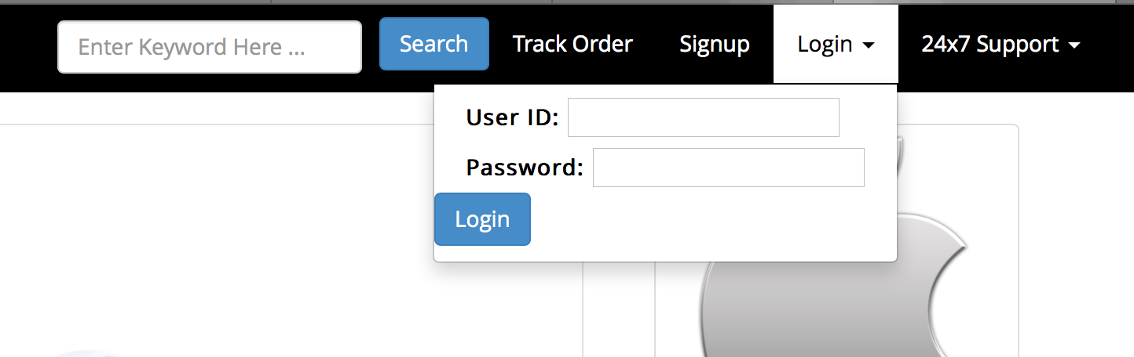

1. SEO – Using Search Engine Optimization by keyword
2. Google Analytics – Find the users by which way they have reached the website, i.e via FB, Google (keyword) or by directly.

* Find the users location and focus on their location to market the website and its benefits.
* Find the time spent on the website and find which page the users spend more time.

The website has been linked with the social media such as Facebook, Twitter, Google+, Instagram, Pinterest. Using these social media at the beginning stage to make the website to reach the audience directly and making them to get knowing about the website.

**Target Audience**

* We target both primary user and secondary users (guest)
* Primary Audience: Teenage boys and Girls
* Secondary Audience: Young Adults and Adults
* Age: 18+
* Gender: Male and Female.
* Also we focus education area because now a day’s education become more technologist and in the school and colleges they used iPad and MacBook for providing good education to students. Discuss the characteristics of the target users

**Site Flow**

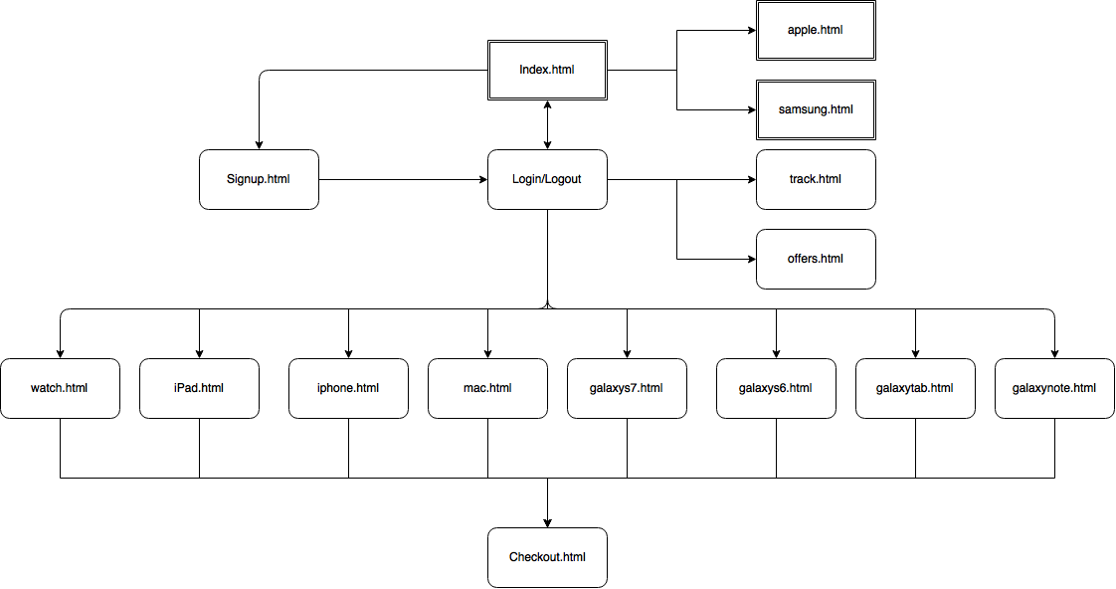

**Small Website**

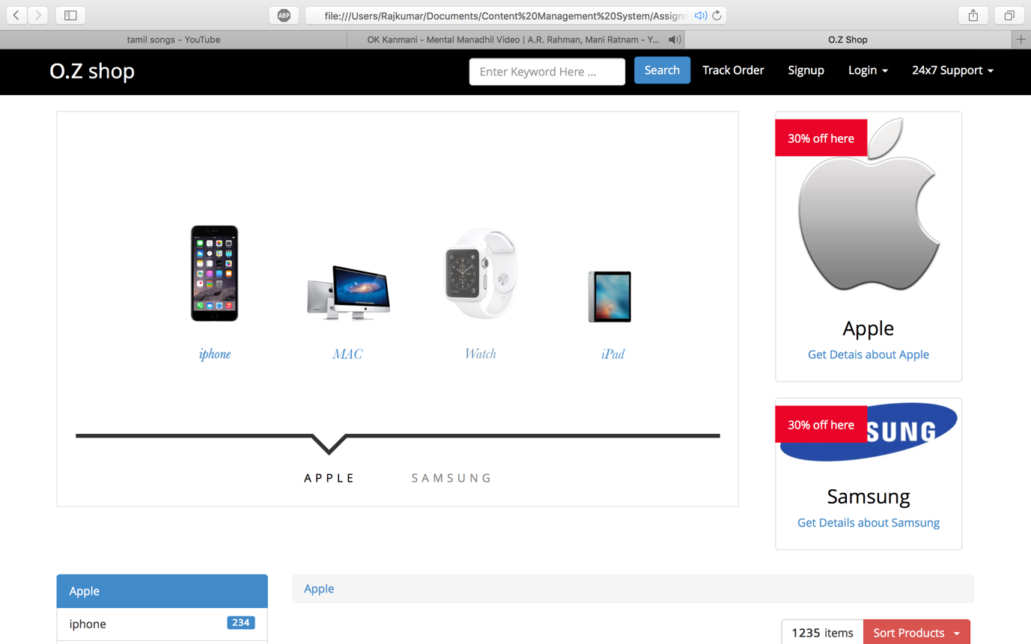

Index/Home page

Track Order

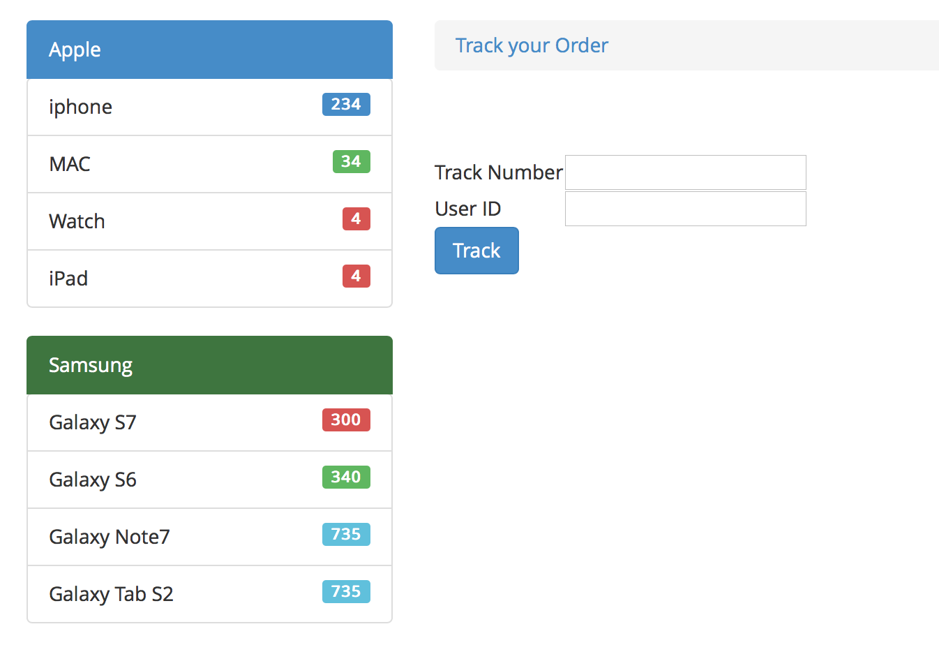

Product Description

