# Components Used

* Arduino Uno

The main controller of the bot.

* IR LEDs x2

Send IR rays which reflect from the ground

* Photo diodes x2

IR rays receiver. Detects whether it is on top of white or black area depending on amount of light received

* L293d Motor Driver

Drives the motors as directed by the Arduino

* Ceramic/Wood Plate (for Body)

Everything is attached here

* Motors + Wheels x2

Left and right. Will rotate to direct the bot

* Batteries

Power Source

* Caster Wheel

Support on the front

# Assembling the Project

* On the body plate first fix the right and left motors and attach wheels to them
* Attach a caster wheel (front bottom) to lift the body from the front
* Solder IR LED and Photo diode on a PCB and envelope them with black tape

A close up of a logo

Description generated with very high confidence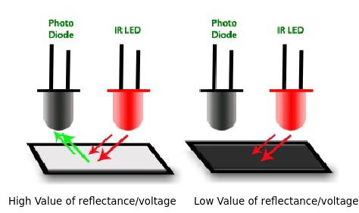

* Repeat for another pair
* Attach them on either side of the caster wheel
* Make sure they are as close to the ground as possible
* Make the connections to the Arduino
* Motors are connected through L293d

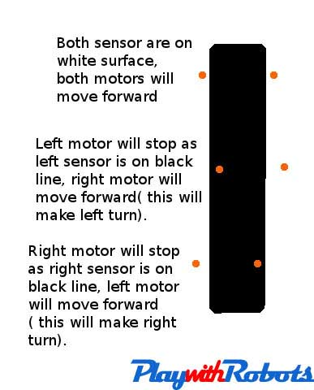 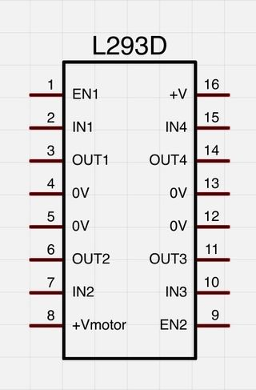

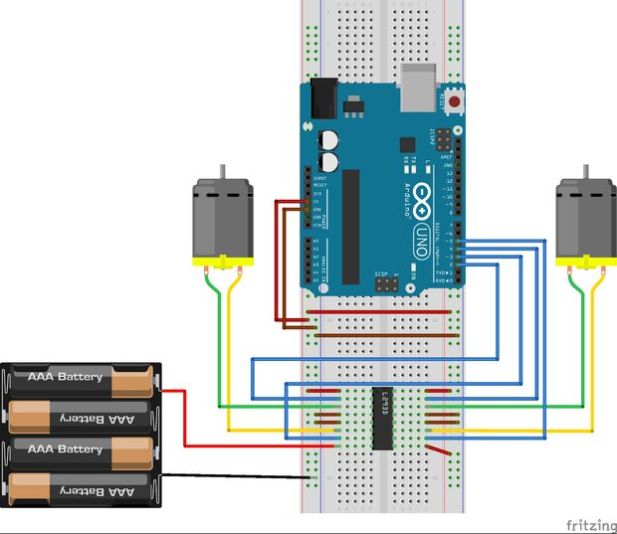

## Taking Initial Readings

* Although assembly is done coding is not yet complete
* From the input pin (where photodiode gives current input) check what are the readings when the LED-Photo Diode are above white and black part respectively.
* Take a range of readings and add a safe limit to be sure.
* Hard code (recommended only during first iteration – later use PID) these values into your code so that now the bot automatically recognizes which part of it is where right now.

## Our Readings

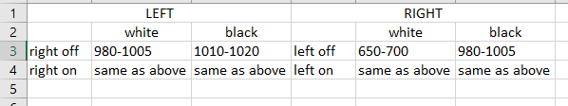

# Problems Faced

* There were large fluctuations in data of sensors. So, we had to make tries in various lighting environments to get an average range
* Not having enough prior knowledge, we made the sensor (LED+Photodiode) ourselves by soldering the 2 on a PCB. However, such components already existed due to which we lost time.
* We intended to implement PID in our code but had to scrap the idea since assembly an initial prototype took longer than we expected to work

# References/Citation

* We had a basic background of using Arduino and L293d. However, to implement this to make our project, we referred to <http://playwithrobots.com/simple-line-follower-robot/>