Name: Raj Shah

PSID: 1499521

Email:rpshah6@uh.edu

=====================================================================================

#Problem 1

# Finds number of Terms in the vector and returns True if EVEN Number of Terms else returns False

#If required Argument is True, Prints the avg.

> find_terms <- function(x,printavg=FALSE){

+ n <- length(x)

+ ans<-(sum(x[0:n])/n)

+ if (printavg == TRUE) print(ans)

+ if (n %% 2 == 0) #Checks No. of Elements in Sequence

+ return(T) #Prints True if Even number of Elements

+ return(F)

> x <- c(1,2,3,4)

> find_terms(x)

[1] TRUE

> y <- c(6,6,6)

> find_terms(y,printavg=T)

[1] 6

[1] FALSE

> z <- c(1,5,3,7,9)

> find_terms(z,printavg=T)

[1] 5

[1] FALSE

> w<-c(7,3,4,9,2,7,5,8)

> find_terms(w,printavg=T)

[1] 5.625

[1] TRUE

> q<-c(9,3,2,4,8,3,4)

> find_terms(q,printavg=F)

[1] FALSE

#Problem 2

## for-loop - goes through values of 'sex' and 'igf1' scalar-by-scalar

#....

>count_m<-0

>count_f<-0

>for (i in 1:length(juul.sex.igf1.noNA$igf1)){

+ ifelse(juul.sex.igf1.noNA$igf1[i]>400,ifelse(juul.sex.igf1.noNA$sex[i]<1.1,count_m<-count_m + 1,count_f<-count_f + 1),1)

+}

>d<-data.frame(count_m,count_f)

>names(d)<-c("M","F")

>print(d)

M F

144 217

#

# ## vectorized solution - operates on 'sex' and 'igf1' as vectors

# #....

>number<-juul.sex.igf1.noNA$sex[juul.sex.igf1.noNA$igf1>400]

>print(table(ifelse(number>1.1,'F','M')))

F M

217 144

# # subsetting solution - via function subset() for the 'juul.sex.igf1.noNA' data frame

# # + another function that actually counts the number

>m_num<-subset(juul.sex.igf1.noNA,sex=="1" & igf1>400 | sex=="2" & igf1>400,select=c(sex))

>c_label<-table(m_num)

>names(c_label)<-c("M","F")

>print(c_label)

M F

144 217

#Problem 3

library(readr)

library(pastecs)

kiwi <- read.csv("C:/Users/Raj Shah/Downloads/Studies UH/MATH 6359 Stastical Computing/test.csv",header=TRUE,sep=",")

attach(kiwi)

head(kiwi)

nrow(kiwi)

plot(juice,ohms)

kiwiohms<-cbind(juice,ohms)

options(scipen=100)

options(digits=2)

stat.desc(kiwiohms,basic=F)

juice ohms

median 41.00 3650.00

mean 35.15 4360.00

SE.mean 1.46 164.39

CI.mean.0.95 2.89 325.29

var 273.49 3458874.02

std.dev 16.54 1859.80

coef.var 0.47 0.43

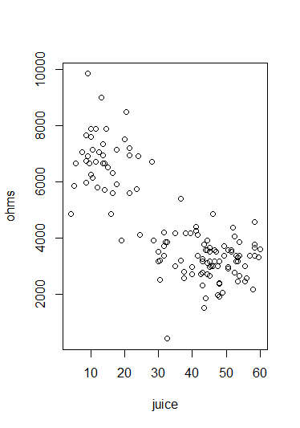

Plot of ohms vs juice of Kiwi fruit

**Short Summary**

This is the data representing the electrical resistance of kiwi fruit depending upon the juice content of the fruit. The mean and standard deviation value for juice is 35.15 and 16.54 respectively. The mean and standard deviation value for ohms is 4360.00 and 1859.80 respectively. We see as the amount of juice increases the electrical resistance decreases.

There is a huge cluster at juice content ~45 and electrical resistance of ~3000 ohms.