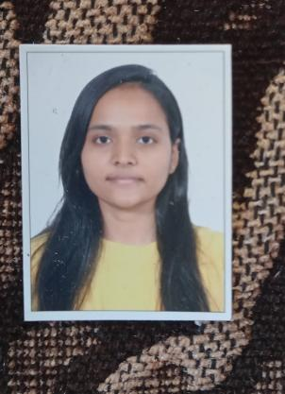gu

8451012064

[Nedhisingh2002@gmail.com](mailto:Nedhisingh2002@gmail.com)

D-5 Vrundavan, Township,

Bhestan,Surat,Gujarat.

**NIDHI SINGH**

Resume

**HONOR**

**Skills**

**Skills**

**Education**

|  |  |  |  |
| --- | --- | --- | --- |
| M.Sc Biotechnology | C.G.Bhakta Institute of BIotechnology,Gujarat | 2022 |  |
| B.Sc MIcrobiology | Lords Universal College,Mumbai | 2019-2022 | CGPA-8.63 |
| HSC | Saraf Junior College,Mumbai | 2017-2019 | 56% |
| SSC | St.Paul Public HIgh School,Gujarat | 2016-2017 | 72% |

|  |
| --- |
| **Languages** |

* **English**
* **Hindi**
* **Gujarati**
* **Team Work**
* **Attention to Detail**
* **Adaptability**
* **Time Management**