📘 PASSWORD CRACKING & CREDENTIAL ATTACK SUITE
Project Report

1️⃣ Project Title
Password Cracking & Credential Attack Suite
(A Red Team & Blue Team Credential Security Assessment Toolkit)

2️⃣ Project Overview
The Password Cracking & Credential Attack Suite is a modular cybersecurity toolkit designed to simulate credential attacks and perform password security assessments in a controlled and ethical environment.
The system demonstrates:
- Dictionary-based password attacks
- Brute-force attack simulation
- Linux shadow hash extraction
- Windows SAM hash extraction (offline)
- Password entropy and complexity analysis
- Organizational risk evaluation
- Structured audit report generation (TXT, JSON, PDF)
The toolkit provides hands-on exposure to real-world password attack methodologies while simultaneously implementing defensive security assessment techniques.

3️⃣ Practical Motivation
Passwords remain the most common authentication mechanism worldwide. Weak password practices lead to:
- Account Takeovers
- Privilege Escalation
- Data Breaches
- Credential Stuffing Attacks
- Lateral Movement in enterprise environments
This project enables understanding of:
- How passwords are stored
- How attackers crack hashes
- How brute-force simulations work
- How password strength is measured
- How organizations audit password security

4️⃣ Project Objectives
- Develop an advanced dictionary generator with mutation rules.
- Extract password hashes from Linux shadow files.
- Extract NTLM hashes from Windows SAM (offline).
- Implement dictionary and brute-force attack simulations.
- Analyze password entropy, complexity, and exposure risk.
- Generate a full security audit report (TXT + JSON + PDF).

5️⃣ Tools & Technologies Used
Programming Language:
- Python 3
Libraries Used:
- hashlib (hashing)
- argparse (CLI)
- math (entropy)
- reportlab (PDF export)
- pycryptodome (Windows SAM decryption simulation)
- json (structured report export)
- os, re, struct (system handling)
Development Environment:
- Linux (Kali)
- Python 3.11+

6️⃣ System Architecture
User Input (CLI)
↓
Dictionary Generator
↓
Hash Extraction (Linux / Windows)
↓
Attack Engine (Dictionary / Brute / Hybrid)
↓
Password Strength Analyzer
↓
Risk Metrics Engine
↓
Report Builder
↓
TXT + JSON + PDF Reports
Project Folder Structure
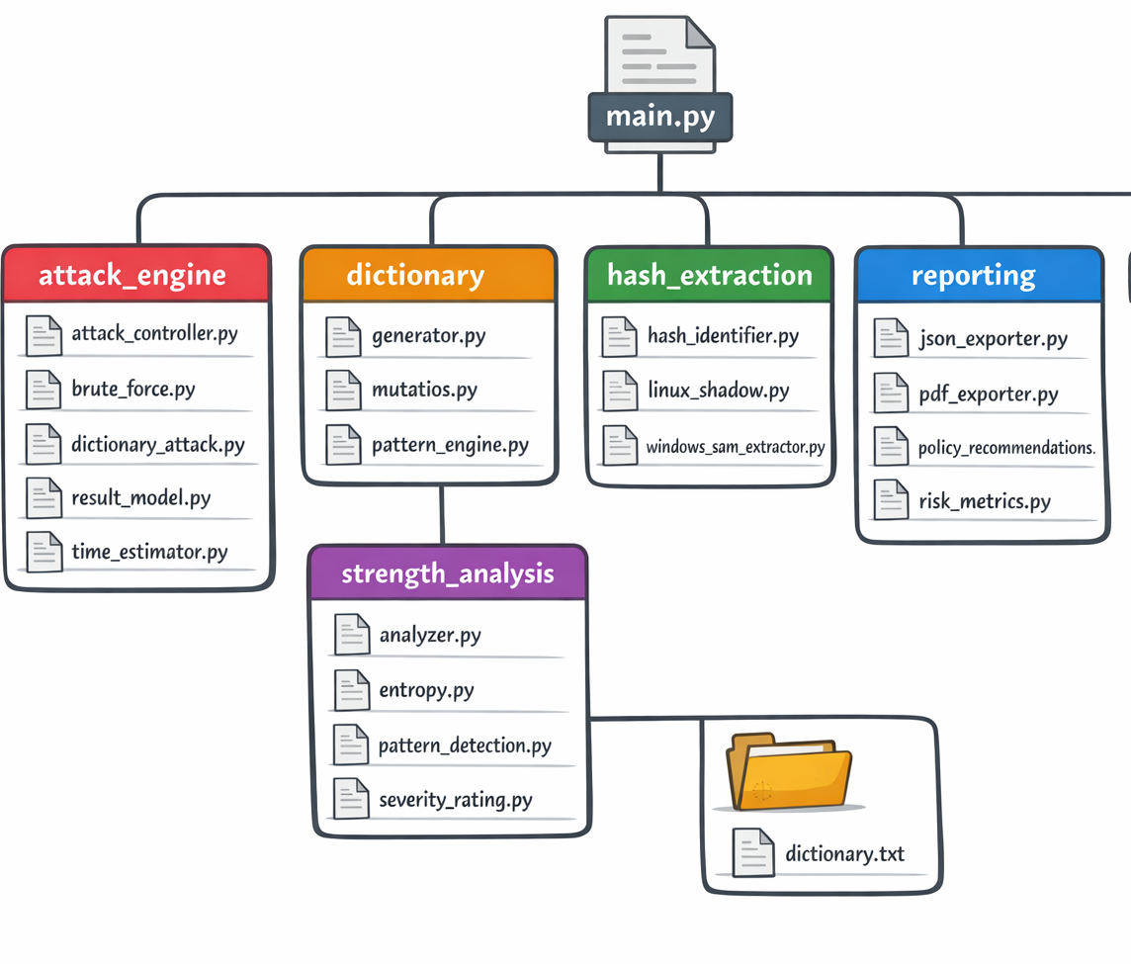

7️⃣ Module Implementation Details

7.1 Dictionary Generator Module
This module generates password candidates using:
- Personal pattern templates (name + DOB)
- Leetspeak substitutions
- Case variations
- Numeric appending
- Symbol appending
Example Patterns:
raja1990
Raja@1990
r4j4
raja123
Dictionary Generation Command
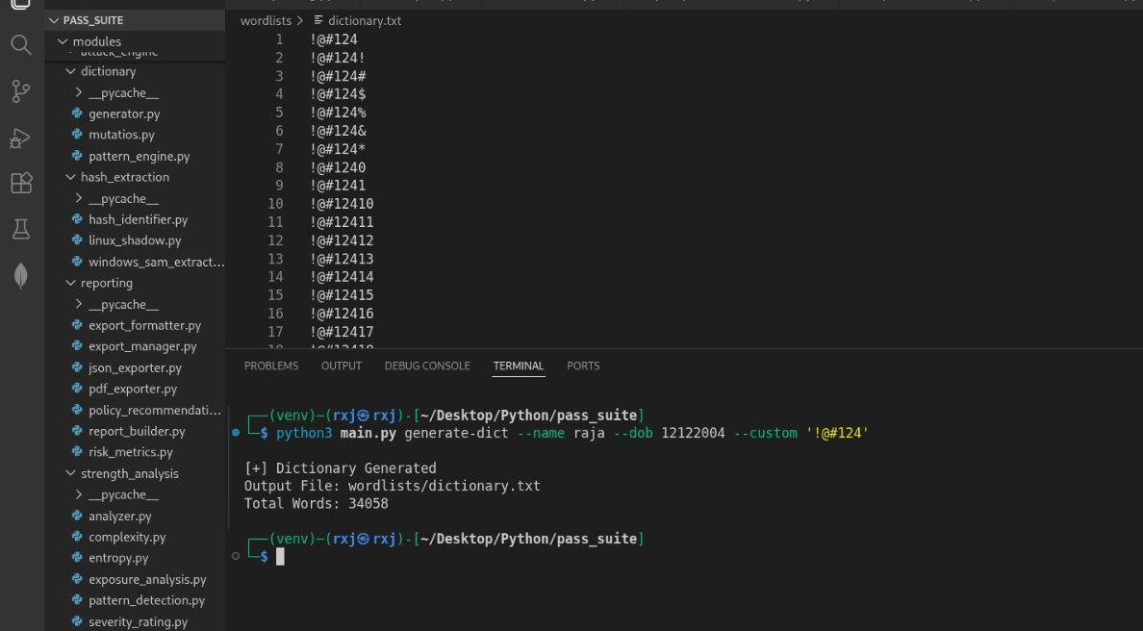
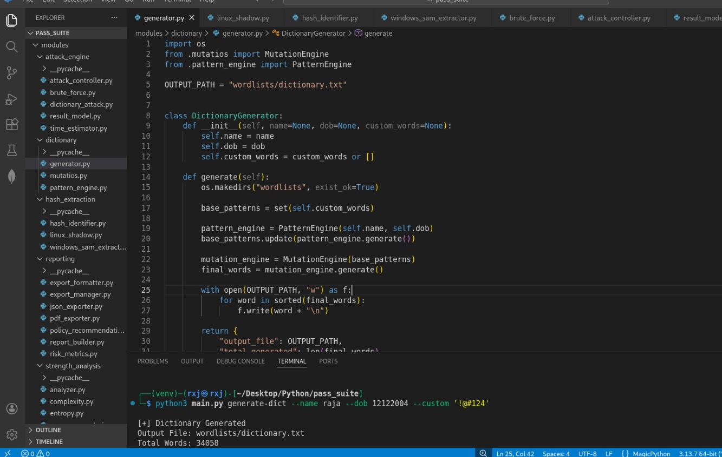

7.2 Linux Shadow Hash Extraction
This module:
- Parses /etc/shadow
- Identifies hash algorithm (MD5, SHA-256, SHA-512)
- Skips locked accounts
- Exports structured hash data

7.3 Windows SAM Extraction (Offline)
This module:
- Validates SAM and SYSTEM hive files
- Extracts Boot Key
- Decrypts NTLM hashes
- Returns structured credential objects

7.4 Attack Engine
A) Dictionary Attack
- Uses wordlists (e.g., rockyou.txt)
- Streams file safely
- Stops on match
- Tracks attempts
- Measures duration

B) Brute-Force Simulation
Supports:
- Incremental length mode
- Custom charset
- Estimated full search space
- Crack time estimation
Brute-Force Attack Execution
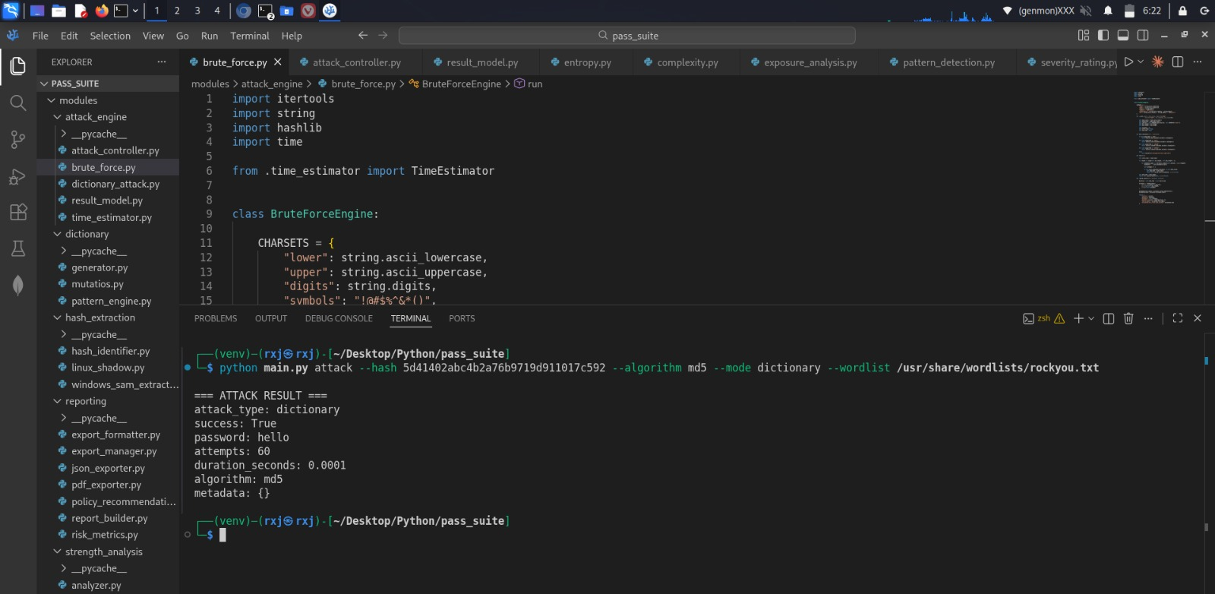

7.5 Password Strength Analyzer
Analyzes:
- Entropy (log2 formula)
- Character diversity
- Pattern detection
- Dictionary exposure
- Severity rating
Severity Levels:
- CRITICAL
- VERY WEAK
- WEAK
- MODERATE
- STRONG
- VERY STRONG
Password Analysis Execution: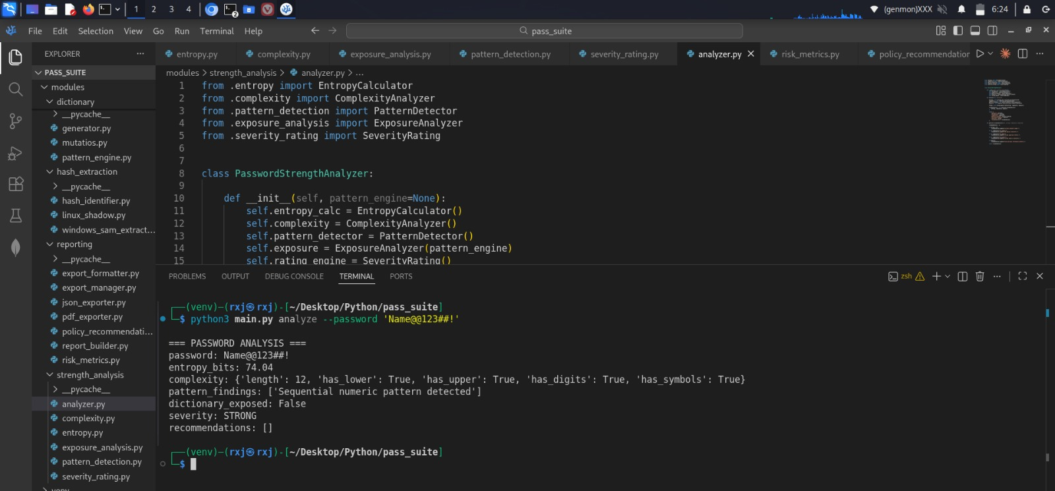

8️⃣ Entropy Calculation Logic
Entropy Formula:
Entropy = Length × log₂(Character Set Size)
Example:
Password: R@ja1990!
Character Set: 26 lower + 26 upper + 10 digits + symbols
Estimated entropy > 60 bits
This helps estimate resistance to brute-force attacks.

9️⃣ Risk Metrics Calculation
The reporting engine computes:
- Total Accounts
- Crack Success Rate
- Average Entropy
- Severity Distribution
- Organizational Risk Level
Example:
Total Accounts: 10
Cracked Accounts: 4
Crack Success Rate: 40%
Average Entropy: 48 bits
🔟 Report Generation System
Outputs:
- audit_report.txt
- audit_report.json
- audit_report.pdf
The PDF contains:
- Executive summary
- Attack results
- Strength analysis
- Risk metrics
- Policy recommendations

11 Red Team Techniques Demonstrated
- Dictionary-based attacks
- Brute-force simulation
- Hash cracking simulation
- Credential extraction
- NTLM handling

12 Blue Team Techniques Demonstrated
- Entropy measurement
- Pattern detection
- Dictionary exposure detection
- Risk scoring
- Password policy recommendations

13 Learning Outcomes
Through this project, the following concepts were implemented and understood:
- Secure password storage mechanisms
- Hashing algorithms
- Brute-force complexity
- Dictionary mutation strategies
- Credential audit methodologies
- Offensive vs Defensive security balance

14 Limitations
- SAM parsing simplified (full registry parsing requires deep Windows internals)
- Brute-force engine is CPU-based (no GPU acceleration)
- No live Active Directory integration
- No distributed cracking support

15 Future Enhancements
- Multi-threaded brute-force engine
- GPU integration
- HTML dashboard report
- Account lockout simulation
- AD environment integration
- Password reuse detection across users

16 Conclusion
The Password Cracking & Credential Attack Suite successfully demonstrates real-world credential attack simulation and defensive password auditing techniques.
The toolkit provides:
- Modular design
- Clean architecture
- Professional CLI interface
- Structured reporting
- JSON + PDF export
- Attack simulation + Blue team analysis
The system bridges theoretical cybersecurity concepts with practical implementation in a controlled environment.

