* 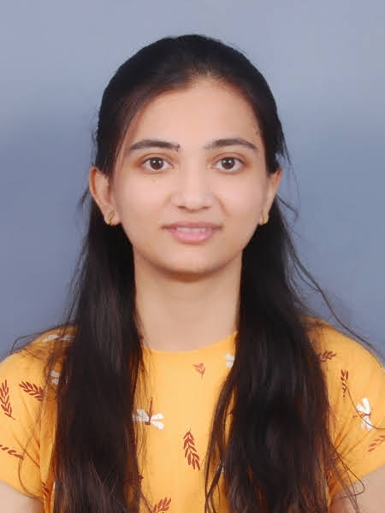v

Rajnandini Vishwas

Analyst A4

9370575147

rajnandini.parmanand-vishwas@capgemini.com

SUMMARY

I am detail

-

oriented, well

-

organized and graduated BTECH

from SGGS IE & T , Nanded , Maharashtra

KEY SKILLS

EXPERIENCE

**Analyst A4**

*(*

*APR 2022*

*-*

*Present)*

**CAPGEMINI**

-

Mumbai

*(*

**Extra-curriculum activities**

Co -Ordinator of web designing committee of technical fiesta

PRAGYAA-2019

SGGS IE & T, NANDED

*(*

**Internship**

MUNI EDUTECH, NANDED

* Performed various tasks on project assigned to me like data analysis.
* Search Engine Optimization Fundamentals, Coursera
* Accenture Discovery Program Inside Sherpa
* IEEE English For Engineering
* Channel management and retailing, Coursera

EDUCATION

**BTECH**

(2017-2021)

**SHRI GURU GOVIND SIGHJI INSTITUTE OF ENGINEERING AND TECHNOLOGY, NANDED**

Specialization - Computer Science and Engineering

**HSC**

*(2015- 2017)*

**YESHWANT MAHAVIDYALAYA, NANDED**

CERTIFICATIONS

•

C , C++

•

PYTHON ,ASP .NET

•

HTML , CSS , JAVASCRIPT

•

SQL

•

Power Point Presentation



in Computer Science and Engineering. I’ve done several certifications to improve my skills and abilities. I’ve also done internship in the same areas to exhibit my interests and knowledge.

Online Shopping Portal

Website for C. Shivaji College, Nanded

•

•

Projects