**“SMART DUSTBIN”**

**A PROJECT REPORT**

***Submitted by***

**Abhishek Tanwar 18BCON002**

**SINGH PRAKASH KUMAR 18BCON050**

***In partial fulfilment for the award of the degree***

***Of***

**BATCHLOR OF TECHNOLOGY**

**IN**

**COMPUTER SCIENCE AND ENGINEERING**

**At**



**JECRC UNIVERSITY, JAIPUR**

**Candidate’s Declaration**

We, **ABHISHEK TANWAR** and **SINGH PRAKASH KUMAR** hereby declare that the work presented in this project entitled **“SMART DUSTBIN”** in partial fulfilment for the award of the Degree of Bachelor of Technology, submitted in the **Department of Computer Science and Engineering** at **JECRC UNIVERSITY, JAIPUR,** is authentic record of my own research work under the supervision of **Dr. ANUJHA SHARMA.**

We also declare that the work embodied in the present Project Report is our original work and has not been submitted by me for any other Degree/Diploma.

**ABHISHEK TANWAR 18BCON002**

**SINGH PRAKASH KUMAR 18BCON050**

**13TH APRIL 2020**

**Certificate of the Supervisor**

This is to certify that the Project entitled **“SMART DUSTBIN”** submitted by **ABHISHEK TANWAR (18BCON002)** and **SINGH PRAKASH KUMAR (18BCON050)** in partial fulfilment for award of Degree of Bachelor of Technology in the Department of **COMPUTER SCIENCE AND ENGINEERING** of **JECRC UNIVERSITY, JAIPUR,** is a record of authentication work carried out by them under my supervision.

The matter embodied in this Project Report is the original work of the candidates and has not been submitted for the award of any other degree or diploma. It is further certified that they have worked with me for the required period in the Department of **COMPUTER SCIENCE AND ENGINEERING, JECRC UNIVERSITY, JAIPUR.**

**SHER SINGH**

**13TH APRIL 2020**

**Acknowledgements**

We would like to express our sincere gratitude to my project guide “**Dr. ANUJHA SHARMA”** and **“SHER SINGH”** for giving me the opportunity to work on this topic. It would never be possible for us to take this project to this level without their innovative ideas and their relentless support and encouragement.

**ABHISHEK TANWAR 18BCON002**

**SINGH PRSKASH KUMAR 18BCON050**

**Abstract**

In this project, we have made a smart dustbin. This project was made so that it could be

helpful to the maximum number of people and make their lives simpler and

comfortable. Our project contains a dustbin with multiple features such as automated

lid which opens by itself if it detects someone’s presence and closes itself once the user

is gone. By this feature we ensure the hygiene is maintained.

Apart from the self-opening feature, it can also send a message to your mobile phone

once the dustbin is full so that you are not taken by surprise when using it.

We were able to achieve all these features using Arduino and ESP8266 module along

with sensors such as HCSR04 and proximity sensor and a built-in power supply.

We are planning to automate the dustbin completely so that it becomes mobile and

add a vacuum cleaner beneath the dustbin so that it can clean the house by itself.

**Keywords:** Arduino, ESP8266.

**CONTENTS**

Chapter 1 Introduction

1.1 Objective.................................................................................................8

1.2 Motivation...............................................................................................8

Chapter 2 Fundamentals..........................................................................................9

2.1 Components involved............................................................................9

2.1.1 Arduino...................................................................................9

2.1.2 Node mcu...............................................................................10

2.1.3 Voltage Regulator...................................................................10

2.1.4 Ultrasonic sensor......................................................................11

2.1.5 Servo motor..............................................................................11

2.1.6 Jumper wires............................................................................12

2.1.7 Power Supply...........................................................................12

2.1.8 Normal Dustbin........................................................................12

2.2 Circuit Diagram...................................................................................12-13

2.3 Code (Esp8266) .................................................................................13-14

2.4 Code (Arduino)...................................................................................14-15

Chapter 3 Future Plans...............................................................................................16

3.1 Further Developments..............................................................................16

3.2 Modifications............................................................................................16

3.3 Contributions.............................................................................................16

3.4 Testing.......................................................................................................16

3.5 Working videos of the project....................................................................17

**CHAPTER 1**

**INTRODUCTION**:

**1.1 OBJECTIVE**

The idea of this project is to help the common people with their daily routines and even the municipal corporation of cities in locating the dust bins which have been filled in the city so that they give them priority in picking them up. This project includes a dustbin which can open itself on detection of any person nearby and close itself on anyone’s absence, plus it is capable of sending alarm when it is full along with its location to the user whenever it is required to be emptied.

1**.2 MOTIVATION**

The idea of the project was to ease the life of people, make it more comfortable and hygienic. It was also made by keeping Municipal cooperation in mind so that they are notified when to come and pick up the main colony dustbins when they are full so that they can become more efficient and all the surroundings are hygienic too.

**CHAPTER 2**

**FUNDAMENTALS**

**2.1 COMPONENTS INVOLVED:**

This project involves the usage of -

**2.1.1Arduino Uno (ATMEGA 328PU):**

[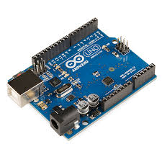](https://www.google.com/imgres?imgurl=https%3A%2F%2Fupload.wikimedia.org%2Fwikipedia%2Fcommons%2F3%2F38%2FArduino_Uno_-_R3.jpg&imgrefurl=https%3A%2F%2Fen.wikipedia.org%2Fwiki%2FArduino&docid=BNbQToRe3kaPgM&tbnid=YWmB1xWbeYqNrM%3A&vet=10ahUKEwimtqPa-_zkAhUVOisKHYYRDIAQMwiAASgDMAM..i&w=600&h=600&bih=747&biw=1536&q=arduino&ved=0ahUKEwimtqPa-_zkAhUVOisKHYYRDIAQMwiAASgDMAM&iact=mrc&uact=8)

Arduino is an open-source electronics platform based on easy-to-use hardware and software. [Arduino boards](https://www.arduino.cc/en/Main/Products) are able to read inputs - light on a sensor, activating a motor, turning on an LED. You can tell your board what to do by sending a set of instructions to the microcontroller on the board. To do so you use the [Arduino programming language](https://www.arduino.cc/en/Reference/HomePage), and [the Arduino Software (IDE)](https://www.arduino.cc/en/Main/Software).

**2.1.2 Node Mcu(ESP8266)**

[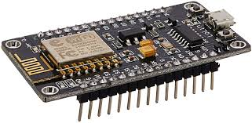](https://www.google.com/imgres?imgurl=https%3A%2F%2Fimages-na.ssl-images-amazon.com%2Fimages%2FI%2F81U4jvpGnYL._SL1500_.jpg&imgrefurl=https%3A%2F%2Fwww.amazon.in%2FESP8266-NodeMcu-WiFi-Development-Board%2Fdp%2FB00UY8C3N0&docid=eFbIwzdab8fpCM&tbnid=LZNYqETe3ZLtdM%3A&vet=10ahUKEwj5rLeR_PzkAhULXSsKHWRrBPcQMwh6KAAwAA..i&w=1500&h=733&bih=747&biw=1536&q=nodemcu&ved=0ahUKEwj5rLeR_PzkAhULXSsKHWRrBPcQMwh6KAAwAA&iact=mrc&uact=8)

Node MCU is an open source [LUA](https://www.lua.org/start.html) based firmware developed for ESP8266 wifi chip. By exploring functionality with ESP8266 chip, Node MCU firmware comes with ESP8266 Development board/kit i.e. Node MCU Development board.

Since Node MCU is open source platform, their hardware design is open for edit/modify/build.

Node MCU Dev Kit/board consist of ESP8266 wifi enabled chip. The ESP8266 is a low-cost Wi-Fi chip developed by Espressif Systems with TCP/IP protocol. For more information about ESP8266, you can refer ESP8266 WiFi Module.

**2.1.3 Voltage Regulator (LM7805)**

[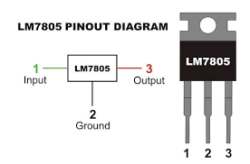](https://www.google.com/imgres?imgurl=https%3A%2F%2Fimages-na.ssl-images-amazon.com%2Fimages%2FI%2F41dlW%252BNN94L.jpg&imgrefurl=https%3A%2F%2Fwww.amazon.in%2FLM7805-Positive-Voltage-Regulator-Pieces%2Fdp%2FB079CDX91C&docid=PsOvm2J8Ea7jiM&tbnid=J-CTOKLws26kRM%3A&vet=10ahUKEwiV5emt_PzkAhVKfisKHUVoC30QMwhzKAEwAQ..i&w=500&h=330&bih=747&biw=1536&q=lm7805&ved=0ahUKEwiV5emt_PzkAhVKfisKHUVoC30QMwhzKAEwAQ&iact=mrc&uact=8)

Lm7805 is a voltage regulator which converts voltages of above 5v to a constant 5v and can pass current upto1.5A through itself in ideal conditions. It is a part of lm78xx series where the last xx denotes the voltage output.

**2.1.4 Ultrasonic sensor (HC-SR04)**

[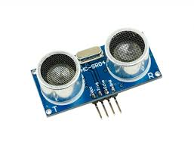](https://www.google.com/imgres?imgurl=https%3A%2F%2Fwww.piborg.org%2Fimage%2Fcache%2Fcatalog%2Ffreeburn%2FBURN-0019%2FDSC_0245-1024x780.jpg&imgrefurl=https%3A%2F%2Fwww.piborg.org%2Fsensors-1136%2Fhc-sr04&docid=hW9rEu1jO745oM&tbnid=oDGV5TESGcMcBM%3A&vet=10ahUKEwjN04HA_PzkAhVSfH0KHSEVCDIQMwhnKAEwAQ..i&w=1024&h=780&bih=747&biw=1536&q=ultrasonioc%20sensor&ved=0ahUKEwjN04HA_PzkAhVSfH0KHSEVCDIQMwhnKAEwAQ&iact=mrc&uact=8)

The HC-SR04 ultrasonic sensor uses sonar to determine distance to an object like bats or dolphins do. It offers excellent non-contact range detection with high accuracy and stable readings in an easy-to-use package. From 2cm to 400 cm or 1" to 13 feet

**2.1.5 Servo motor**

[](https://www.google.com/imgres?imgurl=https%3A%2F%2Frobu.in%2Fwp-content%2Fuploads%2F2017%2F09%2FIMG_0521.jpg&imgrefurl=https%3A%2F%2Frobu.in%2Fproduct%2Ftowerpro-sg90-9gm-1-2kg-180-degree-rotation-servo-motor-good-quality%2F&docid=_v7U4P0vdgugOM&tbnid=Zh2tdeycmbW_QM%3A&vet=10ahUKEwippI3c_PzkAhUGfSsKHYTWDBMQMwh6KAAwAA..i&w=1421&h=1175&bih=747&biw=1536&q=servo&ved=0ahUKEwippI3c_PzkAhUGfSsKHYTWDBMQMwh6KAAwAA&iact=mrc&uact=8)

A servo motor is an electrical device which can push or rotate an object with great precision. If you want to rotate and object at some specific angles or distance, then you use servo motor. It is just made up of simple motor which run through servo mechanism.

**2.1.6 Jumper wires**

[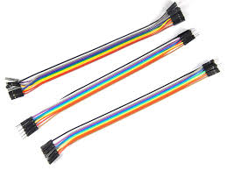](https://www.google.com/imgres?imgurl=https%3A%2F%2Fimages-na.ssl-images-amazon.com%2Fimages%2FI%2F816-FhWxCnL._SL1500_.jpg&imgrefurl=https%3A%2F%2Fwww.amazon.in%2FRobo-India-JW-C3-Jumper-Wire%2Fdp%2FB00YJ67SYW&docid=rIL4IithgBT-1M&tbnid=s6Sr4qe_fjHAyM%3A&vet=10ahUKEwj_9Zj4_PzkAhWDYisKHb6lADcQMwh7KAEwAQ..i&w=1500&h=1125&bih=747&biw=1536&q=jumper%20wires&ved=0ahUKEwj_9Zj4_PzkAhWDYisKHb6lADcQMwh7KAEwAQ&iact=mrc&uact=8)

The term "jumper wire" simply refers to a conducting wire that establishes an electrical connection between two points in a circuit. You can use jumper wires to modify a circuit or to diagnose problems in a circuit. The following steps outline how you can safely use jumper wires in different electrical applications.

**2.1.7 Power supply**

[](https://www.google.com/imgres?imgurl=https%3A%2F%2Fm.media-amazon.com%2Fimages%2FS%2Faplus-media%2Fvc%2Fff8450b1-abcd-4c79-b1cf-9de97ba5c162._CR0%2C0%2C300%2C400_PT0_SX300__.png&imgrefurl=https%3A%2F%2Fwww.amazon.com%2FDuracell-Coppertop-Alkaline-Batteries-Count%2Fdp%2FB000K2NW08&docid=3CNXXyAZjD0mWM&tbnid=230q0WYCDGCazM%3A&vet=10ahUKEwiYrfjB_fzkAhVBfSsKHcsfAhIQMwh_KAIwAg..i&w=300&h=400&bih=747&biw=1536&q=9v%20battery&ved=0ahUKEwiYrfjB_fzkAhVBfSsKHcsfAhIQMwh_KAIwAg&iact=mrc&uact=8)

Also called a power supply unit or PSU, the component that supplies power to a computer. Most personal computers can be plugged into standard electrical outlets. The power supply then pulls the required amount of electricity and converts the AC current to DC current.

**2.1.8 Normal dustbin**

A small box used for storing small amount of waste produced from daily house hold practices.

**2.2 CIRCUIT DIAGRAMS OF INVOLVED CIRCUITS**

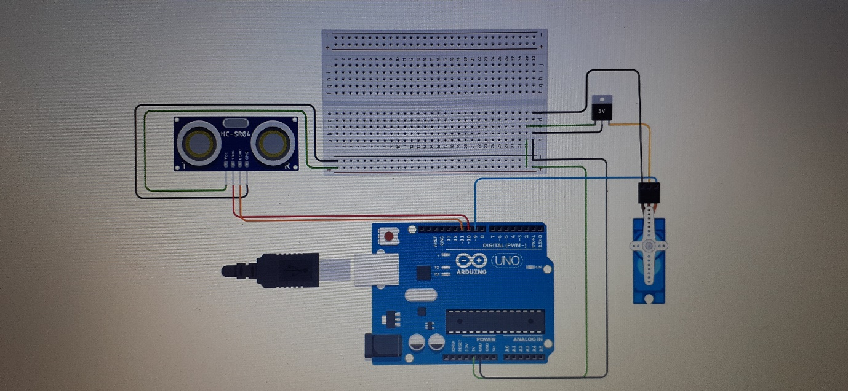

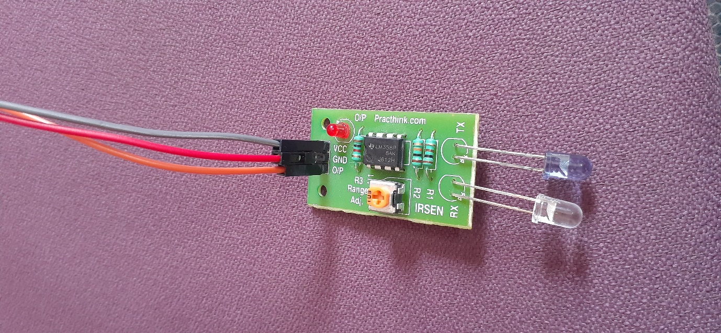

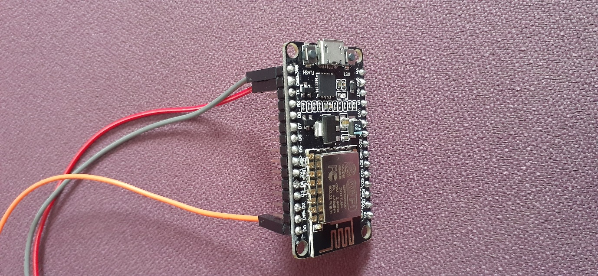

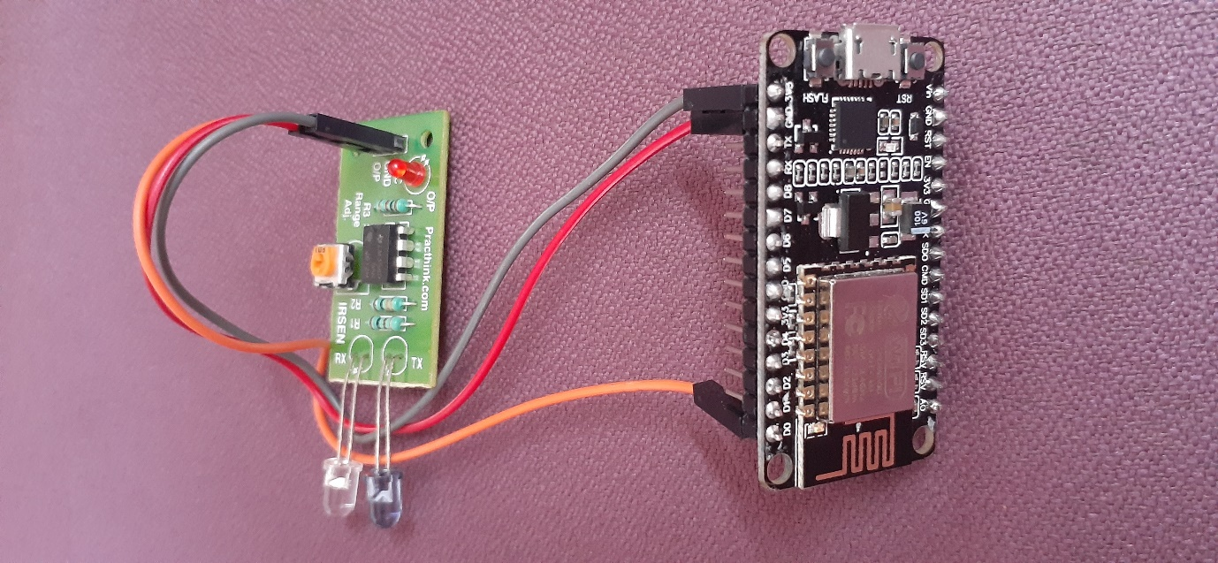

**2.3 PROJECT CODE:(for esp8266)**

#include <ESP8266WiFi.h>

#include <ESP8266HTTPClient.h>

WiFiClient client;

String thingSpeakAddress="http://api.thingspeak.com/update?";

String writeAPIKey;

String tsfield1Name;

String request_string;

HTTPClient http;

void setup()

{

pinMode(D0, INPUT);

WiFi.disconnect();

WiFi.begin("Sherraaa","sherrraa");

while ((!(WiFi.status() == WL_CONNECTED))){

delay(300);

}

}

void loop()

{

if (client.connect("api.thingspeak.com",80)) {

request_string = thingSpeakAddress;

request_string += "key=";

request_string += "THAIYD7KDIUTKABQ";

request_string += "&";

request_string += "field1";

request_string += "=";

request_string += digitalRead(D0);

http.begin(request_string);

http.GET();

http.end();

delay(1000);

}

**2.4 PROJECT CODE:(for Arduino)**

#include <Servo.h>//Servo library

Servo servoo; // Define our Servo

int trigpin = 10;

int echopin = 11;

int dist;

float dur;

float cms;

void setup()//for setting up the pins and variables

{

servoo.attach(9);

pinMode(trigpin, OUTPUT);

pinMode(echopin, INPUT);

}

void loop()

{

digitalWrite(trigpin, LOW);

delay(2);

digitalWrite(trigpin, HIGH);

delayMicroseconds(10);

digitalWrite(trigpin, LOW);

dur = pulseIn(echopin, HIGH);

cms = (dur/58.82);

dist = cms;

if(dist<10)

{

servoo.write(90); // Turn Servo back to center position (90 degrees)

delay(3000);

}

else{

servoo.write(0);

delay(50);

}

}

**CHAPTER 3**

**FUTURE PLANS**

**3.1 FURTHER DEVELOPMENTS:**

This project can have few more additions in the future such as a providing the dustbin with a little mobility so that it can approach the user and then can come back to its original place after its usage. The ability of auto emptying itself is being worked upon so that the user doesn’t have to empty it. Further-more a small vacuum cleaner can also be added beneath it with free roaming feature so that it can clean the house itself.

3.2 **MODIFICATIONS**

The main reason behind using these sensors were that they were easily available in the market and are cheap to use. Further-more we would recommend the usage of more efficient and reliable components. Our project was just a prototype so the usage of cheap components was done to keep the prices as low as possible for us. As Sparkfun provides same components that were used in our project so we would suggest the usage of components from Sparkfun as they are much more reliable

3.3 **CONTRIBUTION**

This project consisted equal efforts from both of us.

The code was written by both of us and then the final code was made by taking good portions of both the codes. The editing of the project video was done by Prakash and the project was explained by Abhishek in the video. The circuit was made with the help of our seniors.

3.4 **TESTING**

The final testing of the product was completed form our end and many suggestions from the experienced students have been considered and deployed and we are planning to put it to the ultimate test by providing few samples to the houses of our friends so that the unexpected problems can be solved.

3.5 **WORKING VIDEOS OF THE PROJECT**

We have done a lot of testing of the project and have completely explain the projects in the videos whose link is given below. These videos were made during the development period of the project.

https://photos.app.goo.gl/8qRqd4w92yRbRfXf8