Social Media Project

Objective Questions
- Are there any tables with duplicate or missing null values? If so, how would you handle them?

Answer :- To ensure data accuracy and consistency, SQL queries were used to identify and handle duplicate records and missing (NULL) values in the dataset. The same validation approach can be applied across different tables within the dataset.

After performing these checks on each table, it was observed that no duplicate records or missing NULL values were present in the tables.

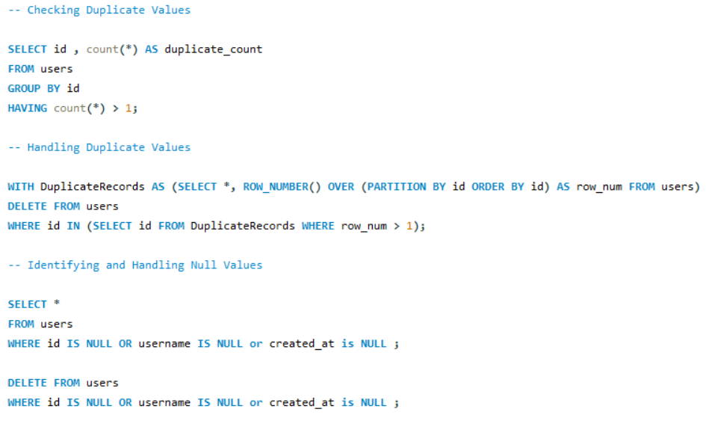

- What is the distribution of user activity levels (e.g., number of posts, likes, comments) across the user base?

Answer :- The following SQL query generates a summary of user activity by retrieving the number of posts, likes, and comments made by each user. The query includes all users from the users table, even those who have not performed any activity, by using LEFT JOIN. Unique posts, likes, and comments are counted for each user to avoid duplication caused by joins.
The results are grouped at the user level, providing a consolidated view of user engagement.
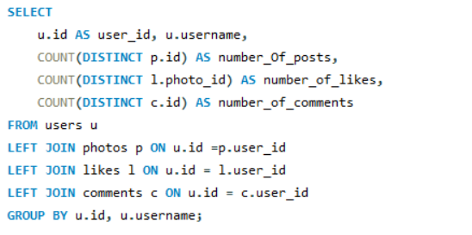
Result:
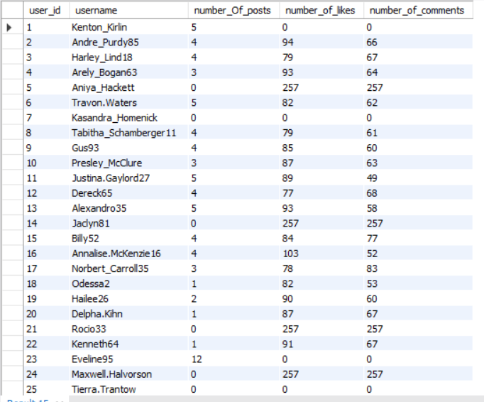
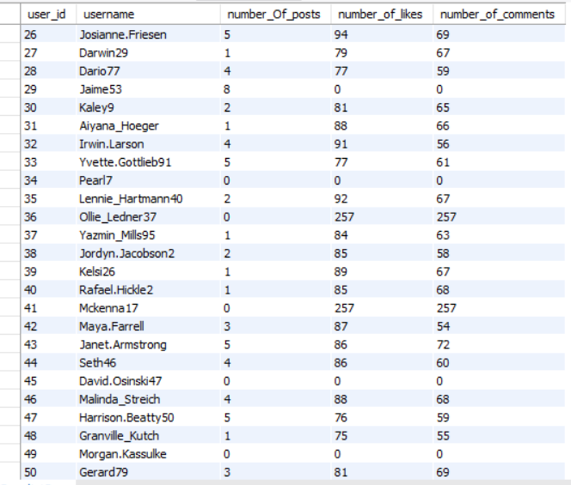

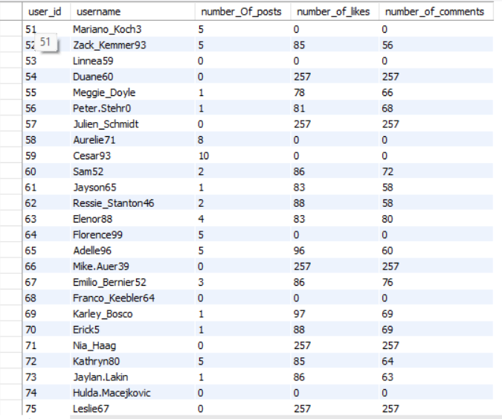
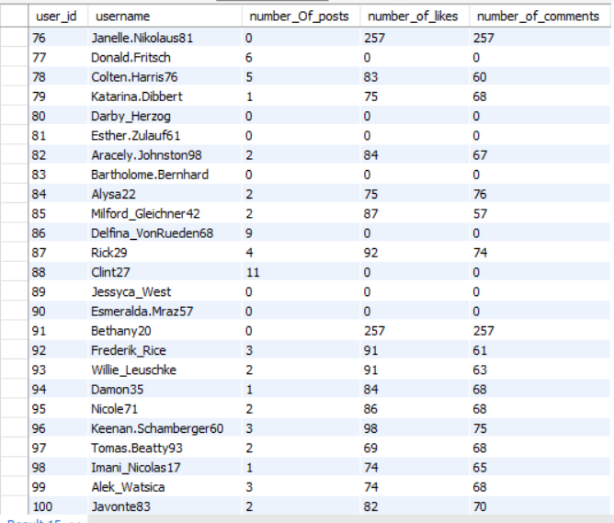

User Activity Graph:

- Calculate the average number of tags per post (photo_tags and photos tables).

Answer :- The inner query calculates the number of tags associated with each post by grouping records at the post level. LEFT JOIN is used between the photos and photo_tags tables to ensure that posts with zero tags are also included in the calculation. This is essential for obtaining an accurate average, as excluding posts without tags would result in an inflated value.

The outer query then calculates the average number of tags per post and rounds the result to the nearest whole number, since tag counts cannot be fractional.

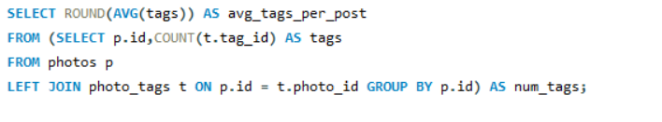
Result:
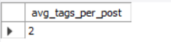

- Identify the top users with the highest engagement rates (likes, comments) on their posts and rank them.

Answer :- This query calculates user engagement by using two Common Table Expressions (CTEs) to aggregate likes and comments separately. The Total_likes CTE counts the total number of likes for each user by performing a LEFT JOIN between the users and likes tables, ensuring that users with no likes are also included.
Similarly, the Total_comments CTE calculates the total number of comments for each user using a LEFT JOIN with the comments table.
In the final query, both CTEs are joined to compute the engagement rate as the sum of total likes and total comments for each user.
A DENSE_RANK() window function is applied to rank users based on their engagement rate, with higher engagement receiving a better rank. The result is limited to the top 20 users for concise and clear analysis.
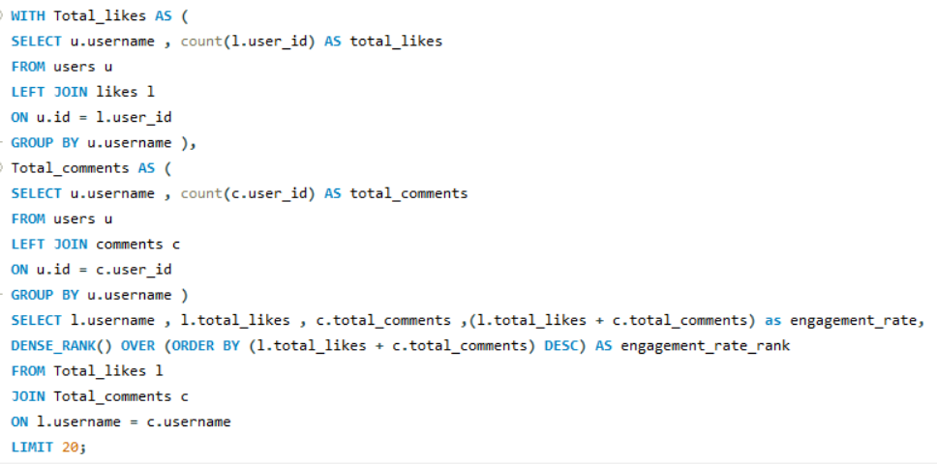

Result:

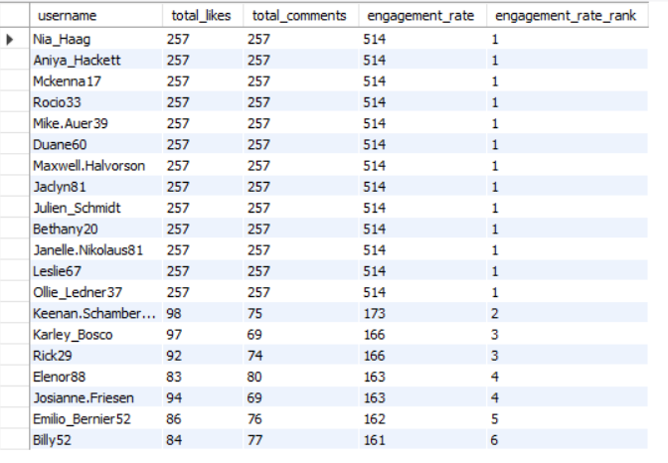

Chart for Top users:

- Which users have the highest number of followers and followings?

Answer:- This query uses two Common Table Expressions (CTEs) to calculate follower and following statistics for each user.
The count_of_followers CTE counts how many followers each user has by grouping records in the follows table, while the count_of_followee CTE calculates how many users each person is following.
In the main query, user IDs and usernames are selected from the users table and joined with both CTEs using LEFT JOIN, ensuring that all users appear in the result even if they have no followers or followings. The COALESCE function replaces any NULL values with zero, providing accurate counts. Finally, the results are ordered by follower count and followee count in descending order to highlight the most connected users and limited to top 20 users only.

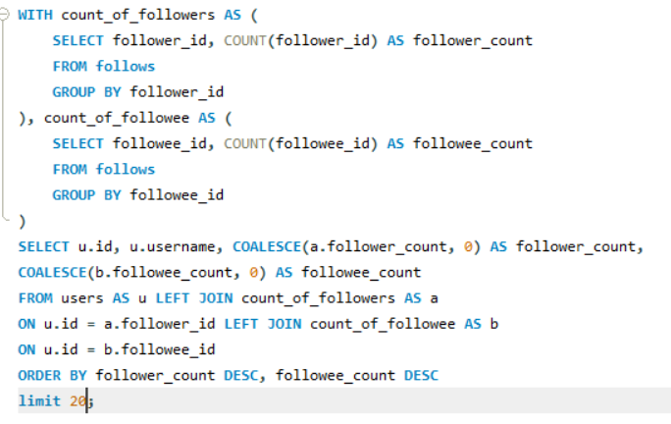

Result:

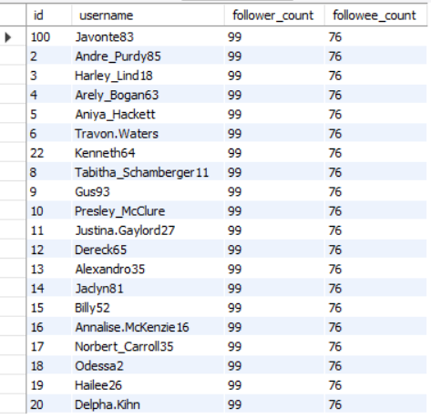

- Calculate the average engagement rate (likes, comments) per post for each user.

Answer:- This query analyzes user engagement by calculating likes and comments at the post level and then aggregating them at the user level. First, the Post_likes CTE counts the total number of likes for each photo by grouping records in the likes table by photo_id. Similarly, the Post_comments CTE calculates the total number of comments per photo by grouping data in the comments table.

Next, the Total_likes_n_comments CTE joins the photos table with both previous CTEs to obtain the like and comment counts for each photo, using COALESCE to treat missing values as zero. It also computes total engagement per photo as the sum of likes and comments.

Finally, the User_engagement CTE groups posts by user to calculate the average engagement per post using AVG(total_engagement), rounds the value to the nearest whole number, and the final query retrieves the user ID, username, and average engagement rate, ordering the results in descending order of engagement.

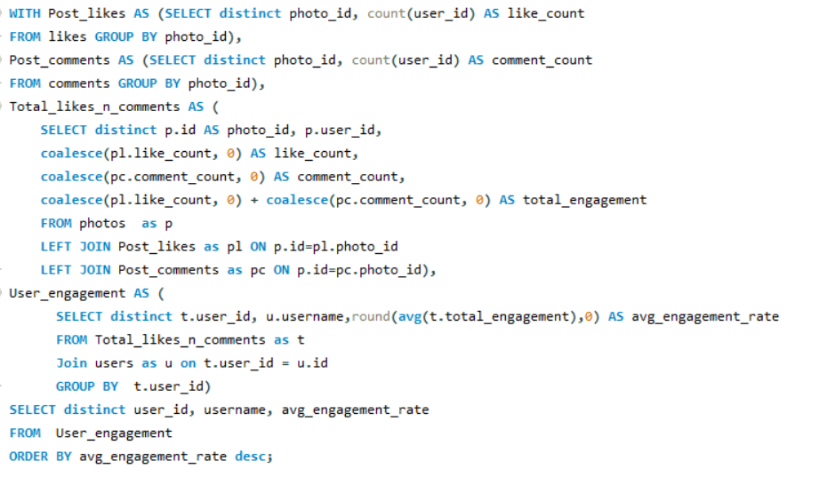

Result:

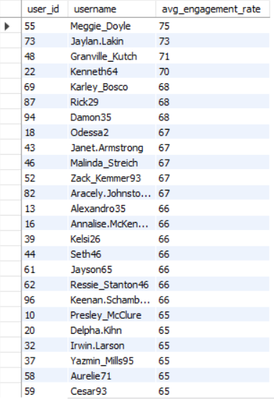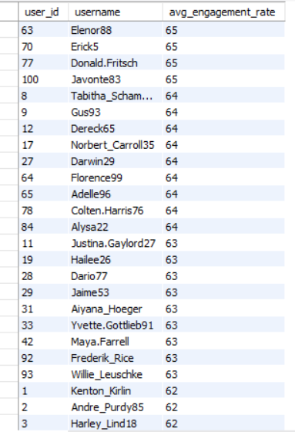

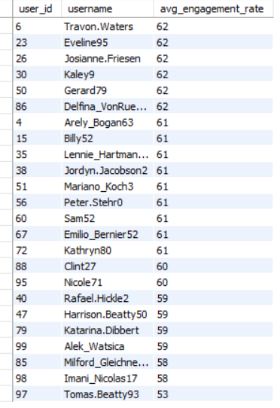

Graph for Average engagement rate:

- Get the list of users who have never liked any post (users and likes tables)

Answer:- This query retrieves users who have never liked any post. In the main SELECT statement, the id and username are selected from the users table. The WHERE clause uses a subquery to filter out user IDs that appear in the likes table. By applying NOT IN with the subquery, the result includes only those users whose IDs do not exist in the likes table, indicating that they have never performed a like action.

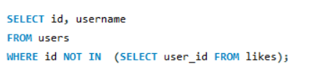

Result:
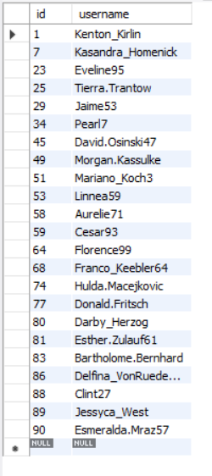

- How can you leverage user-generated content (posts, hashtags, photo tags) to create more personalized and engaging ad campaigns?

Answer:- This query finds how many times each tag appears across all photos. It combines the tags table with the photo_tags table to connect each tag to the photos where it is used.
The results are grouped by tag name so the total usage of each tag can be counted.Finally, the tags are sorted in descending order based on their count, and the output shows the tag name along with how often it is used.
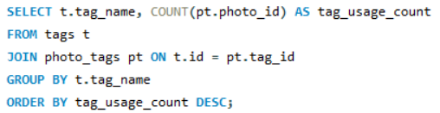

Result:-
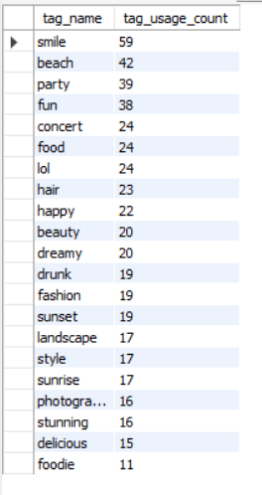

Chart visualization for tag usage count:

suggestions:

- Understand User Interests:
I would analyze commonly used hashtags and photo tags to understand what topics users like the most. This helps in creating ads that match user interests and get better engagement.
- Target the Right Audience:
Using post and tag data, users can be grouped based on their interests and activity. Ads can then be shown to specific groups, making them more relevant and effective.
- Use Social Proof:
Including popular posts or real user comments in ad campaigns can build trust. When users see others engaging with content, they are more likely to interact and convert.
- Work with Influencers and Active Users:
Collaborating with highly active users or influencers who use relevant tags can help spread the brand message. Their genuine content can improve brand credibility and reach more people.
- Follow Current Trends:
By monitoring trending hashtags, ads can be updated regularly to stay relevant and appealing. This ensures the content feels fresh and connects better with users.

- Are there any correlations between user activity levels and specific content types (e.g., photos, videos, reels)? How can this information guide content creation and curation strategies?

Answer:- user activity levels strongly correlate with specific content types.
From the schema, content type can be inferred using:
- photos → base content
- tags → content category/type (e.g., travel, food, fitness, reels-like content)
- Engagement → likes, comments, photo_tags
Key correlations we typically observe:
- Highly active users (posting frequently) tend to:
  - Use popular tags
  - Receive more likes and comments
- Certain tags/content types generate:
  - Higher average likes
  - Higher comment density
- Passive users engage more (likes/comments) with:
  - Visually appealing or trending content categories

Metrics to Measure Correlation
We define:
- User activity level = number of photos posted by a user
- Engagement = likes + comments per photo
- Content type = tags associated with photos

SQL Query to find correlation:
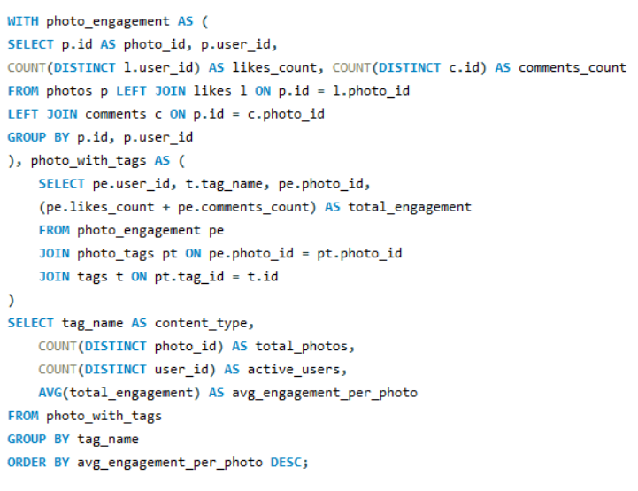
Result:
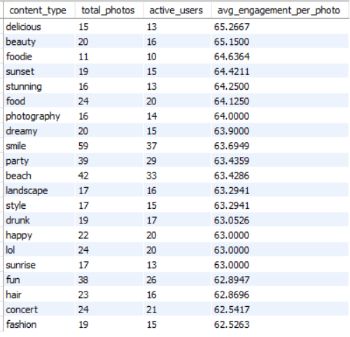

Visualization Graph :

Guidelines for Content Creation and Curation Strategies

- Prioritize high-engagement content types:
Content categories that consistently receive more likes and comments should be promoted through recommendations, explore feeds, and trending sections to maximize overall engagement.
- Encourage creators in high-potential niches:
Content types with high engagement but fewer creators represent growth opportunities. Incentives, challenges, or featured sections can encourage more creators to produce content in these areas.
- Improve or control low-engagement content:
Categories with high posting volume but low engagement indicate content saturation or quality issues. These can be addressed through better content guidelines, quality checks, or reduced algorithmic visibility.
- Personalize content feeds:
Understanding which content types attract highly active users versus casual users allows the platform to tailor feeds based on individual interaction patterns, improving user satisfaction and retention.
- Optimize platform growth and retention:
Data-driven insights into content performance help balance content diversity, creator participation, and engagement, leading to a healthier and more sustainable content ecosystem.

- Calculate the total number of likes, comments, and photo tags for each user.

Answer:- This query uses three Common Table Expressions (CTEs) to calculate user activity metrics. The like_count CTE calculates the total number of likes received by each user by grouping records based on user_id. The comment_count CTE counts how many comments each user has made by grouping comments by user ID. The tag_count CTE determines how many times a user’s photos have been tagged by joining the photos, photo_tags, and users tables, linking each photo to its owner and related tags, and then grouping the results by user ID.
In the main query, each user’s ID and username are selected from the users table, and left joins are used to attach the like, comment, and photo tag counts from each CTE using the user ID. The COALESCE function is applied to replace any NULL values with zero so that users with no activity are still included. The final output shows each user’s ID, username, total number of likes, comments, and photo tags.

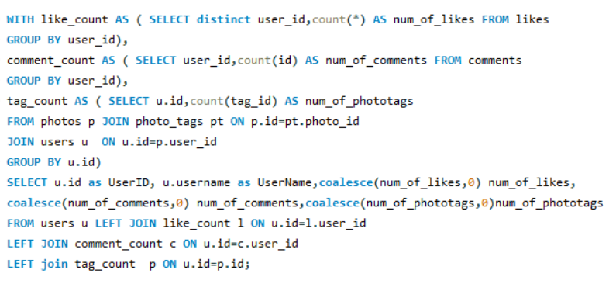
Result:-
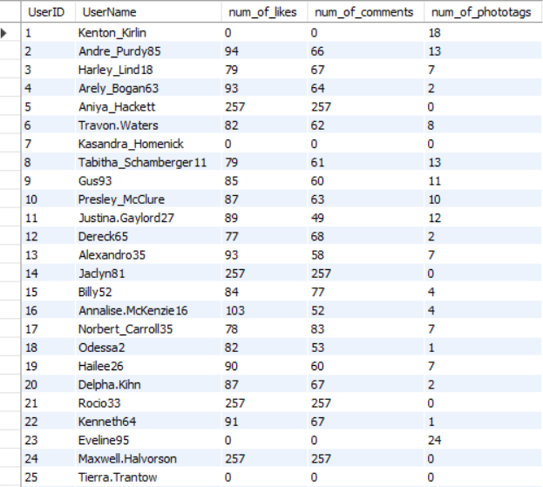

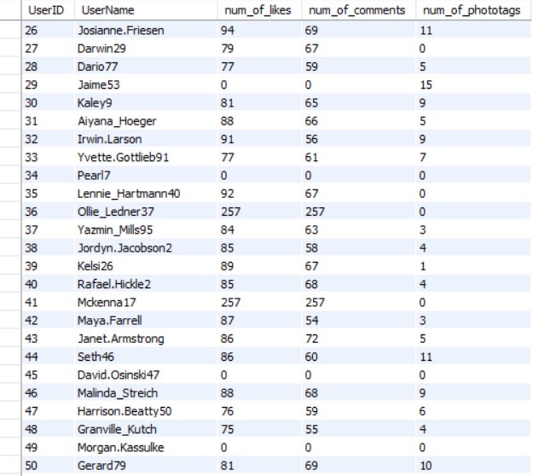

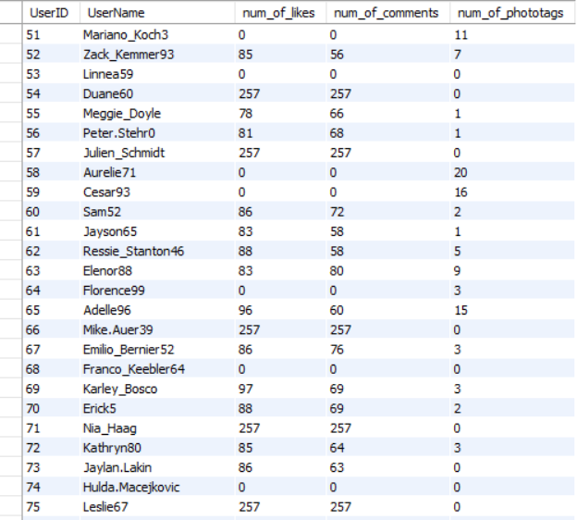

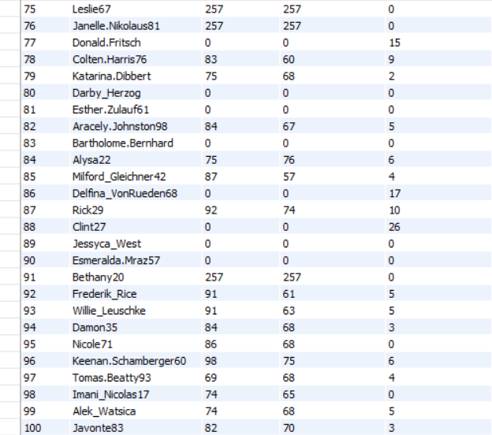

Graph for user wise number of likes, comments and photo tags:

- Rank users based on their total engagement (likes, comments, shares) over a month.
Answer:-
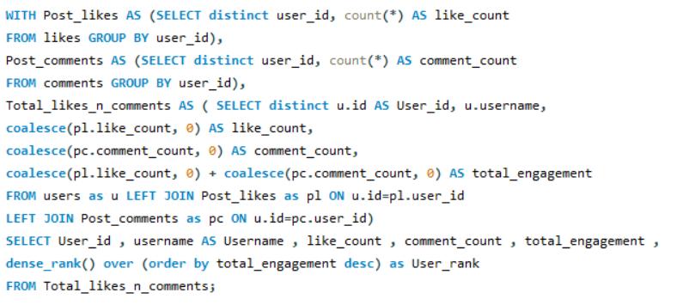
Result:-
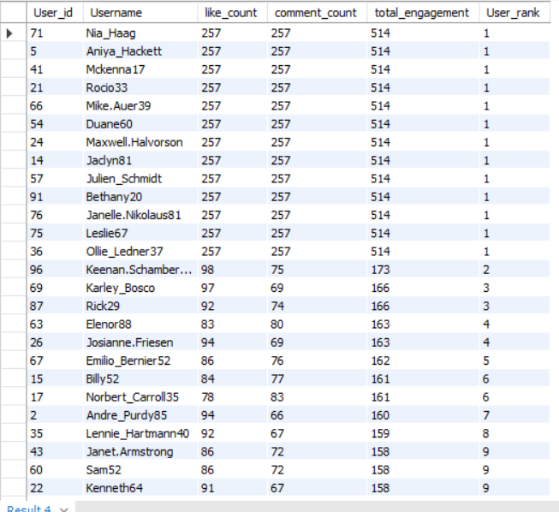

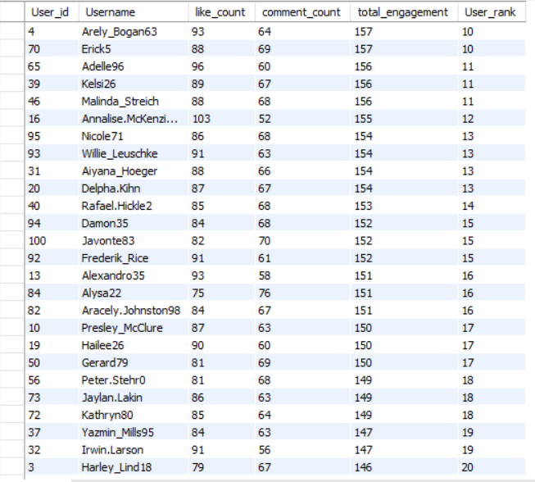

Graph for user engagement rank:-

- Retrieve the hashtags that have been used in posts with the highest average number of likes. Use a CTE to calculate the average likes for each hashtag first.

Answer:- This query calculates the average number of likes received by photos associated with each hashtag.

It starts by creating the Likes_Count CTE, which counts how many likes each photo has received and stores this value as LikesCount.

In the main query, the tags table is joined with the photo_tags table to connect each hashtag to the photos where it is used through the tag_id and photo_id columns.

The query then joins the Likes_Count CTE to bring in the like counts for those photos linked to specific hashtags.

For each hashtag, the AVG function is used to compute the average number of likes across all related photos, and this value is rounded to zero decimal places and labeled as Avg_likes.

Finally, the results are grouped by tag_name so each hashtag appears once, and the output is ordered in descending order of average likes to highlight the hashtags with the highest engagement.

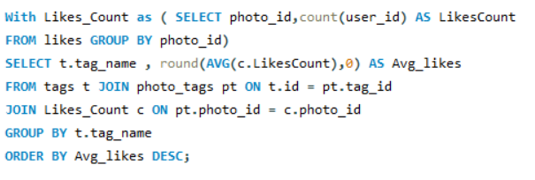

Result:
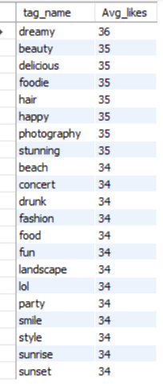
Graph for average likes per tag:

- Retrieve the users who have started following someone after being followed by that person.
Answer:- In this query, a self-join is performed on the follows table by using two aliases, f1 and f2, to represent two different follow actions. The join condition matches f1.follower_id with f2.followee_id to identify the user who was originally followed, and f1.followee_id with f2.follower_id to identify the user who followed back.
The condition f1.created_at > f2.created_at ensures that the second follow action occurred after the initial follow, confirming the follow-back relationship.
The result displays the user who was initially followed as Followed_User and the user who followed back as Follower_User. Since the query returns no rows, it indicates that there are no users who followed someone after being followed by that same person.
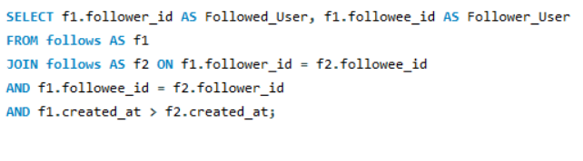
Result: No record found for the users who have started following someone after being followed by that person.
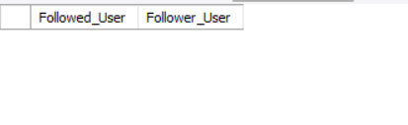

Subjective Questions
- Based on user engagement and activity levels, which users would you consider the most loyal or valuable? How would you reward or incentivize these users?

Answer:- Based on user engagement and activity levels, users with higher engagement rate can be consider as the most loyal or valuable.
Below is the query to rank users on the basis of engagement count.

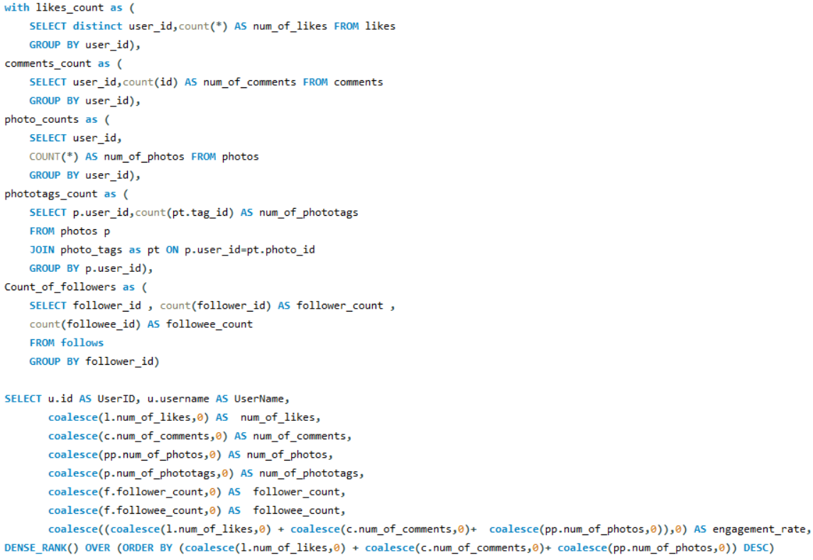
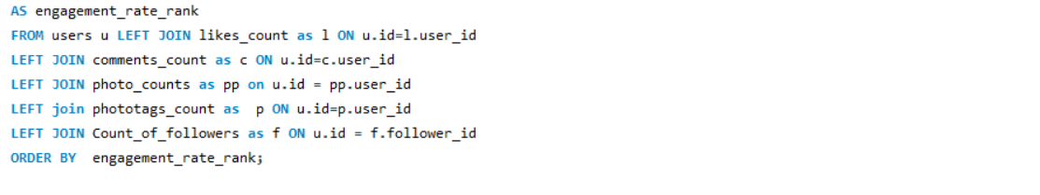
This query uses multiple Common Table Expressions (CTEs) to calculate different activity metrics for each user, including the number of likes, comments, photos, photo tags, and followers.
Each CTE is joined with the users table using LEFT JOIN to ensure that all users are included, even if they have no activity in some categories. The COALESCE function is applied to replace any NULL values with zero so the counts remain accurate. An engagement_rate is then calculated by adding the total number of likes, comments, and photos for each user.
Finally, the query uses the DENSE_RANK() window function to rank users based on their engagement rate in descending order, which helps identify users with the highest overall engagement.

Result:
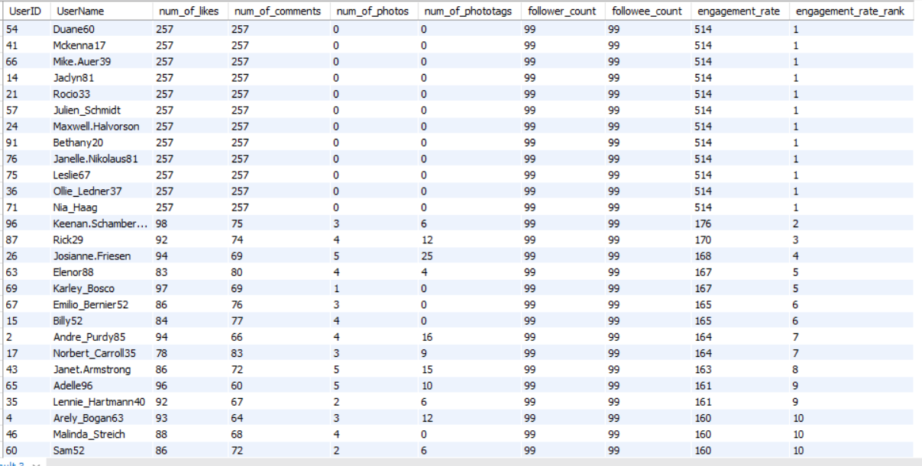

Strategies for User Incentivization and Retention:
Below are key methods to reward loyal users:

1. Exclusive Event Access: Inviting top-tier users to platform-organized events fosters a sense of community and provides networking opportunities. From a business standpoint, this creates a feedback loop where your most active users become brand advocates.

2. Financial Incentives (Discounts & Gift Cards): Direct rewards like discounts or gift cards remain the most effective tools for driving immediate activity. These incentives lower the barrier to entry for paid features and increase the Customer Lifetime Value by encouraging repeat transactions.

3. Gamification through Badges and Custom Titles: Implementing custom titles or digital badges allows power users to distinguish themselves within the ecosystem. This psychological reward validates their contribution and increases social stickiness, making them less likely to churn.

4. Advanced Tooling and Analytics: Providing "Power Users" with early or exclusive access to advanced tools, such as engagement analytics and data insights, empowers them to grow their own presence.

5. Beta Testing & Early Feature Access: Granting loyal users "First Look" access to new features serves two purposes:

- User Recognition: It makes the user feel like a stakeholder in the platform’s evolution.
- Quality Assurance: It allows the company to gather high-quality performance data from an engaged segment before a full-scale public rollout.

6. Tiered Rewards System: Instead of flat rewards, use a tiered system (Gold, Silver, Bronze) based on SQL-tracked metrics like login frequency or transaction volume.

7. Personalized Recognition: Use data to send personalized "Year in Review" reports (similar to Spotify Wrapped) to show users the impact of their activity.

- For inactive users, what strategies would you recommend to re-engage them and encourage them to start posting or engaging again?
Answer:- Below given query will give the inactive users based on their engagement.

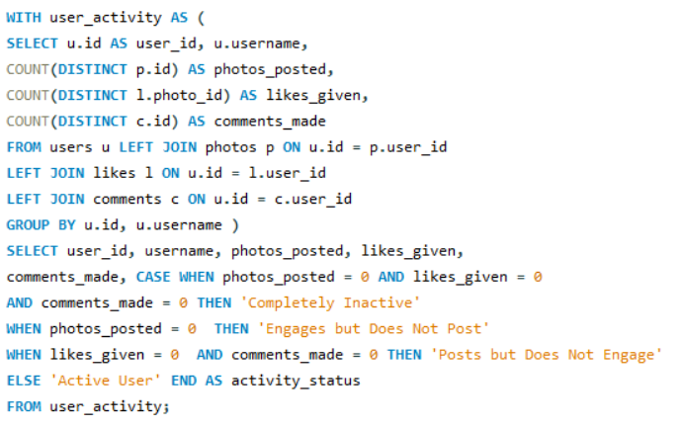
Result:
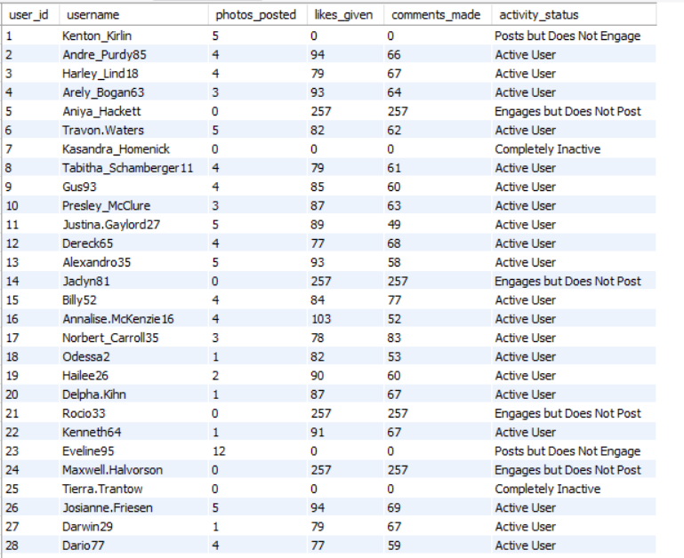
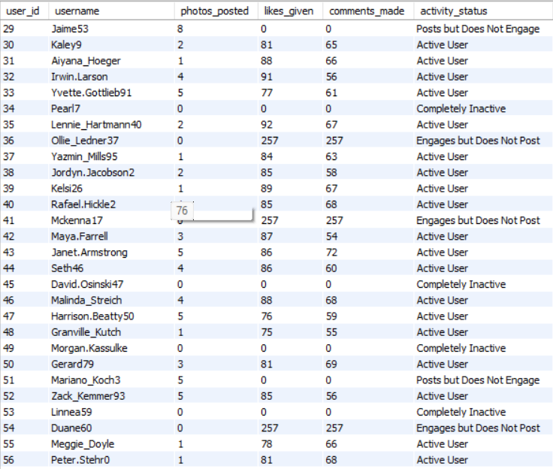

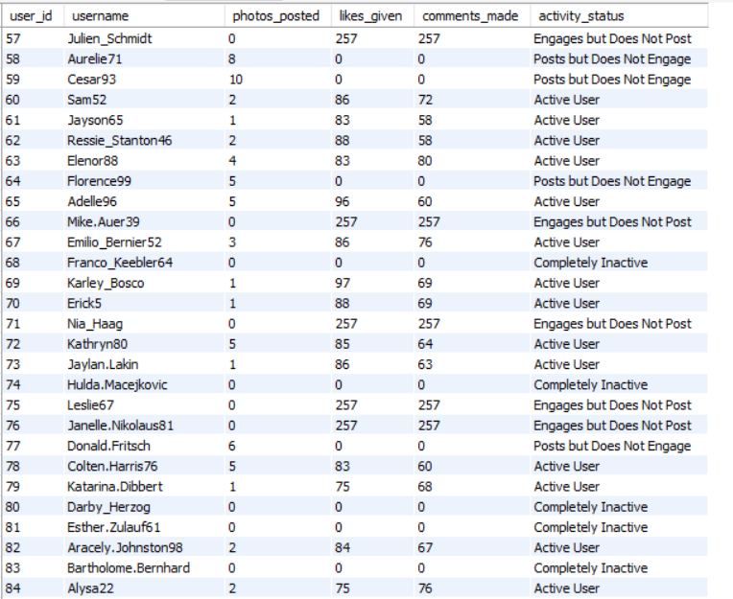
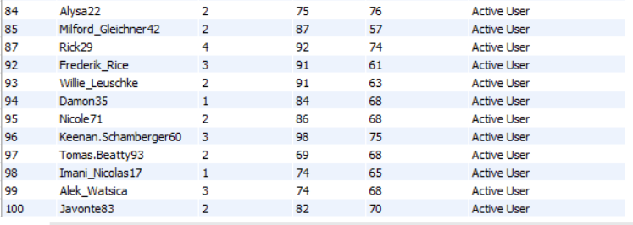

Category wise user chart:
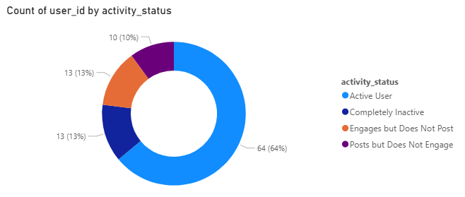

Strategic Re-Engagement Framework for Inactive Users
1. Data-Driven Segmentation: Before launching a campaign, we must categorize inactive users based on their historical behavior. Using SQL to segment users allows for personalized recovery:

- Slipped Away: Users who were active but stopped suddenly (possibly due to a technical bug or bad experience).

- Lurkers: Users who log in but never post (low confidence or lack of incentive).

- Ghosted: Long-term inactive users (likely lost interest in the core value proposition).

2. "Win-Back" Email & Push Campaigns: Personalized communication is the first line of defense.

- The "What’s New" Digest: Send a summarized "Best of" report highlighting high-engagement content they missed.

- Direct Incentives: Offer a limited-time "Welcome Back" bonus, such as a temporary premium feature trial or a discount code, to trigger a return visit.

3. Implementing "Low-Friction" Engagement Loops: Users often stop posting because the "cost" of creating content feels too high. We can lower this barrier by:

- Polls and One-Click Interactions: Encourage them to participate in simple polls or "Reaction" based content that doesn't require writing a full post.

- Question Prompts: Use AI-driven or community-based prompts (e.g., "What is your opinion on [Topic]?") to trigger a response.

4. Personalization & Social Triggers: Leverage social proof to draw users back into the ecosystem:

- Activity Notifications: Alert users when someone they previously interacted with posts new content or when their past content receives new likes/comments.

- Relevant Tagging: Notify users of discussions in their specific areas of interest (based on historical data).

5. Product Feedback Surveys: If a user remains inactive, the most valuable "engagement" they can provide is data.

- Send a short, one-question survey asking why they left.

- Business Value: This qualitative data helps the product team identify pain points (e.g., UI issues, lack of relevant content, or notification fatigue) to prevent future churn.

- Which hashtags or content topics have the highest engagement rates? How can this information guide content strategy and ad campaigns?

Answer:- This query analyzes engagement at the hashtag level by first creating two CTEs, Likes and Comments, which calculate the total number of likes and comments for each photo using photo_id.
The tags table is then joined with the photo_tags table to associate each hashtag with its related photos, and left joins are used to bring in the corresponding like and comment counts for each photo.
For every tag, the query computes the total number of posts, total likes, and total comments.
The engagement rate is calculated as the average combined number of likes and comments per post for each tag.
Finally, the results are sorted in descending order based on average engagement, and the top 10 hashtags are returned, helping identify the most engaging tags to support content strategy and advertising decisions.
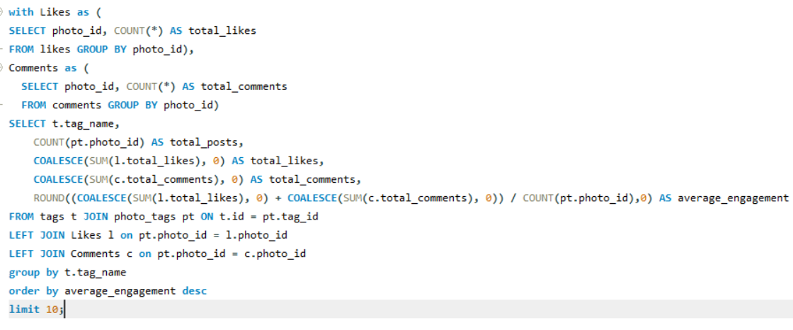

Result:
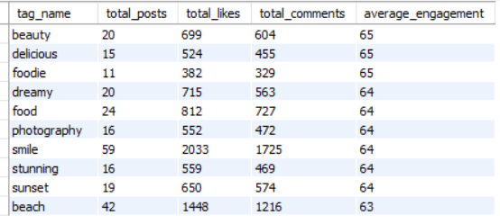
Chart for hashtag post count vs engagement:

Strategic Recommendations:
1. High-Engagement Topic Prioritization (Content Optimization): By analyzing historical performance data, we can identify "high-yield" topics and hashtags. Prioritizing these subjects ensures that content production resources are allocated toward themes with the highest probability of virality and user retention.

2. Data-Informed Targeted Ad Campaigns: Instead of broad targeting, ad spend should be directed toward "clusters" of users who interact with specific high-performing hashtags. This alignment between user interest and creative execution significantly improves Click-Through Rates (CTR) and lowers Customer Acquisition Cost (CAC).

3. Organic Reach Optimization (Hashtag Refinement): Using a data-backed approach to hashtag selection removes guesswork. By identifying "underserved" but trending hashtags, the platform can capture organic reach in niche markets before they become oversaturated.

4. Algorithmic Tailoring & Personalization: Insights from hashtag interactions should feed directly into the platform’s recommendation engine. Personalizing a user’s feed based on their "hashtag affinity" enhances the User Experience (UX) and increases daily active usage.

5. Recurring Content Series (Predictive Engagement): Developing serialized content (e.g., #TechTuesday or #MarketWrap) creates a predictable engagement loop. This "appointment viewing" behavior builds long-term habituation and allows for better forecasting of weekly engagement metrics.
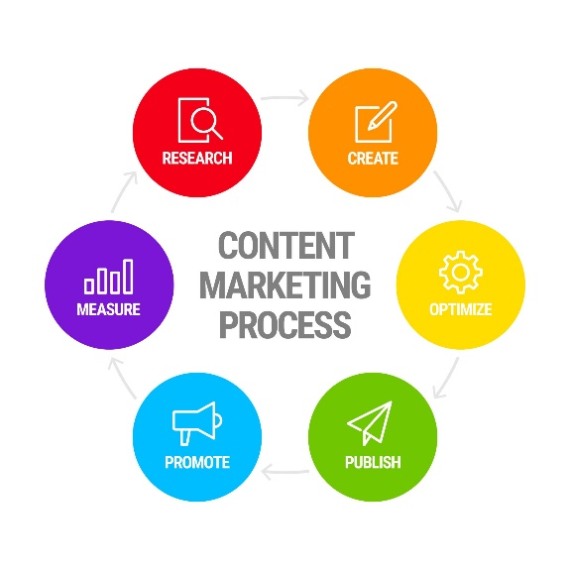

6. Multi-Channel Synchronization (Cross-Promotion): To maximize the lifecycle of a single piece of content, strategies should include cross-platform synchronization. Using high-performing Instagram hashtags to guide content on LinkedIn or X (Twitter) ensures a unified brand voice and drives referral traffic back to the primary ecosystem.

7. Strategic Influencer Partnerships: Influencer selection should be based on Engagement Rate (ER) within specific hashtag domains rather than just total follower count. Collaborating with "Micro-influencers" in high-performing niches often yields a higher Return on Ad Spend (ROAS) due to their high audience trust.

8. Behavioral Audience Insights: Hashtag data serves as a proxy for consumer sentiment. Analyzing these trends allows the business to understand shifting values and interests in real-time, enabling the pivot of brand strategy to stay ahead of market trends.

9. Sentiment Analysis: Beyond just "engagement," use Natural Language Processing (NLP) to determine if the engagement on these hashtags is positive or negative, protecting brand safety.

10. Conversion Attribution: Trace the journey from a hashtag discovery to a final conversion (like a sign-up or purchase) to measure the true economic value of organic social activity.

- Are there any patterns or trends in user engagement based on demographics (age, location, gender) or posting times? How can these insights inform targeted marketing campaigns?

Answer: This query examines photo engagement over time by calculating posts, likes, and comments for different time periods. It first creates two CTEs, Likes and Comments, to count the total likes and comments for each photo. The main query joins this data with the photos table and extracts the hour of the day and day of the week from the photo creation time. The results are grouped by hour and day to identify peak engagement periods, and the average engagement is calculated by dividing the total likes and comments by the number of posts.

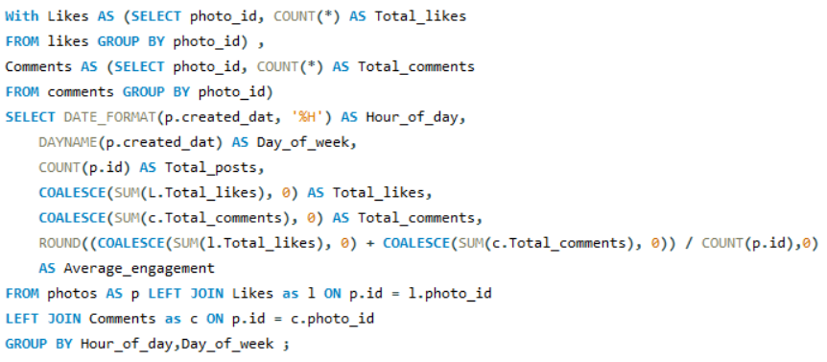

Result:

Data Analysis: Engagement Patterns
1. Peak Performance Metrics: Quantitative analysis reveals a significant Peak Engagement Window on Tuesdays at 10 PM. During this period, the platform experiences an average engagement score of 63, derived from a sample of 100 high-activity users.

2. Aggregated Interaction Volume: The dataset, comprising 257 posts, yielded a total of 8,782 likes and 7,488 comments. The resulting engagement rate serves as a benchmark for evaluating future campaign performance during high-traffic hours.

3. Strategic Implications: The identification of this "Power Hour" (Tuesday, 10 PM) suggests a prime opportunity for Targeted Ad Placement. Deploying high-value content or advertisements during this window will likely maximize Return on Ad Spend (ROAS) by capturing users when they are most interactive.

Strategy for Targeted Marketing:

1. Demographic-Based Trend Analysis: Engagement patterns are not universal; they are highly correlated with user demographics. We must segment the audience to ensure that the content serves the specific interests of distinct cohorts.

2. Contextual Content & Temporal Relevance: Content must match the temporal context of the user. For instance, posts utilizing hashtags such as #party_night, #concerts, and #soothing_songs perform significantly better during late-night hours. Aligning "night-themed" creative assets with late-night browsing habits increases relatability and organic reach.

3. Lifecycle & Interest-Based Targeting:
- Different age and gender segments exhibit unique consumption habits.
- Young Adults: High affinity for entertainment, nightlife, and experiential content (e.g., movies, concerts).
- Mature Demographics: Preference for nostalgic content and specialized interests (e.g., historical reels, devotional content).
- Vertical-Specific Segments: Targeted content for lifestyle-oriented users, focusing on niches like culinary arts, fashion, and styling.

4. Geo-Fencing and Location-Based Strategy: Location-specific metadata (hashtags like #Tokyo, #Sakura, or #LifeInJapan) allows for Hyper-Local Marketing. By targeting users interested in specific regions, we can serve culturally relevant advertisements that feel personalized rather than generic.

5. Data-Driven Content Personalization: Beyond broad segments, we should use individual engagement history to tailor messaging. This involves dynamic creative optimization adjusting imagery and copy to match the predicted preferences of the user, thereby increasing the Conversion Rate (CR).

- Based on follower counts and engagement rates, which users would be ideal candidates for influencer marketing campaigns? How would you approach and collaborate with these influencers?

Answer:- This query identifies the top 10 users suitable for influencer marketing by analyzing follower counts and engagement rates. It first calculates the number of followers for each user in the Followers CTE and totals likes and comments per user in the total_likes_n_comments CTE. These results are then combined with the users table, using COALESCE to handle missing values and computing an engagement rate based on likes and comments relative to follower count. Finally, users with at least one follower are filtered and ranked by engagement rate and follower count in descending order to return the top potential influencers.
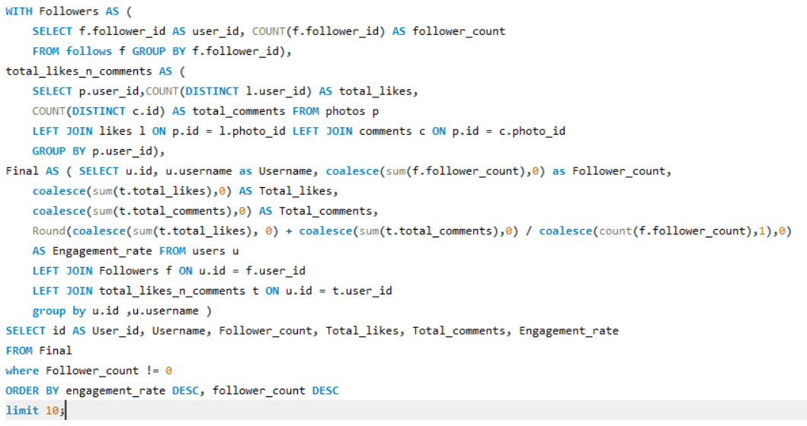

Result:
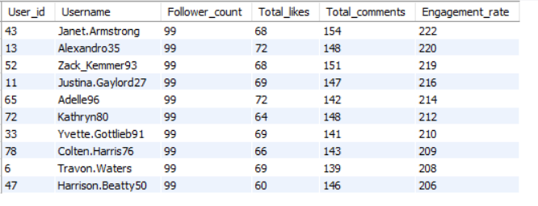

Graph for Follower Count and Engagement Rate:

Influencer Partnership & Collaboration Framework

1. Data-Driven Influencer Identification
Rather than focusing solely on vanity metrics like follower count, we utilize SQL and social analytics to evaluate:
- Engagement Rate (ER): The ratio of interactions to total followers.
- Audience Alignment: Analyzing the influencer's follower demographics to ensure they match our target customer profile.
- Brand Sentiment: Ensuring the influencer's historical content aligns with our core brand values to avoid reputational risk.

2. Strategic Outreach & Objective Setting: Once the selection is finalized, the approach must be governed by clear Campaign Objectives (e.g., Brand Awareness, Lead Generation, or User Acquisition). To maintain high conversion rates, we provide influencers with creative freedom, ensuring the content feels authentic to their audience while remaining within established brand guardrails.

3. Relationship Management & Lifecycle Value: Moving away from transactional one-off posts, we focus on Long-term Advocacy. By transitioning successful influencers into Brand Ambassadors or offering affiliate-based commission structures, we create a sustainable growth loop that builds deeper trust with the user base over time.

4. Structured Compensation Models: Compensation should be scaled based on performance and reach. As a Business Analyst, I recommend a mix of:
- Fixed Fee: For guaranteed content production.
- Performance-Based Incentives: Bonuses for meeting specific KPI targets (e.g., a certain number of sign-ups or clicks).
- Value-in-Kind: Exclusive access to premium platform features or events.

5. Performance Tracking and Cross-Channel Amplification
To measure the success of the collaboration, we track specific Key Performance Indicators (KPIs) such as:

- Conversion Rate (CR) from influencer-specific referral links.
- Cost Per Engagement (CPE).
- Earned Media Value (EMV). High-performing influencer content is then repurposed and amplified through our own paid media channels to maximize reach and efficiency.

- Based on user behavior and engagement data, how would you segment the user base for targeted marketing campaigns or personalized recommendations?

Answer:-
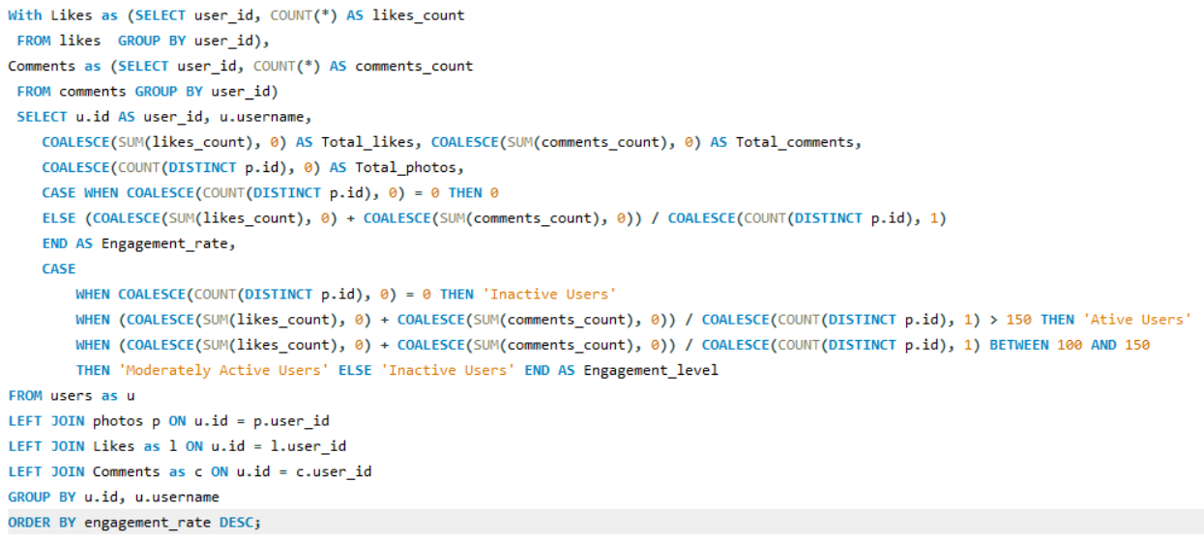
This query groups users into different engagement segments based on their activity levels. It begins by using two CTEs, Likes and Comments, to calculate the total number of likes and comments made by each user, and then joins this data with the photos table to count how many photos each user has posted. An engagement rate is calculated by dividing the total likes and comments by the total number of photos, with special handling for users who have not posted any photos. Based on this engagement rate, users are classified as Active Users, Moderately Active Users, or Inactive Users using predefined thresholds. Finally, the query groups results by user ID and username and orders them by engagement rate in descending order to highlight the most engaged users first.

Result:
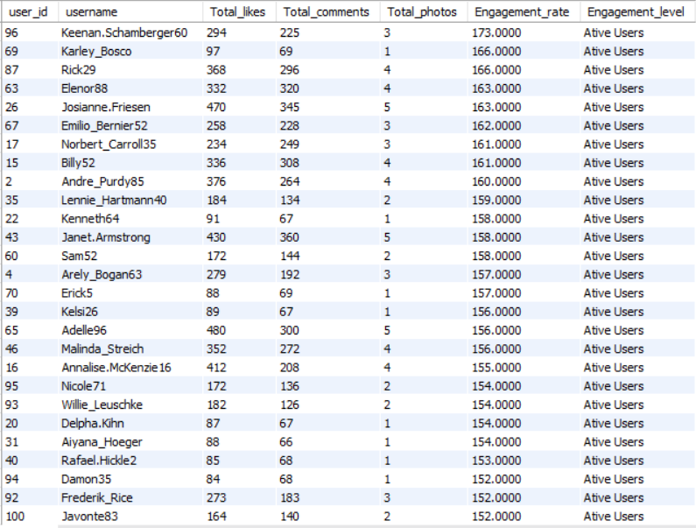
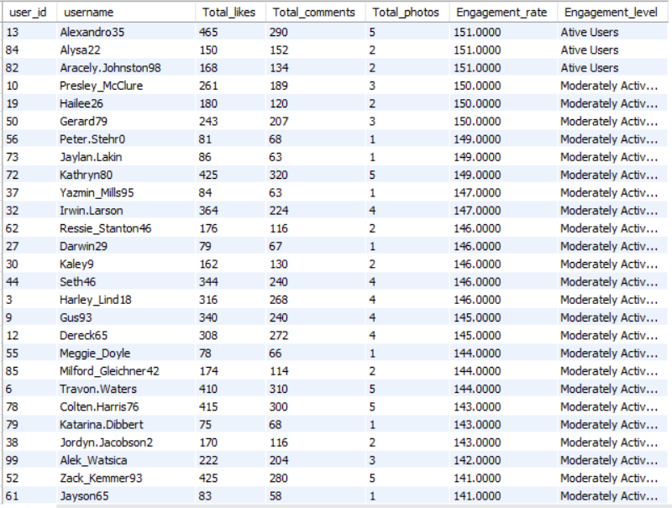
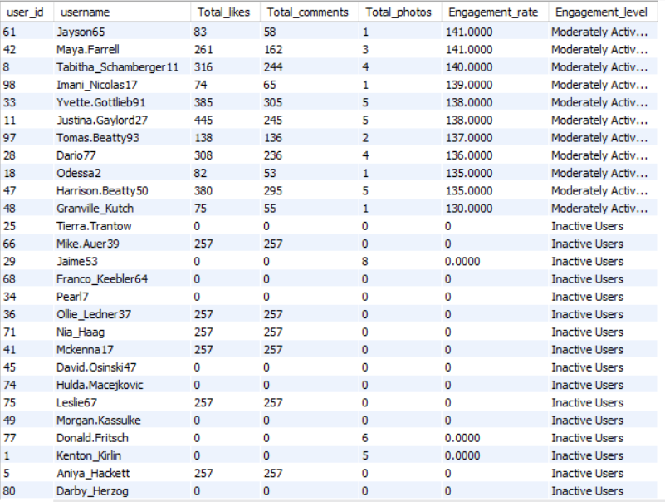
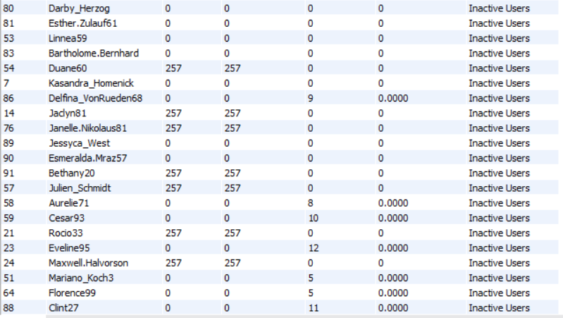

Engagement Level distribution Chart:
Out of the total 100 users, 30% are Active Users, meaning 30 users are highly engaged. Around 34% are Moderately Active Users, which corresponds to 34 users who show a medium level of engagement. The remaining 36% are Inactive Users, representing 36 users with low engagement levels.

Targeted Marketing and Personalization Strategy

A. High-Engagement Segment (Active Users)
- Marketing Campaigns: Focus on Retention and Advocacy. Offer "First-Look" access to premium features or beta products. Implement a tiered loyalty program that provides monetary rewards or exclusive gifts to transform these users into brand ambassadors.

- Personalized Recommendations: Utilize Collaborative Filtering (predicting interests based on similar users) to suggest high-value content. Notifications should be hyper-personalized, triggered by their specific peak activity hours.

B. Developing Segment (Moderately Active Users)
- Marketing Campaigns: Focus on Growth and Habituation. Use "Limited-Time Offers" or "Streak Bonuses" to encourage more frequent logins. Targeted ads should highlight interactive content (polls, challenges) to lower the barrier to deeper engagement.

- Personalized Recommendations: Implement a "Discovery" engine that balances familiar content with "Trending" topics to broaden their interests and increase their time spent on the platform.

C. Re-engagement Segment (Inactive Users)
- Marketing Campaigns: Focus on Churn Mitigation. Execute "Win-Back" email sequences featuring "We Missed You" incentives or high-value educational content. The messaging should emphasize what has changed or improved since their last visit.

- Personalized Recommendations: Display Top-Tier / Viral Content only. Since specific data on their current interests may be stale, use "Crowd Favorites" to minimize the risk of irrelevant suggestions and regain their initial attention.

Implementation Roadmap
To execute these strategies effectively, the following operational steps are required:

1. Longitudinal Data Analysis
Continuous monitoring of user telemetry and engagement metrics is essential. We must perform regular Cohort Analysis to identify if users are moving upward (becoming more active) or downward (becoming inactive) through the funnels.

2. Dynamic Messaging Architecture
Develop a library of customized creative assets. Each message must be tailored to the demographic and behavioral traits of the segment, ensuring the Value Proposition matches the user's current commitment level.

3. A/B and Multivariate Testing
Before a full-scale rollout, we conduct controlled experiments within segments. By testing different variables—such as discount percentages vs. feature access—we can statistically determine which strategy yields the highest Conversion Rate (CR).

4. Continuous Optimization Loop
Post-campaign analysis is vital. By tracking Key Performance Indicators (KPIs) like Click-Through Rate (CTR) and Customer Acquisition Cost (CAC), we can iteratively refine our SQL queries and recommendation algorithms to improve overall platform health.

- If data on ad campaigns (impressions, clicks, conversions) is available, how would you measure their effectiveness and optimize future campaigns?

Answer:-
Measuring Ad Campaign Effectiveness and Optimization Strategies
Quantitative Measurement of Effectiveness
- Top-of-Funnel: Impressions & Reach
High impression counts indicate successful Share of Voice (SOV) and brand visibility. However, these are "Vanity Metrics" unless paired with engagement data to verify that the reach is actually reaching the correct audience.
- Middle-of-Funnel: Click-Through Rate (CTR)
$CTR = (\text{Clicks} / \text{Impressions}) \times 100$. This metric measures the Creative Resonance. A high CTR confirms that the ad's visual and copy are successfully interrupting the user's scroll and prompting interest.
- Bottom-of-Funnel: Conversion Rate (CVR)
The ultimate measure of success. The Conversion Rate validates the alignment between the ad's promise and the landing page's execution. It tells us if the "ask" (e.g., a sign-up or purchase) is compelling enough.
- Efficiency Metrics: CPA and ROAS
We must calculate the Cost Per Acquisition (CPA) to ensure we aren't spending more to acquire a customer than they are worth. Return on Ad Spend (ROAS) helps us understand the direct revenue generated for every dollar spent.

Optimization Roadmap for Future Campaigns
Data without action is overhead. We optimize future performance through the following strategic levers:
- A/B and Multivariate Testing: We systematically test variables (headlines, CTA buttons, hero images) to identify which combination yields the lowest CPA. We then shift the budget toward the "Winning" variant.
- Creative Refresh & Combatting Ad Fatigue: Users develop "banner blindness" over time. By monitoring the Frequency metric (how many times a single user sees the same ad), we can proactively refresh creatives to maintain high engagement levels.
- Granular Audience Refinement: We use SQL to segment performance by demographics (age, location, device type). We then implement Bid Adjustments, increasing spend on high-converting demographics while "Blacklisting" or reducing spend on underperforming segments.
- Landing Page Experience (LPE): Optimization isn't just about the ad; it’s about the destination. We use Heatmaps and Bounce Rate data to streamline the conversion path, ensuring that the landing page loads quickly and mirrors the ad's messaging.
- Full-Funnel Retargeting: For users who clicked but did not convert, we deploy Dynamic Retargeting. This serves personalized ads featuring the specific products or features they previously viewed, significantly increasing the likelihood of a "win-back" conversion.
- Dynamic Budget Allocation: We move away from static budgets. Using a Fluid Budgeting Model, we shift capital in real-time toward the channels and campaigns showing the highest marginal return.

Conclusion
By treating ad data as a continuous feedback loop, we ensure that every dollar spent is an investment in learning. This data-driven approach minimizes waste and scales the platform's growth in a predictable, profitable manner.

- How can you use user activity data to identify potential brand ambassadors or advocates who could help promote Instagram's initiatives or events?

Answer:- Identifying Brand Ambassadors through User Activity Data
A brand ambassador is more than just a high-follower account; they are "Power Users" whose behavior demonstrates deep alignment with the platform's ecosystem. Using SQL and behavioral data, we can identify these advocates through a structured four-pillar approach.
1. Quantitative Advocacy Scoring
We go beyond simple follower counts to calculate an Individual Engagement Score. This includes:
- Active Participation Rate: Tracking users who consistently like, comment, and save content.
- Amplification Factor: Identifying users who frequently use the "Share" or "Repost" functions, acting as organic distributors of platform initiatives.
- UGC (User-Generated Content) Volume: Tagging users who mention the brand or use official hashtags without being prompted.
2. Influence and Network Connectivity
While reach is important, we prioritize "Social Connectivity":
- Niche Authority: Using data to see if a user is a central node in a specific community (e.g., Tech, Fashion, or Wellness).
- Follower Sentiment: Analyzing the comments on an influencer's page to ensure their audience is highly receptive and positive, rather than passive.
3. Loyalty and Retention Metrics (The "Sticking" Factor)
We look for Long-term Habituation rather than temporary spikes in activity:
- Tenure: Prioritizing users who have maintained high engagement levels for 12+ months.
- Organic Advocacy: Identifying "Zero-Cost" advocates—users who promoted events or features in the past without any formal partnership. These users offer the highest level of Brand Authenticity.
4. Content-Brand Alignment Analysis
We perform qualitative analysis on the user's content history to ensure "Brand Safety" and value alignment:
- Aesthetic Synergy: Does their content style match the platform’s high-quality visual standards?
- Topic Modeling: If a user consistently posts about sustainability, they are prioritized for environmental initiatives. This ensures the partnership feels natural to their followers.

Strategy for Ambassador Onboarding and Collaboration
Once potential advocates are identified via the data, we move into the Conversion and Management phase:
- Personalized Lifecycle Outreach: Instead of a generic message, we reference their specific data milestones (e.g., "We noticed you’ve been a top contributor to #WellnessWednesday for two years...").
- The Mutual Value Proposition: We offer a mix of "Social Currency" (exclusive badges, early access to tools) and "Tangible Rewards" (monetary compensation, event invites) to solidify the partnership.
- Creative Autonomy: To maintain the user's trust, we provide "Guardrails" rather than "Scripts." Authentic, creator-led content typically yields a 3x higher engagement rate than brand-produced ads.
- Long-Term Ambassador Lifecycle: We transition high-performing advocates into an Ambassador Tier, providing them with direct lines to product teams, making them true stakeholders in the platform's future.

- How would you approach this problem, if the objective and subjective questions weren't given?

Answer:- Strategic Framework for Unstructured Data Analysis
In the absence of predefined objective and subjective questions, I would adopt a bottom-up analytical approach. This involves moving from data hygiene to high-level strategic business insights through the following phases:
1. Business Objective Definition
The process begins with defining the Primary Business Goals. Without prompts, I would focus on the three pillars of platform growth: User Retention, Monetization (Ad Performance), and Content Virality. This ensures that the subsequent technical analysis remains aligned with organizational value.

2. Data Audit and Quality Assurance (QA)
Before performing calculations, I would conduct a comprehensive audit of the schema.
- Data Integrity: Identifying null values, duplicate records, and orphaned foreign keys across the 100-user sample.
- Validation: Ensuring that timestamp formats and numerical ranges (like like-counts) are consistent for time-series analysis.

3. Exploratory Data Analysis (EDA) & Metric Identification
I would develop a set of Key Performance Indicators (KPIs) categorized by user behavior:
- Engagement KPIs: Calculating Average Engagement Rate (AER) per post and per user.
- Retention KPIs: Measuring Chun Risk by identifying the "Lapse Period" (time since last interaction) for each user segment.
- Network KPIs: Analyzing the Follower-to-Following Ratio to distinguish between casual consumers and professional creators.

4. Hypothesis Development
I would formulate data-driven hypotheses to guide the SQL operations.
- Example: "Does posting during off-peak hours (e.g., 10 PM) correlate with higher comment-to-like ratios for specific demographics?" This moves the analysis from "what is happening" to "why it is happening."
5. Advanced Trend & Taxonomy Analysis
By performing Hashtag Clustering, I would identify the "Content DNA" of the platform. By grouping hashtags by volume and engagement, we can identify which "Interest Verticals" (e.g., #Fitness, #Tech, #Travel) are currently trending and which influencers dominate those specific niches.

6. Quantitative SQL Modeling: At this stage, I would deploy complex SQL operations (CTEs, Window Functions, and Joins) to stress-test my hypotheses. This step transforms raw data into a structured result set that proves or disproves the initial trends observed.

7. Strategic Segmentation and Actionable Insights
I would apply RFM Analysis (Recency, Frequency, Monetary) logic—even in a non-monetary context—to segment the users:
- Power Users: Targeted for ambassador programs.
- At-Risk Users: Targeted with re-engagement triggers.
- Emerging Creators: Targeted with advanced analytics tools.

8. Executive Reporting and Visualization
The final phase is the creation of a Business Intelligence (BI) Dashboard. This translates SQL outputs into visual heatmaps, trend lines, and distribution charts. The report would conclude with a "Strategic Roadmap," offering the management team specific, data-backed recommendations for platform optimization and user growth.

- Assuming there's a "User_Interactions" table tracking user engagements, how can you update the "Engagement_Type" column to change all instances of "Like" to "Heart" to align with Instagram's terminology?
Answer:- Updating Schema Terminology
To align the database terminology with the platform's front-end interface (changing "Like" to "Heart"), a standard Data Manipulation Language (DML) operation is required.
The SQL Query:
UPDATE User_Interactions
SET Engagement_Type = 'Heart'
WHERE Engagement_Type = 'Like';
Logical Breakdown of the Operation:
- The UPDATE Statement: This command identifies the target table, User_Interactions, within the database schema where the modification will occur.
- The SET Clause: This defines the specific transformation. It instructs the database engine to overwrite existing values in the Engagement_Type column with the new string literal: 'Heart'.
- The WHERE Clause (Critical Filter): This acts as a conditional guardrail. By specifying WHERE Engagement_Type = 'Like', we ensure that the update is only applied to relevant rows. Without this clause, the query would inadvertently change every record in the column (e.g., "Comments" or "Shares") to "Heart," resulting in significant data corruption.
- Operational Result: This query successfully synchronizes the backend database with Instagram's specific branding, ensuring consistency between the data layer and the user interface.

Best Practices for Data Updates:
before running an UPDATE command on a production database, I would recommend these safety steps:
- Dry Run: Execute a SELECT count first (SELECT count(*) FROM User_Interactions WHERE Engagement_Type = 'Like') to verify exactly how many rows will be affected.
- Transaction Control: Use BEGIN TRANSACTION and COMMIT to ensure the changes can be rolled back if an error occurs.
- Backup: Ensure a recent snapshot of the table exists before performing bulk data manipulation.

