**Module 3 Challenge: A High-Stakes Investigation**

**Step 1: Investigation preparation.**

1. Create a single directory titled - Lucky_Duck_Investigation

mkdir Lucky_Duck_Investigation

2. Inside this, create a directory for investigation - Roulette_Loss_Investigation

cd Lucky_Duck_Investigation

mkdir Roulette_Loss_Investigation

3. Inside this, create three directories - Player_Analysis, Dealer_Analysis, Player_Dealer_Correlation

mkdir Player_Analysis Dealer_Analysis Player_Dealer_Correlation

4. Create empty files called Notes_Player_Analysis.txt, Notes_Dealer_Analysis.txt, and Notes_Player_Dealer_Correlation.txt in each subdirectory.

cd Player_Analysis

touch Notes_Player_Analysis.txt

cd ../

cd Dealer_Analysis

touch Notes_Dealer_Analysis.txt

cd ../

cd Player_Dealer_Correlation

touch Player_Dealer_Correlation.txt

Completed as instructed:

**Step 2: Gathering Evidence**

1. From Home directory, the following command is run:

wget "<https://drive.google.com/uc?id=1ZLY_fuFu3wz7tOlxf-GUrnvp3htuGKSa>" -O 3-HW-setup-evidence && chmod +x ./3-HW-setup-evidence && ./3-HW-setup-evidence

2. This command adds two more directories in current directory.

- Dealer_Schedules_0310, &

- Roulette_Player_WinLoss_0310

Completed as instructed:

3. Since the losses occurred on March 10, 12 and 15, move the schedules for those days into the directory Dealer_Analysis

From Home directory:

mv ./Dealer_Schedules_0310/0310_Dealer_schedule.txt ./Lucky_Duck_Investigations/Roulette_Loss_Investigation/Dealer_Analysis/

mv ./Dealer_Schedules_0310/0312_Dealer_schedule.txt ./Lucky_Duck_Investigations/Roulette_Loss_Investigation/Dealer_Analysis/

mv ./Dealer_Schedules_0310/0315_Dealer_schedule.txt ./Lucky_Duck_Investigations/Roulette_Loss_Investigation/Dealer_Analysis/

4. Move the WinLoss Player Data files for those days into the directory Player_Analysis.

From Home directory:

mv ./Roulette_Player_WinLoss_0310/0310_win_loss_player_data.txt ./Lucky_Duck_Investigations/Roulette_Loss_Investigation/Player_Analysis/

mv ./Roulette_Player_WinLoss_0310/0312_win_loss_player_data.txt ./Lucky_Duck_Investigations/Roulette_Loss_Investigation/Player_Analysis/

mv ./Roulette_Player_WinLoss_0310/0315_win_loss_player_data.txt ./Lucky_Duck_Investigations/Roulette_Loss_Investigation/Player_Analysis/

Step 3: Correlating the Evidence : Correlate the large losses from the Roulette tables with the dealer schedules.

1. Complete the player analysis:

a. Use grep to isolate all of the losses that occurred on March 10,12 and 15.

grep "-" *

b. Place those results in a file called Roulette_Losses.txt

grep "-" * > Roulette_Losses.txt

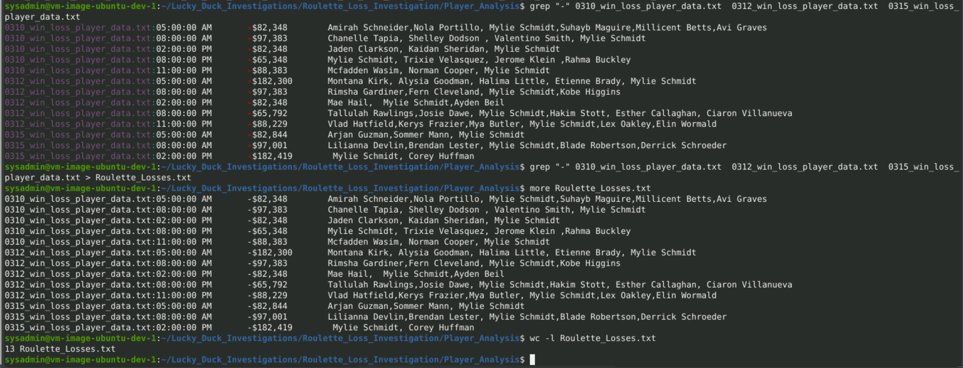

1. Fill in the analysis in Notes_Player_Analysis.txt with the followings:
   1. The time losses occurred on each day.

grep "0310" Roulette_Losses.txt | awk -F'[:"_"" "]' '{print $1, $6, $9}

grep "0312" Roulette_Losses.txt | awk -F'[:"_"" "]' '{print $1, $6, $9}

grep "0315" Roulette_Losses.txt | awk -F'[:"_"" "]' '{print $1, $6, $9}

(this also gets the first name of the player on the list, which I don’t know how to omit)

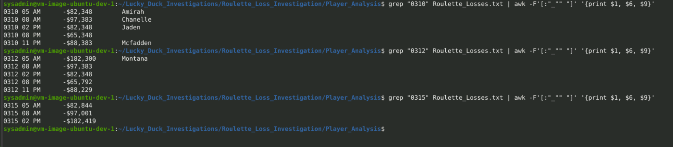

* If there is a certain player who was playing during each losses -- Mylie was there playing on given days and times.

grep "Mylie" Roulette_Losses.txt | awk -F'[:"_"" "]' '{print $1, $6, $9}'

Grep "Mylie" Roulette_Losses.txt | wc -l

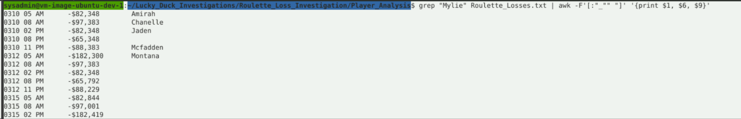

* Total times this player was playing :

grep -wo "Mylie" Roulette_Losses.txt | uniq -c

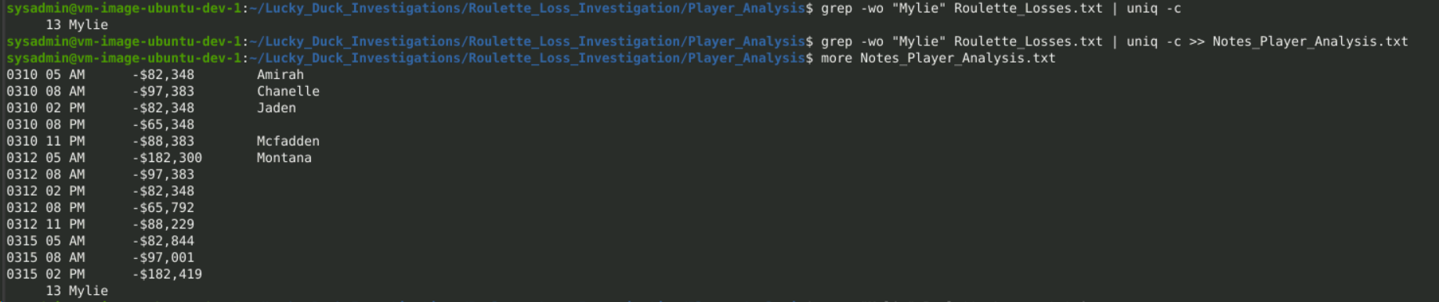

To count all possible players and see how many times they were playing:

Didn't used this:

grep -o -w '[[:alpha:]]\+' Roulette_Losses.txt | awk '{ count[$0]++ } END { for (name in count) print name, count[name] }' | sort -k2nr

Dealer Analysis

1. grep "05:00:00 AM" 0310_Dealer_schedule.txt | awk -F '\t' '{print $1, $2, $3, $4}' > Notes_Dealer_Analysis.txt

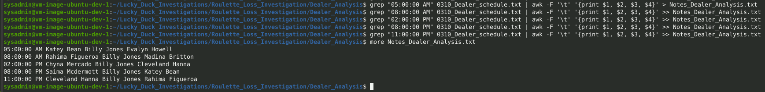

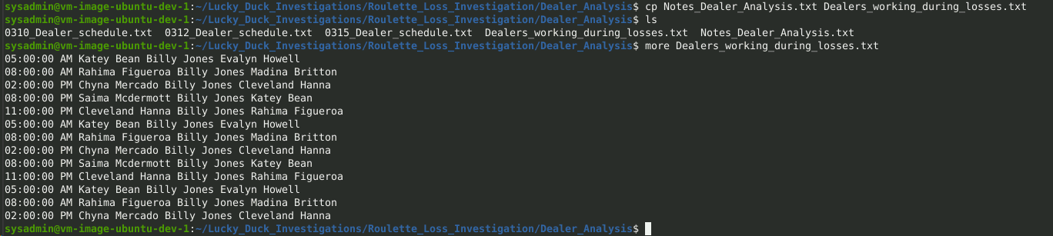

grep "AM" Dealers_working_during_losses.txt | awk -F '\t' '{print $1, $2, $3, $4}' | awk -F[" "] '{print $1, $2, $5, $6}' > Notes_Dealer_Analysis.txt

grep "PM" Dealers_working_during_losses.txt | awk -F '\t' '{print $1, $2, $3, $4}' | awk -F[" "] '{print $5, $6}' | uniq -c >> Notes_Dealer_Analysis.txt

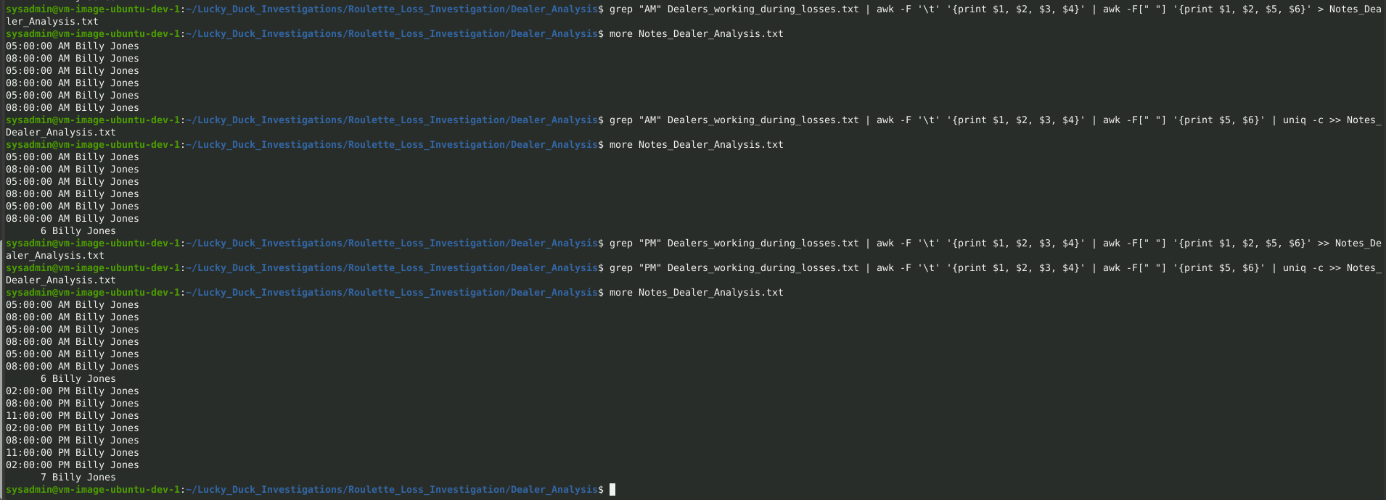

**Step 3: Correlating the Evidence**

Player_Dealer_Correlation

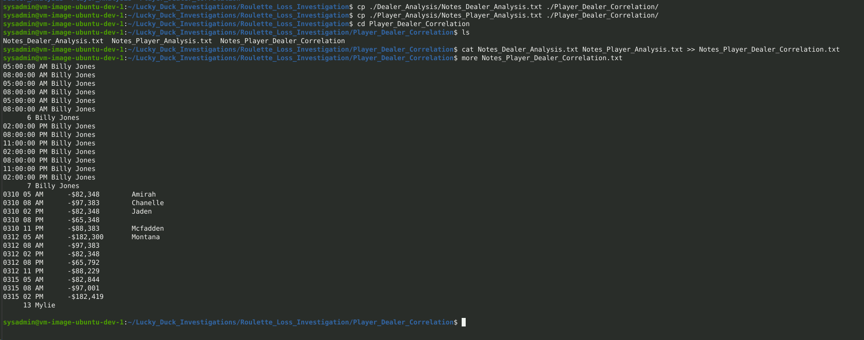

Putting the finding summary: Only the summary bits are edited manually.

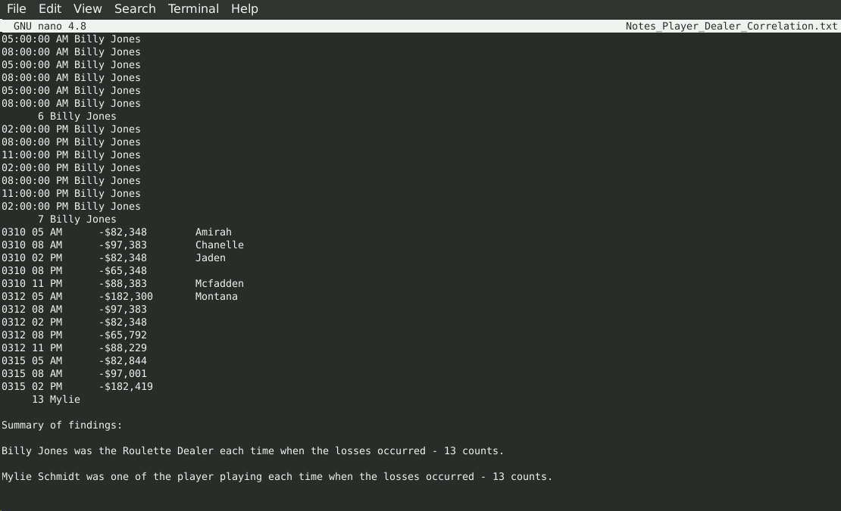

Writing scripts:

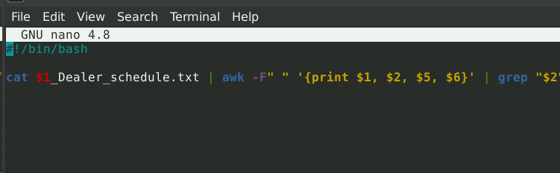



Compressing the files: Completed as per the instructions.

Submitting the Google link: Completed as per the instructions.

The End.