Q3) REPORT

**Step 1 :**

Open Oracle application developer server and open application developer responsibility

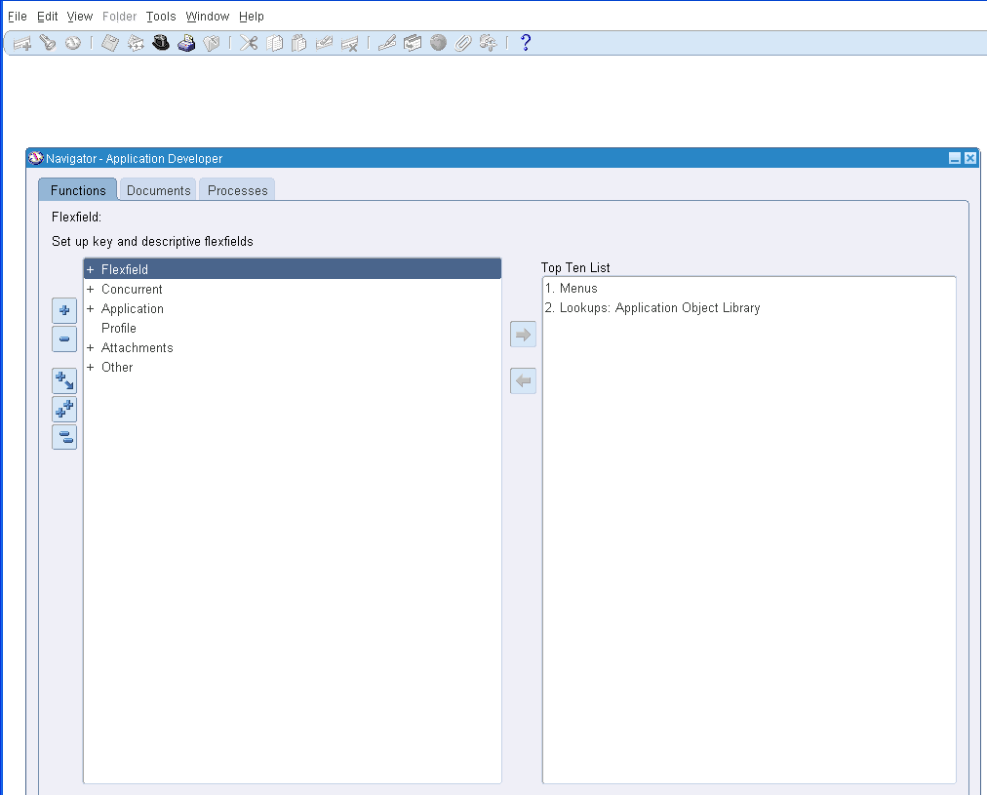

Step2:

Select Concurrent and navigate to Executable

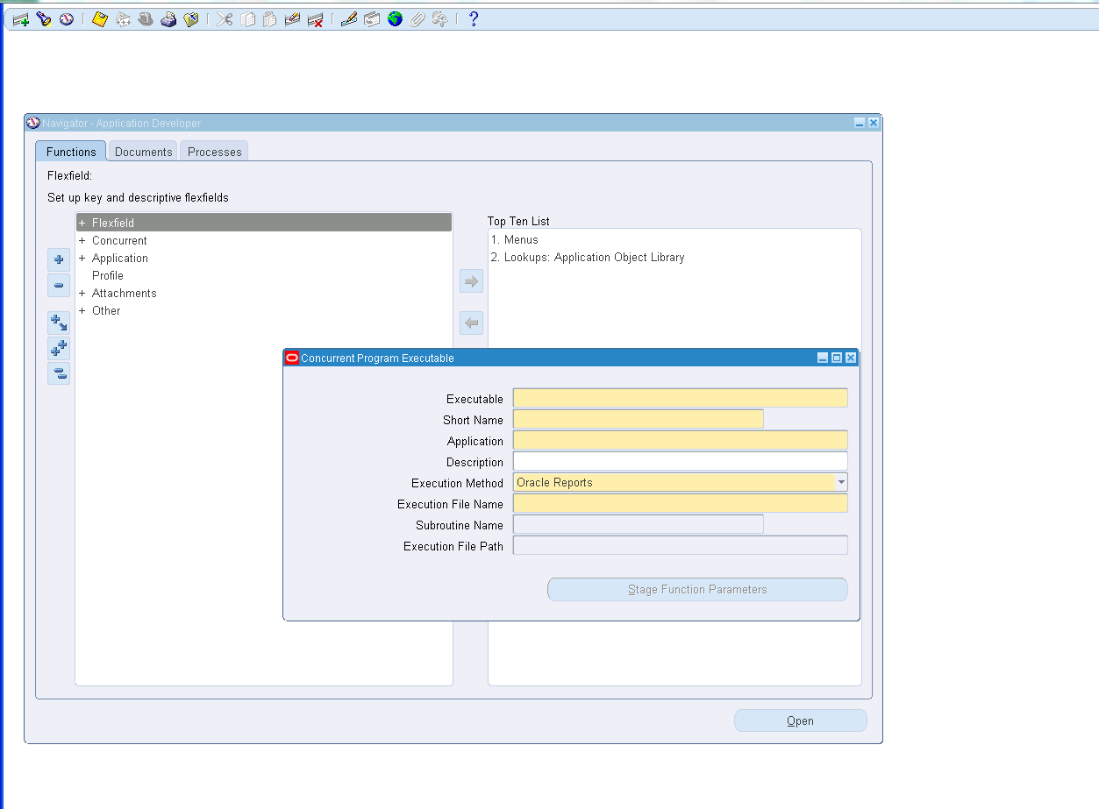

Step 3:

Fill with compiled Report details

Executable – JS_Emp_Report

Short Name – JS_Emp_Report

Application – Custom Development

Execution File Name- JS_Emp_Report

And Save it and exit

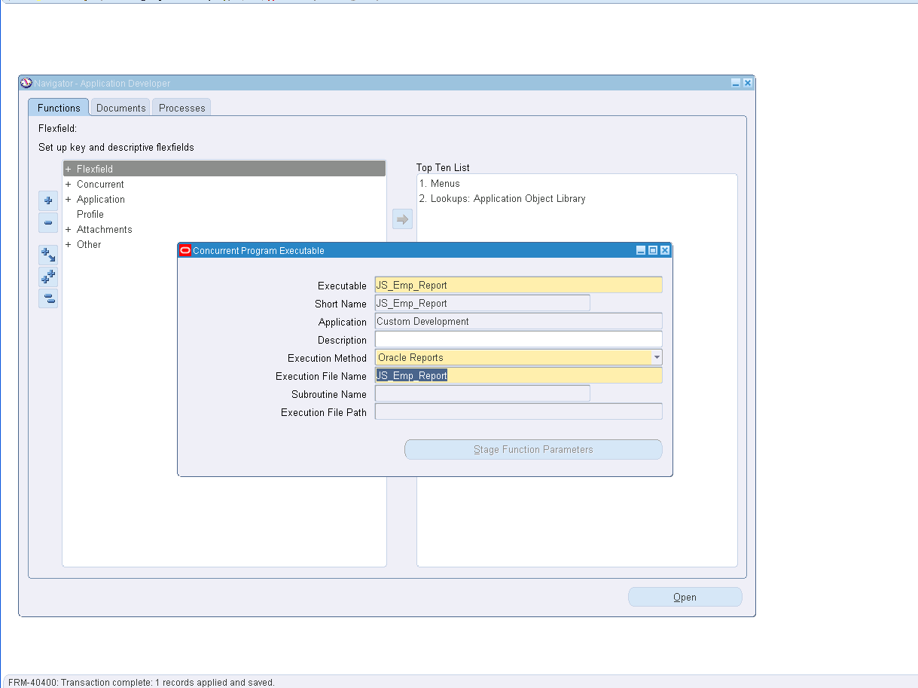

Step 4:

Navigate to Program

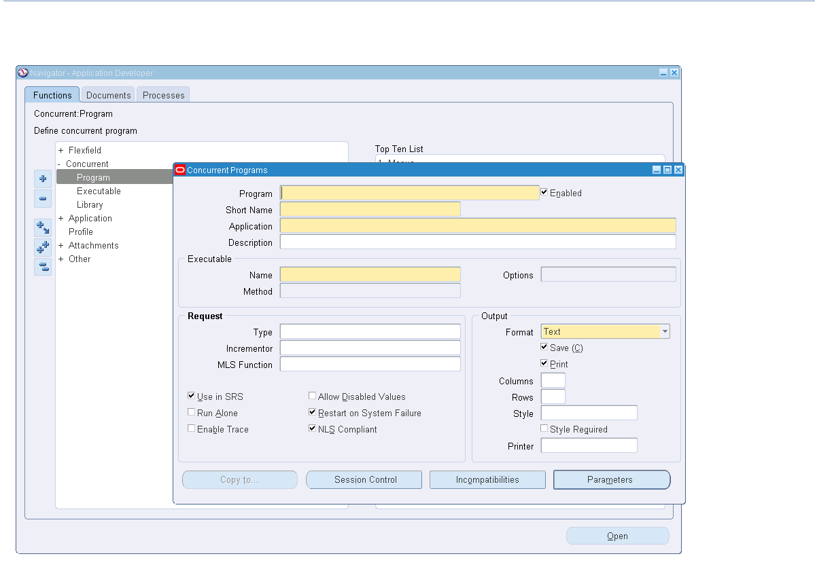

Step 5:

Program – Emp_Details

Short Name – Emp_Details

Application – Custom Development

Name – JS_Emp_Report

Format – Text

Style – A4

And Save it and exit

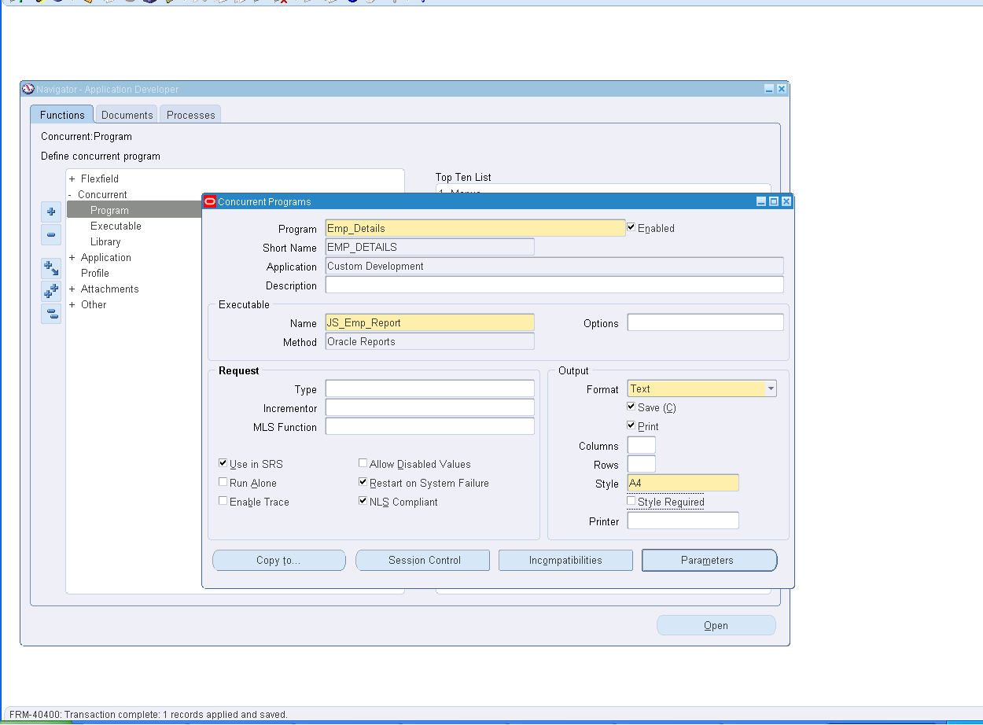

Step6:

Switch responsibility to custom responsibility

And navigate to System Administrator in Custom Responsibility

Click on Security 🡪 Responsibility 🡪 Request.

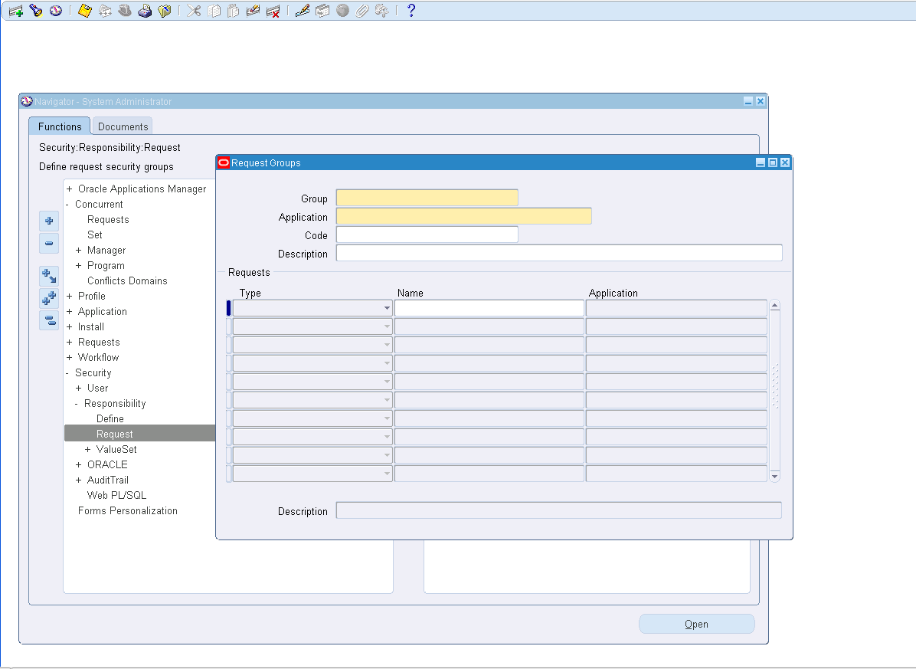

Step 7:

Create a new Request with the details

Group – All Reports

Application – Payables

Requests

Type – Program

Name – Emp_Details

And Save it and exit

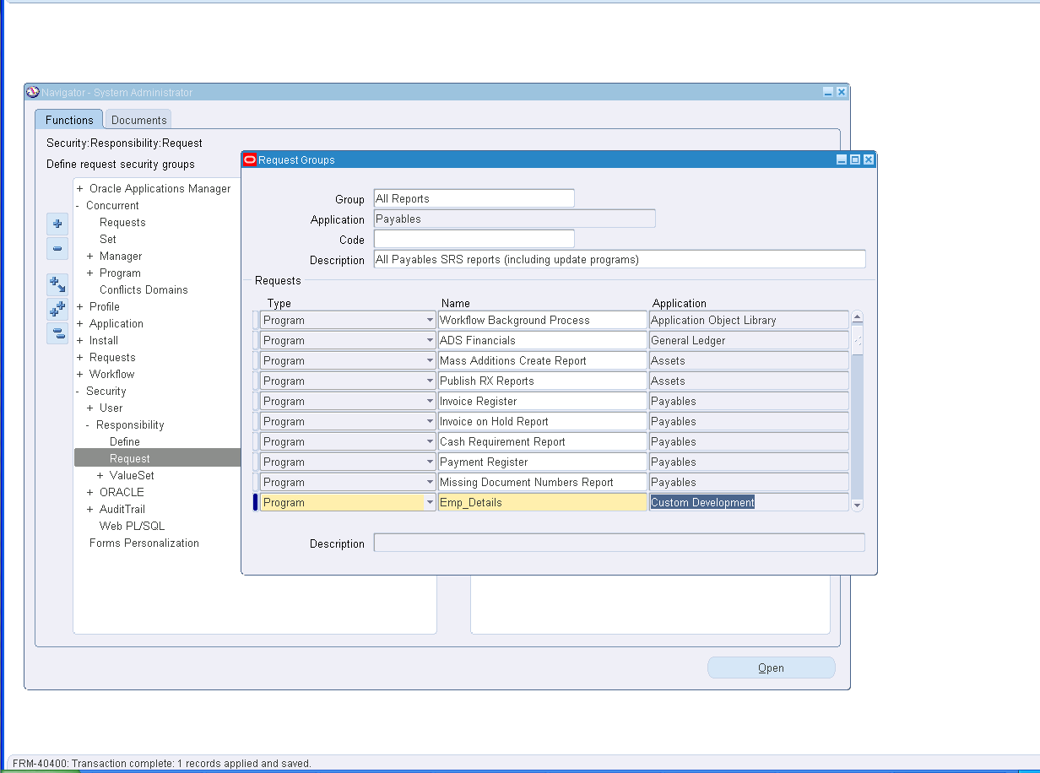

Step 8:

Switch responsibility to custom responsibility

And navigate to Payables, Vision operations (USA) in Custom Responsibility

Navigate to Others 🡪 Requests 🡪 Run

Click on Single Request and then click OK.

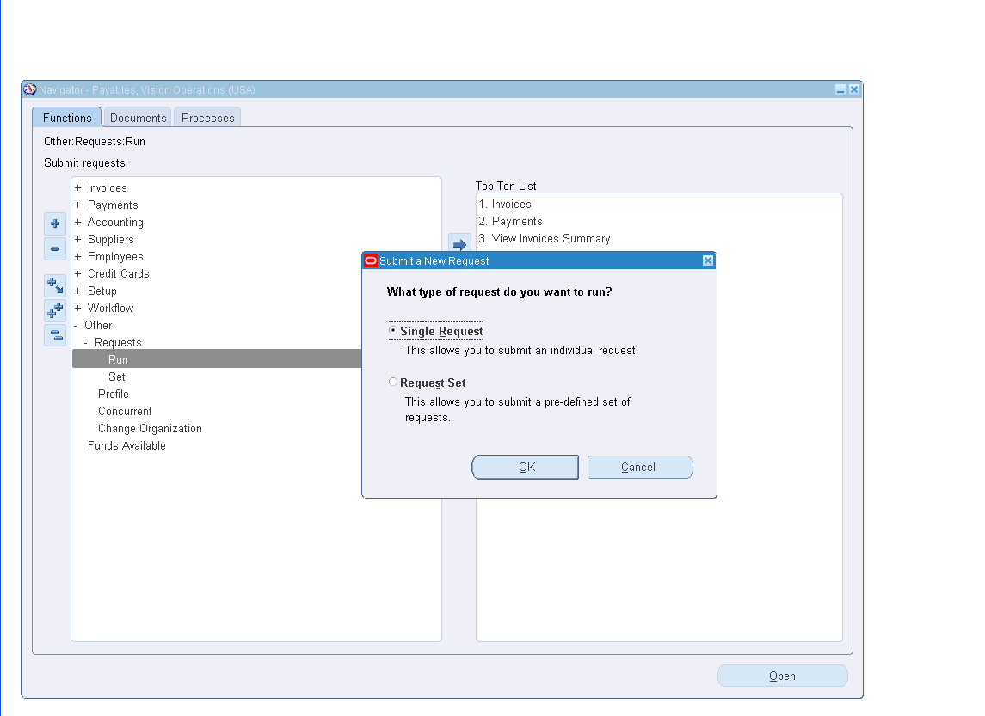

Step 9 :

Name – Emp_Details

Click On Submit .

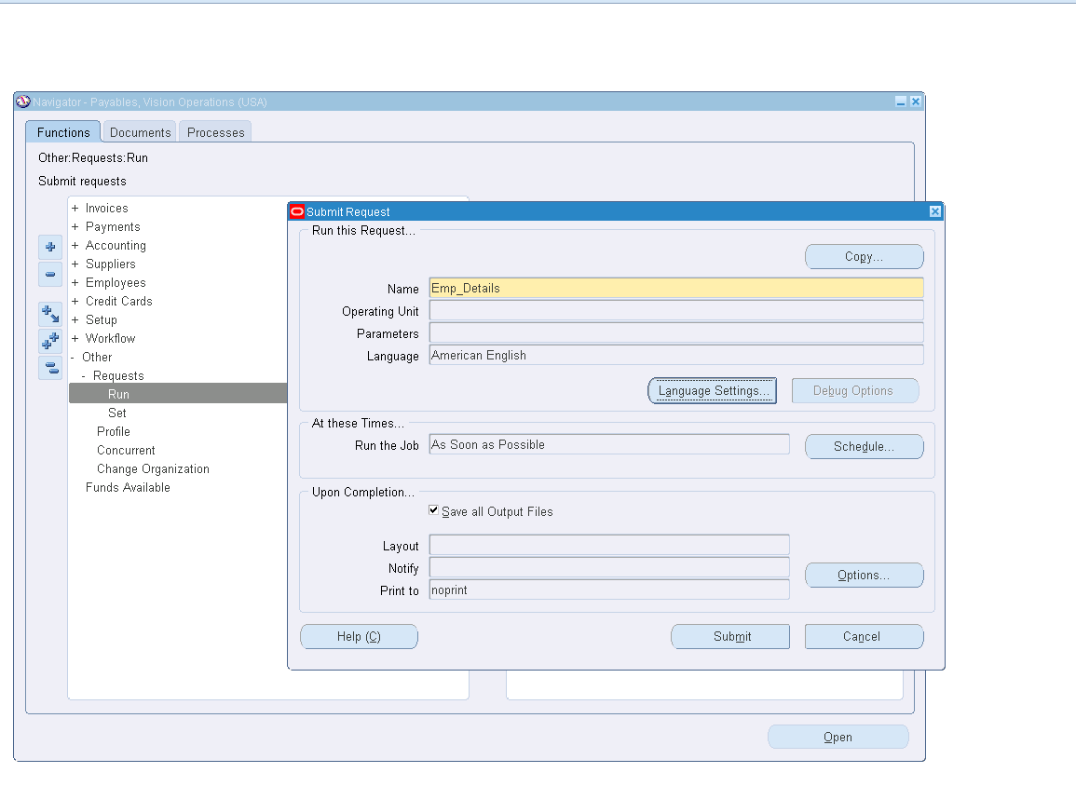

Step 10 :

A window will be displayed with the RequestId i.e.,

Request ID = 5529945

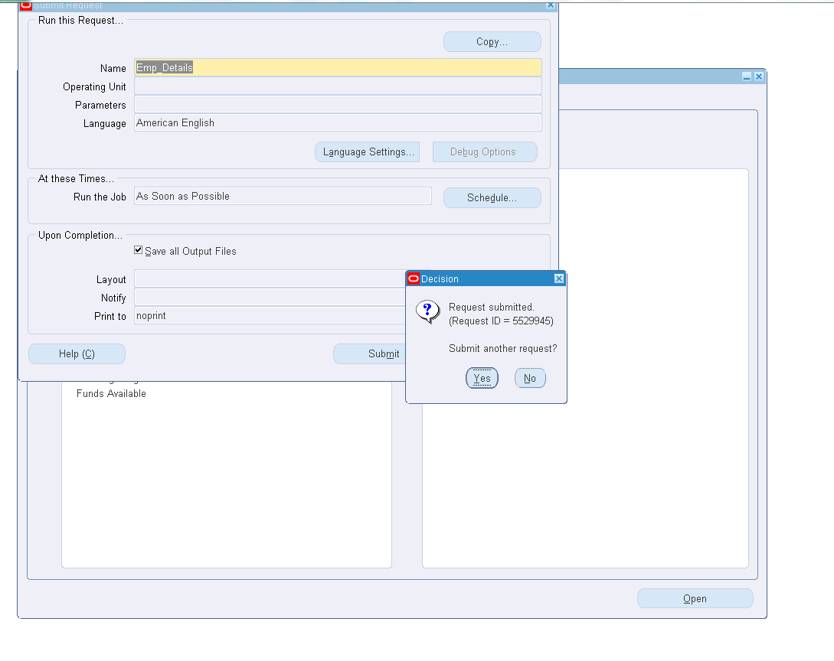

Step 11 :

Click on View tab in the menu bar and click on Requests

Click on Find buttom and select Request ID=5529945

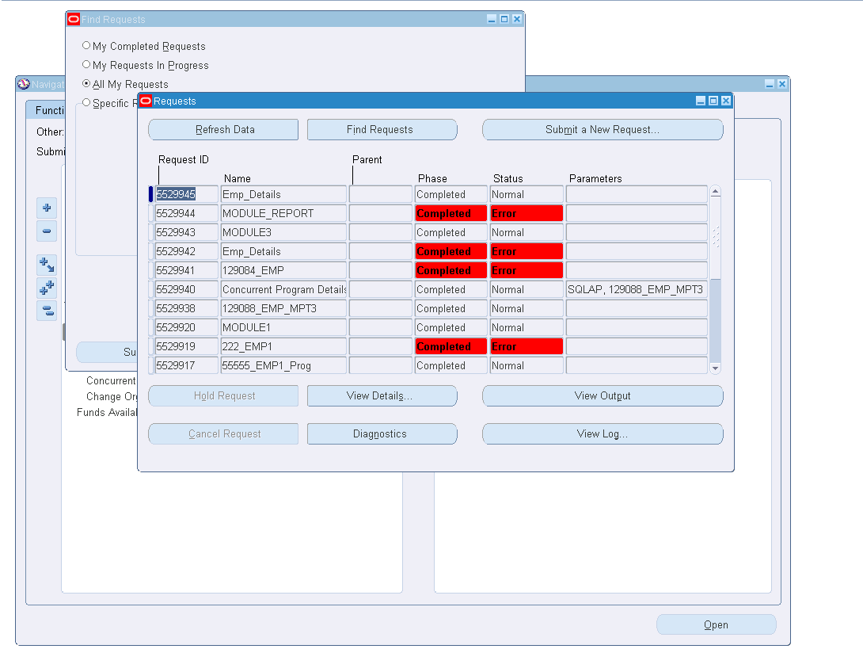

Step 12:

Click on View Output

