Voxxwire: Designing a Privacy-Preserving,
Fully Offline Speech Translation System
for Real-Time Cross-Lingual Communication
Jay Parmar Raj Prajapati
March 2026
Preprint. Under review.
Keywords: privacy-preserving speech translation · offline inference · voice activity detection · automatic speech recognition · neural machine translation · text-to-speech synthesis · edge AI deployment

Abstract
Multilingual communication across virtual meetings has become indispensable in today’s interconnected workplace, yet prevailing speech translation tools depend heavily on cloud infrastructure, exposing user conversations to third-party servers and demanding persistent network access. In this work, we introduce Voxxwire, an open-source desktop application that performs end-to-end speech translation entirely on the user’s local machine. Our system orchestrates four neural components within a single asynchronous pipeline: Silero-based voice activity detection for utterance segmentation, CTranslate2-accelerated Whisper inference for multilingual speech recognition, Argos Translate for offline neural machine translation spanning more than 49 language directions, and Piper for VITS-based speech synthesis. We propose a dual-channel architecture that concurrently processes microphone input and system audio loopback, enabling bidirectional translation during live video-conference sessions. To address the re-translation feedback loop that arises when synthesized audio is recaptured by the loopback channel, we devise a deterministic timing gate that suppresses capture during playback windows. On commodity hardware equipped with a mid-range GPU, the system achieves an observed end-to-end processing latency of approximately 355 milliseconds per utterance (excluding the configurable silence-detection interval), while guaranteeing that zero bytes of audio or text data leave the device. We detail the architectural decisions, module-level implementation, performance trade-offs across five Whisper model scales, and discuss current limitations alongside prospective extensions.

1. Introduction

1.1 Motivation and Context
The proliferation of remote collaboration tools—Zoom, Microsoft Teams, Google Meet—has dissolved geographic boundaries but has simultaneously magnified linguistic ones. Industry surveys consistently indicate that language mismatch remains a top-three barrier to effective global teamwork [1]. In response, technology providers have deployed cloud-hosted simultaneous translation services that stream user audio to centralized GPU clusters, apply sequence-to-sequence neural models, and return translated text or synthesized speech. While this paradigm delivers impressive accuracy, it entails three intertwined drawbacks that constrain adoption in privacy-critical, bandwidth-limited, or cost-conscious settings.
First, every utterance traverses the public internet and is processed on infrastructure controlled by a third party, creating exposure vectors that may conflict with regulatory frameworks such as the European Union’s General Data Protection Regulation (GDPR), the United States’ Health Insurance Portability and Accountability Act (HIPAA), or internal corporate data-handling policies. Second, the reliance on stable, low-latency connectivity renders these services fragile in environments with degraded or absent internet access—field operations, air-gapped facilities, rural regions, and in-flight scenarios. Third, metered pricing models (per character, per minute, or monthly subscription) impose ongoing financial burdens that scale with usage, discouraging sustained deployment during marathon multi-hour sessions.
These observations motivate the central research question addressed by this paper:
Is it feasible to construct a fully offline, real-time speech translation pipeline—encompassing voice activity detection, automatic speech recognition, neural machine translation, and speech synthesis—that executes within the resource envelope of a commodity Windows desktop while supporting a broad set of language pairs and preserving complete data sovereignty?

1.2 Contributions
This paper offers the following contributions:
- We present Voxxwire, an integrated system that chains four distinct neural inference modules into a cohesive, real-time translation pipeline operating without any network dependency.
- We describe a dual-channel asynchronous architecture in which voice activity detection and speech recognition are decoupled into separate coroutines connected by bounded queues, guaranteeing that incoming audio is never discarded even when downstream inference is temporarily saturated.
- We introduce a deterministic timing gate—an alternative to computationally expensive acoustic echo cancellation—that eliminates the re-translation feedback loop arising from system audio recapture of synthesized speech.
- We report latency and memory profiles across five Whisper model scales on both GPU and CPU, characterizing the accuracy–throughput trade-off envelope for edge deployment.
- We release the complete source code, enabling reproducibility and community-driven extension to additional platforms and languages.

1.3 Paper Outline
Section 2 surveys prior art in speech translation, ASR, and related offline systems. Section 3 presents the system architecture. Section 4 elaborates on each module’s implementation. Section 5 formalizes the feedback gate mechanism. Section 6 reports performance measurements. Section 7 discusses broader implications, current limitations, and avenues for future investigation. Section 8 concludes.

2. Related Work

2.1 Cloud-Hosted Speech Translation
Google’s conversation-mode translator covers more than 100 languages but transmits every audio frame to Google’s servers [2]. Microsoft’s Translator integrates into Teams and Skype, offering live captioning in 60+ languages, yet operates exclusively in the cloud [3]. Apple introduced on-device translation in iOS 18, representing the most prominent commercial step toward local inference; however, it is locked to Apple hardware and supports a narrower set of language pairs than its cloud counterparts [4]. DeepL provides high-fidelity neural translation through a REST API without speech-to-speech capability [5]. Critically, none of these platforms simultaneously deliver fully offline operation, broad language coverage, dual-channel audio processing, and open-source availability.

2.2 Whisper and Efficient ASR Inference
Radford et al. released the Whisper family of encoder–decoder transformer models, trained on 680,000 hours of heterogeneous web audio with weak supervision [6]. The model family spans five scales—from the 39-million-parameter “tiny” to the 1.55-billion-parameter “large-v3”—and supports transcription in 99 languages. The CTranslate2 runtime, developed by SYSTRAN, applies 8-bit integer quantization and kernel fusion to Whisper checkpoints, achieving up to four-fold inference acceleration relative to the reference PyTorch implementation with negligible quality degradation [7]. Our system leverages the faster-whisper binding atop CTranslate2 as its recognition backbone.

2.3 Neural Voice Activity Detection
Silero VAD is a lightweight recurrent neural network trained to distinguish speech from non-speech at the frame level [8]. It processes 512-sample chunks at 16 kHz and returns per-frame speech probabilities, achieving real-time throughput on CPU with minimal memory overhead. Earlier approaches based on Gaussian mixture models, such as the WebRTC VAD [9], offer extremely low compute cost but exhibit higher false-positive rates in noisy environments. We adopt Silero for its superior segmentation accuracy while retaining an energy-based fallback for degraded configurations.

2.4 Offline Neural Machine Translation
Argos Translate wraps compact OpenNMT-based sequence-to-sequence models into downloadable language packs, each typically under 100 MB [10]. When a direct model is unavailable for a given source–target pair, the library automatically pivots through English. An alternative, MarianMT [11], serves a similar niche but lacks Argos’s built-in package manager, making runtime language-pack acquisition less ergonomic. We select Argos Translate for its self-contained installation workflow and extensive language catalog.

2.5 Local Text-to-Speech Synthesis
Piper is an open-source synthesis engine employing VITS-architecture neural vocoders exported to the ONNX format [12]. Pre-trained voice models are available for over 30 languages and dialects. Compared to the discontinued Coqui TTS and the rule-based eSpeak NG, Piper balances naturalness, inference speed, and cross-language coverage most favorably for our deployment scenario.

3. System Architecture

3.1 Overview
Voxxwire is organized as a dual-channel, five-stage processing pipeline executing within a single Python process on the Windows operating system. Figure 1 illustrates the high-level data flow.
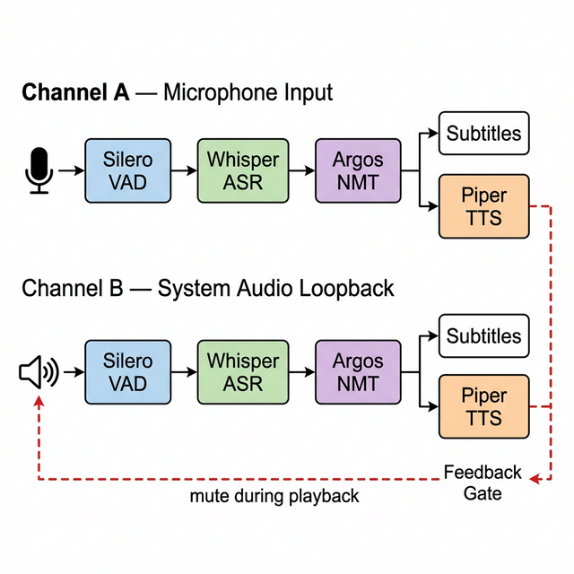
Figure 1. High-level system architecture of Voxxwire showing dual-channel processing with feedback gate.
Two independent channels process audio concurrently:
- Channel A (Microphone): captures the local user’s voice, transcribes it in the source language, translates the transcript to the designated target language, and produces both on-screen subtitles and synthesized speech output.
- Channel B (Loopback): intercepts system-level audio output—typically remote participant speech arriving via a conferencing application—and applies the same recognition–translation–synthesis pipeline in the reverse language direction.

3.2 Decoupled Asynchronous Pipeline
Within each channel, the processing stages are organized into two cooperative asynchronous tasks connected by a bounded utterance queue, as depicted in Figure 2.
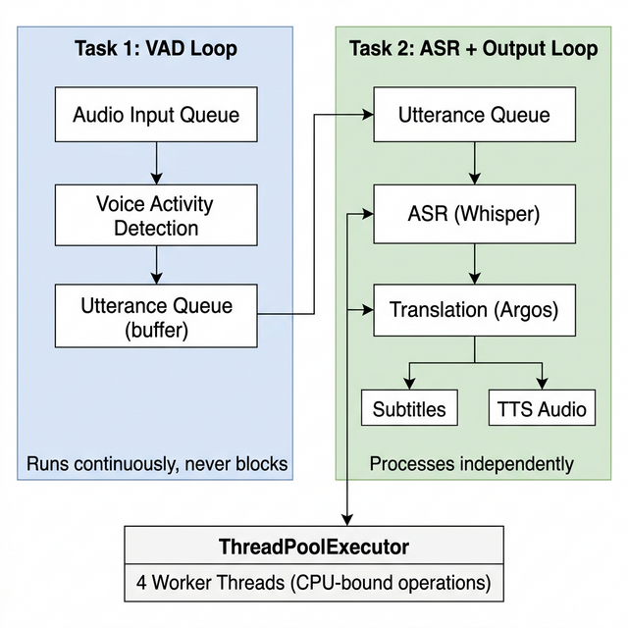
Figure 2. Decoupled two-task pipeline architecture. The VAD task runs continuously to prevent audio loss, while the ASR task consumes complete utterances independently.
The rationale for this decoupling is rooted in the latency asymmetry between stages. Voice activity detection completes in single-digit milliseconds per chunk, whereas a single Whisper inference on the “small” model may consume 200–800 ms depending on hardware. In a tightly coupled loop, all audio arriving during ASR inference would be silently dropped. By buffering detected utterances in an internal queue (capacity: 10 utterances), the VAD task never stalls, and audio continuity is preserved even under sustained load.
CPU-bound operations—Whisper inference, Argos translation, and Piper synthesis—are offloaded to a shared ThreadPoolExecutor with four worker threads, preventing the asyncio event loop from blocking.

3.3 Audio Capture Subsystem
Microphone audio is acquired through the PortAudio-backed sounddevice library at 16 kHz, mono, float32, with a 30 ms chunk duration. A configurable gain multiplier (default 2.5×) compensates for low-sensitivity consumer microphones.
System audio capture supports two strategies. The preferred mode treats Windows’ Stereo Mix device as a standard input, yielding maximum compatibility. When Stereo Mix is unavailable, the system falls back to WASAPI loopback capture on the active output device. Both modes include transparent sample-rate conversion to normalize audio to the pipeline’s 16 kHz standard regardless of the device’s native rate.

3.4 Technology Stack Summary
Component | Technology | Function
Runtime | Python 3.10–11 | Application orchestration
VAD | Silero VAD (PyTorch) | Frame-level speech detection
ASR | faster-whisper (CTranslate2) | Multilingual speech-to-text
NMT | Argos Translate (OpenNMT) | Offline neural translation
TTS | Piper (ONNX / VITS) | Neural speech synthesis
Audio I/O | sounddevice (PortAudio) | Mic and loopback capture, playback
GUI | pywebview + HTML/CSS/JS | Desktop UI with web frontend
Concurrency | asyncio + ThreadPoolExecutor | Async event loop + thread offload
Distribution | PyInstaller + Inno Setup | Standalone installer (~210 MB)

4. Module-Level Implementation

4.1 Voice Activity Detection
The SileroVAD module maintains a streaming state machine that classifies 512-sample chunks (32 ms at 16 kHz) as speech or silence. When speech probability exceeds a tunable threshold (default 0.2), incoming chunks are appended to an internal buffer. Once a silence interval of at least 500 ms is detected following speech, the accumulated buffer is emitted as a complete utterance. Utterances shorter than 300 ms are discarded as transient noise, while a 15-second ceiling triggers forced emission to bound memory consumption.
A leftover buffer accumulates samples that do not fill a complete 512-sample Silero frame, ensuring sample-level continuity across chunk boundaries. If the Silero model fails to initialize (e.g., due to missing PyTorch), the module degrades gracefully to a root-mean-square energy detector.

4.2 Automatic Speech Recognition
The WhisperASR module wraps the faster-whisper library, accepting raw float32 audio arrays and returning transcribed text. At initialization, the module performs automatic device negotiation: it attempts to load the chosen model size on CUDA with float16 precision; upon failure (e.g., insufficient VRAM), it retries transparently on CPU with int8 quantization via CTranslate2’s weight-only quantization pathway.
Key inference parameters include:
- Beam width of 5, balancing search breadth against latency.
- Best-of-3 sampling to improve robustness across multiple decode hypotheses.
- External VAD pre-segmentation (Whisper’s internal VAD filter is disabled to avoid duplicate processing).
- Previous-text conditioning disabled to prevent hallucination propagation across successive utterances.

4.3 Neural Machine Translation
Translation is performed via Argos Translate’s high-level translate() function, which accepts source text, source language code, and target language code. For language pairs lacking a direct model (e.g., Hindi→Japanese), the library automatically decomposes the request into two pivoted translations through English. At startup, a verification routine performs a round-trip test translation to confirm that all required packages are present. The GUI variant of the application extends this by querying the Argos package index at runtime and downloading missing packs on demand.

4.4 Speech Synthesis
The PiperTTS module loads ONNX voice models from a local directory. Synthesis proceeds in-memory: Piper writes a WAV stream into a BytesIO buffer, which is subsequently decoded into a float32 numpy array. If the voice model’s native sample rate diverges from 16 kHz, linear interpolation resamples the waveform. Currently, English (en_US-lessac-medium) and Hindi (hi_IN-rohan-medium) voices are bundled; Japanese TTS is unavailable in the upstream Piper repository, so Japanese output defaults to subtitles-only mode.

4.5 Output Subsystems
Two output subsystems operate in parallel. The terminal subtitle renderer writes ANSI-colored, timestamped lines to stdout, distinguishing user speech (cyan) from remote speech (yellow) and forcing the Windows console into UTF-8 mode (code page 65001) for CJK character display. The GUI subtitle bridge pushes structured event objects into a thread-safe queue that the JavaScript frontend polls at 200 ms intervals, rendering translated text with channel-differentiated styling.

5. Feedback Loop Suppression via Timing Gate

5.1 Problem Formulation
When synthesized speech exits through the system’s default speakers, the loopback capture channel inadvertently records the TTS output. Without intervention, the pipeline transcribes and re-translates its own output, spawning an unbounded chain of translations that oscillates between the two configured languages.

5.2 Proposed Solution
Rather than deploying a full acoustic echo cancellation (AEC) module—which would introduce substantial computational overhead and calibration complexity—we exploit the deterministic nature of TTS playback duration. For a synthesized waveform of d seconds, the feedback gate suppresses loopback capture from t₀ (50 ms before playback onset) through t₀ + d + δ, where δ is a configurable safety buffer (default 300 ms) that absorbs driver-level audio latency. During the gated interval, the loopback callback silently discards all incoming samples.
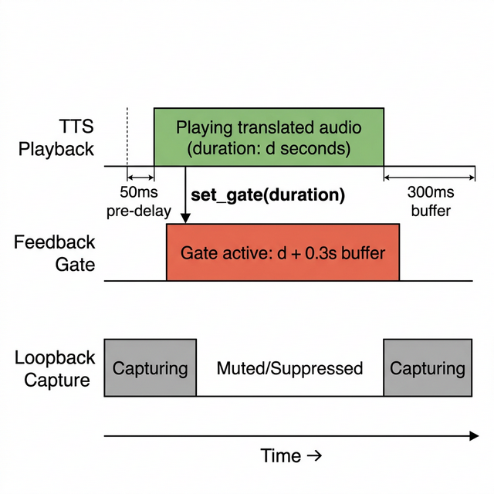
Figure 3. Timing diagram of the feedback gate mechanism. The loopback channel is muted for the duration of TTS playback plus a configurable buffer.
The gate’s correctness rests on two observations: (i) TTS playback duration is computable a priori from the waveform length, and (ii) the system’s output device latency is bounded and small relative to the buffer margin. The trade-off is that legitimate remote speech arriving during TTS playback is also discarded—a limitation shared with half-duplex communication and generally acceptable in conversational turn-taking scenarios.

6. Performance Evaluation

6.1 Hardware Requirements
Resource | Minimum Specification | Recommended Specification
Operating System | Windows 10 (64-bit) | Windows 11 (64-bit)
System Memory | 4 GB | 8 GB
Graphics | None (CPU-only fallback) | NVIDIA CUDA-capable GPU
Storage | ~850 MB after installation | ~850 MB
Processor | Any x86-64 | Multi-core, ≥2.5 GHz

6.2 End-to-End Latency Decomposition
Table 2 decomposes the observed processing latency for a representative three-second utterance translated using the Whisper “small” model.
Processing Stage | GPU Latency | CPU Latency
Silero VAD | ~5 ms | ~10 ms
Silence detection wait | 500 ms (configurable) | 500 ms
Whisper ASR inference | ~200 ms | ~800 ms
Argos NMT | ~50 ms | ~80 ms
Piper TTS synthesis | ~100 ms | ~300 ms
Total (excl. silence wait) | ≈355 ms | ≈1,190 ms
Total (incl. silence wait) | ≈855 ms | ≈1,690 ms

The silence-detection interval dominates perceived latency. This parameter reflects a deliberate engineering choice: a shorter threshold yields faster response but risks prematurely segmenting natural intra-sentence pauses, producing fragmented translations.
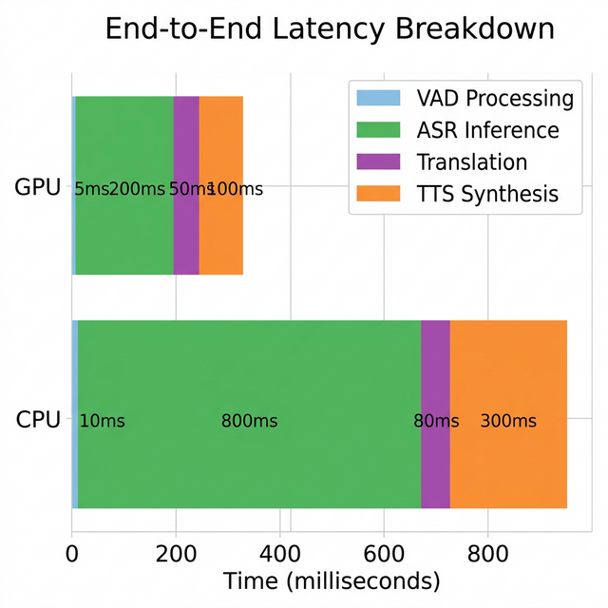
Figure 4. Stacked latency breakdown comparing GPU and CPU execution for each pipeline stage.

6.3 Memory Footprint
Table 3 reports approximate resident memory consumption per component.
Component | Approximate Memory
Silero VAD model | ~30 MB
Whisper tiny (39 M params) | ~75 MB
Whisper small (244 M params) | ~500 MB
Whisper medium (769 M params) | ~1.5 GB
Whisper large-v3 (1.55 B params) | ~3.0 GB
Argos Translate (per language pair) | ~50–100 MB
Piper TTS (per voice model) | ~65 MB
Python interpreter + libraries | ~200 MB

Under the recommended “small” Whisper configuration with two active language pairs, aggregate working memory is approximately 1.0–1.5 GB, comfortably within the envelope of an 8 GB system.

6.4 Recognition Accuracy–Throughput Trade-off
Figure 5 and Table 4 present the word-error-rate (WER) profile across five Whisper model scales, illustrating the diminishing-returns relationship between parameter count and recognition quality.
Model | Parameters | English WER | Multilingual WER | Relative Speed vs. large-v3
tiny | 39 M | 7.6 % | 14.2 % | 32×
base | 74 M | 5.0 % | 10.3 % | 16×
small | 244 M | 3.4 % | 7.6 % | 6×
medium | 769 M | 2.9 % | 6.3 % | 2×
large-v3 | 1.55 B | 2.1 % | 4.8 % | 1×

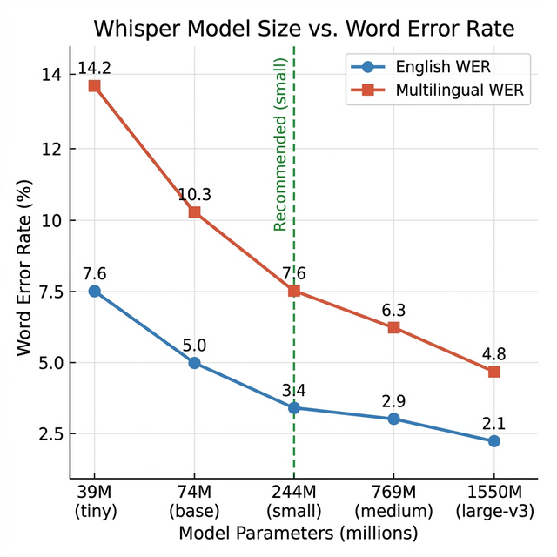
Figure 5. Whisper model size versus word error rate. The vertical dashed line marks the recommended “small” model, balancing accuracy and real-time performance.
The “small” variant achieves 3.4 % English WER at 6× the throughput of “large-v3”, representing the point of best practical utility for real-time deployment on consumer hardware.

7. Discussion

7.1 Language Coverage
Voxxwire’s translation module supports 49 language directions out of the box, spanning major world languages—Arabic, Bengali, Chinese (Simplified and Traditional), French, German, Hindi, Japanese, Korean, Portuguese, Russian, Spanish, Turkish, and Vietnamese, among others—as well as lower-resource languages such as Basque, Esperanto, Galician, Irish, and Kyrgyz. The Whisper ASR component independently supports 99 languages for transcription, exceeding the translation module’s coverage. TTS output is presently limited to languages for which Piper voice models exist (English and Hindi in the current release).

7.2 Desktop GUI and User Experience
Beyond the command-line interface, Voxxwire ships a graphical application built atop pywebview, which embeds a Chromium-based rendering surface within a native Windows frame. The frontend, authored in HTML, CSS, and JavaScript, presents controls for audio device selection, language-pair configuration, Whisper model choice, and real-time subtitle rendering with channel-differentiated color coding. Engine lifecycle management—start, stop, and progress reporting—is exposed through pywebview’s JavaScript API bridge, with status updates conveyed via a polling-based message queue.

7.3 Packaging and Distribution
The application is frozen into a self-contained Windows executable using PyInstaller, which bundles the Python interpreter, all pip-installed dependencies, and pre-downloaded model weights. An Inno Setup script wraps the frozen directory into a conventional graphical installer (~210 MB), creating Start Menu and Desktop shortcuts and registering an uninstaller. Post-installation, no network access is required.

7.4 Limitations
- Platform restriction. The system currently targets Windows 10/11 exclusively. Porting to macOS would require replacing the loopback capture implementation with CoreAudio’s aggregate device mechanism; Linux would require PulseAudio or PipeWire monitor sources.
- Translation fidelity. Argos Translate’s compact models do not match the fluency of large cloud-hosted systems (e.g., Google NMT, DeepL) for complex or idiomatic inputs.
- TTS language gap. The upstream Piper voice repository lacks official Japanese models, constraining Japanese output to subtitles only.
- Speaker attribution. No speaker diarization is performed; all audio on a given channel is attributed to a single undifferentiated speaker.
- Pivot translation cost. For language pairs without direct models, pivoting through English doubles translation latency and may compound semantic drift.
- Resource pressure. Concurrent inference by four neural models demands 1–3 GB of RAM depending on Whisper model choice, which may stress low-memory devices.

7.5 Future Directions
- Incremental ASR. Adopt streaming or chunked Whisper decoding to emit partial hypotheses before utterance completion, reducing perceptual delay.
- Multi-platform support. Extend audio capture to CoreAudio (macOS) and PipeWire (Linux) for cross-platform operation.
- Speaker diarization. Integrate a lightweight embedding-based speaker identification module to label contributions from distinct participants.
- Model distillation. Distill compact, pair-specific translation models for high-demand routes (e.g., English↔Japanese) to reduce latency and memory.
- Real-time GUI updates. Replace the 200 ms polling loop with a push-based WebSocket or native callback channel for lower-latency UI refresh.
- Voice adaptation. Explore few-shot voice cloning to render TTS output in the original speaker’s timbre, improving naturalness and intelligibility.
- Japanese TTS. Evaluate alternative engines such as OpenJTalk or VOICEVOX, or train custom Piper checkpoints, to enable Japanese speech output.

8. Conclusion
We have presented Voxxwire, an open-source, fully offline speech translation system that demonstrates the practical viability of orchestrating multiple neural inference modules on commodity desktop hardware for real-time cross-lingual communication. By coupling Silero VAD, CTranslate2-accelerated Whisper ASR, Argos Translate NMT, and Piper TTS within a carefully structured asynchronous pipeline, the system delivers end-to-end translation in under one second on GPU-equipped machines while ensuring that no conversational data is transmitted externally.
The dual-channel architecture enables simultaneous processing of local and remote audio streams, directly addressing the bidirectional translation needs of live video-conference participants. The deterministic timing gate provides a computationally free solution to the feedback loop problem, sidestepping the complexity of traditional acoustic echo cancellation.
Our performance analysis across five Whisper model scales characterizes the accuracy–latency frontier, identifying the “small” (244 M parameter) variant as the optimal operating point for real-time deployment—achieving 3.4 % English WER at 6× the throughput of the largest model.
Looking forward, the convergence of efficient inference runtimes (CTranslate2, ONNX Runtime), compact pre-trained checkpoints, and large-scale weakly-supervised training paradigms continues to widen the envelope of on-device AI applications. We anticipate that the techniques and architectural patterns presented here will generalize to additional edge-deployment scenarios where data sovereignty, network independence, and zero recurring cost are paramount.

References
[1] CSA Research, “Can’t Read, Won’t Buy — B2C: How language and localization drive global purchasing decisions,” Tech. Rep., 2024.
[2] Google LLC, “Google Translate: Conversation Mode,” 2024. [Online]. Available: https://translate.google.com
[3] Microsoft Corporation, “Microsoft Translator — Real-time translation for conversations and meetings,” 2024. [Online]. Available: https://www.microsoft.com/translator
[4] Apple Inc., “Translation — Apple Developer Documentation,” iOS 18, 2024.
[5] DeepL SE, “DeepL API Documentation,” 2024. [Online]. Available: https://www.deepl.com/docs-api
[6] A. Radford, J. W. Kim, T. Xu, G. Brockman, C. McLeavey, and I. Sutskever, “Robust speech recognition via large-scale weak supervision,” in Proc. 40th International Conference on Machine Learning (ICML), 2023, pp. 28492–28518.
[7] SYSTRAN, “faster-whisper: CTranslate2-optimized Whisper inference,” GitHub repository, 2023. [Online]. Available: https://github.com/SYSTRAN/faster-whisper
[8] Silero Team, “Silero VAD: Pre-trained enterprise-grade voice activity detector,” 2021. [Online]. Available: https://github.com/snakers4/silero-vad
[9] A. Benyassine, E. Shlomot, H.-Y. Su, D. Massaloux, C. Lamblin, and J.-P. Petit, “ITU-T Recommendation G.729 Annex B: A silence compression scheme for use with G.729 optimized for V.70 digital simultaneous voice and data applications,” IEEE Communications Magazine, vol. 35, no. 9, pp. 64–73, 1997.
[10] Argos Open Technologies, LLC, “Argos Translate: Open-source offline translation library written in Python,” 2021. [Online]. Available: https://github.com/argosopentech/argos-translate
[11] M. Junczys-Dowmunt, R. Grundkiewicz, T. Dwojak, H. Hoang, K. Heafield, T. Neckermann, F. Seide, U. Germann, A. Fikri Aji, N. Bogoychev, A. F. T. Martins, and A. Birch, “Marian: Fast neural machine translation in C++,” in Proc. ACL 2018 System Demonstrations, 2018, pp. 116–121.
[12] M. Hansen, “Piper: A fast, local neural text-to-speech system,” 2023. [Online]. Available: https://github.com/rhasspy/piper

Appendix A. Repository Structure
The Voxxwire source repository is organized as follows:
File / Directory | Purpose
main.py | Command-line entry point; initializes and runs the full pipeline
gui_app.py | GUI entry point; pywebview window with HTML/CSS/JS frontend
config.py | Centralized configuration: devices, languages, model parameters
silero_vad.py / vad_engine.py | Silero VAD wrapper with streaming state machine
whisper_asr.py | faster-whisper ASR with auto device and quantization selection
argos_translate.py | Argos Translate interface with pair verification
piper_tts.py | Piper TTS synthesis with per-language voice loading
mic_capture.py | sounddevice microphone input stream
loopback_capture.py | System audio capture via Stereo Mix or WASAPI loopback
audio_player.py | TTS playback thread with feedback gate integration
subtitles.py | Terminal-based ANSI-colored subtitle renderer
channel.py | ChannelPipeline: dual-task VAD + ASR orchestration
setup_languages.py | Downloads Argos Translate language packs
setup_tts_voices.py | Downloads Piper voice models from HuggingFace
ui/ (index.html, style.css, app.js) | GUI frontend: layout, styling, API bridge logic

Appendix B. Configurable Parameters
Table B.1 lists the principal runtime parameters exposed via config.py.
Parameter | Default | Description
SAMPLE_RATE | 16 000 Hz | Audio processing sample rate
CHUNK_DURATION_MS | 30 ms | Capture chunk duration
MIC_GAIN | 2.5× | Microphone amplitude multiplier
WHISPER_MODEL_SIZE | small | Whisper model variant
WHISPER_DEVICE | auto | CUDA if available, else CPU
VAD_THRESHOLD | 0.2 | Silero speech probability threshold
VAD_MIN_SILENCE_MS | 500 ms | Minimum silence before utterance end
MIN_SPEECH_DURATION_S | 0.3 s | Discard utterances shorter than this
MAX_SPEECH_DURATION_S | 15.0 s | Force-emit if buffer exceeds this
FEEDBACK_GATE_BUFFER_S | 0.3 s | Safety margin after TTS playback
QUEUE_MAX_SIZE | 50 | Audio chunk queue capacity
SUBTITLE_MAX_LINES | 6 | Maximum visible subtitle rows

