//PROGRAM.CS

using System;

using System.Threading;

using System.Threading.Tasks;

using Confluent.Kafka;

class Program

{

    static string bootstrapServers = "localhost:9092";

    static string topic = "chat-topic";

    static async Task Main(string[] args)

    {

        Console.Write("Enter your name: ");

        var user = Console.ReadLine();

        var cts = new CancellationTokenSource();

        Task consumerTask = Task.Run(() => StartConsumer(cts.Token));

        var config = new ProducerConfig { BootstrapServers = bootstrapServers };

        using var producer = new ProducerBuilder<Null, string>(config).Build();

        Console.WriteLine("Start chatting (type 'exit' to quit):");

        while (true)

        {

            var message = Console.ReadLine();

            if (message.ToLower() == "exit")

            {

                cts.Cancel();

                break;

            }

            var fullMessage = $"{user}: {message}";

            await producer.ProduceAsync(topic, new Message<Null, string> { Value = fullMessage });

        }

        await consumerTask;

    }

    static void StartConsumer(CancellationToken cancellationToken)

{

    var config = new ConsumerConfig

{

    BootstrapServers = bootstrapServers,

    GroupId = $"chat-group-{Guid.NewGuid()}",

    AutoOffsetReset = AutoOffsetReset.Latest

};

    using var consumer = new ConsumerBuilder<Ignore, string>(config).Build();

    consumer.Subscribe(topic);

    try

    {

        while (!cancellationToken.IsCancellationRequested)

        {

            var cr = consumer.Consume(cancellationToken);

            Console.WriteLine($"[RECEIVED] {cr.Message.Value}");

        }

    }

    catch (OperationCanceledException)

    {

        consumer.Close();

    }

}

}

<Project Sdk="Microsoft.NET.Sdk">

  <PropertyGroup>

    <OutputType>Exe</OutputType>

    <TargetFramework>net8.0</TargetFramework>

    <RootNamespace>kafka_chat</RootNamespace>

    <ImplicitUsings>enable</ImplicitUsings>

    <Nullable>enable</Nullable>

  </PropertyGroup>

  <ItemGroup>

    <PackageReference Include="Confluent.Kafka" Version="2.11.0" />

  </ItemGroup>

</Project>

version: '2'

services:

  zookeeper:

    image: confluentinc/cp-zookeeper:7.4.0

    hostname: zookeeper

    container_name: zookeeper

    environment:

      ZOOKEEPER_CLIENT_PORT: 2181

      ZOOKEEPER_TICK_TIME: 2000

    ports:

      - "2181:2181"

  kafka:

    image: confluentinc/cp-kafka:7.4.0

    hostname: kafka

    container_name: kafka

    ports:

      - "9092:9092"

    environment:

      KAFKA_BROKER_ID: 1

      KAFKA_ZOOKEEPER_CONNECT: zookeeper:2181

      KAFKA_ADVERTISED_LISTENERS: PLAINTEXT://localhost:9092

      KAFKA_OFFSETS_TOPIC_REPLICATION_FACTOR: 1

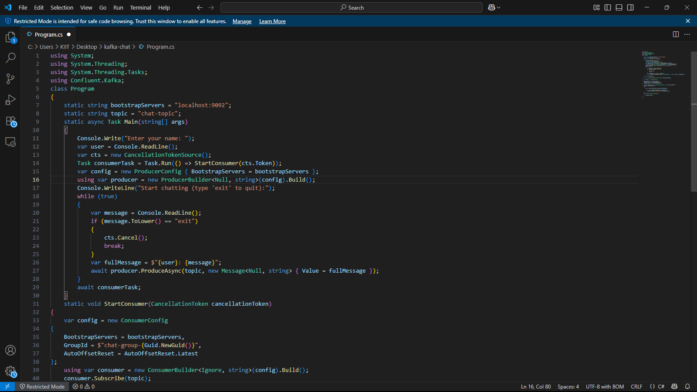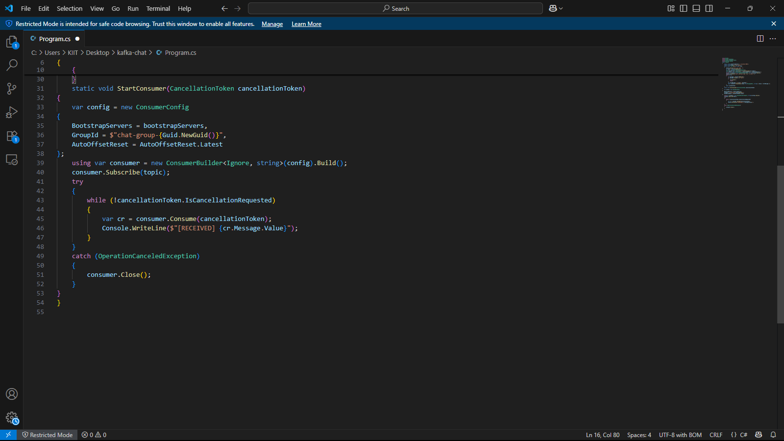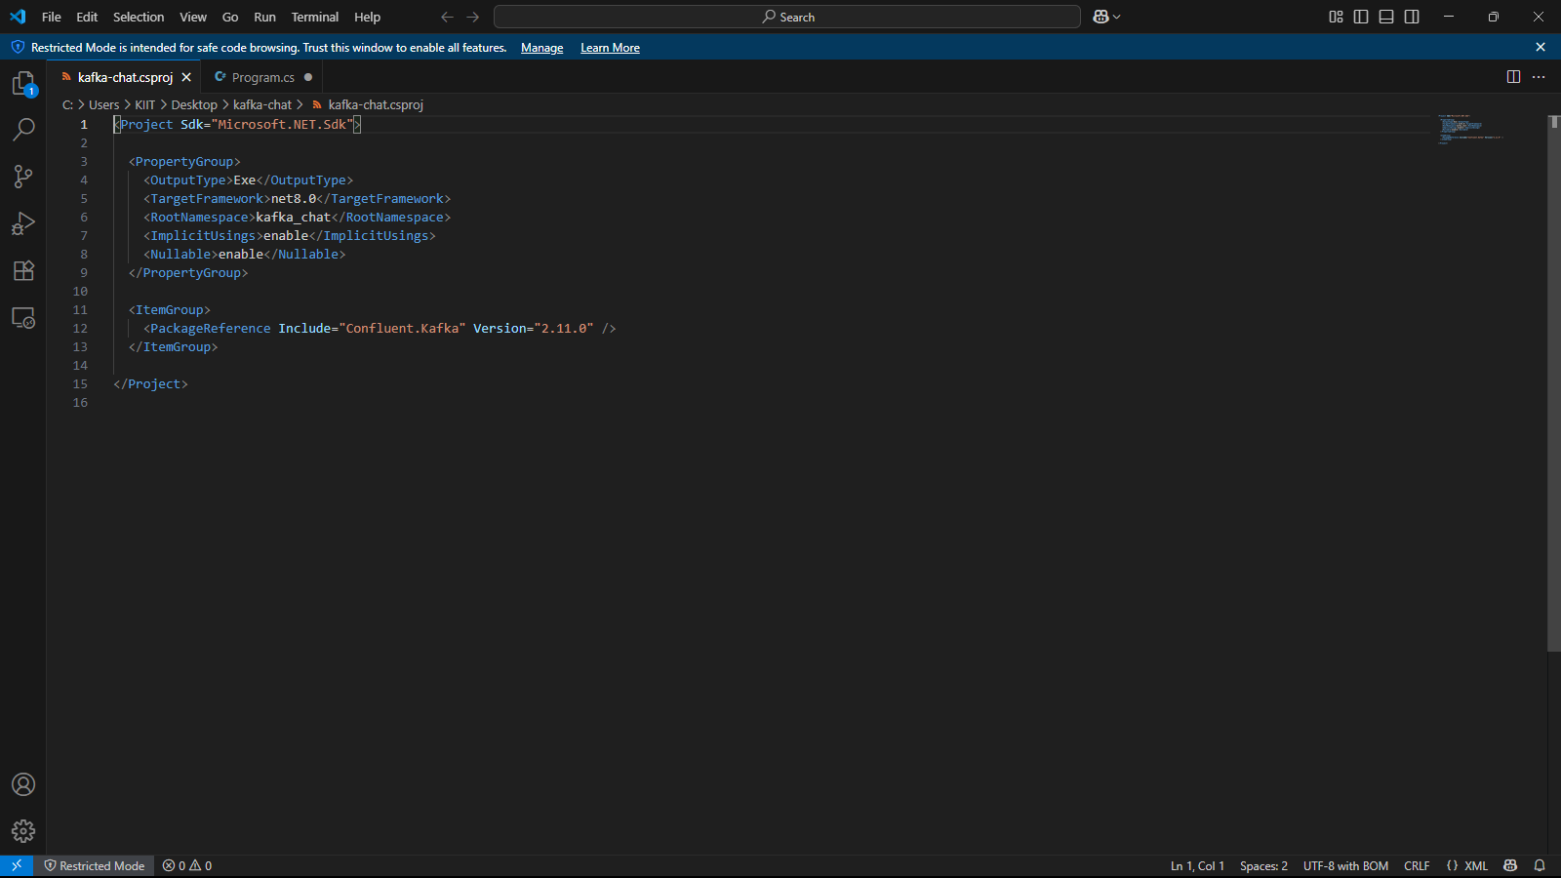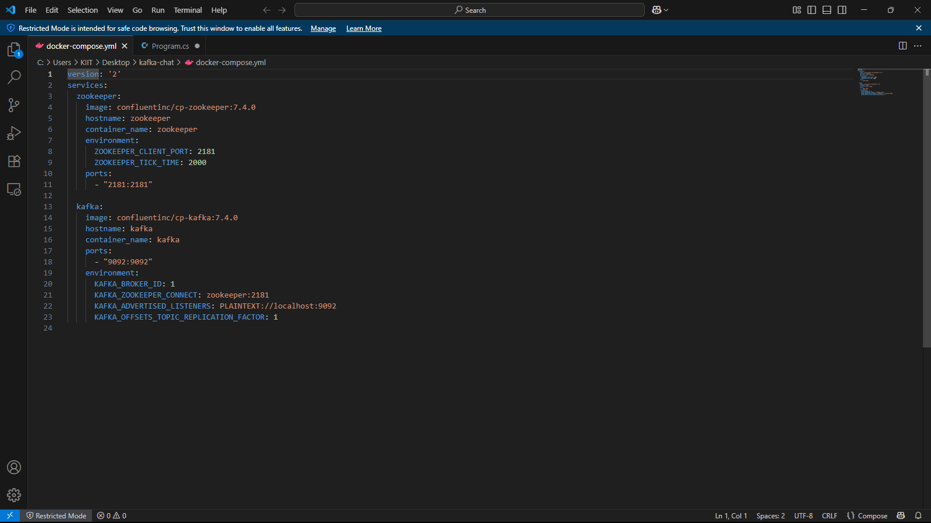

**OUTPUT**

