Session 7 – Basic Statistics

Assignment - 1

1. Histogram for all variables in a dataset mtcars. Write a program to create histograms for all columns.
2. str(mtcars)
3. 'data.frame': 32 obs. of 11 variables:
4. $ mpg : num 21 21 22.8 21.4 18.7 18.1 14.3 24.4 22.8 19.2 ...
5. $ cyl : num 6 6 4 6 8 6 8 4 4 6 ...
6. $ disp: num 160 160 108 258 360 ...
7. $ hp : num 110 110 93 110 175 105 245 62 95 123 ...
8. $ drat: num 3.9 3.9 3.85 3.08 3.15 2.76 3.21 3.69 3.92 3.92 ...
9. $ wt : num 2.62 2.88 2.32 3.21 3.44 ...
10. $ qsec: num 16.5 17 18.6 19.4 17 ...
11. $ vs : num 0 0 1 1 0 1 0 1 1 1 ...
12. $ am : num 1 1 1 0 0 0 0 0 0 0 ...
13. $ gear: num 4 4 4 3 3 3 3 4 4 4 ...
14. $ carb: num 4 4 1 1 2 1 4 2 2 4 ...
15. > par(mfrow=c(3,4))
16. > lapply(mtcars[2:11], hist)

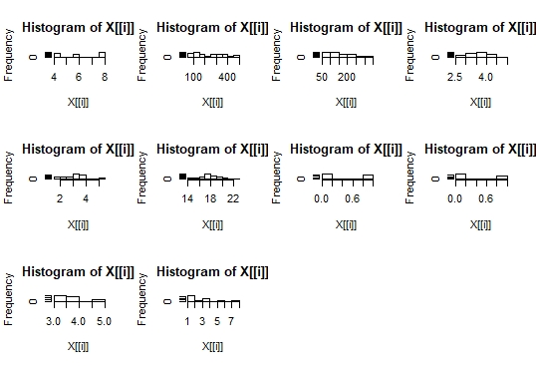

2. Check the probability distribution of all variables in mtcars

par(mfrow=c(3,4))

> prob <- function(prob){

+ x <- sort(prob)

+ hx <- dnorm(prob)

+ p <- plot(x, hx, type="l")

+ }

> lapply(mtcars[2:11], prob)

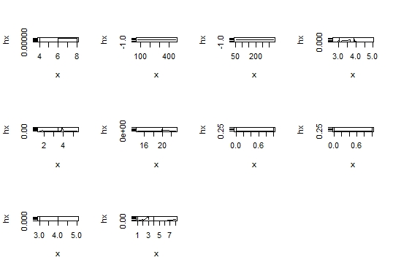

3. Write a program to create boxplot for all variables.

par(mfrow=c(3,4))

lapply(mtcars[2:11], boxplot)