A Report on Internship

DATA SCIENCE INTERNSHIP AT SKILLCRAFT TECHNOLOGY
Exploratory Data Analysis, Data Visualization and
Predictive Modelling using Python

Submitted To
School of Computer Science and Engineering
IILM University, Greater Noida, U.P.

In partial fulfilment of the requirement of degree of
Bachelor of Technology in Computer Science and Engineering (B.Tech CSE)

By

Name of Student: RAJ VARDHAN
Roll Number: 25SCS1003000502
Enrollment Number: Engineering/2025/01708
Program & Semester: B.Tech CSE, 3rd Semester
Batch: 2025-29
Chapter No. | Chapter Name | Page Nos.
 | Cover Page | ---
1. | Candidate's Declaration | ii
2. | Acknowledgement | iii
3. | Internship Completion Certificate | iv
4. | Project Description | 1
 | 4.1 Introduction | 1
 | 4.2 Organization Profile | 1
 | 4.3 Problem Statement | 1
 | 4.4 Project Objectives | 2
 | 4.5 Scope of the Project | 2
 | 4.6 Technologies and Tools Used | 3
 | 4.7 System Architecture | 3
 | 4.8 Methodology | 4
 | 4.9 Expected Outcomes | 5
 | 4.10 Certificates of Completion and Communication Proof | 5
5. | Bibliography/References | 9
TABLE OF CONTENTS

CANDIDATE'S DECLARATION
I, Raj Vardhan, Roll No. 25SCS1003000502, do hereby declare that the internship report titled "Data Science Internship at SkillCraft Technology" has been completed by me to fulfil the requirement for the award of the degree of Bachelor of Technology in Computer Science and Engineering. All the references have been quoted and I have not taken as such any material from any other source. I affirm that this report is my own work and has not been submitted to any other institute for any degree/diploma requirement, and I shall be solely responsible for any kind of copyright violation in this regard.

Signature : Raj
Student Name: Raj Vardhan
Roll No.: 25SCS1003000502

ACKNOWLEDGEMENT
I am using this opportunity to express my gratitude to everyone who supported me throughout my Data Science internship at SkillCraft Technology. I am thankful for their aspiring guidance, invaluably constructive criticism, and friendly advice during the course of this work.
I would like to express my sincere gratitude to Mr. Pranav Bansal, Tech Lead at SkillCraft Technology, for his valuable mentorship, timely feedback, and continuous encouragement throughout the internship period from 20th July 2026 to 20th August 2026. His guidance was instrumental in helping me understand practical applications of data science concepts.
I am also sincerely grateful to the School of Computer Science and Engineering, IILM University, Greater Noida, for providing me the opportunity and support to undertake this internship as part of my academic curriculum.
I express my gratitude to my parents and friends for their constant blessings and encouragement.

Signature: Raj
Student Name: Raj Vardhan
Roll No.: 25SCS1003000502

INTERNSHIP COMPLETION CERTIFICATE
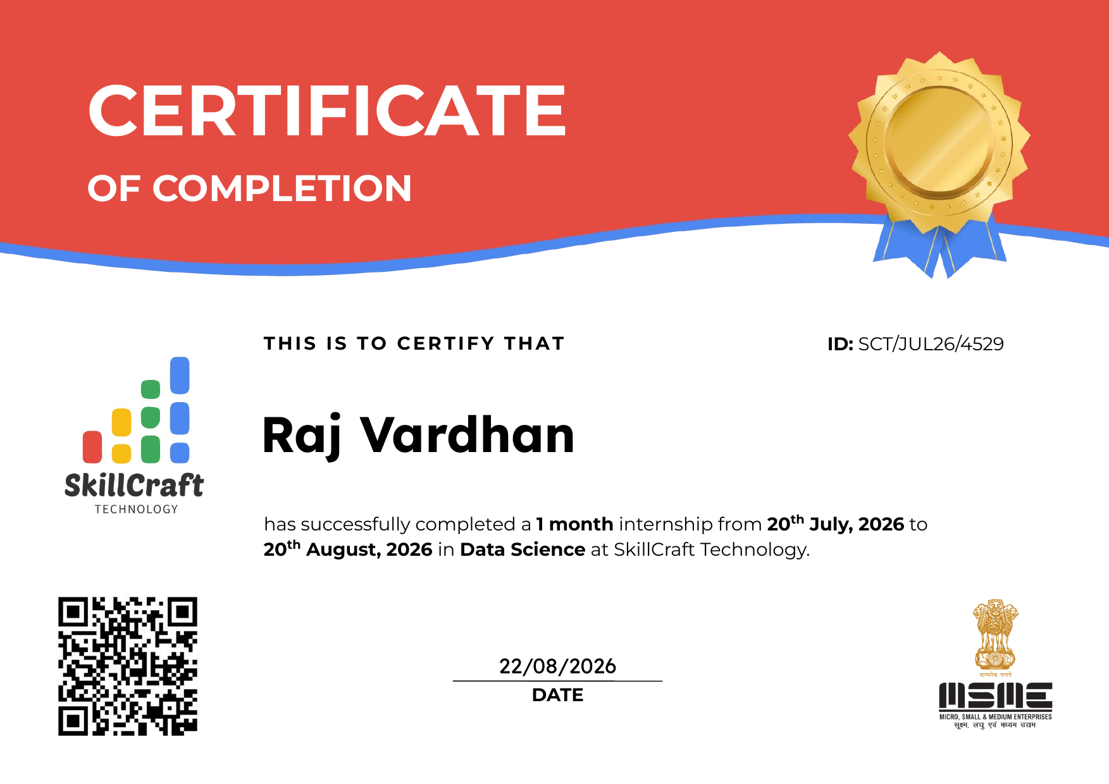
Fig 0.1: Internship Completion Certificate issued by SkillCraft Technology

CHAPTER 4: PROJECT DESCRIPTION
4.1 Introduction
Data Science has emerged as one of the most influential and rapidly growing fields in the technology industry, enabling organizations to derive meaningful insights from raw data and make informed, data-driven decisions. With the exponential growth of digital data, the demand for professionals skilled in data cleaning, exploratory data analysis, visualization, and predictive modelling has increased significantly across every industry sector.
As part of the academic curriculum of the B.Tech Computer Science and Engineering program at IILM University, Greater Noida, I undertook a one-month internship as a Data Science Intern at SkillCraft Technology from 20th July 2026 to 20th August 2026. This internship provided a valuable opportunity to apply theoretical concepts learned during coursework to real-world datasets and practical problem statements.
During the internship, I was assigned four distinct tasks covering the core stages of the data science workflow: data visualization, data cleaning and exploratory data analysis, predictive modelling using a decision tree classifier, and analysis of real-world traffic accident data. This report documents the objectives, methodology, tools used, and outcomes of the internship in detail.
4.2 Organization Profile
SkillCraft Technology is a technology-driven organization registered under the Micro, Small and Medium Enterprises (MSME) scheme, based in Vashi, Navi Mumbai, India. The organization offers structured, mentorship-based internship programs to students and early-career professionals in domains such as Data Science, Web Development, and Software Engineering, with the objective of bridging the gap between academic learning and industry-relevant skills.
The organization follows a task-based learning model, wherein interns are assigned a series of progressively challenging, real-world tasks under the guidance of experienced mentors, allowing them to build a practical, project-based portfolio by the end of the program.
4.3 Problem Statement
Organizations across industries generate vast volumes of data on a daily basis, ranging from demographic records to transactional and sensor-based data. However, raw data in its unprocessed form rarely offers direct insight; it must be cleaned, explored, visualized, and, where applicable, modelled before it can support meaningful decision-making.
The internship required addressing four distinct, real-world data problems: (i) visualizing the age-wise distribution of a population using appropriate charts, (ii) cleaning and exploring the Titanic passenger dataset to uncover survival-related patterns, (iii) building a classification model to predict whether a customer would purchase a product or service based on demographic and behavioural data, and (iv) analyzing traffic accident records to identify contributing factors and accident hotspots. Each task represents a common, practical challenge faced by data science teams in the industry.
4.4 Project Objectives
- To understand and apply the complete data science workflow, including data collection, cleaning, exploratory analysis, visualization, and modelling.
- To create clear and informative bar charts/histograms to visualize the distribution of categorical and continuous variables.
- To perform systematic data cleaning and exploratory data analysis (EDA) on the Titanic dataset to identify relationships and trends among variables.
- To build and evaluate a decision tree classification model capable of predicting customer purchase behaviour using the Bank Marketing dataset.
- To analyze traffic accident data and identify patterns related to road conditions, weather, and time of day.
- To gain hands-on proficiency in Python and its data science libraries, and to strengthen problem-solving and analytical thinking skills.
4.5 Scope of the Project
The scope of this internship was limited to the analysis of publicly available, structured datasets using Python-based tools within a one-month timeframe. It covered data acquisition, cleaning, exploratory data analysis, static data visualization, and the development of a single classification model (decision tree). The scope did not extend to the deployment of models into production environments, integration with live/streaming data sources, or the development of a full-fledged web or dashboard application. The primary focus remained on building strong analytical and technical foundations in the core stages of the data science lifecycle.
4.6 Technologies and Tools Used
- Python 3 — core programming language used for all four tasks.
- Jupyter Notebook / Google Colab — interactive development environment for writing and running code.
- Pandas and NumPy — for data loading, cleaning, transformation, and numerical computation.
- Matplotlib and Seaborn — for static data visualization, including bar charts, histograms, and heatmaps.
- Scikit-learn — for building, training, and evaluating the decision tree classification model.
- Kaggle and the UCI Machine Learning Repository — as sources of publicly available datasets (Titanic dataset and Bank Marketing dataset).
- GitHub — for version control and submission of the completed tasks and project code.
4.7 System Architecture
The overall workflow followed across all four tasks can be represented as a linear data science pipeline, moving from raw data acquisition to the generation of actionable insights, as illustrated below:
1 | Data Collection (Kaggle / UCI Repository)
2 | Data Cleaning & Preprocessing (handling missing values, encoding)
3 | Exploratory Data Analysis (summary statistics, relationships)
4 | Data Visualization (bar charts, histograms, heatmaps)
5 | Model Building & Evaluation (Decision Tree Classifier)
6 | Insight Generation & Reporting

4.8 Methodology
The methodology adopted for each of the four tasks undertaken during the internship is described below.
4.8.1 Task 1: Visualization of Population Distribution
A dataset containing age-wise population figures was loaded using Pandas. A bar chart was constructed using Matplotlib/Seaborn to visualize the distribution of the population across three age categories: 0-20 years, 21-64 years, and 65+ years. Appropriate axis labels, titles, and data labels were added to make the chart self-explanatory, and the resulting visualization was interpreted to highlight the proportion of the working-age population relative to other age groups.
4.8.2 Task 2: Data Cleaning and Exploratory Data Analysis (Titanic Dataset)
The Titanic dataset from Kaggle was imported and inspected for missing values, primarily in the Age, Cabin, and Embarked columns. Missing numerical values were handled through imputation, while irrelevant or highly incomplete columns were dropped. Summary statistics were generated to understand the central tendency and spread of key variables. Relationships between survival and other variables such as sex, passenger class, and age were explored using count plots, bar charts, and a correlation heatmap, revealing patterns such as higher survival rates among female and first-class passengers.
4.8.3 Task 3: Decision Tree Classifier (Bank Marketing Dataset)
The Bank Marketing dataset from the UCI Machine Learning Repository was used to predict whether a customer would subscribe to a product or service. Categorical variables were encoded into numerical form, and the dataset was split into training and testing sets. A Decision Tree Classifier was built using Scikit-learn and trained on the training data. The model's performance was evaluated using accuracy, a confusion matrix, and precision/recall metrics, and the resulting decision tree structure was visualized to interpret the most influential features driving customer purchase decisions.
4.8.4 Task 4: Traffic Accident Data Analysis
A traffic accident dataset containing attributes such as weather conditions, road conditions, time of day, and location was analyzed to identify patterns and contributing factors behind road accidents. Exploratory data analysis was performed to examine how accident frequency varied with weather and time of day, and visualizations such as bar charts and heatmaps were used to highlight accident hotspots and the conditions under which accidents were most frequent.
4.9 Expected Outcomes
- A clear, well-labelled bar chart/histogram representing the age-wise distribution of the population.
- A cleaned and analysis-ready Titanic dataset, along with identified survival patterns across gender, passenger class, and age groups.
- A trained and evaluated decision tree classification model capable of predicting customer purchase likelihood, along with an interpretation of the most influential features.
- Actionable insights into the key factors contributing to road accidents, including high-risk time periods and conditions, useful for road-safety recommendations.
- Overall, practical, hands-on exposure to the complete data science lifecycle and strengthened proficiency in Python-based data analysis and visualization tools.
4.10 Certificates of Completion and Other Communication/Mail Proof
The following documents, issued by SkillCraft Technology, serve as proof of internship completion and communication:
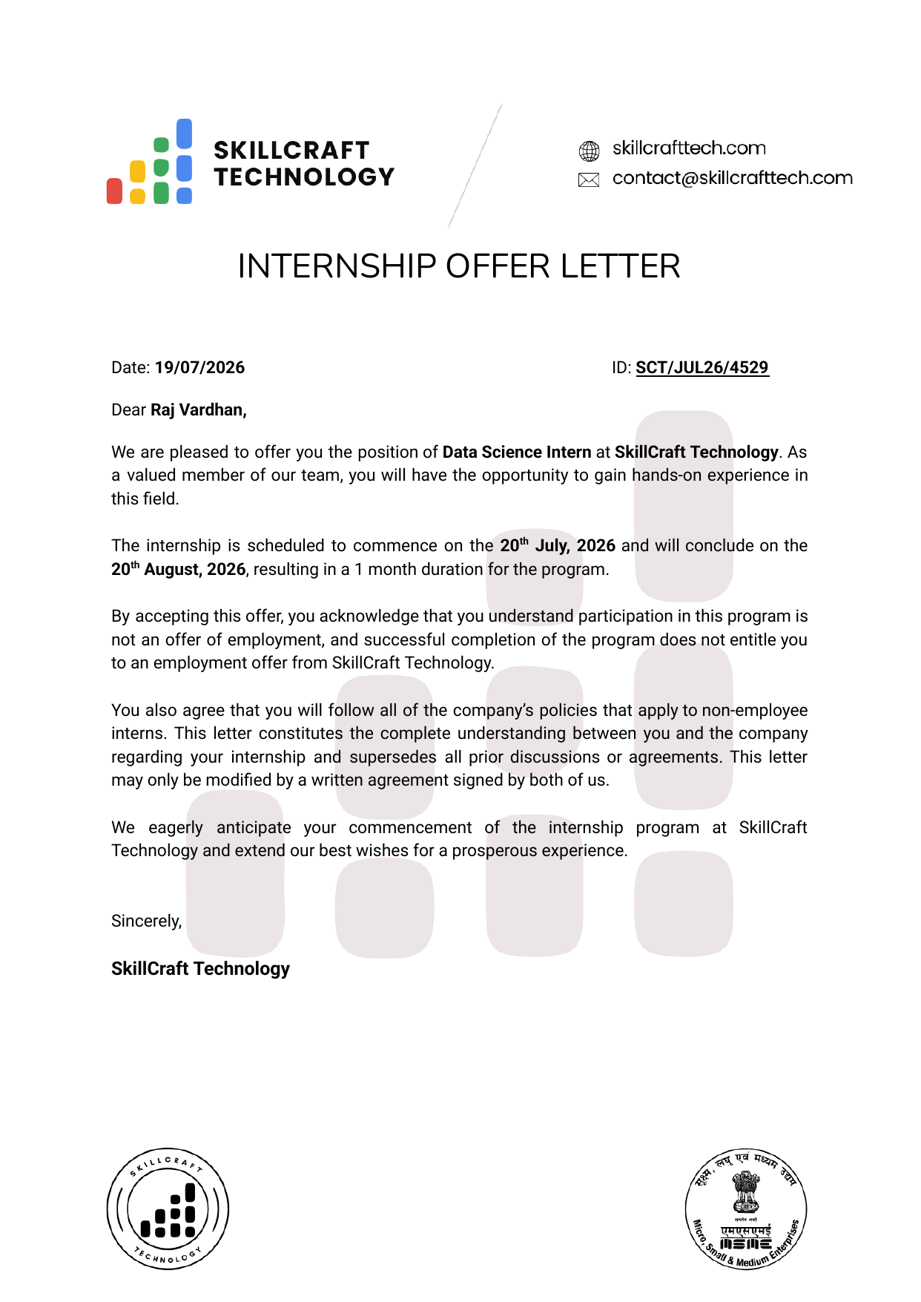
Fig 4.1: Internship Offer Letter


Fig 4.2: Certificate of Completion
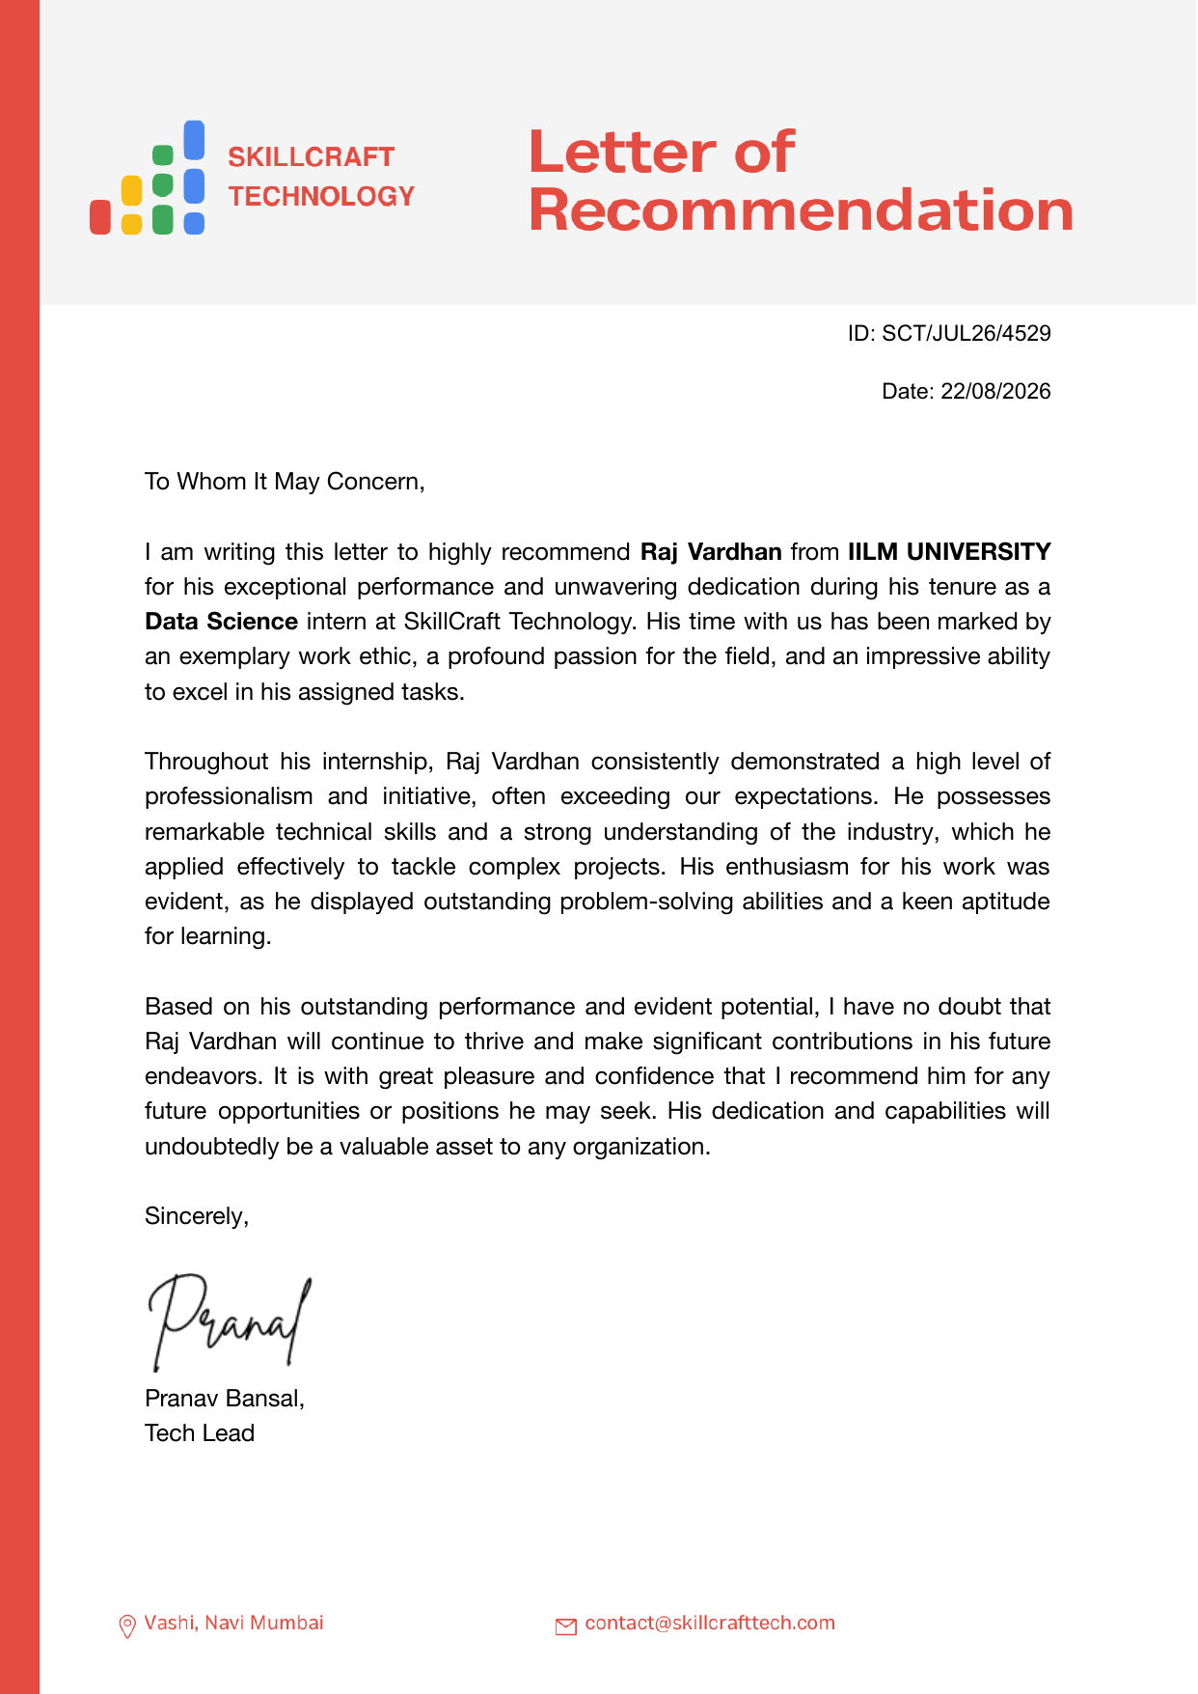
Fig 4.3: Letter of Recommendation

CHAPTER 5: BIBLIOGRAPHY/REFERENCES
1. SkillCraft Technology, Internship Offer Letter and Certificate of Completion, SkillCraft Technology, Vashi, Navi Mumbai, 2026.
2. Kaggle. Titanic - Machine Learning from Disaster [Dataset]. Available at: https://www.kaggle.com/c/titanic
3. UCI Machine Learning Repository. Bank Marketing Dataset. Available at: https://archive.ics.uci.edu/ml/datasets/bank+marketing
4. Pandas Development Team. Pandas Documentation. Available at: https://pandas.pydata.org/docs/
5. Matplotlib Development Team. Matplotlib Documentation. Available at: https://matplotlib.org/stable/contents.html
6. Seaborn Documentation. Available at: https://seaborn.pydata.org/
7. Pedregosa, F., et al. Scikit-learn: Machine Learning in Python. Available at: https://scikit-learn.org/stable/documentation.html
8. statsofindia.in / UN World Population Prospects 2022 — India's Population Distribution by Age.

