**Research Methods for Computing**

**COM4061-N**

Literature Search/Review

**Author**: Raj kumar Bhukya

**Student Number**: w9598301

**Readership:**

* **Date of Submission**: *10/05/2023*
* **Part 1 Word Count:** 2096 (excluding references)

**Contents**

Introduction 3

Research question 3

Key concepts 3

Table of Synonyms 3

Database Search 4

Database One: Discovery 4

Database Two: ScienceDirect 5

Database Three: IEEE Explore 7

Inclusion and Exclusion Process 8

Conclusion and Limitations 10

References 11

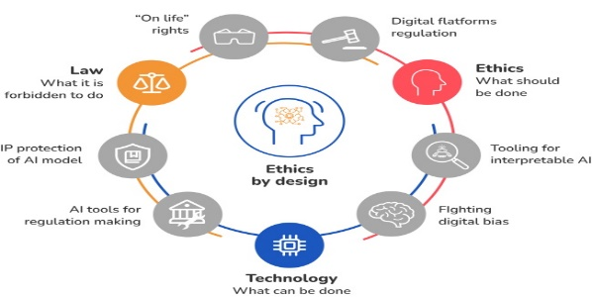.

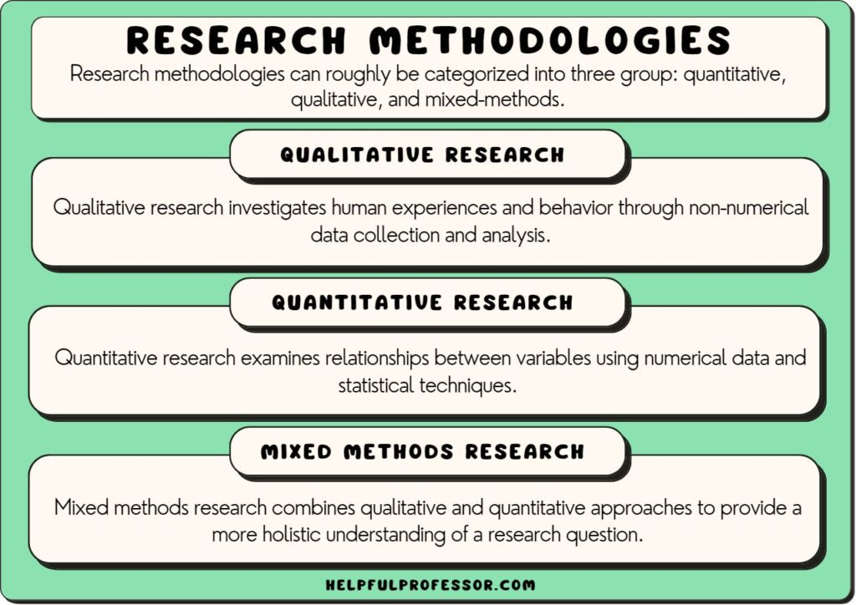

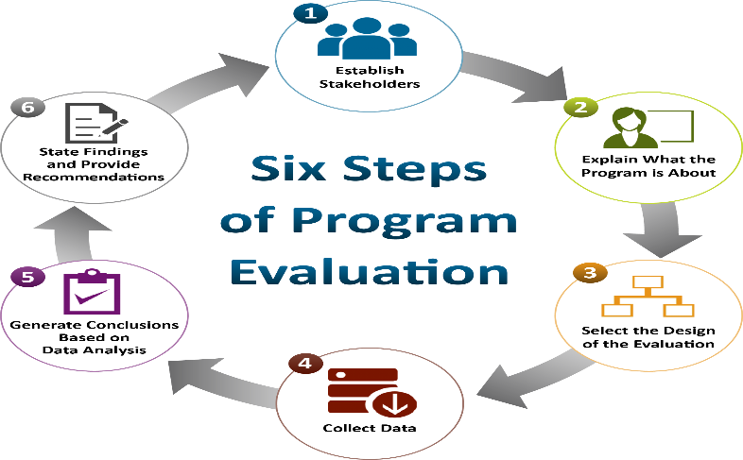

## **Introduction**

Cryptocurrencies and blockchain technology have emerged as game changers in banking and digital commerce. The introduction of Bitcoin in 2009 signalled the start of a new age, ushering in a decentralised digital currency that functions on a secure and transparent network known as blockchain. Since then, cryptocurrencies and blockchain technology have spawned a wave of innovation across a variety of industries.

At its foundation, blockchain is a distributed ledger technology that allows for the secure and transparent recording and verification of transactions. It runs on a decentralised network of computers known as nodes, which collaboratively maintain and authenticate the blockchain's integrity. This decentralised architecture eliminates the need for intermediaries to assist transactions, such as banks or financial organisations.

Blockchain's underlying technology is cryptography, which assures the security and integrity of the data recorded within the blockchain. Transactions are encrypted and organised into blocks, which are then linked chronologically. Because of its immutability and openness, blockchain is extremely resistant to manipulation and fraud, establishing trust in participants.

Cryptocurrencies like Bitcoin, Ethereum, and Litecoin are digital assets that use blockchain technology to trade value. These cryptocurrencies use blockchain networks to enable peer-to-peer transactions without the use of intermediaries. They have grown in prominence as alternative payment methods, investment assets, and mediums of exchange, posing a threat to established financial systems.Blockchain technology's potential applications go beyond money. Supply chain management, healthcare, and voting are examples of industries.

## **Research question**

1. What are the results for financial institutions and how do cryptocurrencies affect the established financial system?
2. What results might this have for society and the economy? How might the use of cryptocurrencies and blockchain technology change in the future?

## **Key concepts**

Security awareness programs

Security awareness models

Modern cyber threats

## **Table of Synonyms**

|  |  |  |  |
| --- | --- | --- | --- |
| **Awareness** | Perception | Alertness |  |
| **Measure** | Metric | Scale | Quantify |
| **Model** | Framework | Design |  |
| **Organization** | Institution | Grouping |  |
| **Modern** | Current | Emerging | New |
| **Staff** | Users | Personnel | Humans |
| **Programs** | Plans | Procedures | Methods |

# **Database Search**

These databases were used by me to obtain study findings and data. I have discovered additional databases to add to the literature review in order to obtain more trustworthy results and progress learning.

1. Discovery Teesside university library
2. Database Two: ScienceDirect
3. Database Three: IEEE Explore

## **Database One: Discovery**

|  |  |  |  |  |
| --- | --- | --- | --- | --- |
| **Question** | **Keywords** | **Filters** | **Number**  **of Articles** | **Notes** |
| How does cryptocurrency affect the financial sector? | cryptocurrency | None | 32,670 | Too many articles from different disciplines. Mixture of books and newspaper articles as well as non-peer reviewed work. No logical technical synonym for the word awareness. Will need to use other relevant keywords to refine my search. |
| How does cryptocurrency affect the financial sector? | cryptocurrency | Year: 2013 to  2023  Include: Peer reviewed, journal article, newspaper article, conference proceedings | 5,559 | Even after adding some sort of filter the results in article are more than expected |
| How does cryptocurrency affect the financial sector? | "Cryptocurrency" and "Finance" | Year: 2013 to  2023,  Included: Peer Reviewed, Journal Article, Conference Proceeding, Newspaper Article, cryptocurrencies, blockchain, Discipline:  Computer  Science | 808 | Too many results. Need to filter results to focus on abstract as opposed to full text as it captures the theme of the article. |
| How does cryptocurrency affect the financial sector?? | "Cryptocurrency" and "Finance" | Year: 2018 to  2023,  Included: Peer Reviewed, Journal Article, Conference Proceeding, Newspaper Article, cryptocurrencies, blockchain, | 758 | Most relevant journal: Scholl et al 2018 explains, the security awareness maturity model by SANS The authors also provide two methods of |
|  |  | Discipline:  Computer  Science |  | measuring awareness  levels i.e. surveys and  benchmarks |
| How does cryptocurrency affect the financial sector? | "Cryptocurrency" and "Finance" | Year: 2023  Included: Peer Reviewed, Journal Article, Conference Proceeding, Newspaper Article, cryptocurrencies, blockchain,  Exclude: engineering, economics, physics, business economics | 41 | All I have filtered the paper with in low still its not able to review all articles still need add filters |
| How does cryptocurrency affect the financial sector? | "Cryptocurrency" and "Finance" | Year: 2023  Included: Peer Reviewed, Journal Article, Conference Proceeding, Newspaper Article, cryptocurrencies, blockchain, economics,  Exclude: engineering, physics, business economics | 5 | Reviewable list of journals found. |

## **Database Two: ScienceDirect**

|  |  |  |  |  |
| --- | --- | --- | --- | --- |
| **Question** | **Keywords** | **Filters** | **Number**  **of Articles** | **Notes** |
| How does cryptocurrency affect the financial sector? | cryptocurrency | None | 5,261 | Too many journals found from different academic fields. |
| How does cryptocurrency affect the financial sector? | cryptocurrency | Year: 2014 to  2023  Include: Review articles, Research  articles,  Conference  abstracts | 4,362 | Relevant journals appear at the top of the list however the list is too long for review. Keywords such as security awareness appear in the abstracts. |
| What are the potential risks and benefits of cryptocurrencies for financial institutions? | "Cryptocurrency" and "Finance" | Year: 2013 to  2023  Include: Review articles, Research  Articles, Conference  abstracts | 145 | Most relevant article  Bauer et al  Relevant keywords found such as: organizations |
| How do make change in banking sector with block chain technology? | "Cryptocurrency" and "Finance" | Year: 2018 to  2023  Include: Review articles, Research  Articles, Conference  abstracts | 472 | Search query still producing a long list of articles.  Next search needs specific keywords like narrow down the results. |
| What tools do organisations use to measure security awareness? | "Cryptocurrency" and "Finance" | Year: 2020 to  2023  Include: Review articles, Research  articles, book chapters,  publication title: computer science | 409 | Cyber security threats have evolved in recent years. There is need to filter the search to reflect current cyber threats. |
| How do make change in banking sector with block chain technology? | Crypto and industries | Year: 2023 Include:  Research articles, review articles  Publication title:  Internet things | 06 | Reviewable list of journals found. |

## **Database Three: IEEE Explore**

|  |  |  |  |  |
| --- | --- | --- | --- | --- |
| **Question** | **Keywords** | **Filters** | **Number**  **of Articles** | **Notes** |
| How does cryptocurrency affect the financial sector? | “cryptocurrency” | None | 4,291 | The search results are not as much as the previous two databases  but still a long list to review. |
| How does cryptocurrency affect the financial sector? | “cryptocurrency” | Year[:2014](https://dl-acm-org.ezproxy.tees.ac.uk/results.cfm?query=%28Information%20security%20awareness%29&filtered=resources%2Eft%2EresourceFormat%3DPDF&within=owners%2Eowner%3DHOSTED&dte=&bfr=&srt=%5Fscore)-2019 Filters Applied:  Journals,  Conferences | 3,975 | Journal count is too large. |
| What are the potential risks and benefits of cryptocurrencies for financial institutions? | "Cryptocurrency" and "Finance" | Year[:2014](https://dl-acm-org.ezproxy.tees.ac.uk/results.cfm?query=%28Information%20security%20awareness%29&filtered=resources%2Eft%2EresourceFormat%3DPDF&within=owners%2Eowner%3DHOSTED&dte=&bfr=&srt=%5Fscore)-2023 Filters Applied:  Journals,  Conferences | 145 | Not enough searches when adding synonyms. |
| How do make change in banking sector with block chain technology | "Cryptocurrency" and "Finance" AND “INDUSTRIES” | Year[:2014](https://dl-acm-org.ezproxy.tees.ac.uk/results.cfm?query=%28Information%20security%20awareness%29&filtered=resources%2Eft%2EresourceFormat%3DPDF&within=owners%2Eowner%3DHOSTED&dte=&bfr=&srt=%5Fscore)-2023 Filters Applied:  Journals,  Conferences | 31 | Not enough searches when adding synonyms |
| What tools do organisations use to measure security awareness? | "Cryptocurrency" and "Finance" AND “INDUSTRIES” | Year: 2020-2023 Filters Applied:  Journals,  Conferences | 18 | Important new keyword found relevant to topic. |
| What tools do organisations use to security awareness levels of users as regards modern cyber threats? | "Cryptocurrency" | Year:2022 Filters Applied:  Conferences Journals  2022 5th International Conference on Contemporary Computing and Informatics (IC3I)  block chain crypto currencies  2022 | 16 | Reviewable list of journals found. |

I have selected these papers to get the information that what ideas I have with my research methodology I have in my mind and these because they found me interesting made me easy to add filters and has good resolution of papers

## **Inclusion and Exclusion Process:**

|  |  |  |  |
| --- | --- | --- | --- |
|  | Research paper title | Included/Excluded | Reason |
| 1 | Prospects of Digital Currency in India- A Way Forward | Included | This paper is very straight forward to my research ideas and the methodology. |
| 2 | Trading volume and liquidity provision in cryptocurrency markets | excluded | There is no great impact on this paper it just explains the strategy of block chain therapy |
| 3 | On the performance of cryptocurrency funds | Included | The study finds evidence that cryptocurrency funds perform better than passive benchmarks or conventional risk factors, as they generate significant positive returns known as alphas |
| 4 | Can Bitcoin help money cross the border: International evidence | Excluded | No primary research conducted in the study. |
| 5 | Evaluation of the Effective Anti-Phishing  Awareness and Training in Governmental and  Private Organizations in Riyadh, *2018 21st*  *Saudi Computer Society National Computer Conference* | Included | Did a comprehensive study of security awareness in the public and private sector. The researchers also collected and evaluated primary data. |
| 6 | A study on the impact of regulatory compliance awareness on security management performance and information  technology capabilities, *2017 13th International Conference on Natural*  *Computation, Fuzzy Systems and Knowledge*  *Discovery (ICNC-FSKD)* | Excluded | The paper is not relevant to the research topic. |
| 7 | Online cyber security Awareness Modules for  College and High School Students, *2018*  *National Cyber Summit (NCS)* 2018 | Included | The paper is relevant to the topic despite the fact the research was only conducted in schools. |
| 8 | Gender and Age Classification Enabled Blockchain Security Mechanism for assisting Mobile Application  [2022 5th International Conference on Contemporary Computing and Informatics (IC3I)](https://ieeexplore.ieee.org/xpl/conhome/10072015/proceeding) | Included | The paper is very much focused to my topic and my methodology it all speaks about security in mobile application. |

|  |  |  |  |
| --- | --- | --- | --- |
| 9 | A Case on Decentralized use of Blockchain  [2022 5th International Conference on Contemporary Computing and Informatics (IC3I)](https://ieeexplore.ieee.org/xpl/conhome/10072015/proceeding) | Included | This article highlights the shift towards transparency and decentralization in the corporate world |
| 10 | Investigating the Accuracy and Performance Enhancement in Metaverse  [2022 5th International Conference on Contemporary Computing and Informatics (IC3I)](https://ieeexplore.ieee.org/xpl/conhome/10072015/proceeding) | Excluded | It is not relevant to the topic. It explains about metaverse plot. |
| 11 | Machine Learning Adoption in Blockchain-Based Smart Applications  [2022 5th International Conference on Contemporary Computing and Informatics (IC3I)](https://ieeexplore.ieee.org/xpl/conhome/10072015/proceeding) | Included | The paper discusses the use of machine learning (ML) to strengthen the security of blockchain-based intelligent systems |
| 12 | Predictive Control Integrated with Block Chain and Machine Learning for Smart Power Plants  [2022 5th International Conference on Contemporary Computing and Informatics (IC3I)](https://ieeexplore.ieee.org/xpl/conhome/10072015/proceeding) | Excluded | The paper irrelevant to my topic it discusses about electricity industry, specifically in the context of digital power generation networks |
| 13 | Block chain Technology Adoption in various Domains and the way of getting Double Security  [2022 5th International Conference on Contemporary Computing and Informatics (IC3I)](https://ieeexplore.ieee.org/xpl/conhome/10072015/proceeding) | Included | The paper describes how cryptocurrencies, specifically Bitcoin, aim to return power to ordinary people and reduce the control of governments, banks, and other centralized entities over financial assets. |
| 14 | Innovation Intervention: Cyber Stalking  [2022 5th International Conference on Contemporary Computing and Informatics (IC3I)](https://ieeexplore.ieee.org/xpl/conhome/10072015/proceeding) | Included | The paper is relevant to the topic despite the fact the research was only conducted in schools. |
| 15 | Administration of Digital Identities Using Blockchain  [2022 5th International Conference on Contemporary Computing and Informatics (IC3I)](https://ieeexplore.ieee.org/xpl/conhome/10072015/proceeding) | Excluded | This part of paper highlight’s identity verification systems, which is a critical issue in today's world where centralized systems are vulnerable to data breaches and identity theft. |
| 16 | IoT Systems Internal Mapping with the Integration of Blockchain Technology  [2022 5th International Conference on Contemporary Computing and Informatics (IC3I)](https://ieeexplore.ieee.org/xpl/conhome/10072015/proceeding) | Included | The paper is much more related to my topic and highlights the use of Bitcoin to ensure the authenticity and accuracy of data collected through IoT devices. |
| 17 | Analysis of blockchain technology based on digital management systems and data mining technology  [2022 5th International Conference on Contemporary Computing and Informatics (IC3I)](https://ieeexplore.ieee.org/xpl/conhome/10072015/proceeding) | Excluded | This is not related to my topic; However, it touches on the use of blockchain technology in electronic data management. |
| 18 | Blockchain-based Trust Management System in Implementation in Social Internet of Things | Included | Appropriate research methodology used which is relevant to my topic. |
| 19 | Evaluation of Block-chain Transaction Accuracy using Neural Network Model  [2022 5th International Conference on Contemporary Computing and Informatics (IC3I)](https://ieeexplore.ieee.org/xpl/conhome/10072015/proceeding) | Excluded | Main theme of the paper not relevant to my topic. |
| 20 | Investigating the Accuracy and Performance Enhancement in Metaverse  [2022 5th International Conference on Contemporary Computing and Informatics (IC3I)](https://ieeexplore.ieee.org/xpl/conhome/10072015/proceeding) | Excluded | The paper is irrelevant to the aim of the research. |
| 21 | Enhancing Cybersecurity polices with block chain technology  [2022 5th International Conference on Contemporary Computing and Informatics (IC3I)](https://ieeexplore.ieee.org/xpl/conhome/10072015/proceeding) | Included | The paper discusses about the topic and discuss about improving data security and addressing cybersecurity concerns. |
| 22 | A Case on Decentralized use of Blockchain | Included | It highlights the potential of blockchain technology in providing solutions for data security, decentralization, transparency, and efficiency. |
|  |  |  |  |
| 23 | Gender and Age Classification Enabled Blockchain Security Mechanism for assisting Mobile Application  [2022 5th International Conference on Contemporary Computing and Informatics (IC3I)](https://ieeexplore.ieee.org/xpl/conhome/10072015/proceeding) | Included | The paper is relevant to the aim of the research. It doesn’t speak about my research methodology |
| 24 | Cryptocurrency as a Hedging Alternative- DCC GARCH Model Analysis using R Programming  [2022 5th International Conference on Contemporary Computing and Informatics (IC3I)](https://ieeexplore.ieee.org/xpl/conhome/10072015/proceeding) | Included | Paper discusses current information financial technology sector relevant to the topic. |

Total Included= 15

Total Excluded =10

## **Conclusion and Limitations**

**Conclusion**

Finally, blockchain technology has transformed the world of cryptocurrency. It has developed a decentralised and secure transaction mechanism, removing the need for intermediaries and increasing confidence among players. Blockchain maintains data integrity and immutability through the application of cryptographic algorithms, making it highly resistant to tampering and fraud.

The advantages of cryptocurrency and blockchain technology are substantial. They provide better transparency, lower transaction costs, improved security, and increased efficiency in a variety of businesses. Cryptocurrencies have the ability to disrupt established financial systems, permit cross-border transactions, enable micropayments, and bring financial inclusion to previously unbanked populations.

However, cryptocurrencies and blockchain technology acceptance and deployment are not without problems and considerations. Consumer protection, money laundering, tax evasion, and security breaches all require regulatory and legal frameworks to be constructed. Blockchain network scalability and energy consumption issues necessitate novel solutions. Furthermore, public education and knowledge regarding cryptocurrencies and their underlying technology are critical to promoting responsible usage and preventing frauds or fraudulent operations.

To realise the full potential of cryptocurrencies and blockchain technology, more research and development in areas such as scalability, privacy, interoperability, and governance structures is required. Collaboration between governments, regulatory bodies, businesses, and technology experts is crucial to establish standards, ensure compliance, and foster innovation in this rapidly evolving field.

Overall, cryptocurrencies and blockchain technology show significant promise for revolutionising numerous sectors such as finance, supply chain, healthcare, and others. Blockchain technology has the ability to revolutionise the way we transact, store data, and establish trust in the digital age by harnessing the power of decentralised networks, cryptographic algorithms, and smart contracts. It is an interesting and dynamic field that will continue to expand and affect the future of our global economy and society.

**limitation**

While cryptocurrency and blockchain technology have several advantages, it is vital to recognise some of their limitations and concerns. Here are some of the most significant crypto restrictions in blockchain technology:

Scalability is one of the fundamental drawbacks of blockchain technology. The blockchain network may become slower and less efficient as the volume of transactions increases. This problem emerges as a result of blockchain's decentralised structure, as each node is required to validate and keep each transaction. Off-chain transactions and sharding are being investigated as scaling alternatives, although mainstream adoption and implementation are still in the works.

Mining cryptocurrencies, particularly proof-of-work (PoW) consensus techniques, necessitates tremendous processing power and energy usage. This has sparked concerns about blockchain's environmental impact.

## **References**

ALIYEV, A.G. (2022) 'Study of Development Trends and Application Risks of Cryptocurrency and Blockchain Technologies in the Digital Environment', *Informatica Economical,*26(3/2022), pp. 37-49.

Apostu, S.A.*et al.*(2022) 'NFTs and Cryptocurrencies-The Metamorphosis of the Economy under the Sign of Blockchain: A Time Series Approach', *Mathematics (Basel),*10(17), pp. 3218.

Araya, J.I.I. and Rifà-Pous, H. (2023) 'Anomaly-based cyberattacks detection for smart homes: A systematic literature review', *Internet of Things,*, pp. 100792. Available at: <https://doi.org/10.1016/j.iot.2023.100792.>

B. Kumar, K. E. Mustofa and B. M. Adugna (2022) 'A Study in Understanding the Major Factors influencing the Investment Decision Making in Cryptocurrency Markets by Gen Z and Millennials', *- 2022 5th International Conference on Contemporary Computing and Informatics (IC3I).*doi: 10.1109/IC3I56241.2022.10073371.

Bhat, V., Nagarkar, J. and Singh, A. (2022) 'Prospects of Digital Currency in India- A Way Forward', *Cardiometry,*(24), pp. 486-497.

Caraveo-Cacep, M.A., Vázquez-Medina, R. and Hernández Zavala, A. (2023) 'A survey on low-cost development boards for applying cryptography in IoT systems', *Internet of Things,*22, pp. 100743. Available at: <https://doi.org/10.1016/j.iot.2023.100743.>

Cheikhrouhou, O.*et al.*(2023) 'A lightweight blockchain and fog-enabled secure remote patient monitoring system', *Internet of Things,*22, pp. 100691. Available at: <https://doi.org/10.1016/j.iot.2023.100691.>

Chowdhury, M.A.F.*et al.*(2023) 'NFTs, DeFi, and other assets efficiency and volatility dynamics: An asymmetric multifractality analysis', *International Review of Financial Analysis,*87.

Hosseini Shirvani, M. and Masdari, M. (2023) 'A survey study on trust-based security in Internet of Things: Challenges and issues', *Internet of Things,*21, pp. 100640. Available at: <https://doi.org/10.1016/j.iot.2022.100640.>

Prados-Castillo, J.F.*et al.*(2023) 'Potential of the Crypto Economy in Financial Management and Fundraising for Tourism', *Sustainability (Basel, Switzerland),*15(6), pp. 4978.

Putra, M.A.P.*et al.*(2023) 'ACS: Accuracy-based client selection mechanism for federated industrial IoT', *Internet of Things,*21, pp. 100657. Available at: <https://doi.org/10.1016/j.iot.2022.100657.>

R. Al-Amri*et al.*(2021) 'Role of Shariah compliance on Cryptocurrency Acceptance among Malaysians: An Empirical Study', *- 2021 International Conference on Intelligent Technology, System and Service for Internet of Everything (ITSS-IoE).*doi: 10.1109/ITSS-IoE53029.2021.9615291.

Thabit, F.*et al.*(2023) 'Cryptography Algorithms for Enhancing IoT Security', *Internet of Things,*22, pp. 100759. Available at: <https://doi.org/10.1016/j.iot.2023.100759.>