

Dharmsinh Desai University, Nadiad

Faculty of Technology, Department of Computer Engineering

B.Tech. CE Semester – VI

Subject: (CE-619) Service Oriented Computing

Project Title:

Newsfeed Service

By:

Raj Panchal ( Roll No:CE074 ID:17CEUBG104 )

Jaydeep Mahajan ( Roll No:CE066 ID:17CEUOG098 )

Guided By:

Prof. Ankit P. Vaishnav



Dharmsinh Desai University, Nadiad

Faculty of Technology, Department of Computer Engineering

**CERTIFICATE**

This is to certify that Service Oriented Computing project entitled “News Feed Service” is the bonafied report of work carried out by

1. **Raj Panchal (17CEUBG104)**

**2) Jaydeep Mahajan (17CEUOG098)**

Of Department of Computer Engineering, Semester VI, academic year 2019-20, under our supervision and guidance.

|  |
| --- |
| Guide |
|  |
| **Prof. Ankit P. Vaishnav** |
| Assistant Professor of |
| Department of Computer Engineering |
| Dharmsinh Desai University, Nadiad. |
|  |

# Table of Contents

1. Abstract.………………………………………………………………………………1
2. Introduction…………………………………………………………………………...2
3. Software Requirements Specification………………………………………………...3
4. Design………………………………………………………………………………...4
5. Implementation……………………………………………………………………….9
6. Testing……………………………………………………………………………….11
7. Screen-shots………………………………………………………………………….13
8. Conclusion…………………………………………………………………………...16
9. Limitation and Future Extension…………………………………………………….17
10. Bibliography…………………………………………………………………………18

1.ABSTRACT

News feeds are an example of automated syndication. News feed technologies allow information to be automatically provided and updated on Web sites, emailed to users, etc. As the name implies news feeds are normally used to provide news; however, the technology can be used to syndicate a wide range of information. The BBC ticker is an example of a news feed application. A major limitation with this approach is that the ticker can only be used with information provided by the BBC. News aggregator websites allow users to view news and updates from various sources at one convenient location. They fetch the data, organize them in tags / categories, and display it in the right order for easier consumption.

News feeds keep you informed when websites add new content. You get the latest headlines as soon as its published, without having to visit the websites you have taken the feed from.

2. INTRODUCTION

2.1 Brief Introduction:

We have created Newsfeed service that provides real time updates and information on all websites. It includes functionality like add news, update news , delete news, search news, display all news. According to this news information newsfeed provides on the all website that linked to this service. News information consists field like publish date , author , title, content, image, video link etc.

2.2 Tools/Technologies Used:

Technologies:

* WCF – Windows Communication Foundation
* ASP.net Web Application

Tools:

* Microsoft Visual Studio 2019
* SQL server

3. SOFTWARE REQUIREMENTS

SPECIFICATION

Types of Users :

* Service subscriber
* Service provider

System function requirements:

R.1 Service Provider

R.2.1 Add news update :

Input : News Information.

Output : Confirmation message.

R.2.2 View all news updates :

Input : User selection.

Output : List of all news updates.

R.2.3 Search news updates :

Input : Keyword.

Output : Information about that news.

R.2.4 Update news :

Input : New news updates

Output : Success message.

R.2.5 Delete news update :

Input : Select news updates .

Output : Success message.

Input : Chef name.

Output : Success message.

4. DESIGN

**Use case Diagram :**

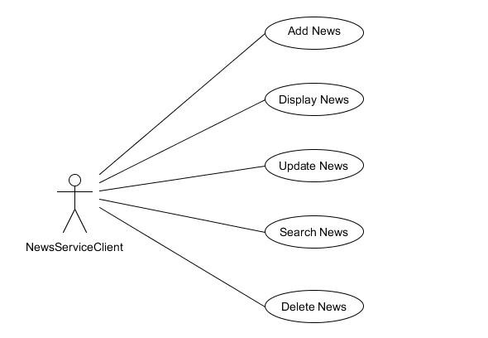

**Class diagram :**

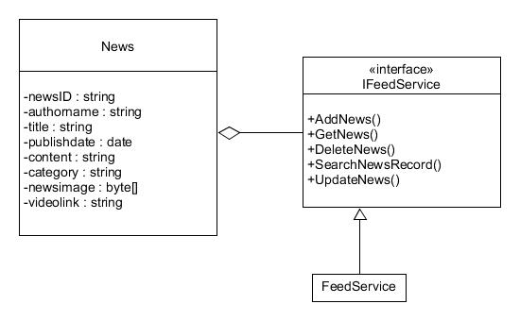

**Sequence diagrams:**

For Add News :

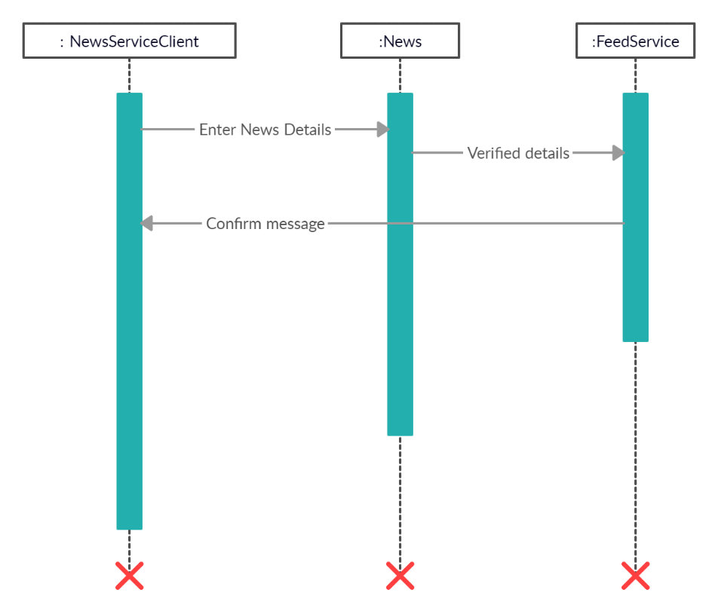

For Delete News :

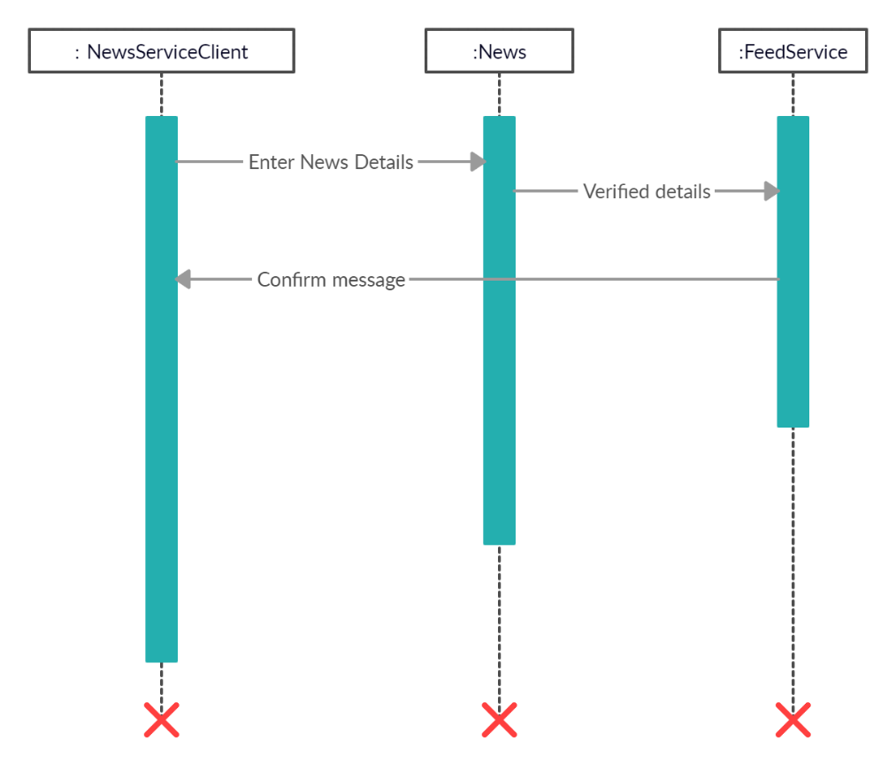

**Activity diagrams:**

Add news:

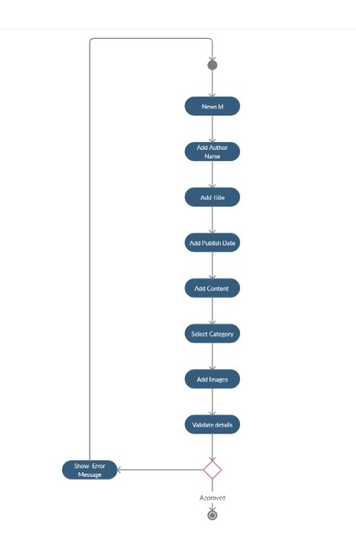

Delete news:

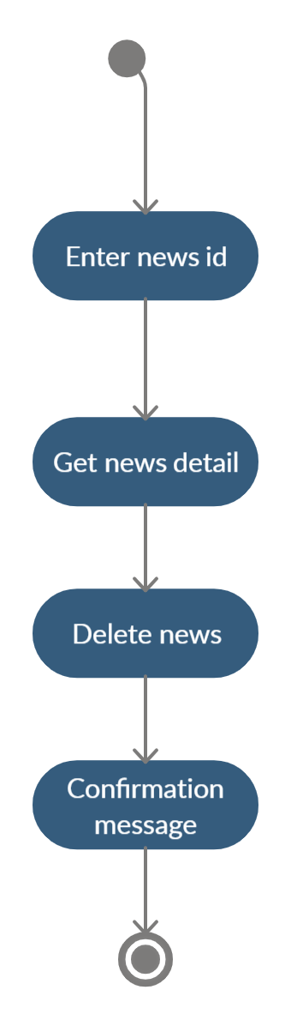

**Data dictionary :**

# Data Dictionary for NewsFeed Service

|  |  |  |  |  |  |
| --- | --- | --- | --- | --- | --- |
| News | | | | | |
| Field | Type | Required | Unique | PK/FK | Reference Table |
| NewsID | Varchar (50) | Yes | Yes | PK | - |
| Authorname | char(50) | Yes | No | - | - |
| Title | Varchar(50) | Yes | No | - | - |
| PublishDate | Datetime | No | No | - | - |
| Content | Varchar(max) | Yes | No | - | - |
| Category | Varchar(50) | Yes | No | - | - |
| NewsImage | Varbinary(max) | No | No | - | - |
| VideoLink | Varchar(300) | No | No | - | - |

5. IMPLEMENTATION DETAIL

I). Module:

* Main Home Module:

This module list different functionality that can be used by news service provider like

add news, update news, display news, delete news etc.

* Add News Module:

This module use for add new news into the database like news Id, author name, title, category, publish date, image, content, video link by any service provider.

* Display News Module :

This module is used to display all news in proper format with title , publish date, image, author name, description, video link .

* Delete News Module :

This module is build for delete any news from news feed by just simply entering news id.

* Update News Module :

This module is build for update in news information like content, title or videolink .

II). Function prototypes

* Add news :

public string AddNews(News nw)

* Delete news :

public string DeleteNews(News nw)

* View all news :

public DataSet GetNews()

* Search news record :

public DataSet SearchNewsRecord(News nw)

* Update news :

public string UpdateNews(News nw)

* Filter news:

public DataSet FilterNewsRecord(string category)

6. TESTING

In this system we have used Black Box testing.

The main focus of black box testing is on the validation of your functional requirements.

Here are the generic steps followed to carry out any type of Black Box Testing.

* Initially, the requirements and specifications of the system are examined.
* Tester chooses valid inputs (positive test scenario) to check whether SUT processes them correctly. Also, some invalid inputs (negative test scenario) are chosen to verify that the SUT is able to detect them.
* Tester determines expected outputs for all those inputs.
* Software tester constructs test cases with the selected inputs.
* The test cases are executed.
* Software tester compares the actual outputs with the expected outputs.
* Defects if any are fixed and re-tested.

Different test cases :

Add news:

If user clicks without entering any of the required field system show the error message. otherwise news would add to successfully in database and display the message “News Added Successfully.”

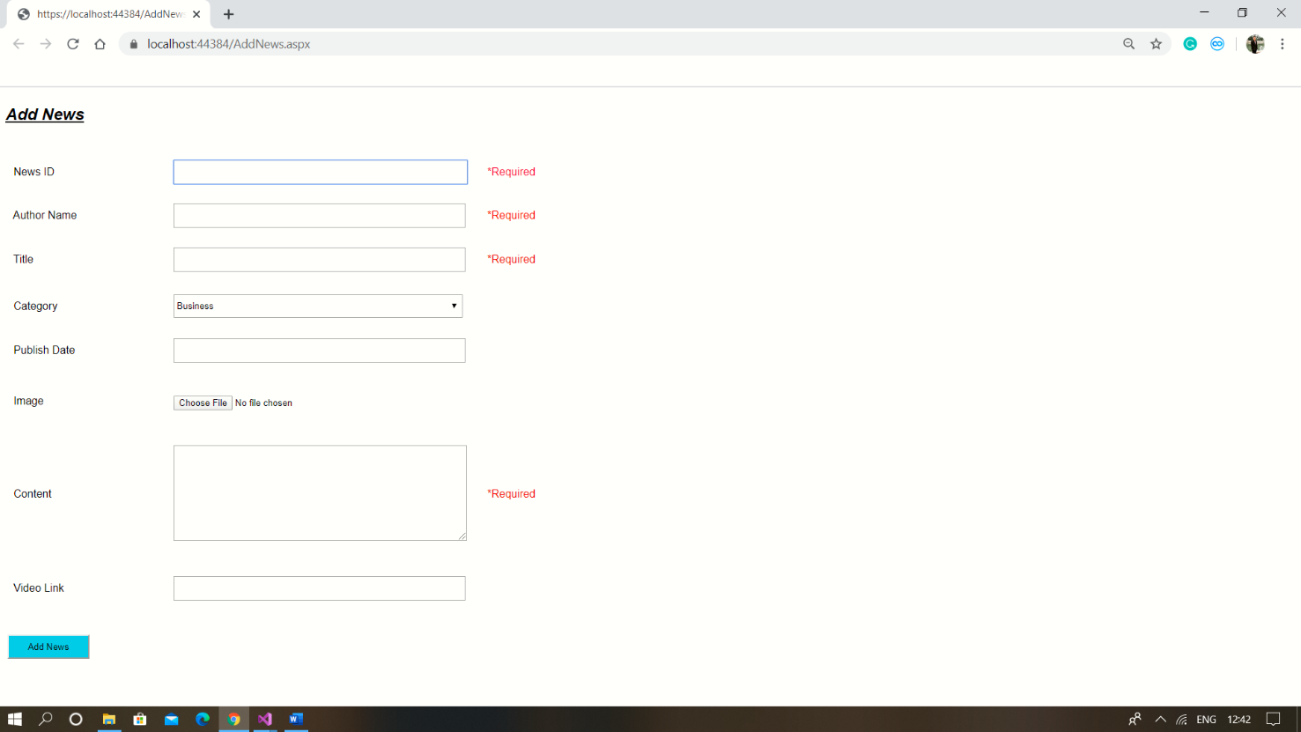

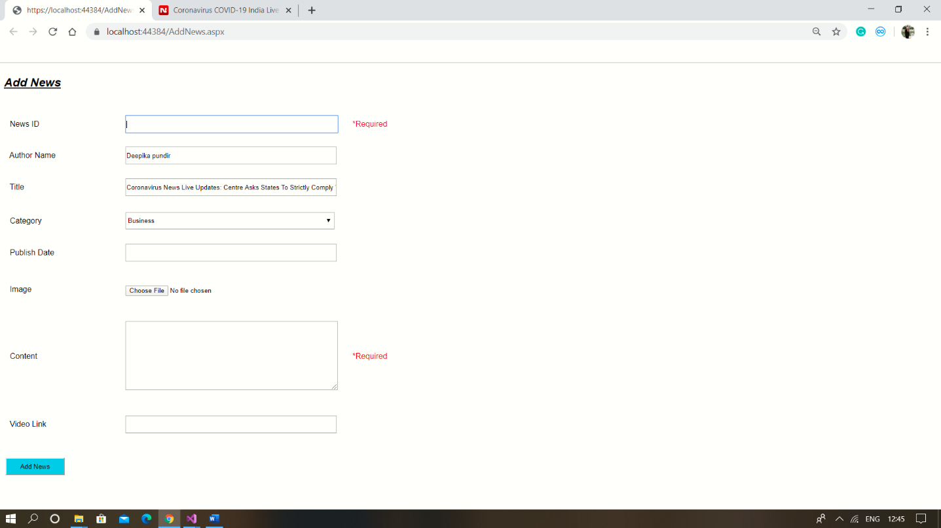

Update news :

In Update If user enters correct news id then it display the corresponding news information otherwise it display Error message.

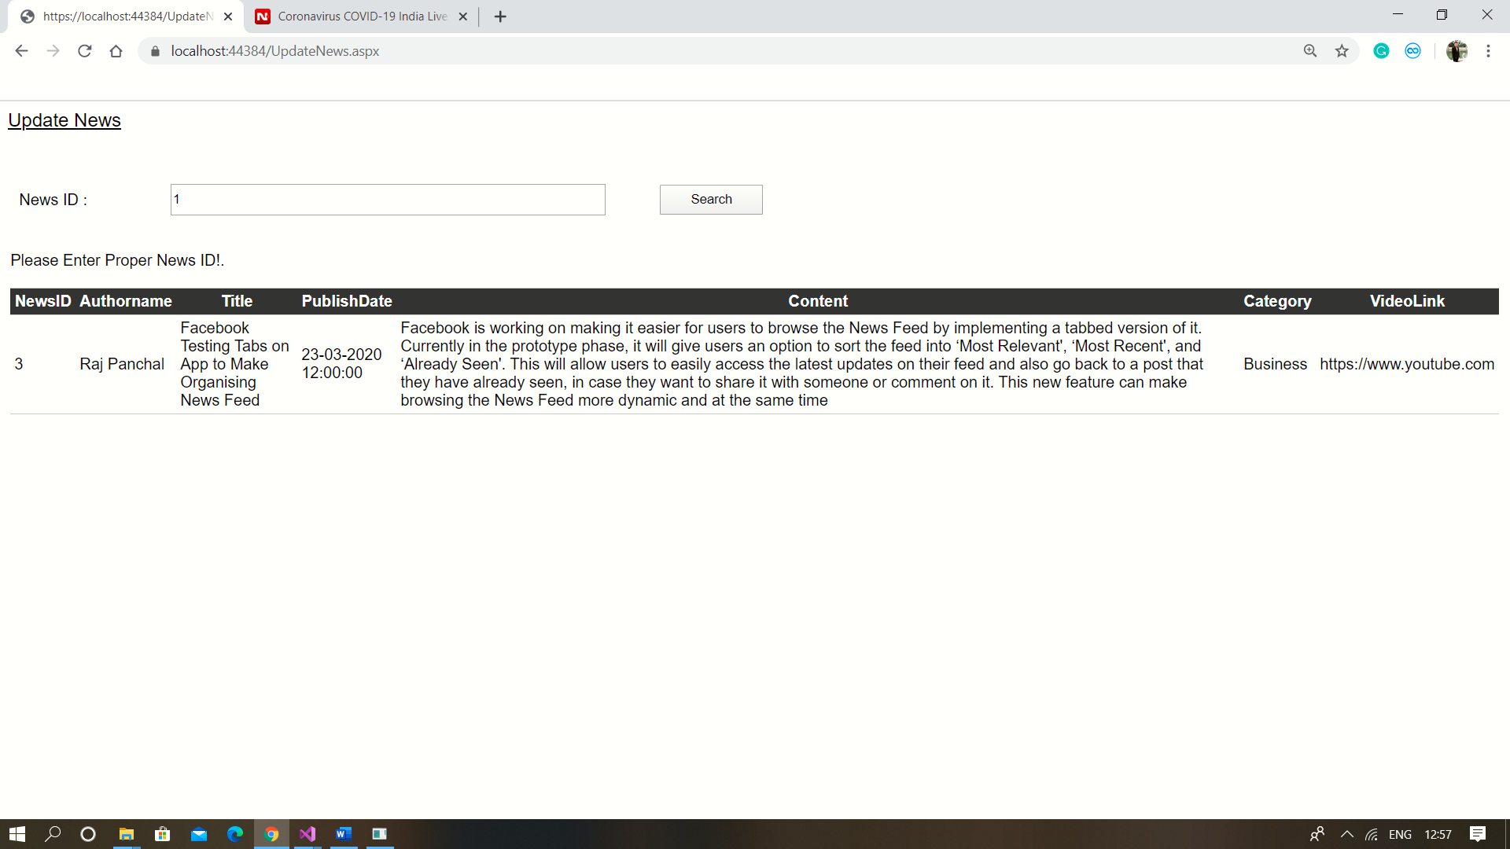

7. SCREEN-SHOTS

Main page :

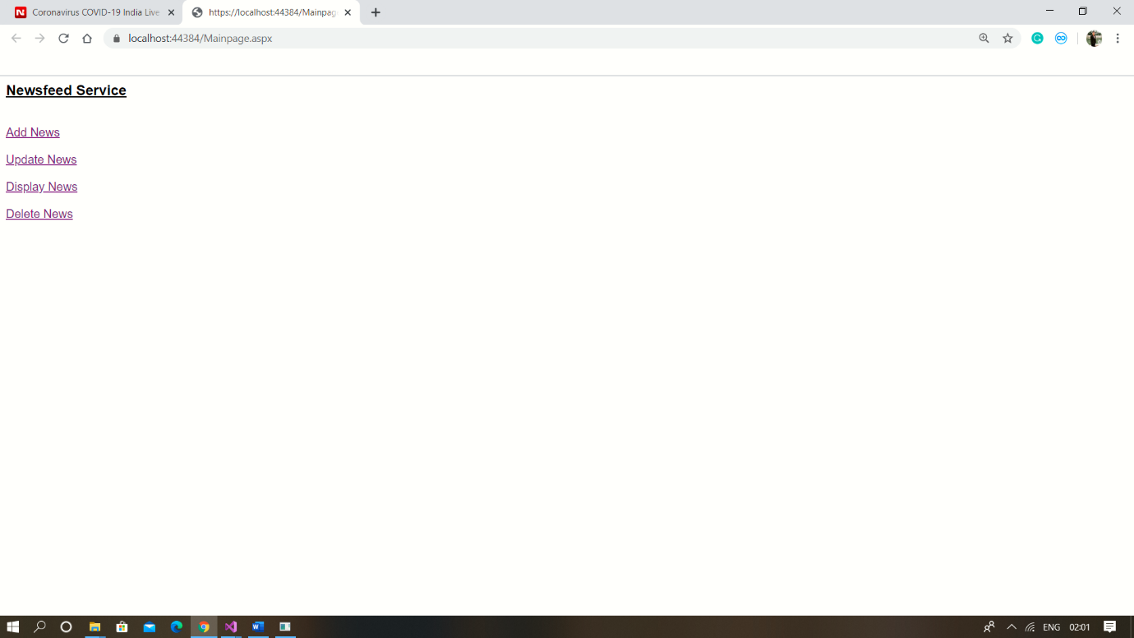

Add news :

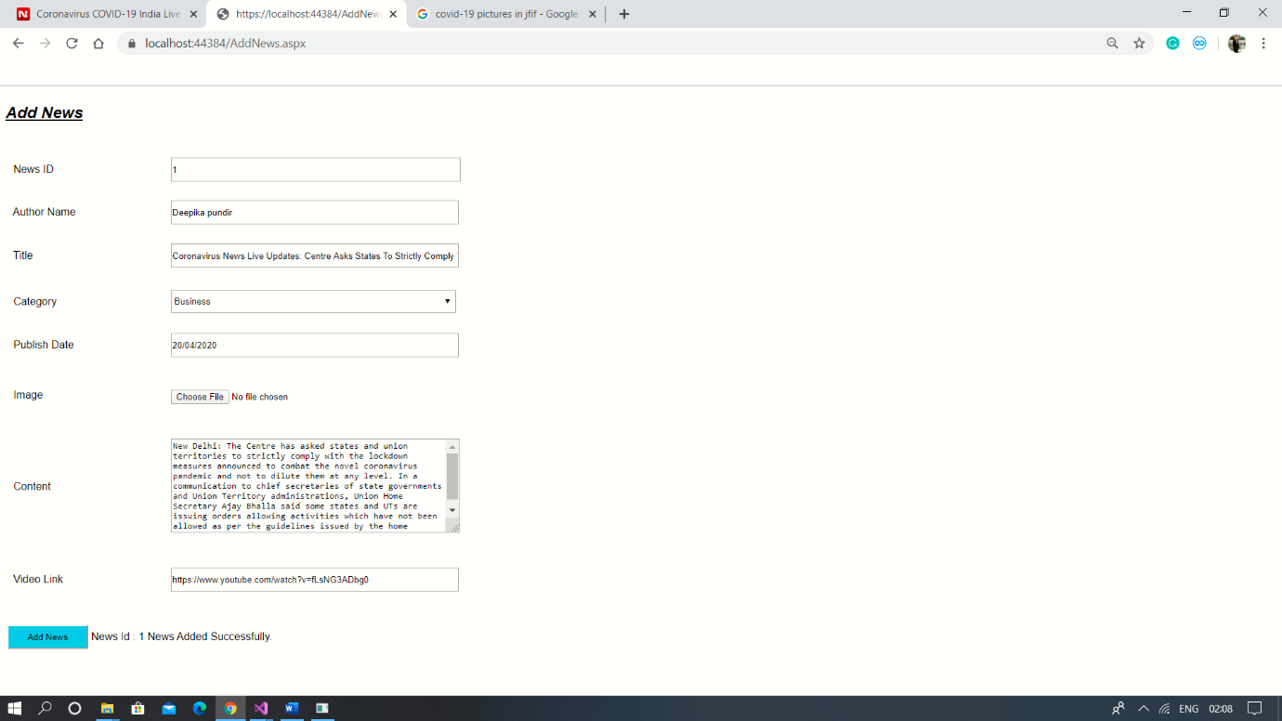

Display all news :

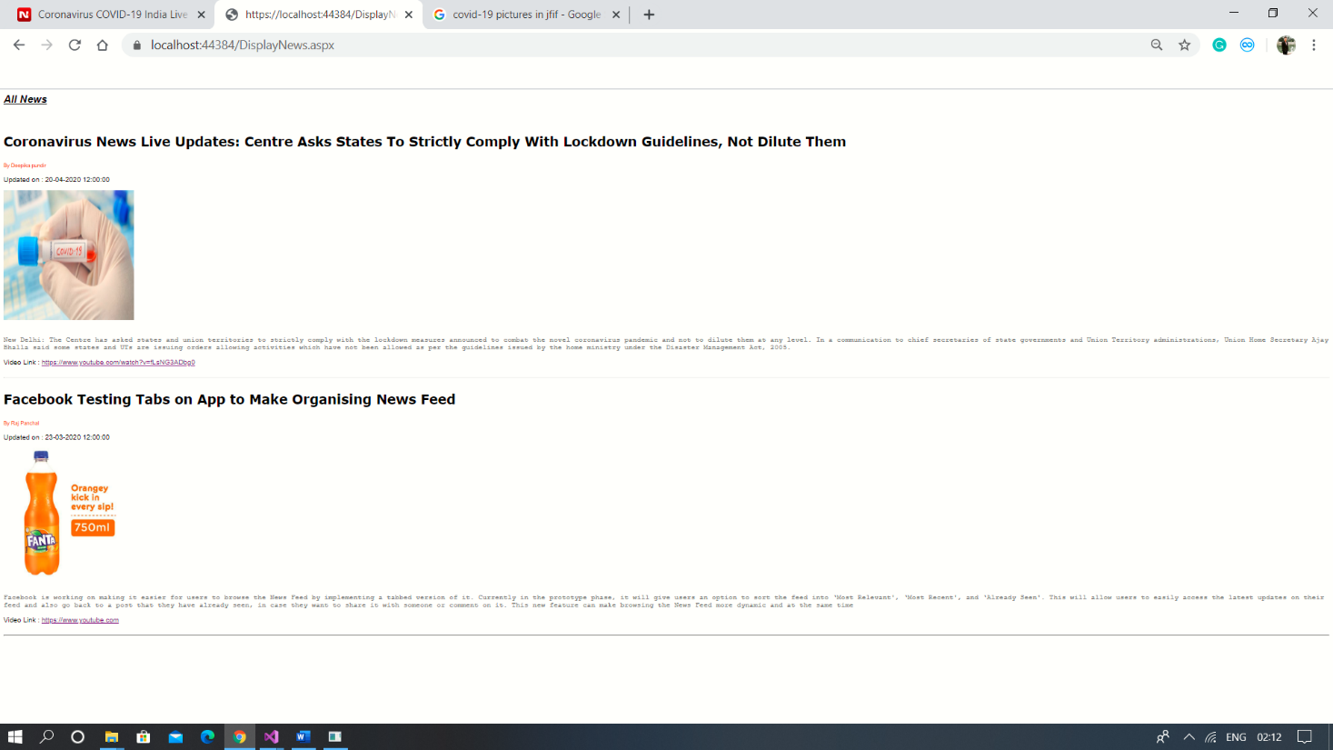

Update news :

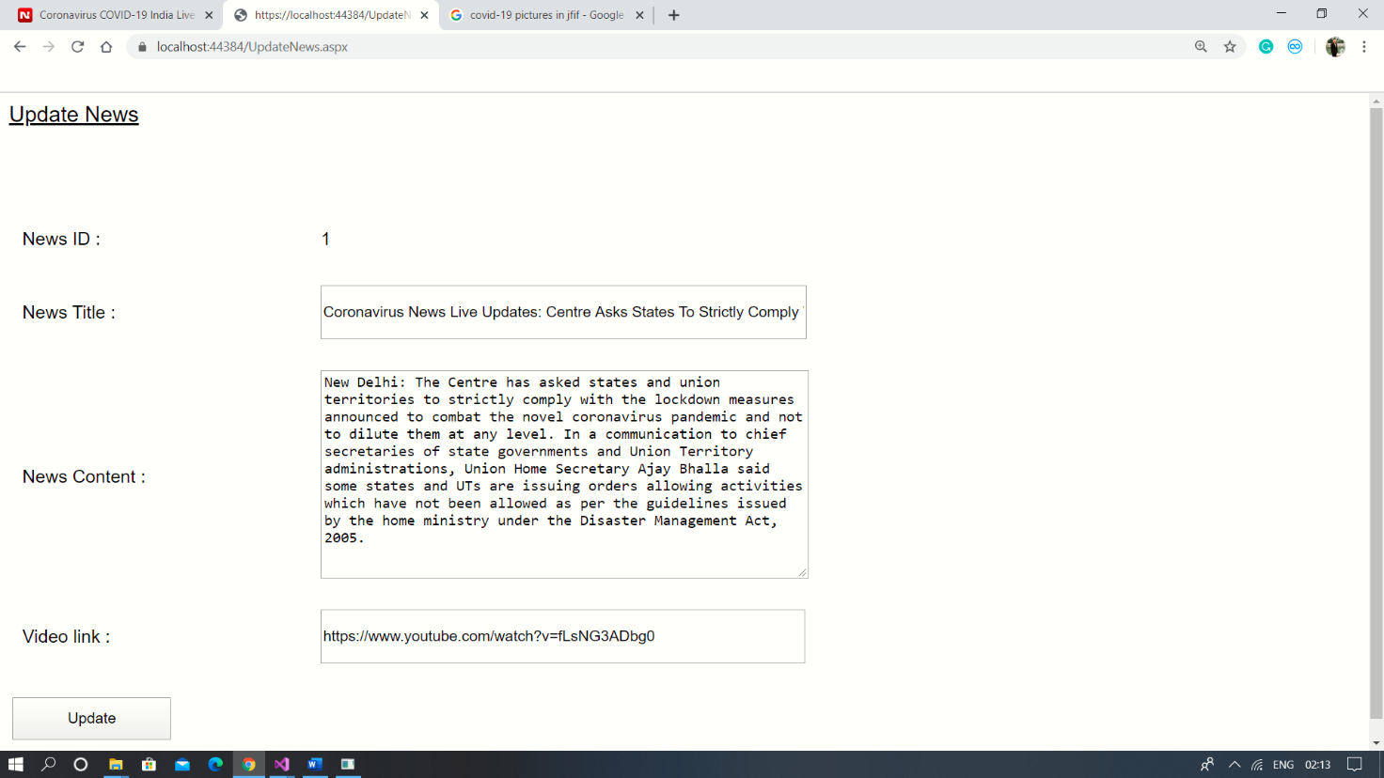

Delete news :

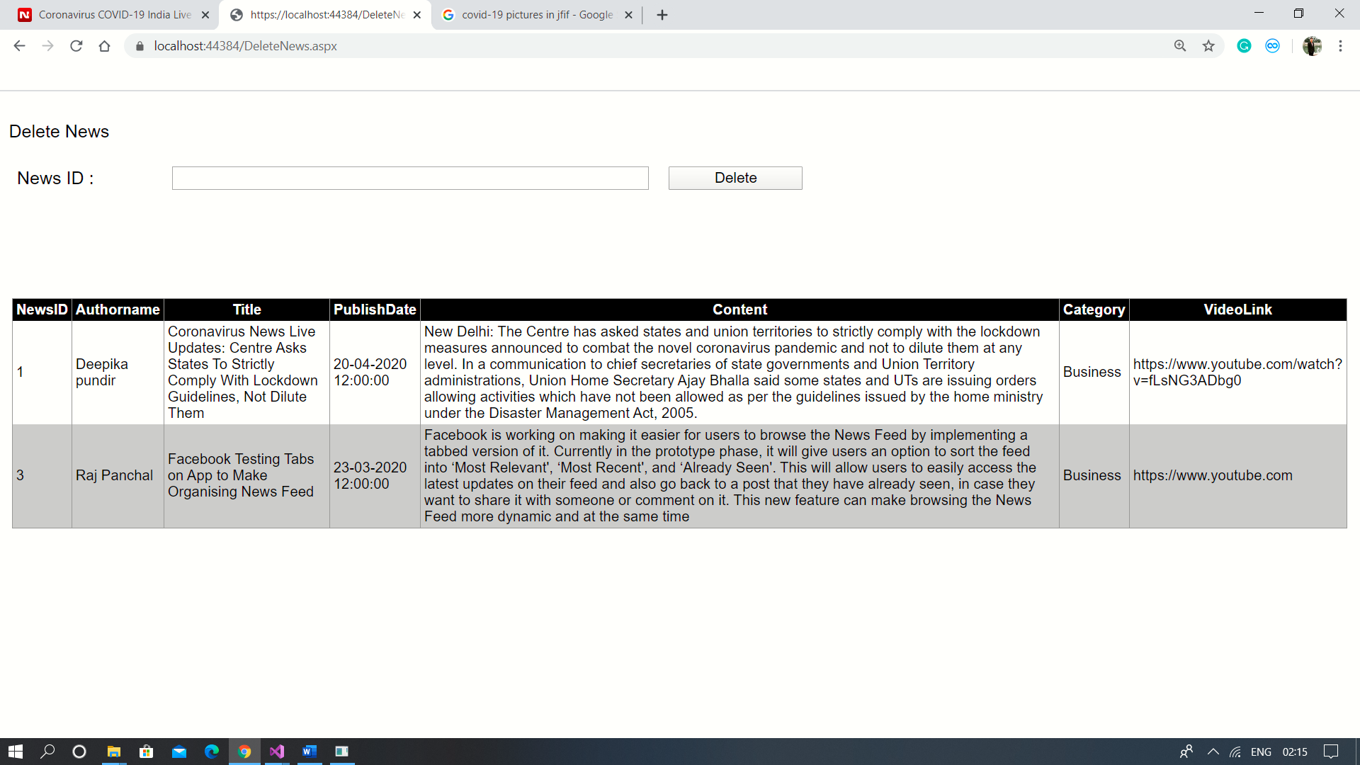

8. CONCLUSION

Functionality Successfully Implemented :

* Add news
* Delete news
* Update news
* Display news
* Search news
* Filter news by category wise

Above all functionality has been successfully implemented by us.

9. LIMITATION AND FUTURE EXTENSION

Limitation of System :

Though this system mostly contained all major functionality it doesn’t provide good UI, It needs to some improvement in front end design so service provider would get better experience with service.

Possible future extension to project:

In future we want to remove limitation from project that we have described above.

We will try to implement better UI.

10. BIBLIOGRAPHY

Reference Link :

<https://stackoverflow.com/>

<https://www.c-sharpcorner.com/>

<https://www.indiatoday.in/rss>

<https://gadgets.ndtv.com/apps/news/facebook-app-tabbed-news-feed-feature-sorting-easier-internal-2182486>