Big Data Analytics | Lab 10

Explore JasperSoft Studio: Open Source Reporting Solution



Raj Panchal  
17CEUBG104

**Aim: Delivering Reports including visualizations and customized properties.**

**Lab Setup:**

Download Jaspersoft Studio using following link :

<https://community.jaspersoft.com/project/jaspersoft-studio>

Also required MongoDB tools and Apache NetBeans IDE 12.1, Apache Tomcat server.

**Exercise:**

Task 1: University Name on X-axis, Avg Percentage by various students on Y-Axis. Use a bar chart.

Import **Source_Data.csv** file in mongodb which is in the Lab10 directory using **mongoimport** command.



Open **Jaspersoft Studio**.

In **Repository explorer** Right Click **Data Adapters** Select **Create Data Adapter** >> **MongoDB Connection**.

Provide Name: **MongoDB Connection**

Mongo URI: **mongodb://localhost:27017/{database_name}**

Click **Finish.**

Goto **File** >> **New** >> **JasperReport**.

From **Report Templates** Select **Blank Letter** Layout click **Next**.

Provide **File name**: Task1.jrxml

Click **Finish**.

You can see the **Task1.jrxml** in the **Workspace** Part.

Click the **Dataset and Query Dialog** icon.

Select **MongoDB Connection** from **Data Adapter** icon.

Select **MongoDbQuery** from **Language** dropdown menu and write following query,

|  |
| --- |
| {  collectionName: "student_master",  findQuery : {TrainingExam1Percentage : {$ne : ''},TrainingExam2Percentage:{$ne : ''}},  limit : 25  } |

Click **Read Fields.** It shows all fields of collection.

Click **OK**.

Now, At the Right side From **Basic Elements** drag **Chart** icon on **Design** Part.

In the **Chart Wizard** section select **Bar Chart**. Click **Next**.

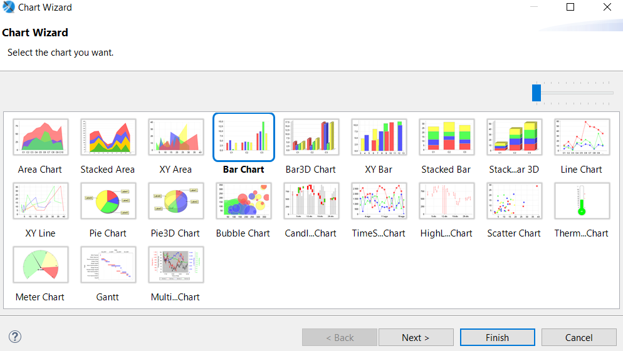

Then In **Chart Data Configuration** Set the parameters as below:

Series :$F{First Name}

Value :($F{TrainingExam1Percentage}+$F{TrainingExam2Percentage})/2

Label : $F{First Name}

Category :$F{University Name}

Then Click **Finish**.

Goto **Preview**.

It will Generate Graph like below.

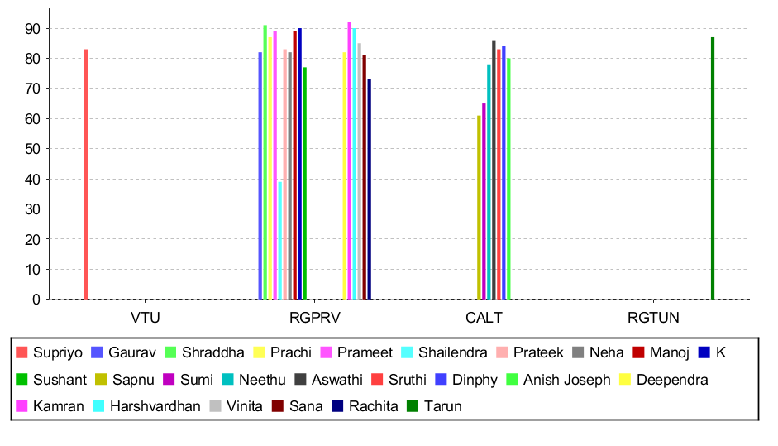

Task 2: Embed the JasperReport to your java application/web.

I have created a Java web application with apache maven using NetBeans IDE 12.1.

Open the **Apache NetBeans IDE 12.1**.

From Menu Bar Select **File** >> **New Project**.

Categories : **Java with Maven**

Projects : **Web Application**.

Provide **Project Name** and **Project Location** then click **Next**.

Select Server : **Apache Tomcat or TomEE**.

Java EE Version :**Java EE 7 Web**

Click **Finish**.

It creates a web application containing the following structure.

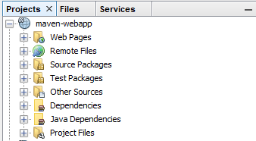

First we need to download necessary dependencies for the project.

Goto **Project Files** >> **pom.xml**.

Add the dependencies as below.

|  |
| --- |
| <dependency>  <groupId>org.mongodb</groupId>  <artifactId>mongo-java-driver</artifactId>  <version>3.12.7</version>  </dependency>  <dependency>  <groupId>net.sf.jasperreports</groupId>  <artifactId>jasperreports</artifactId>  <version>6.14.0</version>  </dependency> |

Right Click **Dependencies** select **Download Declared Dependencies**.

Then choose the jasper report file that you want to embed with a web application. Remember that this file should not contain any query that only contains report configuration.

In the **Workspace** section Select **MyReports** >> **JasperReports** >> **Compile Report**.

Then copy the .jasper file and the following location.

**{project-name}/src/main/resources/**

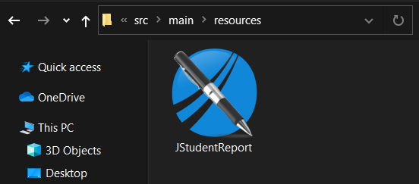

After this You need to create the following files.

Click on  to create a new file.

**StudentRc.java**

|  |
| --- |
| /*  * To change this license header, choose License Headers in Project Properties.  * To change this template file, choose Tools | Templates  * and open the template in the editor.  */  package com.webapp.maven.webapp;  /**  *  * @author HP  */  public class StudentRc {    public Double percentage;  public String university;  public String background;  public StudentRc(Double percentage, String university, String background) {  this.percentage = percentage;  this.university = university;  this.background = background;  }    public StudentRc() {  }    public Double getPercentage() {  return percentage;  }  public String getUniversity() {  return university;  }  public String getBackground() {  return background;  }  public void setPercentage(Double percentage) {  this.percentage = percentage;  }  public void setUniversity(String university) {  this.university = university;  }  public void setBackground(String background) {  this.background = background;  }  @Override  public String toString() {  return "StudentRc{" + "percentage=" + percentage + ", university=" + university + ", background=" + background + '}';  }    } |

**MongoConnection.java**

|  |
| --- |
| /*  * To change this license header, choose License Headers in Project Properties.  * To change this template file, choose Tools | Templates  * and open the template in the editor.  */  package com.webapp.maven.webapp;  /**  *  * @author HP  */  import com.mongodb.MongoClient;  import com.mongodb.client.MongoCollection;  import org.bson.Document;  public class MongoConnection {    MongoClient mongoc;  public MongoCollection<Document> getMongoCollection()  {  mongoc = new MongoClient( "localhost" , 27017 );  return mongoc.getDatabase("demo").getCollection("student_master");  }    } |

**Retriever.java**

|  |
| --- |
| /*  * To change this license header, choose License Headers in Project Properties.  * To change this template file, choose Tools | Templates  * and open the template in the editor.  */  package com.webapp.maven.webapp;  import com.mongodb.BasicDBObject;  import com.mongodb.DBObject;  import com.webapp.maven.webapp.*;  import com.mongodb.client.MongoCollection;  import com.mongodb.client.MongoCursor;  import java.util.ArrayList;  import java.util.HashMap;  import java.util.HashSet;  import java.util.Iterator;  import java.util.List;  import java.util.Map.Entry;  import java.util.Set;  import org.bson.Document;  /**  *  * @author HP  */  public class Retriever {    MongoConnection mcon;  public List<StudentRc> getStudentList(String bck)  {  mcon = new MongoConnection();  MongoCollection<Document> mcol = mcon.getMongoCollection();  DBObject query = BasicDBObject.parse("{$group:{_id:\"$University Name\",avgp:{$avg:\"$DegreePercentage\"}}}");  MongoCursor<Document> mcr = mcol.find().iterator();    Set<String> unlist = getUniversityList();  List<StudentRc> lsr = new ArrayList<StudentRc>();  HashMap<String,List<Double>> avpercentage = new HashMap<String,List<Double>>();  HashMap<String,String> backuni = new HashMap<String,String>();  while(mcr.hasNext())  {  Document row = mcr.next();  if(!row.getString("Background(CS\\NCS)").equals(bck) && !bck.equals("__ALL__"))  continue;  String uname = row.getString("University Name");  if(!avpercentage.containsKey(uname))  {  avpercentage.put(uname, new ArrayList<Double>());  backuni.put(uname, row.getString("Background(CS\\NCS)"));  }  avpercentage.get(uname).add(Double.parseDouble(row.get("DegreePercentage").toString()));  }  Iterator<Entry<String,String>> bguin = backuni.entrySet().iterator();  while(bguin.hasNext())  {  Entry<String,String> temp = bguin.next();  Double avpr = 0.0;  avpr = avpercentage.get(temp.getKey()).stream().map(pr -> pr).reduce(avpr, (accumulator, _item) -> accumulator + _item);  avpr = avpr / avpercentage.get(temp.getKey()).size();  lsr.add(new StudentRc(avpr, temp.getKey(), temp.getValue()));  }  mcon.mongoc.close();  return lsr;  }  public Set<String> getUniversityList()  {  mcon = new MongoConnection();  MongoCursor<Document> mcr = mcon.getMongoCollection().find().iterator();  Set<String> stu = new HashSet<String>();  while(mcr.hasNext())  {  Document row = mcr.next();  stu.add(row.getString("University Name"));  }  mcon.mongoc.close();  return stu;  }    } |

**SelectParameter.jsp**

|  |
| --- |
| <%--  Document : SelectParameter  Created on : Oct 1, 2020, 10:02:03 PM  Author : HP  --%>  <%@page contentType="text/html" pageEncoding="UTF-8"%>  <%@page import="java.util.Set"%>  <%@page import="com.webapp.maven.webapp.Retriever"%>  <!DOCTYPE html>  <html>  <head>  <meta http-equiv="Content-Type" content="text/html; charset=UTF-8">  <title>Select Backgroungtype</title>  <link rel="stylesheet" href="https://stackpath.bootstrapcdn.com/bootstrap/4.4.1/css/bootstrap.min.css" integrity="sha384-Vkoo8x4CGsO3+Hhxv8T/Q5PaXtkKtu6ug5TOeNV6gBiFeWPGFN9MuhOf23Q9Ifjh" crossorigin="anonymous">  <script src="https://stackpath.bootstrapcdn.com/bootstrap/4.4.1/js/bootstrap.min.js" integrity="sha384-wfSDF2E50Y2D1uUdj0O3uMBJnjuUD4Ih7YwaYd1iqfktj0Uod8GCExl3Og8ifwB6" crossorigin="anonymous"></script>  </head>  <body>  <br><br>  <div class="container w-75 m-auto shadow p-3 mb-5 bg-white rounded">  <div class="alert alert-light text-secondary w-50 m-auto " role="alert">  Select <text class="text-primary">Background</text> From below Dropdown  </div>  <br>  <select id="background" class="form-control form-control-sm w-50 m-auto" onchange="navigateToUni()" >  <option></option>  <option>CS</option>  <option>NCS</option>  <option>__ALL__</option>  </select><!-- comment --></div>  </body>  <script>  function navigateToUni()  {  uname = document.getElementById("background");  window.location.replace("/maven-webapp/DisplayReport.jsp?bckg="+uname.value);  }  </script>  </html> |

**DisplayReport.jsp**

|  |
| --- |
| <%--  Document : DisplayReport  Created on : Oct 1, 2020, 10:08:02 PM  Author : HP  --%>  <%@page contentType="text/html" pageEncoding="UTF-8"%>  <%@page import="net.sf.jasperreports.engine.JasperPrintManager"%>  <%@page import="com.webapp.maven.webapp.Retriever"%>  <%@page import="net.sf.jasperreports.engine.JasperRunManager"%>  <%@page import="java.util.List"%>  <%@page import="java.util.ArrayList"%>  <%@page import="com.webapp.maven.webapp.StudentRc"%>  <%@page import="net.sf.jasperreports.engine.JasperPrint"%>  <%@page import="net.sf.jasperreports.engine.JasperFillManager"%>  <%@page import="java.util.Map"%>  <%@page import="java.util.HashMap"%>  <%@page import="net.sf.jasperreports.engine.data.JRBeanCollectionDataSource"%>  <!DOCTYPE html>  <html>  <head>  <meta http-equiv="Content-Type" content="text/html; charset=UTF-8">  <title>JSP Page</title>  </head>  <body>  <%  String bckg = request.getParameter("bckg");  List<StudentRc> li = (new Retriever()).getStudentList(bckg);      JRBeanCollectionDataSource beanColDataSource = new JRBeanCollectionDataSource(li);  Map<String, Object> parameters = new HashMap<String, Object>();  String jpath = "C:\\Users\\HP\\Documents\\NetBeansProjects\\maven-webapp\\src\\main\\resources\\JStudentReport.jasper";  byte bytes[] = JasperRunManager.runReportToPdf(jpath, parameters,beanColDataSource);  response.setContentType("application/pdf");  response.setContentLength(bytes.length);  ServletOutputStream outStream = response.getOutputStream();  outStream.write(bytes, 0, bytes.length);  outStream.flush();  outStream.close();  %>  </body>  </html> |

Finally click on   button to run project**.**

You are able to see web page like below.

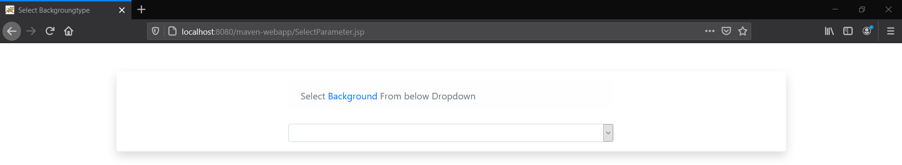

Now you can select the **background type** of student_master table from the dropdown and it generates the report with a **bar chart** containing **University Name** on **X-axis** and **average percentage** on **Y-axis**.

Bar chart for CS background:

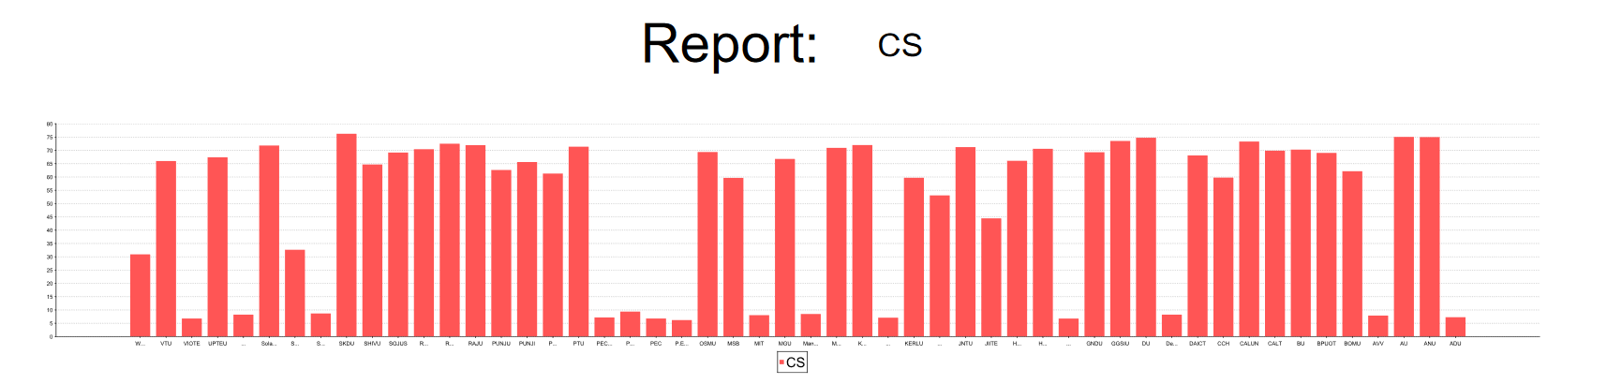

Bar chart for NCS background:

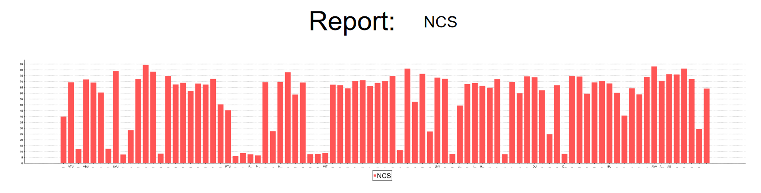

Task 3 : Populate dropdown for parameter.

I have already performed this task in the above activity.

Here I have created a dropdown menu for selection of background type (**CS**/**NCS**).

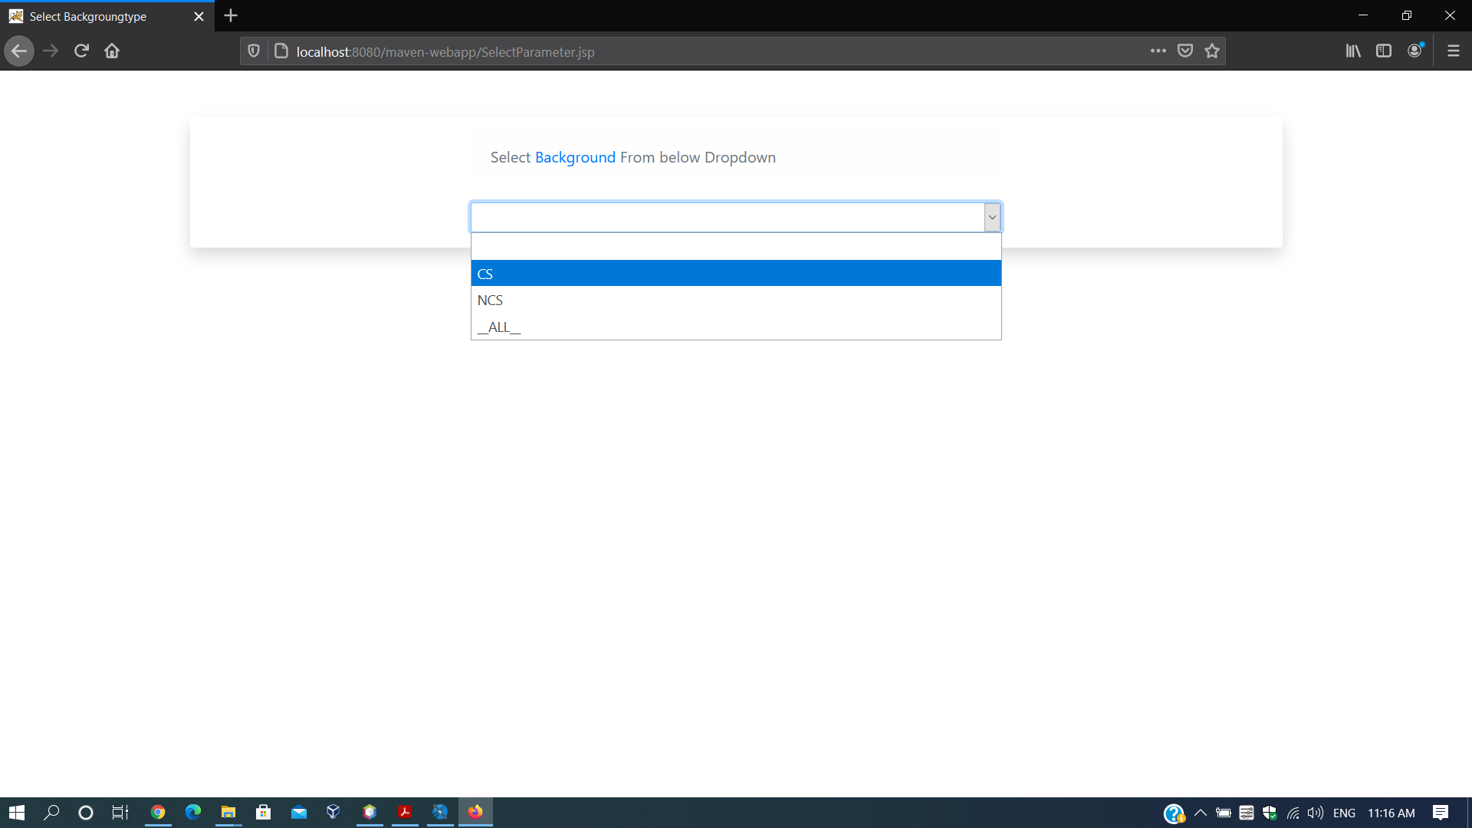

Bar Chart for all backgrounds (**CS/NCS/None**).

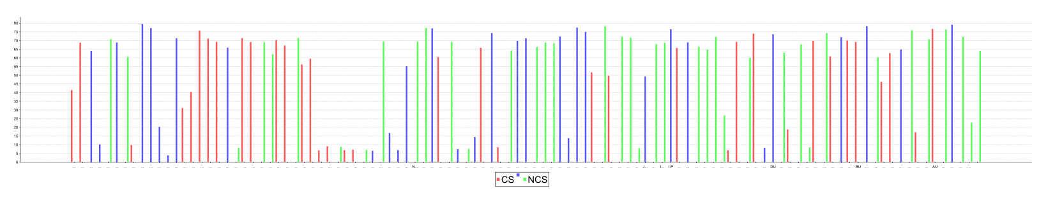

**Document Link :**

<https://docs.google.com/document/d/1zxGddFvd6_ig_LwXsR21HD5YpbqR2nLpy3c0BGhnMUg/edit?usp=sharing>