Big Data Analytics | Lab 9

Explore Mahout: - Distributed Linear Algebra Framework mathematically expressive Scala DSL



Raj Panchal  
17CEUBG104

**Aim: Leveraging machine learning using Mahout like tools.**

**Task : Run recommendation of a sample dataset using Mahout Library.**

Recommendation is a popular technique that provides close recommendations based on user information such as previous purchases, clicks, and ratings.

* Amazon uses this technique to display a list of recommended items that you might be interested in, drawing information from your past actions. There are recommender engines that work behind Amazon to capture user behavior and recommend selected items based on your earlier actions.
* Facebook uses the recommender technique to identify and recommend the “people you may know list”.

**Step 1: Install maven and mahout.**

Install Maven using below command:

**$ Sudo apt-get install maven**

Check it installed or not using the below command.

**$ mvn -version**

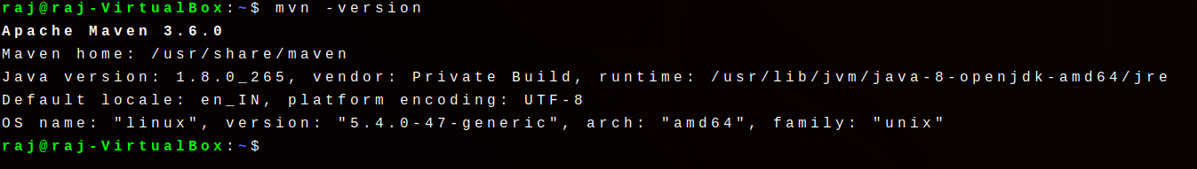

Download zip file from given link.

<https://mahout.apache.org/>

Unzip the Mahout source file.

Move the unzip folder into /usr/local directory.

**$ sudo mv mahout-0.14.0 /usr/local/mahout**

Go to the mahout directory in the terminal.

**$ cd /usr/local/mahout**

Then run the following command.

**$ mvn install**

This will take around 40 minutes because it takes time to test all algorithms.

**Step 2: Compile and run the project.**

Extract the **mahoutdemo** named application.

You can see the content below.

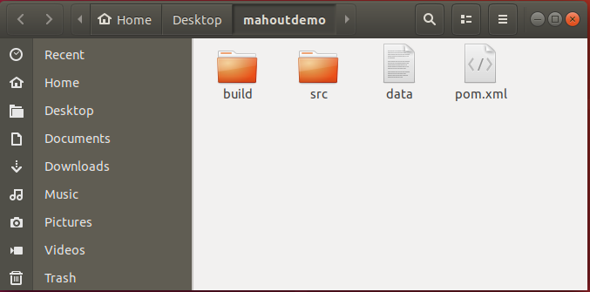

Now open the pom.xml file in the Text editor and update the following lines.

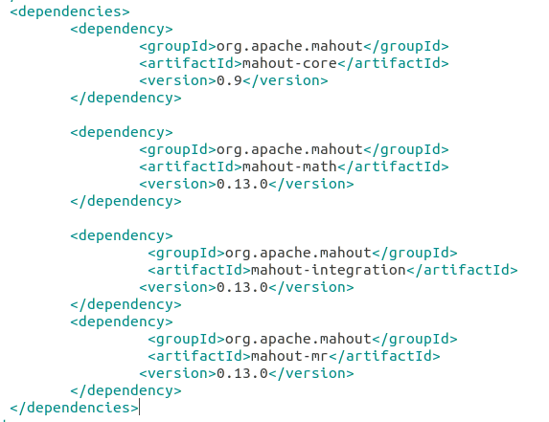

Then Go to the **mahoutdemo** folder and run the below command.

**$ mvn install**

It’s primary jobs are

* Download dependencies.
* Build Project.

This command creates the target folder in the current folder containing all dependencies. 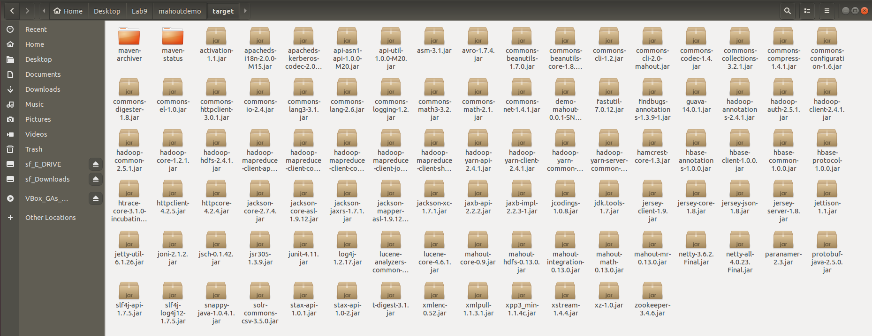

If it succeeds then it shows **BUILD SUCCESS** message, otherwise **BUILD FAIL**.

**Step 3: Observe the Output.**

Use below command to show the output.

**$ java -jar target/demo-mahout-0.0.1-SNAPSHOT.jar**

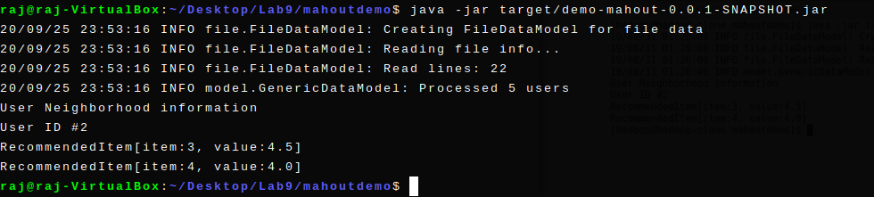

It shows the recommendation for user with user id 2.