# Image Processing – Lab 01

Aim: Explore the Octave GUI and matrix related operation, image related different function.

Description:

* For matrix creation :

A = [6 43 2 11 87;

12 6 34 0 5;

34 18 7 41 9]

Above code creates 3*5 matrix A.

Different operation on Image:

* imread (“filename”):

Read an image as a matrix from the file name or from the online resource url.

* imwrite (img,”filename”):

Write images in various file formats.

The image img can be binary, grayscale, RGB, or multi-dimensional image.

* rgb2gray (rgb_img):

Transform an image or colormap from red-green-blue (RGB) color space to a grayscale intensity image. The input may be of class uint8, uint16, int8, int16, single or double. The output is of the same class as the input.

* im2bw (img):

Convert image to binary, black and white, by threshold. The input image img can be either be a grayscale or RGB image.

* imshow(img):

Display the imge img, where img can be a 2-dimensional (grayscale image) or a 3-dimensional (RGB) matrix.

* imresize(im,scale)

Resize image with interpolation. Scales image im by a factor scale or into the size M rows by N columns.

Assignment

1. 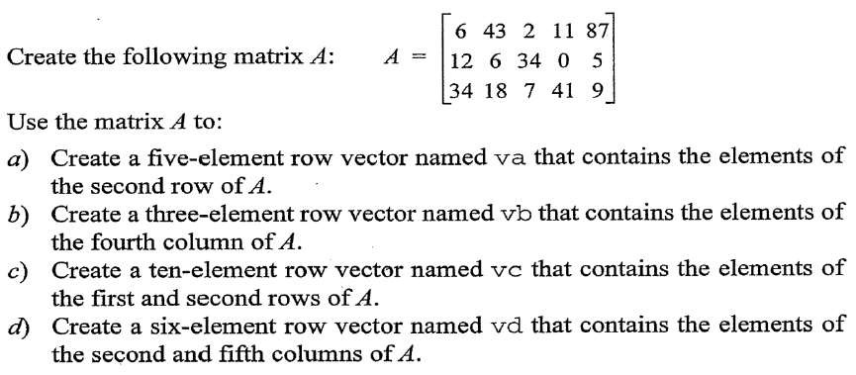

Code & Output:

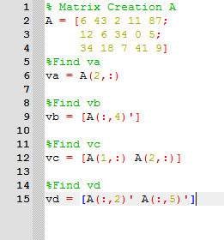 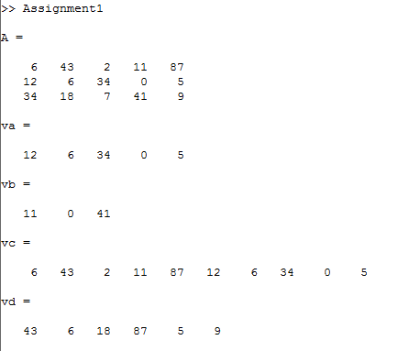

1. 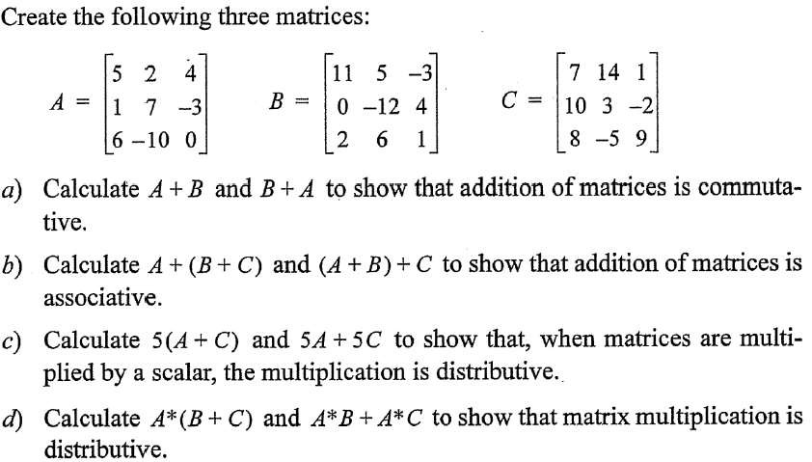

Code :

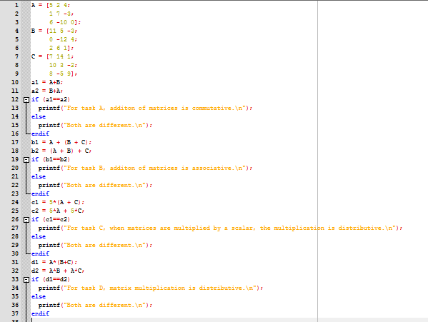

Output:

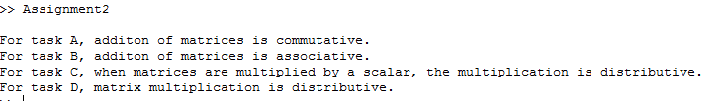

1. 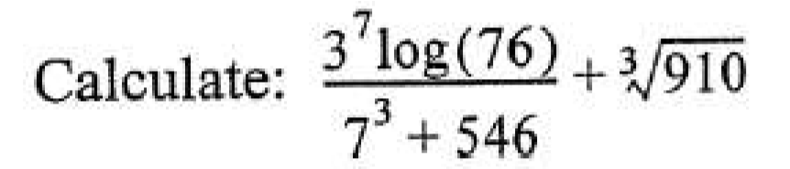

Code :

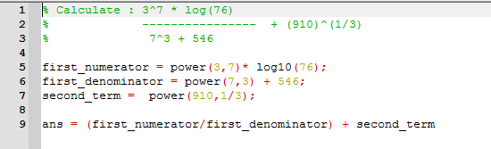

Output :

C:\Users\Admin\Desktop\a6.PNG

1. 

Code :

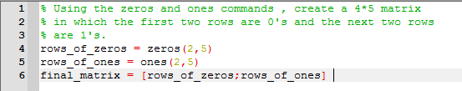

Output :

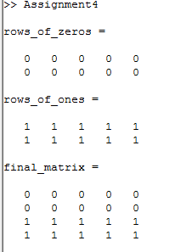

5. Take your own photo(RGB image) and create following images and save them for future use.

1) Gray scale image

2) Black and white image

3) Over Exposed image

4) Under Exposed image

5).keep your face only-crop rest of the image.

6).Resize the image to 256*256.

Code :

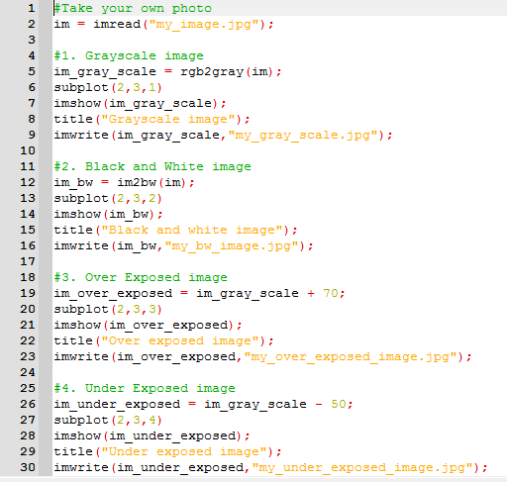

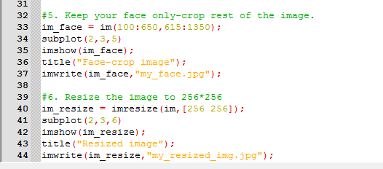

Output :

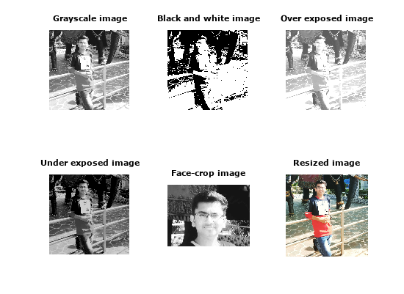

6. Take your own photo and process them for following results using loop controling structures.

1) flip your image vertically

2) create the mirror image

3) rotate the image by 90 degree

4)rotate the image by 270 degree

Code :

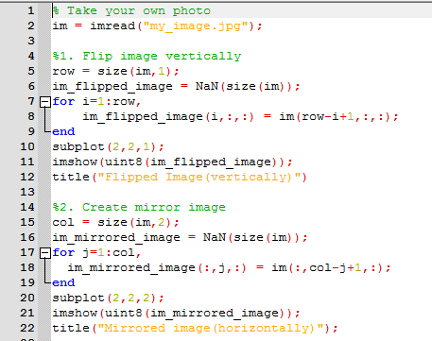

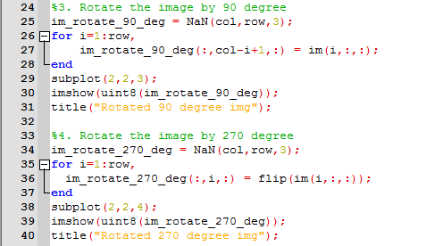

Output :

