Lincoln University College
Faculty of Computer Science and Multimedia Timed - A Medication Reminder Application A PROJECT REPORT
Submitted to
Department of Information Technology
Phoenix College of Management
Maitidevi, Kathmandu
In partial fulfillment of the requirements for the Bachelor in Information Technology (BIT)
Submitted by
Reezan Shrestha
BIT 5th Semester
University ID : LC0003001325
2024/12/26
DECLARATION
I hereby declare that the project report entitled "Timed - A Medication Reminder Application" is my original work, completed under the guidance of Mr. Saishab Bhattarai. This report has not been submitted elsewhere, in full or in part, for the award of any degree, diploma, or other academic recognition.
Signature:
Name: Reezan Shrestha
Date: 2024/12/26
i

Lincoln University College
Faculty of Computer Science and Multimedia
Phoenix College of Management
Maitidevi, Kathmandu
Bachelors in Information Technology (BIT)
LETTER OF APPROVAL
The Project report entitled "Timed - A Medication Reminder Application" submitted by Reezan Shrestha , in partial fulfillment of the requirements for the Bachelor’s degree in Information Technology, has been accepted as a record of work independently carried out by the group of departments.
In our opinion, it is satisfactory in the score and quality of a project for the required degree.
Er. Santosh Dhungana Head of Department
Mr. Saishab Bhattarai Internal Examiner
Mr. Bijay Mishra
Program Coordinator
External Examiner
ii
ABSTRACT
The "Timed - Medication Reminder Application" is designed to enhance medication adherence and health management for individuals with chronic conditions such as hy pertension and diabetes. By providing timely reminders for medications and medical appointments, the app helps prevent complications and improve overall health out comes. It simplifies complex medication schedules, empowering users to manage their treatments independently and effectively, thereby improving quality of life. With cus tomization options to cater to diverse patient needs, "Timed - Medication Reminder Application" extends its impact to broader public health systems, promoting healthier lifestyles and empowered healthcare management.
Keywords: Medication Reminder, Smartphone App, Appointment Schedul ing, Digital Health, Personalized Care.
iii
ACKNOWLEDGMENT
I would like to express my heartfelt gratitude to Mr. Saishab Bhattarai for his invalu able guidance and support throughout this project. His expertise and encouragement were instrumental in the successful completion of this work.
I am also deeply thankful to my team members, Lhakpa Tsheri Sherpa and Sak shyam Sapkota, for their collaboration and dedication throughout the project. Their contributions played a crucial role in achieving our objectives.
Additionally, I extend my gratitude to the External Advisors for their encourage ment and assistance during the course of this work. Lastly, I am profoundly grateful to my family and friends for their constant support and motivation, which helped me persevere and complete this project successfully.
iv
CERTIFICATE
This is to certify that the project report entitled "Timed - A Medication Reminder Application" submitted by Reezan Shrestha University ID: LC0003001325 to Lincoln University College in partial fulfillment of the requirements for the Bachelor in Infor mation Technology, is a record of original work carried out under my supervision and guidance.
Supervisor Name: Saishab Bhattarai
Designation: Project Coordinator
Signature:
v
Contents
LIST OF FIGURES 2 LIST OF TABLES 3 LIST OF ABBREVIATIONS 4
1 INTRODUCTION 5 1.1 Introduction . . . . . . . . . . . . . . . . . . . . . . . . . . . . . . . . 5 1.2 Problem Statement . . . . . . . . . . . . . . . . . . . . . . . . . . . . 6 1.3 Project Objectives . . . . . . . . . . . . . . . . . . . . . . . . . . . . 6 1.4 Significance of Project . . . . . . . . . . . . . . . . . . . . . . . . . . 6 1.5 Limitations of the Project . . . . . . . . . . . . . . . . . . . . . . . . 7 1.6 Development Methodology . . . . . . . . . . . . . . . . . . . . . . . . 7 1.7 Organization of the Report . . . . . . . . . . . . . . . . . . . . . . . . 8
2 Background Study and Literature Review 10 2.1 Background of the Study . . . . . . . . . . . . . . . . . . . . . . . . . 10 2.2 Literature Review . . . . . . . . . . . . . . . . . . . . . . . . . . . . . 11
vi
3 System Analysis 13 3.1 System Analysis . . . . . . . . . . . . . . . . . . . . . . . . . . . . . . 13 3.1.1 Requirement Analysis . . . . . . . . . . . . . . . . . . . . . . 14 3.1.2 Feasibility Analysis . . . . . . . . . . . . . . . . . . . . . . . . 16 3.1.3 System Modeling . . . . . . . . . . . . . . . . . . . . . . . . . 19 3.1.4 Dynamic modeling using State and Sequence Diagrams . . . . 21 3.1.5 Process modeling using Activity Diagrams . . . . . . . . . . . 21
4 System Design 23 4.1 Refinement of Classes and Object . . . . . . . . . . . . . . . . . . . . 23 4.2 Component Diagram . . . . . . . . . . . . . . . . . . . . . . . . . . . 24 4.3 Deployment diagram . . . . . . . . . . . . . . . . . . . . . . . . . . . 27
5 Implementation and Testing 29 5.1 Implementation . . . . . . . . . . . . . . . . . . . . . . . . . . . . . . 29 5.1.1 Tools Used . . . . . . . . . . . . . . . . . . . . . . . . . . . . . 29 5.1.2 Implementation Details of Modules . . . . . . . . . . . . . . . 30 5.2 Testing . . . . . . . . . . . . . . . . . . . . . . . . . . . . . . . . . . . 31 5.2.1 Test Cases for Unit Testing . . . . . . . . . . . . . . . . . . . 31 5.2.2 Test Cases for System Testing . . . . . . . . . . . . . . . . . . 34 5.3 Result Analysis . . . . . . . . . . . . . . . . . . . . . . . . . . . . . . 35
6 Conclusion and Future Recommendations 36 vii
6.1 Conclusion . . . . . . . . . . . . . . . . . . . . . . . . . . . . . . . . . 36 6.2 Future Recommendations . . . . . . . . . . . . . . . . . . . . . . . . 37
References 38
Appendices 40 6.3 Firebase Schema . . . . . . . . . . . . . . . . . . . . . . . . . . . . . 40 6.4 Design Mockups . . . . . . . . . . . . . . . . . . . . . . . . . . . . . . 41
1
List of Figures
3.1 Scrum Methodology . . . . . . . . . . . . . . . . . . . . . . . . . . . . 14 3.2 Gantt Chart . . . . . . . . . . . . . . . . . . . . . . . . . . . . . . . . 18 3.3 Use Case Diagram of Medication Reminder Application . . . . . . . 19 3.4 class Diagram of Medication Reminder Application . . . . . . . . . . 20 3.5 Sequence Diagram of Reminder . . . . . . . . . . . . . . . . . . . . . 21 3.6 Activity Diagram of Medication Reminder Application . . . . . . . . 22
4.1 class Diagram of Medication Reminder Application . . . . . . . . . . 24 4.2 Component diagram of A Medication Reminder Application . . . . . 26 4.3 Deployment diagram of A Medication Reminder Application . . . . . 28
6.1 Home Page . . . . . . . . . . . . . . . . . . . . . . . . . . . . . . . . 41 6.2 Landing Page . . . . . . . . . . . . . . . . . . . . . . . . . . . . . . . 41 6.3 Profile Page . . . . . . . . . . . . . . . . . . . . . . . . . . . . . . . . 41
2
List of Tables
3.1 Schedule of "Timed - A Medication Reminder Application" . . . . . . 18
5.2 Test Cases for Unit Testing . . . . . . . . . . . . . . . . . . . . . . . 33 5.4 Test Cases for System Testing . . . . . . . . . . . . . . . . . . . . . . 34
3
LIST OF ABBREVIATIONS
API: Application Programming Interface
ELA: Elderly Living Alone
EMR: Electronic Medical Records
ER: Entity-Relationship
EHR: Electronic Health Records
FCM: Firebase Cloud Messaging
iOS: iPhone Operating System
IT: Information Technology
mHealth: Mobile Health
RFID: Radio-Frequency Identification
RESTful API: Representational State Transfer (REST) Application Programming In terface
SMRAs: Smartphone Medication Reminder Applications
UAT: User Acceptance Testing
UI: User Interface
UML: Unified Modeling Language
UX: User Experience
4
Chapter 1
INTRODUCTION
1.1 Introduction
In the current era of rapid changes, one must be aware towards chronic clinical condi tions, especially chronic hyper tension and diabetes, as they require regular follow up, drug schedule adherence, and visits to doctors. Most patients are unable to follow up on the typically busy treatment schedules, leading to a lower medication consump tion level and causing complications, thereby increasing needless hospital admissions. Therefore, we have developed Timed- Medication Reminder Application, an all-in one solution to make medication adherence and health management with chronic diseases more efficient.
Timed- Medication Reminder Application keeps reminding users on time regarding medicines and medical appointments, thereby keeping the patients on track with their treatment plans. The user-friendly nature of the app and personal notifications attached to the app would thus serve as an agent enforcing patient adherence to prescribed therapies, resulting in better health outcomes, fewer emergencies, and an enhanced quality of life for the patients. It is therefore a worthy investment aimed at alleviating complicated drug schedules and making adherence autonomic so that it can not only lift the burden on health care systems.
5
1.2 Problem Statement
The problem of forgetting to take medications or just difficulties in management of complex regimens makes many middle-aged and older patients suffering from chronic conditions such as hypertension and diabetes not to adhere to their medications at all. As a result they experience worsened health outcomes with increased healthcare expenses[5]. We are in need of a user-friendly means by which to remind patients about times when they should take their medicine or when they have appointments scheduled. Thus, we designed our “Timed-Medicine Reminder Mobile Application” which sends timely reminders and allows tracking that enhance adherence to medica tions and improve health management.
1.3 Project Objectives
• To implement a timely notification system that consistently alerts users to take their medications and schedule upcoming doctor appointments.
• To effectively arrange and handle users prescription regimens and doctor ap pointments.
• To store and alert users with their medication and health data.
1.4 Significance of Project
The app called “Timed- Medication Reminder Application” is an important project that is meant to enhance medication adherence and health management for people suffering from chronic diseases like hypertension or diabetes. The timely reminders prompt users to take their medications as prescribed and attend their medical ap pointments accordingly. This way of following the prescriptions prevents complica tions and ultimately ensures better health outcomes. Besides, by making complex medication schedules easier to understand, this application enhances patient auton omy in medicine therapy i.e., they can administer treatment plans more efficiently. By
6
so doing, it leads not only to improved quality of life. Moreover, this project could be customized to cater to other patients thereby increasing its positive impact on public health systems. By doing so, we say that the “Timed-Medicine reminder application” fills a gap in health care as far as adherence is concerned thus promoting healthier and empowered citizens.
1.5 Limitations of the Project
• Technology Reachability Compromised: Elderly people may not possess smartphones or experience issues that limit their ability to utilize mobile appli cations, thus hampering the proper delivery of messages to the target audience by the app.
• Data Safety Related Aspects: A bigger question that arises from keeping health-related details is privacy as well as security. Organizations like health services must obey laws on data protection even if it may be tricky at times.
• Limited Multi-language Support: The application currently supports only the English language, limiting its usability for non-English speaking users. Fur ther localization features can be incorporated to support multiple languages for broader accessibility in the future.
• Cater only two diseases: The application caters only hypertension and di abetes. It does not yet support a wide range of chronic conditions, which may limit its applicability for patients with other health issues. Future updates could expand the range of supported diseases to offer broader healthcare support.
1.6 Development Methodology
• Scrum Methodology: The "Timed - A Medication Reminder Application" follows the Scrum methodology, focusing on iterative development with regular sprint planning, daily stand-ups, and sprint reviews. This approach ensures
7
continuous collaboration, quick adaptation to changes, and the delivery of func tional increments that meet user needs.
1.7 Organization of the Report
This report is structured into several chapters with each discussing a specific area of the project ‘Timed - A Medication Reminder Application’. The layout is as follows:
• Chapter 1: Introduction
This chapter presents an overview of the project including the introduction, problem statement, objectives of the project, significance, limitations encoun tered, and an outline of the report organization.
• Chapter 2: Background Study and Literature Review This chapter brings together background of the study and all available scholarly work and published materials regarding treatment compliance, mHealth appli cations, and their importance in the management of long-term illnesses, while also pointing out the gaps in the present solutions that this project seeks to address.
• Chapter 3: System Analysis
The System Analysis section provides a comprehensive overview of the project’s requirements, objectives, and constraints. It outlines the functional and non functional requirements, feasibility studies, and the methodologies used to gather information, ensuring a clear understanding of the system’s purpose and the processes involved in its development.
• Chapter 4: System Design
The System Design section details the architecture and components of the sys tem, including both high-level and detailed designs. It outlines the design de cisions, models, and diagrams used to structure the system, ensuring that it meets the specified requirements and is scalable, efficient, and user-friendly.
8
• Chapter 5: Implementation and Testing
The Implementation and Testing section describes the process of translating the system design into a working software application. It covers the coding, inte gration, and deployment stages, as well as the testing methodologies employed to ensure the system functions correctly, meets user requirements, and is free from defects. This section also highlights the types of tests conducted, such as unit testing, system testing, and user acceptance testing.
• Chapter 6: Conclusion and Recommendations
This final chapter contains a summary of findings, conclusions drawn from the project, and suggestions for future improvements or developments.
• Bibliography
This section includes a list of all sources and references mentioned throughout the report, formatted in the appropriate citation style.
• Appendices
This section contains additional information, such as technical documents, screen shots of the app, or any other materials that support the project but are not part of the main chapters.
9
Chapter 2
Background Study and Literature Review
2.1 Background of the Study
In particular, older people and midlife patients suffering from chronic ailments like hy pertension and diabetes mellitus often forget their prescriptions as prescribed. Per the research report of S. Balakrishnan between July and September 2020, a community based cross-section survey was carried out in three districts of Eastern Nepal. The findings revealed that over half (66.5%) of the elderly (60 years and above) had at least one chronic non-communicable disease including diabetes (13.5%) or hyperten sion (31.6%)[3]. This group faces challenging times in maintaining good health man agement because of the high occurrences.
In addition, complicated medication schedules and frequent lapses on taking med ication have resulted into non adherence with the involvement of poorer health out comes hence relying more on hospitals. This problems can be solved through the use of smartphone medication reminder applications (SMRAs), which are affordable and realistic steps forward[7]. These applications utilize a new method to increase adherence by sending notifications for medication as well as doctor appointments in such a timely manner.
10
Our Flutter-based project, the "Timed- Medication Reminder Application", is designed to have customized reminders and user-friendly UI such that it may enhance the clarity of patients understanding of how medication should be taken. The novel approach for managing adherence challenges is smartphone adherence applications which provide state of the art functionalities directly to patients and healthcare givers in order to facilitate better drug taking behavior at their level.[4] This project intends to exploit mobile technologies to ease the burden on health systems and improve health outcomes.
2.2 Literature Review
Medication reminder systems, According to Deepti Ameta, My MediHealth use mo bile devices for the management and reminders of medication schedule particularly for children. More advanced systems utilize RFID technology and sensors to ensure adherence. However, issues regarding functionality and user participation persist[2]. Research has shown that for senior citizens, Elderly Living Alone (ELA) missing doses is often caused by forgetting to take medicines or having no one to remind them about those schedules if they live alone. Most people aged 60 years and above face challenges when it comes to remembering and monitoring time for drug administration.[11].
As outlined in B. Aggarwal, After 30 days of follow-up, only 1 out of 10 individuals claimed to have been admitted back to the hospital in the last month but none of them adhered to medication as expected. On average, they missed one or more pills or doses each week. There was an inclination that baseline depression scores for those who did not take their medications at all during this period exceeded by much those who did take them[1]. Numerous elements of the Wedjat app contribute to a decrease in medication mistakes. It not only notifies users when to take their medications on time, but it also alerts them to potential drug interactions. Furthermore, calendars are used to send reminders and automatically reschedule missed doses. Through syn chronizing with EMR systems, this app can maintain a record of the medications you take[10]. According to Santo nonetheless, it is important to emphasize that the
11
effectiveness of these applications should be subjected to further studies with larger samples as well as longer follow-up periods[9]
Based on the findings presented in Prafful Naikode, Medsy is yet another piece of software that aims to develop a medication reminder system. Someone would be really irate, for instance, if they had to take their medication three times a day and this app would not let them set an alarm for it[6]. We attempted to address this issue in a unique manner by letting platform users set up as many notifications and reminders as they would like. As outlined in Ms. S Medication reminder systems is a life-saving, money-saving and time-saving software that is straightforward to apply and offers an exquisite person interface[8].
12
Chapter 3
System Analysis
3.1 System Analysis
The "Timed - A Medication Reminder Application" is developed using the Scrum methodology, which involves a series of iterative processes. Initially, the requirement analysis phase is conducted to gather and prioritize both functional and non-functional requirements. Based on these requirements, the team creates a product backlog, which guides the development process. The system is designed incrementally in each sprint, with the design evolving as new features are developed. During each sprint, the development team codes and implements the features, ensuring that each iteration results in a potentially shippable product increment.
13
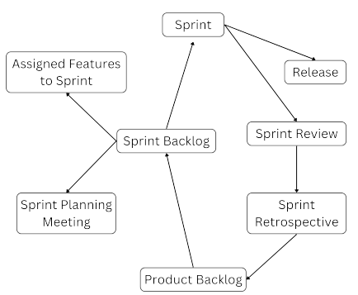Figure 3.1: Scrum Methodology
3.1.1 Requirement Analysis
Before commencing the development of "Timed - A Medication Reminder Applica tion", requirement gathering research was carried out extensively, as the program was intended to be functional and non-functional requirements.
Functional Requirements
The "Timed - A Medication Reminder Application" includes the following key func tional requirements.
1. User Login: Users must be able to securely log in to their accounts to access personalized medication schedules and settings.
14
2. Register Medicine Data: Users should be able to register detailed informa tion about their medications, including the name, time and date of the drug. This helps ensure that users are organized and on track with their prescribed treatment.
3. Receive Medication and Dosage Reminders: The application must send timely reminders to users that they should take the medications at the correct times and administer the correct dose. Users can choose to snooze or dismiss these reminders according to their preferences.
4. Appointment Scheduling and Reminders: Users can schedule medical ap pointments for check-ups or follow-ups within the app. The system will send timely reminders about upcoming appointments, ensuring that users don’t miss their scheduled visits.
5. Medicine Supply Notifications: The app will alert users when their med ication supply is running low. This feature helps users stay ahead of their medication needs and avoid running out of critical prescriptions.
15
Non-Functional Requirements
Various non-functional requirements have been analyzed and identified, which are outlined as follows:
• Performance: The app should send reminders quickly and handle many users at the same time without delays.
• Usability: The app should be easy to use, letting users set up their medication reminders quickly. It should also support features for people with accessibility needs, like screen readers.
• Reliability: The app should be available most of the time and include features to fix errors or recover from issues.
• Security: User data should be kept safe and private, using encryption and secure communication.
• Scalability: The app should be able to grow and handle more users as needed.
• Compatibility: The app should work well on both Android and iOS devices, including those with lower performance.
3.1.2 Feasibility Analysis
To ensure the successful development and implementation of the "Timed - A Medica tion Reminder Application," a thorough feasibility study was conducted. The study evaluated the project’s viability from technical, operational, economic, and scheduling perspectives, as outlined below:
Technical Feasibility Study
The project leverages modern, accessible technologies to ensure technical feasibility. Flutter is used for cross-platform development, providing seamless performance on both Android and iOS platforms. Firebase serves as the backend, offering reliable
16
cloud-based database storage and authentication services. The required programming tools, frameworks, and libraries are readily available and well-documented, ensuring that the technical requirements of the application can be met efficiently.
Operational Feasibility Study
The application is designed to be user-centric, focusing on simplicity and ease of use. Its intuitive User Interface (UI) allows users to manage medication schedules and appointments effortlessly, requiring only basic familiarity with smartphones. The system ensures accessibility for users with diverse technical skills, making it practical for patients managing chronic health conditions.
Economic Feasibility Study
Cost-effectiveness is a key factor in the project’s economic feasibility. By utilizing open-source tools like Flutter and Firebase, development costs are minimized while maintaining high-quality output. The system does not require any additional hard ware, as it operates seamlessly on existing smartphones. This approach reduces over head costs and ensures affordability for both developers and end-users.
Schedule Feasibility Study
The project has been planned meticulously to ensure timely completion within the scheduled timeframe. Each development phase, from research to deployment, is as signed specific durations to maintain focus and efficiency, reducing the risk of delays.
17
Task Name | Duration
Planning | 1 weeks
Requirement Analysis | 2 weeks
Design | 5 weeks
Development | 11 weeks
Testing and Debugging | 13 weeks

Table 3.1: Schedule of "Timed - A Medication Reminder Application" 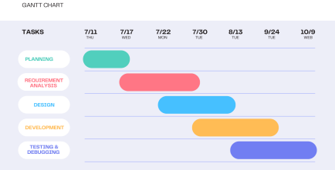Figure 3.2: Gantt Chart
18
3.1.3 System Modeling
The process of developing abstract models of a system, with each model presenting a different view or perspective of that system.
• Use Case Diagram:
A Use Case Diagram is a visual representation of the interactions between users (or actors) and a system.
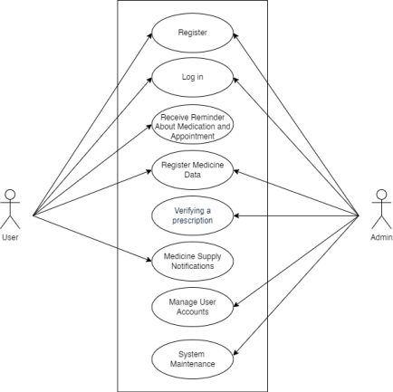Figure 3.3: Use Case Diagram of Medication Reminder Application
19
• Class Diagram:
A Class Diagram shows the system’s classes, their attributes, methods, and the relationships between them. It provides an overview of how the system is organized and how objects interact.
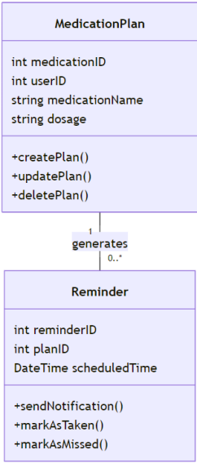
Figure 3.4: class Diagram of Medication Reminder Application 20
3.1.4 Dynamic modeling using State and Sequence Diagrams
The sequence diagram illustrates the interactions between system components, helping to visualize both current behavior and the requirements for new features.
• Sequence Diagram
sequence diagram visually represents how objects or components in the system interact over time. It helps to understand the flow of processes and the order in which operations occur. For the "Timed - A Medication Reminder Application," the sequence diagram would detail the sequence of actions between the user, the medication reminder system, and other system components.
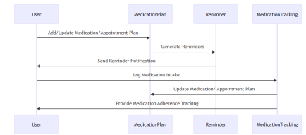Figure 3.5: Sequence Diagram of Reminder
3.1.5 Process modeling using Activity Diagrams
• Activity Diagram
An activity diagram represents the workflow of the system, showcasing the se quence of activities and decisions involved.
21
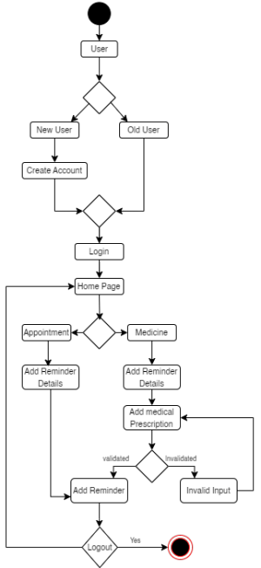Figure 3.6: Activity Diagram of Medication Reminder Application
22
Chapter 4
System Design
System design is a crucial phase in the software development process that involves defining the architecture, components, modules, and data flow of the system. It transforms the requirements gathered during the analysis phase into a blueprint for constructing the system. The design phase ensures that the system will be both effective and efficient in meeting its functional and non-functional requirements. It outlines how the system will be structured, how its components will interact, and how the data will flow throughout the system.
4.1 Refinement of Classes and Object
Initially, the identification and further refining of the essential classes will be consid ered in the object-oriented system design. These classes mainly represent entities of Timed - A Medication Reminder Application. They are designed from the functional requirements of the system.
23
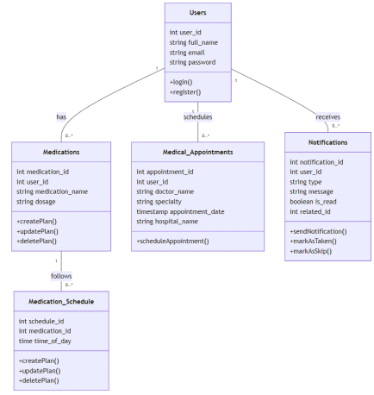Figure 4.1: class Diagram of Medication Reminder Application
4.2 Component Diagram
The Component Diagram illustrates the relationship between the various components of the system and how they interact with one another. It shows the high-level view of the system’s architecture from an object-oriented perspective.
24
i. Frontend Component:
Built with Flutter, this component provides an intuitive interface for managing re minders, viewing medication schedules, and handling notifications. It manages user interactions and communicates with the backend for data synchronization.
ii. Backend Component:
Implemented in Flutter, it handles the core functionalities like scheduling reminders, sending notifications, and processing user input locally.
iii. Database Component:
The Firebase Realtime Database, hosted in the cloud, handles all data storage and retrieval operations. The database ensures real-time synchronization between user devices, providing secure and efficient data management.
25
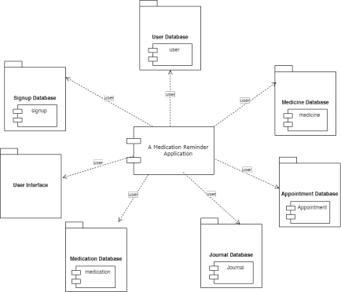Figure 4.2: Component diagram of A Medication Reminder Application
26
4.3 Deployment diagram
The Deployment Diagram describes the physical deployment of the system’s compo nents on hardware resources. It shows how the system’s software is distributed across various hardware nodes and how these nodes communicate with each other.
i. User Devices (Client-Side):
Users will access the Timed - A Medication Reminder application via their smart phones. The frontend and backend of the application run on these devices, developed using Flutter, providing an intuitive interface and managing all core functionalities.
ii. Database Server:
The Firebase Realtime Database is hosted in the cloud and handles all data storage and retrieval operations. It securely stores user profiles, medication schedules, and notification settings, ensuring real-time synchronization between user devices and the database.
27
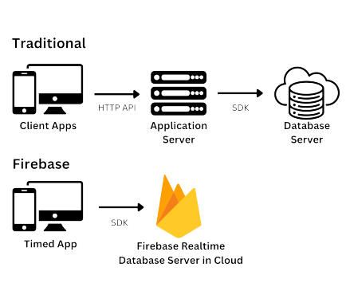Figure 4.3: Deployment diagram of A Medication Reminder Application
28
Chapter 5
Implementation and Testing
5.1 Implementation
The implementation of the Timed - A Medication Reminder Application project was carried out using a combination of integrated technologies for the user interface, back end logic, and a robust cloud-based database system. This section outlines the tools, technologies, and modules utilized to develop the application, including a detailed explanation of the implementation process for each module.
5.1.1 Tools Used
The following tools were used for the development and implementation of the "Timed A Medication Reminder Application":
• Flutter: A cross-platform framework used to build the mobile app for both iOS and Android platforms.
• Dart: The programming language used with Flutter for writing the app’s busi ness logic.
• Firebase: Provides backend services, including a real-time database for storing user data and cloud functions for handling notifications.
• Firebase Cloud Messaging (FCM): Used for sending push notifications to users for reminders on medication and appointments.
• GitHub: For version control and collaboration among the development team. 29
• Android Emulator / iOS Simulator: Used for testing the app across differ ent device configurations.
• Trello: A project management tool used for organizing tasks, tracking progress, and collaborating with the development team.
• Figma: A design tool used for creating user interface (UI) mockups and visual designs for the app.
5.1.2 Implementation Details of Modules
The "Timed" app is divided into several modules to ensure its scalability and main tainability:
• User Module: Manages user information, including medical history and med ication schedules.
• Medication Module: Defines medication details, including name, dosage, and frequency of intake.
• Reminder Module: Responsible for scheduling and sending notifications to the user at the correct times for medication and appointments.
• Appointment Module: Stores details of medical appointments, including the doctor’s name, date, time, and reason for the appointment.
• Health Journal Module : The Health Journal Module allows users to record their daily health data for future reference, including blood pressure and sugar levels.
• Schedule Module: Manages the scheduling of medications and appointments, triggering reminders at appropriate times.
30
5.2 Testing
Testing was performed to verify the functionality, usability, and performance of the Timed - A Medication Reminder Application. The following testing methodologies were employed:
5.2.1 Test Cases for Unit Testing
Unit testing happened to ensure correctness in single parts or components of the system. For each function, the expected output and edge-case handling were tested.
SN | Test Case | Input Data | Expected Outcome | Actual  Output | Remarks
1 | Login Page | Full Name: testing and password: testing | Invalid  username  or pass word | Invalid  username  or pass word | PASS
2 | Register | Full Name: testing Email: testgmail.com Password: test@T123 Repassword:  test@T123 | Invalid  email  address! | Invalid  email  address! | PASS
3 | Register | Full Name: testing Email:  test@gmail.com  Password: test  Repassword: test | Weak  password,  please  enter a strong  password | Weak  password,  please  enter a strong  password | PASS

31
4 | Register | Full Name: testing Email:  test@gmail.com  Password: test@T123 Repassword:  test@T123 | Account  created | Account  created | PASS
5 | Login Page | Email:  test@gmail.com  Password: test@T123 | Redirect to the Home page | Redirect to the Home page | PASS
6 | Medicine  Add Page | Unit: Mylod5  How Often: Once daily  Time: 8:00 AM  Quantity: 5 pill(s) | Medication reminder  added suc cessfully | Medication reminder  added suc cessfully | PASS
7 | Add Ap pointment | Hospital Name: om hospital  Appointment Name: eye check  Date: Dec 1, 2024 | Reminder  added suc cessfully | Reminder  added suc cessfully | PASS
8 | Change  Password | Current Password: test@T123  New Password: TEST@t1234  Confirm Password: TEST@t1234 | change  password  success  fully | change  password  success  fully | PASS
9 | Home | Take medicine | Number of medicine  decrease | Number of medicine  decrease | PASS
10 | Logout | Are you sure you want to log out: Logout | Redirect to the Login Page | Redirect to the Login Page | PASS

32
11 | Logout | Are you sure you want to log out: Cancel | Redirect to the Profile Page | Redirect to the Profile Page | PASS

Table 5.2: Test Cases for Unit Testing
33
5.2.2 Test Cases for System Testing
The testing of an entire system was done with evaluating the full system by deter mining if all the components are functional together.
SN | Types of Test | Description
1 | End-to-End Test | Simulate the entire user journey from signing up for the service, setting up medication reminders, viewing reminders, and being given notifications. The user was able to register, set reminders, and receive notifications without errors.
2 | Performance Test | Evaluate how quickly the system can respond to multiple users setting and sending reminders at the same time.  The system performed well with minimal latency.
3 | Notification Test | Test the reliability of sending medication and ap pointment reminders on time.  All notifications were received accurately and on time.
4 | Usability Test | Verify that the user interface is intuitive and user friendly.  The platform provided easy navigation, and acces sibility for all users, including elderly patients.

Table 5.4: Test Cases for System Testing
34
5.3 Result Analysis
The testing phase revealed that the "Timed-A Medication Reminder Application" app functions as expected across all modules. Unit tests passed successfully for individual components such as medication scheduling, user data management, and appointment reminders. System tests confirmed that the app’s modules interact seamlessly, with notifications triggered accurately and user data syncing properly between local and cloud databases. Performance testing showed that the app performs well on both Android and iOS devices, with minimal lag or delays in loading.
Overall, the app performed well during testing and is ready for deployment after minor optimizations based on user feedback.
35
Chapter 6
Conclusion and Future
Recommendations
6.1 Conclusion
"Timed-A Medication Reminder Application" is aimed at improving the manage ment of medication adherence among patients with chronic diseases such as diabetes and hypertension. Medication non-adherence is a significant problem affecting older adults and middle-aged patients across the world. By providing timely reminders for medication and medical appointments, "Timed-A Medication Reminder Application" empowers individuals to take control of their health. The easy-to-use interface helping to address a common issue and reducing hospital visits and associated costs. The app also enhances patient autonomy, enabling users to manage their medication schedules independently and efficiently.
However, despite its promising features, "Timed-A Medication Reminder Application" still faces several challenges. These include issues related to access to technology, user compliance, data security concerns, and device limitations. Not all users may have access to the necessary devices or reliable internet connections, particularly in un derprivileged regions. Furthermore, ensuring that users remain consistent with their medication adherence requires continuous user engagement and motivation. Security concerns regarding user data, especially sensitive health information, must also be addressed through robust encryption and secure data storage mechanisms. Addition ally, device limitations, such as varying operating system versions and screen sizes,
36
may affect the app’s performance and user experience.
6.2 Future Recommendations
To improve the app and address these challenges, future work could focus on:
• Improved User Engagement: Incorporating features such as gamification, reminders for missed doses, and incentives for consistent medication adherence can motivate users to maintain their schedules.
• Accessibility and Inclusivity: Expanding the app’s reach to users with lim ited access to smartphones or the internet by offering offline capabilities or compatibility with low-cost devices.
• Data Security Enhancements: Strengthening data protection by implement ing end-to-end encryption and complying with healthcare data protection reg ulations to ensure user confidentiality.
• Platform Optimization: Ensuring the app is compatible with a wide range of devices and operating systems, providing a smooth user experience across different screen sizes and configurations.
• Integration with Healthcare Systems: Future versions of the app could integrate with electronic health records (EHR) systems, allowing healthcare providers to monitor patient adherence and make adjustments to treatment plans as needed.
In conclusion, while "Timed- A Medication Reminder Application" demonstrates sig nificant potential to improve medication adherence and enhance the quality of life for patients with chronic conditions, continuous improvements and adjustments are necessary to make the app more accessible, secure, and engaging. With the right modifications, "Timed-A Medication Reminder Application" can achieve its goal of helping patients with hypertension, diabetes, and other chronic diseases manage their medication schedules more effectively, leading to better health outcomes and reduced healthcare costs.
37
References
[1] B. Aggarwal, A. Pender, L. Mosca, and H. Mochari-Greenberger. Factors associ ated with medication adherence among heart failure patients and their caregivers. Journal of Nursing Education and Practice, 5(3):22–27, 2015.
[2] Deepti Ameta, Kalpana Mudaliar, and Palak Patel. Medication reminder and healthcare – an android application. International Journal of Managing Public Sector Information and Communication Technologies, 6:39–48, 06 2015.
[3] S. Balakrishnan, I. Karmacharya, S. Ghimire, S. K. Mistry, D. R. Singh, O. P. Yadav, N. Gudi, L. B. Rawal, and U. N. Yadav. Prevalence of multimorbidity and its correlates among older adults in eastern nepal. BMC Geriatrics, 22(1):425, 2022.
[4] Lindsey Dayer, Seth Heldenbrand, Paul Anderson, Paul O. Gubbins, and Bradley C. Martin. Smartphone medication adherence apps: Potential bene fits to patients and providers. Journal of the American Pharmacists Association, 53(2):172–181, 2013.
[5] R Govindani, A Sharma, N Patel, and et al. Assessment of medication adherence among patients with hypertension and diabetes mellitus in a tertiary healthcare center: A descriptive study. Cureus, 16(6):e63126, June 2024.
[6] Prafful Naikode, Poojal Pithwa, and Lakshita Landge. Med-x, medicine reminder app. International Journal of Research Publication and Reviews, 2(11):1196– 1199, 2021.
[7] Daniel Y Park, Elizabeth M Goering, Katharine J Head, and Rebecca J Bartlett Ellis. Implications for training on smartphone medication reminder app
38
use by adults with chronic conditions: Pilot study applying the technology ac ceptance model. JMIR Formativ Res, 1(1):e5, Nov 2017.
[8] Ms. S. A. Patil, Ms. Monika Bhanuse, Ms. Snehal Mali, and Ms. Vishaka Swami. Review on mobile application for medicine reminder. International Journal of Research Publication and Reviews, 2(6):213–216, 2021.
[9] K. Santo, C. K. Chow, A. Thiagalingam, K. Rogers, J. Chalmers, and J. Redfern. Medication reminder apps to improve medication adherence in coronary heart disease (medapp-chd) study: a randomised controlled trial protocol. BMJ Open, 7(10):e017540, 2017.
[10] John K. Zao, Mei Ying Wang, Peihsuan Tsai, and Jane W.S. Liu. Smart phone based medicine in-take scheduler, reminder and monitor. In 12th IEEE Interna tional Conference on e-Health Networking, Application and Services, Healthcom 2010, 12th IEEE International Conference on e-Health Networking, Application and Services, Healthcom 2010, pages 162–168, United States, 2010. IEEE Com puter Society.
[11] Nor Saradatul Akmar Zulkifli, Liew Yoon Hong, Nor Syahidatul Nadiah Ismail, Mohd Zamri Bin Osman, and Anis Farihan Mat Raffei. Ela remind: A medicine box reminder system for elderly living alone (ela) implementing the infrared sen sor, internet of things and mobile application. 2022 4th International Conference on Smart Sensors and Application (ICSSA), pages 144–149, 2022.
39
Appendices
6.3 Firebase Schema
Users Collection
The ‘users‘ collection stores user account details.
• Document Structure:
{
"Full name": "ram rai",
"email address": "abc@example.com",
"password": "hashed_password",
"conform password": "hashed_password",
}
• Fields:
– full name: Full name of the user.
– email: Email address of the user.
– password: Hashed password for authentication.
– conform password: conform Hashed password for authentication. 40
6.4 Design Mockups
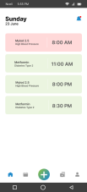Figure 6.1: Home Page Figure 6.2: Landing Page
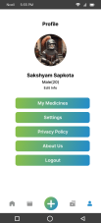
Figure 6.3: Profile Page
41

