Name: Raj jaiswal  
PID:191049  
Roll No.760  
Class & Batch:TE/IT/B  
Subject: IP Lab  
Date of Conduction: 22/07/2021  
Date of Submission: 24/07/2021  
  
 **EXPERIMENT 1**  
**Aim:**To design a personal profile using HTML5  
  
**Code:**

<!DOCTYPE html>

<html>

<head>

<title>Personal profile</title>

<head>

<body bgcolor="red">

<h1 align=center>PERSONAL PROFILE</h1>

<hr>

<center><img src="image.jpeg" width="350" height="200"></center>

<pre><i><h2>

Work hard

<h2></i></pre>

<br>

<hr>

<pre>

<b>NAME: Raj Jaiswal</b>

<b>MOB NO: 8433686978</b>

<b>COLLEGE:</b> ST. FRANCIS INSTITUTE OF TECHNOLOGY

</pre>

<br>

<b><p>Hobbies:</p></b>

<ol>

<li>PLAYING CRICKET</li>

<li>WORKOUT</li>

</ol>

<br>

<p><b>Academic qualifications:</b></p>

<table border=1>

<tr>

<th>EXAM</th>

<th>SCORE</th>

</tr>

<tr>

<td>SSC</td>

<td>75.60%</td>

</tr>

<tr>

<td>HSC</td>

<td>80.04%</td>

</tr>

<tr>

<td>SEM 1</td>

<td>8.28</td>

</tr>

<tr>

<td>SEM 2</td>

<td>8.17</td>

</tr>

<tr>

<td>SEM 3</td>

<td>8.10</td>

</tr>

<tr>

<td>SEM 4</td>

<td>8.58</td>

</tr>

<br>

</body>

</html>

**Output:** 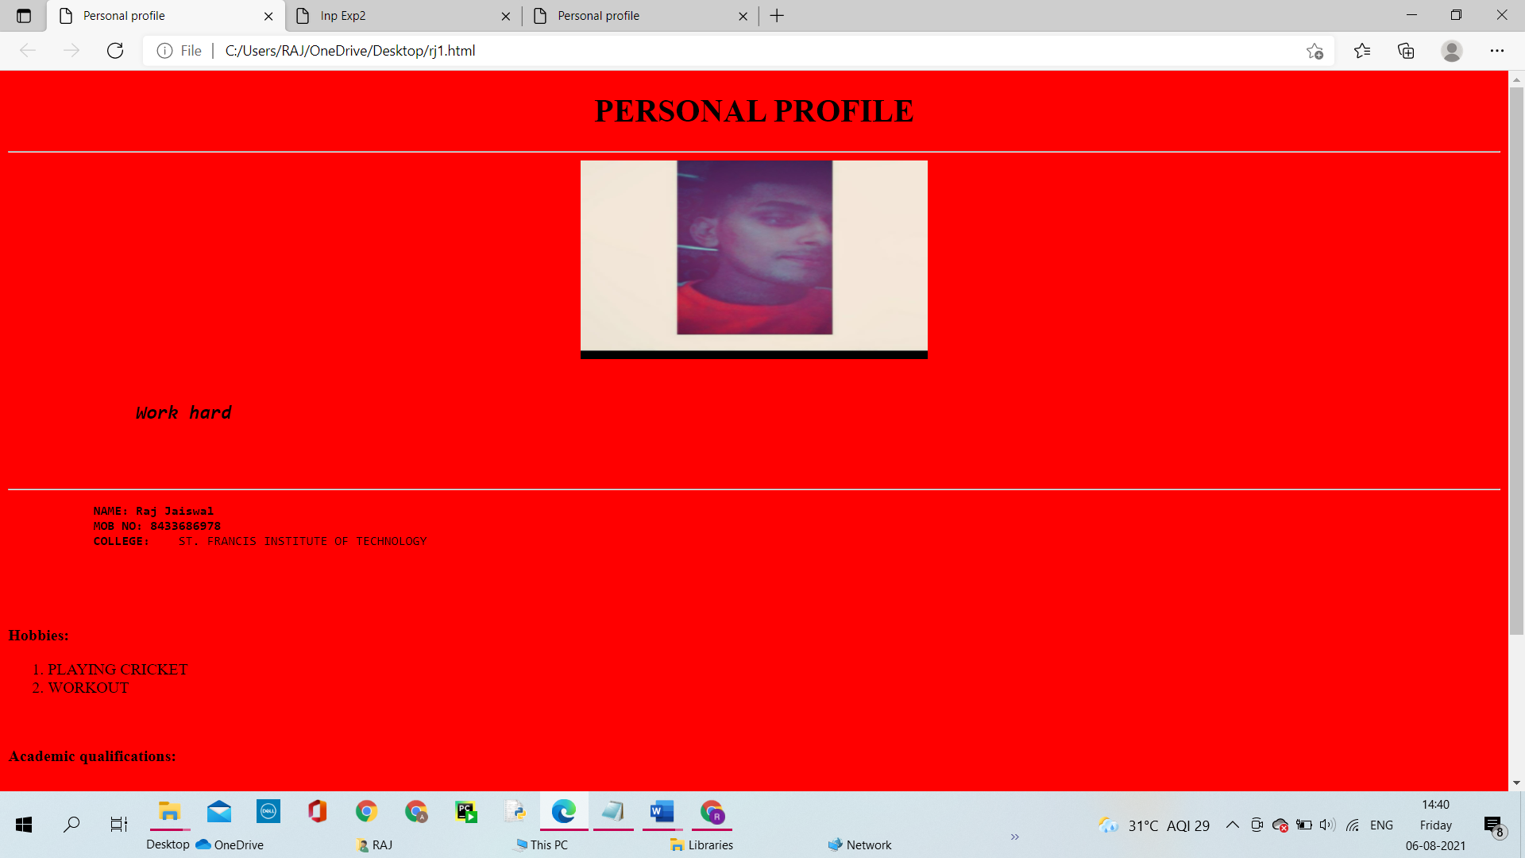

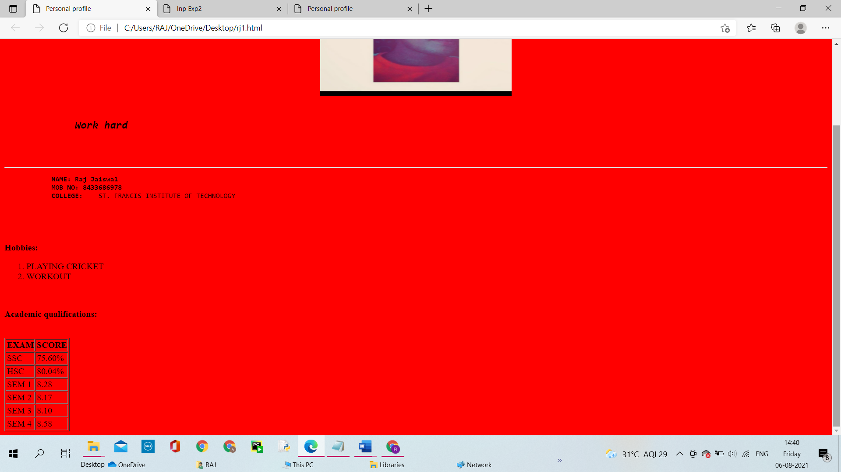

**Conclusion: 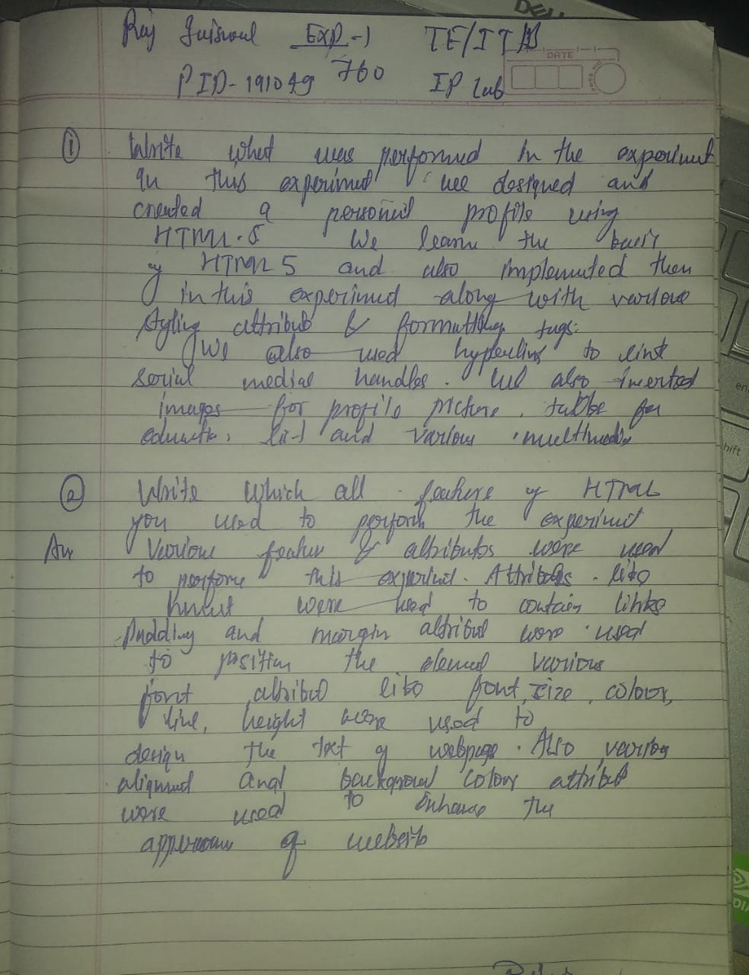**

**RAJ JAISWAL**

**TE/IT/B ROLL NO:760**