**EXPERIMENT NO 5**

**D15A-37**

**SOURCE CODE:**

server.js

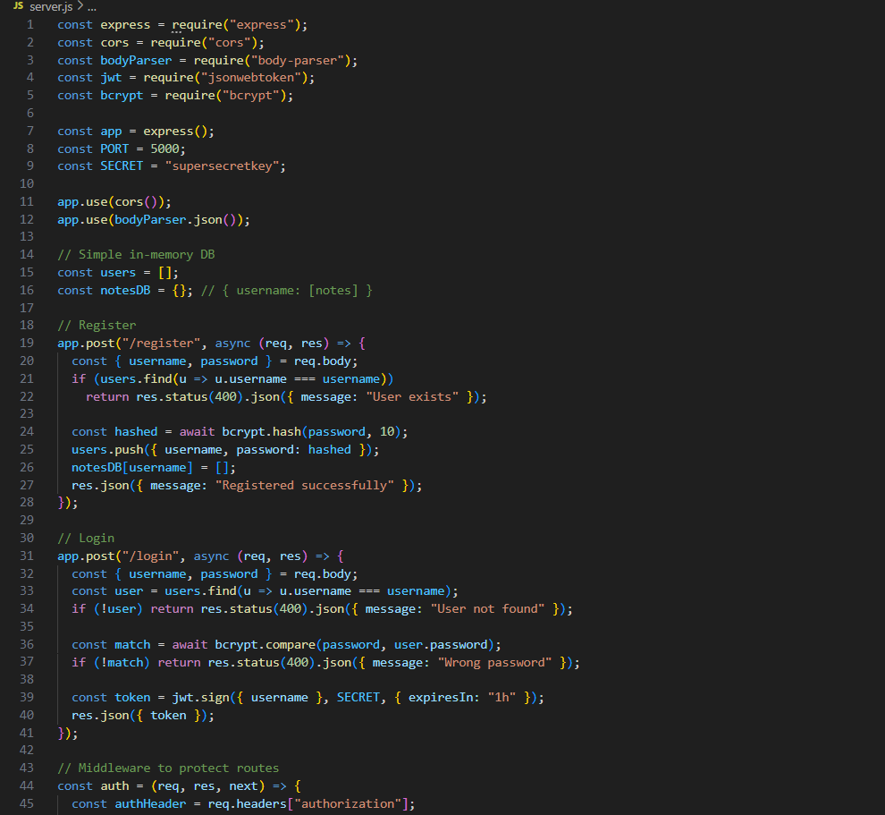

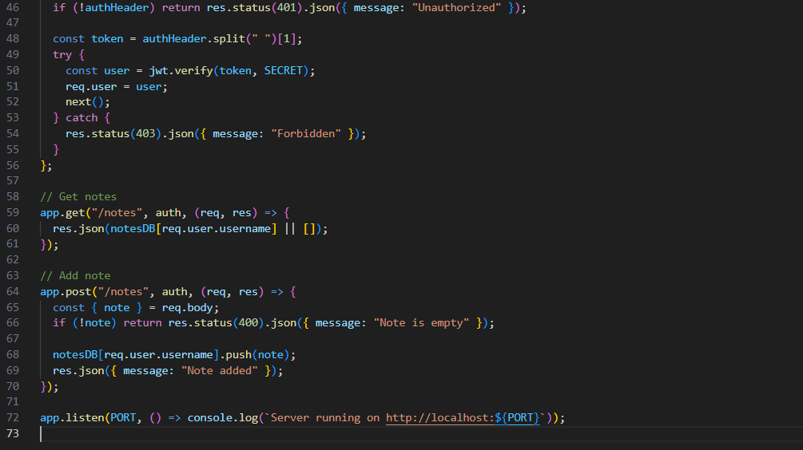

Frontend

AuthContext.js

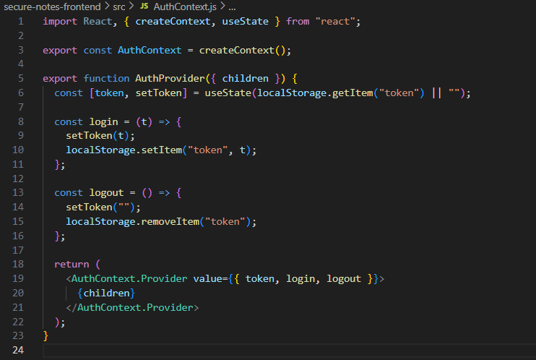

App.js

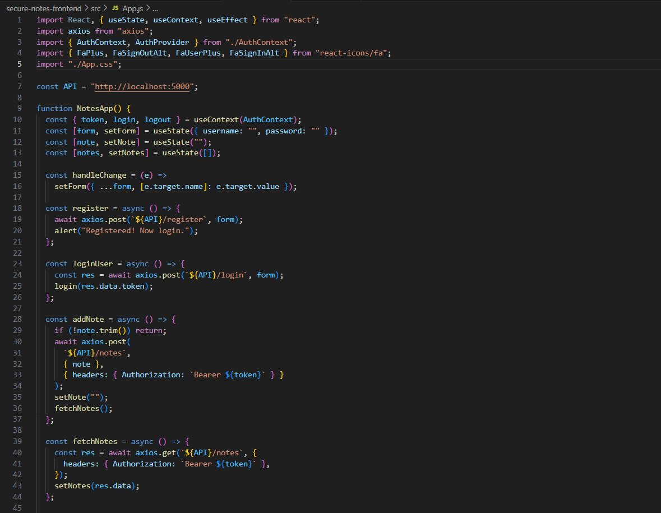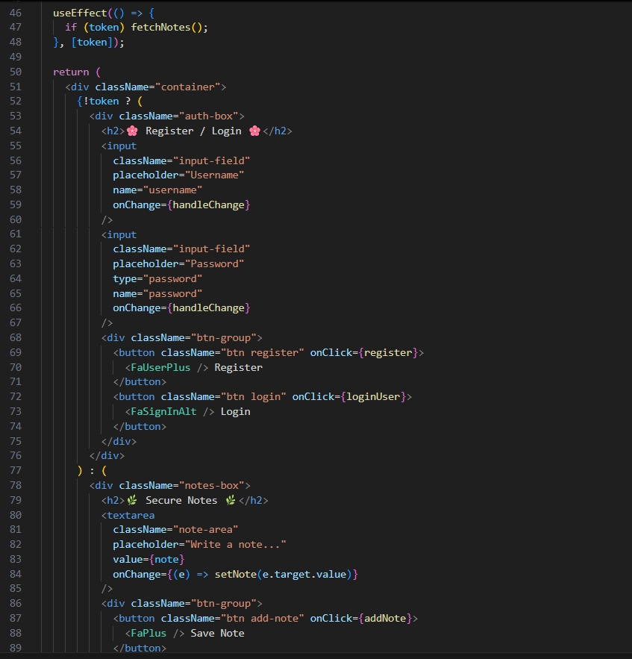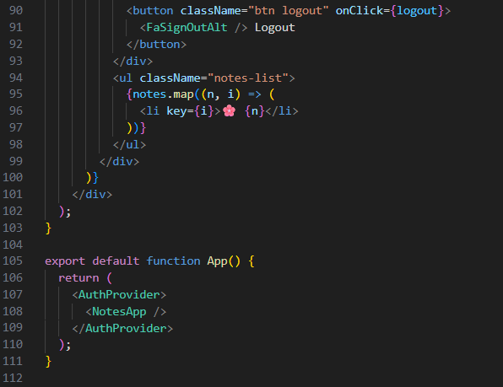

EXTRA 30%

Password hashing



Local storage

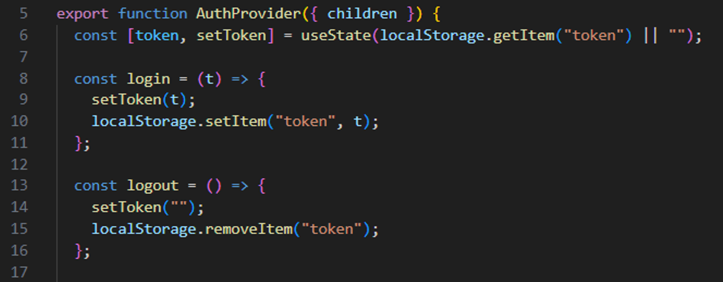

**OUTPUT:**

|  |
| --- |
|  |

**FIGURE 1: SecureNotes Login/ Registration page**

|  |
| --- |
|  |

**FIGURE 2: After registering successfully on the website**

|  |
| --- |
|  |

**FIGURE 3: After logging in, user can create their secure notes**

|  |
| --- |
|  |

**FIGURE 4: User types in their notes**

|  |
| --- |
|  |

**FIGURE 5: After clicking on save note, the notes get logged**