Accuracy - confidence

* Accuracy and confidence (calibration?) across information stages
* Does information seeking affect accuracy/confidence?
  + Information value
  + Information amount
* Does differential generation affect accuracy/confidence?
  + Initial Differentials
  + Differential Change
* Does reasoning strategy affect accuracy/confidence?

ANALYSIS TO DO

* Redo diagnostic score so it can be calculated for t2diagnoses + takes likelihoods into account more directly (does not penalise fewer diagnoses)
* VR: clear test of analyses - is confidence/accuracy a result of information seeking amount and differential change? VR history value before pause and calls for help
* Compute most used strategy for participants – can then do individual difference correlations
* Classification of high and low diagnosis score – trained classifier on PCA components of information seeking
* Linear model – stage and information seeking for confidence at each stage? (confidence ~ stage*infoamount)

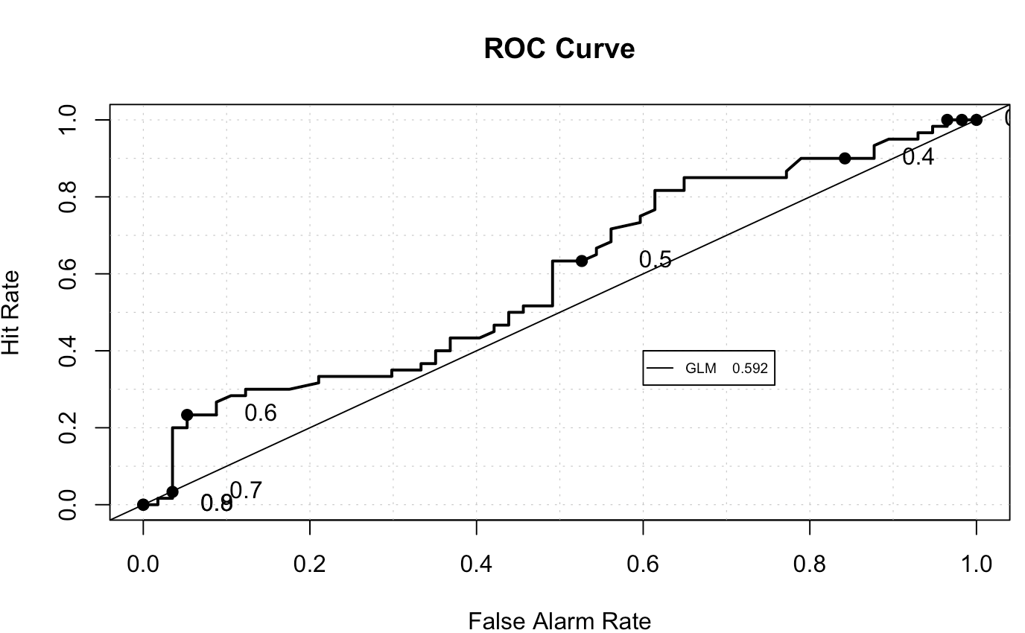

(check test conducted to get p value to compare to AUC = 0.5)

**Measure of information amount and value: by stage, pause point or overall?**

**Change in confidence  
Initial differentials / Change in differentials**

**Accuracy: Diagnostic Score**

* + - **Denominator: sum all likelihood values**
    - **Numerator: sum all likelihood values for likely/probably differentials, half of likelihood for improbable.**

**Performance: OMS Score**

**Time to call for help**

**ONLINE STUDY FINDINGS (to replicate):**

Initial Diagnostic Breadth Predicts Information Seeking and Confidence Change

**NO**

Amount of Information Seeking Predicted Changes in Confidence

**NO**

Participants with Higher Diagnostic Ability Sought More Useful Information

**ONLY WITH HISTORY VALUE**

**BUT: relationship between initial diagnostic score (and number of diagnoses) and OMS Score**

**VR FINDINGS:**

Confidence increases and differentials decrease over the course of the scenario

Participants give more appropriate sets of diagnoses when seeking better/more history?

**r(115)  = 0.214, p = .02**

Participants are more confident when seeking more/better history? **(Can’t see much connection between information seeking amount and confidence except between testing and t1confidence but not other actions, negative relationship between initial confidence and history taking value)**

But participants who are more confident do not necessarily give more suitable diagnoses **(YES)**

Participants report lower differentials early on tend to seek less information afterwards, form of premature closure **(NO) (we do see this in the online study studentAggData$meanInitialDiffs and studentAggData$laterPropOfInfo, t = 2.6421, r  = .28, df = 83, p-value = 0.009846)**

Participants ask for help quicker for more severe cases, but can be delayed by taking too much history **(YES)**

**Time to calls for help is:**

* **Quicker for more confidence**
* **Quicker for more severe cases**

