**Market Segmentation Analysis (EV) Market**

**Fermi Estimation**

Analysis and behavioral study of which country's population is suitable for buying EV vehicles? Are the youth generation capable or only the people with high income?

Can a middle-class person buy an Electronic Vehicle?

**Data Pre-Processing**

It describes the processes of preparing data for analysis by cleansing, converting, and integrating it. Data preparation aims to raise the data's quality and suitability for the intended output.

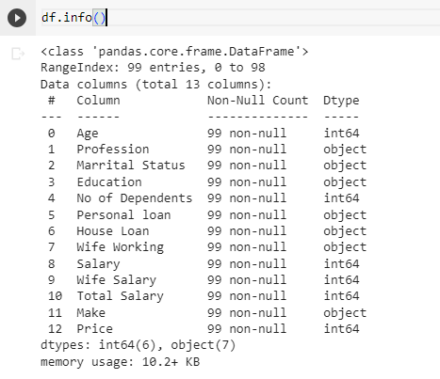

**K-Means Clustering**

One of the most popular methods for gaining a general understanding of the data's structure is clustering. It can be summed up as the process of finding data subgroups where data points in the same subgroup (cluster) are extremely similar and other data points in other clusters are very dissimilar. To put it another way, we look for homogeneous subgroups within the data so that the data points in each cluster are as comparable as feasible based on a similarity metric like the Euclidean distance or the correlation-based distance.

The iterative K Means technique seeks to divide the dataset into clusters (pre-defined unique, non-overlapping groupings) where each data point only belongs to one group. It seeks to improve the



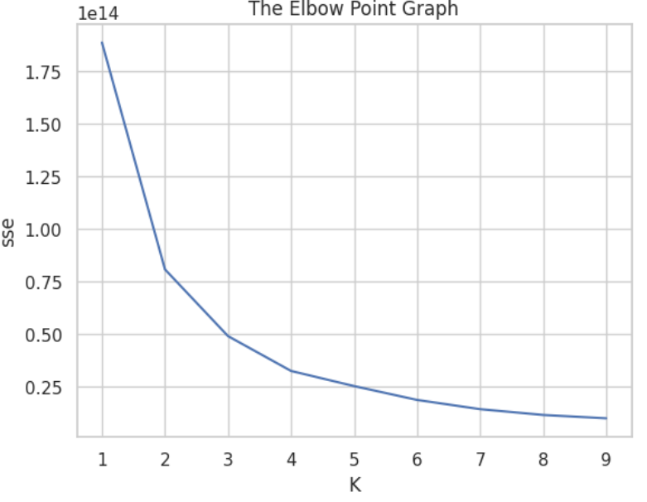

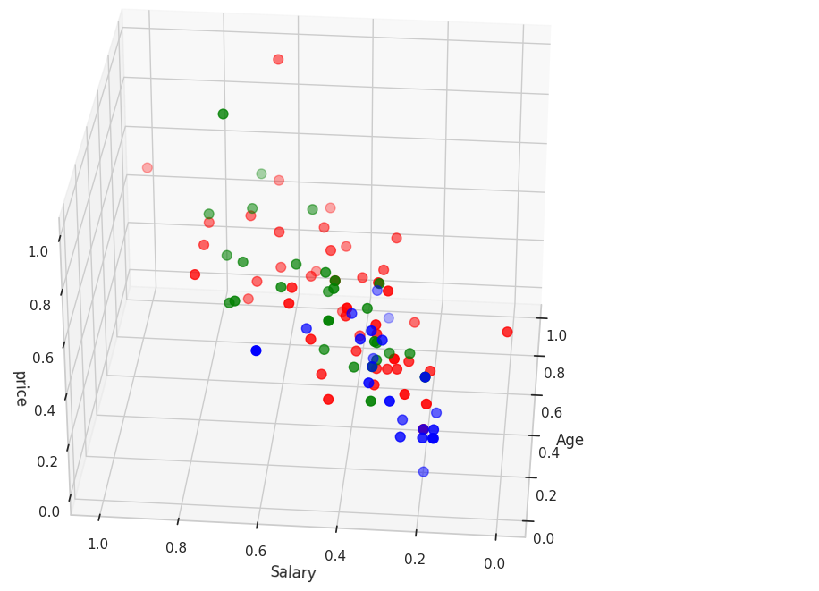

Observations:

We found that 3 cluster groups can be formed from the data given (based on

the price of the vehicle) using the K-Means algorithm and Elbow Point Method

• While looking at the patterns, we find that as the Age increases the cost of the

vehicle also rises.

• Also, the amount spent on the car goes up with the number of dependents. The

same is true for the salary field too.

• The visualizations provided give a clear idea about the patterns.

**Conclusion:**

Older folks with greater salaries typically purchase vehicles between $10 and $20,000. However, the sudden increase in younger demographics' knowledge about climate change has an impact on their choice to purchase electric vehicles. The mid-tier is therefore the suggested market niche, and extensive marketing about the benefits of electric vehicles for the environment is needed.