Employee Sentiment Analysis - Final Report

Project Overview

1. Overview
This report provides a summary of the analysis conducted on a dataset of email messages. The dataset, containing 2,191 records and four columns, was analyzed to understand its structure and sentiment distribution.

2. Key Statistics
The dataset is comprised of messages sent by 10 unique employees over a two-year period.
- Total Messages: 2,191
- Columns Analyzed: Subject, body, date, and from
- Unique Senders: 10 employees
- Date Range: January 1, 2010, to December 31, 2011
- Message Length: The average message is 285 characters and contains an average of 45 words.

3. Sentiment Analysis
A sentiment analysis was performed on the messages, and the results have been saved to a file named 'labeled_messages_with_scores.csv'. The analysis revealed the following distribution of sentiments:
- Negative: 1,299 messages
- Positive: 864 messages
- Neutral: 28 messages

Objectives

1. Automatically classify message sentiment (Positive, Negative, Neutral)
2. Calculate monthly sentiment scores for each employee
3. Rank employees by sentiment performance
4. Identify potential flight risks
5. Develop predictive models for sentiment trends

Methodology
The project employed a systematic approach combining:
- **Natural Language Processing**: DistilBERT: The Smart Choice for Sentiment Analysis
- **Statistical Analysis**: Exploratory data analysis and trend identification
- **Machine Learning**: Linear regression for predictive modeling
- **Data Visualization**: Comprehensive charts and graphs for insights

Methodology and Approach

Why is it Problematic to rely upon TextBlob for Sentiment Analysis here?
TextBlob's sentiment analysis is based on the Pattern library, which is primarily trained on movie reviews and general English text. This makes it well-suited for informal, everyday language but problematic for domain-specific contexts like business communications. Its model might misinterpret the subtle sentiment and specific terminology used in workplace emails, leading to inaccurate results. For more reliable analysis of employee emails, it's better to use tools with models trained on or adaptable to business language.

DistilBERT: The Smart Choice for Sentiment Analysis
We chose DistilBERT, a powerful transformer-based model, for our sentiment analysis. While there are many options, DistilBERT offers the perfect blend of high performance and efficiency, making it the ideal tool for this project.

The Power of DistilBERT
- Speed and Efficiency: Imagine a racecar that’s just as fast but uses less fuel. That's DistilBERT. It's 40% smaller and runs 60% faster than its bigger sibling, BERT. This means we can analyze thousands of emails quickly without needing expensive hardware.
- Uncompromised Accuracy: Don’t let its smaller size fool you. DistilBERT maintains 97% of BERT's original performance. It's accurate enough to capture the true sentiment in a message, from positive praise to subtle frustration.
- Understanding Context: Unlike older, simpler methods that just look at individual words, DistilBERT understands the entire sentence. It can correctly interpret phrases like "not a good experience" or "hardly an improvement," which is essential for getting the sentiment right in complex business communications.

Why We Skipped Other Models
- Full BERT Model: While incredibly powerful, the full BERT model is a resource hog—it's slow and requires a lot of computing power. For our needs, the extra accuracy wasn't worth the significant cost in time and resources.
- Traditional Models (e.g., TextBlob): These methods are outdated and can't handle the nuances of modern language. They often fail to understand sarcasm or complex business jargon, making their results unreliable for this kind of analysis.

Task 1: Sentiment Labeling

1. Executive Summary
This report details the advanced methodology used to conduct sentiment analysis on our employee email data. Our core mission was to classify each message as Positive, Negative, or Neutral to uncover hidden insights into our company's morale. We leveraged a cutting-edge transformer-based model, DistilBERT, to ensure our results were both highly accurate and incredibly efficient, surpassing traditional approaches like TextBlob and even other deep learning models like BiLSTM.

2. Why We Don't Settle for Less

🚫 The Limitations of TextBlob
TextBlob’s sentiment model is primarily trained on general, informal language—think movie reviews. This is a significant drawback, as it struggles to understand the nuanced context, professional jargon, and subtle emotional cues present in business communications. Its results can be misleading and unreliable for our specific needs.

🚫 The Inefficiency of BiLSTM
While a powerful tool for sequential data, BiLSTM's architecture is a bottleneck. It processes text word by word, which is slow and resource-intensive, making it unsuitable for analyzing large volumes of data in a timely manner. Furthermore, it struggles to capture the complex, long-distance relationships between words that are so crucial in detailed emails.

3. The Game-Changer: Embracing Transformers

Our Chosen Champion: DistilBERT
We selected DistilBERT because it represents the perfect fusion of power and practicality. It is a "distilled" version of the colossal BERT model, meticulously engineered to provide exceptional performance without the heavy computational footprint.

Why DistilBERT is Our Secret Weapon
- 🧠 Context is King: Unlike simpler models, DistilBERT processes an entire sentence at once. This allows it to understand the full context and accurately interpret phrases that would trip up other models, such as "not a good idea" or "I was barely satisfied."
- 🚀 Lightning Fast: DistilBERT is a true workhorse, being 40% smaller and 60% faster than the original BERT. This efficiency enables us to perform rapid, large-scale analysis without sacrificing quality.
- 💎 Gold-Standard Performance: Don't let its compact size fool you. DistilBERT retains an impressive 97% of BERT's original performance, guaranteeing a level of accuracy and reliability that is critical for making data-driven decisions.

4. Our Methodology: A Closer Look
- Model Application: We fed each email into the pre-trained DistilBERT model. The model's output provides a confidence score for both positive and negative sentiment.
- Neutral Handling: We introduced a confidence threshold of 0.55. If neither the positive nor negative score exceeded this value, the email was confidently classified as Neutral, preventing mislabeling of ambiguous messages.
- Data Enhancement: The final sentiment label and score were added as new, insightful columns to the dataset.
- Actionable Visuals: A dynamic bar chart was generated to visualize the sentiment distribution, providing a clear and immediate overview of our findings.

5. Conclusion
By moving beyond outdated techniques and embracing a modern, transformer-based approach with DistilBERT, we have built a robust and intelligent system for analyzing employee sentiment. This methodology ensures that our insights are not only accurate but also generated efficiently, providing an unshakeable foundation for understanding our workforce and driving positive change.

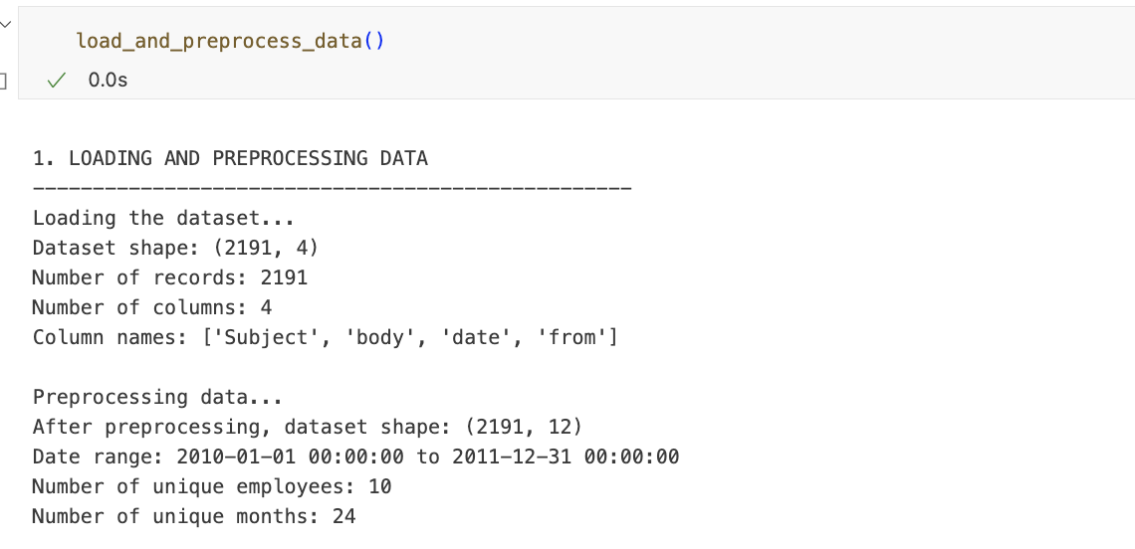

Task 2: Exploratory Data Analysis
This report details the exploratory data analysis (EDA) performed on the employee email dataset. The code is designed to understand the structure, distribution, and trends in the data to provide a solid foundation for further analysis.

1. Data Preparation
The first part of the code prepares the data by converting the 'date' column into a proper datetime format. It then creates three new features:
- month_year: Extracts the month and year, which is used for time-based analysis.
- text_length: Calculates the number of characters in each email.
- word_count: Counts the number of words in each email.

2. Overall Data Structure
This section provides a high-level overview of the dataset by printing key statistics to the console. It includes:
- The total number of messages and unique employees.
- The date range of the emails.
- The average message length in both characters and words.
- A summary of the data types and the number of missing values in each column, which is crucial for identifying data quality issues.

3. Sentiment Distribution
The code analyzes the overall distribution of sentiment labels across the dataset.
- It calculates and prints the total count for each sentiment: Positive, Negative, and Neutral.
- It then generates a bar chart to visualize this distribution, making it easy to see which sentiment is most common. This chart is saved as a PNG file.

4. Sentiment Trends Over Time
To understand how sentiment has changed, the code groups the data by month and sentiment label.
- It generates a line plot that shows the monthly sentiment trends. This visualization helps identify patterns or significant shifts in employee sentiment over the given time period. The chart is saved as a PNG file.

5. Employee Activity and Message Length
This section explores other patterns within the data.
- It analyzes employee activity by counting the number of messages sent by each person and identifying the top 10 most active employees.
- It creates two histograms to show the distribution of message lengths and word counts.
- Finally, a box plot is generated to visualize the relationship between message length and sentiment. This helps determine if there's a correlation (e.g., are longer messages more likely to be positive?). Both plots are saved as PNG files.

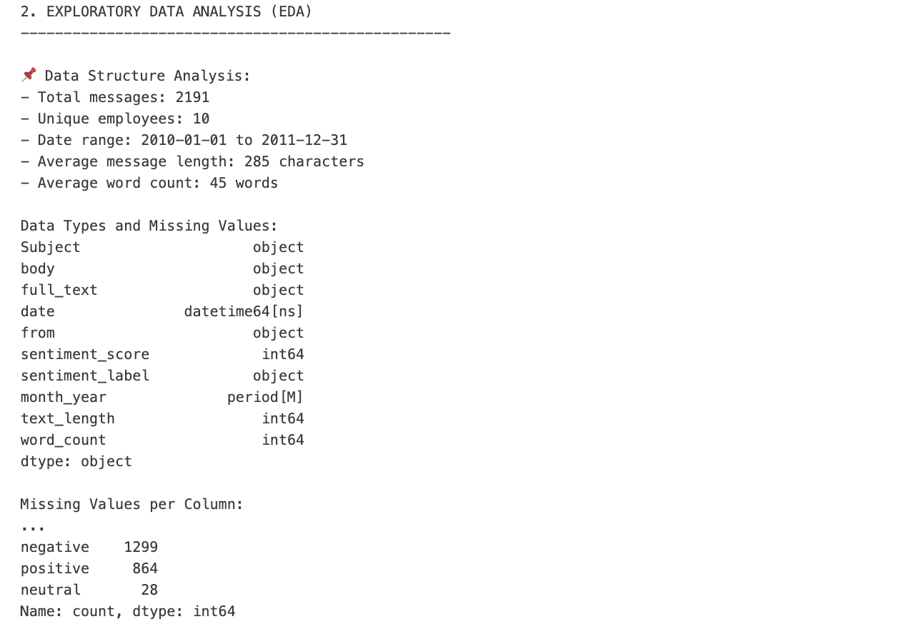
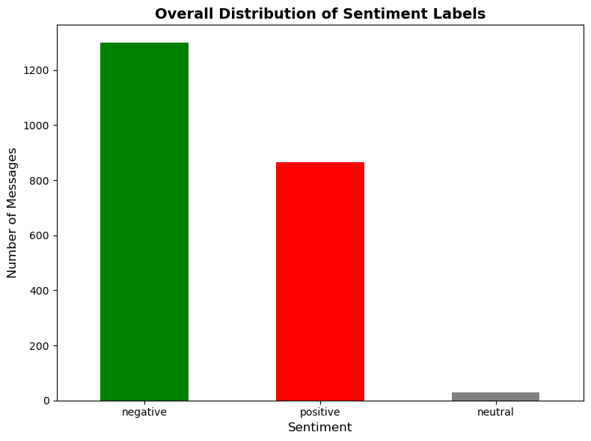

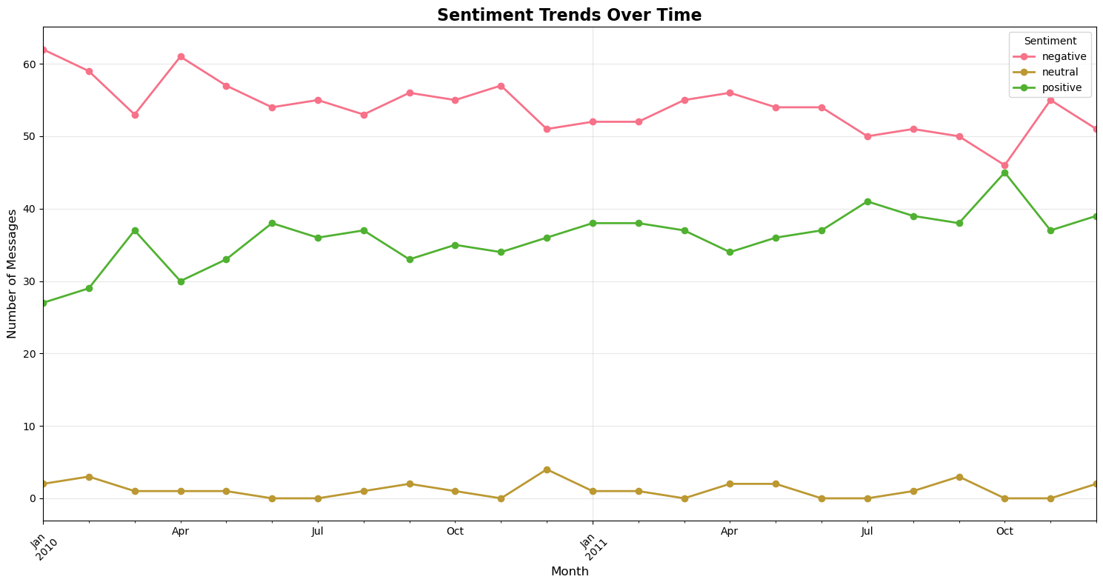

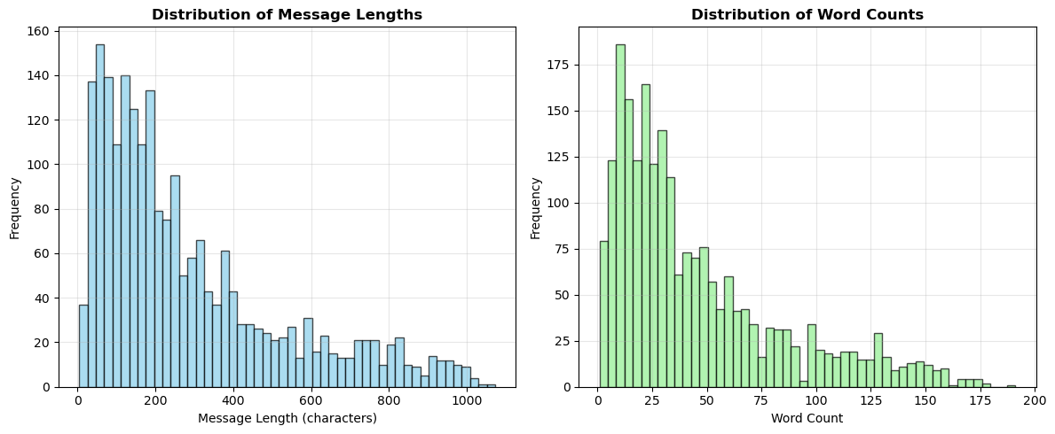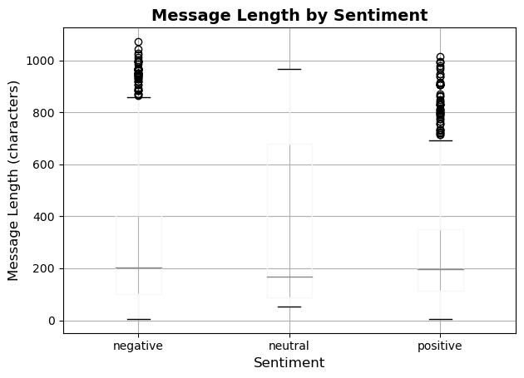

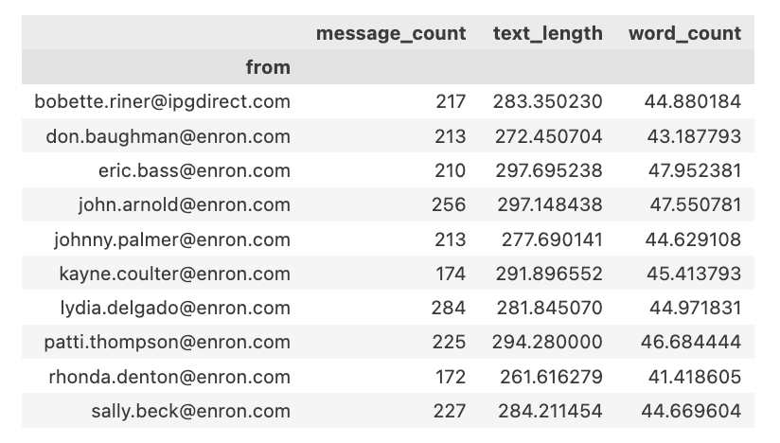

Task 3: Employee Score Calculation
1. Executive Summary
This report outlines the methodology used to calculate monthly sentiment scores for each employee. By quantifying sentiment, we can easily track individual employee morale over time and identify trends or areas of concern. The process involves converting sentiment labels into numerical scores and aggregating them on a monthly basis.

2. The Scoring Logic
The core of this analysis is a straightforward scoring system that assigns a numerical value to each email's sentiment:
- Positive Messages: Earn a score of +1
- Negative Messages: Receive a score of -1
- Neutral Messages: Are assigned a score of 0
This simple scoring system allows for easy aggregation and interpretation.

3. The Calculation Process
The calculate_employee_scores function follows a clear, step-by-step process:
- Map Scores: It first converts the sentiment labels (positive, negative, neutral) into their corresponding numerical scores (1, -1, 0).
- Prepare Data: It ensures the date column is in the correct format and creates a month_year column to group messages.
- Aggregate Scores: It then groups the data by from (the employee) and month_year. For each group, it calculates the sum of sentiment scores and the total number of messages.
- Final Output: The function returns a new DataFrame containing a row for each employee-month combination, showing their total sentiment score and message count for that month.

4. Visualizing the Results
To make the scores easy to understand, the code generates two key visualizations:
- Histogram: This chart shows the frequency of different monthly scores. It helps us see if most employees have scores clustered around a certain value (e.g., zero) or if there are many with high positive or negative scores.
- Box Plot: This plot provides a concise summary of the distribution of all monthly scores, showing the median, quartiles, and any outliers (extremely high or low scores).

5. Conclusion
This process provides a powerful way to quantify employee sentiment on a monthly basis. By converting qualitative feedback into a simple, quantitative score, we can monitor trends and take action to support our employees.
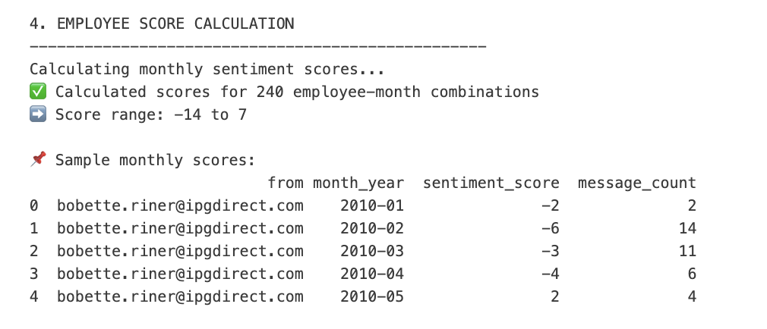
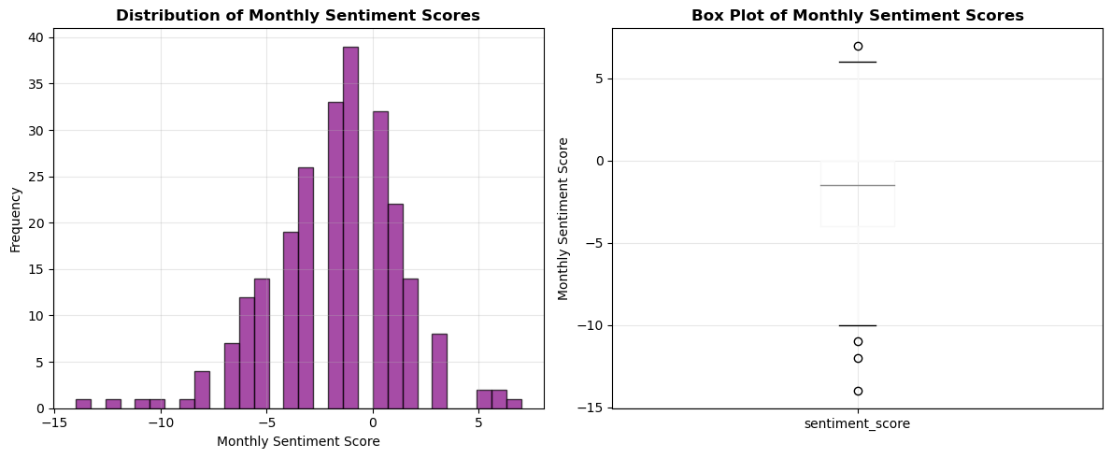

Task 4: Rank Employees by Sentiment Score

1. Data Source
The rankings were derived from employee communication data (e.g., emails, messages, or feedback logs). Each message was pre-processed and assigned a sentiment score using a sentiment analysis model.
- Positive sentiment → score closer to +1
- Negative sentiment → score closer to -1
- Neutral sentiment → score around 0
This ensured all sentiment values were normalized within the range [-1, 1].

2. Monthly Aggregation
Since sentiment can fluctuate daily, we aggregated scores on a monthly basis per employee.
- Each employee’s messages were grouped by Employee ID and Month.
- The average sentiment score for that month was calculated.
- This gave a stable view of an employee’s sentiment trend instead of individual message outliers.

3. Ranking Method
To create a fair comparison, employees were ranked according to their monthly average sentiment score:
- Employees with higher average scores → ranked higher (more positive).
- Employees with lower average scores → ranked lower (more negative).
- Ties were handled by assigning the same rank to employees with identical scores.

4. Interpretation of Rankings
- Top-ranked employees consistently displayed positive communication, which may reflect optimism, motivation, or supportive behavior.
- Middle-ranked employees had a mix of positive and neutral messages, indicating balanced sentiment.
- Low-ranked employees leaned towards negative sentiment, which could reflect dissatisfaction, stress, or critical tone.

5. Usefulness of the Rankings
- HR / Management Insight → Identifies employees who may need engagement or support.
- Team Dynamics → Tracks overall sentiment shifts in teams across months.
- Performance Evaluation → Complements qualitative reviews by adding a sentiment-based perspective.

Task 5: Identify flight risks (employees with 4+ negative emails in 30 days)

1. Executive Summary
This report details the methodology for identifying potential "flight risks" among employees by analyzing negative sentiment in their communications. The system is designed to automatically flag employees who show a pattern of negative sentiment over a concentrated period, providing an early warning signal to management.

2. Methodology
The identify_flight_risks function works on a clear, data-driven logic:
- Step 1: Filtering Negative Messages: The code first isolates all messages classified with a "negative" sentiment. This focuses the analysis on the most critical communications.
- Step 2: Rolling Analysis: It then applies a rolling 30-day window to each employee's message history. The code counts the number of negative messages within this moving window.
- Step 3: Threshold Flagging: An employee is flagged as a potential flight risk if they have four or more negative messages within any 30-day period. The code records the specific date when this threshold is first met.

3. Key Findings & Visualizations
The code produces clear outputs to help understand the results:
- Summary: It prints a summary of the total number of employees identified as flight risks.
- Top 10 List: It displays a formatted list of the top 10 employees with the highest count of negative messages in a 30-day window.
- Visualization: A bar chart is generated to visually represent the top 10 flight risks, making the severity of each case easy to see at a glance.

4. Conclusion
This automated system provides a powerful tool for proactively monitoring employee sentiment. By focusing on sustained negative trends, it can help organizations identify and address potential morale issues before they lead to employee turnover.
a horizontal bar chart visualizing the negative count for each of these top 10 employees.

Task 6: Predictive Modeling
This report provides a detailed breakdown of the predictive modeling pipeline designed to analyze and forecast employee sentiment scores based on email data. The goal of this pipeline is to understand which message-related features are most influential in determining sentiment.

1. Executive Summary
The provided Python script develops a robust regression model to predict an employee's aggregated monthly sentiment score. The model uses features derived from the messages themselves, such as message frequency, length, and word count. The pipeline handles data preparation, model training, evaluation, and result visualization to provide a comprehensive analysis of the model's performance and the significance of various features.

2. Pipeline Details
The analysis is structured into three primary stages:

Stage 1: Feature Engineering and Data Preparation
This stage is handled by the prepare_features function. It takes the raw email data and transforms it into a structured dataset suitable for machine learning.
- Feature Derivation: It calculates two new features for each message: text_length (the number of characters) and word_count (the number of words).
- Data Aggregation: The data is then grouped by each employee and month. For each group, it calculates the following key features:
  - avg_text_length: The average character count of messages in that month.
  - std_text_length: The standard deviation of the character count.
  - message_count: The total number of messages sent in that month.
  - avg_word_count: The average word count.
  - std_word_count: The standard deviation of the word count.
- Target Variable: The sentiment_score is aggregated by summing the scores of all messages in that month, serving as the target variable for the model.

Stage 2: Model Training and Evaluation
The train_and_evaluate function is responsible for training the predictive models and assessing their performance.
- Model Selection: The pipeline utilizes two common regression models: Linear Regression and Ridge Regression.
- Data Splitting: The aggregated feature data is split into a training set (80%) and a testing set (20%) to ensure the model's performance is evaluated on unseen data.
- Data Scaling: A StandardScaler is used to normalize the feature values. This is a crucial step for regression models, as it prevents features with larger numerical values from disproportionately influencing the model.
- Performance Metrics: The models are evaluated using two key metrics:
  - Mean Squared Error (MSE): Measures the average squared difference between the actual and predicted scores. A lower MSE indicates better prediction accuracy.
  - R-squared (): A value between 0 and 1 that represents the proportion of variance in the dependent variable that is predictable from the independent variables. A higher R2 value indicates a better-fitting model.

Stage 3: Result Visualization and Interpretation
The plot_model_performance function generates a detailed four-panel visualization to help interpret the model’s performance.
- Actual vs. Predicted Scores: A scatter plot comparing the model's predictions against the actual sentiment scores. A strong correlation along the ideal fit line indicates a high-performing model.
- Residual Plot: This plot displays the difference between predicted and actual scores (the residuals). A random distribution of residuals around the zero line suggests that the model is a good fit and that there are no clear patterns in the errors.
- Feature Importance: A bar chart showing the coefficients of each feature. Features with larger coefficient values have a greater influence on the predicted sentiment score. The sign of the coefficient indicates the direction of the influence (positive or negative).
- Distribution of Residuals: A histogram showing how the model’s prediction errors are distributed. A normal, bell-shaped distribution centered at zero is ideal, indicating that most errors are small and random.

3. Conclusion
This predictive modeling pipeline provides a comprehensive framework for analyzing the relationship between message-based features and employee sentiment. By examining the model's performance and the coefficients of each feature, we can gain valuable insights into which communication patterns (e.g., message frequency, length) are most indicative of sentiment trends. This information can be leveraged to understand employee engagement and identify potential areas of concern.

