**Experiment 1.a: Copy contents of R0 into R1 to R14**

**Aim:**

Load a value on to R0 and copy it using move command into other general purpose registers.

**Tool Used:**

Keil uVision4

**Theory:**

LDR loads the value into the register, MOV copies the value at 2nd register to the 1st register. Here we have loaded the value of R0 with the direct value using = keyword.

**Code:**

 AREA PROGRAM, CODE, READONLY

 ENTRY

MAIN

  LDR R0, =0x00000001 ;Load value of R0

  ;copy the value to all other registers

  MOV R1, R0

  MOV R2, R0

  MOV R3, R0

  MOV R4, R0

  MOV R5, R0

  MOV R6, R0

  MOV R7, R0

 MOV R8, R0

 MOV R9, R0

 MOV R10, R0

 MOV R11, R0

 MOV R12, R0

 MOV R13, R0

 MOV R14, R0

 END

**Register Output:**

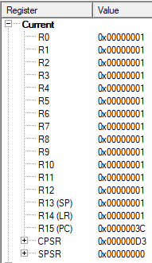

The program counter results in 3C indicating that 3C/4 = 15 instruction have been performed.

**Outputs:**

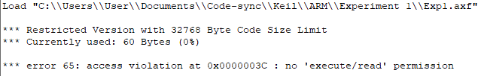

**Result:**

The value of R0 is copied onto all other registers and is verified to be correct.