**Experiment 12**

**Aim:**

To write an ARM Assembly Language to find the number of times a character is repeated in a string.

**Tool Used:**

Keil uVision4

**Theory:**

The value of string is loaded using DCB and DCD values and compared until the value is 0.

**Code:**

    AREA PROGRAM, CODE, READONLY

    ENTRY

MAIN

        LDR R0, VALUE1

        MOV R1, #'E'

LOOP2   LDRB R3,[R0],#1

        CMP R3,R1

        BNE LOOP2

        ADDS R3,R3,#0

        BEQ LOOP1

        ADD R7,R7,#1

        B LOOP2

LOOP1   SWI &11

    AREA PROGRAM, DATA, READONLY

VALUE1 DCD STRING ; DCD = Define Constant Double word

STRING DCB "EMBEDDED" ; DCB = Define Constant Byte

    END

**Output:**

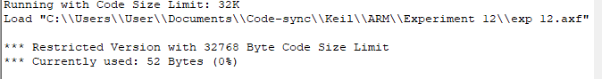

The word Embedded has 3 E in it which is displayed in R7.

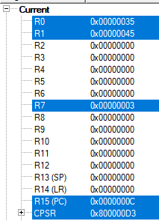

**Result:**

The experiments to find the number of times a character is repeated in a string has been performed and verified to be correct.